Supplementary figures and tables

Fig. S1. Scanning electron micrograph of strain YP2^{T}. The scale bar is 1 μm.

Fig. S2. Effects of temperature (a), pH (b) and NaCl concentrations (c) on the growth of strain YP2^{T}.

Fig. S3. Oxygen requirement for the growth of strain YP2^{T}.

Fig. S4. Phospholipid(a) and aminolipid(b) profiles of strain YP2^{T}.

Fig. S5. Phylogenetic trees based on 16S rRNA gene sequences reconstructed using the Maximum-Likelihood method based on strain YP2^{T} and related taxa in the order Rhodospirillales. Bootstrap values more than 50 % based on 1000 replications are shown at branch nodes. Escherichia coli ATCC 11775^{T} was used as the outgroup. Scale bar represents substitutions per site. The GenBank accession numbers for 16S rRNA gene sequences are shown in parentheses.

Table S1. Genome properties of strain YP2^{T}.
Table S2. Comparison of cellular fatty acid profiles of strain YP2^{T}. Values are percentages of the total fatty acids. ND, not detected. Values in bold indicate major components (>10.0%). All data were obtained from this study.

Table S3. The ANI, AAI, POCP and 16S rRNA gene similarities value among representative species of published families within the order Rhodospirillal
Fig.S1

Fig. S2
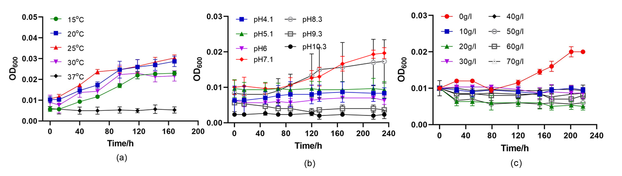

Fig. S3

Fig S4
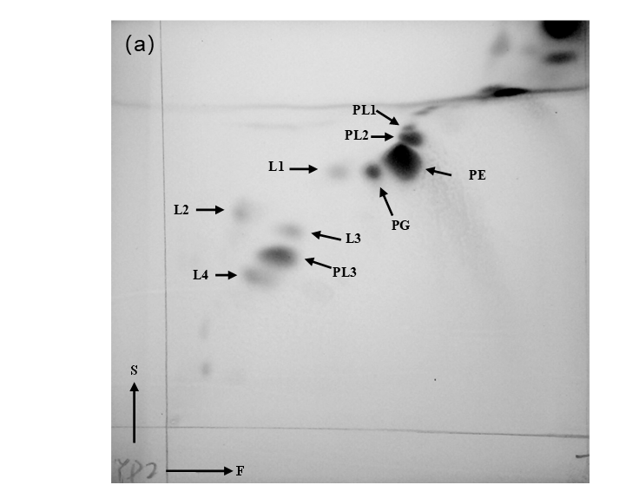
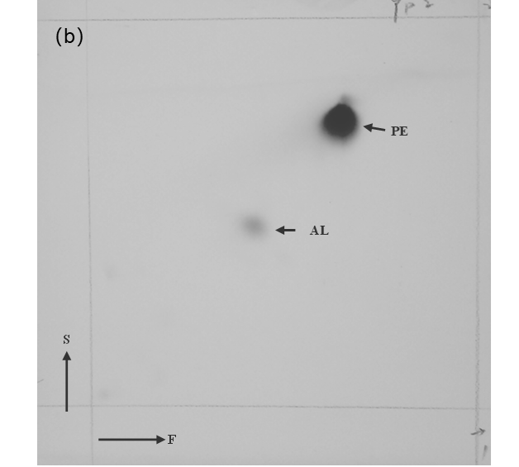

Fig. S5

Table S1.
Contents | Shumkonia mesophila YP2^{T}
DNA (bp) | 5,388,487
G+C content (%) | 66
ORFs (No.) | 5053
N50 length | 225,250
CRISPRs | 1
ORFs with KEGG matches | 2,314
ORFs with Swiss matches | 3,540
ORFs with GO matches | 3,592
tRNA | 49
5s rRNA | 1
16s rRNA | 1
23s rRNA | 1

Table S2.
Fatty acid | Shumkonia mesophila YP2^{T} | Oceanibaculum nanhaiense L54-1-50^{T}
iso-C_{10:0} | 0.5 | 0.5
anteiso-C_{11:0} | 0.5 | 0.6
C_{12:0} | 6.3 | 4.4
C_{11:0} 2OH | 0.4 | 0.5
anteiso-C_{13:0} | 0.5 | 0.8
C_{14:0} | 1.2 | 1.5
anteiso-C_{15:0} | 1.3 | 1.5
Sum In Feature 2 | 1.1 | 3.9
Sum In Feature 3 | 23.1 | 5.6
C_{16:1} w5c | 1.0 | ND
C_{16:0} | 34.6 | 12.6
anteiso-C_{17:1} w9c | 2.1 | 1.6
anteiso-C_{17:0} | 0.6 | 1.2
C_{17:0} cyclo | 3.6 | ND
C_{17:1} w7c | ND | 0.5
C_{16:0}-3OH | 1.3 | 1.9
Sum In Feature 5 | 1.4 | 0.4
Sum In Feature 8 | 17.9 | 50.0
C_{18:0} | 0.9 | 2.1
C_{18:1} w7c 11-methyl | ND | 1.1
iso-C_{19:0} | 0.9 | 2.9
C_{19:0} cyclo w8c | 0.5 | 5.9
ND, not detected; Sum In Feature 2, C_{14:0} 3OH/C_{16:1} iso I; Sum In Feature 3, C_{16:1} w7c/C_{16:1} w6c; Sum In Feature 5, C_{18:0} ante/C_{18:2} w6,9c ; Sum In Feature 8, C_{18:1}ω7c and/or C_{18:1}ω6
Table S3.
Type strain 1 | 16s | AAI | ANI | POCP | Type strain 2
Shumkonia mesophila YP2^{T} | 85.5 | 53.0 | 66.0 | 26.3 | Acetobacter aceti NBRC 14818^{T}
Shumkonia mesophila YP2^{T} | 87.3 | 56.6 | 69.4 | 38.0 | Azospirillum lipoferum DSM 1691^{T}
Shumkonia mesophila YP2^{T} | 85.0 | 53.1 | 67.6 | 37.3 | Geminicoccus roseus D2-3^{T}
Shumkonia mesophila YP2^{T} | 84.4 | 54.7 | 64.9 | 35.9 | Kiloniella laminariae LD81^{T}
Shumkonia mesophila YP2^{T} | 88.4 | 55.7 | 67.4 | 39.2 | Nisaea denitrificans DSM 18348^{T}
Shumkonia mesophila YP2^{T} | 88.5 | 55.6 | 67.4 | 38.8 | Nisaea nitritireducens DR41-18^{T}
Shumkonia mesophila YP2^{T} | 89.9 | 57.8 | 69.7 | 42.4 | Oceanibaculum indicum P24^{T}
Shumkonia mesophila YP2^{T} | 90.2 | 57.7 | 69.8 | 43.0 | Oceanibaculum nanhaiense L54-1-50^{T}
Shumkonia mesophila YP2^{T} | 90.0 | 57.6 | 69.6 | 41.9 | Oceanibaculum pacificum LMC2up-L3^{T}
Shumkonia mesophila YP2^{T} | 85.6 | 54.1 | 68.0 | 32.3 | Reyranella massiliensis 521^{T}
Shumkonia mesophila YP2^{T} | 85.8 | 57.5 | 69.2 | 40.0 | Rhodospirillum rubrum ATCC 11170^{T}
Shumkonia mesophila YP2^{T} | 86.9 | 55.9 | 68.7 | 40.8 | Rhodovibrio salinarum DSM 9154^{T}
Shumkonia mesophila YP2^{T} | 89.9 | 56.6 | 69.6 | 39.4 | Stella humosa DSM 5900^{T}
Shumkonia mesophila YP2^{T} | 83.9 | 56.3 | 64.9 | 38.7 | Terasakiella pusilla DSM 6293^{T}
Shumkonia mesophila YP2^{T} | 89.8 | 56.1 | 69.8 | 40.9 | Thalassobaculum fulvum HSF7^{T}
Shumkonia mesophila YP2^{T} | 88.6 | 55.2 | 69.1 | 38.1 | Thalassobaculum litoreum DSM 18839^{T}
Shumkonia mesophila YP2^{T} | 88.0 | 55.4 | 69.0 | 38.7 | Thalassobaculum salexigens CZ41-10a^{T}
Shumkonia mesophila YP2^{T} | 82.9 | 54.8 | 65.4 | 40.9 | Thalassospira lucentensis QMT2^{T}
Shumkonia mesophila YP2^{T} | 88.6 | 55.6 | 68.7 | 33.5 | Zavarzinia compransoris LMG-5821^{T}

