Supplementary Material

GPR35-mediated Kynurenic Acid Sensing Acts as a Defender Against Gut Microbiota Disorder in Ulcerative Colitis
Di Wang^{1, †}, Wenbao Wang^{2, †}, Xue Bing¹, Chenguang Xu¹, Jiahua Qiu¹, Jiangang Shen¹, Jinwen Huang¹, Junda, Li¹ and Biao Xie¹*

¹ Department of Gastroenterology, People's Hospital of Longhua, Shenzhen 518109, P.R. China
² College of Pharmacy, Qiqihar Medical University, Qiqihar, 161006, Heilongjiang, PR China
*Correspondence should be addressed to Biao Xie, Chief physician,
Department of Gastroenterology, People's Hospital of Longhua, NO.38 Jinglong Construction Road, Longhua District, Shenzhen 518109, China. Tel/Fax: +0755-27741585; E-mail: xiebiaohxq@163.com

† These authors contributed equally to this work

Figure S1 Schematic representation of rat disposal process in each group.

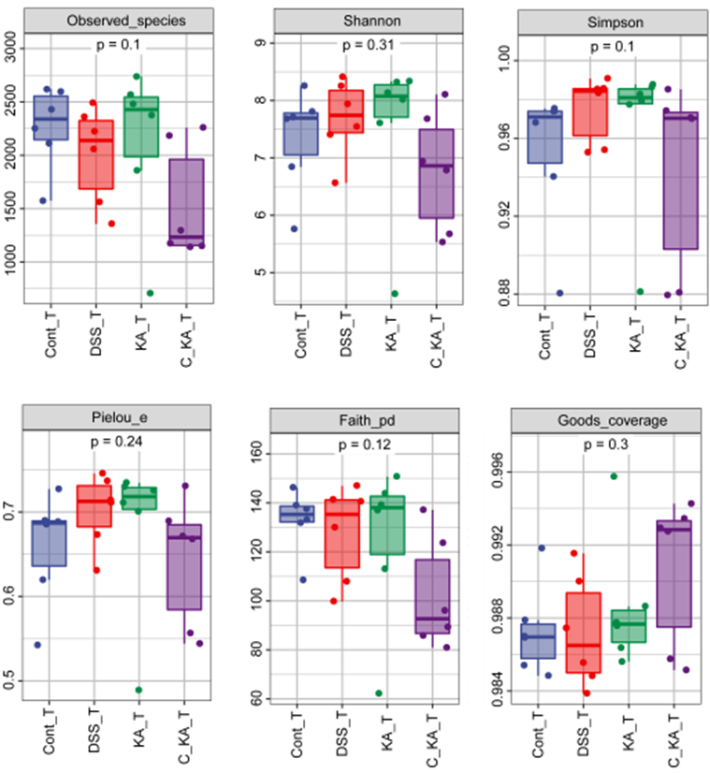
Figure S2 α-diversity analysis of gut microbiota by Observed_species, Shannon, Simpson, Faith_pd, Goods_coverage and Pielou_e indexes.

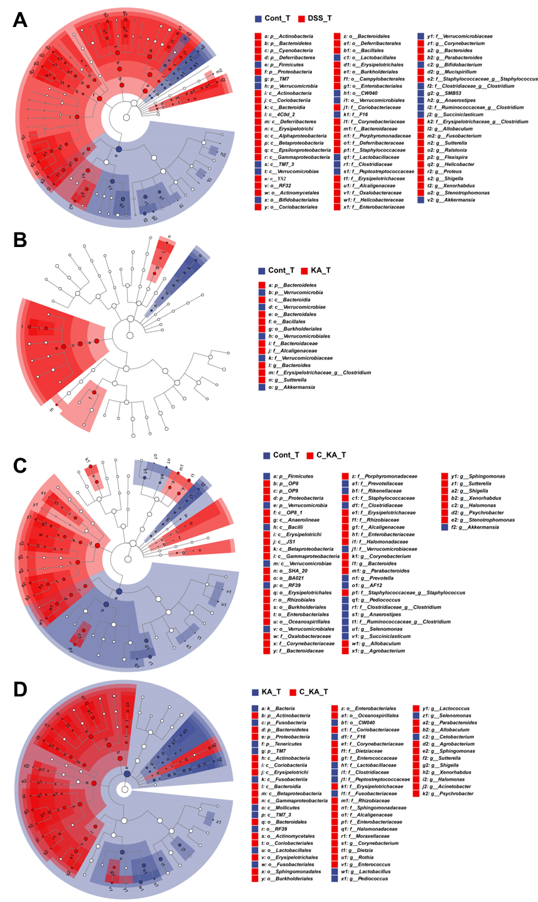
Figure S3 The LEfSe analysis of the differential gut microbiome in Cont_T and DSS_T groups (A), Cont_T and KA_T groups (B), Cont_T and C_KA_T groups (C), KA_T and C_KA_T groups (D). The size of the circles was based on the relative abundance, the solid circle represented LDA > 3.0, P < 0.05, and the hollow circle represented P > 0.05.
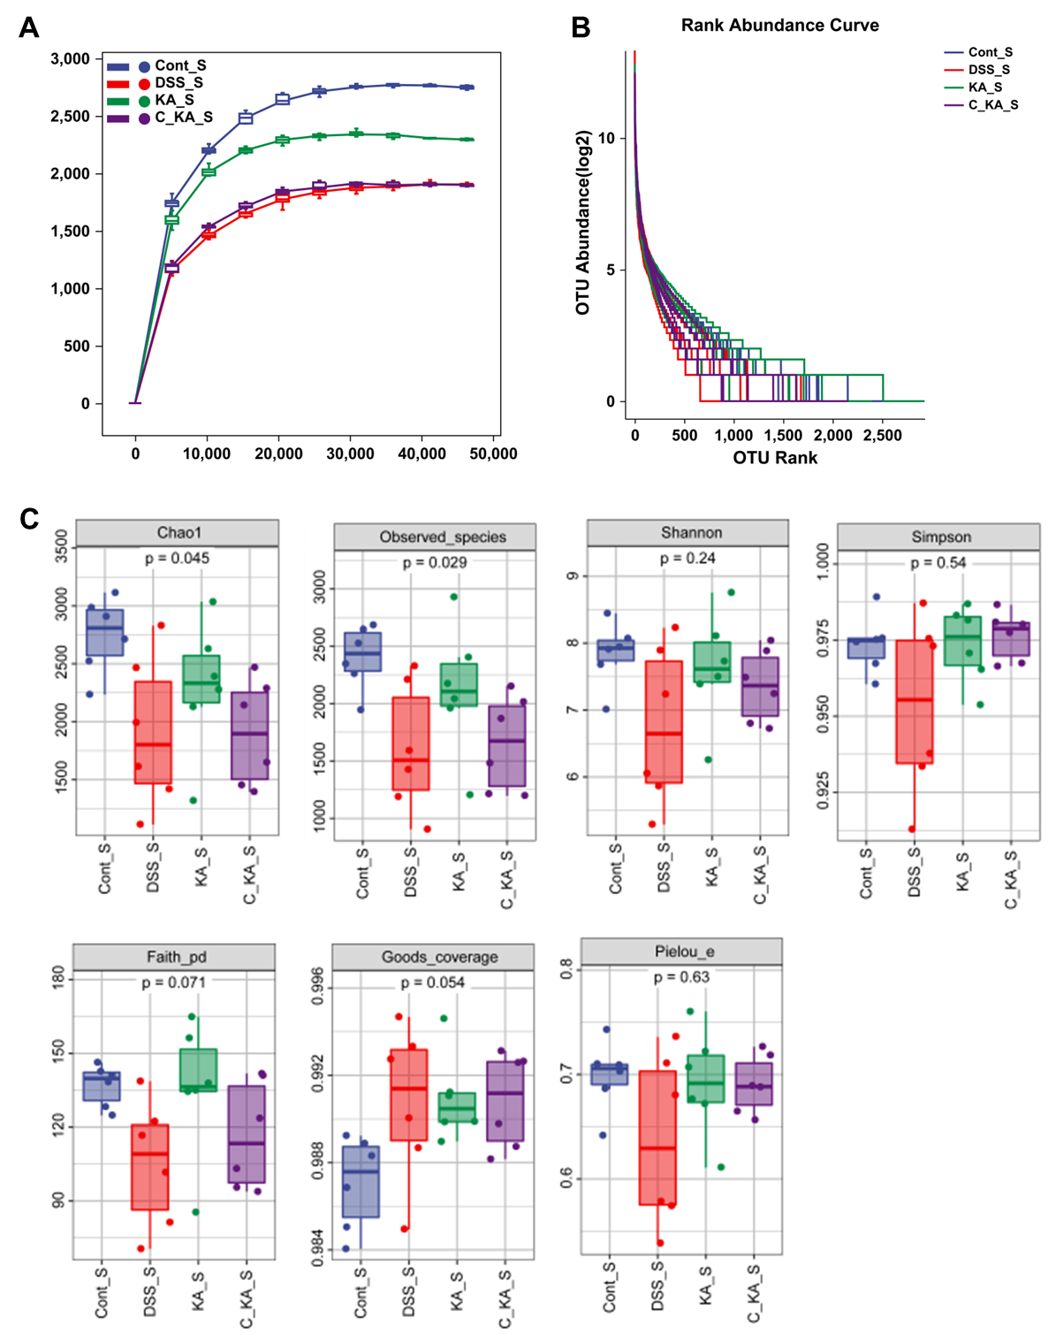
Figure S4 (A, B) Rarefaction curve (A) and Rank abundance curve (B) of each group. (C) α-diversity analysis of gut microbiota by Chao1, Observed_species, Shannon, Simpson, Faith_pd, Goods_coverage and Pielou_e indexes.

The raw unedited western blot images presented in Figure 1E
p-ERK12 ERK12 β-actin

The raw unedited western blot images presented in Figure 4E
p-ERK12 ERK12 β-actin

