Supplementary materials
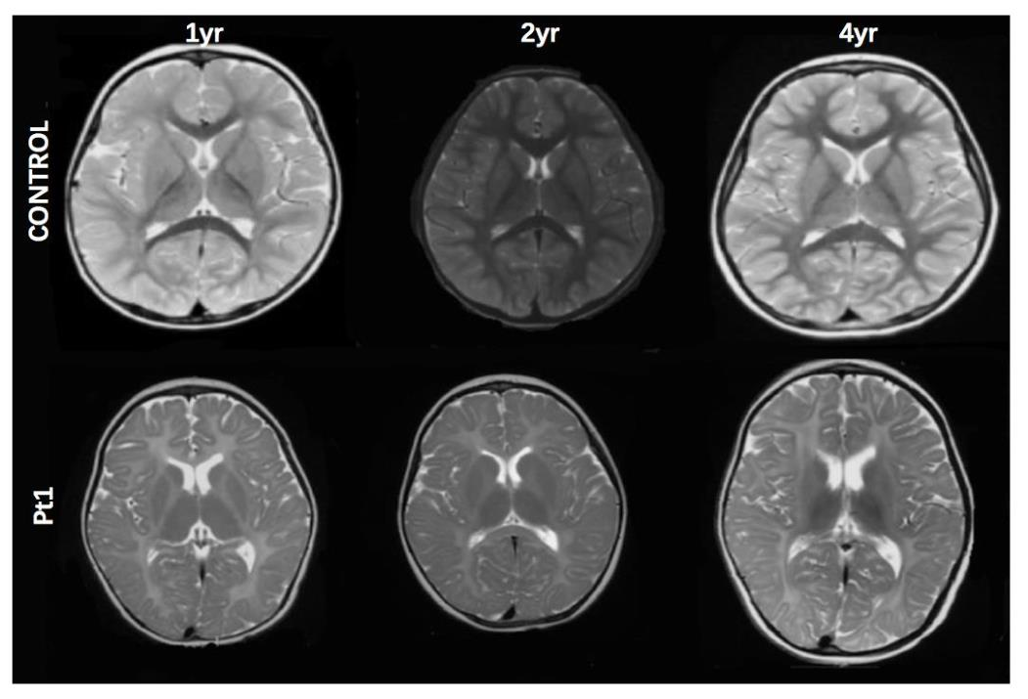
Fig. S1 Comparison of brain MRI images between a healthy child (upper row) and Pt1 (bottom row) at different ages. Diffuse hyperintensity in white matter presented in the axial T2WI on Pt1.

Fig. S2 PLP1 expression in the control and patient fibroblasts using western blotting. (a) PLP1 expression in the fibroblasts of all four groups. (b) There were no differences in PLP1 expression between Pt1 and Pt2 and the control group (n=3 P>0.05), but there was a significant difference between Pt3 and the control group (n=3 p<0.05). Error bars represent the mean ± SD of three independent experiments.

