Supplementary information
Continuous increase in evaporative demand shortens the growing season of European ecosystems in the last decade

Supplementary Information for
Continuous increase in evaporative demand shortens the growing season of European ecosystems in the last decade
Mehdi Rahmati^{1,2*}, Alexander Graf², Christian Poppe², Wulf Amelung³, Wouter Dorigo⁴, Harrie-Jan Hendricks Franssen², Carsten Montzka², Dani Or^{5, 6}, Matthias Sprenger⁷, Jan Vanderborght², Niko E. C. Verhoest⁸, Harry Vereecken²
¹Department of Soil Science and Engineering, University of Maragheh, Maragheh, Iran
²Agrosphere Institute IBG-3, Forschungszentrum Jülich GmbH, 52425 Jülich, Germany
³Institute of Crop Science and Resource Conservation (INRES)- Soil Science and Soil Ecology, University of Bonn, Bonn, Germany
⁴ Department of Geodesy and Geoinformation, TU Vien, Vienna, Austria
⁵Department of Environmental Systems Science, ETH Zurich, Switzerland
⁶Division of Hydrologic Sciences (DHS) - Desert Research Institute, Reno, NV, USA
⁷Lawrence Berkeley National Laboratory, Berkeley, California, USA
⁸Laboratory of Hydrology and Water Management, Ghent University, Ghent, Belgium

*Corresponding authors: Mehdi Rahmati: mehdirmti@gmail.com, m.rahmati@fz-juelich.de

The PDF file includes Supplementary Figures 1 to 12, supplementary Table 1, and one supplementary discussion.
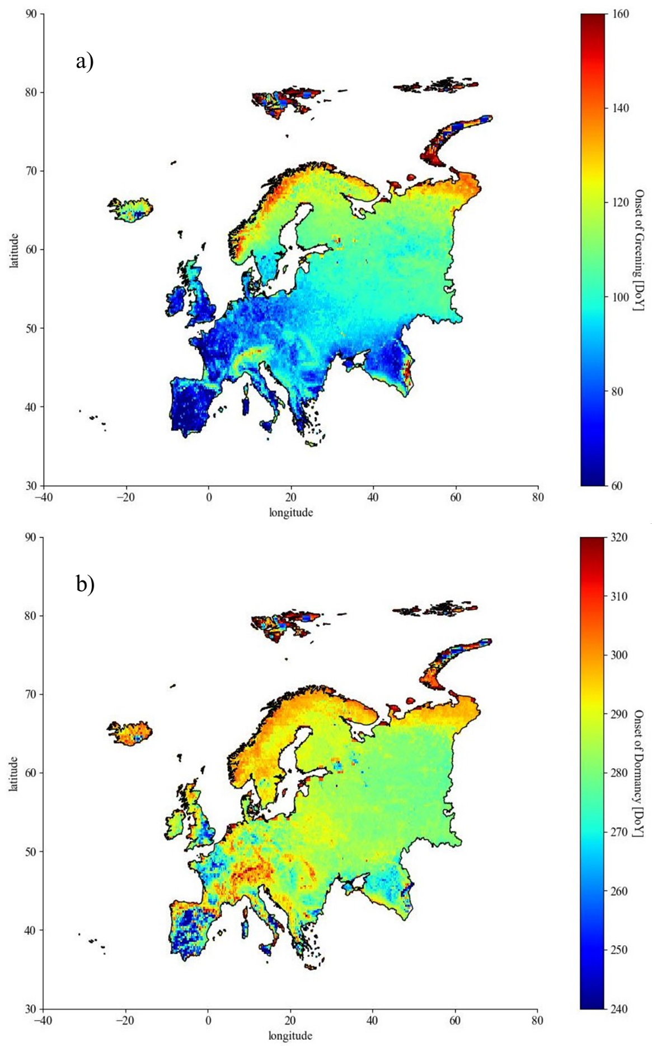
Supplementary Figure 1 | Variation of the long-term (1982-2020) average of onsets of greening (a) and dormancy (b) across Europe.
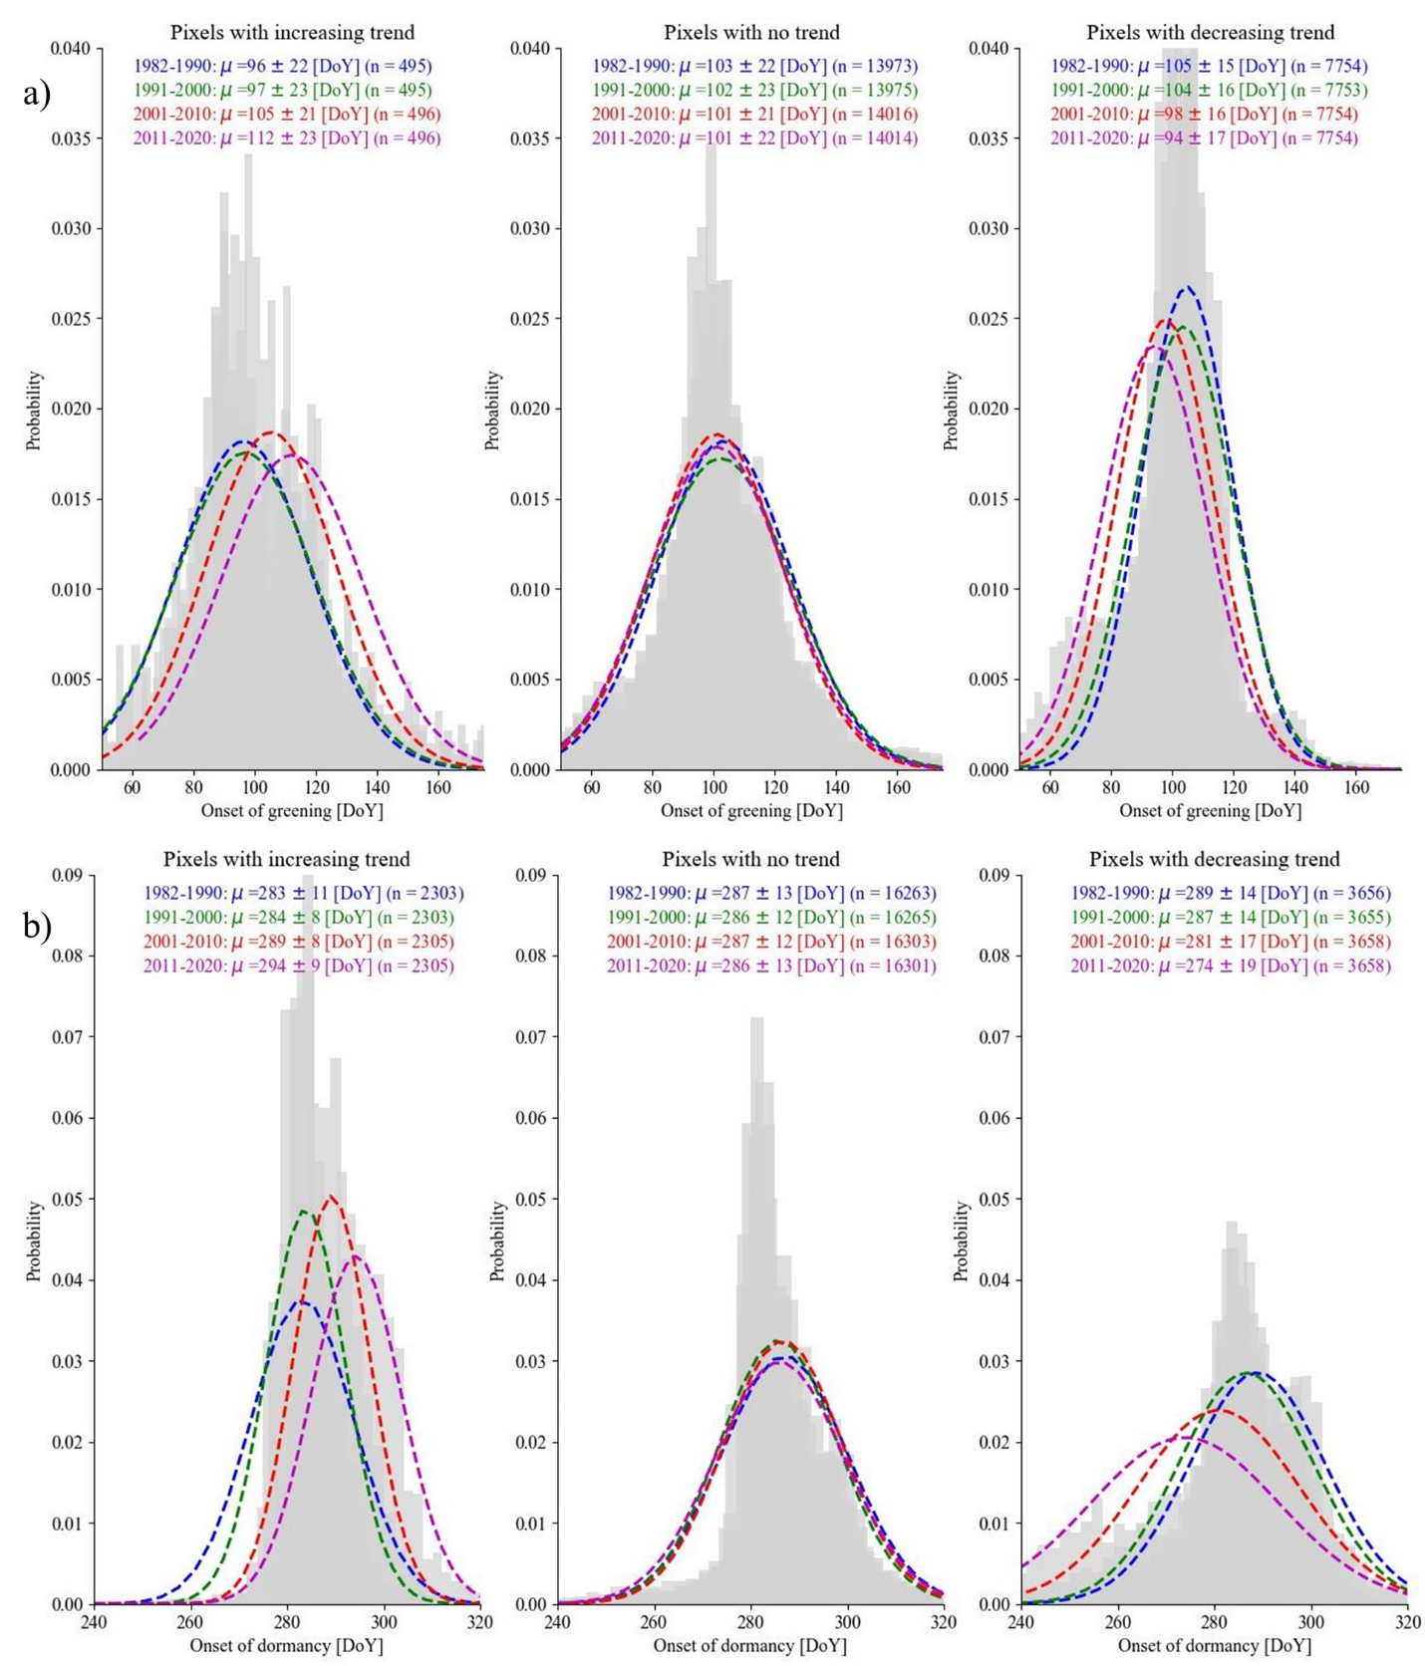
Supplementary Figure 2 | Histogram of the onsets of greening (a) and dormancy (b) in different decades and different pixels with significant decreasing or increasing trend or without significant trend.
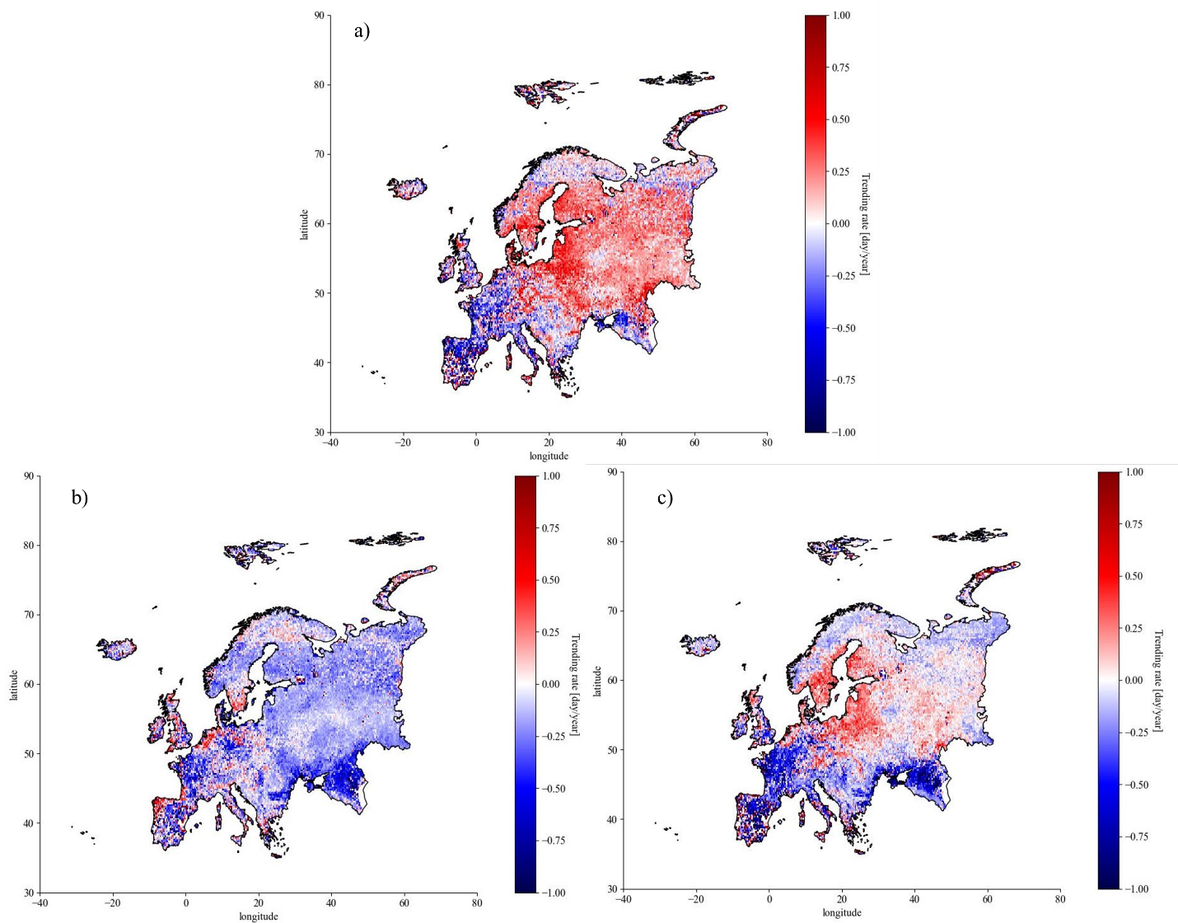
Supplementary Figure 3 | Variation of the long-term (1982-2020) trend of length of growing season (a), onset of greening (b), and onset of dormancy (c) in Europe. Positive and negative trending rates respectively mean lengthening and shortening of growing season or later and earlier onset of greening and dormancy. The analysis is based on the implementation of the original nonparametric test of Mann-Kendall^{30,31} trend analysis testing the significance of change of data by time. The color bar is intentionally limited to +1 and -1 (obtained from the map histogram) to increase the contrast of the map.

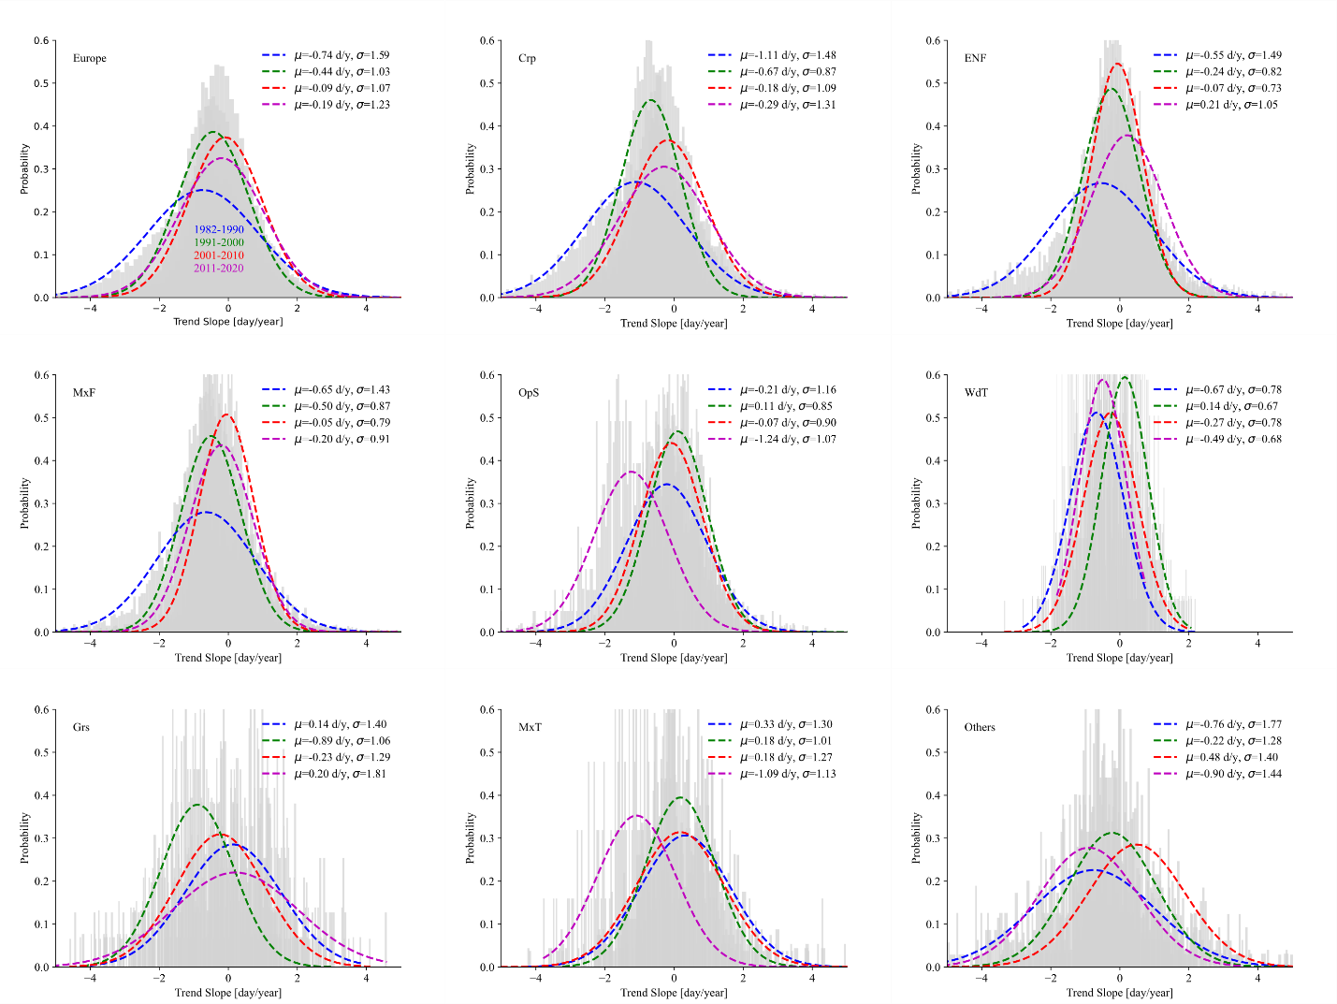
Supplementary Figure 4 | Histogram of trend of slope of onset of greening in different decades under different land cover types like croplands (Crp), evergreen needleleaf forests (ENF), mixed forest (MxF), open shrublands (OpS), wooden tundra (WdT), grasslands (Grs), and mixed tundra (MdT). The letter μ and σ correspond to the mean and standard deviations.
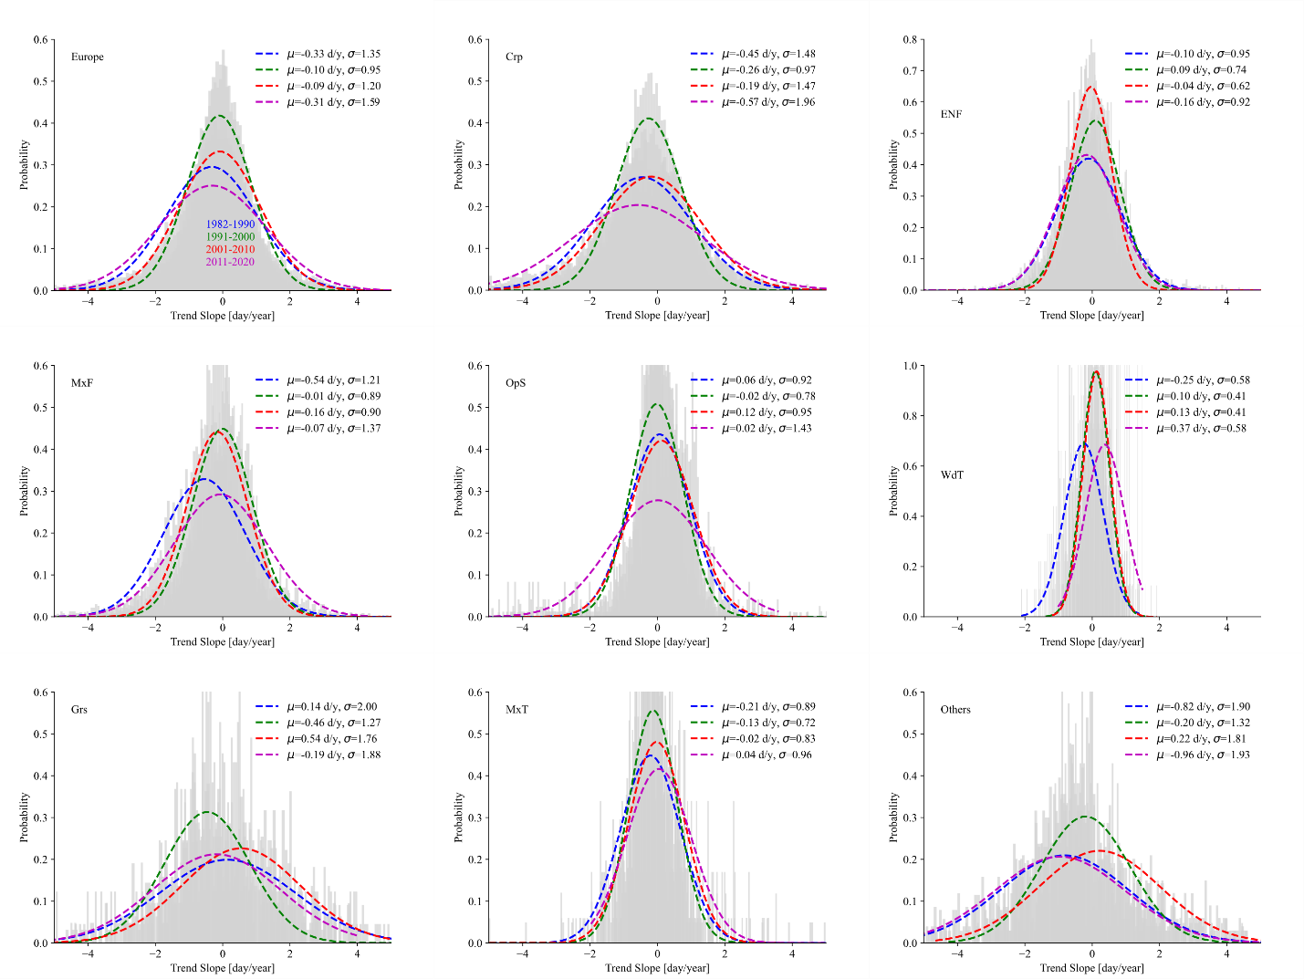
Supplementary Figure 5 | Histogram of trend of slope of onset of dormancy in different decades under different land cover types like croplands (Crp), evergreen needleleaf forests (ENF), mixed forest (MxF), open shrublands (OpS), wooden tundra (WdT), grasslands (Grs), and mixed tundra (MdT). The letter μ and σ correspond to the mean and standard deviations.
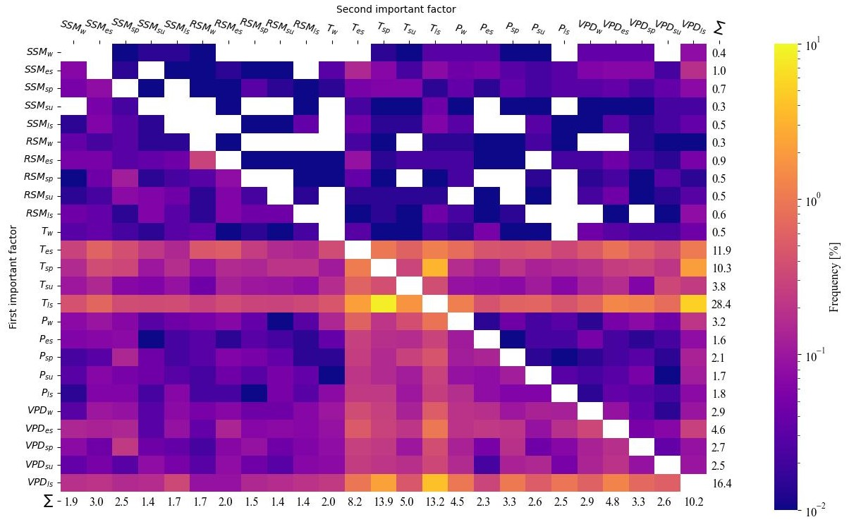
Supplementary Figure 6 | The first and second most important control factors of length of season across Europe. SSM and RSM refer to surface soil moisture and root zone soil moisture, respectively, T is temperature, P precipitation, and VPD vapor pressure deficit. Subscripts w, es, sp, su and ls refer to winter, early spring, spring, summer, and late summer periods.

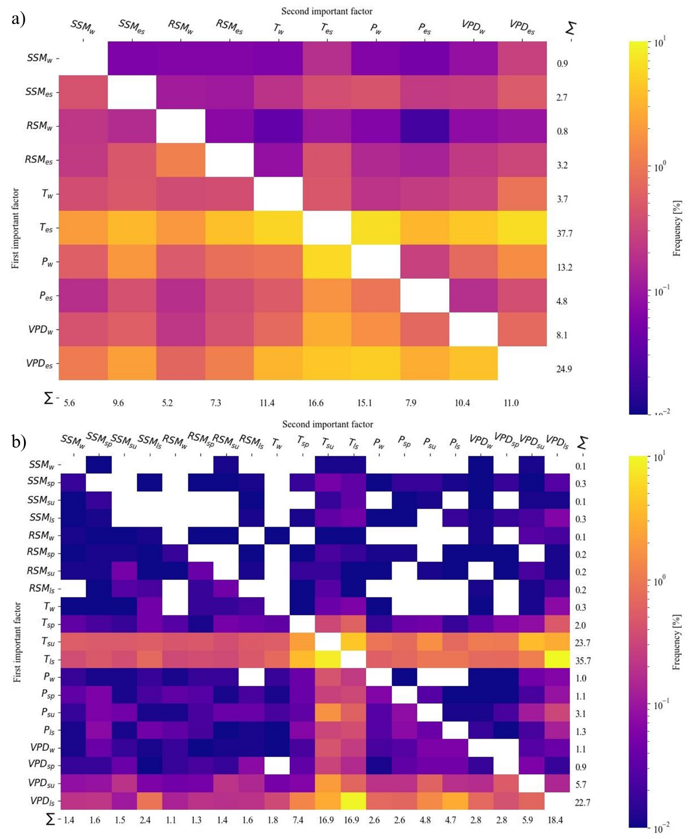
Supplementary Figure 7 | The first and second most important control factors of onsets of greening (a) and dormancy (b) across Europe. SSM and RSM imply soil moisture at surface and rooting depth, respectively, T implies temperature, P implies precipitation, and VPD implies vapor pressure deficit. Subscripts w, es, sp, su, and ls imply winter, early spring, spring, summer, and late summer periods.
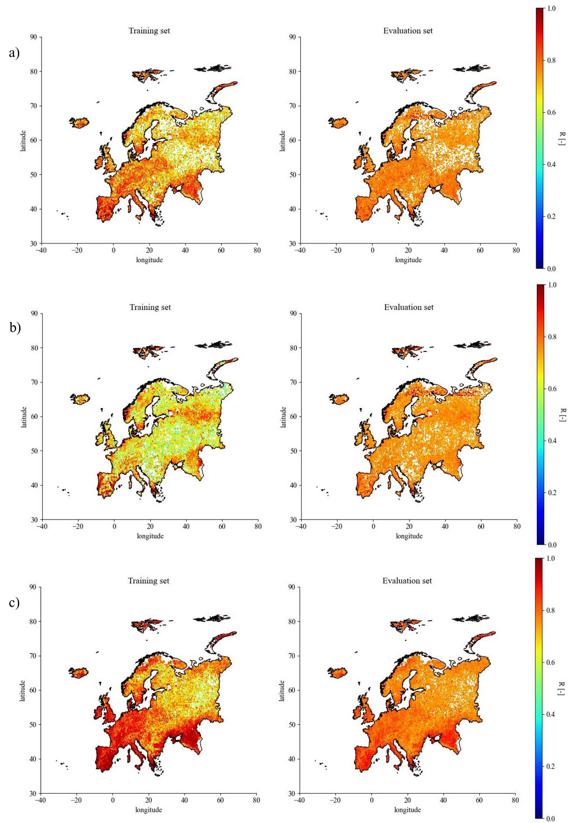
Supplementary Figure 8 | The mean accuracy of the fitted model to predict length of growing season (a), onset of greening (b), and onset of dormancy (c) using main meteorological data plus soil water content at surface soil and rooting depth. The R corresponds to the Pearson correlation between the calculated season length and that predicted by the model. Training and evaluation sets refer to subsets of data that are used to train and evaluate the developed networks by randomly splitting the data into them, with 70 percent of the data used to train the networks and the rest used to test them as independent data.
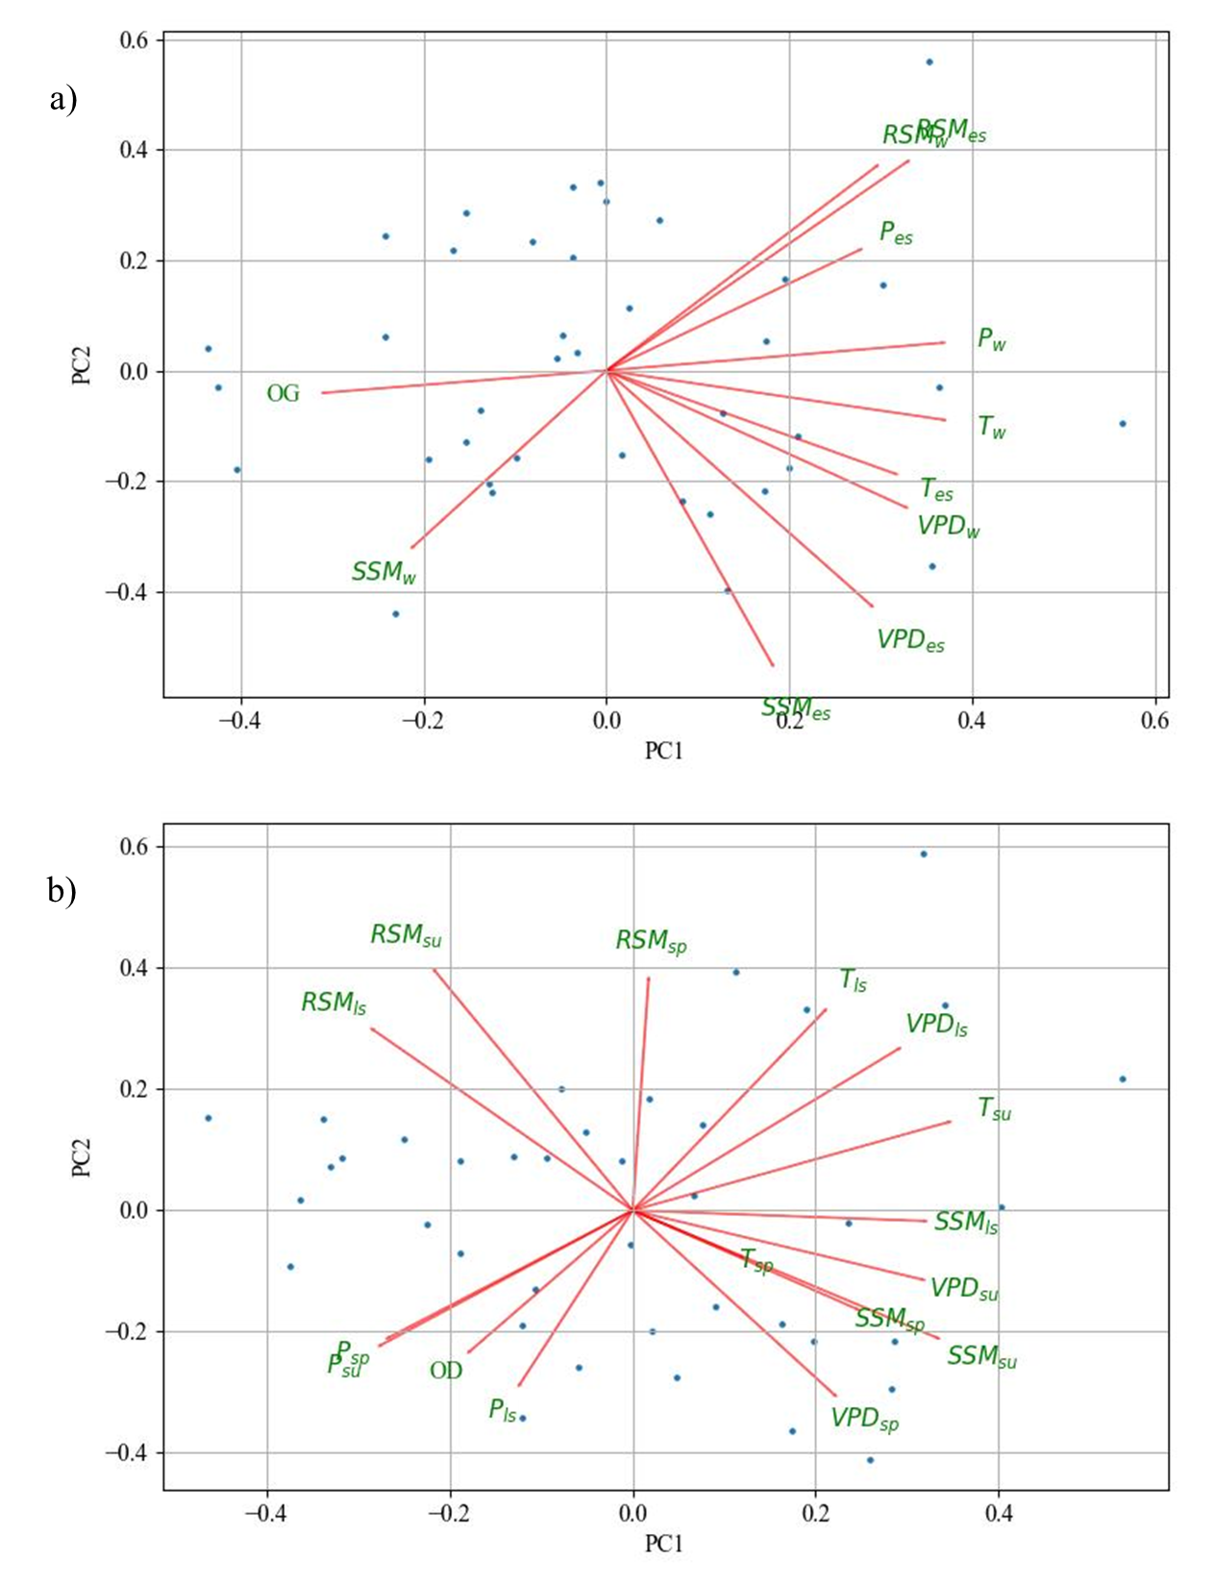
Supplementary Figure 9 | Relationship between onset of greening (a) and onset of dormancy (b) and meteorological and soil variables. OG and OD refer to onsets of greening and dormancy, SSM and RSM refer to surface soil moisture and root zone soil moisture, T is temperature, P precipitation, and VPD vapor pressure deficit. Subscripts w and es refer to winter and early spring periods which parameters are averaged for.

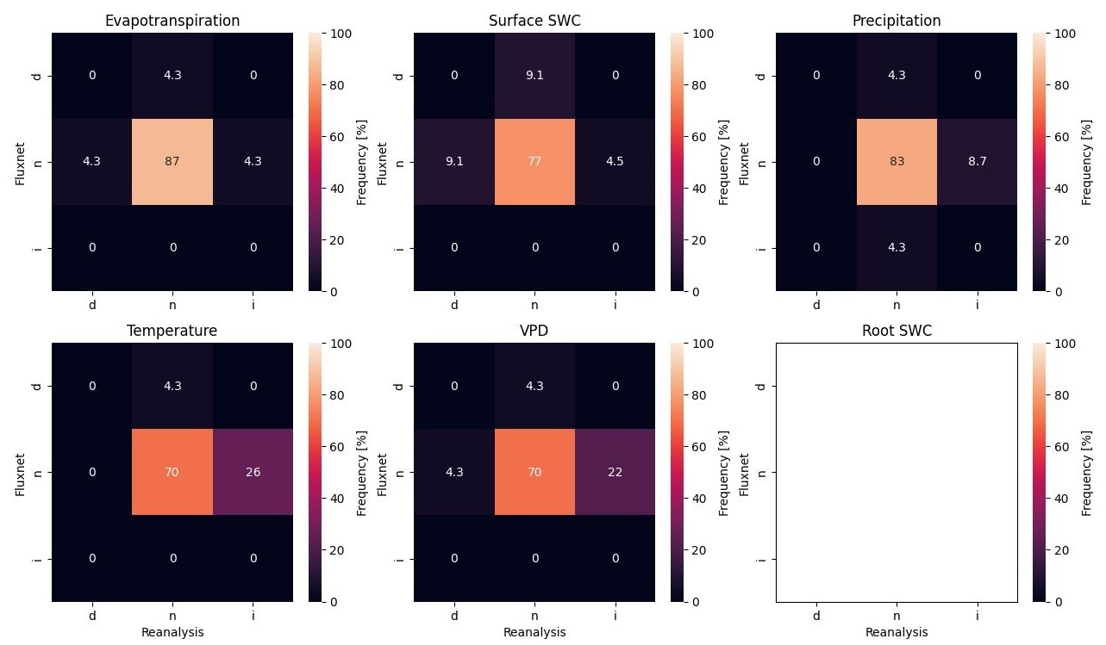
Supplementary Figure 10 | Heatmaps showing the confusion matrix between existing trends from FLUXNET and reanalysis data on evapotranspiration, soil water content (SWC) at the soil surface, precipitation, temperature, and vapor pressure deficit (VPD). No SWC was reported in the root zone in the FLUXNET database. A total of 25 FLUXNET stations with data from 2000 to 2017 were included in this analysis. In heatmaps, the x-axis corresponds to the reanalysis data and the y-axis corresponds to the FLUXNET data. The x and y labels of i, n and d correspond to an increasing trend, no trend, and a decreasing trend in the Mann-Kendall analysis.

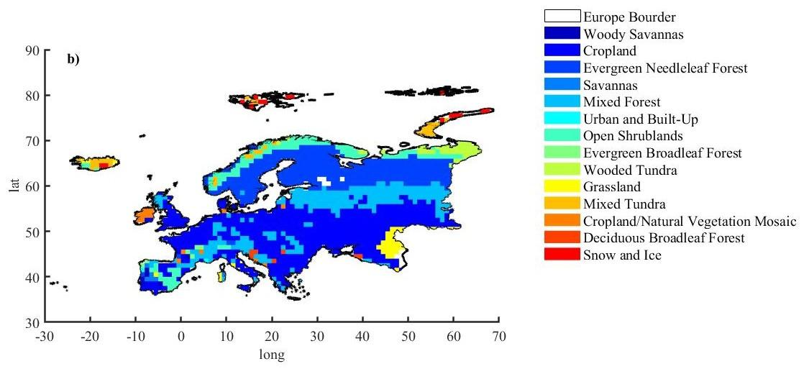
Supplementary Figure 11 | GLDAS Vegetation Class/Mask used in this investigation

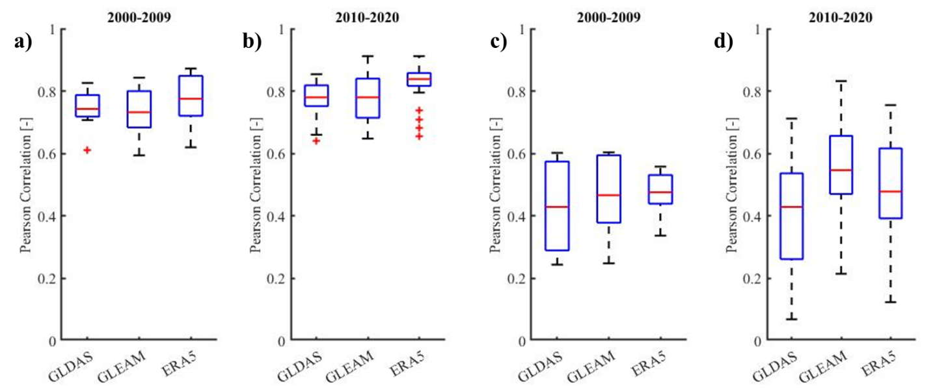
Supplementary Figure 12 | Pearson correlations between FLUXNET evapotranspiration, ET, (a and b) and surface soil moisture, SSM, (c and d) data and ET and SSM of other datasets (GLDAS, GLEAM, and ERA5-land).

Supplementary Table 1 | Variation different variables averaged over summer [peaking time of greening till onset of dormancy] in different decades and areas with significant decreasing, increasing, or no trend obtained from Mann-Kendal analysis. The reported values correspond to the mean ± standard deviations
Trend type | Period | ET  [mm/d] | SSM  [cm³/cm³] | RSM  [mm] | P  [mm/d] | T  [C] | VPD  [kPa]
Increasing | 1982-1990 | 1.39 ± 0.76 | 0.28 ± 0.06 | 371.51 ± 176.90 | 1.02 ± 0.38 | 10.89 ± 4.32 | 0.31 ± 0.20
Increasing | 1991-2000 | 1.49 ± 0.85 | 0.30 ± 0.05 | 376.75 ± 172.50 | 1.36 ± 0.47 | 11.43 ± 4.28 | 0.37 ± 0.22
Increasing | 2001-2010 | 1.66 ± 0.86 | 0.31 ± 0.05 | 393.27 ± 169.59 | 1.71 ± 0.55 | 12.40 ± 4.07 | 0.41 ± 0.25
Increasing | 2011-2020 | 1.80 ± 0.90 | 0.32 ± 0.06 | 394.76 ± 170.85 | 1.60 ± 0.40 | 12.96 ± 4.26 | 0.43 ± 0.28
No trend | 1982-1990 | 1.51 ± 0.64 | 0.28 ± 0.41 | 385.63 ± 169.42 | 1.99 ± 0.91 | 11.38 ± 3.31 | 0.29 ± 0.19
No trend | 1991-2000 | 1.56 ± 0.72 | 0.28 ± 0.41 | 368.82 ± 165.09 | 2.16 ± 0.87 | 11.68 ± 3.43 | 0.34 ± 0.21
No trend | 2001-2010 | 1.58 ± 0.66 | 0.29 ± 0.41 | 369.48 ± 159.94 | 2.19 ± 0.82 | 11.97 ± 3.28 | 0.34 ± 0.21
No trend | 2011-2020 | 1.57 ± 0.69 | 0.29 ± 0.41 | 367.20 ± 166.05 | 1.74 ± 0.71 | 11.88 ± 3.36 | 0.34 ± 0.22
Decreasing | 1982-1990 | 1.50 ± 0.57 | 0.24 ± 0.05 | 386.72 ± 151.45 | 2.26 ± 0.68 | 12.14 ± 2.25 | 0.29 ± 0.21
Decreasing | 1991-2000 | 1.48 ± 0.59 | 0.23 ± 0.06 | 366.87 ± 151.16 | 2.03 ± 0.59 | 12.38 ± 2.27 | 0.31 ± 0.21
Decreasing | 2001-2010 | 1.36 ± 0.57 | 0.22 ± 0.06 | 352.44 ± 152.70 | 1.99 ± 0.58 | 11.50 ± 2.16 | 0.26 ± 0.19
Decreasing | 2011-2020 | 1.20 ± 0.54 | 0.21 ± 0.06 | 342.82 ± 157.53 | 1.54 ± 0.46 | 10.65 ± 2.16 | 0.23 ± 0.17
 | Frequencies [%]
Increasing | - | 30.9 | 20.2 | 1.5 | 0.5 | 46.5 | 34.9
No trend | - | 65.3 | 74.6 | 89.2 | 59.7 | 52.6 | 64.6
Decreasing | - | 3.9 | 5.2 | 9.3 | 39.8 | 0.9 | 0.5
ET stands for evapotranspiration, SSM for soil moisture at the surface, RSM for soil moisture in the root zone, P for precipitation, T for temperature, and VPD for vapor pressure deficit.
Supplementary Discussion: To test whether the hypothesis that SM is not a control factor for the timing of OG and OD, but VPD is a control factor, is correct, we performed an additional evaluation on the temporal evolution of ET, RSM, SSM, T, VPD, and P data averaged for summertime [from the peaking time of greening till onset of dormancy]. We first analyzed the general trend of the above variables for the entire period (1982-2020) and then calculated the decade-wise mean value of these variables for different areas with increasing, decreasing and no trend (the results are reported in supplementary Table in above). 89% of the pixels in Europe show no significant trend for the summer RSM where the mean value of different decades for these areas varies around 367 to 386 mm. Similarly, 75% of the pixels show no significant trend for the summer SSM, and 20% show an increasing trend. 60% of the pixels also show no significant trend for summer P, but 40% show a decreasing trend where daily averaged summertime rainfall is decreased from 2.26 to 1.54 mm/d. 47% of the pixels show a significant increase of 2.0°C for summer T in the last decade (2011-2020) compared to the first decade (1982-1990). For the remaining 53% of pixels, we still record a 0.5°C increase in summer T, although the trend is not significant. 35% of the pixels show a significant increase for summer VPD, with 120 Pa higher VPD in the last decade (2011-2020) than in the first decade (1982-1990). The remaining pixels show an increase of 50 Pa in the last decade compared to the first decade, even though the trend is not significant. Interestingly, for 65% of the pixels there is no significant trend for summer ET (showing a mean value of 1.51 to 1.58 mm/d) and only for 31% of pixels we see and increasing trend where ET is increased from 1.40 mm/d in first decade to 1.80 mm/d in the last decade. For the remaining pixels we see no significant change in ET values among different decades. This means that some factor other than water availability is controlling summer ET otherwise we would see an increase in ET accompanied by depletion in the SSM and RSM. However, as reported by Graf et al. ⁵⁰, it can be argued that no change in ET can be the net result of a simultaneous increase in potential ET along with a decrease in the availability of water for evapotranspiration. However, we already show that there is no such decrease in water availability during the summer in our case. This confirms our hypothesis that although there is still sufficient water for ET and promising atmospheric conditions for soil water transpiration, AWD exceeds the water supply rate of plants and then wilt/senescence sets in. For cropland, the story might be different. The higher T-value probably leads to an earlier harvest on arable land, and after that there is usually no new crop or no plants with a high LAI on the land.
To confirm the obtained trend for the above-mentioned variables using in situ data, we performed a Mann-Kendall trend analysis over those variables obtained from the FLUXNET database and compared them to obtained results for the corresponding pixels in the reanalysis data using an error matrix (see supplementary Fig. 10 above). A total of 25 FLUXNET stations in Europe contain (almost) complete data from 2000 to 2020. Overall, the trends obtained from both in situ and reanalysis data agree 87% for ET, 77% for SSM, 83% for P, 70% for T, and 70% for VPD. Therefore, we can be confident that our conclusion can also be confirmed by ground observation data.

