An Original Aspirin-containing Carbonic Anhydrase 9 Inhibitor Overcomes Hypoxia-induced Drug Resistance to Enhance the Efficacy of Myocardial Protection
Wen Zhou^{a, b}, Bin Zhang^{b}, Keyu Fan^{b}, Xiaojian Yin^{c}, Jinfeng Liu^{d}, Shaohua Gou^{a, b}*

[a] Jiangsu Province Hi-Tech Key Laboratory for Biomedical Research, Southeast University, Nanjing, 211189, Jiangsu, P. R. China.
[b] Pharmaceutical Research Center and School of Chemistry and Chemical Engineering, Southeast University, Nanjing, 211189, Jiangsu, P. R. China.
[c] State Key Laboratory of Natural Medicines, China Pharmaceutical University, Nanjing, 210009, Jiangsu, P. R. China.
[d] School of Basic Medical Sciences and Clinical Pharmacy, China Pharmaceutical University, Nanjing, 211198, Jiangsu, P. R. China.
E-mail: sgou@seu.edu.cn (S.Gou)

Supporting Information
Fig. S1 UV absorption spectrum of AcAs (100 μM).
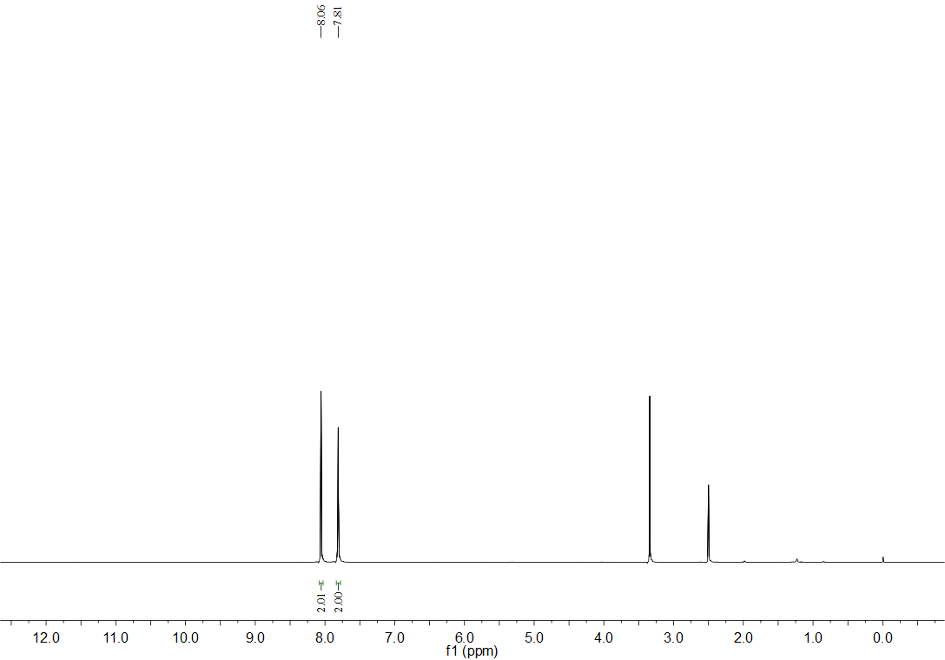
Fig. S2 ¹H NMR (600 MHz, DMSO-d₆) spectrum of the intermediate 2. δ 8.06 (s, 2H), 7.81 (s, 2H).
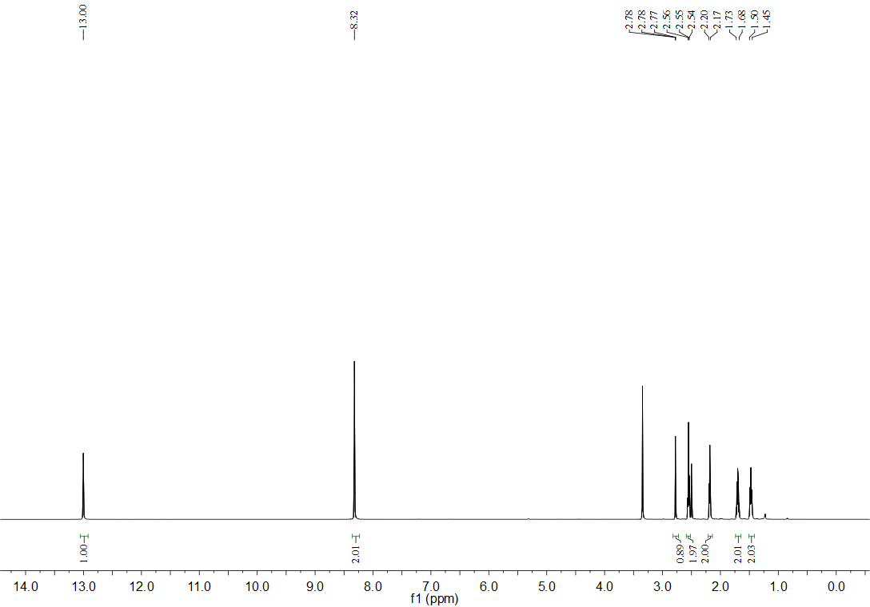
Fig. S3 ¹H NMR (600 MHz, DMSO-d₆) spectrum of the intermediate 3. δ 13.0 (s, 1H), 8.32 (s, 2H), 2.78 (t, J = 2.4 Hz, 1H), 2.55 (t, J = 7.2 Hz, 2H), 2.20–2.17 (m, 2H), 1.73–1.68 (m, 2H), 1.50–1.45 (m, 2H).

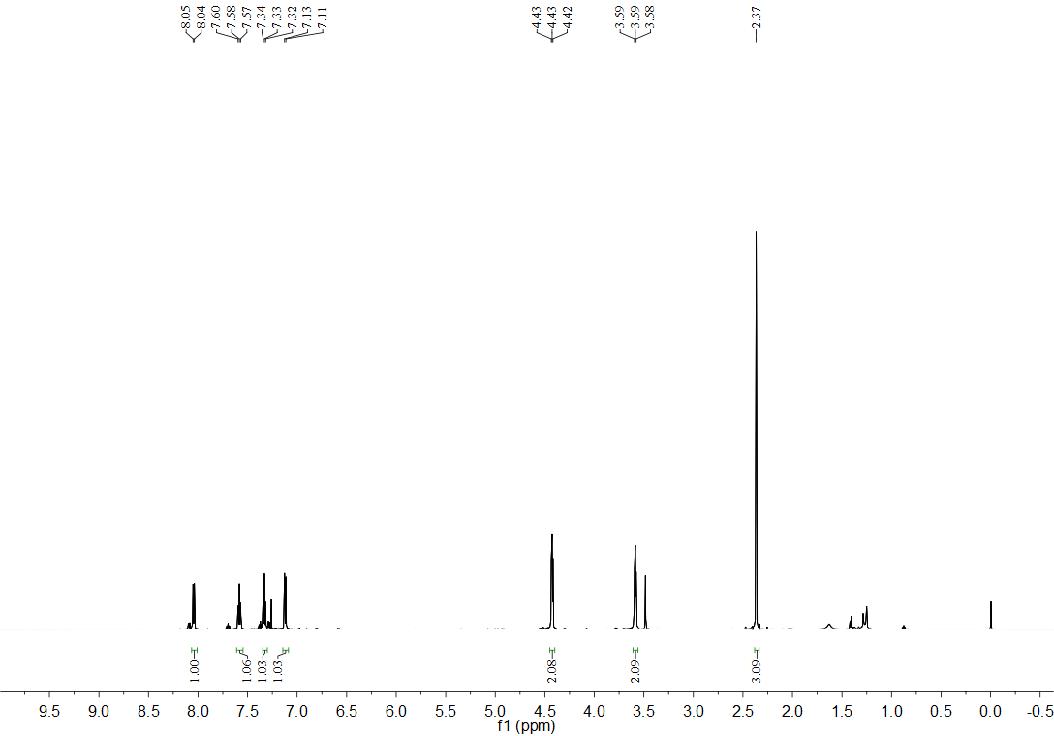
Fig. S4 ¹H NMR (600 MHz, CDCl₃) spectrum of the intermediate 6. δ 8.04 (d, J = 7.8 Hz, 1H), 7.58 (t, J = 7.8 Hz, 1H), 7.33 (t, J = 7.8 Hz, 1H), 7.12 (d, J = 7.8 Hz, 1H), 4.43 (d, J = 4.8 Hz, 1H), 3.59 (d, J = 4.8 Hz, 1H), 2.37 (s, 3H)

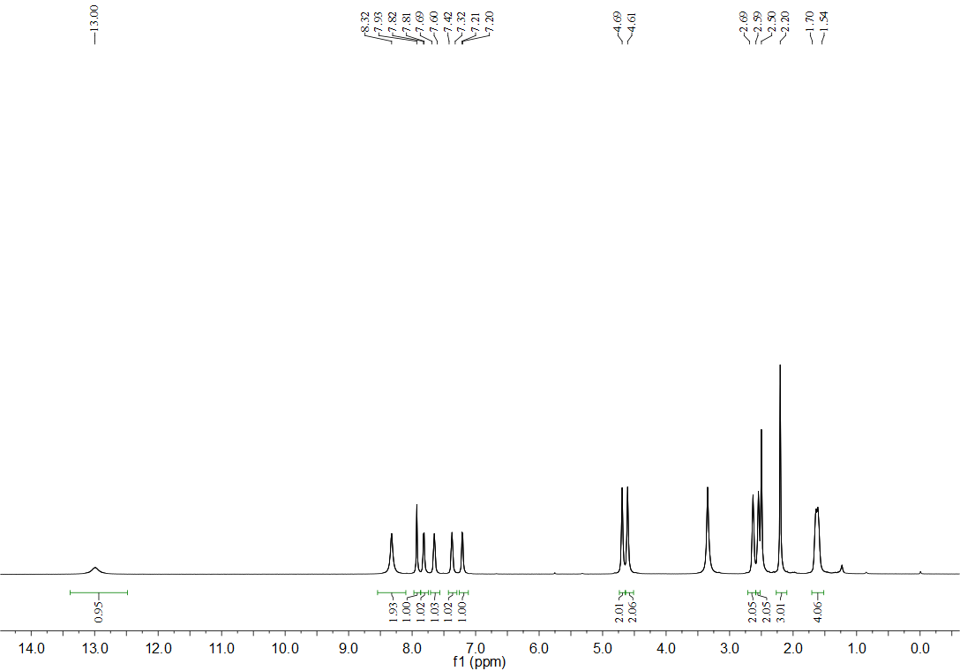
Fig. S5 ¹H NMR (600 MHz, DMSO-d₆) spectrum of AcAs. δ 13.00 (s, 1H), 8.32 (s, 2H), 7.93 (s, 1H), 7.82 (d, J = 6.9 Hz, 1H), 7.69–7.60 (m, 1H), 7.42–7.32 (m, 1H), 7.21 (d, J = 7.6 Hz, 1H), 4.69 (s, 2H), 4.61 (s, 2H), 2.69–2.59 (m, 2H), 2.59–2.50 (m, 2H), 2.20 (s, 3H), 1.70–1.54 (m, 4H)

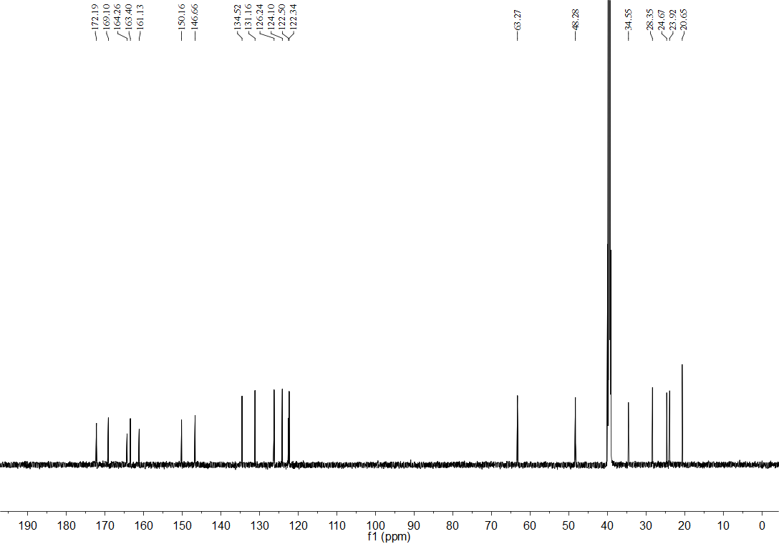
Fig. S6 ¹³C NMR (150 MHz, DMSO-d₆) spectrum of AcAs. δ 172.19, 169.10, 164.26, 163.40, 161.13, 150.16, 146.66, 134.52, 131.16, 126.24, 124.10, 122.50, 122.34, 63.27, 48.28, 34.55, 28.35, 24.67, 23.92, 20.65

Fig. S7 ESI/TOF Ms spectrum of AcAs.

Fig. S8 The purity of AcAs detected by HPLC.
Table S1 Assignments of the observed peaks in the ESI/TOF Ms spectrum of AcAs.
Species | Formula | Observed m/z | Calculated m/z
[AcAs]H⁺ | C₂₀H₂₃N₇O₇S₂ | 538.11157 | 537.1

Table S2 Molecular Formula Strings of the compounds AcAs, As and Ac.
Compound ID | SMILES
AcAs | NS(C1=NN=C(NC(CCCCC2=CN(CCOC(C3=CC=CC=C3OC(C)=O)=O)N=N2)=O)S1)(=O)=O
aspirin (As) | OC(C1=CC=CC=C1OC(C)=O)=O
acetazolamide (Ac) | NS(C1=NN=C(NC(C)=O)S1)(=O)=O

Table S3 3D PDB files of docking models for Figure 5D: (1) Ac; (2) AcAs. 3D structure of CAIX (PDB ID: 6FE2) was downloaded from NCBI database (http://www.ncbi.nlm. nih.gov/).
- Ac
REMARK 4 XXXX COMPLIES WITH FORMAT V. 2.0
HETATM 1 N UNK 1 -29.212 11.191 -33.632 0.00 0.00 inhi N
HETATM 2 N UNK 1 -27.996 11.546 -34.182 0.00 0.00 inhi N
HETATM 3 C UNK 1 -26.991 10.952 -33.575 0.00 0.00 inhi C
HETATM 4 S UNK 1 -27.447 9.915 -32.286 0.00 0.00 inhi S
HETATM 5 C UNK 1 -29.071 10.345 -32.635 0.00 0.00 inhi C
HETATM 6 S UNK 1 -25.286 11.206 -34.055 0.00 0.00 inhi S
HETATM 7 O UNK 1 -24.411 10.760 -32.987 0.00 0.00 inhi O
HETATM 8 O UNK 1 -25.005 10.446 -35.257 0.00 0.00 inhi O
HETATM 9 N UNK 1 -25.022 12.855 -34.352 0.00 0.00 inhi N
HETATM 10 H UNK 1 -25.720 13.542 -34.068 0.00 0.00 inhi H
HETATM 11 H UNK 1 -24.166 13.158 -34.817 0.00 0.00 inhi H
HETATM 12 N UNK 1 -30.115 9.856 -31.942 0.00 0.00 inhi N
HETATM 13 C UNK 1 -30.483 10.435 -30.758 0.00 0.00 inhi C
HETATM 14 C UNK 1 -31.654 9.886 -29.981 0.00 0.00 inhi C
HETATM 15 O UNK 1 -29.871 11.386 -30.335 0.00 0.00 inhi O
HETATM 16 H UNK 1 -30.629 9.059 -32.298 0.00 0.00 inhi H

(2) AcAs
REMARK 4 XXXX COMPLIES WITH FORMAT V. 2.0
HETATM 1 N UNK 1 -28.014 12.493 -31.825 0.00 0.00 inhi N
HETATM 2 N UNK 1 -27.619 13.054 -32.978 0.00 0.00 inhi N
HETATM 3 N UNK 1 -28.349 12.422 -34.126 0.00 0.00 inhi N
HETATM 4 C UNK 1 -29.214 11.417 -33.422 0.00 0.00 inhi C
HETATM 5 C UNK 1 -29.000 11.481 -32.100 0.00 0.00 inhi C
HETATM 6 C UNK 1 -29.680 10.632 -31.071 0.00 0.00 inhi C
HETATM 7 C UNK 1 -30.192 11.516 -29.941 0.00 0.00 inhi C
HETATM 8 C UNK 1 -31.326 10.805 -29.214 0.00 0.00 inhi C
HETATM 9 C UNK 1 -31.509 9.411 -29.799 0.00 0.00 inhi C
HETATM 10 C UNK 1 -32.521 9.462 -30.917 0.00 0.00 inhi C
HETATM 11 N UNK 1 -33.507 10.412 -30.904 0.00 0.00 inhi N
HETATM 12 H UNK 1 -33.558 11.079 -30.145 0.00 0.00 inhi H
HETATM 13 O UNK 1 -32.460 8.666 -31.823 0.00 0.00 inhi O
HETATM 14 C UNK 1 -34.408 10.457 -31.902 0.00 0.00 inhi C
HETATM 15 N UNK 1 -34.597 11.531 -32.638 0.00 0.00 inhi N
HETATM 16 N UNK 1 -35.574 11.333 -33.596 0.00 0.00 inhi N
HETATM 17 C UNK 1 -36.078 10.119 -33.538 0.00 0.00 inhi C
HETATM 18 S UNK 1 -35.402 9.122 -32.315 0.00 0.00 inhi S
HETATM 19 S UNK 1 -37.362 9.551 -34.648 0.00 0.00 inhi S
HETATM 20 O UNK 1 -37.462 8.107 -34.571 0.00 0.00 inhi O
HETATM 21 O UNK 1 -38.627 10.145 -34.266 0.00 0.00 inhi O
HETATM 22 N UNK 1 -36.978 10.007 -36.236 0.00 0.00 inhi N
HETATM 23 H UNK 1 -36.162 10.593 -36.415 0.00 0.00 inhi H
HETATM 24 H UNK 1 -37.561 9.695 -37.011 0.00 0.00 inhi H
HETATM 25 C UNK 1 -28.244 12.711 -35.563 0.00 0.00 inhi C
HETATM 26 C UNK 1 -29.631 12.681 -36.191 0.00 0.00 inhi C
HETATM 27 O UNK 1 -30.594 12.948 -35.209 0.00 0.00 inhi O
HETATM 28 C UNK 1 -31.050 14.199 -35.346 0.00 0.00 inhi C
HETATM 29 O UNK 1 -32.156 14.393 -35.793 0.00 0.00 inhi O
HETATM 30 C UNK 1 -30.273 15.244 -34.985 0.00 0.00 inhi C
HETATM 31 C UNK 1 -29.388 15.804 -35.906 0.00 0.00 inhi C
HETATM 32 C UNK 1 -28.586 16.883 -35.533 0.00 0.00 inhi C
HETATM 33 C UNK 1 -28.671 17.403 -34.242 0.00 0.00 inhi C
HETATM 34 C UNK 1 -29.557 16.842 -33.321 0.00 0.00 inhi C
HETATM 35 C UNK 1 -30.359 15.763 -33.693 0.00 0.00 inhi C
HETATM 36 O UNK 1 -31.220 15.219 -32.800 0.00 0.00 inhi O
HETATM 37 C UNK 1 -30.724 15.228 -31.558 0.00 0.00 inhi C
HETATM 38 C UNK 1 -31.216 16.241 -30.554 0.00 0.00 inhi C
HETATM 39 O UNK 1 -29.880 14.424 -31.238 0.00 0.00 inhi O

