Supplementary information

Precise control of liposome size using characteristic time depends on solvent type and membrane properties

Sunghak Choi^{1,⸸}, Bong Su Kang^{2,⸸} , Eunhye Yang³, Kee Sung Kim⁴, Moon Kyu Kwak^{2,*}, Pahn-Shick Chang^{1,3,5,6,*}, and Ho-Sup Jung^{1,*}.

¹Center for Food and Bioconvergence, Department of Food Science and Biotechnology, Seoul National University, Seoul 08826, South Korea
²School of Mechanical Engineering, Kyungpook National University, Daegu 41566, South Korea
³Department of Agricultural Biotechnology, Seoul National University, Seoul 08826, Republic of Korea
⁴Research Inst. of Advanced. Materials, Collage of Engineering, Seoul National University, Seoul 08826, South Korea
⁵Center for Agricultural Microorganism and Enzyme, Seoul National University, Seoul 08826, Republic of Korea
⁶Research Institute of Agriculture and Life Sciences, Seoul National University, Seoul 08826, Republic of Korea
*corresponding.author@email.example
E-mail: mkkwak@knu.ac.kr (M.K.K), pschang@snu.ac.kr (P.-S.C), jhs@snu.ac.kr (H.-S.J)

Morphological investigation of synthesized liposomes by transmission electron microscopy

To verify the assembled shape of synthesized liposomes and validate DLS measurement results, the morphology of samples was investigated via transmission electron microscopy. 10 μl of each sample was transferred to a formvar/carbon 200 mesh copper grid (Electron Microscopy Sciences, Hatfield, PA, USA) and left for 5 mins. The copper grid was then placed on a uranyl acetate drop for 5 mins. After the staining process, the excess solution and stain were removed from the grid using filter paper. TEM images were obtained with Energy-Filtering Transmission Electron Microscope at 120 kV (Talos L120C, FEI, Czech).
As shown in Figure S1, the liposomes were prepared with a spherical shape, and the size of each sample was coincident to DLS measurement data in Figure 1c.
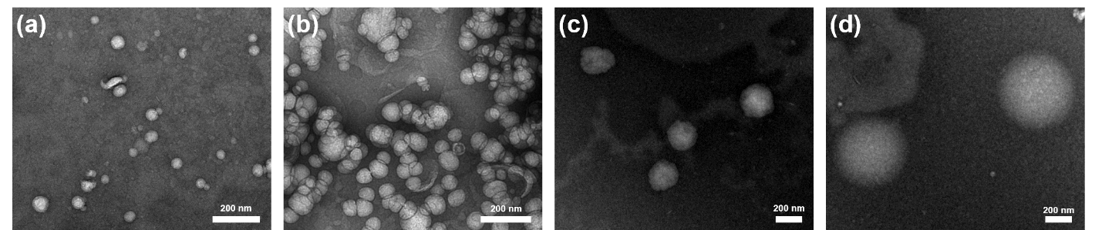
Figure S1. TEM images of the liposomes prepared using IPA at (a) FRR=19, (b) FRR=11.5, (c) FRR=6.5, and (d) FRR=4 (Scale bar = 200 nm).

