Screen-printed electrochemically activated ink on stretchable fabric for wearable micro-supercapacitors
Xiaoyan Li^{a, ∗}, Xiaoping Linª, Zhihui Zhang^{b}, Xianghong Liª, Wei Zhangª, Kaili Song^{c, ∗}
ªCollege of Textile and Garment, Hebei University of Science & Technology, The Innovation Center of Textile and Garment Technology, Hebei 050018, PR China
^{b}Advanced Technology Research Institute of Dyeing and Finishing Co. Ltd.Shandong,271000, PR China.
^{c}Engineering Research Center for Eco-Dyeing and Finishing of Textiles, College of Materials and Textiles, Zhejiang Sci-Tech University, Zhejiang, 310018, PR China.

Table S1 Box-Behnken experimental design factors and levels
Level | Factors
Level | A-CO-CNT/(g) | B-Hydroxyethyl cellulose/(mL) | C-Curing temperature/(℃)
-1 | 0.135 | 8 | 80
0 | 0.27 | 10 | 84
1 | 0.54 | 12 | 88

Table S2 Analysis of coefficients of determination and resolution accuracy
Target values | R²adj | R² | Resolution accuracy
Resistance value | 0.9735 | 0.9884 | 22.891

Adhesion test
The ability of the conductive ink to adhere to the cotton/spandex composite fabric was tested using the 100-frame method. Using a knife, make 10 evenly spaced 1 mm lines on the surface of the sample with a steady force, each one straight through the substrate, then repeat the last operation by rotating 90°, after which all 100 cells are firmly adhered with tape. The tape is peeled off at an angle of inclination close to 60° within 0.5-1 s and the ink adhesion level is determined by the amount of ink grid held up by the tape. The adhesion determination method is shown in Table S3.
The adhesion test Fig. S1 shows that some of the ink layer is peeling off at the crossed edges of its small cells, affecting an area of 5%, indicating that the conductive ink has good adhesion.

Table S3 Method of determining adhesion
Level | Description
0 | Completely smooth, without any chevron flaking.
1 | Small pieces of peeling at the intersection of small cells, affecting 5% of the area.
2 | Small grid intersections spalling along the edges, affecting 5-15% of the area.
3 | Small compartments flaking neatly along the edges, affecting 15-35% of the area.
4 | Small cells spalling along the entire edge, some cells partially or completely spalling, affecting 35-65% of the area.
5 | Any spalling grade greater than that graded according to 4.

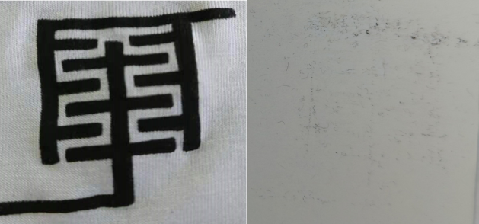
Fig. S1 Adhesion test chart

Alcohol resistance test
With a concentration of 95% ethanol-soaked white cotton cloth wrapped in a load weighing 500 g, to 40-60 times/min frequency wipe the surface of the sample ink layer, back and forth cycle 100 times, the results found that regardless of the transfer rate of conductive ink, the ink layer did not appear to leak the base, discolouration and other phenomena, and white cotton cloth are not stained by the ink layer.

*Corresponding author: Email: xiaoyanli89@hebust.edu.cn; kailisong@zstu.edu.cn

