Supplementary Figure S1
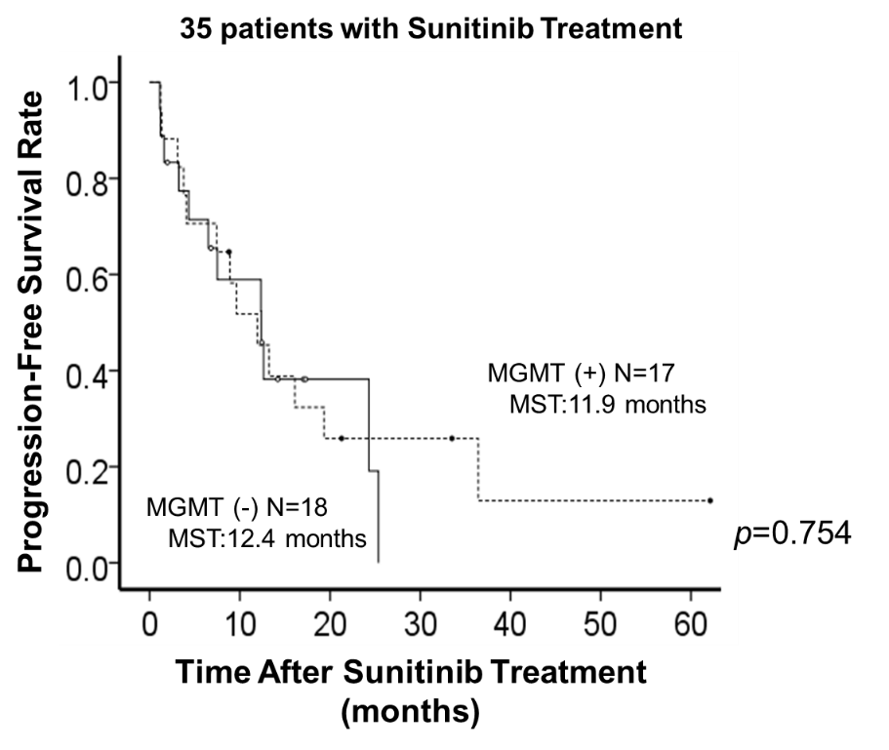

Supplementary Figure S1.Progression-free survival from the start of sunitinib treatment in 35 patients with positive and negative MGMT expression. Statistical significance was determined by log-rank test.

