Additional File 1. Clinical characteristics of patients with pancreatic neuroendocrine neoplasms
N=87
Age (median, years) | 58 (18-84)
Sex (male / female) | 51 / 36
Tumor size (median, cm) | 1.7 (0.3-13.5)
MEN-1/ VHL | 8 / 5
Multiple lesions | 11 (12.6%)
Symptoms | 29 (33.3%)
 | (pain in the right quadrant, abdominal tumor, liver dysfunction, jaundice, black stools, hypoglycemia, etc.)
Pathological functional PNEN | 26 (29.9%)
 | (insulinoma, 17; gastrinoma, 4; glucagonoma, 2; serotonin, 2; somatostatinoma, 1)
Localization | head, 30; body, 19; tail, 27; multiple, 11
Surgical procedure | pancreaticoduodenectomy, 28; distal pancreatectomy, 45; total pancreatectomy 3; enucleation, 7; partial resection, 2; middle pancreatectomy, 2
MEN-1, multiple endocrine neoplasm type 1; VHL, von Hippel-Lindau disease; PNEN, pancreatic neuroendocrine neoplasm.

Additional File 2. Time transition of resected PNEN patients during study period. PNEN, pancreatic neuroendocrine neoplasm.
(a) Total number of PNEN patients

(b) Depending on the tumor size (< 1 cm, 1-2 cm, > 2 cm)

Additional File 3. Receiver operating characteristic curve of tumor size with and without lymph node metastasis in pancreatic neuroendocrine neoplasm.
AUC, area under the curve.
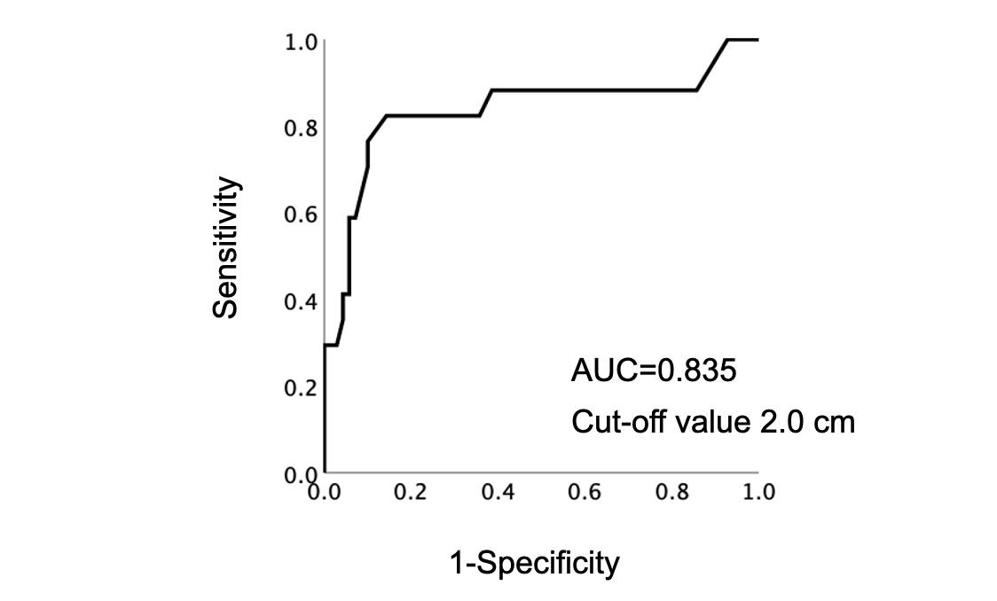

Additional File 4. Overall survival analysis for patients with resected pancreatic neuroendocrine neoplasm. We analyzed resected PNEN survival using Kaplan-Meyer method, showing that both overall and recurrence free survival were favorable. OS, overall survival; RFS, recurrence free survival.

Additional File 5. Review of observed PNEN cases
 | N=17
Age (median, years) | 66 (35-88)
Sex (male / female) | 11 / 6
Tumor size (median, mm) | [Initial] 8 (5-23)→[Current] 9.5 (7-25)
Hypervascular lesion | 15 (88.2%)
EUS-FNA | G1: 2, G2: 2
Observation periods (median, months) | 34 (2.4-114)
Death | 0
PNEN, pancreatic neuroendocrine neoplasm; EUS, endoscopic ultrasound; FNA, fine needle aspiration.

