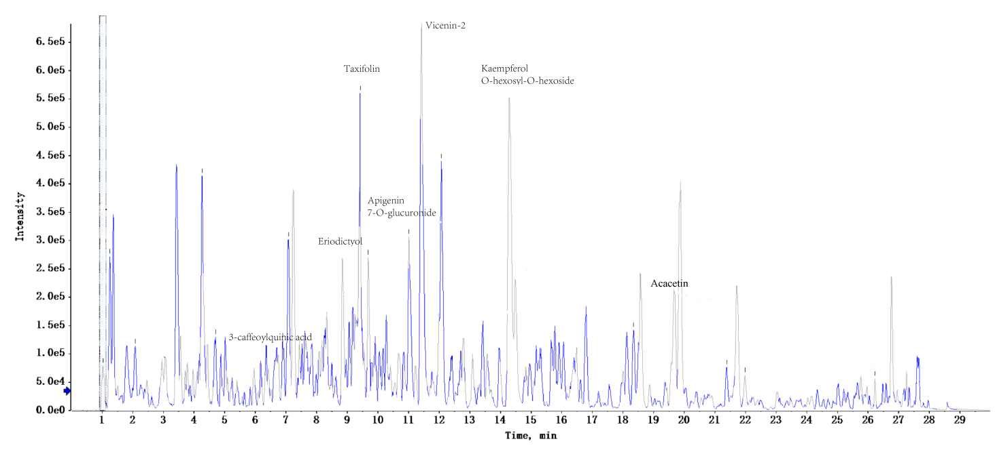
Fig. S1 Identification of OAE.
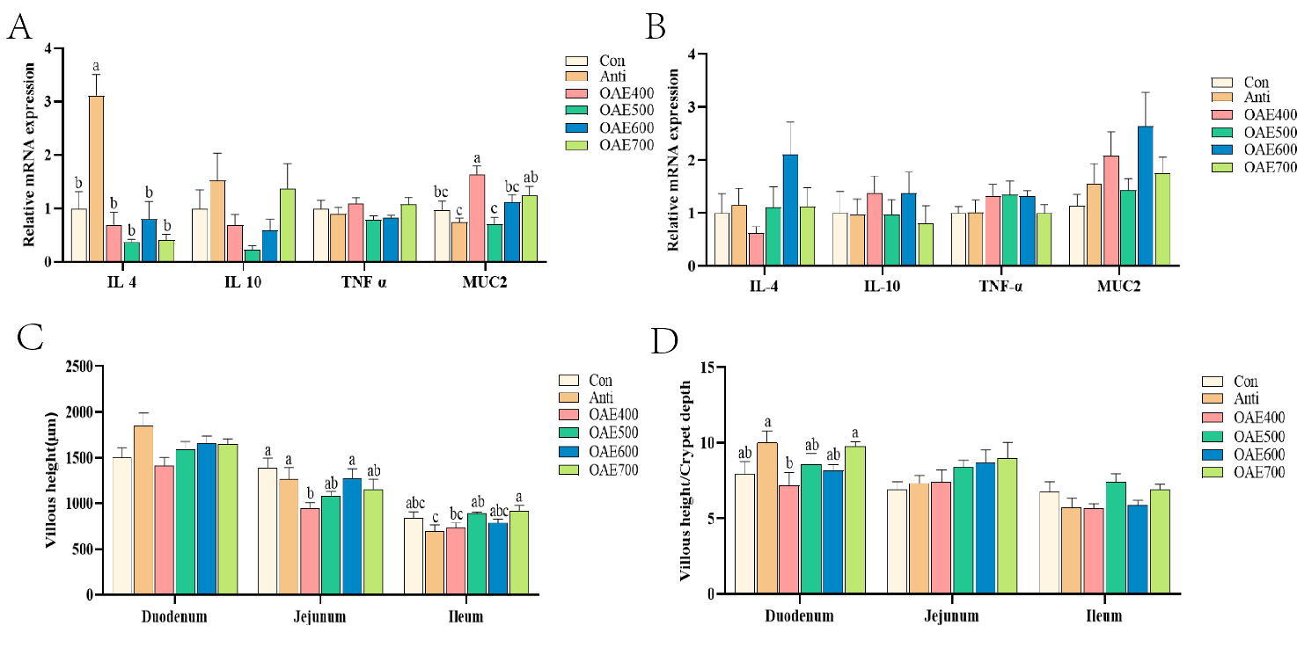
Fig. S2 OAE affected intestinal morphology and mucosal immunity. The relative mRNA expression of IL-4, IL-10, TNF-α and MUC2 in jejunum (A) and ileum (B) at D21. Intestinal villus height (C) and villus height/crypt depth (D) at D42. Data are expressed as means ± standard deviation. a-cTreatments with no common superscripts differ significantly (p < 0.05). IL, interleukin; TNF-α, tumor necrosis factor-α; MUC2, mucin 2
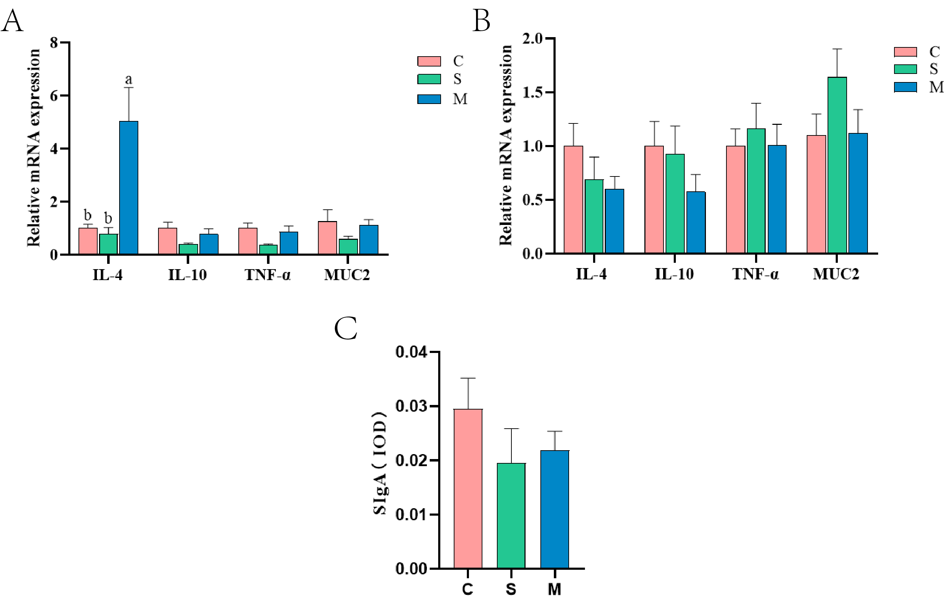
Fig. S3 Microorganism and supernatant for intestinal health. The relative mRNA expression of IL-4, IL-10, TNF-α and MUC2 in jejunum (A) and ileum (B) at D21. At D42, the secretion levels of SIgA in jejunum (C). Data are expressed as means ± standard deviation. a-cTreatments with no common superscripts differ significantly (p < 0.05). IL, interleukin; TNF-α, tumor necrosis factor-α; MUC2, mucin 2; SIgA, Secreted immunoglobulin A

