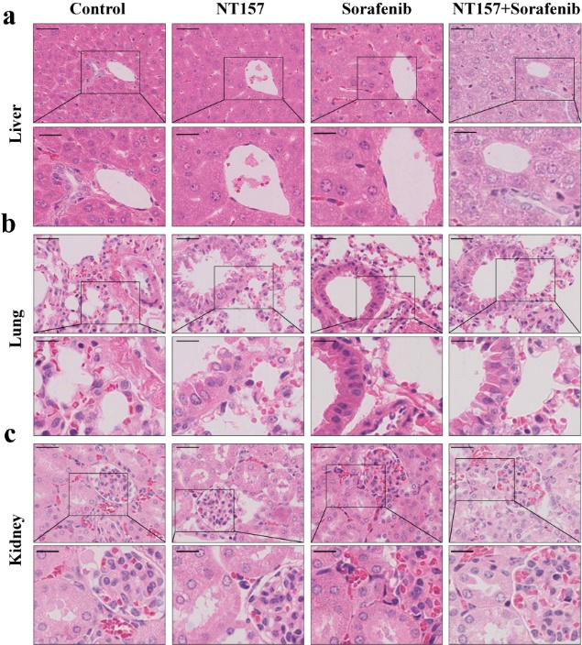
Supplementary Figure 5. Hematoxylin-eosin staining revealed that there were no signs of injury in livers, kidneys, and lungs after NT157 treatment and combination therapy with sorafenib and NT157. 100× (Scale bar, 50 μm) and 200× (Scale bar, 50 μm).

