SUPPORTING INFORMATION

Acetylphenyl-Substituted Imidazolium Salts: Synthesis, Characterization, in silico Studies and Inhibitory Properties against Some Metabolic Enzymes

Özlem Demirci¹, Burcu Tezcan², Yeliz Demir³, Tugba Taskin-Tok ^{4,5}, Yetkin Gök^{*1,7}, Aydın Aktaş⁸, Bilgehan Güzel², İlhami Gülçin⁹

¹Department of Chemistry, Faculty of Arts and Science, Inönü University, 44280-Malatya, Türkiye
²Department of Chemistry, Faculty of Arts and Science, Cukurova University, 01330-Adana, Türkiye
³Nihat Delibalta Göle Vocational High School, Ardahan University, 75700-Ardahan, Türkiye
⁴Department of Chemistry, Faculty of Arts and Sciences, Gaziantep University, 27310-Gaziantep, Türkiye
⁵Department of Bioinformatics and Computational Biology, Institute of Health Sciences, Gaziantep University, 27310-Gaziantep, Türkiye
⁷Organic and Organometallic Chemistry Research Laboratory, Department of Chemistry, Faculty of Arts and Science, Inönü University, 44280-Malatya, Türkiye
⁸Vocational School of Health Service, Inonu University, 44280-Malatya, Türkiye
⁹Atatürk University, Faculty of Science, Department of Chemistry, 25240-Erzurum, Türkiye

*Corresponding Author: Prof. Yetkin Gök
Address: Department of Chemistry, Faculty of Science
Inonu University, Malatya 44280, Turkey
e-mail : yetkin.gok@inonu.edu.tr

¹H NMR and ¹³C NMR spectra of salt 2a

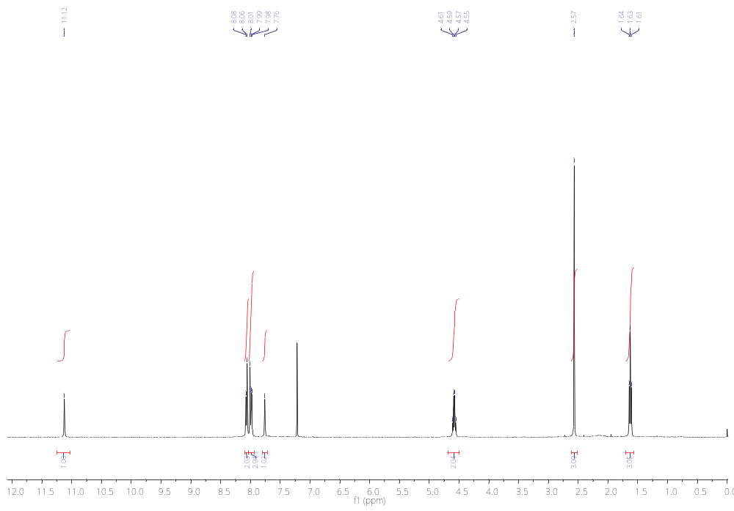
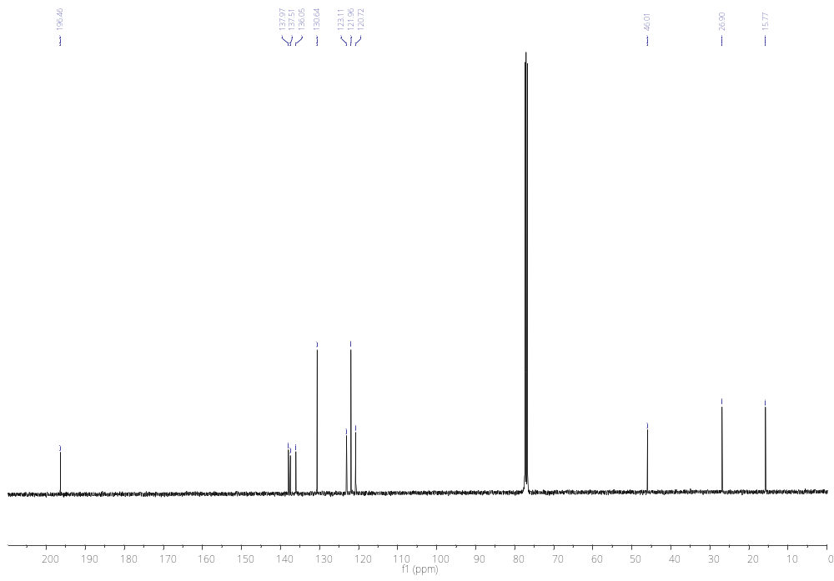

¹H NMR and ¹³C NMR spectra of salt 2b
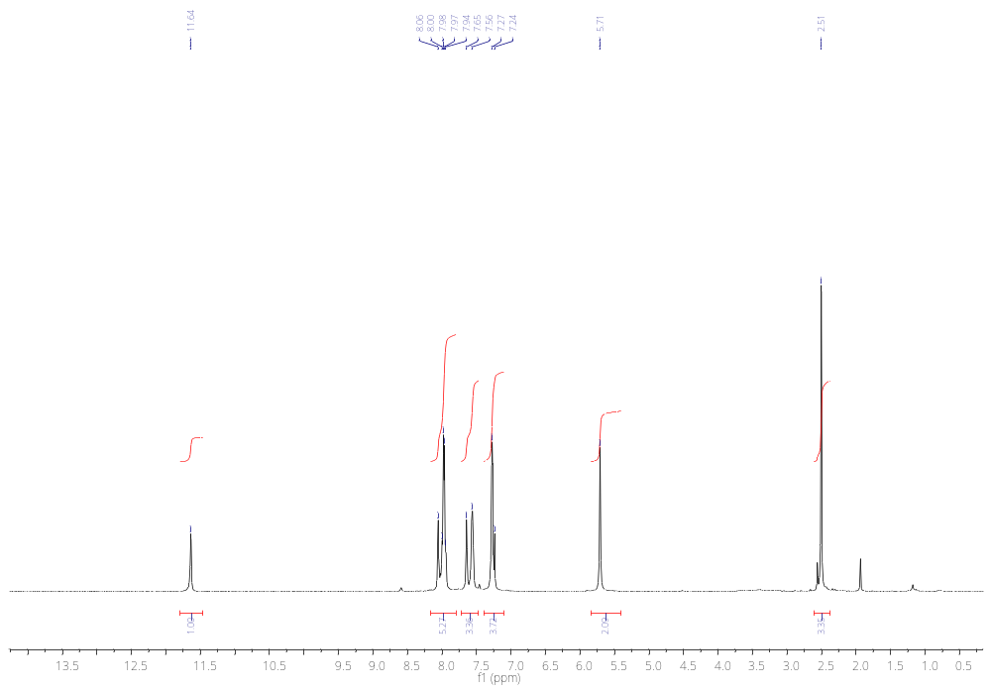
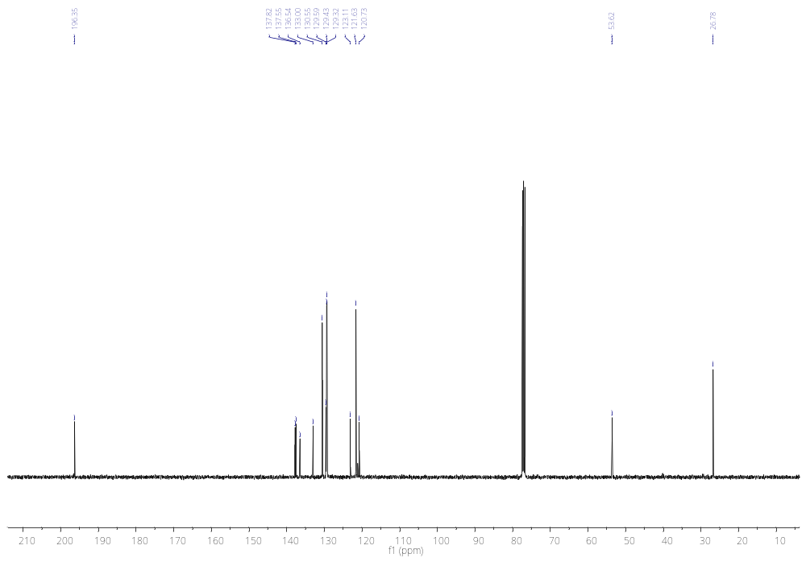

¹H NMR and ¹³C NMR spectra of salt 2c
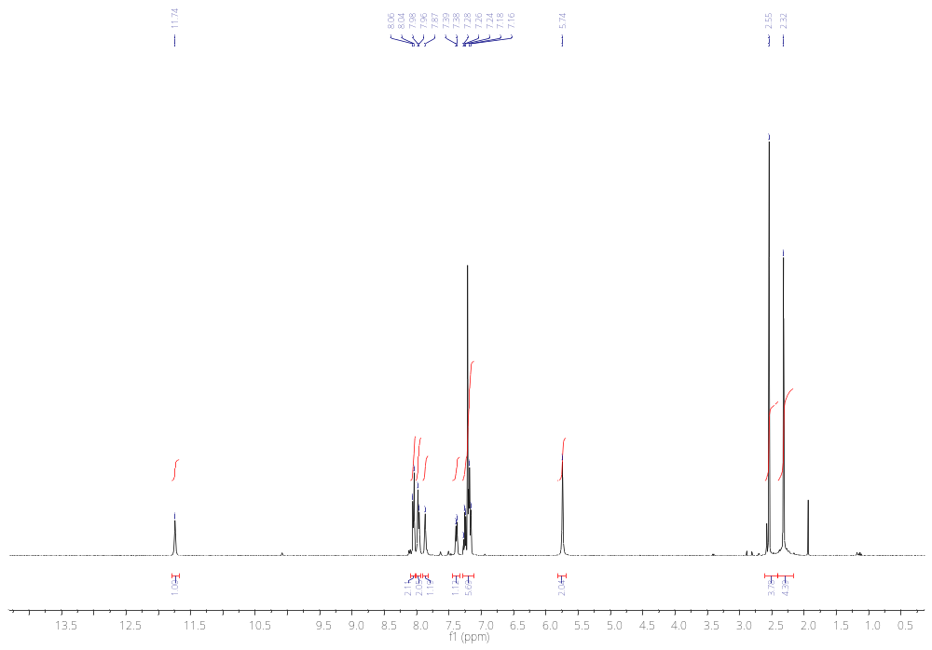
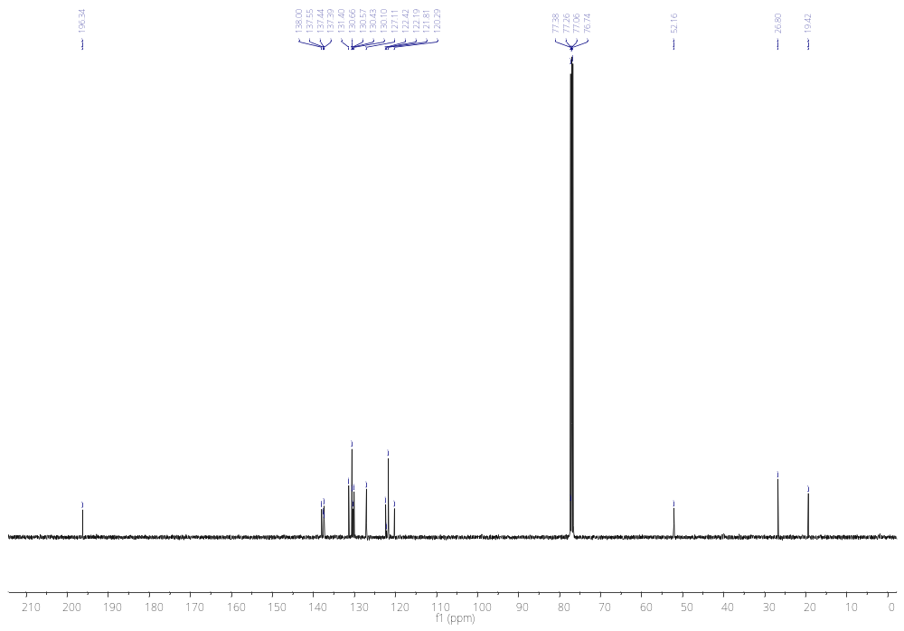

¹H NMR and ¹³C NMR spectra of salt 2d
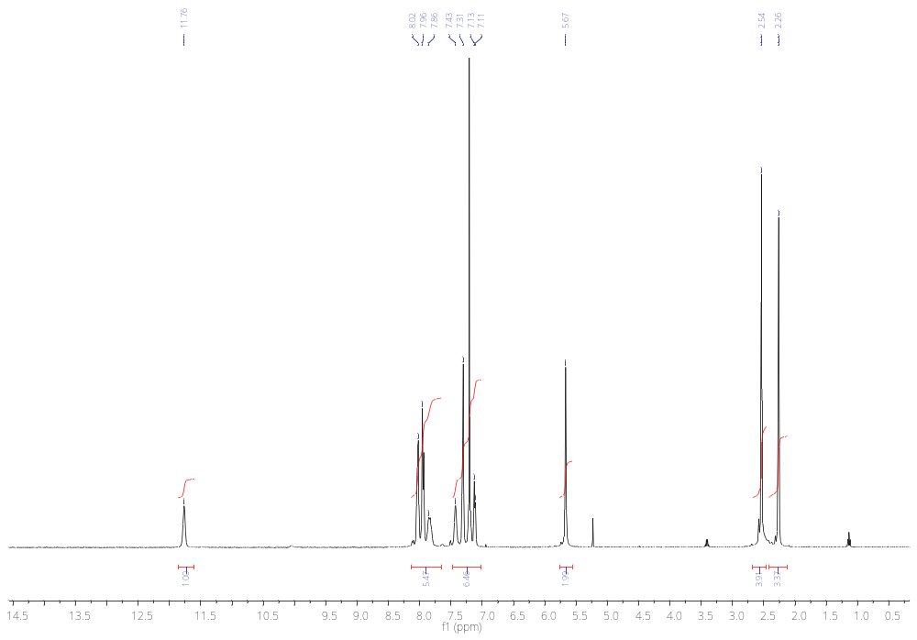
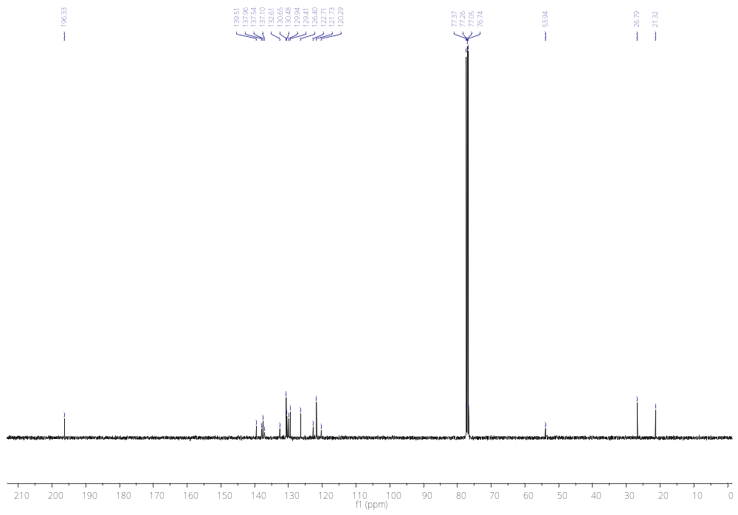

¹H NMR and ¹³C NMR spectra of salt 2e
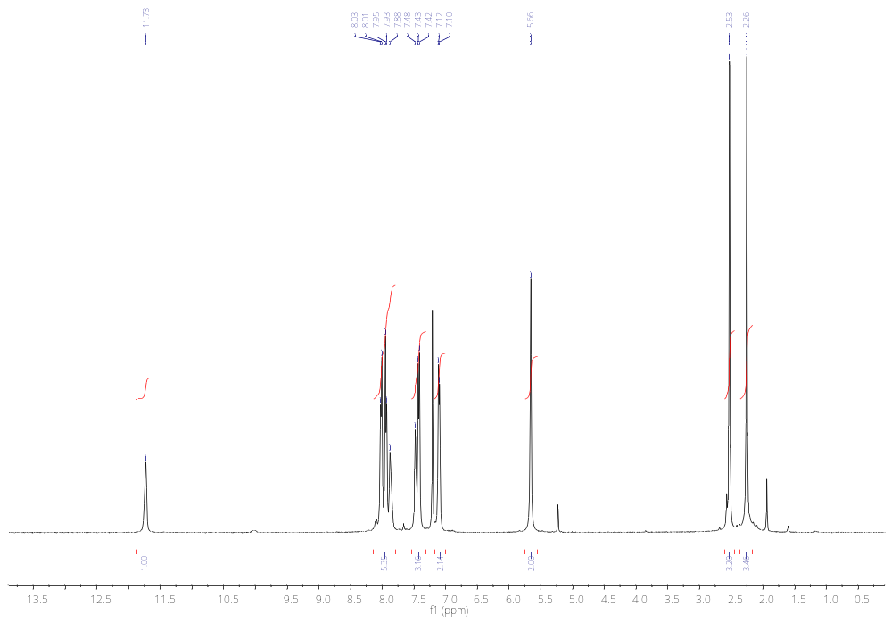
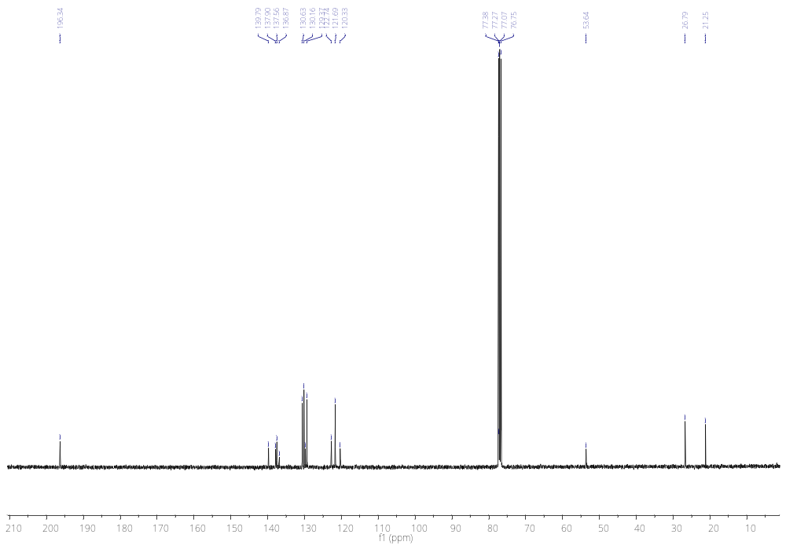

¹H NMR and ¹³C NMR spectra of salt 2f
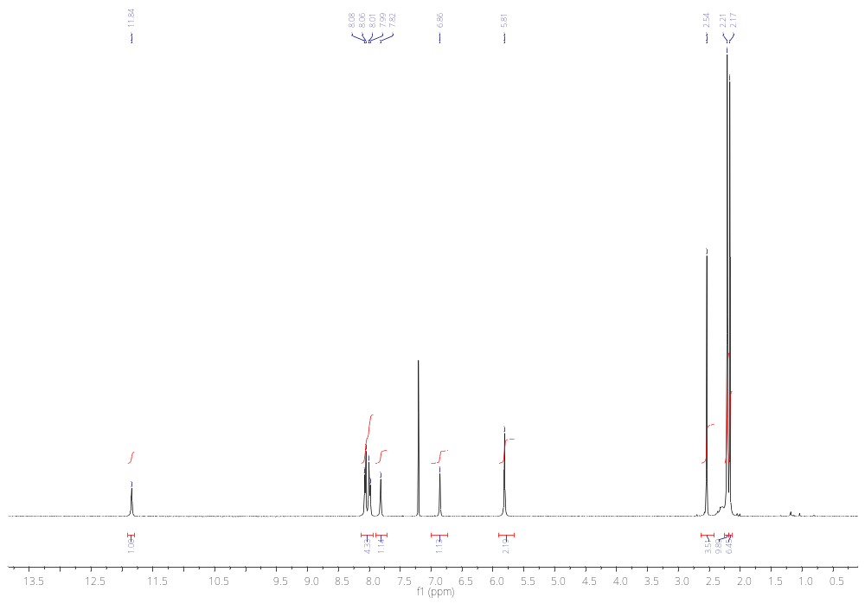
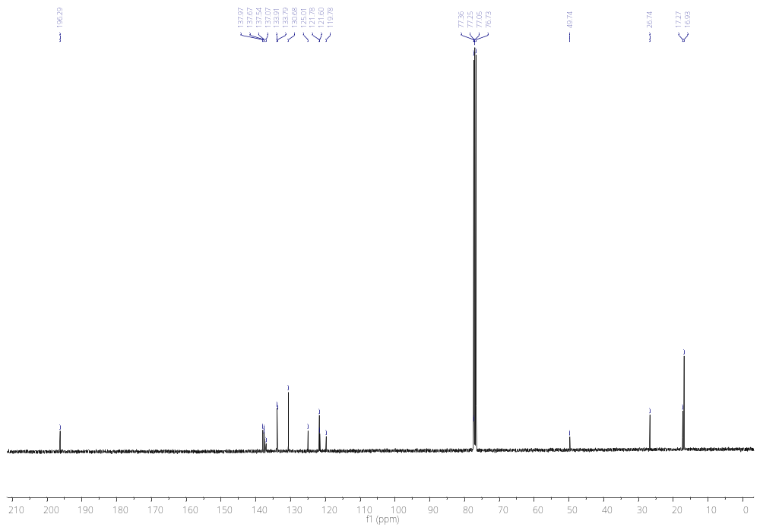

¹H NMR and ¹³C NMR spectra of salt 2g
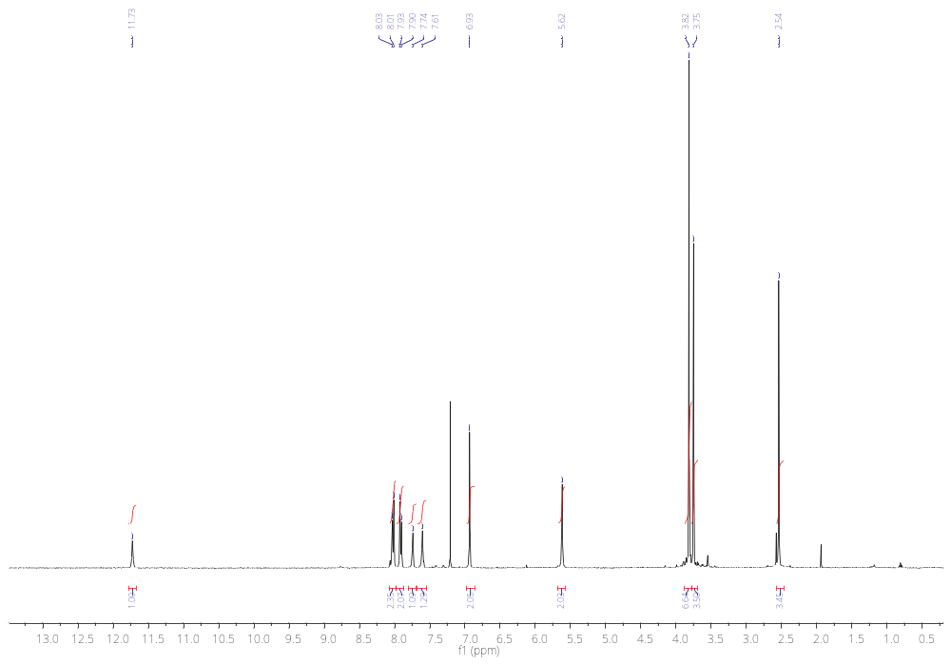
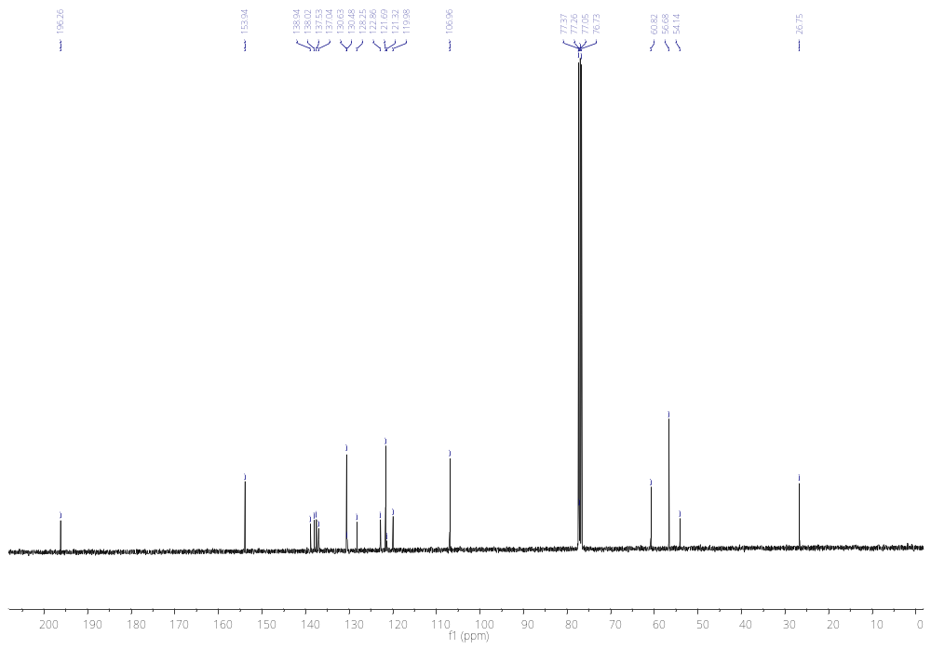

¹H NMR, ¹⁹F NMR, and ¹³C NMR spectra of salt 3a
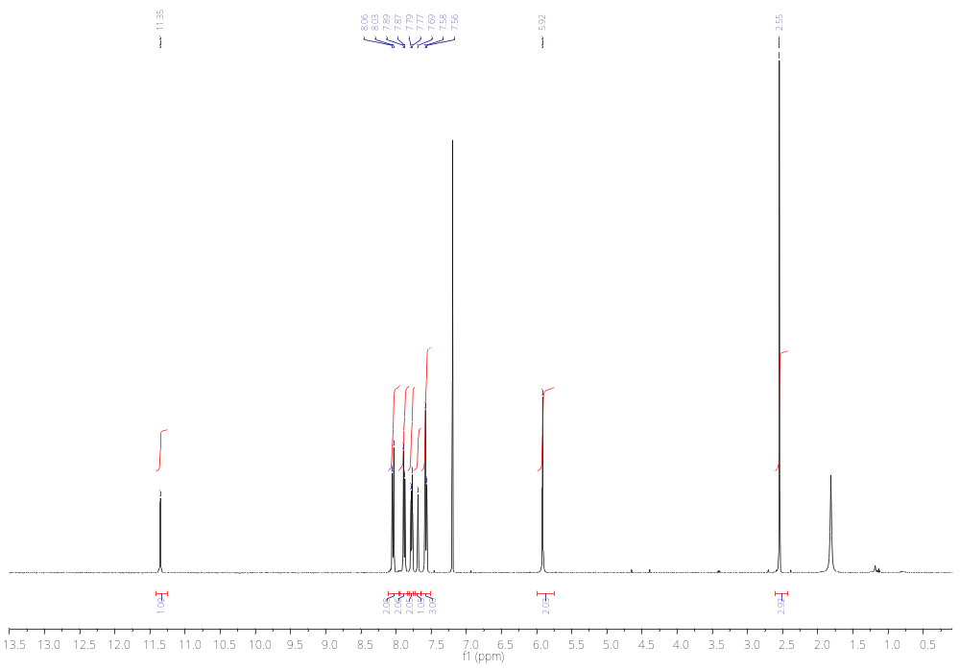
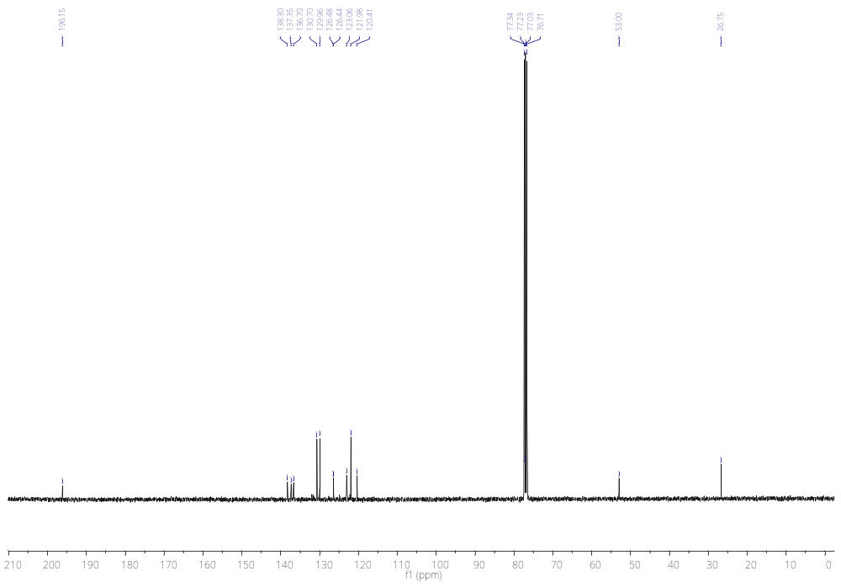
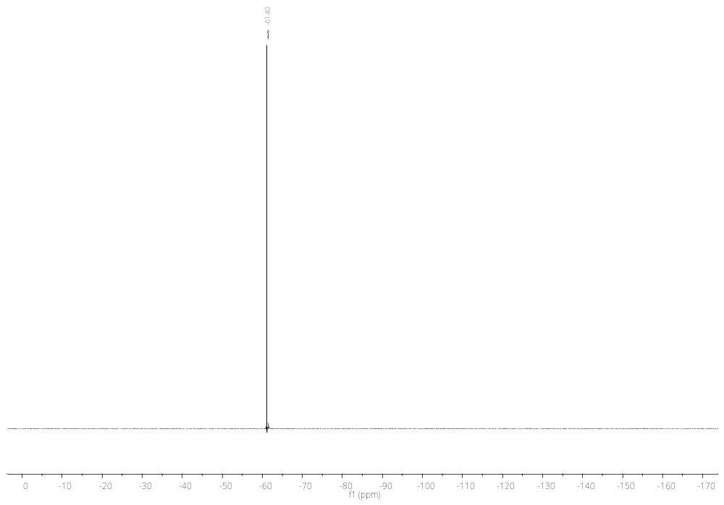

¹H NMR, ¹⁹F NMR, and ¹³C NMR spectra of salt 3b
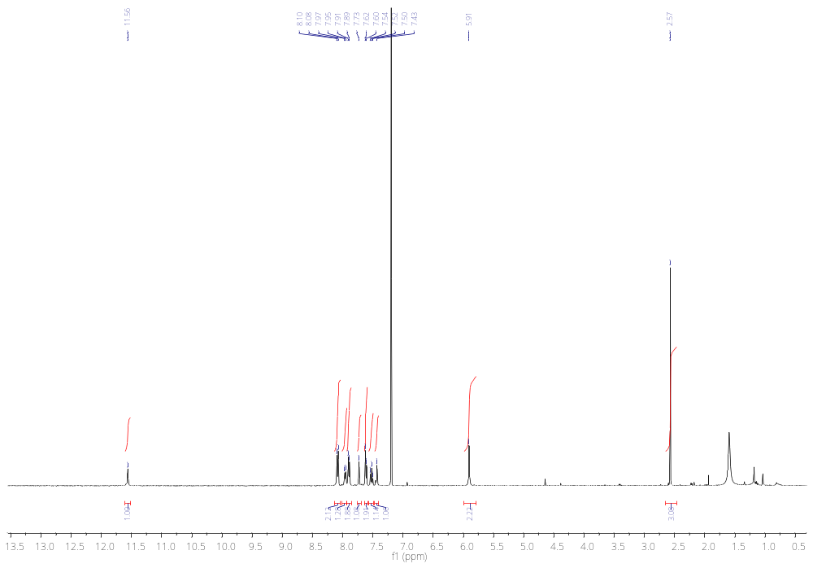
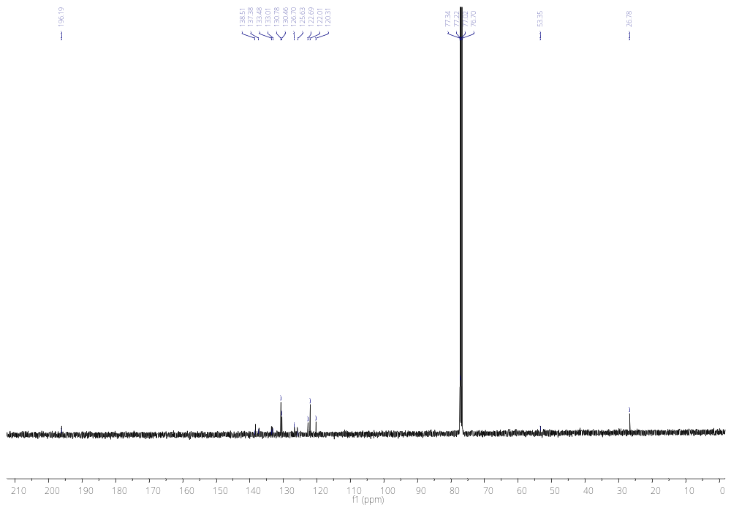
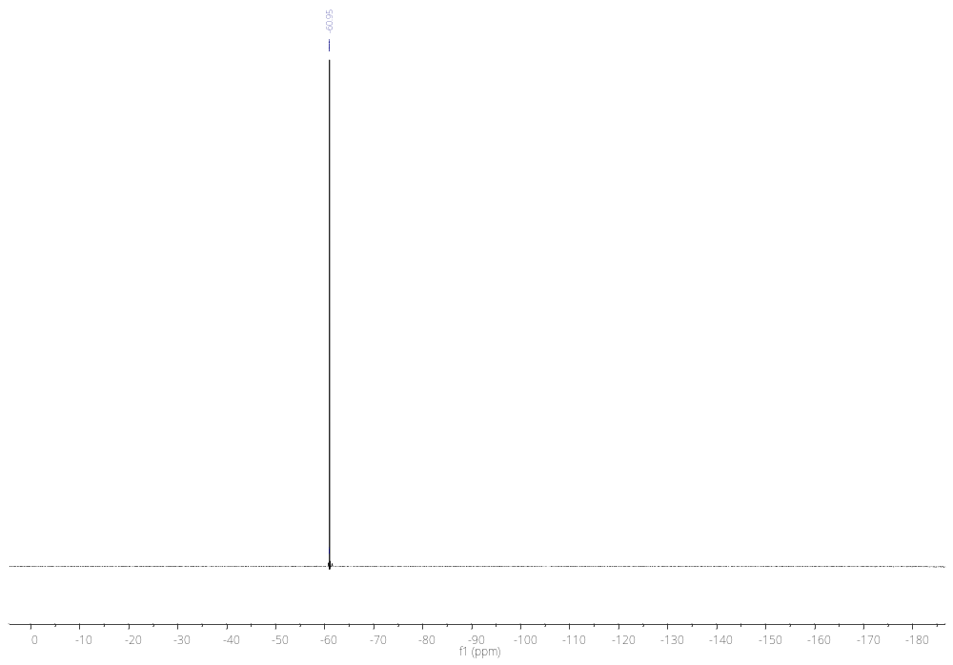

¹H NMR, ¹⁹F NMR, and ¹³C NMR spectra of salt 3c

¹H NMR, ¹⁹F NMR, and ¹³C NMR spectra of salt 3d
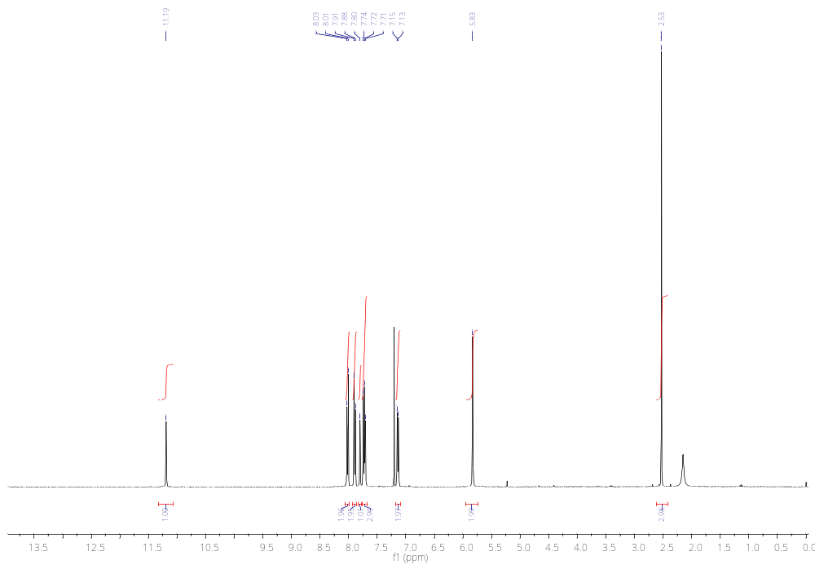
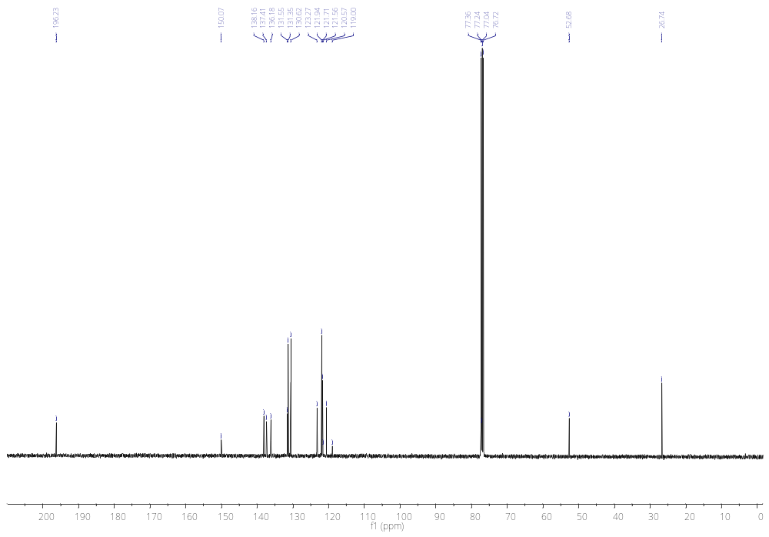
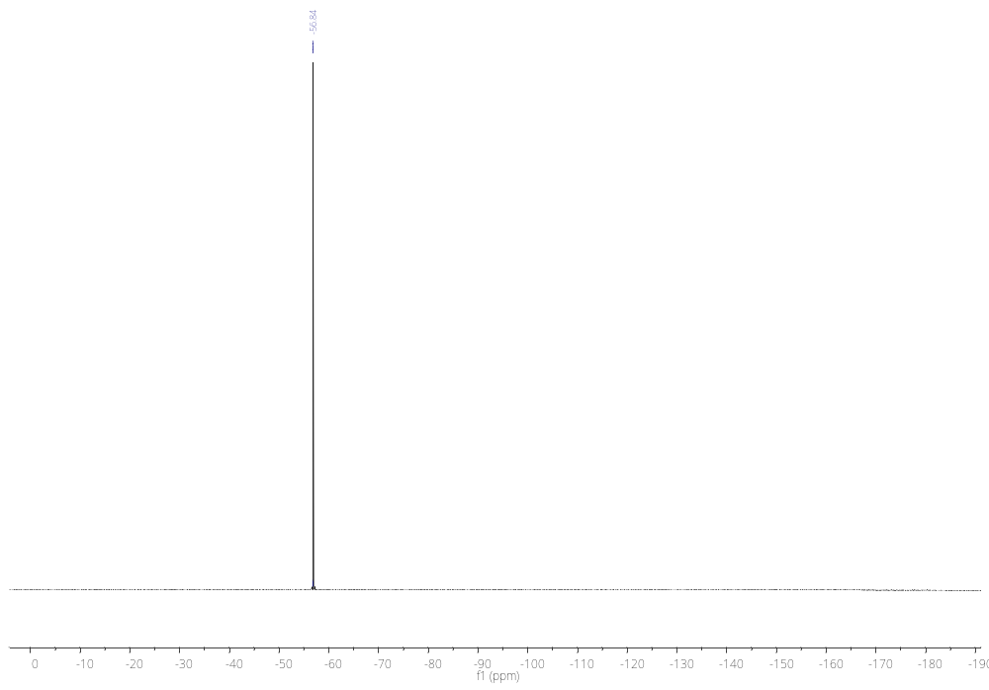

¹H NMR, ¹⁹F NMR, and ¹³C NMR spectra of salt 3e
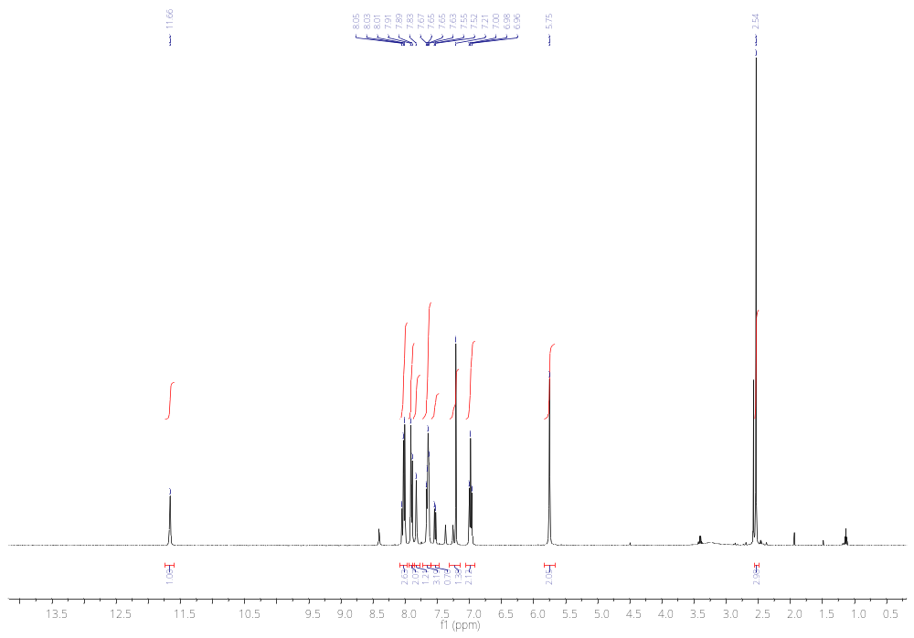
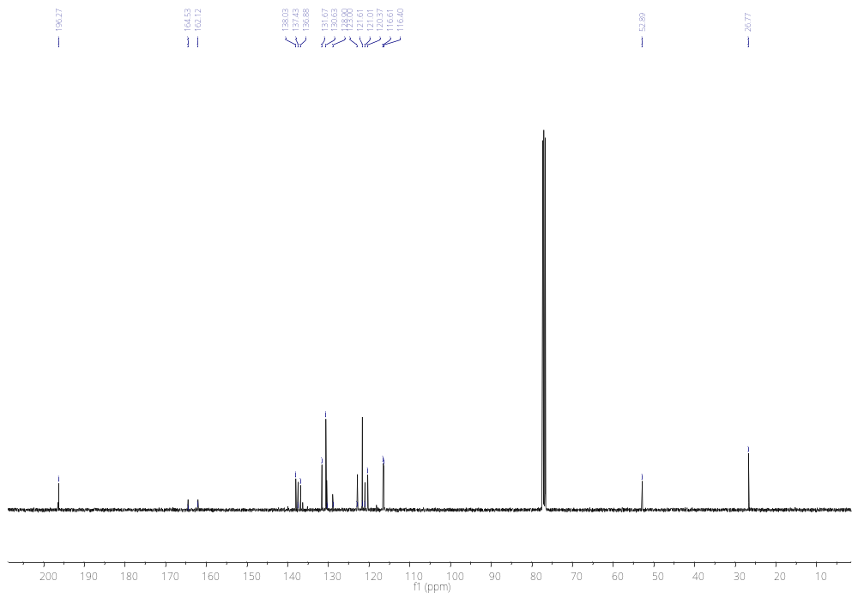

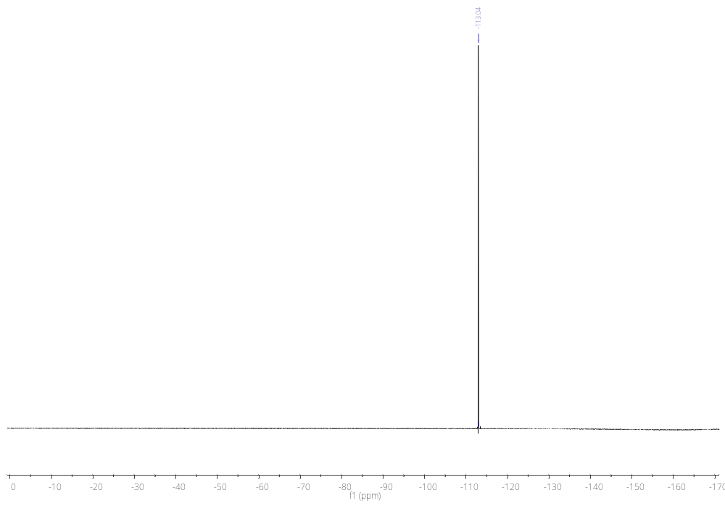
¹H NMR, ¹⁹F NMR, and ¹³C NMR spectra of salt 3f
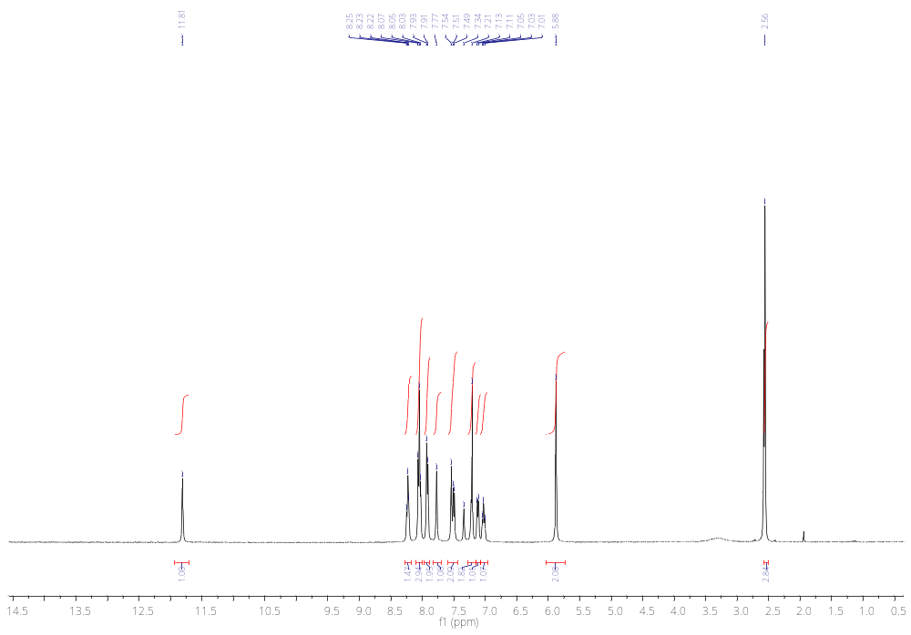
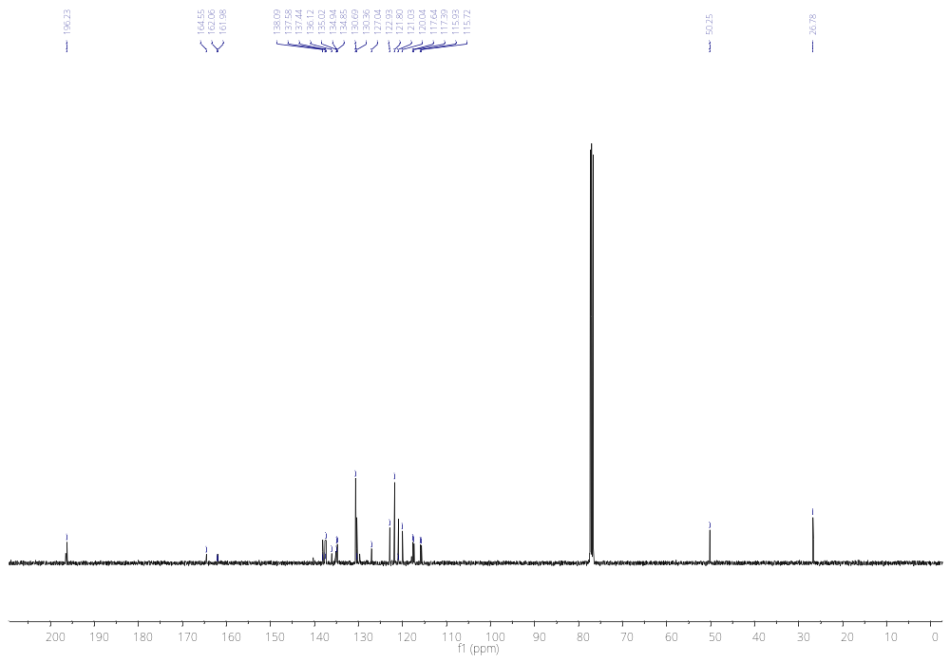
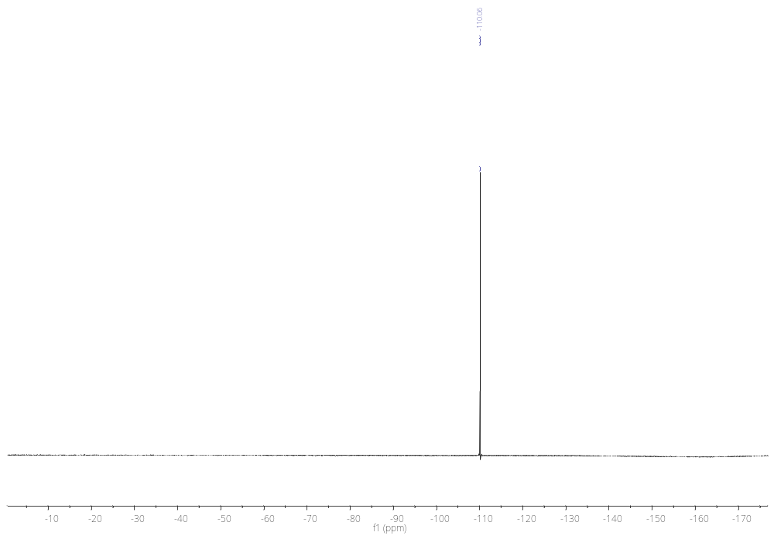

FTIR spectrum data for salt 2a

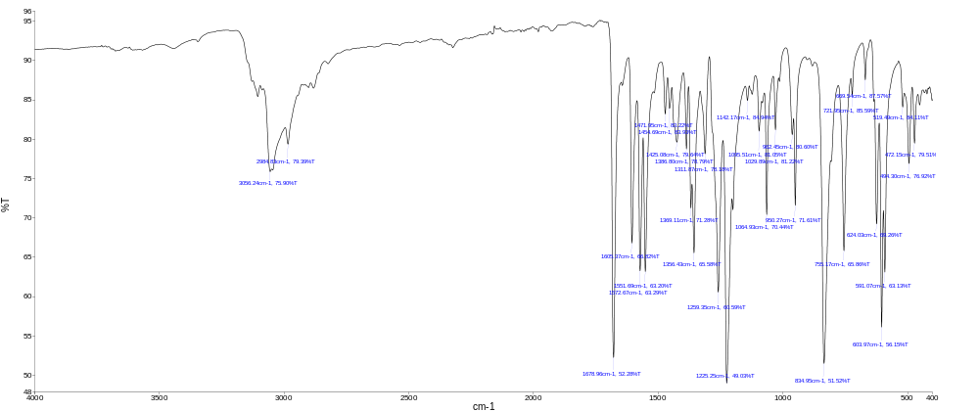

FTIR spectrum data for salt 2b

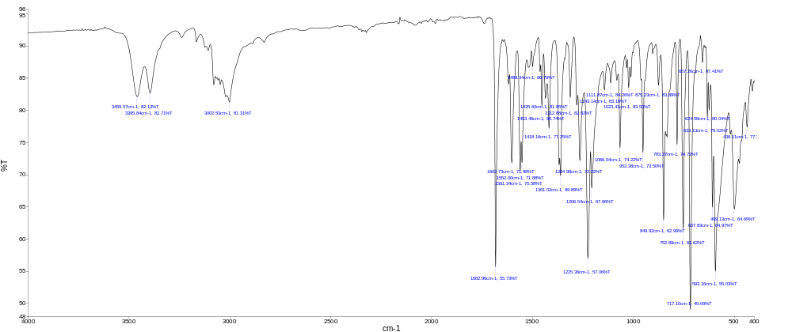

FTIR spectrum data for salt 2c

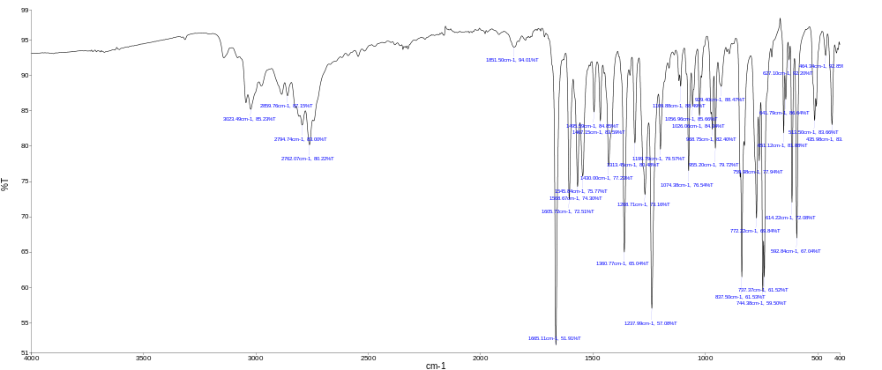

FTIR spectrum data for salt 2d

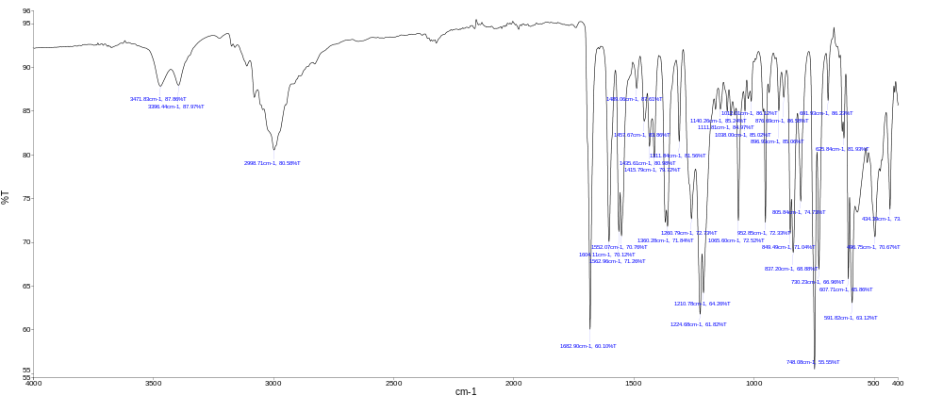

FTIR spectrum data for salt 2e

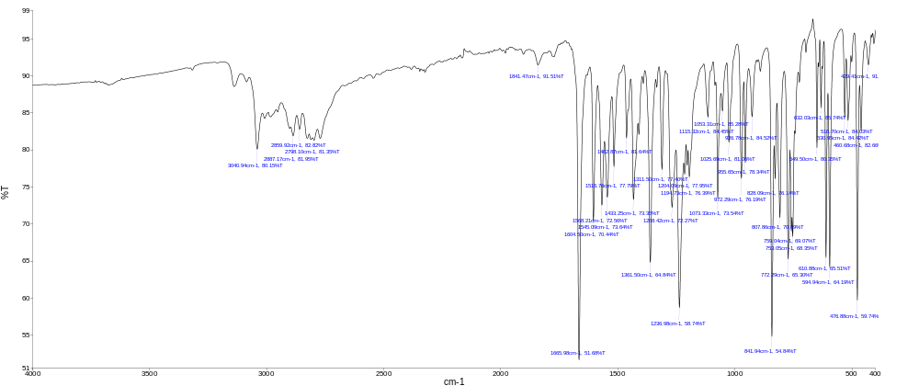

FTIR spectrum data for salt 2f

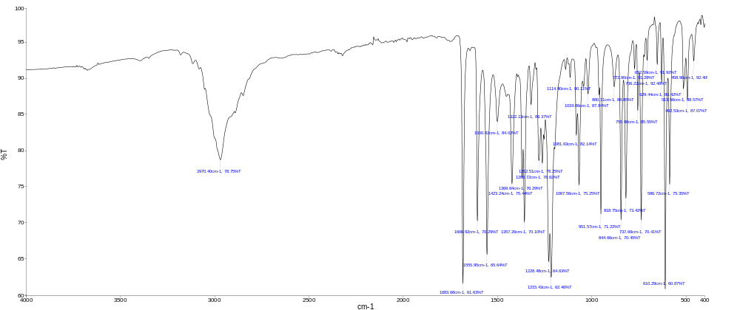

FTIR spectrum data for salt 2g

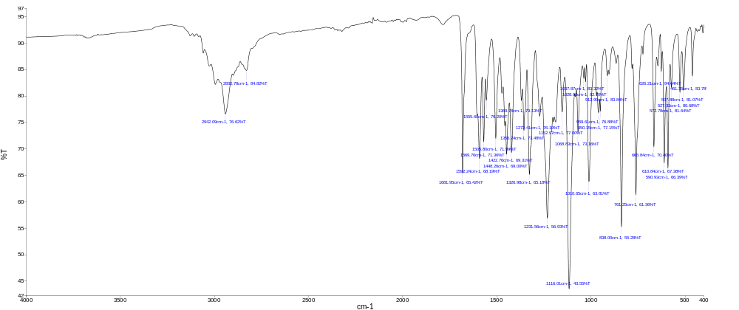

FTIR spectrum data for salt 3a

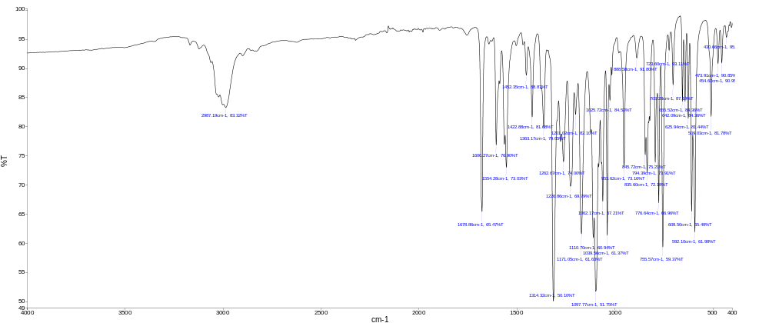

FTIR spectrum data for salt 3b

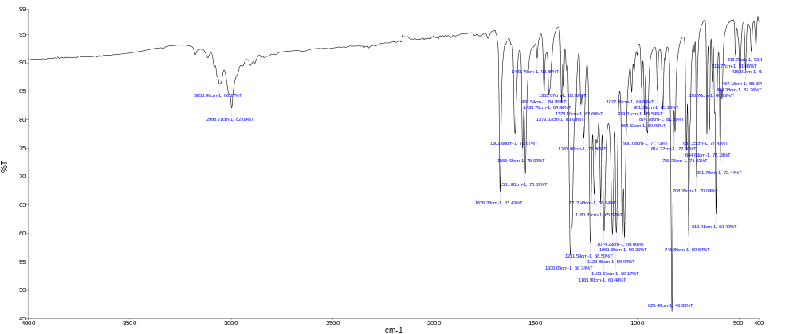

FTIR spectrum data for salt 3c

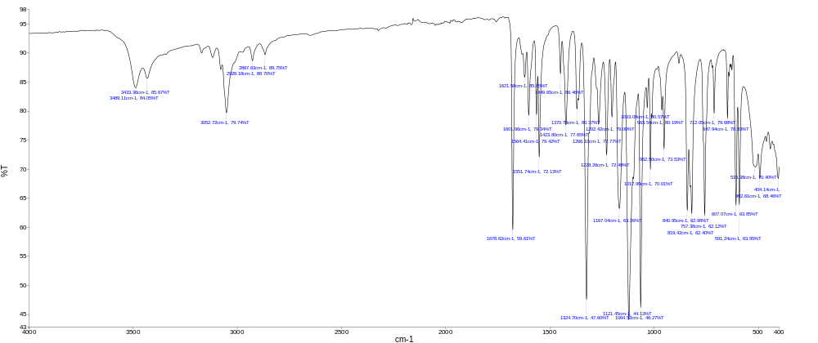

FTIR spectrum data for salt 3d

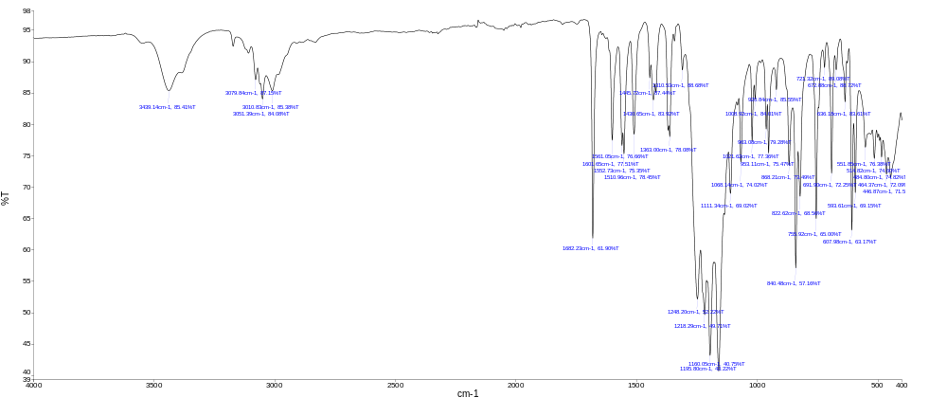

FTIR spectrum data for salt 3f

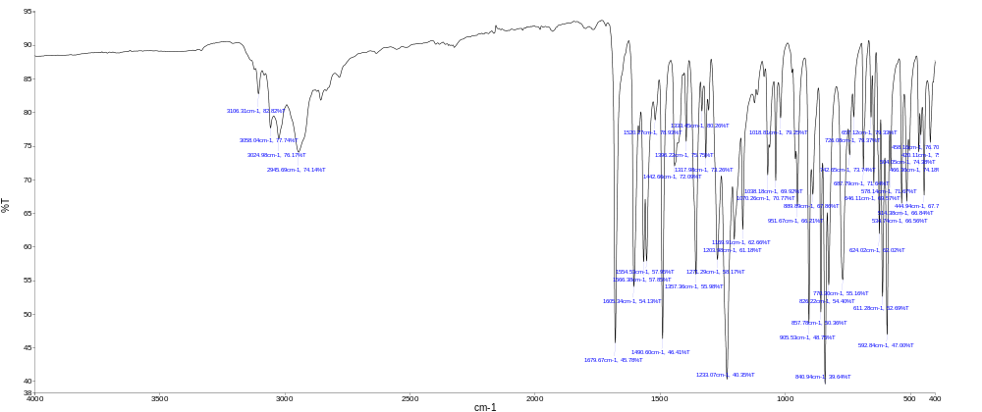

FTIR spectrum data for salt 3e

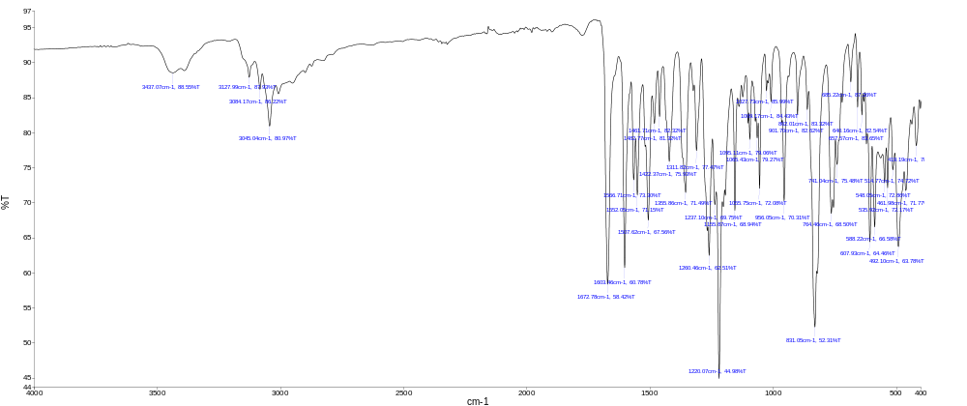

Fig. S1. 3D interactions of Acetazolamide (AZA) with active site in hCA-I.

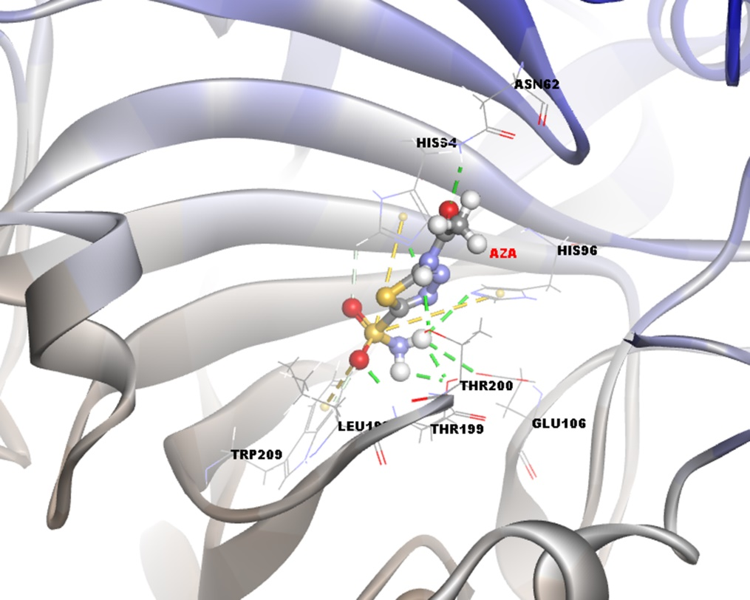
Fig. S2. 3D interactions of Acetazolamide (AZA) with active site in hCA-II.

Fig. S3. 3D interactions of Tacrine (TAC) with active site in AChE.

Table S1
Interactions types and distances of top pose compound 2b, 2c, 2e, 2f, 2g and 3a, 3b, 3c, 3d, 3e, 3f against hCAI, hCAII, AChE and Acetazolamide (AZA), Tacrine (TAC) as control compounds of the current targets, respectively.

Interactions (hCA-I ) | Distance Å | Bonding | Bonding Types | Binding site of target (hCA-I ) | Binding site of ligand (2c )
:2c:N3 - :2c:Cl | 3.8126 | Electrostatic | Attractive Charge | :2c:Cl | :2c:N3
A:HIS67:HD1 - :2c:O14 | 2.0980 | Hydrogen Bond | Conventional Hydrogen Bond | A:HIS67:HD1 | :2c:O14
A:ASN69:HD21 - :2c:O14 | 2.3330 | Hydrogen Bond | Conventional Hydrogen Bond | A:ASN69:HD21 | :2c:O14
:2c:H3 - A:GLN92:OE1 | 2.6575 | Hydrogen Bond | Carbon Hydrogen Bond | A:GLN92:OE1 | :2c:H3
:2c:Cl - A:HIS94 | 4.1262 | Electrostatic | Pi-Anion | A:HIS94 | :2c:Cl
:2c - A:PHE91 | 4.8810 | Hydrophobic | Pi-Pi T-shaped | A:PHE91 | :2c
A:ALA121 - :2c:C22 | 4.2f44 | Hydrophobic | Alkyl | A:ALA121 | :2c:C22
:2c:C22 - A:VAL143 | 3.3276 | Hydrophobic | Alkyl | A:VAL143 | :2c:C22
A:HIS94 - :2c:C22 | 4.4277 | Hydrophobic | Pi-Alkyl | A:HIS94 | :2c:C22
A:HIS119 - :2c:C22 | 4.6632 | Hydrophobic | Pi-Alkyl | A:HIS119 | :2c:C22
A:TRP209 - :2c:C22 | 5.2810 | Hydrophobic | Pi-Alkyl | A:TRP209 | :2c:C22
:2c - A:LEU198 | 5.4244 | Hydrophobic | Pi-Alkyl | A:LEU198 | :2c
:2c - A:LEU198 | 4.6723 | Hydrophobic | Pi-Alkyl | A:LEU198 | :2c
Interactions (hCA-I ) | Distance Å | Bonding | Bonding Types | Binding site of target (hCA-I ) | Binding site of ligand (2g )
:2g:N3 - :2g:Cl | 5.2332 | Electrostatic | Attractive Charge | :2g:Cl | :2g:N3
A:TRP5:HE1 - :2g:O37 | 2.0643 | Hydrogen Bond | Conventional Hydrogen Bond | A:TRP5:HE1 | :2g:O37
A:TRP5:HE1 - :2g:O38 | 2.0277 | Hydrogen Bond | Conventional Hydrogen Bond | A:TRP5:HE1 | :2g:O38
A:THR199:HN - :2g:O14 | 1.7670 | Hydrogen Bond | Conventional Hydrogen Bond | A:THR199:HN | :2g:O14
A:LEU198:HA - :2g:O14 | 2.9397 | Hydrogen Bond | Carbon Hydrogen Bond | A:LEU198:HA | :2g:O14
:2g:H3 - A:PRO201:O | 2.7220 | Hydrogen Bond | Carbon Hydrogen Bond | A:PRO201:O | :2g:H3
:2g:H14 - A:TYR20:OH | 2.1339 | Hydrogen Bond | Carbon Hydrogen Bond | A:TYR20:OH | :2g:H14
:2g:Cl - A:HIS94 | 4.1262 | Electrostatic | Pi-Anion | A:HIS94 | :2g:Cl
A:LEU198:HD22 - :2g | 2.3848 | Hydrophobic | Pi-Sigma | A:LEU198:HD22 | :2g
A:HIS200 - :2g | 4.2373 | Hydrophobic | Pi-Pi Stacked | A:HIS200 | :2g
:2g:C40 - A:VAL62 | 4.3101 | Hydrophobic | Alkyl | A:VAL62 | :2g:C40
:2g:C44 - A:PRO3 | 4.3527 | Hydrophobic | Alkyl | A:PRO3 | :2g:C44
:2g:C48 - A:PRO3 | 4.8791 | Hydrophobic | Alkyl | A:PRO3 | :2g:C48
:2g:C48 - A:PRO201 | 4.6037 | Hydrophobic | Alkyl | A:PRO201 | :2g:C48
:2g:C48 - A:PRO202 | 4.5344 | Hydrophobic | Alkyl | A:PRO202 | :2g:C48
A:TRP5 - :2g:C44 | 4.9552 | Hydrophobic | Pi-Alkyl | A:TRP5 | :2g:C44
A:TRP5 - :2g:C48 | 4.1027 | Hydrophobic | Pi-Alkyl | A:TRP5 | :2g:C48
A:TYR20 - :2g:C48 | 4.8856 | Hydrophobic | Pi-Alkyl | A:TYR20 | :2g:C48
A:HIS64 - :2g:C40 | 4.4920 | Hydrophobic | Pi-Alkyl | A:HIS64 | :2g:C40
A:HIS67 - :2g:C40 | 5.3237 | Hydrophobic | Pi-Alkyl | A:HIS67 | :2g:C40
:2g - A:LEU198 | 5.0548 | Hydrophobic | Pi-Alkyl | A:LEU198 | :2g
:2g - A:PRO202 | 5.3245 | Hydrophobic | Pi-Alkyl | A:PRO202 | :2g
Interactions (hCA-I ) | Distance Å | Bonding | Bonding Types | Binding site of target (hCA-I ) | Binding site of ligand (2e)
:2e:N3 - :2e:Cl | 4.8045 | Electrostatic | Attractive Charge | :2e:Cl | :2e:N3
A:THR199:HN - :2e:O14 | 1.8746 | Hydrogen Bond | Conventional Hydrogen Bond | A:THR199:HN | :2e:O14
A:LEU198:HA - :2e:O14 | 2.7719 | Hydrogen Bond | Carbon Hydrogen Bond | A:LEU198:HA | :2e:O14
:2e:Cl - A:HIS94 | 4.1262 | Electrostatic | Pi-Anion | A:HIS94 | :2e:Cl
A:HIS200 - :2e | 5.4707 | Hydrophobic | Pi-Pi Stacked | A:HIS200 | :2e
A:PHE91 - :2e | 4.6152 | Hydrophobic | Pi-Pi T-shaped | A:PHE91 | :2e
A:HIS94 - :2e | 5.1251 | Hydrophobic | Pi-Pi T-shaped | A:HIS94 | :2e
:2e - A:PHE91 | 4.5641 | Hydrophobic | Pi-Pi T-shaped | A:PHE91 | :2e
:2e - A:LEU131 | 5.2471 | Hydrophobic | Pi-Alkyl | A:LEU131 | :2e
:2e - A:ALA121 | 5.1911 | Hydrophobic | Pi-Alkyl | A:ALA121 | :2e
:2e - A:LEU198 | 4.8909 | Hydrophobic | Pi-Alkyl | A:LEU198 | :2e
:2e - A:LEU131 | 5.2147 | Hydrophobic | Pi-Alkyl | A:LEU131 | :2e
Interactions (hCA-I ) | Distance Å | Bonding | Bonding Types | Binding site of target (hCA-I ) | Binding site of ligand (AZA )
A:HIS200:HN - A:AZA:O2 | 2.4260 | Hydrogen Bond | Conventional Hydrogen Bond | A:HIS200:HN | A:AZA:O2
A:AZA:H4 - A:THR199:OG1 | 2.0705 | Hydrogen Bond | Conventional Hydrogen Bond | A:THR199:OG1 | A:AZA:H4
A:AZA:H5 - A:THR199:OG1 | 2.0747 | Hydrogen Bond | Conventional Hydrogen Bond | A:THR199:OG1 | A:AZA:H5
A:AZA:H6 - A:GLN92:OE1 | 1.9207 | Hydrogen Bond | Conventional Hydrogen Bond | A:GLN92:OE1 | A:AZA:H6
A:LEU198:HA - A:AZA:O1 | 2.6821 | Hydrogen Bond | Carbon Hydrogen Bond | A:LEU198:HA | A:AZA:O1
A:AZA:S1 - A:HIS96 | 5.7399 | Other | Pi-Sulfur | A:HIS96 | A:AZA:S1
A:HIS94 - A:AZA | 4.3858 | Hydrophobic | Pi-Pi T-shaped | A:HIS94 | A:AZA
A:AZA - A:ALA121 | 5.0809 | Hydrophobic | Pi-Alkyl | A:ALA121 | A:AZA
A:AZA - A:LEU198 | 5.2676 | Hydrophobic | Pi-Alkyl | A:LEU198 | A:AZA
Interactions (hCA-I ) | Distance Å | Bonding | Bonding Types | Binding site of target (hCA-I ) | Binding site of ligand (3f)
:3f:N3 - :3f:Br | 4.2906 | Electrostatic | Attractive Charge | :3f:Br | :3f:N3
A:THR199:HN - :3f:O14 | 1.8921 | Hydrogen Bond | Conventional Hydrogen Bond | A:THR199:HN | :3f:O14
A:HIS67:HE1 - :3f:Br | 2.7992 | Hydrogen Bond | Carbon Hydrogen Bond | A:HIS67:HE1 | :3f:Br
A:LEU198:HA - :3f:O14 | 2.6828 | Hydrogen Bond | Carbon Hydrogen Bond | A:LEU198:HA | :3f:O14
A:HIS200:HE1 - :3f:Br | 1.9189 | Hydrogen Bond | Carbon Hydrogen Bond | A:HIS200:HE1 | :3f:Br
A:HIS200 - :3f | 3.6339 | Hydrophobic | Pi-Pi Stacked | A:HIS200 | :3f
:3f - A:LEU198 | 5.0511 | Hydrophobic | Pi-Alkyl | A:LEU198 | :3f
:3f - A:PRO202 | 4.4901 | Hydrophobic | Pi-Alkyl | A:PRO202 | :3f
:3f - A:PRO202 | 3.9109 | Hydrophobic | Pi-Alkyl | A:PRO202 | :3f
:3f - A:LEU198 | 3.6074 | Hydrophobic | Pi-Alkyl | A:LEU198 | :3f
Interactions (hCA-I ) | Distance Å | Bonding | Bonding Types | Binding site of target (hCA-I ) | Binding site of ligand (3c)
:3c:N - :3c:Br1 | 3.3377 | Electrostatic | Attractive Charge | :3c:N | :3c:Br1
A:TRP5:HE1 - :3c:F | 2.4215 | Hydrogen Bond;Halogen | Conventional Hydrogen Bond;Halogen (Fluorine) | A:TRP5:HE1 | :3c:F
A:THR199:HN - :3c:O | 2.0458 | Hydrogen Bond | Conventional Hydrogen Bond | A:THR199:HN | :3c:O
A:TRP5:HD1 - :3c:F | 2.5983 | Hydrogen Bond | Carbon Hydrogen Bond | A:TRP5:HD1 | :3c:F
A:HIS67:HE1 - :3c:Br1 | 2.7992 | Hydrogen Bond | Carbon Hydrogen Bond | A:HIS67:HE1 | :3c:Br1
A:HIS200:HE1 - :3c:Br1 | 1.9189 | Hydrogen Bond | Carbon Hydrogen Bond | A:HIS200:HE1 | :3c:Br1
A:PRO202:N - :3c:F | 3.4645 | Halogen | Halogen (Fluorine) | A:PRO202:N | :3c:F
A:LEU198:HD22 - :3c | 2.2c87 | Hydrophobic | Pi-Sigma | A:LEU198:HD22 | :3c
A:PRO202:HD2 - :3c | 2.2g49 | Hydrophobic | Pi-Sigma | A:PRO202:HD2 | :3c
A:HIS200 - :3c | 4.2448 | Hydrophobic | Pi-Pi Stacked | A:HIS200 | :3c
:3c:C - A:PRO3 | 4.7959 | Hydrophobic | Alkyl | A:PRO3 | :3c:C
:3c:C - A:PRO201 | 5.2513 | Hydrophobic | Alkyl | A:PRO201 | :3c:C
:3c:C - A:PRO202 | 4.4592 | Hydrophobic | Alkyl | A:PRO202 | :3c:C
A:TRP5 - :3c:C | 4.7674 | Hydrophobic | Pi-Alkyl | A:TRP5 | :3c:C
A:TYR20 - :3c:C | 5.0040 | Hydrophobic | Pi-Alkyl | A:TYR20 | :3c:C
:3c - A:LEU198 | 4.8310 | Hydrophobic | Pi-Alkyl | A:LEU198 | :3c
:3c - A:PRO202 | 5.1890 | Hydrophobic | Pi-Alkyl | A:PRO202 | :3c
Interactions (hCA-I ) | Distance Å | Bonding | Bonding Types | Binding site of target (hCA-I ) | Binding site of ligand (3a)
:3a:N3 - :3a:Br1 | 4.2535 | Electrostatic | Attractive Charge | :3a:Br1 | :3a:N3
A:TRP5:HE1 - :3a:F39 | 2.1278 | Hydrogen Bond;Halogen | Conventional Hydrogen Bond;Halogen (Fluorine) | A:TRP5:HE1 | :3a:F39
A:THR199:HN - :3a:O14 | 1.8776 | Hydrogen Bond | Conventional Hydrogen Bond | A:THR199:HN | :3a:O14
A:HIS200:HD1 - :3a:F40 | 2.5596 | Hydrogen Bond;Halogen | Conventional Hydrogen Bond;Halogen (Fluorine) | A:HIS200:HD1 | :3a:F40
A:HIS67:HE1 - :3a:Br1 | 2.7992 | Hydrogen Bond | Carbon Hydrogen Bond | A:HIS67:HE1 | :3a:Br1
A:LEU198:HA - :3a:O14 | 2.6189 | Hydrogen Bond | Carbon Hydrogen Bond | A:LEU198:HA | :3a:O14
A:HIS200:HE1 - :3a:F40 | 2.8425 | Hydrogen Bond | Carbon Hydrogen Bond | A:HIS200:HE1 | :3a:F40
A:HIS200:HE1 - :3a:Br1 | 1.9189 | Hydrogen Bond | Carbon Hydrogen Bond | A:HIS200:HE1 | :3a:Br1
A:PRO201:O - :3a:F40 | 2.6406 | Halogen | Halogen (Fluorine) | A:PRO201:O | :3a:F40
A:HIS200 - :3a | 3.5401 | Hydrophobic | Pi-Pi Stacked | A:HIS200 | :3a
A:TRP5 - :3a:C22 | 4.7455 | Hydrophobic | Pi-Alkyl | A:TRP5 | :3a:C22
A:TRP5 - :3a:C22 | 4.9008 | Hydrophobic | Pi-Alkyl | A:TRP5 | :3a:C22
:3a - A:LEU198 | 5.1501 | Hydrophobic | Pi-Alkyl | A:LEU198 | :3a
:3a - A:PRO202 | 4.2620 | Hydrophobic | Pi-Alkyl | A:PRO202 | :3a
:3a - A:PRO202 | 3.8869 | Hydrophobic | Pi-Alkyl | A:PRO202 | :3a
:3a - A:LEU198 | 3.6282 | Hydrophobic | Pi-Alkyl | A:LEU198 | :3a

Interactions (hCA-II ) | Distance Å | Bonding | Bonding Types | Binding site of target (hCA-II ) | Binding site of ligand (2b )
:2b:N3 - :2b:Cl1 | 4.5583 | Electrostatic | Attractive Charge | :2b:Cl1 | :2b:N3
A:LEU198:HA - :2b:O14 | 1.9944 | Hydrogen Bond | Carbon Hydrogen Bond | A:LEU198:HA | :2b:O14
:2b:N3 - A:PHE131 | 3.7485 | Electrostatic | Pi-Cation | A:PHE131 | :2b:N3
:2b - A:PHE131 | 4.1222 | Hydrophobic | Pi-Pi Stacked | A:PHE131 | :2b
A:HIS94 - :2b | 5.1642 | Hydrophobic | Pi-Pi T-shaped | A:HIS94 | :2b
:2b - A:VAL121 | 5.0724 | Hydrophobic | Pi-Alkyl | A:VAL121 | :2b
:2b - A:VAL121 | 4.5426 | Hydrophobic | Pi-Alkyl | A:VAL121 | :2b
:2b - A:LEU198 | 4.3138 | Hydrophobic | Pi-Alkyl | A:LEU198 | :2b
:2b - A:ILE91 | 5.0943 | Hydrophobic | Pi-Alkyl | A:ILE91 | :2b
Interactions (hCA-II ) | Distance Å | Bonding | Bonding Types | Binding site of target (hCA-II ) | Binding site of ligand (2c)
:2c:N3 - :2c:Cl | 4.0614 | Electrostatic | Attractive Charge | :2c:Cl | :2c:N3
A:TRP5:HE1 - :2c:O14 | 2.0220 | Hydrogen Bond | Conventional Hydrogen Bond | A:TRP5:HE1 | :2c:O14
:2c:H3 - A:THR200:OG1 | 2.9330 | Hydrogen Bond | Carbon Hydrogen Bond | A:THR200:OG1 | :2c:H3
:2c:Cl - A:PHE131 | 3.4594 | Electrostatic | Pi-Anion | A:PHE131 | :2c:Cl
A:THR199:HN - :2c | 3.0517 | Hydrogen Bond | Pi-Donor Hydrogen Bond | A:THR199:HN | :2c
A:PRO201:O - :2c | 2.9832 | Other | Pi-Lone Pair | A:PRO201:O | :2c
A:HIS94 - :2c:C22 | 4.0209 | Hydrophobic | Pi-Alkyl | A:HIS94 | :2c:C22
A:HIS96 - :2c:C22 | 5.1474 | Hydrophobic | Pi-Alkyl | A:HIS96 | :2c:C22
:2c - A:LEU198 | 4.2172 | Hydrophobic | Pi-Alkyl | A:LEU198 | :2c
:2c - A:PRO202 | 5.3916 | Hydrophobic | Pi-Alkyl | A:PRO202 | :2c
:2c - A:VAL121 | 5.4562 | Hydrophobic | Pi-Alkyl | A:VAL121 | :2c
:2c - A:VAL143 | 4.9458 | Hydrophobic | Pi-Alkyl | A:VAL143 | :2c
:2c - A:LEU198 | 4.8246 | Hydrophobic | Pi-Alkyl | A:LEU198 | :2c
Interactions (hCA-II ) | Distance Å | Bonding | Bonding Types | Binding site of target (hCA-II ) | Binding site of ligand (2f )
:2f:N3 - :2f:Cl | 3.3139 | Electrostatic | Attractive Charge | :2f:Cl | :2f:N3
:2f:Cl - A:PHE131 | 3.4594 | Electrostatic | Pi-Anion | A:PHE131 | :2f:Cl
A:PRO201:O - :2f | 2.9783 | Other | Pi-Lone Pair | A:PRO201:O | :2f
:2f:C51 - A:VAL121 | 3.4287 | Hydrophobic | Alkyl | A:VAL121 | :2f:C51
:2f:C51 - A:LEU141 | 4.7501 | Hydrophobic | Alkyl | A:LEU141 | :2f:C51
:2f:C51 - A:VAL143 | 5.3221 | Hydrophobic | Alkyl | A:VAL143 | :2f:C51
:2f:C51 - A:LEU198 | 4.5026 | Hydrophobic | Alkyl | A:LEU198 | :2f:C51
:2f:C47 - A:VAL143 | 3.6481 | Hydrophobic | Alkyl | A:VAL143 | :2f:C47
:2f:C47 - A:LEU198 | 4.4373 | Hydrophobic | Alkyl | A:LEU198 | :2f:C47
:2f:C47 - A:VAL207 | 4.3437 | Hydrophobic | Alkyl | A:VAL207 | :2f:C47
A:HIS94 - :2f:C39 | 4.2438 | Hydrophobic | Pi-Alkyl | A:HIS94 | :2f:C39
A:HIS94 - :2f:C22 | 3.9997 | Hydrophobic | Pi-Alkyl | A:HIS94 | :2f:C22
A:HIS96 - :2f:C39 | 4.0312 | Hydrophobic | Pi-Alkyl | A:HIS96 | :2f:C39
A:HIS119 - :2f:C43 | 4.4099 | Hydrophobic | Pi-Alkyl | A:HIS119 | :2f:C43
A:HIS119 - :2f:C39 | 5.4163 | Hydrophobic | Pi-Alkyl | A:HIS119 | :2f:C39
A:PHE131 - :2f:C51 | 5.3025 | Hydrophobic | Pi-Alkyl | A:PHE131 | :2f:C51
A:TRP209 - :2f:C47 | 4.8435 | Hydrophobic | Pi-Alkyl | A:TRP209 | :2f:C47
A:TRP209 - :2f:C43 | 4.6060 | Hydrophobic | Pi-Alkyl | A:TRP209 | :2f:C43
:2f - A:LEU198 | 5.0803 | Hydrophobic | Pi-Alkyl | A:LEU198 | :2f
:2f - A:VAL121 | 5.0597 | Hydrophobic | Pi-Alkyl | A:VAL121 | :2f
:2f - A:LEU198 | 4.7625 | Hydrophobic | Pi-Alkyl | A:LEU198 | :2f
:2f - A:PRO202 | 4.8967 | Hydrophobic | Pi-Alkyl | A:PRO202 | :2f
Interactions (hCA-II ) | Distance Å | Bonding | Bonding Types | Binding site of target (hCA-II ) | Binding site of ligand (AZA )
A:ASN62:HD21 - A:AZA:O3 | 2.3003 | Hydrogen Bond | Conventional Hydrogen Bond | A:ASN62:HD21 | A:AZA:O3
A:THR199:HN - A:AZA:O2 | 1.9038 | Hydrogen Bond | Conventional Hydrogen Bond | A:THR199:HN | A:AZA:O2
A:AZA:N3 - A:HIS94:NE2 | 2.7735 | Hydrogen Bond | Conventional Hydrogen Bond | A:HIS94:NE2 | A:AZA:N3
A:AZA:H4 - A:THR199:OG1 | 2.0738 | Hydrogen Bond | Conventional Hydrogen Bond | A:THR199:OG1 | A:AZA:H4
A:AZA:H5 - A:HIS96:NE2 | 2.8350 | Hydrogen Bond | Conventional Hydrogen Bond | A:HIS96:NE2 | A:AZA:H5
A:AZA:H5 - A:GLU106:OE1 | 3.0362 | Hydrogen Bond | Conventional Hydrogen Bond | A:GLU106:OE1 | A:AZA:H5
A:AZA:H5 - A:THR199:OG1 | 2.0846 | Hydrogen Bond | Conventional Hydrogen Bond | A:THR199:OG1 | A:AZA:H5
A:AZA:H6 - A:THR200:OG1 | 2.1281 | Hydrogen Bond | Conventional Hydrogen Bond | A:THR200:OG1 | A:AZA:H6
A:HIS94:HE1 - A:AZA:O1 | 2.4824 | Hydrogen Bond | Carbon Hydrogen Bond | A:HIS94:HE1 | A:AZA:O1
A:LEU198:HA - A:AZA:O2 | 2.3133 | Hydrogen Bond | Carbon Hydrogen Bond | A:LEU198:HA | A:AZA:O2
A:AZA:S1 - A:HIS94 | 4.8384 | Other | Pi-Sulfur | A:HIS94 | A:AZA:S1
A:AZA:S1 - A:HIS96 | 5.5667 | Other | Pi-Sulfur | A:HIS96 | A:AZA:S1
A:AZA:S1 - A:TRP209 | 5.4390 | Other | Pi-Sulfur | A:TRP209 | A:AZA:S1
Interactions (hCA-II ) | Distance Å | Bonding | Bonding Types | Binding site of target (hCA-II ) | Binding site of ligand (3b )
:3b:N3 - :3b:Br | 3.6402 | Electrostatic | Attractive Charge | :3b:Br | :3b:N3
A:ASN67:HD21 - :3b:F42 | 2.9087 | Hydrogen Bond;Halogen | Conventional Hydrogen Bond;Halogen (Fluorine) | A:ASN67:HD21 | :3b:F42
A:GLU69:OE2 - :3b:F41 | 3.1405 | Halogen | Halogen (Fluorine) | A:GLU69:OE2 | :3b:F41
A:GLU69:OE2 - :3b:F42 | 3.6507 | Halogen | Halogen (Fluorine) | A:GLU69:OE2 | :3b:F42
A:ILE91:O - :3b:F40 | 3.0397 | Halogen | Halogen (Fluorine) | A:ILE91:O | :3b:F40
A:GLN92:HE22 - :3b | 2.4247 | Hydrogen Bond | Pi-Donor Hydrogen Bond | A:GLN92:HE22 | :3b
:3b:H10 - A:PHE131 | 2.7102 | Hydrophobic | Pi-Sigma | A:PHE131 | :3b:H10
A:PHE131 - :3b | 5.1800 | Hydrophobic | Pi-Pi T-shaped | A:PHE131 | :3b
:3b:C39 - A:ILE91 | 4.8387 | Hydrophobic | Alkyl | A:ILE91 | :3b:C39
:3b - A:ILE91 | 5.0474 | Hydrophobic | Pi-Alkyl | A:ILE91 | :3b
:3b - A:VAL121 | 5.4483 | Hydrophobic | Pi-Alkyl | A:VAL121 | :3b
:3b - A:LEU198 | 4.9295 | Hydrophobic | Pi-Alkyl | A:LEU198 | :3b
Interactions (hCA-II ) | Distance Å | Bonding | Bonding Types | Binding site of target (hCA-II ) | Binding site of ligand (3e )
:3e:N3 - :3e:Br | 5.1830 | Electrostatic | Attractive Charge | :3e:Br | :3e:N3
A:THR199:HN - :3e:O14 | 1.8914 | Hydrogen Bond | Conventional Hydrogen Bond | A:THR199:HN | :3e:O14
A:LEU198:HA - :3e:O14 | 2.3009 | Hydrogen Bond | Carbon Hydrogen Bond | A:LEU198:HA | :3e:O14
:3e:H2 - A:ASN62:OD1 | 2.8538 | Hydrogen Bond | Carbon Hydrogen Bond | A:ASN62:OD1 | :3e:H2
A:PRO201:O - :3e:F39 | 3.2551 | Halogen | Halogen (Fluorine) | A:PRO201:O | :3e:F39
A:TRP5 - :3e | 5.1052 | Hydrophobic | Pi-Pi T-shaped | A:TRP5 | :3e
:3e - A:TRP5 | 5.9136 | Hydrophobic | Pi-Pi T-shaped | A:TRP5 | :3e
Interactions (hCA-II ) | Distance Å | Bonding | Bonding Types | Binding site of target (hCA-II ) | Binding site of ligand (3f )
:3f:N3 - :3f:Br | 3.6561 | Electrostatic | Attractive Charge | :3f:Br | :3f:N3
A:HIS119:ND1 - :3f:F23 | 3.4553 | Halogen | Halogen (Fluorine) | A:HIS119:ND1 | :3f:F23
A:PRO201:O - :3f | 2.9142 | Other | Pi-Lone Pair | A:PRO201:O | :3f
:3f - A:LEU198 | 4.2302 | Hydrophobic | Pi-Alkyl | A:LEU198 | :3f
:3f - A:VAL121 | 5.3937 | Hydrophobic | Pi-Alkyl | A:VAL121 | :3f
:3f - A:VAL143 | 5.2260 | Hydrophobic | Pi-Alkyl | A:VAL143 | :3f
:3f - A:LEU198 | 4.9025 | Hydrophobic | Pi-Alkyl | A:LEU198 | :3f
:3f - A:PRO202 | 5.2826 | Hydrophobic | Pi-Alkyl | A:PRO202 | :3f

Interactions (AChE) | Distance Å | Bonding | Bonding Types | Binding site of target (hAChE ) | Binding site of ligand (2g )
:2g:N3 - :2g:Cl | 2.7906 | Electrostatic | Attractive Charge | :2g:N3 | :2g:Cl
A:GLY122:HN - :2g:O39 | 2.8277 | Hydrogen Bond | Conventional Hydrogen Bond | A:GLY122:HN | :2g:O39
A:SER203:HG - :2g:O37 | 2.0252 | Hydrogen Bond | Conventional Hydrogen Bond | A:SER203:HG | :2g:O37
A:SER293:HN - :2g:O14 | 1.9628 | Hydrogen Bond | Conventional Hydrogen Bond | A:SER293:HN | :2g:O14
A:HIS447:HE2 - :2g:O37 | 2.7922 | Hydrogen Bond | Conventional Hydrogen Bond | A:HIS447:HE2 | :2g:O37
A:GLY122:HA2 - :2g:O39 | 2.4946 | Hydrogen Bond | Carbon Hydrogen Bond | A:GLY122:HA2 | :2g:O39
A:GLU292:HA - :2g:O14 | 2.9347 | Hydrogen Bond | Carbon Hydrogen Bond | A:GLU292:HA | :2g:O14
:2g:H4 - A:TYR124:OH | 1.9018 | Hydrogen Bond | Carbon Hydrogen Bond | A:TYR124:OH | :2g:H4
A:PHE338 - :2g | 4.8204 | Hydrophobic | Pi-Pi T-shaped | A:PHE338 | :2g
:2g - A:PHE297 | 4.7556 | Hydrophobic | Pi-Pi T-shaped | A:PHE297 | :2g
A:TRP86 - :2g:C48 | 4.0875 | Hydrophobic | Pi-Alkyl | A:TRP86 | :2g:C48
A:TRP86 - :2g:C48 | 4.6649 | Hydrophobic | Pi-Alkyl | A:TRP86 | :2g:C48
A:TRP236 - :2g:C40 | 4.5260 | Hydrophobic | Pi-Alkyl | A:TRP236 | :2g:C40
A:PHE295 - :2g:C40 | 4.3602 | Hydrophobic | Pi-Alkyl | A:PHE295 | :2g:C40
A:PHE297 - :2g:C40 | 4.4695 | Hydrophobic | Pi-Alkyl | A:PHE297 | :2g:C40
A:TYR337 - :2g:C48 | 4.3871 | Hydrophobic | Pi-Alkyl | A:TYR337 | :2g:C48
A:PHE338 - :2g:C40 | 5.0826 | Hydrophobic | Pi-Alkyl | A:PHE338 | :2g:C40
A:HIS447 - :2g:C40 | 5.2058 | Hydrophobic | Pi-Alkyl | A:HIS447 | :2g:C40
A:HIS447 - :2g:C44 | 5.0774 | Hydrophobic | Pi-Alkyl | A:HIS447 | :2g:C44
Interactions (AChE) | Distance Å | Bonding | Bonding Types | Binding site of target (hAChE ) | Binding site of ligand (2f )
:2f:N3 - :2f:Cl | 3.9125 | Electrostatic | Attractive Charge | :2f:N3 | :2f:Cl
A:PHE295:HN - :2f:O14 | 2.1642 | Hydrogen Bond | Conventional Hydrogen Bond | A:PHE295:HN | :2f:O14
A:VAL294:HA - :2f:O14 | 2.3016 | Hydrogen Bond | Carbon Hydrogen Bond | A:VAL294:HA | :2f:O14
:2f:H3 - A:TYR337:OH | 1.8506 | Hydrogen Bond | Carbon Hydrogen Bond | A:TYR337:OH | :2f:H3
:2f:H5 - A:TYR337:OH | 2.7099 | Hydrogen Bond | Carbon Hydrogen Bond | A:TYR337:OH | :2f:H5
A:TRP86 - :2f | 4.3909 | Hydrophobic | Pi-Pi Stacked | A:TRP86 | :2f
A:TRP86 - :2f | 4.0467 | Hydrophobic | Pi-Pi Stacked | A:TRP86 | :2f
A:TRP86 - :2f:C22 | 5.0023 | Hydrophobic | Pi-Alkyl | A:TRP86 | :2f:C22
A:TRP86 - :2f:C47 | 4.5158 | Hydrophobic | Pi-Alkyl | A:TRP86 | :2f:C47
A:TRP86 - :2f:C43 | 4.4450 | Hydrophobic | Pi-Alkyl | A:TRP86 | :2f:C43
A:TRP86 - :2f:C39 | 4.9532 | Hydrophobic | Pi-Alkyl | A:TRP86 | :2f:C39
A:TRP86 - :2f:C22 | 5.4170 | Hydrophobic | Pi-Alkyl | A:TRP86 | :2f:C22
A:TYR337 - :2f:C51 | 4.2825 | Hydrophobic | Pi-Alkyl | A:TYR337 | :2f:C51
A:HIS447 - :2f:C51 | 5.2845 | Hydrophobic | Pi-Alkyl | A:HIS447 | :2f:C51
A:HIS447 - :2f:C47 | 4.5148 | Hydrophobic | Pi-Alkyl | A:HIS447 | :2f:C47
Interactions (AChE) | Distance Å | Bonding | Bonding Types | Binding site of target (hAChE ) | Binding site of ligand (2e )
:2e:N3 - :2e:Cl | 2.8481 | Electrostatic | Attractive Charge | :2e:N3 | :2e:Cl
A:GLY121:HN - :2e:O14 | 1.9155 | Hydrogen Bond | Conventional Hydrogen Bond | A:GLY121:HN | :2e:O14
A:GLY122:HN - :2e:O14 | 2.0906 | Hydrogen Bond | Conventional Hydrogen Bond | A:GLY122:HN | :2e:O14
A:SER203:HG - :2e:O14 | 1.7541 | Hydrogen Bond | Conventional Hydrogen Bond | A:SER203:HG | :2e:O14
A:ALA204:HN - :2e:O14 | 2.3919 | Hydrogen Bond | Conventional Hydrogen Bond | A:ALA204:HN | :2e:O14
A:SER203:HB1 - :2e:O14 | 2.5275 | Hydrogen Bond | Carbon Hydrogen Bond | A:SER203:HB1 | :2e:O14
:2e:N3 - A:TYR341 | 4.3003 | Electrostatic | Pi-Cation | A:TYR341 | :2e:N3
:2e:Cl - A:PHE295 | 4.9380 | Electrostatic | Pi-Anion | A:PHE295 | :2e:Cl
A:TRP286 - :2e | 4.8709 | Hydrophobic | Pi-Pi T-shaped | A:TRP286 | :2e
A:PHE338 - :2e | 5.1048 | Hydrophobic | Pi-Pi T-shaped | A:PHE338 | :2e
:2e - A:PHE297 | 5.7600 | Hydrophobic | Pi-Pi T-shaped | A:PHE297 | :2e
:2e - A:TYR337 | 5.4028 | Hydrophobic | Pi-Pi T-shaped | A:TYR337 | :2e
:2e - A:TYR341 | 4.5909 | Hydrophobic | Pi-Pi T-shaped | A:TYR341 | :2e
:2e:C38 - A:LEU289 | 4.5963 | Hydrophobic | Alkyl | A:LEU289 | :2e:C38
:2e:C38 - A:ARG296 | 4.8880 | Hydrophobic | Alkyl | A:ARG296 | :2e:C38
A:TRP286 - :2e:C38 | 4.6579 | Hydrophobic | Pi-Alkyl | A:TRP286 | :2e:C38
Interactions (AChE) | Distance Å | Bonding | Bonding Types | Binding site of target (hAChE ) | Binding site of ligand (TAC )
:TAC:H27 - A:GLU202:OE1 | 1.9707 | Hydrogen Bond | Conventional Hydrogen Bond | A:GLU202:OE1 | :TAC:H27
A:TRP86 - :TAC | 4.0979 | Hydrophobic | Pi-Pi Stacked | A:TRP86 | :TAC
A:TRP86 - :TAC | 4.9290 | Hydrophobic | Pi-Pi Stacked | A:TRP86 | :TAC
A:TRP86 - :TAC | 3.7454 | Hydrophobic | Pi-Pi Stacked | A:TRP86 | :TAC
A:TRP86 - :TAC | 4.6814 | Hydrophobic | Pi-Pi Stacked | A:TRP86 | :TAC
A:TRP86 - :TAC | 4.9323 | Hydrophobic | Pi-Alkyl | A:TRP86 | :TAC
A:TRP86 - :TAC | 4.6616 | Hydrophobic | Pi-Alkyl | A:TRP86 | :TAC
A:TYR337 - :TAC | 4.8422 | Hydrophobic | Pi-Alkyl | A:TYR337 | :TAC
A:HIS447 - :TAC | 4.5681 | Hydrophobic | Pi-Alkyl | A:HIS447 | :TAC
Interactions (AChE) | Distance Å | Bonding | Bonding Types | Binding site of target (hAChE ) | Binding site of ligand (3f )
:3f:N3 - A:ASP74:OD2 | 4.5560 | Electrostatic | Attractive Charge | A:ASP74:OD2 | :3f:N3
:3f:N3 - :3f:Br | 4.8812 | Electrostatic | Attractive Charge | :3f:N3 | :3f:Br
A:PHE295:HN - :3f:O14 | 1.9413 | Hydrogen Bond | Conventional Hydrogen Bond | A:PHE295:HN | :3f:O14
A:PRO88:HD2 - :3f:F23 | 1.8781 | Hydrogen Bond | Carbon Hydrogen Bond | A:PRO88:HD2 | :3f:F23
A:VAL294:HA - :3f:O14 | 2.9493 | Hydrogen Bond | Carbon Hydrogen Bond | A:VAL294:HA | :3f:O14
:3f:H1 - A:ASP74:OD2 | 2.7774 | Hydrogen Bond | Carbon Hydrogen Bond | A:ASP74:OD2 | :3f:H1
:3f:H2 - A:ASP74:OD2 | 2.5011 | Hydrogen Bond | Carbon Hydrogen Bond | A:ASP74:OD2 | :3f:H2
A:GLN71:OE1 - :3f:F23 | 2.7068 | Halogen | Halogen (Fluorine) | A:GLN71:OE1 | :3f:F23
A:TYR72:O - :3f:F23 | 2.8686 | Halogen | Halogen (Fluorine) | A:TYR72:O | :3f:F23
A:ASN87:OD1 - :3f:F23 | 3.5229 | Halogen | Halogen (Fluorine) | A:ASN87:OD1 | :3f:F23
:3f:Br - A:TRP86 | 2.8651 | Electrostatic | Pi-Anion | A:TRP86 | :3f:Br
:3f:Br - A:TYR337 | 4.3120 | Electrostatic | Pi-Anion | A:TYR337 | :3f:Br
A:PHE297 - :3f | 5.9280 | Hydrophobic | Pi-Pi T-shaped | A:PHE297 | :3f
:3f - A:TYR337 | 5.6888 | Hydrophobic | Pi-Pi T-shaped | A:TYR337 | :3f
Interactions (AChE) | Distance Å | Bonding | Bonding Types | Binding site of target (hAChE ) | Binding site of ligand (3d )
:3d:N3 - :3d:Br | 4.1394 | Electrostatic | Attractive Charge | :3d:N3 | :3d:Br
A:THR75:HN - :3d:F43 | 2.1858 | Hydrogen Bond;Halogen | Conventional Hydrogen Bond;Halogen (Fluorine) | A:THR75:HN | :3d:F43
A:GLY121:HN - :3d:O14 | 1.9459 | Hydrogen Bond | Conventional Hydrogen Bond | A:GLY121:HN | :3d:O14
A:GLY122:HN - :3d:O14 | 2.0779 | Hydrogen Bond | Conventional Hydrogen Bond | A:GLY122:HN | :3d:O14
A:SER203:HG - :3d:O14 | 1.7885 | Hydrogen Bond | Conventional Hydrogen Bond | A:SER203:HG | :3d:O14
A:ALA204:HN - :3d:O14 | 2.5350 | Hydrogen Bond | Conventional Hydrogen Bond | A:ALA204:HN | :3d:O14
A:SER203:HB1 - :3d:O14 | 2.6402 | Hydrogen Bond | Carbon Hydrogen Bond | A:SER203:HB1 | :3d:O14
:3d:H3 - A:TYR124:OH | 2.4068 | Hydrogen Bond | Carbon Hydrogen Bond | A:TYR124:OH | :3d:H3
A:ASP74:OD1 - :3d:F41 | 3.3451 | Halogen | Halogen (Fluorine) | A:ASP74:OD1 | :3d:F41
A:ASP74:OD1 - :3d:F43 | 3.1623 | Halogen | Halogen (Fluorine) | A:ASP74:OD1 | :3d:F43
A:THR75:C - :3d:F43 | 3.1203 | Halogen | Halogen (Fluorine) | A:THR75:C | :3d:F43
:3d:N3 - A:TYR341 | 4.6571 | Electrostatic | Pi-Cation | A:TYR341 | :3d:N3
:3d:Br - A:TYR341 | 4.0917 | Electrostatic | Pi-Anion | A:TYR341 | :3d:Br
A:TRP286 - :3d | 4.9987 | Hydrophobic | Pi-Pi Stacked | A:TRP286 | :3d
A:TRP286 - :3d | 4.7324 | Hydrophobic | Pi-Pi Stacked | A:TRP286 | :3d
A:PHE338 - :3d | 4.9044 | Hydrophobic | Pi-Pi T-shaped | A:PHE338 | :3d
A:TYR341 - :3d | 4.6638 | Hydrophobic | Pi-Pi T-shaped | A:TYR341 | :3d
:3d - A:TYR341 | 4.6052 | Hydrophobic | Pi-Pi T-shaped | A:TYR341 | :3d
:3d:C40 - A:LEU76 | 4.4935 | Hydrophobic | Alkyl | A:LEU76 | :3d:C40
A:TYR72 - :3d:C40 | 5.3858 | Hydrophobic | Pi-Alkyl | A:TYR72 | :3d:C40
Interactions (AChE) | Distance Å | Bonding | Bonding Types | Binding site of target (hAChE ) | Binding site of ligand (3e )
:3e:N3 - :3e:Br | 4.3395 | Electrostatic | Attractive Charge | :3e:N3 | :3e:Br
A:GLY121:HN - :3e:O14 | 1.8216 | Hydrogen Bond | Conventional Hydrogen Bond | A:GLY121:HN | :3e:O14
A:GLY122:HN - :3e:O14 | 1.9115 | Hydrogen Bond | Conventional Hydrogen Bond | A:GLY122:HN | :3e:O14
A:ALA204:HN - :3e:O14 | 2.4016 | Hydrogen Bond | Conventional Hydrogen Bond | A:ALA204:HN | :3e:O14
A:SER203:HB1 - :3e:O14 | 2.6551 | Hydrogen Bond | Carbon Hydrogen Bond | A:SER203:HB1 | :3e:O14
A:SER293:O - :3e:F39 | 3.3455 | Halogen | Halogen (Fluorine) | A:SER293:O | :3e:F39
A:ARG296:O - :3e:F39 | 3.3088 | Halogen | Halogen (Fluorine) | A:ARG296:O | :3e:F39
:3e:N3 - A:TYR341 | 4.4424 | Electrostatic | Pi-Cation | A:TYR341 | :3e:N3
:3e:Br - A:TYR341 | 4.0917 | Electrostatic | Pi-Anion | A:TYR341 | :3e:Br
A:VAL294:HA - :3e | 2.8594 | Hydrophobic | Pi-Sigma | A:VAL294:HA | :3e
A:TRP286 - :3e | 4.7252 | Hydrophobic | Pi-Pi T-shaped | A:TRP286 | :3e
A:PHE338 - :3e | 5.0590 | Hydrophobic | Pi-Pi T-shaped | A:PHE338 | :3e
:3e - A:PHE297 | 5.6485 | Hydrophobic | Pi-Pi T-shaped | A:PHE297 | :3e
:3e - A:TYR337 | 5.5048 | Hydrophobic | Pi-Pi T-shaped | A:TYR337 | :3e
:3e - A:TYR341 | 4.6650 | Hydrophobic | Pi-Pi T-shaped | A:TYR341 | :3e

