Supplementary Figure 1. Positions of previously reported quantitative trait loci (QTLs) for chilling requirement (red) and bloom date (black) in chromosome 1 of the peach genome (Fan et al. 2010; Romeu et al. 2014; Zhebentyayeva et al. 2014; Bielenberg et al. 2015; Cantín et al. 2020; Rawandoozi et al. 2021). The scale indicates the physical position (Mbp). The orange square region indicates the interval considered for haplotype construction.

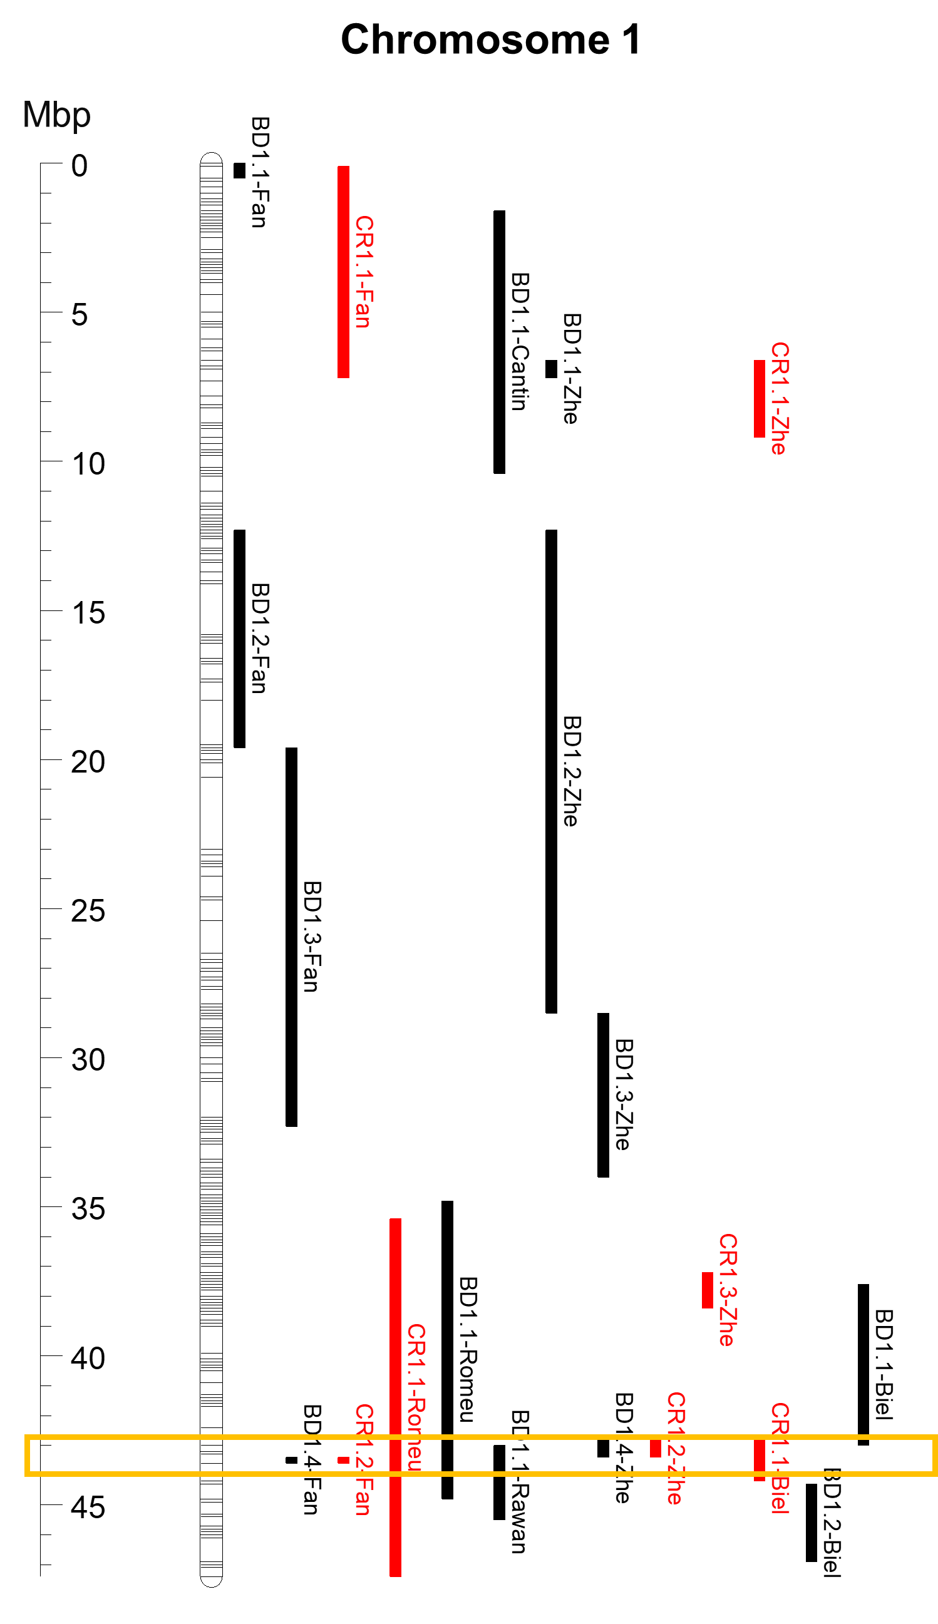
Supplementary Figure 2. Comparison of FAM and HEX fluorescence values for each KASP assay using real-time (A) and endpoint (B) PCRs in the validation plate. Circles, triangles, diamonds, and squares indicate no amplification, AA, AB, and BB genotypes, correspondently.
