Supplementary Information

Single charge regime electrodynamic force measuring in solution by upconversion photonic force microscope
Xuchen Shan^{1†}, Lei Ding^{2,3,4†}, Shihui Wen⁵, Chaohao Chen², Dajing Wang¹, Hongyan Zhu¹, Peng Nie⁶, Xunyu Lu⁷, Shen S.J. Wang⁸, Xiaolan Zhong^{1*}, Qian Peter Su³, Baolei Liu¹, Jie Lu⁹, Peter Reece¹⁰, Lingqian Chang¹¹, Dayong Jin^{5,12}, and Fan Wang^{1,2*}

¹School of Physics, Beihang University, Beijing, China.
²School of Electrical and Data Engineering, Faculty of Engineering and Information Technology, University of Technology Sydney, Sydney, NSW, Australia.
³School of Biomedical Engineering, Faculty of Engineering and Information Technology, University of Technology Sydney, Sydney, NSW, Australia.
⁴School of Mathematical and Physical Sciences, Faculty of Science, University of Technology Sydney, NSW 2007, Australia.
⁵Institute for Biomedical Materials and Devices (IBMD), School of Mathematical and Physical Sciences, Faculty of Science, University of Technology Sydney, NSW 2007, Australia.
⁶State Key Laboratory of Biocontrol, School of Life Sciences, Sun Yat-sen University, Guangzhou, China.
⁷Particles and Catalysis Research Laboratory, School of Chemical Engineering, The University of New South Wales, Sydney, NSW 2052, Australia.
⁸Computing and Information Systems Department, Melbourne School of Engineering, University of Melbourne, Melbourne, Victoria, Australia.
⁹Centre for Artificial Intelligence, Faculty of Engineering and IT, University of Technology Sydney, Sydney, New South Wales 2007, Australia.
¹⁰School of Physics, The University of New South Wales, Sydney, New South Wales, Australia.
¹¹Beijing Advanced Innovation Center for Biomedical Engineering, School of Biological Science and Medical Engineering, Beihang University, Beijing 100191, China
¹²UTS-SUStechJoint Research Centre for Biomedical Materials & Devices, Department of Biomedical Engineering, Southern University of Science and Technology, Shenzhen, People’s Republic of China.

†These authors contributed equally.
*Correspondence to fanwang@buaa.edu.cn, zhongxl@buaa.edu.cn

S1: Lanthanide-doped upconversion nanoparticles (Ln-NPs). 3
S2: Analytical interpretation of 3D force sensitivity. 5
S3: Monte Carlo simulation for 3D force sensitivity. 7
S4: Power spectrum method for measuring 3D trap stiffness 8
S5: Video tracking method for measuring 3D trap stiffness 9
S6: Astigmatism-empowered optical tweezers configuration. 10
S7: Deep neural network empowered optical astigmatism video tracking (DNN-OA-VT) method. 11
S8: Electrodynamic force from a single nanoparticle with net charges. 12
S9: Charge number of a trapped single nanoparticle. 13
References 30

S1: Lanthanide-doped upconversion nanoparticles (Ln-NPs).
For the machine learning training model, we use the nanoparticles (NaYF₄:20%Yb³⁺,2%Er³⁺) with four kinds of diameters of 16.5nm, 30.9 nm, 46.4 nm, and 48.3 nm, respectively. For other experiments in the main text, we use NaYF₄:20%Yb³⁺,2%Er³⁺ with a diameter of 58 nm. The TEM images of nanoparticles are shown in Supplementary Fig. 1 and the characteristic parameters are in Supplementary Table 1.
Synthesis of NaYF₄:20%Yb³⁺,2%Er³⁺ nanoparticles.
Upconversion nanocrystals were synthesised according to the previously reported method^{1,2}. In a typical experiment, 1 mmol RECl₃·6H₂O (RE = Y, Yb, Er) with the molar ratio of 78:20:2 was added to a flask containing 6 mL oleic acid (OA) and 15 mL 1-octadecene (ODE). The mixture was heated to 160 °C under argon flow for 30 min to obtain a clear solution and then cooled down to room temperature, followed by the addition of 5 mL methanol solution of NH₄F (4 mmol) and NaOH (2.5 mmol). After stirring for 30 min, the solution was heated to 150 °C under argon flow for 20 min. Followed, the solution was heated to 300 °C for 90 min. Finally, the reaction solution was cooled down to room temperature and the products were precipitated by ethanol and centrifuged (9000 rpm for 5 min), then washed three times with cyclohexane, ethanol and methanol to get the NaYF₄:20%Yb³⁺,2%Er³⁺ nanoparticles.
To get the NaYF₄:20%Yb³⁺,2%Er³⁺ nanoparticles with the desired size, layer-by-layer epitaxial growth was employed. The preparation process of precursors was similar to the core nanoparticle synthesis until the step where the reaction solution was slowly heated to 150°C and kept for 20 min. Instead of further heating to 300 °C to trigger nanocrystal growth, the solution was cooled down to room temperature to yield the NaYF₄:20%Yb³⁺,2%Er³⁺ precursors. For epitaxial growth, 0.15 mmol as prepared core nanocrystals were added to a containing 6 ml OA and 6 ml ODE. The mixture was heated to 170 °C under argon for 30 min, and then further heated to 300 °C. Next, 0.25 ml as prepared shell precursors were injected into the reaction mixture and ripened at 300 °C for 4 min, followed by the same injection and ripening cycles for several times to get the NaYF₄:20%Yb³⁺,2%Er³⁺ nanocrystals with the desired sizes. Finally, the slurry was cooled down to room temperature and the formed nanocrystals were purified according to the same procedure used for the core nanocrystals.
Preparation of ligand-free Ln-NPs
One millilitre cyclohexane solution of the synthesised NaYF₄:20%Yb³⁺,2%Er³⁺ (20 mg/mL) was added to 5 mL of HCl solution (0.1 M) and ultrasonicated for 15 min to remove surface oleic acid. Then, the acquired Ln-NPs were centrifuged at 16500 rpm for 30 min. The precipitated Ln-NPs were washed with ethanol and deionised water successively for 3 times, and the final product was dispersed in deionised water.

S2: Analytical interpretation of 3D force sensitivity.
According to Langevin equation³, under the thermal equilibrium condition, the position (probability distribution) of a particle undergoing Brownian motion in solution follows the Maxwell-Boltzmann distribution, as shown:
$$\begin{aligned}P\left(x\right)∝\exp\left(-\frac{U\left(x\right)}{k_{B}T}\right) \#(1)\end{aligned}$$
where $U(x)$ is the potential energy, $k_{B}$ is the Boltzmann’s constant, $T$ is the experimental temperature. Approximately, an optical trap could be treated as a harmonic potential well which has a potential energy as:
$$\begin{aligned}U\left(x\right)=\frac{1}{2}kx^{2}\#\#(2)\end{aligned}$$
here $k$ is the trap stiffness, and x = 0 is the position centre of the harmonic potential well. Hence the particle’s position follows Gaussian distribution:
$$\begin{aligned}P\left(x\right)∝\exp\left(-\frac{kx^{2}}{2k_{B}T}\right)\#\left(3\right)\end{aligned}$$
and the instant trapping force can be expressed as $F=kx$ when the particle is located in the laser beam spot. This position distribution of the trapped single nanoparticle will produce a shift away from the original equilibrium position when a constant external force applies on the particle, with expression as:
$$\begin{aligned}P\left(x\right)∝\exp\left(-\frac{k{(x-δ_{eq})}^{2}}{2k_{B}T}\right)\#\left(4\right)\end{aligned}$$
Here $δ_{eq}$ is the position shift, which results in a restoring force $F_{ex}=kδ_{eq}$ to balance the constant external force. Therefore, the external force can be obtained by measuring the distribution shift. This technology is called Photonic Force Microscope^{4,5}. The force sensitivity depends on the localisation accuracy of the $δ_{eq}$, with $∆F_{ex}=k{SD}_{eq}$. Here ${SD}_{eq}$ is the standard deviation of the detected distribution shifts ($δ_{eq}$) . The highest reported sensitivity before this work is 2.4 femtonewtons by Zensen et al⁶. Here, we are using a video tracking method to detect distribution shifts, which generates a better signal-to-background ratio and force sensitivity. Below is the force sensitivity formula derivation process.

We first estimate the position possibility of a trapped single nanoparticle by our imaging method. According to the equipartition theorem (Equation 2), the possibility of the trapped particle at the location $x_{i}$ is $P_{k}\left(x_{i}\right)∝\exp\left(-\frac{{x_{i}}^{2}}{2{σ_{k}}^{2}}\right)$, with $σ_{k}=\sqrt{k_{B}T/k}$ is the variance. A single nanoscale emitter’s location is a Gaussian distribution with a variance of $σ_{p}$ (also called localisation accuracy). Hence the possibility for the particle (located at $x_{i}$) detected at position $x$ is $P_{det}\left(x\right)∝\exp\left(-\frac{(x-{x_{i})}^{2}}{2{σ_{p}}^{2}}\right)$. Therefore, the final possibility of a trapped particle located at position $x$ is the sum of all the detecting possibilities for the particle located at different positions, as $P∝\sum_{i}{P_{k}P_{det}}$. This is also regarded as a convolution process. So, the possibility can be obtained by integration:
$$\begin{aligned}P\left(x\right)∝\int_{-∞}^{+∞}{\exp\left(-\frac{(x-{x_{i})}^{2}}{2{σ_{p}}^{2}}\right)}\exp\left(-\frac{{x_{i}}^{2}}{2{σ_{k}}^{2}}\right){dx_{i}}\#\left(5\right)\end{aligned}$$
$$\begin{aligned}=\int_{-∞}^{+∞}{exp⁡\left(-(\frac{1}{2{σ_{p}}^{2}}+\frac{1}{2{σ_{k}}^{2}}){x_{i}}^{2}+\frac{xx_{i}}{{σ_{p}}^{2}}-{\frac{x^{2}}{{{2σ}_{p}}^{2}}}\right)}{dx_{i}}\#\left(6\right)\end{aligned}$$
Applying the mathematic formula, $\int_{-∞}^{+∞}{e^{-ax^{2}+bx+c}dx}=\sqrt{\frac{π}{a}}e^{\frac{b^{2}+4ac}{4a}}$, equation (6) can be simplified as:
$$\begin{aligned}P\left(x\right)∝\exp\left(-\frac{x^{2}}{2({σ_{p}}^{2}+{σ_{k}}^{2})}\right)\#\left(7\right)\end{aligned}$$
With this detected position distribution, the localisation accuracy can be calculated by a statistics method. Similar to deriving the localisation accuracy for single molecule localisation microscopy⁷, the measuring accuracy of position shift consists of two parts,
$$\begin{aligned}{{SD}_{eq}}^{2}=〈{δ_{eq}}^{2}〉=\frac{{σ_{p}}^{2}+{σ_{k}}^{2}}{N}+\frac{a^{2}/12}{N}\#\left(8\right)\end{aligned}$$
where the first term comes from the possibility (distribution) of the detected position. For N measurements, the statistical centre localisation accuracy is (${σ_{p}}^{2}+{σ_{k}}^{2}$)/N. The second term comes from the location uncertainty of the statistic point. a is the size of the unit of the grid axis for the statistic histogram, and $a^{2}/12$ is the variance of a top-hat distribution that matches the grid axis. Note that, the histogram here is the position trajectory rather than photon counts, hence we don’t have a background noise term for the measuring accuracy of the position shift. Substituting $σ_{k}=\sqrt{k_{B}T/k}$ into equation (8), the final accuracy can be expressed as:
$$\begin{aligned}{SD}_{eq}=\sqrt{\frac{{σ_{p}}^{2}+k_{B}T/k+a^{2}/12}{N}}\#\left(9\right)\end{aligned}$$
During the post-analysing process, the a is about ${6×SD}_{eq}/N_{h}$. Here 6 is to cover all the efficient statistical points, according to Gaussian distribution. $N_{h}$ is the axis grid number, and its value is 30 in our experiment. Hence, equation (9) can be further derived to:
$$\begin{aligned}{{SD}_{eq}}^{2}=\frac{{σ_{p}}^{2}+k_{B}T/k}{N}+\frac{3}{{{N∙N}_{h}}^{2}}{{SD}_{eq}}^{2}\#\left(10\right)\end{aligned}$$
$$\begin{aligned}{SD}_{eq}=\sqrt{\frac{{σ_{p}}^{2}+k_{B}T/k}{N-3/{N_{h}}^{2}}}\#\left(11\right)\end{aligned}$$
Finally, we obtained the equation for the force sensitivity as:
$$\begin{aligned}{∆F_{ex}=kSD}_{eq}=\sqrt{\frac{{{(kσ}_{p})}^{2}+\left(k_{B}T\right)k}{N-3/{N_{h}}^{2}}}\#\left(12\right)\end{aligned}$$
For most cases, the sampling number N is much larger than $3/{N_{h}}^{2}$. So the equation can be simplified as:
$$\begin{aligned}∆F_{ex}=\sqrt{\frac{{{(kσ}_{p})}^{2}+{(k}_{B}T)k}{N}}\#\left(13\right)\end{aligned}$$
From equation (13), we know the force sensitivity is determined by three factors, stiffness ($k$), localisation accuracy ($σ_{p}$) and data number ($N$).

S3: Monte Carlo simulation for 3D force sensitivity.
To verify the relationship between force sensitivity and three factors in equation (13), we carry out the simulation using Monte Carlo simulation. Here we first simulate the 3D motion of a single trapped nanoparticle (Figure 2a in the main text) and the parameters are summarised in Supplementary Table 2. And then we simulate the influence of three factors, stiffness ($k$), data number ($N$), and localisation accuracy ($σ_{p}$), on the force sensitivity. According to the experiment stiffness (here we regard the stiffness per power as stable under different laser power^{8,9}) on three axes and the simulation parameters (Supplementary Table 3), we evaluate the force sensitivity changing with the trap stiffness on x-, y-, and z-axis, respectively (Fig. 2c in the main text and Supplementary Fig. 3-4). As for the influence of data numbers on force sensitivity, we test the force and position distribution shift under different data numbers. Supplementary Table 4 shows the parameters we used in this simulation. The results demonstrate that higher force sensitivity requires more data (Fig. 2d in the main text). We also simulate the effect of localisation accuracy on force sensitivity. The localisation error is obtained from the convolution of Brownian motion possibility and single emitter locating error (Supplementary Information S2). According to the parameters (Supplementary Table 5), we obtain the performance of force sensitivity under high and low localisation accuracy and show the variations of position shift under different localisation accuracy on three axes (Fig. 2e in the main text).

S4: Power spectrum method for measuring 3D trap stiffness
Generally, power spectrum analysis of the optically trapped single particle is widely used to obtain the stiffness. This method requires to detect the scattering strength of the trapped particle by a quadrant photodiode detector (QPD). For the trapped particle in an aqueous solution, the Brownian motion of the particle can be described by the overdamped Langevin equation^{8,10}. So the spectrum of the trapped particle fits the Lorentzian equation,
$$\begin{aligned}S=〈\frac{{\left|\tilde{x}\right|}^{2}}{T}〉=\frac{D/2π^{2}}{{f_{c}}^{2}+f^{2}} \#\left(14\right)\end{aligned}$$
where $\tilde{x}$ is the Fourier transform of $x(t)$, $T$ is the temperature, and $D$ is the diffusion coefficient. Here we have introduced the corner frequency $f_{c}=κ/(2πγ_{0})$, and $D=k_{B}T/γ_{0}$ is the Einstein equation for the diffusion of particles in a fluid medium, where $γ_{0}$ is the drag coefficient of the particle and $k_{B}$ is Boltzmann constant. So, we can obtain the value of $f_{c}$ by fitting our experimental data by equation (14) and then calculate the trap stiffness $κ$ (Supplementary Fig. 5).
In Figure 3 in the main text, for 1 um polystyrene sphere (PS), we first record the power spectra of the trapped PS, and then obtain the corner frequency by the Lorentzian fitting. Finally, we calculate the stiffness by the relationship between corner frequency and stiffness. Due to the small scattering cross-section of Ln-NPs, the power spectrum method doesn’t work, so we obtain the stiffness of the trapped single Ln-NP by our video tracking method and then calculate the corner frequency according to the relationship of corner frequency and stiffness.

S5: Video tracking method for measuring 3D trap stiffness
The video tracking method is always used to analyse the motion of trapped fluorescent nanoparticles. Based on the recorded images of trapped nanoparticle motion, we can extract the position information from every 2D-image frame and obtain the trap stiffness of the trapped nanoparticle by fitting the statistical distribution of nanoparticle positions into a Gaussian function (more details are described in Supplementary S2). However, the recorded 2D images cannot provide the axial information when the trapped nanoparticle moves in the direction parallel to the light propagation.
In this work, we modified the setup of optical tweezers by introducing a cylindrical lens, which can provide optical astigmatism on 2D images when the trapped nanoparticle moves out of the focus region (more details are introduced in Supplementary S6 and Fig. 7). In addition, to improve the axial localisation accuracy, we take advantage of machine learning (see Supplementary Information S7) to analyse the blur edges of 2D images by processing loads of images at different z positions. After the modification of optical tweezers and data processing, we finally build the high-accuracy method to detect the 3D trap stiffness of trapped single Ln-NPs. In Supplementary Figs. 8-10, we show the lateral and axial accuracies of our method in a large z-axis range (from -500 to 500 nm).

S6: Astigmatism-empowered optical tweezers configuration.
The far-field optical tweezers system (main text, Figure 3a and Supplementary Fig. 7) consists of three parts of a system - scattering detection, trapping beam manipulation and optical imaging. The 976.5 laser diode (BL976-PAG900 - 976 nm, Thorlabs) is controlled by a homemade Labview and the trapping beam is controlled by the spatial light modulator (SLM). The beam arrives at the objective through two pairs of the lens and a dichroic mirror. The focused light will trap the nanoparticles. The incident light and the scattering light by nanoparticles will produce the signal on the PSD (position sensing detector, Thorlabs, Inc). The fluorescence light from the trapped nanoparticle is collected by the same objective and gets through again the dichroic mirror, finally recorded by a sCMOS from Andor (Sona). In this path, we add the cylindrical lens (CL) for introducing the astigmatism features in 2D images. Note that the characterisation problem cannot be circumvented by fixing the particle on the trapping chamber bottom. The typical trapping height is between 20 to 50 μm above the chamber bottom, which generates huge spherical aberration on the emission PSF that show different profiles with the PSFs on the chamber bottom.

S7: Deep neural network empowered optical astigmatism video tracking (DNN-OA-VT) method.
Recently, deep neural network with a multiple-nets structure has shown its success at recognising the weeny signatures in images¹¹. Here we designed a machine learning method for extracting the axial position of the optically trapped nanoparticles from the astigmatism-modified PSFs, enabling the measurement of axial trap stiffness. DNN-OA-VT (Figure 4 in the main text) includes a training stage and an applying stage. In the training stage, a single nanoparticle is initially trapped at z = 0 position (e.g., 20 μm away from the trapping chamber bottom). And then, the trapped centre/laser centre is actively moved to z = Z₁ (e.g., 19.5 μm away from the trapping chamber bottom) by a spatial light modulator (SLM). Continually, the laser centre is moved from Z₁ to Z_{N}, (e.g., 20.5 μm away from the trapping chamber bottom). It should be noted that the imaging plane is fixed on z = 0 during the whole training process. Machine learning recognises the detail of astigmatic PSF of images as much as possible so that our DNN-OA-VT method can weaken the random effect of Brownian motion of trapped particles, and thus has a better accuracy, compared to x-y ratio method. To further increase the accuracy, we take a video to record a series of PSF images (e.g., K images) for each trapping axial position (from Z₁ to Z_{N}). After M individual trapped nanoparticles, we can obtain K*M images as a group to characterise one axial position. Therefore, for the training process, a total number of K*N*M images are obtained and input into the DNN structure to recognise the characteristic image features for different axial positions. The deviation between the real and the labelled positions (modulated axial position) caused by Brownian motion is equally distributed on both sides of the labelled positions and will be finally minimised by a large amount of training data.
In the applying stage (Figure 4b in the main text), a single nanoparticle is trapped at the z=0 position, while its instant position varies within a small range with time. Taking a video of the emission pattern for 10 s will generate a series of images (e.g., 10,000 slides if the exposure time is 1 ms). The trained DNN can convert each of them into an axial position value. The statistic of axial positions can be fitted into equation (3) to extract the axial trap stiffness. The lateral trap stiffness can be extracted from these images through conventional Gaussian fitting. To characterise the position localisation accuracy, the testing images are the ones that have the averaged spot aspect ratio for a certain trapping centre location, and the centre location is the true value for the axial position as well.

S8: Electrodynamic force from a single nanoparticle with net charges.
The nanoparticles with net charges will experience an electrodynamic force in an external electric field. To calculate the force, we first obtain the net charge of the nanoparticle from the zeta potential value. The effective charge of a nanoparticle in water can be regarded as the charge distribution, which can be described by the Poisson–Boltzmann equation. Then the surface charge density of a nanoparticle obeys Loeb's empirical relationship^{12,13}.
$$\begin{aligned}σ\left(ϕ\right)=ε_{0}εκ\frac{k_{B}T}{ze}\left[2\sinh\left(\frac{zϕ}{2}\right)+\frac{4}{κa}\tanh\left(\frac{zϕ}{4}\right)\right]\#\left(15\right)\end{aligned}$$
where $ε_{0}$ is vacuum permittivity, $ε$ is the relative permittivity (dimensionless) of the aqueous solution, $k_{B}$ is Boltzmann constant, $z$ is the valence of ion, $e$ is the electron charge, $ϕ=eφ/k_{B}T$ is the reduced (dimensionless) zeta potential. $κ^{-1}$ is the length of the Debye Shield given by $κ^{2}=\frac{e^{2}nN_{A}×{10}^{3}}{k_{B}Tε_{0}ε}$ or $κ=3.288\sqrt{2n}×{10}^{9}$, where $n$ is the total concentration of ions (positive and negative), $N_{A}$ is Avogadro constant. All the units of the parameters are summarised in Supplementary Table 6.
So, for a trapped nanoparticle with a radius of a, the surface charge,
$$\begin{aligned}Q_{e}=4πa^{2}σ\left(ϕ\right)\#\left(16\right)\end{aligned}$$
$$\begin{aligned}Q_{e}={4πa^{2}ε}_{0}εκ\frac{k_{B}T}{ze}\left[2\sinh\left(\frac{zϕ}{2}\right)+\frac{4}{κa}\tanh\left(\frac{zϕ}{4}\right)\right]\#\left(17\right)\end{aligned}$$
Here, we set the distance of electric field 1 cm (d = 0.01 m), and the potential (U = 10 V for Figure 5 a-d, U = 0.1 and 0.2 V for Figure 5 e-h in the main text). So the electrodynamic force of a single trapped nanoparticle can be calculated by,
$$\begin{aligned}F=E×Q_{e} \#\left(18\right)\end{aligned}$$
where $E$ is electric field intensity, it is equal to the value of $E$ = U/d.

S9: Charge number of a trapped single nanoparticle.
Under the external electric field, the nanoparticles in solution will be trapped in a new position. The balance between the electrodynamic force and the trapping force gives the shift distance compared to the original trapping position without an external electric field. The optical force of a trapped single nanoparticle obtained from our DNN-OA-VT method was demonstrated reasonable in the main text and S8. The sensitivity of this method is around 600 aN, which is the electrodynamic force level of nanoparticle with four charges under the external electric field. The charge number can be calculated by,
$$\begin{aligned}N=\frac{Q}{e}=\frac{F_{OT}}{e×E}= \frac{F_{OT}}{e×\frac{U}{d}}\#\left(19\right)\end{aligned}$$
where $Q$ is the net charge of the trapped nanoparticle, $F_{OT}$ is the optical force from the trapped nanoparticle by DNN-OA-VT method (around 600 aN), the electric potential of $U$ is 10 V, $d$ is 1 cm.
To achieve the measurement of electric force within single charge regime, we first modify the upconversion nanoparticles using polymer to reduce the absolute value of zeta potential as low as possible according to the reported method¹⁴, and then carry out the trapping experiments under the electric potential with 2 V and 1 cm distance. We finally obtained an electrodynamic force of 363 aN from a single trapped nanoparticle, which locates the force regime of a nanoparticle with 11 charges according to equation (19). Based on the experimental sensitivity of 600 aN, decreasing the distance between electrodes (d) to 2.7 mm enables the force measuring for the nanoparticle with a single net charge under the electric potential of 10 V.

Supplementary Table 1 | The characteristic parameters of the four batches of lanthanide-doped nanoparticles (NaYF₄: 20% Yb³⁺ and 2% Er³⁺) used for machine learning.

Sample | 1 | 2 | 3 | 4
Diameter (nm) | 16.5 | 30.9 | 46.4 | 48.3
Diameter std (nm) | 3.1 | 1.7 | 1.8 | 1.3
Height (nm) | 16.5 | 30.9 | 31.9 | 35
Height std (nm) | 3.1 | 1.7 | 1 | 1.1

Supplementary Table 2 | The simulation parameters for 3D trapping in Fig. 2a.
Axis | x | y | z
Laser power (mW) | 35.8 | 35.8 | 35.8
Temperature (K) | 300 | 300 | 300
Trap stiffness (pN/μm/mW) | 0.137 | 0.05 | 0.026
Scatter number | 5,000,000 | 5,000,000 | 5,000,000
Simulation edge (μm) | 0.5 | 0.5 | 0.5

Supplementary Table 3 | The parameters for simulating the influence of trap stiffness on force sensitivity used in Fig. 2c.
Laser power (mW) | 10 | 20 | 30 | 40 | 50 | 70 | 90
Temperature (K) | 300 | 300 | 300 | 300 | 300 | 300 | 300
Simulation edge x (μm) | 0.35 | 0.2 | 0.15 | 0.12 | 0.08 | 0.08 | 0.08
Simulation edge y (μm) | 0.4 | 0.25 | 0.2 | 0.17 | 0.15 | 0.12 | 0.12
Simulation edge z (μm) | 0.5 | 0.35 | 0.25 | 0.22 | 0.2 | 0.17 | 0.17
Data number | 568000 | 399000 | 318000 | 291000 | 218000 | 243000 | 362000

Supplementary Table 4 | The parameters for simulating the influence of data number on force sensitivity used in Fig. 2d.

Axis | x | y | z
Laser power (mW) | 35.8 | 35.8 | 35.8
Temperature (K) | 300 | 300 | 300
Trap stiffness (pN/μm/mW) | 0.137 | 0.05 | 0.026
Simulation edge (μm) | 0.13 | 0.17 | 0.25

Supplementary Table 5 | The parameters for simulating the influence of localisation error on force sensitivity used in Fig. 2e.
Axis | x | y | z
Laser power (mW) | 35.8 | 35.8 | 35.8
Temperature (K) | 300 | 300 | 300
Trap stiffness (pN/μm/mW) | 0.137 | 0.05 | 0.026
Simulation edge (μm) | 0.13 | 0.17 | 0.25
Data number | 247000 | 247000 | 247000

Supplementary Table 6 | The unit of parameters used in S8.
Name | $$e$$ | N_{A} | $$k_{B}$$ | $$ε_{0}$$ | $$ε$$
Unit | C | mol⁻¹ | m²×kg/(s²×K) | F/m | dimensionless
Value | 1.6×10⁻¹⁹ | 6.02×10²³ | 1.38×10⁻²³ | 8.85×10⁻¹² | 81
Name | $ϕ$ | $$φ$$ | $$κ$$ | n | $$σ$$
Unit | V | V | m⁻¹ | mol/L | C/m²

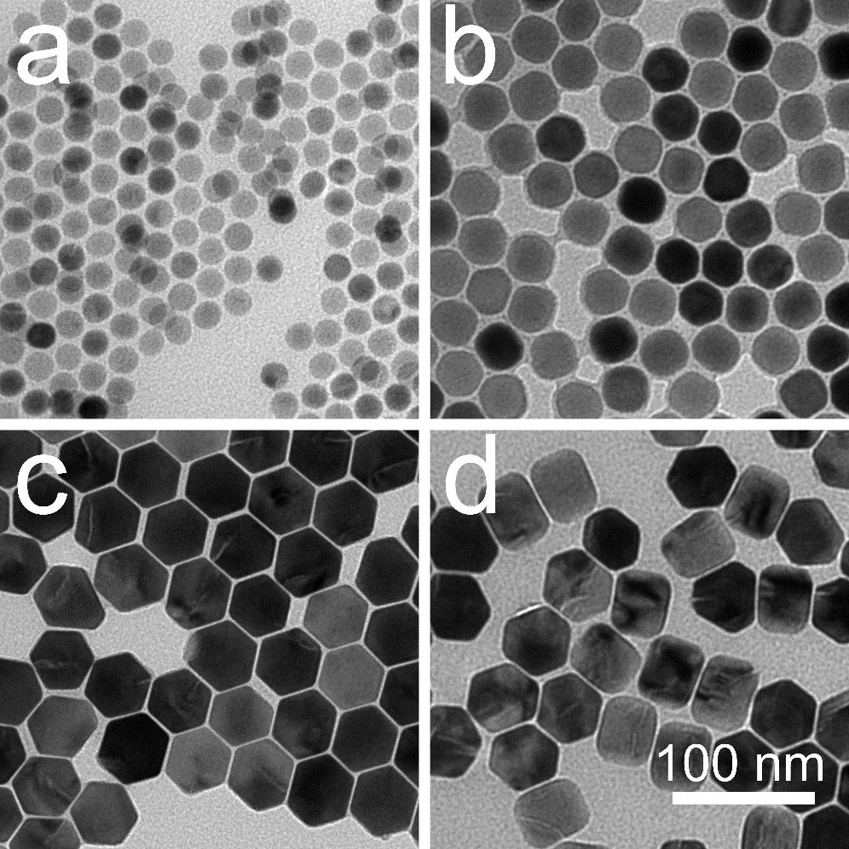
Supplementary Fig. 1 | TEM images of the four batches of lanthanide-doped nanoparticles used for machine learning. These nanoparticles are NaYF₄ crystals doped with the same concentration of Er³⁺ (2%) and Yb³⁺ (20%) with different diameters: (a) 16.5 nm, (b) 30.9 nm, (c) 46.4 nm, and (d) 48.3 nm.

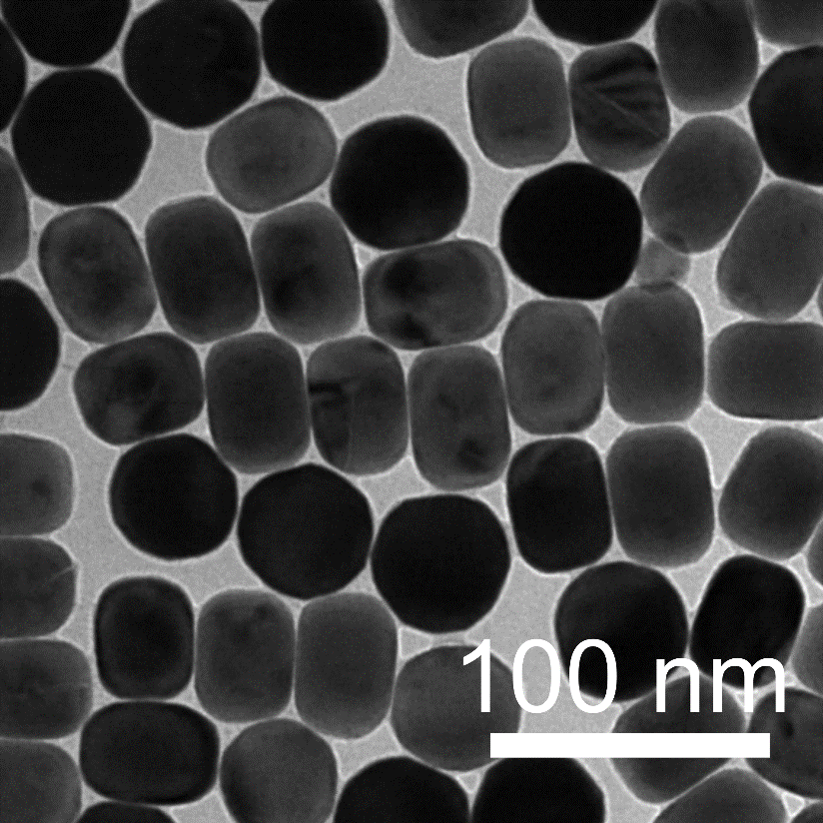
Supplementary Fig. 2 | TEM image of the lanthanide-doped nanoparticles used in Fig. 2 and 5. These nanoparticles are NaYF₄ crystals doped with the concentration of Er³⁺ (2%) and Yb³⁺ (20%) with the diameter of 58 nm.

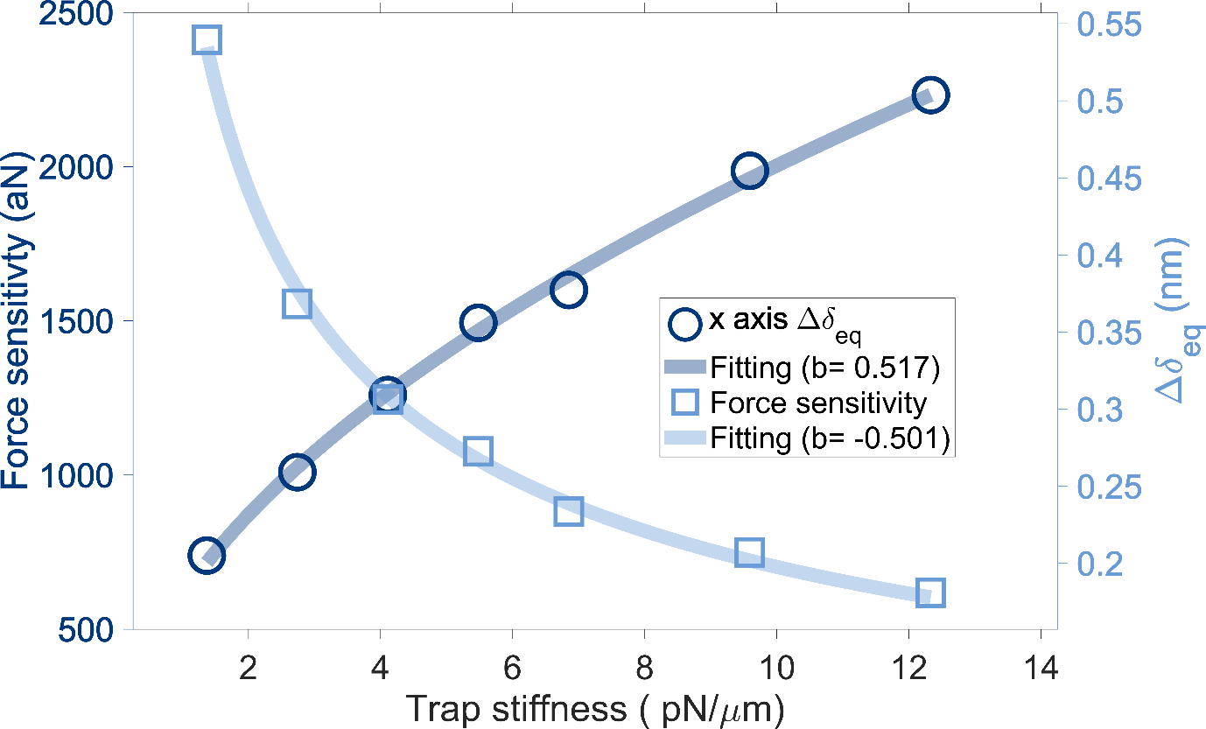
Supplementary Fig. 3 | The role of trap stiffness (x-axis) on force sensitivity. Here $σ_{p}$ (localisation error) is 0. Data number Nr is 10,000, laser power is from 10 to 90mW.

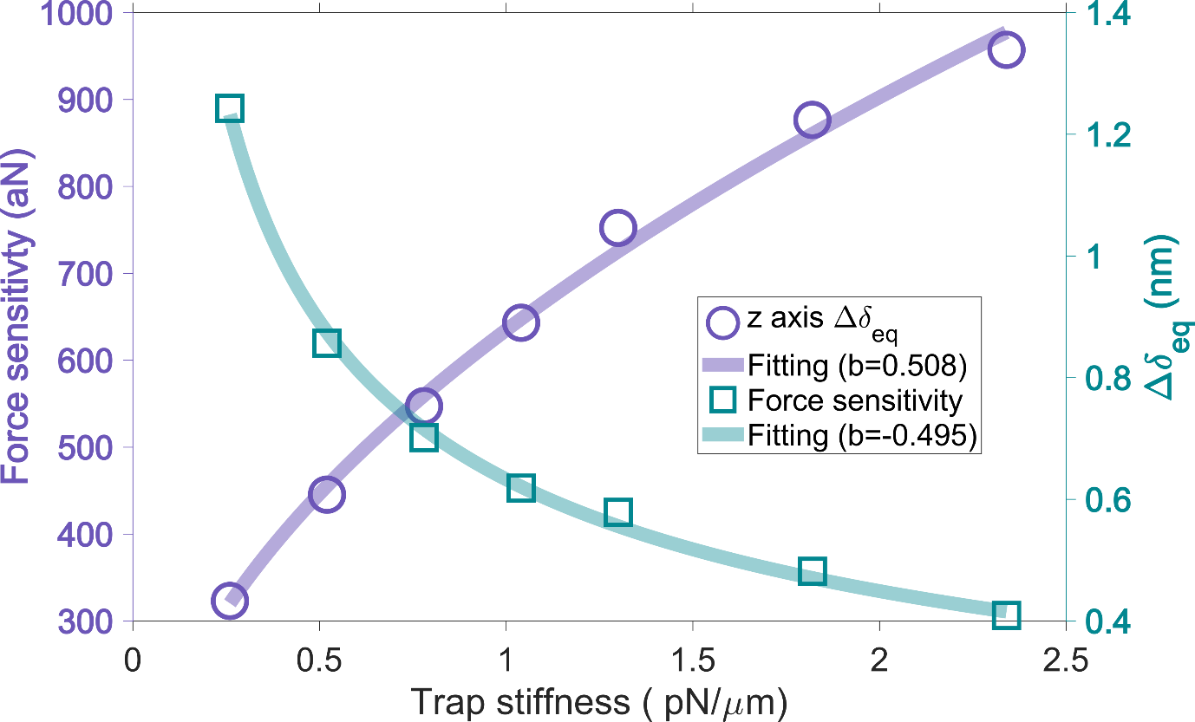
Supplementary Fig. 4 | The role of trap stiffness (z-axis) on force sensitivity. Here $σ_{p}$ is 0. Data number Nr is 10,000, laser power is from 10 to 90mW.

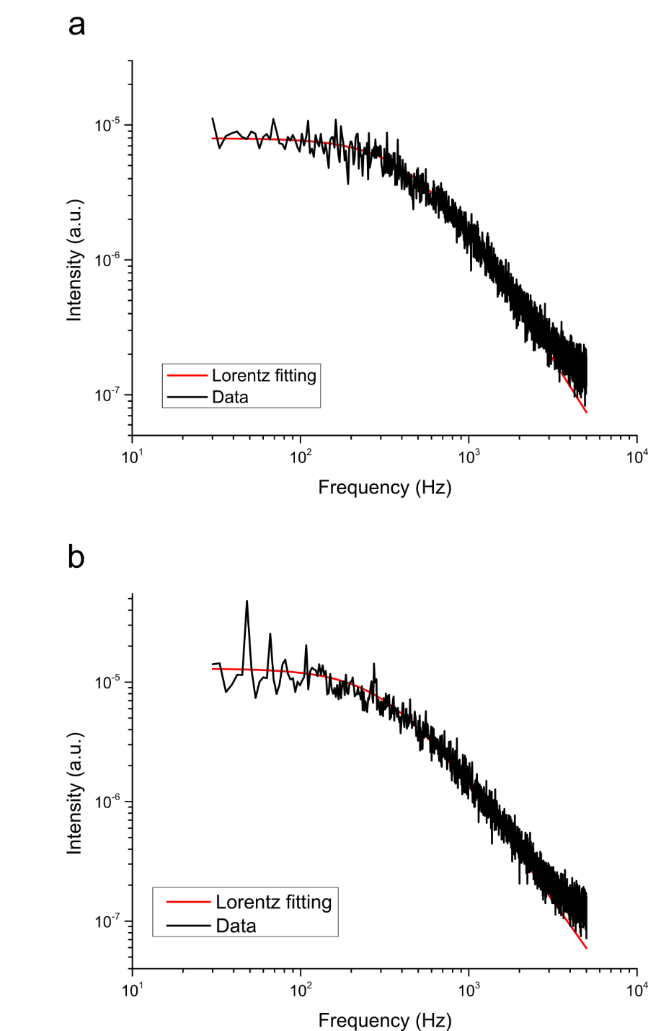
Supplementary Fig. 5 | Trap stiffness of a 1-μm-diameter polystyrene sphere on x direction (a) and y direction (b). The laser power is 10 mW.

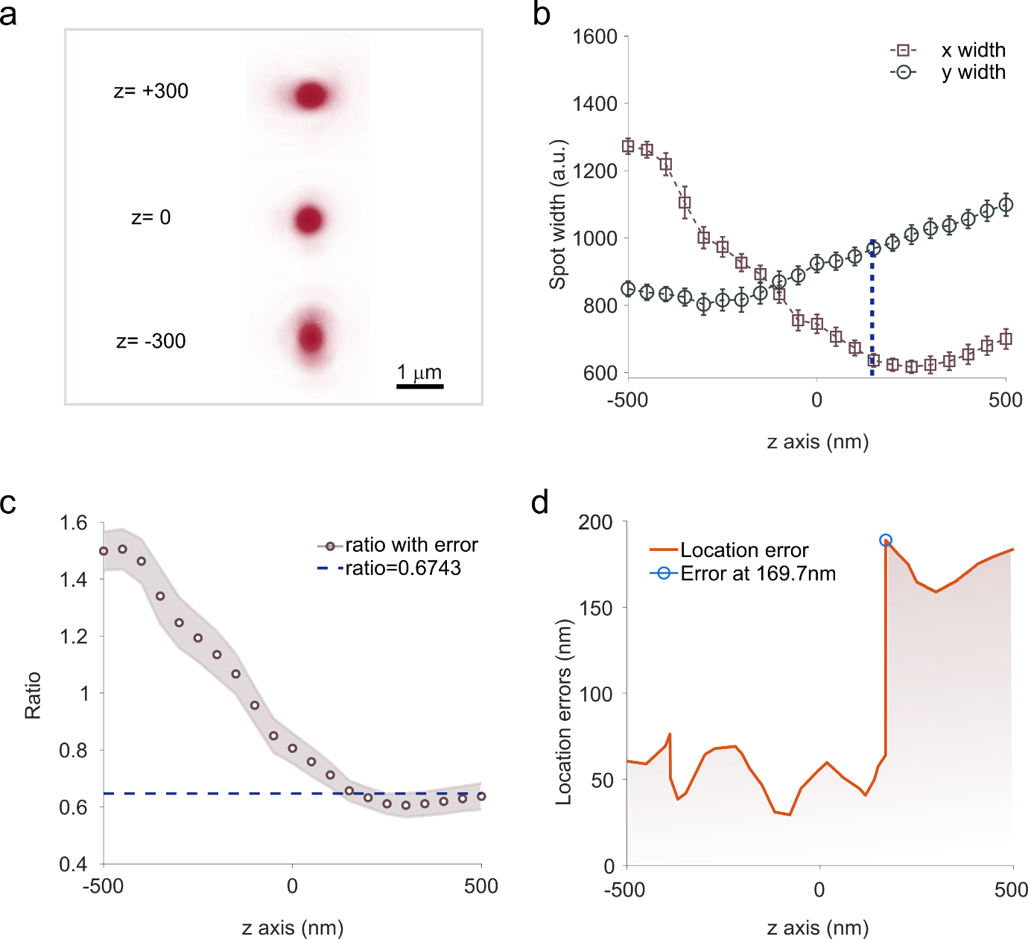
Supplementary Fig. 6 | Astigmatic PSF varying with z position for fluorescent Ln-NP on cover glass. a) Images of the fixed nanoparticles with astigmatic features at different z positions. b) Lateral variations of the PSF width at different z positions. 976.5-nm laser power is 80mW, exposure time is 0.1 s. z = 0 stands for the focus position. c) The x-y ratio of PSF width varying with the z position. d) Location errors of the nanoparticle at different z position according to the calibration curve in c.

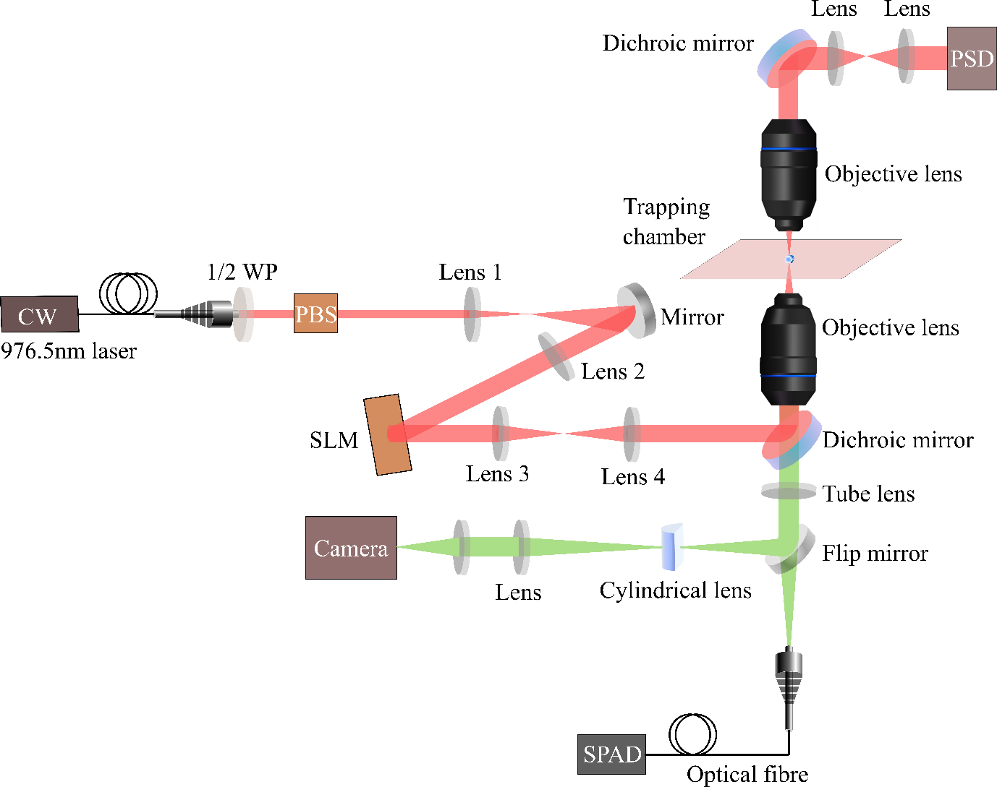
Supplementary Fig. 7 | The schematic of optical tweezers system. The trapping laser is 976.5nm continuous wave laser (Thorlabs, Inc). The polarisation of the laser is controlled by a polariser and a halfwave plate. The spatial light modulator (SLM) is used to optimising the trapping beam and controlling the trapping position. The camera is sCMOS from Andor (Sona). The PSD (position sensing detector, Thorlabs, Inc) is used for particles power spectrum analysis.

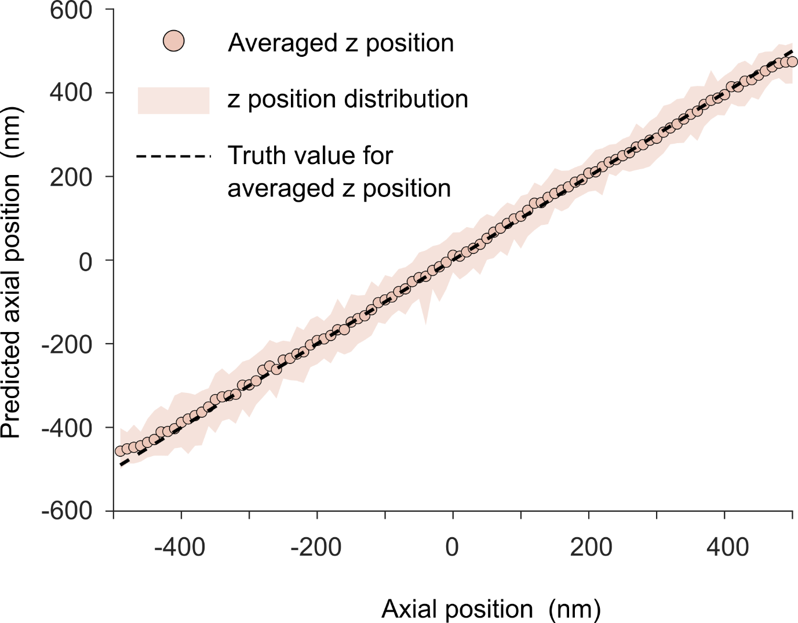
Supplementary Fig. 8 | Axial localisation accuracy with axial variations. The dotted line represents the truth statistic centre value, which is controlled by the SLM, and the circular edge means the measured statistic centre, which is similar with Figure 4 d in the main text. The pink edge denotes the transient positions of the trapped particle.

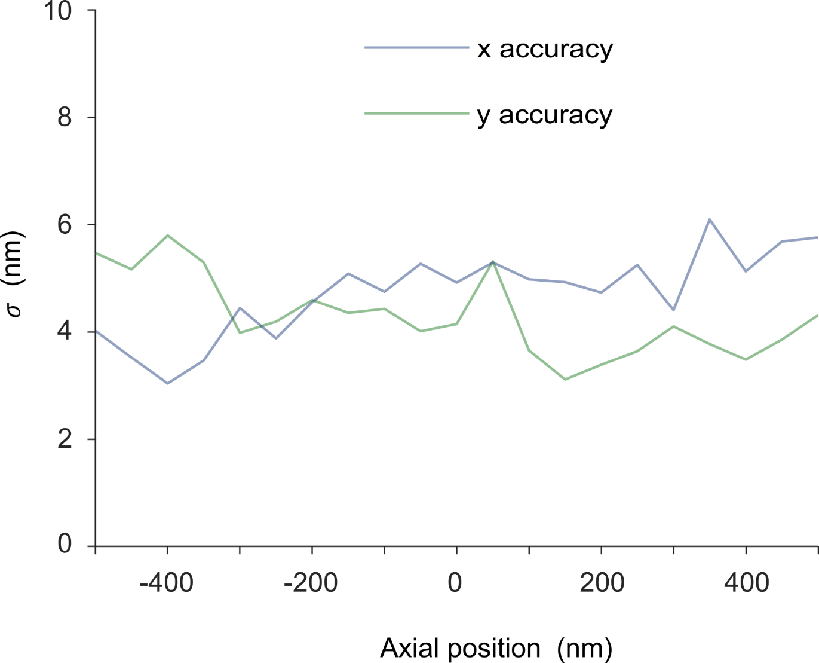
Supplementary Fig. 9 | Lateral position accuracy with axial variations from -500 nm to 500 nm by SLM.

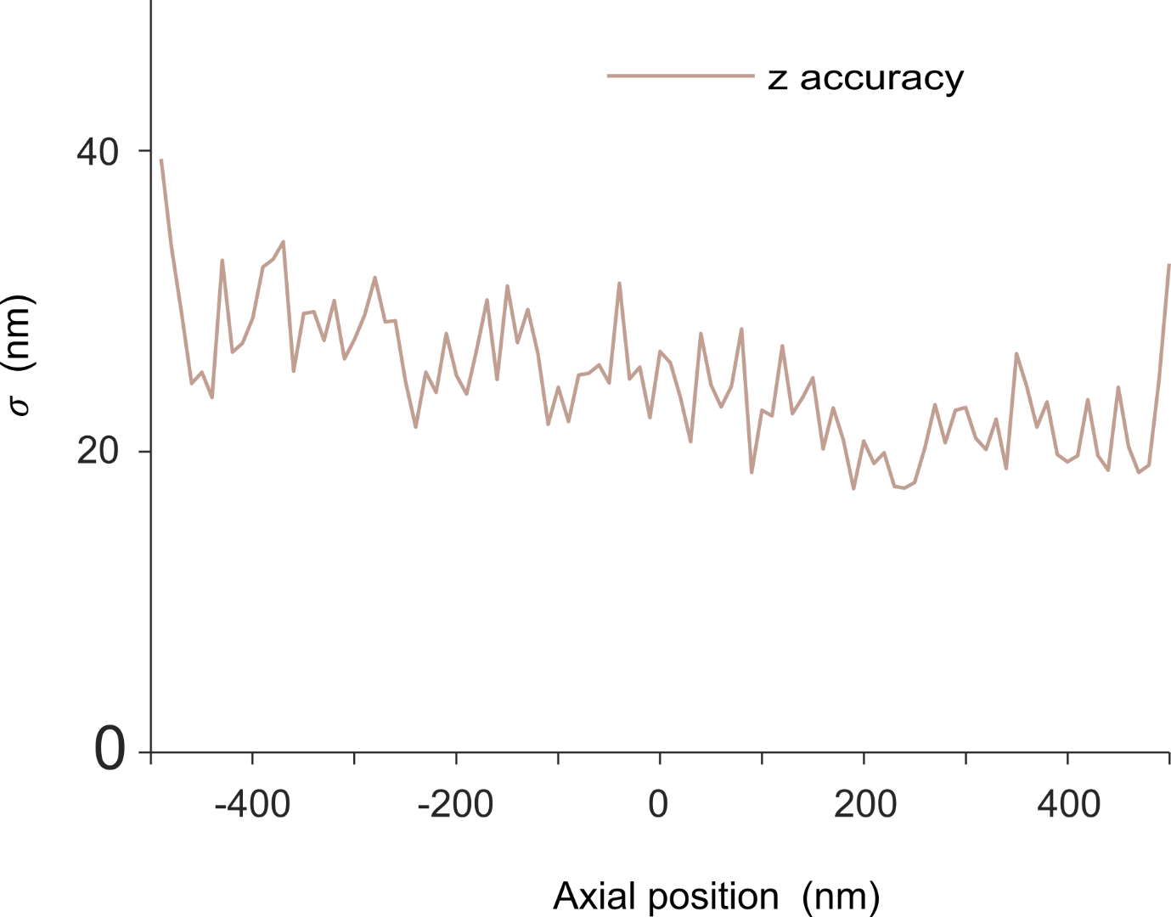
Supplementary Fig. 10 | Axial position accuracy with axial variations from -500 nm to 500 nm by SLM.

References

1. Liu, Y. et al. Amplified stimulated emission in upconversion nanoparticles for super-resolution nanoscopy. Nature 543, 229–233 (2017).
2. Shan, X. et al. Optical tweezers beyond refractive index mismatch using highly doped upconversion nanoparticles. Nat. Nanotechnol. 16, 531–537 (2021).
3. Gieseler, J. et al. Optical tweezers - from calibration to applications: a tutorial. Adv. Opt. Photonics 13, 74 (2021).
4. Florin, E. L., Pralle, A., Stelzer, E. H. K. & Hörber, J. K. H. Photonic forcemicroscope calibration by thermal noise analysis. Appl. Phys. A Mater. Sci. Process. 66, 75–78 (1998).
5. Maragò, O. M. et al. Femtonewton force sensing with optically trapped nanotubes. Nano Lett. 8, 3211–3216 (2008).
6. Zensen, C., Villadsen, N., Winterer, F., Keiding, S. R. & Lohmüller, T. Pushing nanoparticles with light - A femtonewton resolved measurement of optical scattering forces. APL Photonics 1, (2016).
7. Huang, B., Wang, W., Bates, M. & Zhuang, X. Three-Dimensional Super-Resolution Reconstruction Microscopy. Science (80-. ). 319, 810–813 (2008).
8. Reece, P. J. et al. Characterization of semiconductor nanowires using optical tweezers. Nano Lett. 11, 2375–2381 (2011).
9. Rohrbach, A. Stiffness of optical traps: Quantitative agreement between experiment and electromagnetic theory. Phys. Rev. Lett. 95, 1–4 (2005).
10. Pesce, G., Jones, P. H., Maragò, O. M. & Volpe, G. Optical tweezers: theory and practice. European Physical Journal Plus vol. 135 (Springer Berlin Heidelberg, 2020).
11. Helgadottir, S., Argun, A. & Volpe, G. Digital microscopy enhanced by deep learning. Optica 6, (2019).
12. Loeb, A. L., Wiersema, P. H. & Overbeek, J. T. G. The electrical double layer around a spherical colloid particle. (MIT Press, 1961).
13. Hunter, R. J. Zeta Potential in Colloid Science: Principles and Applications. (Academic Press, 1981).
14. Ding, L. et al. Lanthanide Ion Resonance‐Driven Rayleigh Scattering of Nanoparticles for Dual‐Modality. Adv. Sci. 2203354 (2022).

