Supplementary figures

Museum specimens shedding light on the evolutionary history and diversity of the hedgehog family Erinaceidae

Ying Zeng^{1,#}, Kai He^{2,#,$}, Xing Chen^{3,#}, Weipeng Bai⁴, Hongzhou Lin¹, Jianhai Chen ⁵, Nedko Nedyalkov⁶, Nobuyuki Yamaguchi^{7,8}, Keerthy Vijayan⁹, Ramamoorthy Suganthasakthivel⁹, Brawin Kumar¹⁰, Yuqing Han¹, Zhongzheng Chen¹¹, Wenzhi Wang^{12,13}, Yang Liu¹,$

- State Key Laboratory of Biocontrol, School of Ecology, Sun Yat-sen University, Guangzhou, 510275, China;
- Key Laboratory of Conservation and Application in Biodiversity of South China, School of Life Sciences, Guangzhou University, Guangzhou, Guangdong 510006, China
- School of Zoology, Faculty of Life sciences, Tel Aviv University, Tel Aviv 6997801 Israel
- Key Laboratory of Vertebrate Evolution and Human Origins of Chinese Academy of Sciences, IVPP, CAS, Beijing 100044, China; CAS Center for Excellence in Life and Paleoenvironment, Beijing 100044, China
- Institutes for Systems Genetics, Frontiers Science Center for Disease-related Molecular Network, West China Hospital, Sichuan University, Chengdu 610041, China
- National Museum of Natural History, Bulgarian Academy of Sciences, Sofia, Bulgaria
- Department of Biological and Environmental Sciences, Faculty of Arts and Sciences, Qatar University, PO Box 2713, Doha, Qatar
- Institute of Tropical Biodiversity and Sustainable Development, University Malaysia Terengganu, 21030, Kuala Nerus, Terengganu, Malaysia
- Wildlife Biology Department, Kerala Forest Research Institute, Peechi, Kerala, 680653, India
- Indian Institute of Science Education and Research, Tirupati, India
- Collaborative Innovation Center of Recovery and Reconstruction of Degraded Ecosystem in Wanjiang Basin Co-founded by Anhui Province and Ministry of Education, School of Ecology and Environment, Anhui Normal University, Wuhu, Anhui 241002, China
- Wildlife Forensic Science Service, Kunming, 650203, China
- Guizhou Jiandee Laboratories Co., Ltd. Guiyang, 550014, China

Corresponding authors: Dr. Kai He(hekai@gzhu.edu.cn); Dr. Yang Liu (liuy353@mail.sysu.edu.cn)

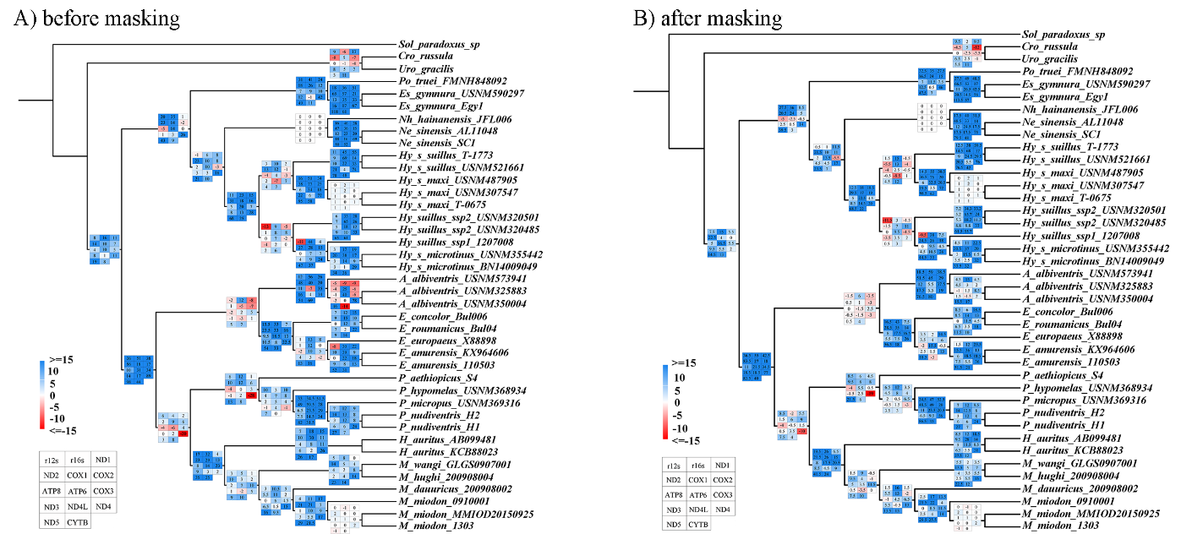
Fig. S1 Maximum likelihood tree of Erinaceidae based on dataset MtG. The different values linked to the branch were different genes’ Bremer values, which were corresponding with the legend on the left bottom. Figure S1A used original alignment and figure S1B used after de-contamination alignment.

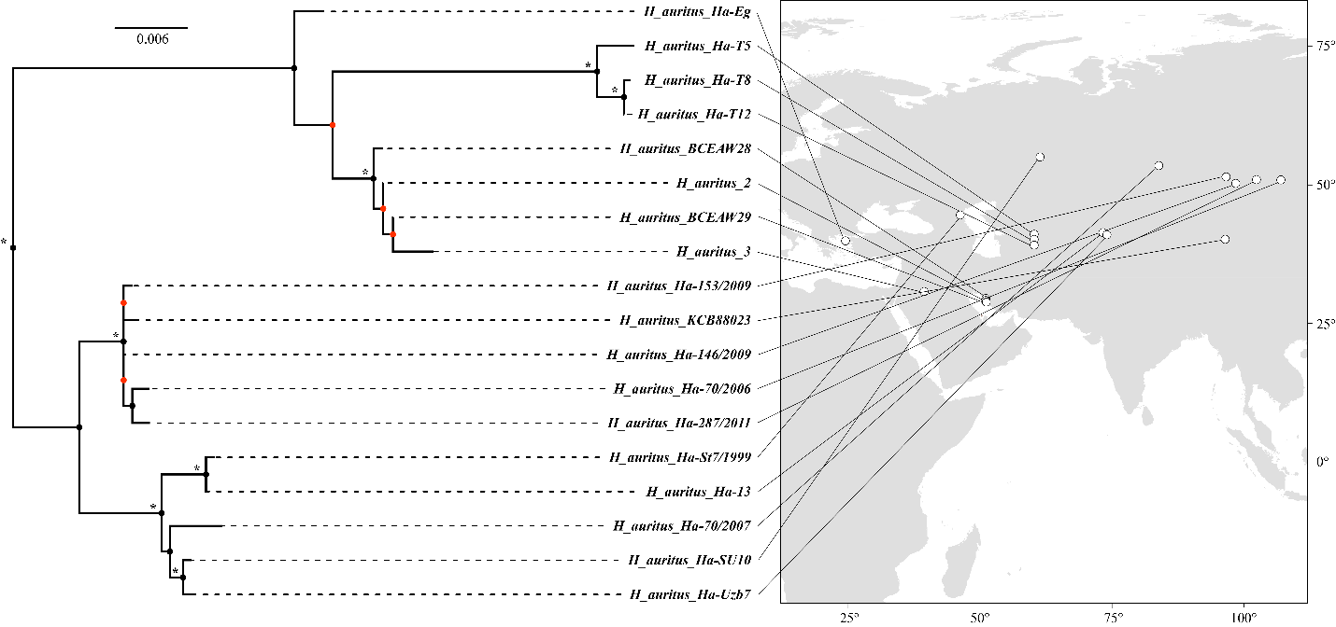
Fig. S2 Maximum likelihood tree of hedgehogs’ genus Hemiechinus auritus sampled in the analysis and their corresponding distributions. A node with an asterisk indicates the bootstrap proportion of the node is higher than or equal to 95. The remaining nodes that didn't label indicate bootstrap proportion is between 70 and 95. The red node indicates bootstrap proportion of the node is lower than 70.

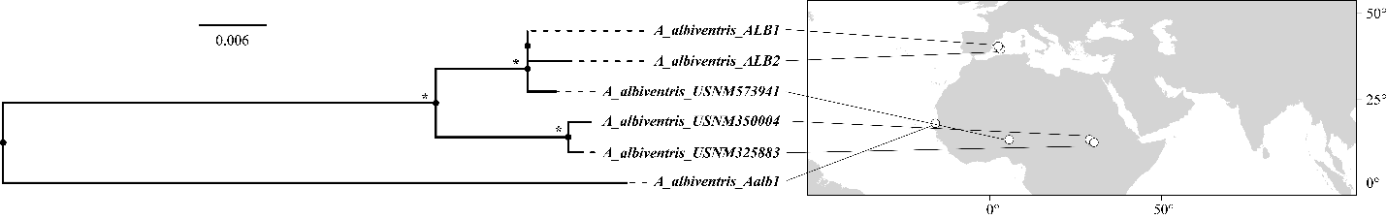Fig. S3 Maximum likelihood tree of hedgehogs’ genus Atelerix albiventris sampled in the analysis and their corresponding distributions. A node with an asterisk indicates the bootstrap proportion of the node is higher than or equal to 95. The remaining nodes that didn't label indicate bootstrap proportion is between 70 and 95.

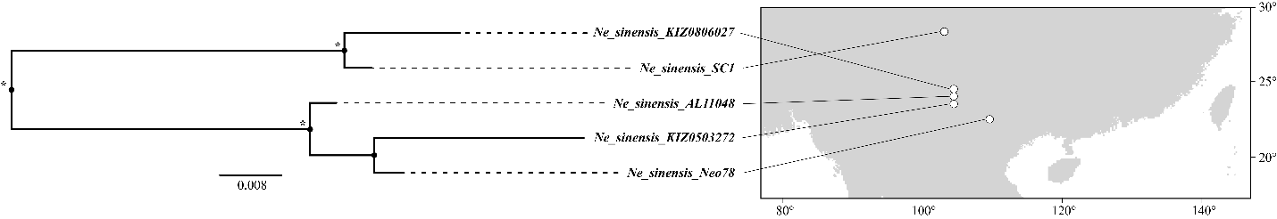
Fig. S4 Maximum likelihood tree of gymnures’ genus Neotetracus sinensis sampled in the analysis and their corresponding distributions. A node with an asterisk indicates the bootstrap proportion of the node is higher than or equal to 95. The remaining nodes that didn't label indicate bootstrap proportion is between 70 and 95.

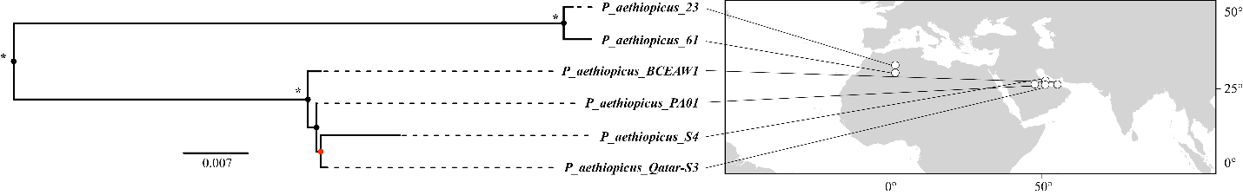
Fig. S5 Maximum likelihood tree of hedgehogs’ genus Paraechinus aethiopicus sampled in the analysis and their corresponding distributions. A node with an asterisk indicates the bootstrap proportion of the node is higher than or equal to 95. The remaining nodes that didn't label indicate bootstrap proportion is between 70 and 95. The red node indicates the bootstrap proportion of the node is lower than 70.
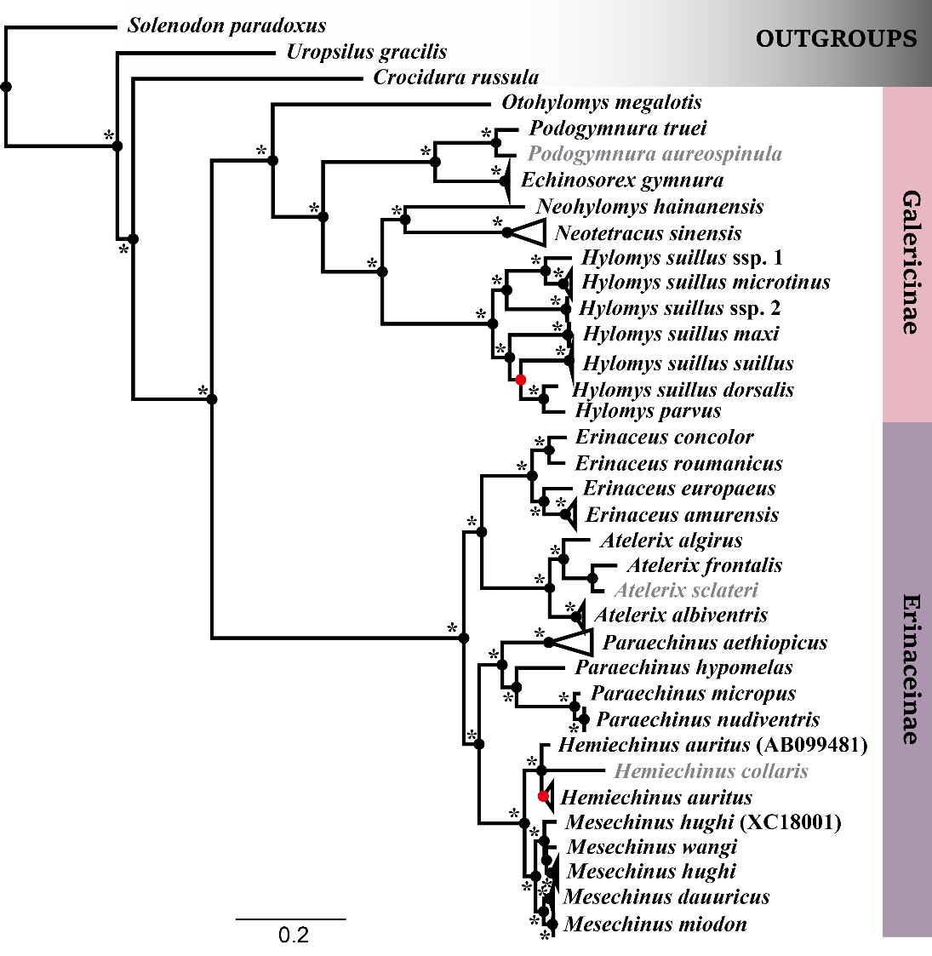
Fig. S6 Maximum likelihood tree of all extant Erinaceidae based on combined MtG and morphological data. A node with an asterisk indicates the bootstrap proportion of the node is higher than or equal to 95. The remaining nodes that didn't label indicate bootstrap proportion is between 70 and 95. The red node indicates the bootstrap proportion of the node is lower than 70. Multiple samplings of the same species or subspecies collapsed. The name in the parentheses is an individual of the clade, which didn't cluster with other individuals of the same species for some reason. The species that only possess the morphological signals was displayed as grey name.
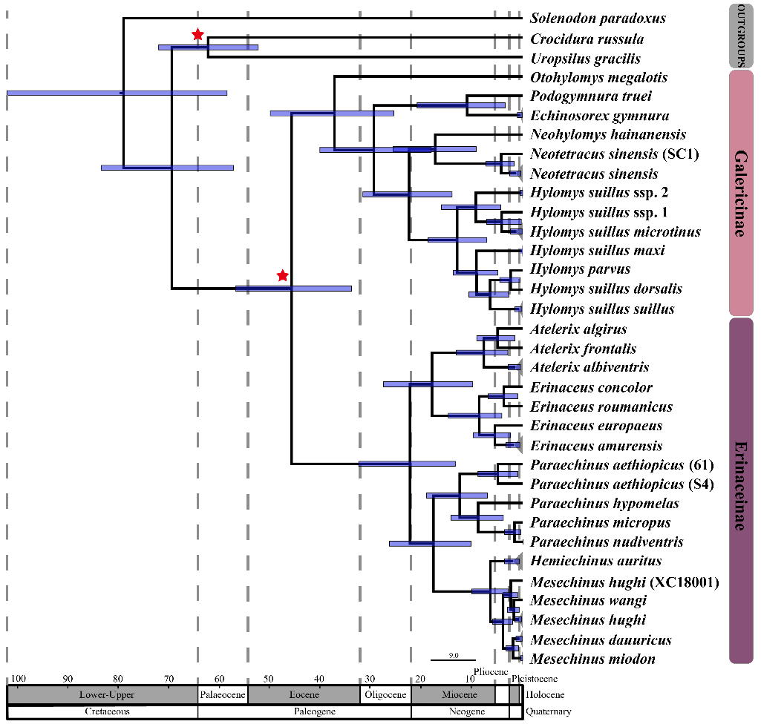
Fig. S7 Chronogram from the Bayesian analysis of MtG data using a relaxed molecular clock. Branch lengths represent time. Node bars indicate the 95% CI for the clade age. A node with a red pentagon indicates using a fossil calibration there. The name in the parentheses is an individual of the clade, which didn't cluster with other individuals of the same species for some reason.

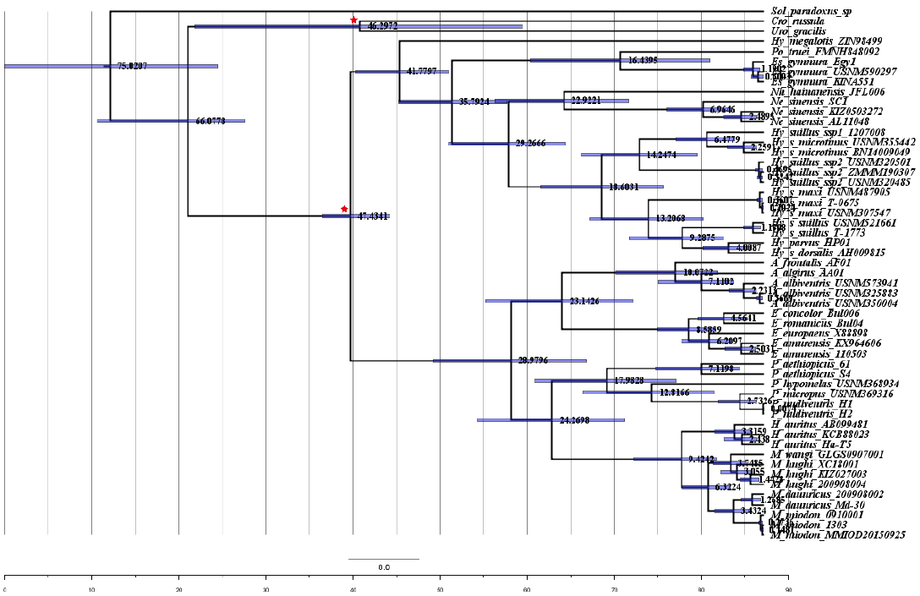
Fig. S8 Chronogram from the Bayesian analysis of MtG data using MCMCTree. Branch lengths represent time. Node bars indicate the 95% CI for the clade age. A node with a red pentagon indicates using a fossil calibration there. Whole numbers represent the mean time of the node.

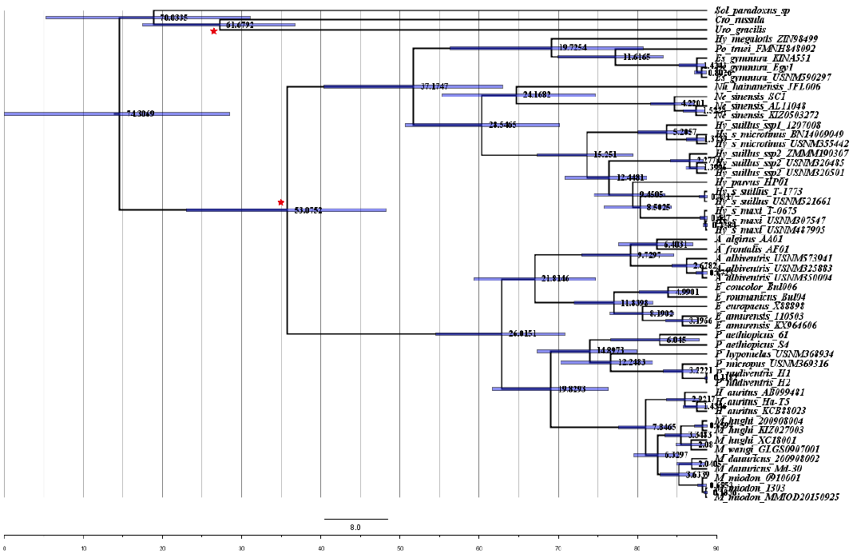
Fig. S9 Chronogram from the Bayesian analysis of MtG data using a relaxed molecular clock. Branch lengths represent time. Node bars indicate the 95% CI for the clade age. A node with a red pentagon indicates using a fossil calibration there. Whole numbers represent the mean time of the node.

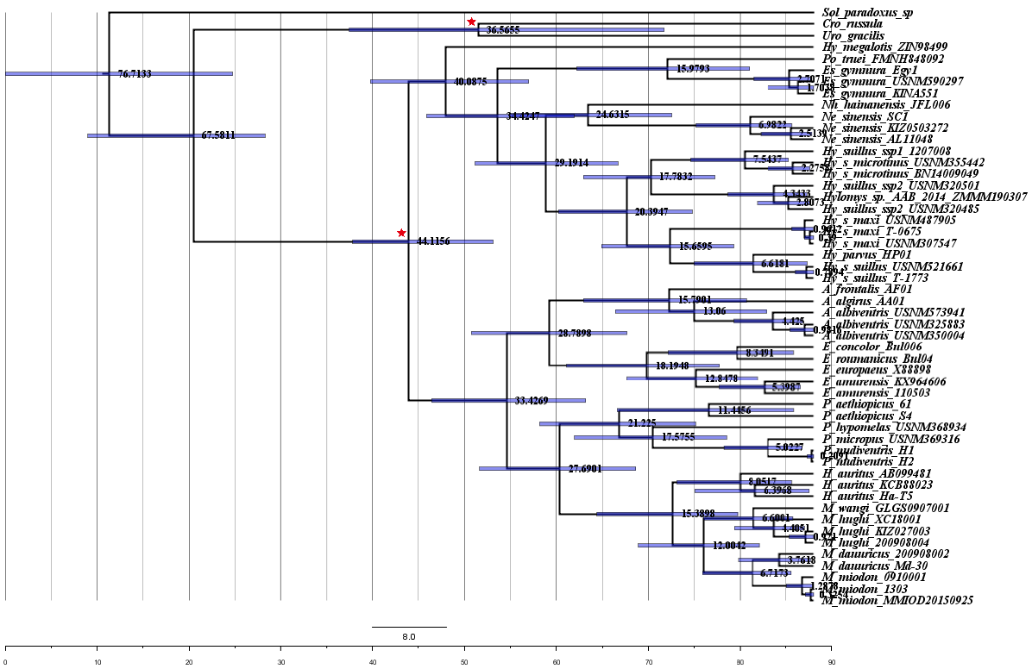
Fig. S10 Chronogram from the Bayesian analysis of MtG2nd data using MCMCTree. Branch lengths represent time. Node bars indicate the 95% CI for the clade age. A node with a red pentagon indicates using a fossil calibration there. Whole numbers represent the mean time of the node.

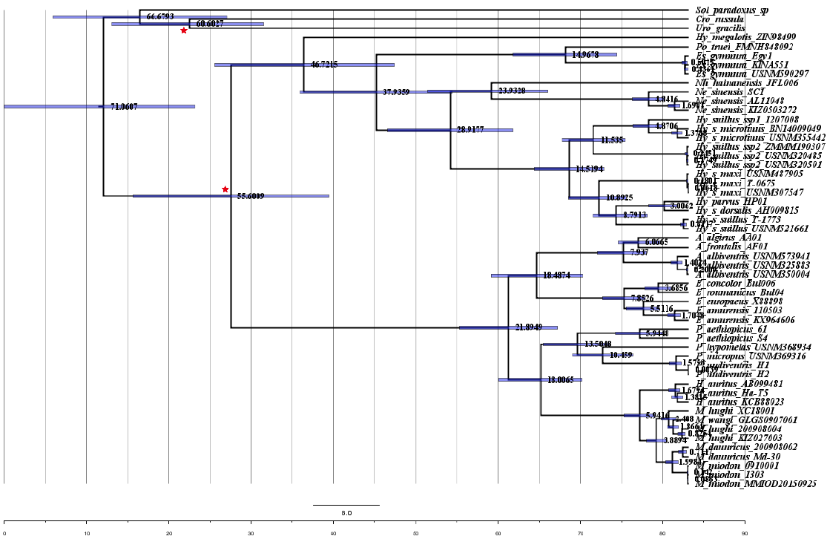
Fig. S11 Chronogram from the Bayesian analysis of MtG-nuDNA data using a relaxed molecular clock. Branch lengths represent time. Node bars indicate the 95% CI for the clade age. A node with a red pentagon indicates using a fossil calibration there. Whole numbers represent the mean time of the node.

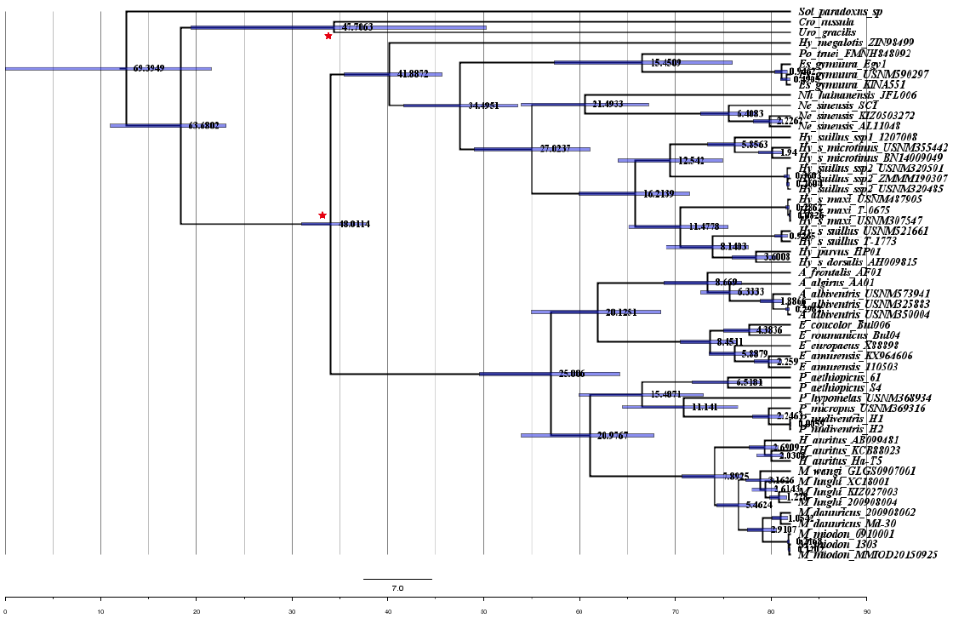
Fig. S12 Chronogram from the Bayesian analysis of MtG-nuDNA data using MCMCTree. Branch lengths represent time. Node bars indicate the 95% CI for the clade age. A node with a red pentagon indicates using a fossil calibration there. Whole numbers represent the mean time of the node.
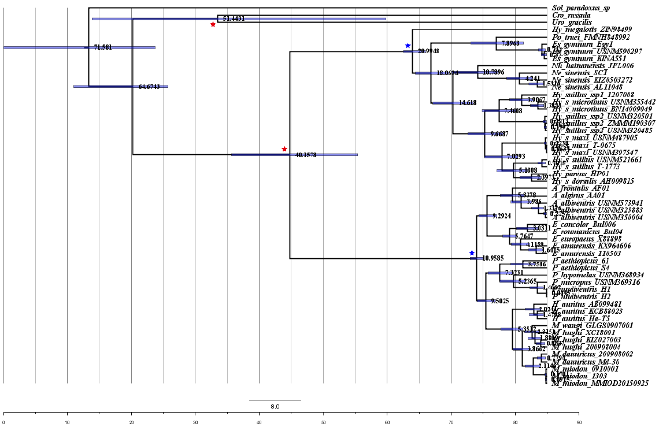
Fig. S13 Chronogram from the Bayesian analysis of MtG data using MCMCTree. Branch lengths represent time. Node bars indicate the 95% CI for the clade age. A node with a red pentagon indicates using a fossil calibration there and a node with a blue pentagon indicates using a secondary calibration there. Whole numbers represent the mean time of the node.
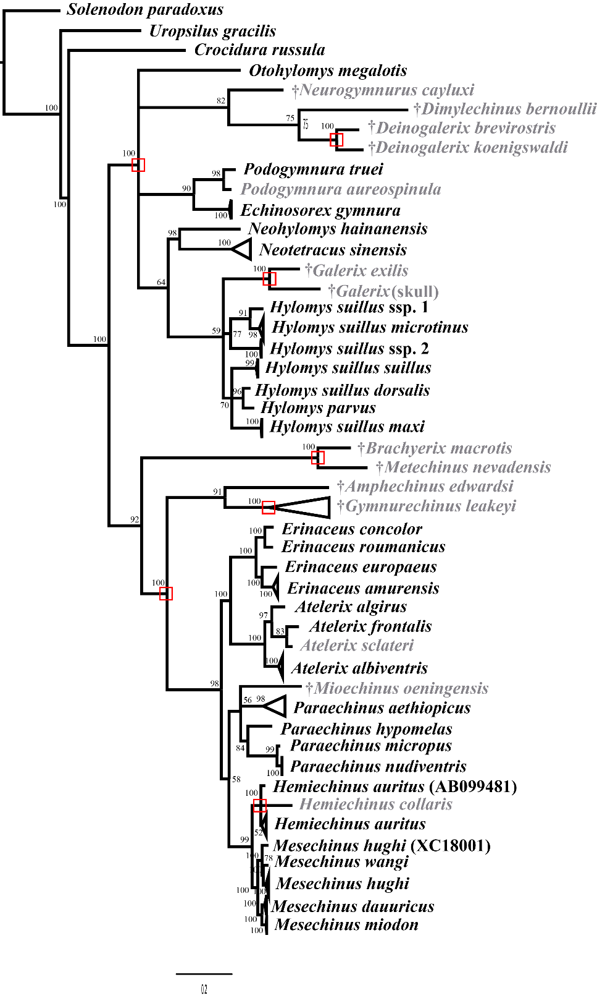
Fig S14. Bayesian tree of Erinaceidae based on MtG dataset. Whole numbers represent the Bayesian post probability (PP) of the node. A node inside the red box was constrained. Multiple samplings of the same species or subspecies collapsed. The name in the parentheses is an individual of the clade, which didn't cluster with other individuals of the same species for some reason. The species that only possess the morphological signals was displayed as grey name and a name labelled † is fossil species.

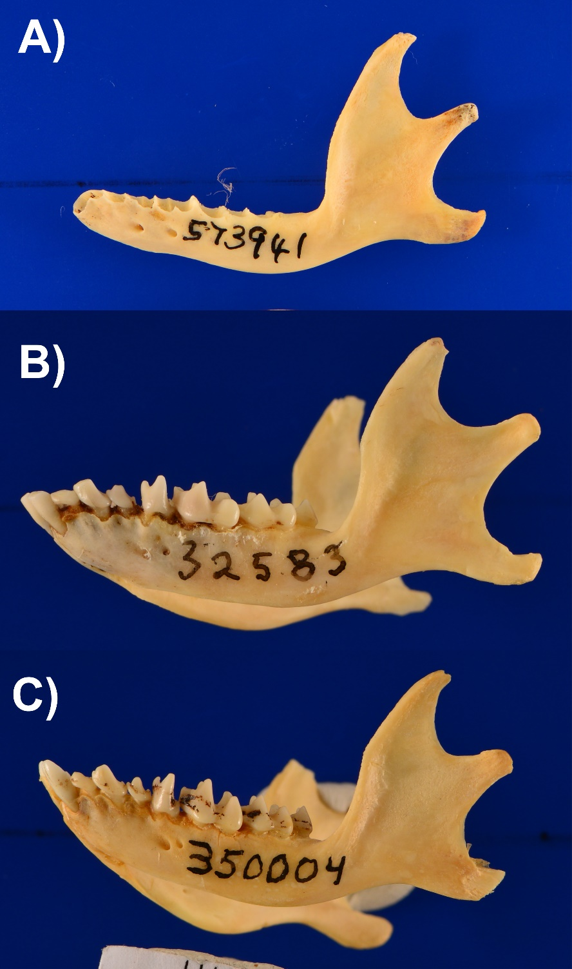

Fig S15. Lateral view of the mandible of three A. albiventris specimens deposited in the USNM. USNM573941 (A) from Niger is found in a distinct clade from 350004 from Sudan (B) and 325883 from Nigeria (C). Their phylogenetic relationships and distributions are shown in Fig S3. Photo by K. H.

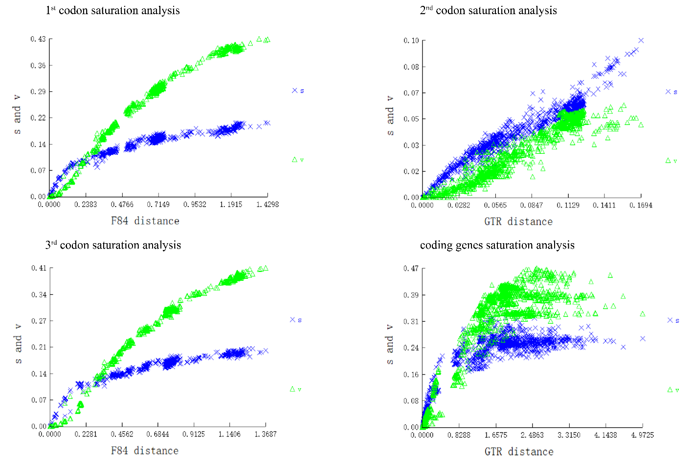
Fig S16. Mitochondrial coding genes’ saturation analyses using DAMBE. The abscissa represents genetic distances generated based on the F84 model or GTR model. Ordinate represents s and v values.

