Supporting Information
Multi-band camouflage design with thermal management
Lehong Huang^{1,2,3,4}, Haochuan Li¹, Zhiguo Li^{1,3,4}, Wenbo Zhang^{1,2,3}, Caiwen Ma^{1,3,4*}, Chunmin Zhang^{2*}, Yuxuan Wei^{1,3,4}, Liang Zhou^{1,4}, Xun Li¹, Zhiyuan Cheng^{1.3.4}, Xiaohui Guo¹ and Shiping Guo²

¹Xi’an Institute of Optics and Precision Mechanics, Chinese Academy of Sciences, Xi’an 710119, China
²School of Physics, Xi’an Jiaotong University, Xi’an 710049, China
³University of Chinese Academy of Sciences, Beijing 100049, China
⁴Key Laboratory of Space Precision Measurement Technology, Chinese Academy of Sciences, Xi’an 710119, China
*Corresponding author. Email: cwma@opt.ac.cn; zcm@xjtu.edu.cn

Section S1. Optical constants of Ge, $YbF_{3}$ and titanium alloys
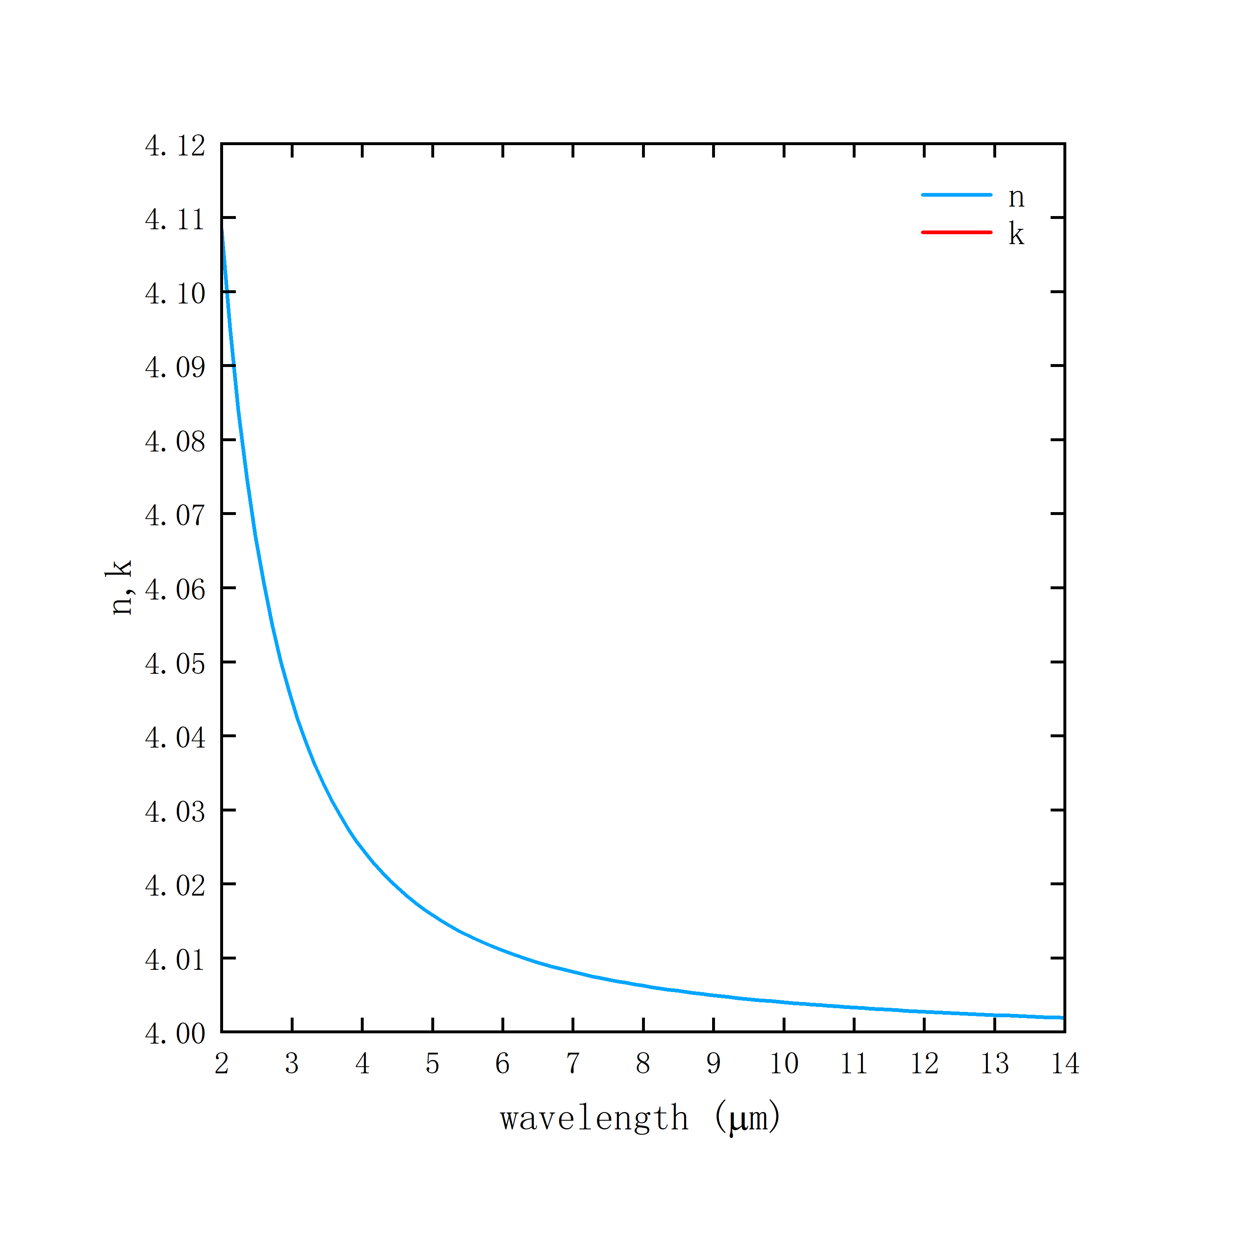
Fig. S1. (a) Refractive index n, extinction coefficient k of Ge
Optical constants (refractive index n, extinction coefficient k) for Ge in the Palik manual.
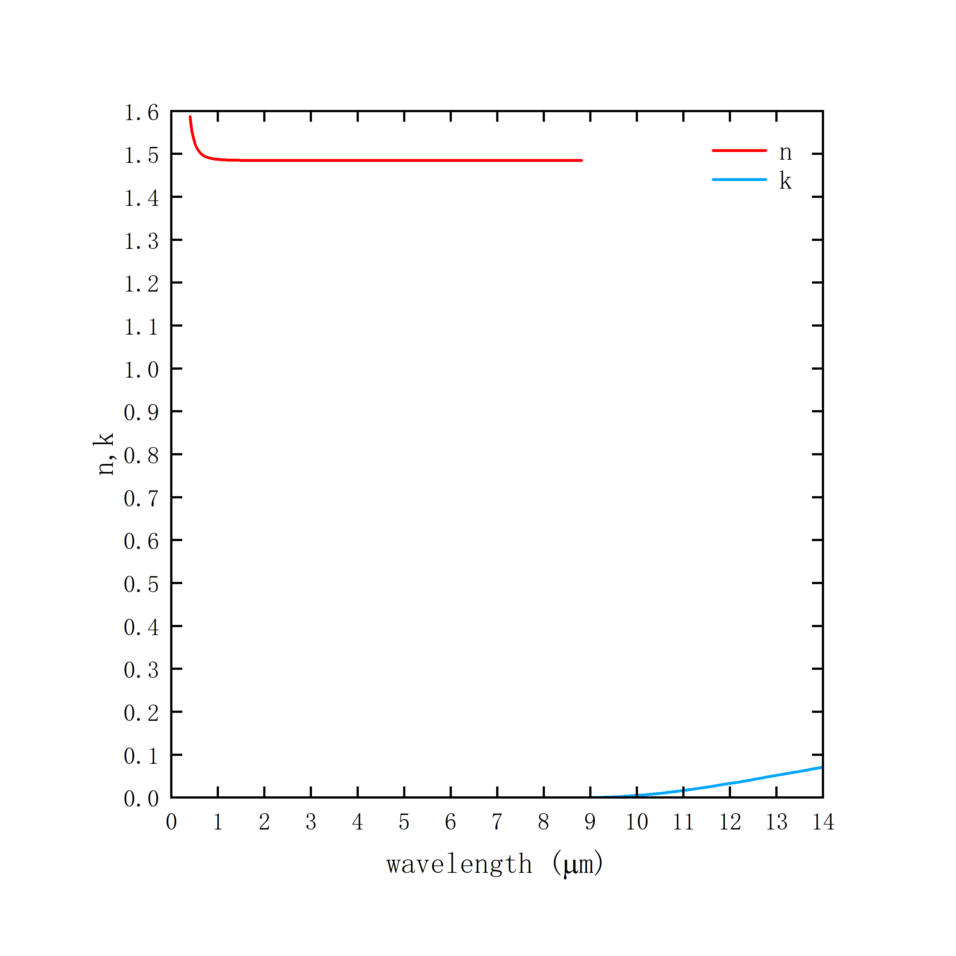
Fig.S1. (b) Refractive index n, extinction coefficient k of $YbF_{3}$
The optical constants (refractive index n, extinction coefficient k) of $YbF_{3}$ were measured by an infrared ellipsometer.

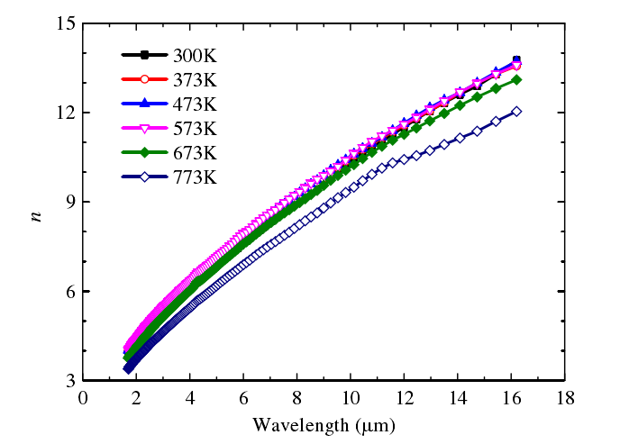
Fig.S1. (c) Refractive index n of titanium alloy TC4 from 300 K to 773 K

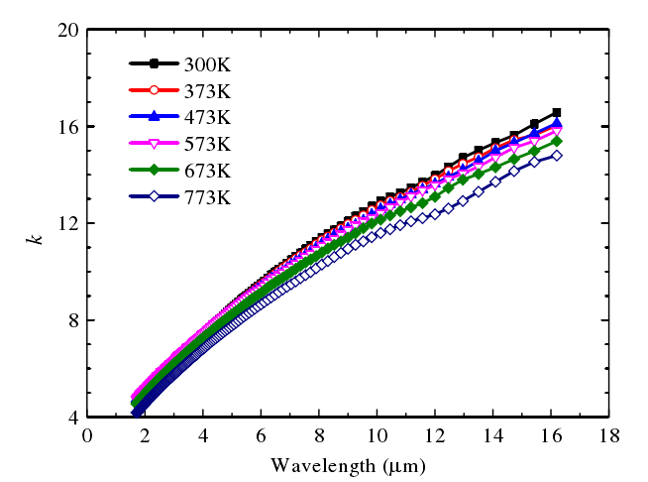

Fig.S1. (d) Extinction coefficient k for titanium alloy TC4 from 300 K to 773 K
Optical constants (refractive index n, extinction coefficient k) of the titanium alloy TC4 measured from 300 K to 773 K in the literature "Experimental study of high-temperature optical constants of typical engineering materials based on the ellipsometric method".

Section S2. Thermal conductivity of silica aerogels
The commercial nano-silica aerogel insulation purchased, as shown in Fig.S2. (a).
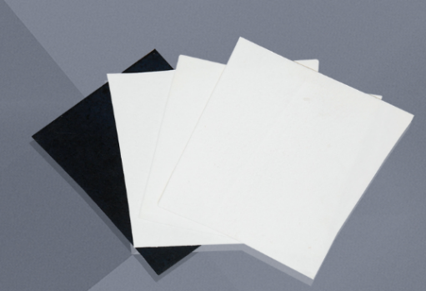
Fig.S2. (a)Nano silica aerogel sample
The paper "High-temperature infrared camouflage with efficient thermal management" uses the "nearest function" extrapolation in COMSOL software to obtain thermal conductivity in the temperature range 300-800 K and compares it with the thermal conductivity of air, asbestos and glass fibers, as shown in Fig.S2. (b).
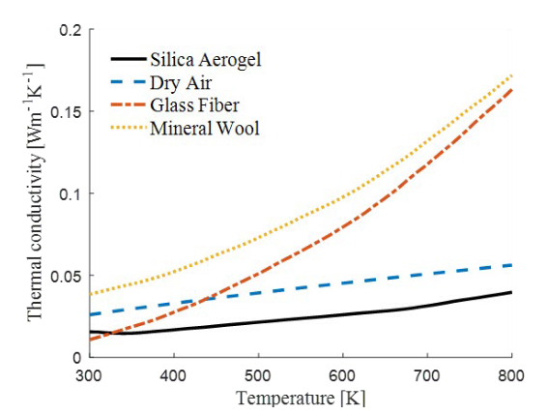
Fig.S2. (b) Comparison of the thermal conductivity of different materials

Section S3. Error analysis of simulation data and experimental data
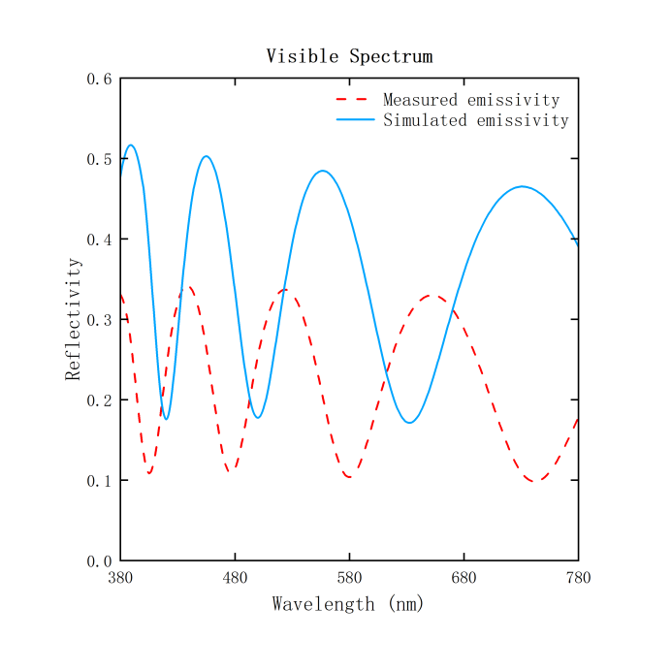
Fig.S3. (a) Select the reflectance simulated in the visible band of the emitter (blue solid line) and the reflectance measured by spectrophotometer (red dashed line).
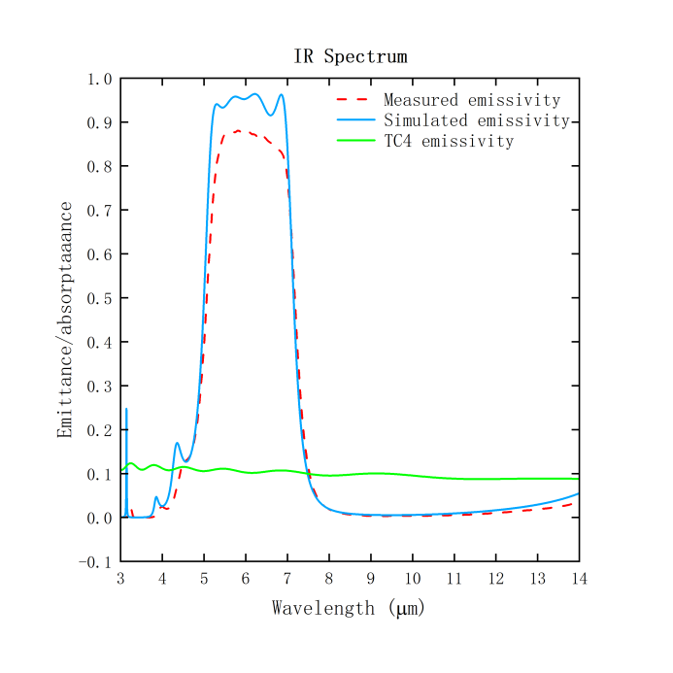
Fig.S3. (b) Emission spectra of selected emitters: simulated normal emissivity/absorption (blue solid line) of Ge/$YbF_{3}$ multilayer film emitters measured by FTIR spectroscopy (red dashed line) and compared with measured emissivity/absorption of titanium alloy (TC4)
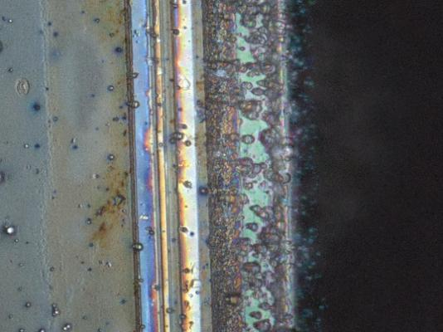 | 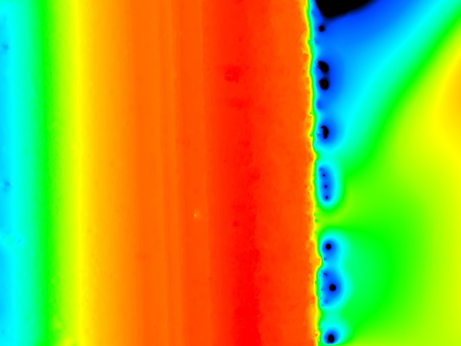
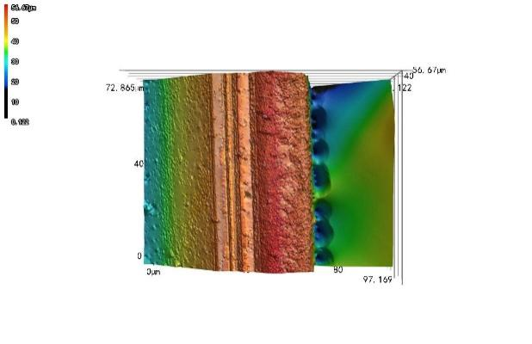 | 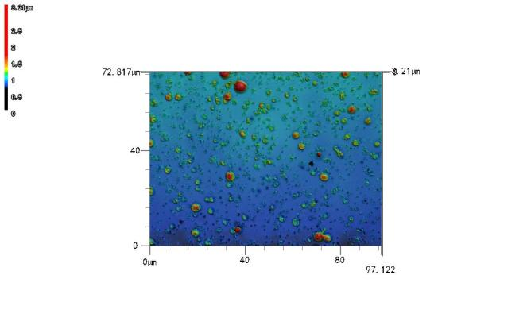
Fig.S3. (c)Sample film under laser confocal microscope
It can be noted that there is some error between the simulated emission/reflection spectra and the actual measured emission/reflection spectra (Fig.S3. (a)/(b)), which we suspect is due to processing errors during the electron beam evaporation deposition coating process. A confocal laser microscope was applied to observe the flatness of the multilayer sample (Fig.S3. (c)) and it was found that there were some pores on the surface of the film layer, which may have introduced processing errors and thus caused the errors between the simulated and measured data.

Section S4. Temperature endurance and film strength
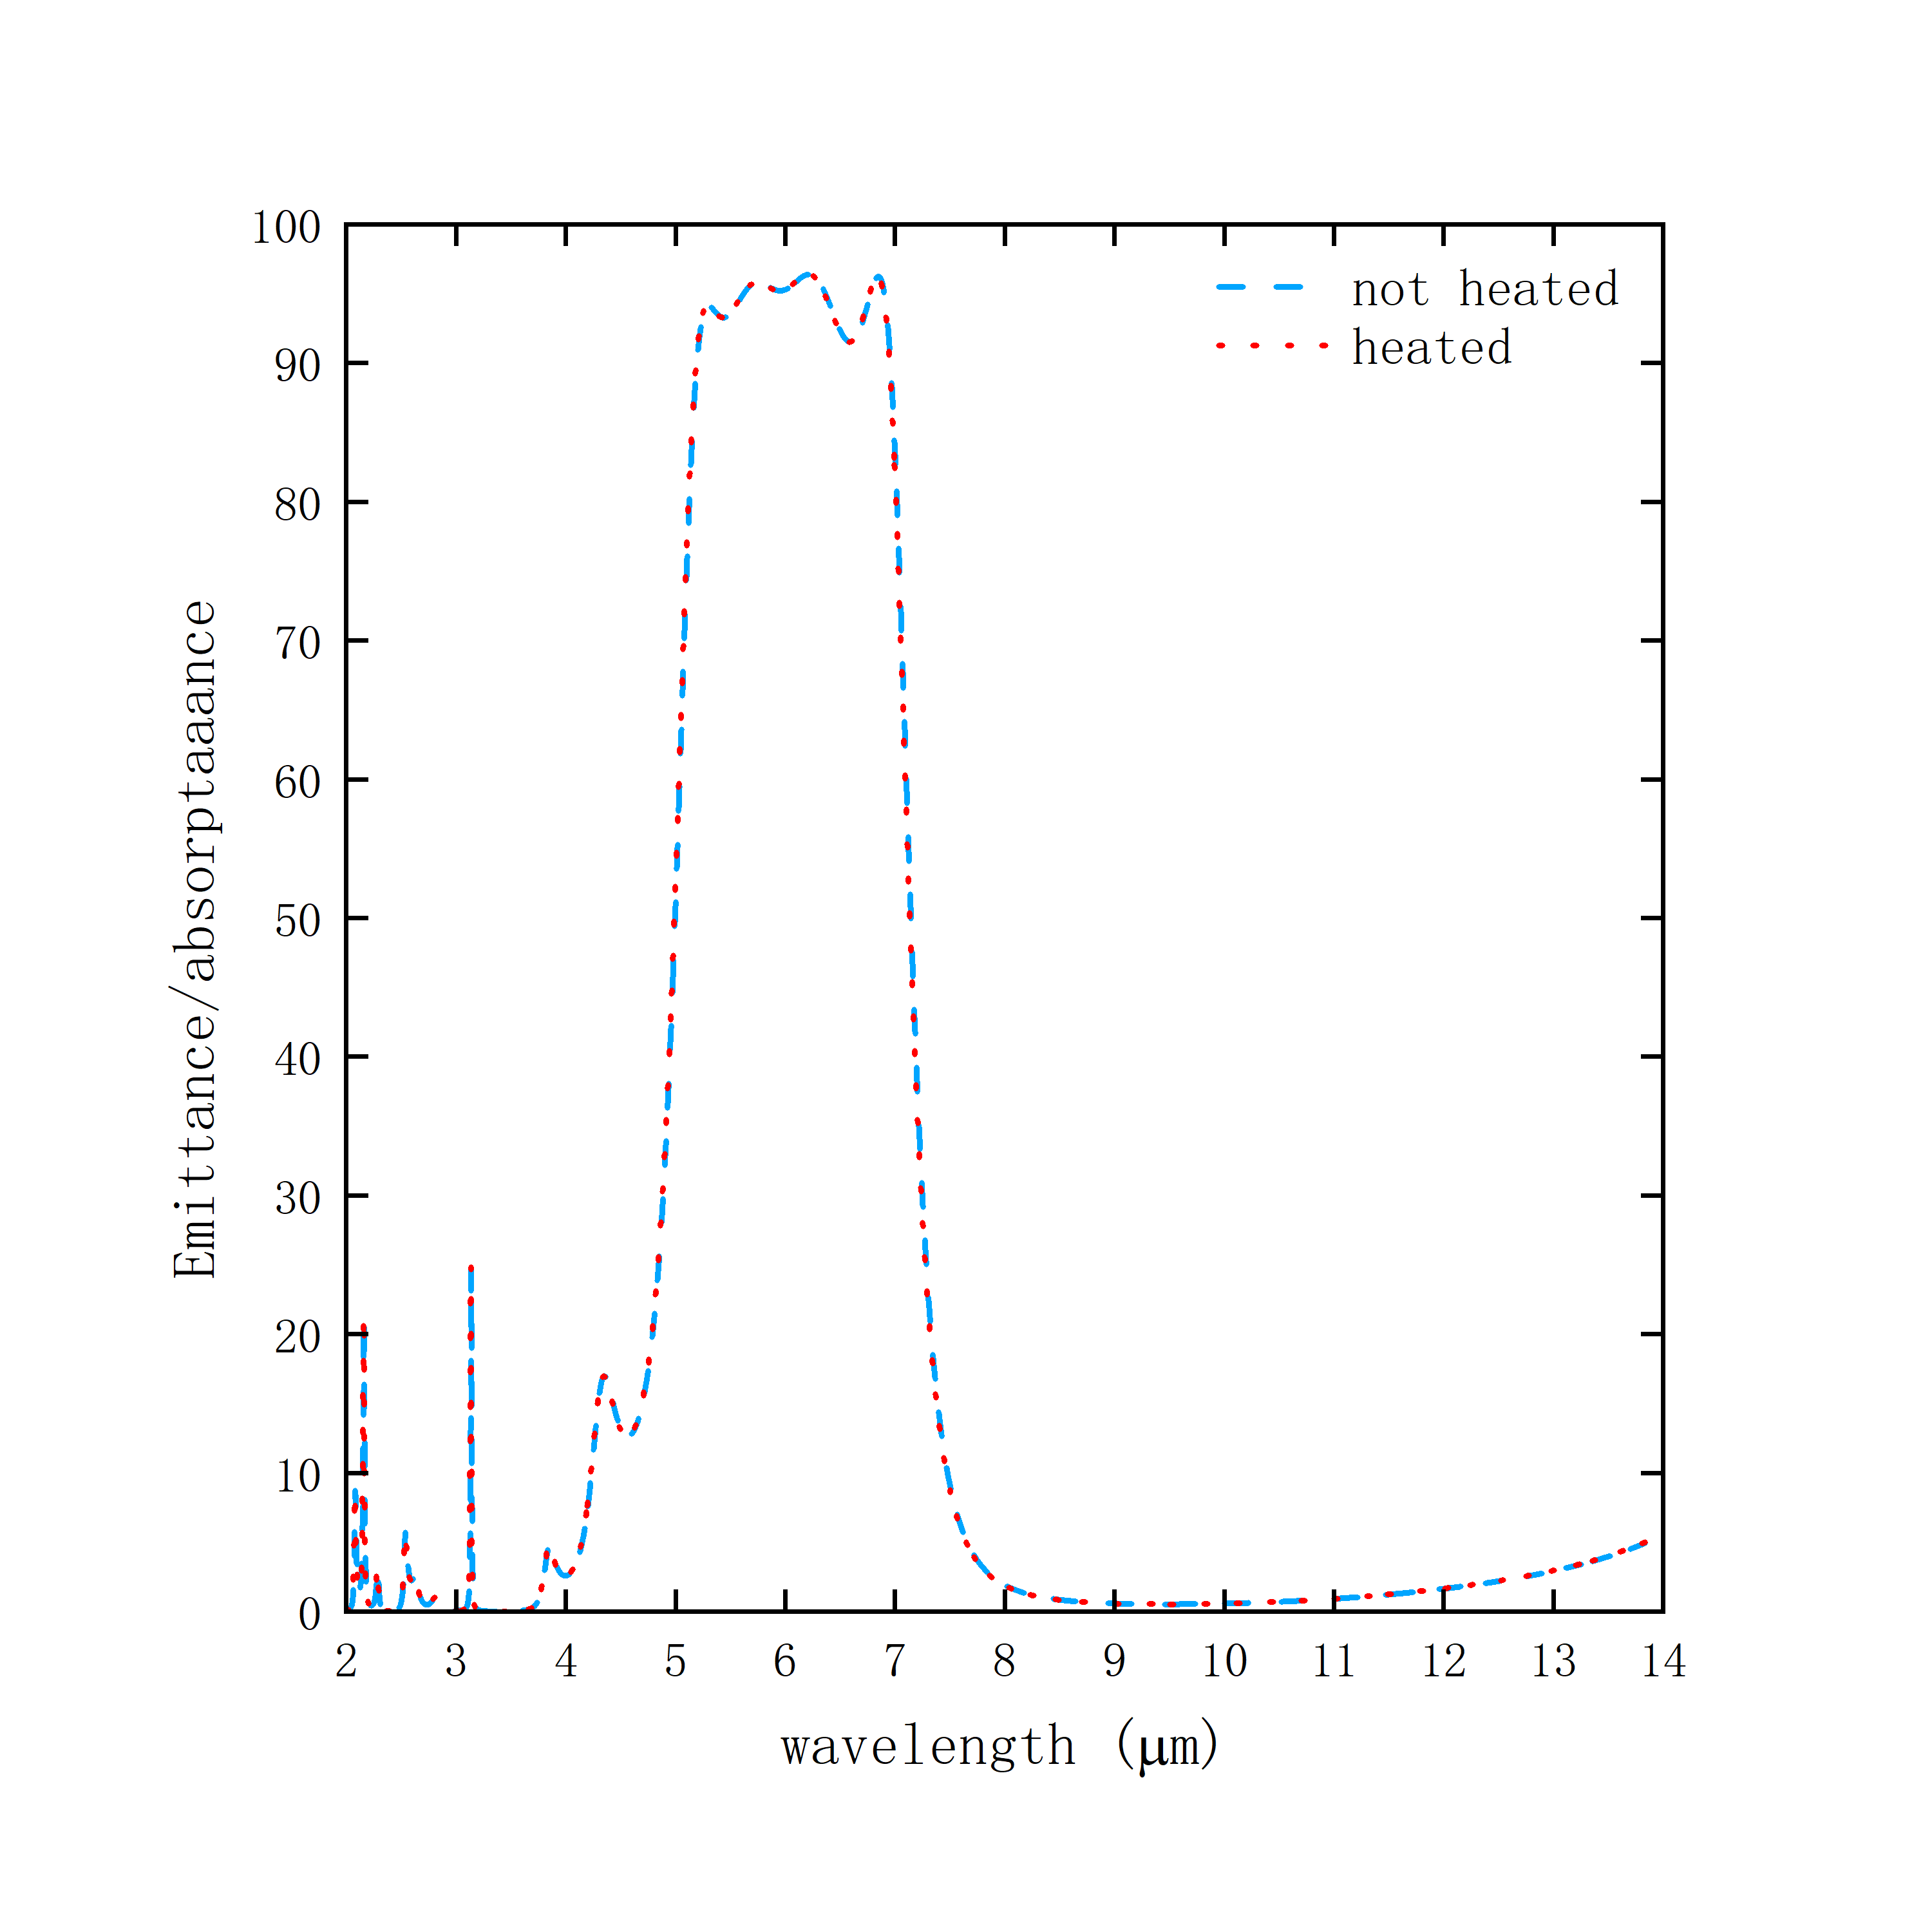
Fig.S4 Emission spectra of $Ge/YbF_{3}$ multilayers before heating (blue dashed line) and after heating at 623 K for 1 h (orange dashed line)
The emission spectra of $Ge/YbF_{3}$ multilayers before heating (blue dashed line) and after heating at 623 K for 1 hour (orange dashed line) are basically the same (Fig. S4), indicating the strong temperature tolerance of the designed multilayer structure. no delamination occurred after heating at 623 K for 1 hour, indicating the strong membrane strength of the designed multilayer structure.

