Figure S1. Estimation of the effects (at 95% confidence level) using the Pareto chart according to the 2²-rotational central composite design for the response variable lignin extracted (%) in the delignification process of the straw and bagasse mixture.
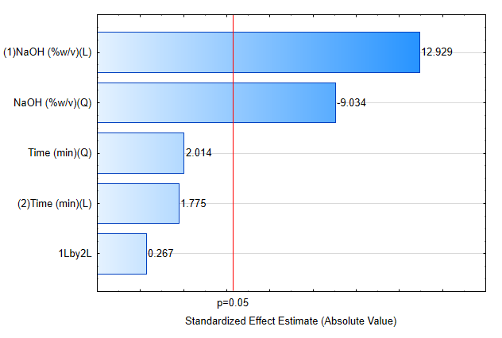
Table S1 - ANOVA for dependent variable lignin extraction (%) for 2²-rotational central composite design for the delignification process of the straw and bagasse mixture.

Factor | SQ | GL | MQ | F | p-value
Regression | 1283.888 | 3 | 427.963 | 8.0338 | 0.01143
Residues | 372.887 | 7 | 53.270
Lack of Fit | 363.452 | 5 | 72.6903 | 15.4094 | 0.062058
Pure error | 9.435 | 2 | 4.7173
Total | 1656.775 | 10
R²=0.77493; R²_{adj} = 0.67847

Figure S2. Response surface that relates lignin extraction (%) to time and NaOH concentration for delignification process of the straw and bagasse mixture.

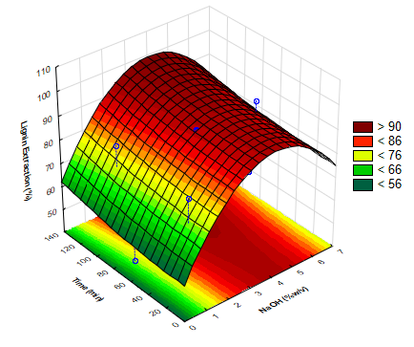

Figure S3. Estimation of the effects (at 95% confidence level) using the Pareto chart according to the 2²-rotational central composite design for the response variable lignin precipitate (g) in the recovery process of lignin using the liquid fraction obtained by delignification process.

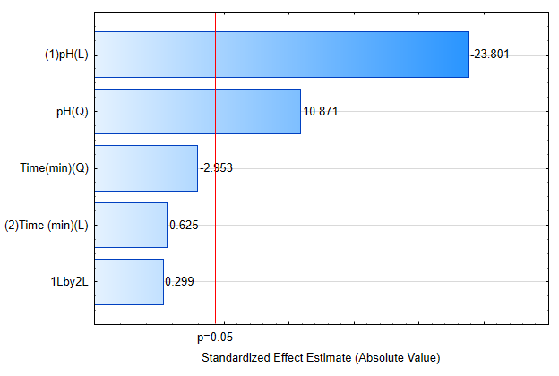
Table S2. ANOVA for dependent variable lignin precipitate (g) for 2²-rotational central composite design for the recovery process of lignin using the liquid fraction obtained by delignification process.

Factor | SQ | GL | MQ | F | p-value
Regression | 0.236276 | 3 | 0.078759 | 19.91727 | 0.00083
Residues | 0.027680 | 7 | 0.003954
Lack of Fit | 0.027028 | 5 | 0.005406 | 16.5741 | 0.057876
Pure error | 0.000652 | 2 | 0.000326
Total | 0.263956 | 10
R²=0.89513; R²_{adj} = 0.85019.

Figure S4. Response surface that relates lignin precipitate (g) to time and pH for the recovery process of lignin using the liquid fraction obtained by delignification process.

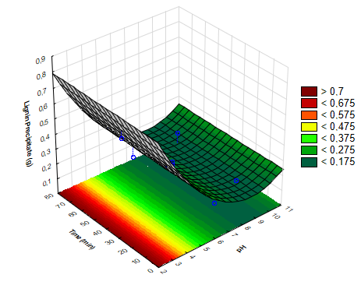

Figure S5. FTIR-ATR of lignin untreated (LIG), carbonized lignin at 600ºC (LIG_{Tc-600}) and sulfonated carbonaceous solids (Tc = 600ºC) with (SCS_{Tc-600}[Adj.]) and without (SCS_{Tc-600}) sulfonation adjustment.
