Supplemental Materials
for
Long-lasting Effects of a Prosocial Counter-Misinformation Intervention in an Informational Autocracy
Content

Study 1 - Fake and real news headlines 2
Pro-government fake news headlines 2
Pro-government real news headlines 4
Anti-government fake news headlines 6
Anti-government real news headlines 8
Politically neutral fake news headlines 10
Politically neutral real news headlines 12
Table S1: Descriptive statistics of fake and real news headlines (Study 1) 14
Figure S1: Media truth discernment as a function of political ideology and political leaning of the headline (Study 1) 15
Study 2 - Fake and real news headlines – immediately post-intervention 16
Fake news headlines 16
Real news headlines 20
Study 2 - Fake and real news headlines – follow-up 24
Fake news headlines 24
Real news headlines 28
Table S2: Descriptive statistics of main variables (Study 2) 32

Study 1 - Fake and real news headlines

Pro-government fake news headlines



Pro-government real news headlines



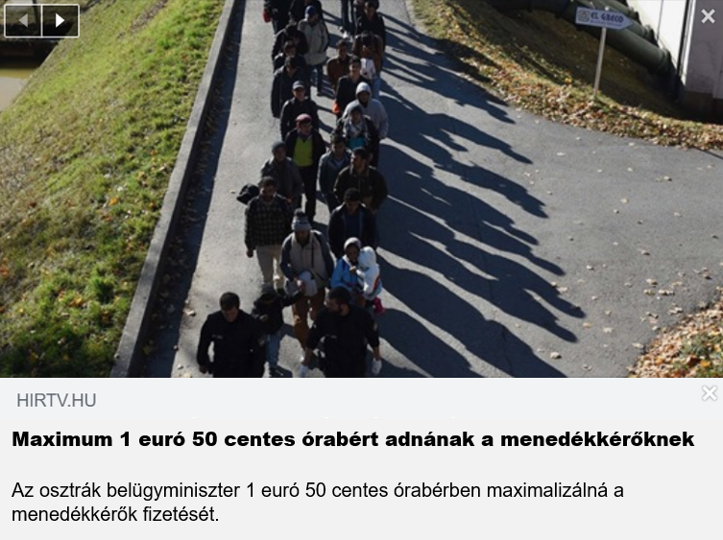

Anti-government fake news headlines


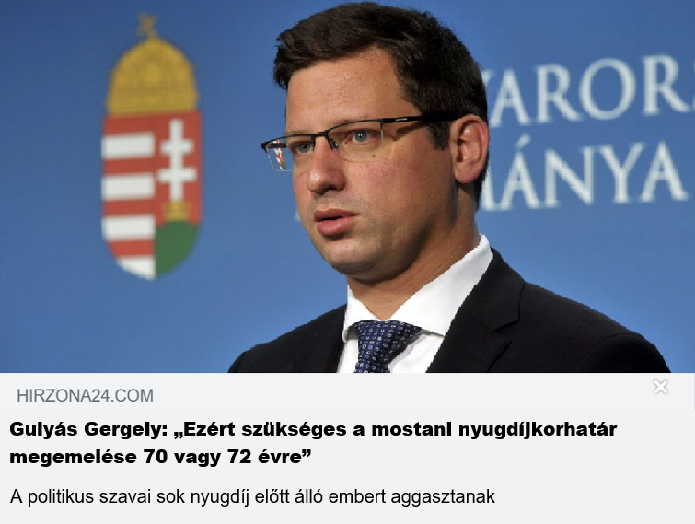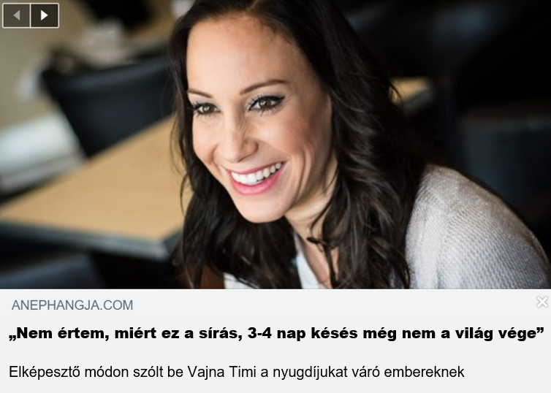

Anti-government real news headlines

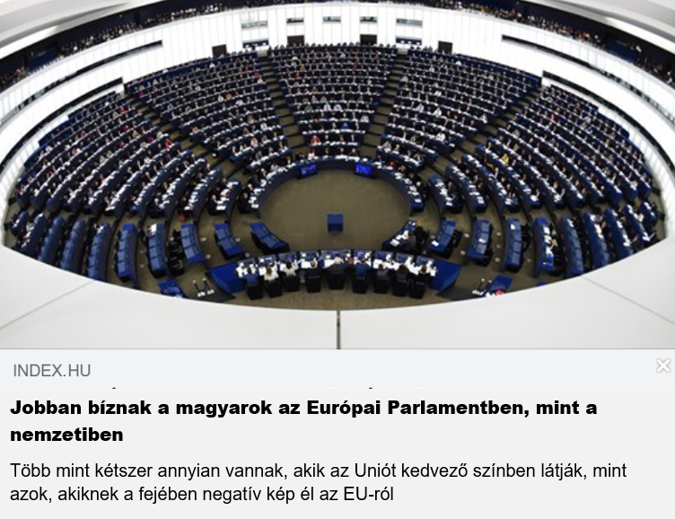


Politically neutral fake news headlines

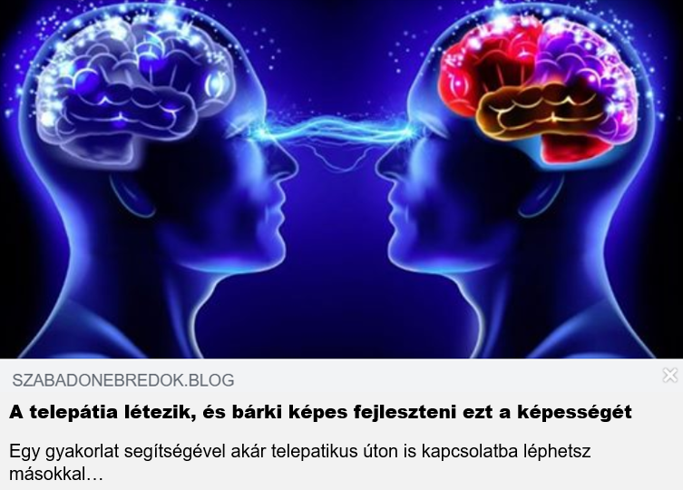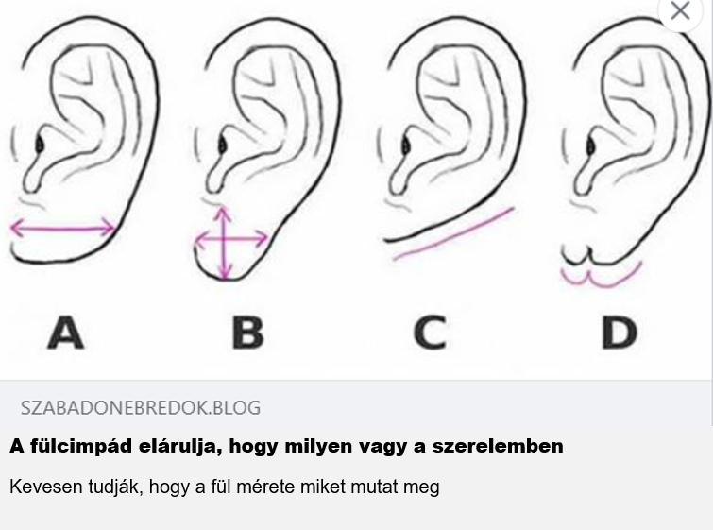



Politically neutral real news headlines




Table S1: Descriptive statistics of fake and real news headlines (Study 1)
 |  | N = 991
 |  | M | SD
 | Accuracy of pro-government fake news | 1.97 | .66
 | Accuracy of pro-government real news | 2.22 | .59
 | Accuracy of anti-government fake news | 2.28 | .63
Accuracy of anti-government real news |  | 2.54 | .70
 | Accuracy of politically neutral fake news | 1.90 | .53
 | Accuracy of politically neutral real news | 2.37 | .56

Note: The acceptance of fake and real news was measured with a scale from 1 (not at all accurate)
to 4 (very accurate), higher means indicate higher perceived accuracy.

Figure S1. Media truth discernment as a function of political ideology and political leaning of the headline (Study 1). Supporters of the opposition were considerably better at discerning fake from real news (irrespective of the type of news) than supporters of the government. Error bars represent 95% CIs.

Notes. High media truth discernment score indicates an increased capacity to distinguish real from fake news. “Government supporters” is rather similar to “Republican voters” in the US context, while “Voters of the opposition” is in analogy with “Democrat voters”.

Study 2 - Fake and real news headlines – immediately post-intervention

Fake news headlines


Real news headlines





Study 2 - Fake and real news headlines – follow-up

Fake news headlines





Real news headlines

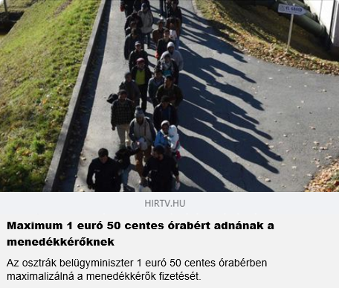
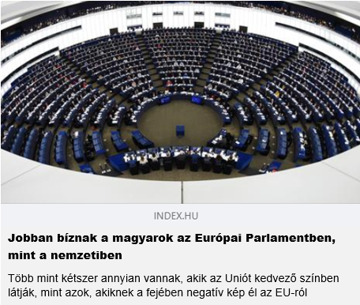




Table S2: Descriptive statistics of main variables – Study 2
 | Intervention |  | Control
 | Raw M | SD | Raw M | SD
Accuracy of fake news – immediately post-intervention | 1.77 | 0.49 | 1.92 | 0.45
Accuracy of real news – immediately post-intervention | 2.51 | 0.45 | 2.51 | 0.41
Accuracy of fake news – follow-up | 1.85 | 0.45 | 1.96 | 0.42
Accuracy of real news – follow-up | 2.53 | 0.48 | 2.47 | 0.47
Bullshit receptivity – pre-intervention | 2.39 | 0.93 | 2.36 | 0.90
Bullshit receptivity – post-intervention | 2.30 | 0.89 | 2.41 | 0.94
Bullshit receptivity – follow-up | 2.12 | 0.87 | 2.28 | 0.87
Cognitive reflection – immediately post-intervention | 3.04 | 1.45 | 3.00 | 1.33
Need for cognition – immediately post-intervention | 4.97 | 1.12 | 4.81 | 0.99
Digital literacy – follow-up | 2.34 | 0.64 | 2.29 | 0.64
Conspiracy mentality – follow-up | 65.20 | 14.70 | 66.96 | 13.86

Note: The acceptance of fake and real news was measured with a scale from 1 (not at all accurate)
to 4 (very accurate), higher means indicate higher perceived accuracy. Bullshit receptivity scales were measured using 5-point Likert scales (1 – not at all profound; 5 – very profound): the higher the mean, the greater bullshit receptivity is. Cognitive reflection items were coded as correct (1) and wrong (0), higher mean represent higher analytical thinking. We used 7-point Likert scales to measure Need for cognition (1 – I don’t agree at all; 7 – I completely agree): the higher the mean, the greater the need for cognition. Answers to the Digital literacy items ranged between 1 (never) and 5 (very often), lower means indicate higher digital literacy. Conspiracy mentality was measured with a scale from 1 (low conspiracy mentality) to 11 (high conspiracy mentality): the higher the mean, the higher the conspiracy mentality is.

