Supplementary Information

Non-Adiabatic Electronic and Vibrational Ring-Opening Dynamics resolved with Attosecond Core-Level Spectroscopy

S. Severino^{1,†}, K.M. Ziems^{2,†}, M. Reduzzi¹, A. Summers¹, H.-W. Sun¹, Y.-H. Chien¹,
S. Gräfe^{2,3,4}, J. Biegert^{1,5,*}

¹ ICFO - Institut de Ciencies Fotoniques, The Barcelona Institute of Science and Technology, 08860 Castelldefels (Barcelona), Spain
² Institute of Physical Chemistry and Max Planck School of Photonics, Friedrich-Schiller-Universität Jena, Germany
³ Fraunhofer Institute for Applied Optics and Precision Engineering, Albert-Einstein-Str. 7, Jena, Germany
⁴ Institute of Applied Physics and Abbe Center of Photonics, Friedrich-Schiller-Universität Jena, Germany
⁵ ICREA, Pg. Lluís Companys 23, 08010 Barcelona, Spain
*Correspondence to: jens.biegert@icfo.eu
†These authors contributed equally

S1 Experimental Setup

X-ray absorption fine structure (XAFS) spectroscopy measurements are performed in a home-built soft X-ray (SXR) beamline in which a Mach-Zehnder interferometer permits attosecond-resolved pump-probe experiments; Suppl. Fig. S1 shows a sketch of the setup. A 380-μJ, 1850-nm (0.7 eV), sub-2-cycle, CEP-stable pulse from a home-built 1-kHz laser system (1) is sent into the beamline. This pulse is split by 70/30 beam splitter (BS) and the low energy portion is directed as pump to the target. The high-energy part is focused into a high-pressure gas target (GT) (2–4), with backing pressures up to 12 bar in Helium.

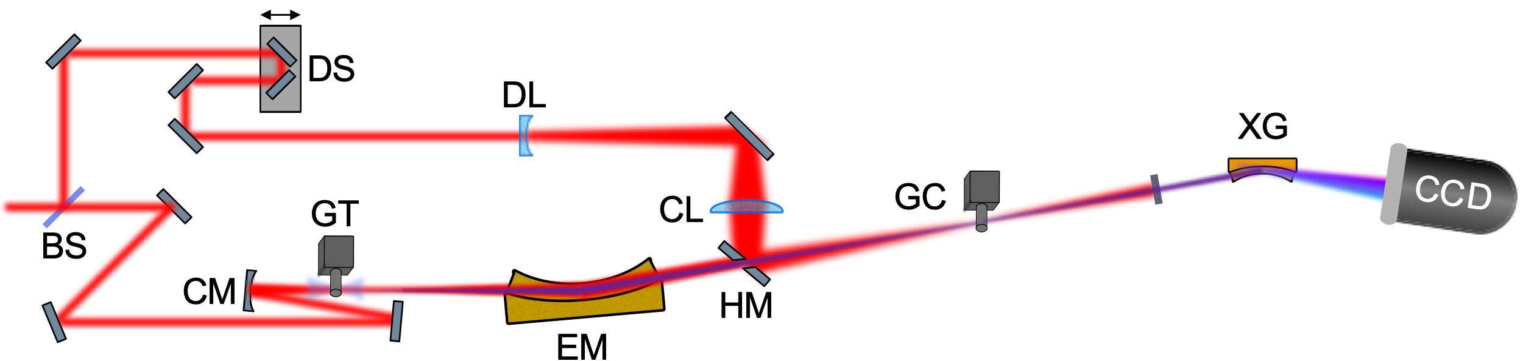
Figure S1. Sketch of the pump-probe scheme in the Attosecond Beamline to study ultrafast carrier and lattice dynamics in graphite. The output of the laser system is separated by a beam-splitter (BS) into a pump and high-harmonic driver with a ratio 30/70. The transmitted beam is focused (CM) into a gas target (GT) filled with Helium to produce isolated attosecond soft X-ray pulses via high harmonic generation which constitute the probe of the experiment. The X-ray are focused by an ellipsoidal mirror (EM) onto the gas cell (GC), being transmitted through a holy mirror (HM). The transmitted X-rays is then dispersed by an X-ray grating (XG) and detected by an X-ray camera (CCD). The reflection of the beam-splitter constitutes the pump arm, synchronized with the probe with a delay stage (DS). The beam is first expanded (DL), then focused with a calcium fluoride lens (CL) onto the GC, where the beam is overlapped in space and time with the probe. The remaining pump light is then blocked by a movable slit (MS) and a second metallic filter (MF) to reduce stray light on the camera.

The conditions for the present experiment were identical to the ones in Ref. (4) for producing an isolated 165-as pulse in the SXR water window with a spectrum from 250 to 500 eV (see Fig S2 a). The emerging SXR pulse is focused onto target with a SXR ellipsoidal mirror (EM) (Carl Zeiss AG) to a focal spot of 15 ± 5 𝜇𝑚 FWHM. The target is a gas sample cell (GC) (4mm long) with 400μm holes to pass the laser beams and through which the vapours of furan (Sigma-Aldrich, concentration >95%) at room temperature exit. After the target, a 100 nm Sn filter (MF) is used to reject the pump light before the SXR radiation is dispersed with a home-built SXR spectrograph, which consists of a flat-field aberration-corrected and reflecting concave grating (2400 lines/mm; Hitachi High Technologies America, Inc.) and a cooled, back-illuminated CCD (PIXIS-XO; Princeton Instruments); the resolution of the spectrograph is 0.3 eV at the Carbon K-edge at 284 eV. The pump-probe delay is controlled via a closed-loop delay stage (Smaract GmbH) and the pump beam is recombined with the SXR one with a holey mirror (HM) before the target. In order to achieve high intensity, the pump beam is focused with a combination of a diverging (f = -300 mm) and a focusing (f = 300 mm) lenses, respectively DL and FL, at a relative distance of 40 cm. This ensures a large beam size on the holey mirror that allows to reduce losses and a focal spot of 50 ± 1 𝜇𝑚 FWHM. This is almost three times larger than the probe spot size, which ensures probing a homogeneously pumped region of the sample by the much smaller SXR beam. A pump pulse duration of 17 fs was retrieved from a second-.order-harmonic frequency-resolved optical gating (FROG) measurement (see Fig S2 c). The estimated pump intensity at the focus is estimated to be $9.6±2×{10}^{13} W/{cm}^{2}$.

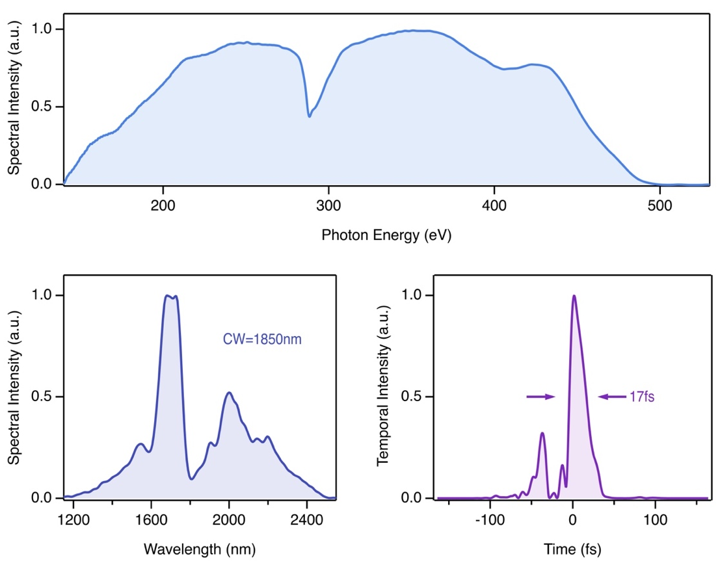
(a)
(c)
(b)
Figure S2. Spectral and temporal characterization of the pump and probe pulses. (a) the spectrally resolved SXR attosecond pulse. (b): measured spectral profile of the 1.85 μm pump. (c) Reconstructed temporal profiles from second-harmonic frequency resolved optical gating (SH-FROG) measurements of the 1.85 μm pump.

S2 Data acquisition

The data acquisition protocol consists of a collection of series of spectra with different combinations of pump and probe beams on the sample. Shutters along the probe and the pump paths are synchronized with the CCD camera and were used to alternate in a sequence of 55 spectra of 15 seconds integration for the pump plus probe (Ipp), 55 spectra of 15 s integration for the probe (I₀) and 10 spectra of 15 s for the pump (Ip) case. This scheme allows to minimize the shot-to-shot noise of the SXR beam; the pump-only acquisition enables the correct background subtraction of the Ipp spectra. Each delay step resulted in 35 min of measurement time. To account for possible slow drifts in the SXR flux, we normalise each background corrected pump plus probe spectrum to the corresponding I₀ on two energy regions, one before the carbon K-edge (260-280 eV) and one after (300-320 eV), both being far enough from the edge such that no pump induced effect are present. Finally, the contributions of each delay step are summed together and the resulting spectra, $\overline{Ipp}$ and $\overline{I0}$, are then used to build the differential absorption as $∆A=-ln\left(\frac{\overline{Ipp}}{\overline{I0}}\right)$.
In the first part of the measurement (-45 fs : 115 fs), we used a pump-probe delay step size of 2.5 fs to catch all the details of the first part of the dynamic; afterwards the step size has been increased first to 5 fs (115 fs : 180 fs) and then to 20 fs (180 fs : 380 fs) in order to capture the long timescales dynamics. In Fig S3 we show the complete data set.

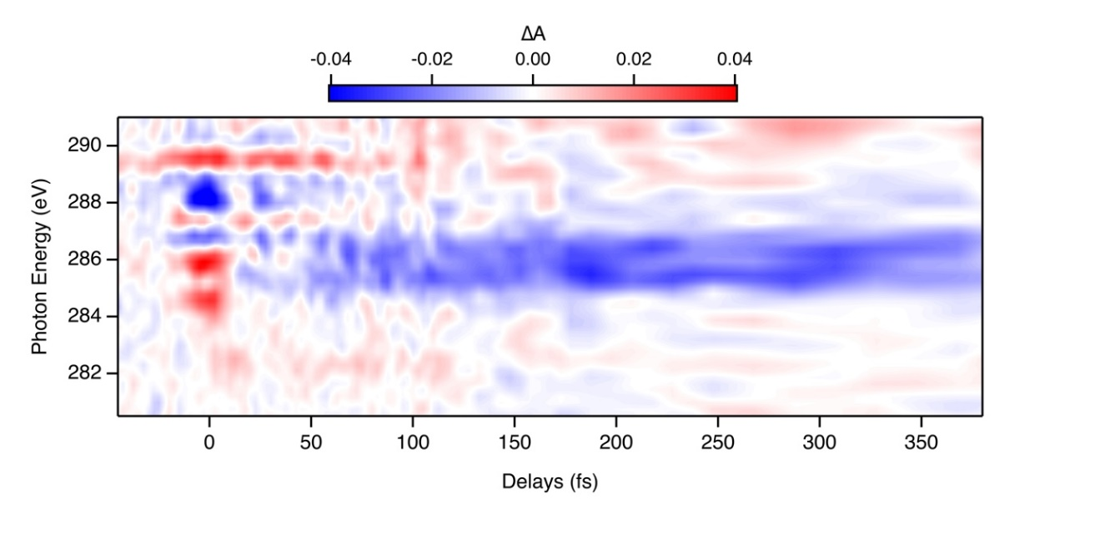
Figure S3. Time-dependent AttoXAFS measurement in furan. Experimentally retrieved DA trace. Positive delay indicates that pump pulse proceeded the probe one.

S3 Global Fit

The differential attosecond-resolved XANES measurement (main paper in Fig2a) can be modelled to extract the rich dynamics in more details according to the following:

$$\overline{A}\left(E,τ \right)= \sum_{i=1}^{3}{A_{i}\left(E\right)f_{i}(τ)}.$$

Where $f_{i}\left(τ\right)$ is the convolution between a Gaussian and an exponential decay function:
$$f_{i}\left(τ\right)= {\frac{1}{γ_{i}\sqrt{2π}}e}^{-{\frac{1}{2}\left(\frac{τ-τ_{0i}}{γ_{i}}\right)}^{2}}⋇e^{-\frac{τ-τ_{0i}}{τ_{i}}}.$$

The number of independent spectral amplitudes was set to three to differentiate features of the overlap region, rich dynamics, and long lasting contributions.. The free parameters used in the fit are $A_{i}\left(E\right)$, along with the width, $γ_{i}$, and the center, $τ_{i}^{0}$, of the Gaussian function and the characteristic exponential decay time, $τ_{i}$. In Fig. S4 and Tab. S1, we show the results of the fit done following a least square fitting procedure. We can see how they reproduce the main characteristics of the data. The three independent components have very distinct temporal behavior: $f_{1}$ is present just at the pump-probe overlap, it is symmetric in its rise and decay and it has a FWHM that is comparable with the one of the pump pulse (see Fig. S2c); its spectral amplitude, $A_{1}$, has strong positive contribution at 284.5 eV and 286 eV. $f_{2}$ lasts till roughly 100 fs. Finally, $f_{3}$ peaks at later times but does not decay and its amplitude has strong negative contribution between 285 eV and 287 eV and a positive contribution at 282.5 eV. In Figure S5 we show the comparison between the $∆A$ trace and the one obtained as sub$∆A= ∆A - {(A}_{1}f_{1}+A_{3}f_{3})$, which we will refer to as sub$∆A$. This corresponds to the differential attosecond-resolved XANES measurement subtracted by the overlap and long-lasting features that can obscure the extracting of the rich dynamics. Thus, in the sub$∆A$ the fast dynamics around the pump-probe overlap and the long-lasting signal are not present, while the dynamics between 15 fs and 150 fs are highlighted, such as the oscillations and energy shifts.
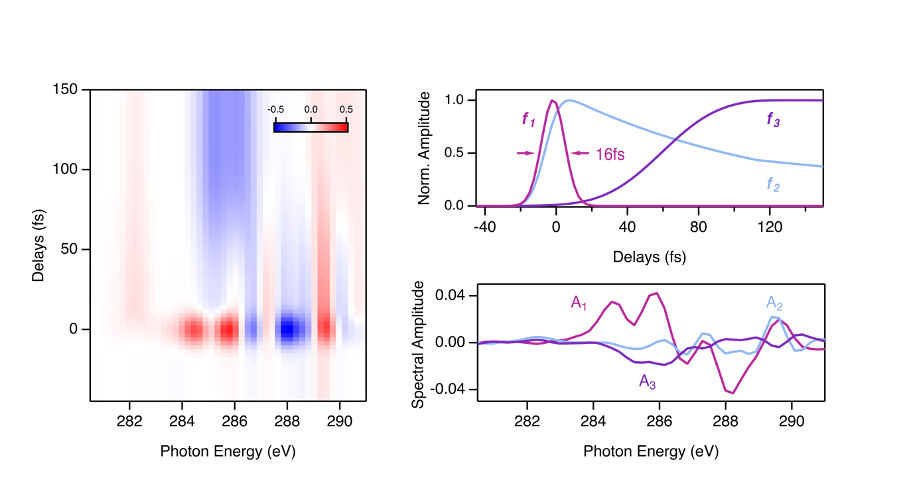
(a)
(b)
(c)
Figure S4: Results of the global fit described in the text. (a): the 2D fit result; (b): time dependence of the f_{i}; (c): spectral amplitude A_{i}.

Table S1: parameters obtained from the global fit described in the text.

 | $τ_{0i}$ (fs) | $γ_{i}$ (fs) | $τ_{i}$ (fs)
i = 1 | -1.7 | 6.7 | 0.1
i = 2 | -3.2 | 25.1 | 69.9
i = 3 | 52.2 | 10 | 6165697

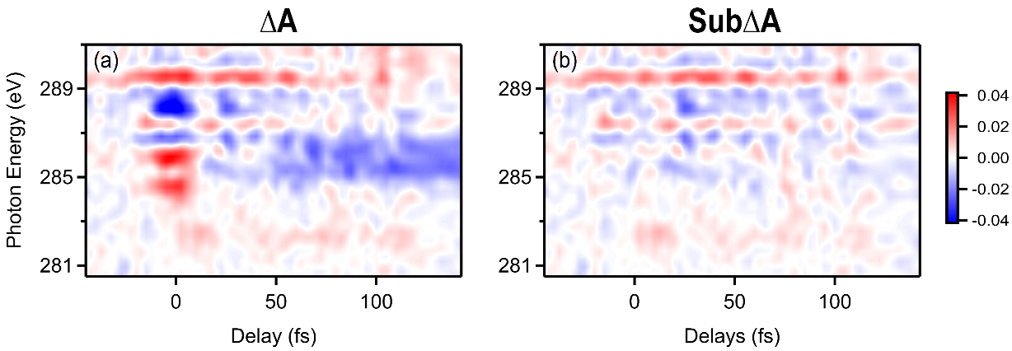
Figure S5: Comparison between the ΔA (a) and the subΔA (b) traces. The subΔA has been obtained removing (A₁f₁) and (A₃,f₃) from the ΔA. More details in the text.

S4 Static Absorption of Furan

Despite many previous studies, a complete and consistent characterization of the XAFS spectrum of furan has remained elusive. Here, through a combination of experiment and theory, we provide an exhaustive interpretation of its main features at the carbon K-edge. Figure S6 shows the measured ground state absorption spectrum of furan and its comparison with simulations. The comparison between the measured and simulated ground state absorption spectrum of furan at the carbon K-edge allows us to provide an assignment of its main spectroscopic features. At the ground state equilibrium, furan has a planar geometry with a C_{2v} symmetry (see inset of Fig. S6), with two identical carbon atoms bonded to each other, C₁, and two bonded to the oxygen, C₂. XAFS calculations show that C₁ and C₂ generate distinct contributions to the soft X-ray Absorption Spectrum (XAS). The first two features of the GS spectrum correspond to the transitions to the Lowest Unoccupied Molecular Orbital (LUMO) with π* electronic configuration from, respectively, C₁ and C₂ 1s core orbital, 1s_{C1}→π*(LUMO) and 1s_{C2}→π*(LUMO). The shoulder peak at 287.2 eV is assigned a 1s_{C1}→3s Rydberg state excitation. The higher energy features at 288.0 eV and 289.3 eV are primarily comprised of 1s→π*(higher order) transitions, respectively from C₁ and C₂, mixed with excitations to Rydberg states. Finally, the feature at 292 eV is largely 1s_{C1} excitation into different σ* orbitals.
Interestingly, our XAFS calculations allow us to attribute the presence of a resonance to a Rydberg state at 287.2 eV from C₁ that has never been identified before. The assignment of this feature has been a primary area of ambiguity to date. In fact, while Newbury et al. did not resolve it (5), E.E. Rennie et al. show it but did not interpret it (6).

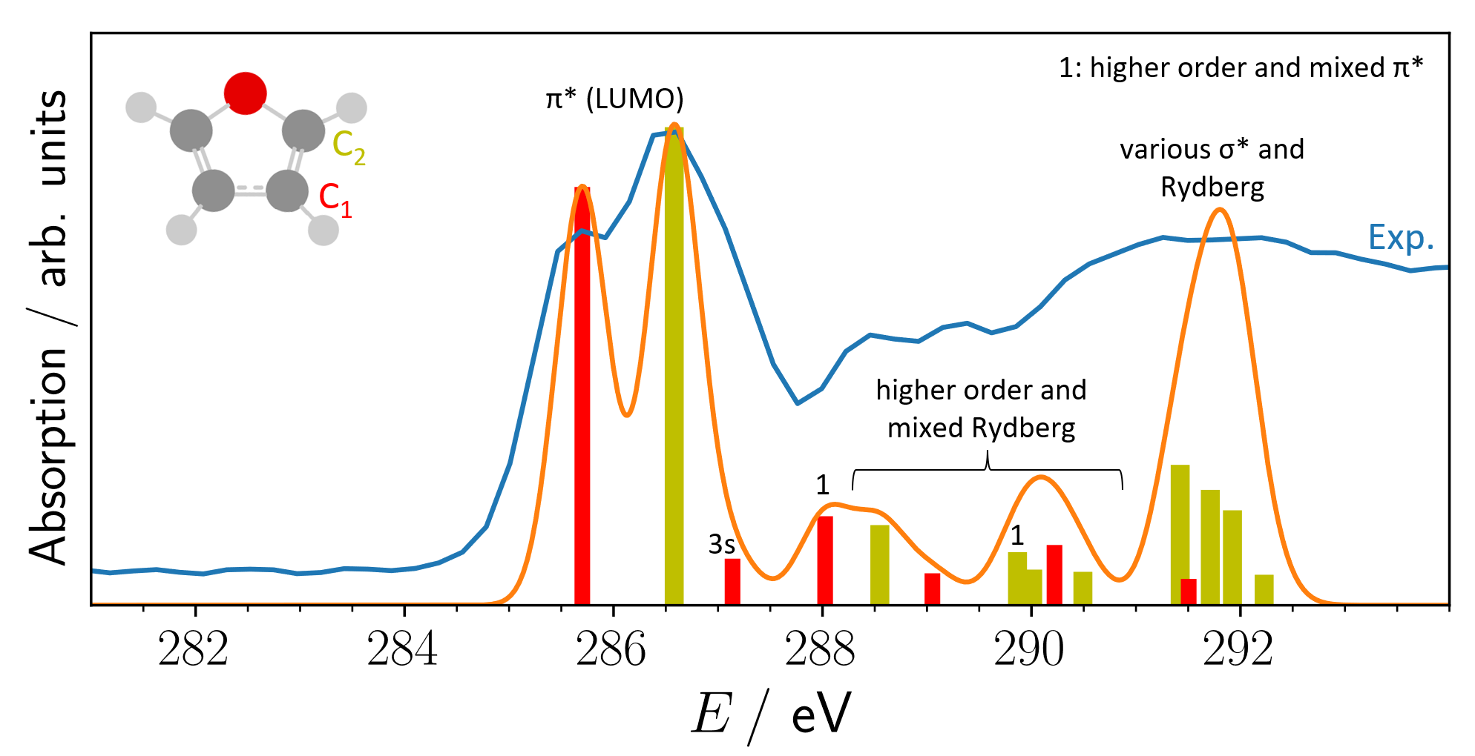
Figure S6: XAS of electronic GS (S₀) at FC region: Excitation bars, Gaussian -smoothed spectra (orange line), and experimental comparison (blue line). Excitations from different carbons are color-coded and indicated in the inset on the top left.

S5 Rise and decay of the ππ* signature

According to the simulations, in the first 60 fs of the relaxation dynamics the ππ* electronic state is expected to be the most populated one before passing a CI that leads to population of the πσ* state. This is confirmed in the experimental data: Figure S7b shows that both the $∆A$ and the sub$∆A$ match with the simulated ππ* $∆A$ spectrum in the temporal region (15 fs : 60 fs). At the overlap (-15 fs : 15 fs) the $∆A$ deviates from simulated spectra because of the strong-field effect (Fig. S7a). This overlap feature can be removed using our global fit approach discussed in S3 and shows perfect agreement with the (15 fs : 60 fs) region. This confirms the theoretical prediction of ππ* population in the first 60 fs. Fitting the temporal evolution of the characteristic XAFS features of this state we find further experimental confirmation: Figure S8 shows the peak at 289.5 eV as function of pump-probe delay, superimposed to the fit result obtained using the convolution of a Gaussian and a decay exponential function. The free parameters used are the width, γ, the center of the Gaussian function, τ₀, and the characteristic exponential decay time, τ. It reaches its maximum value at zero delay and decays in 65 ± 10 fs, in good accordance with the theory predictions.
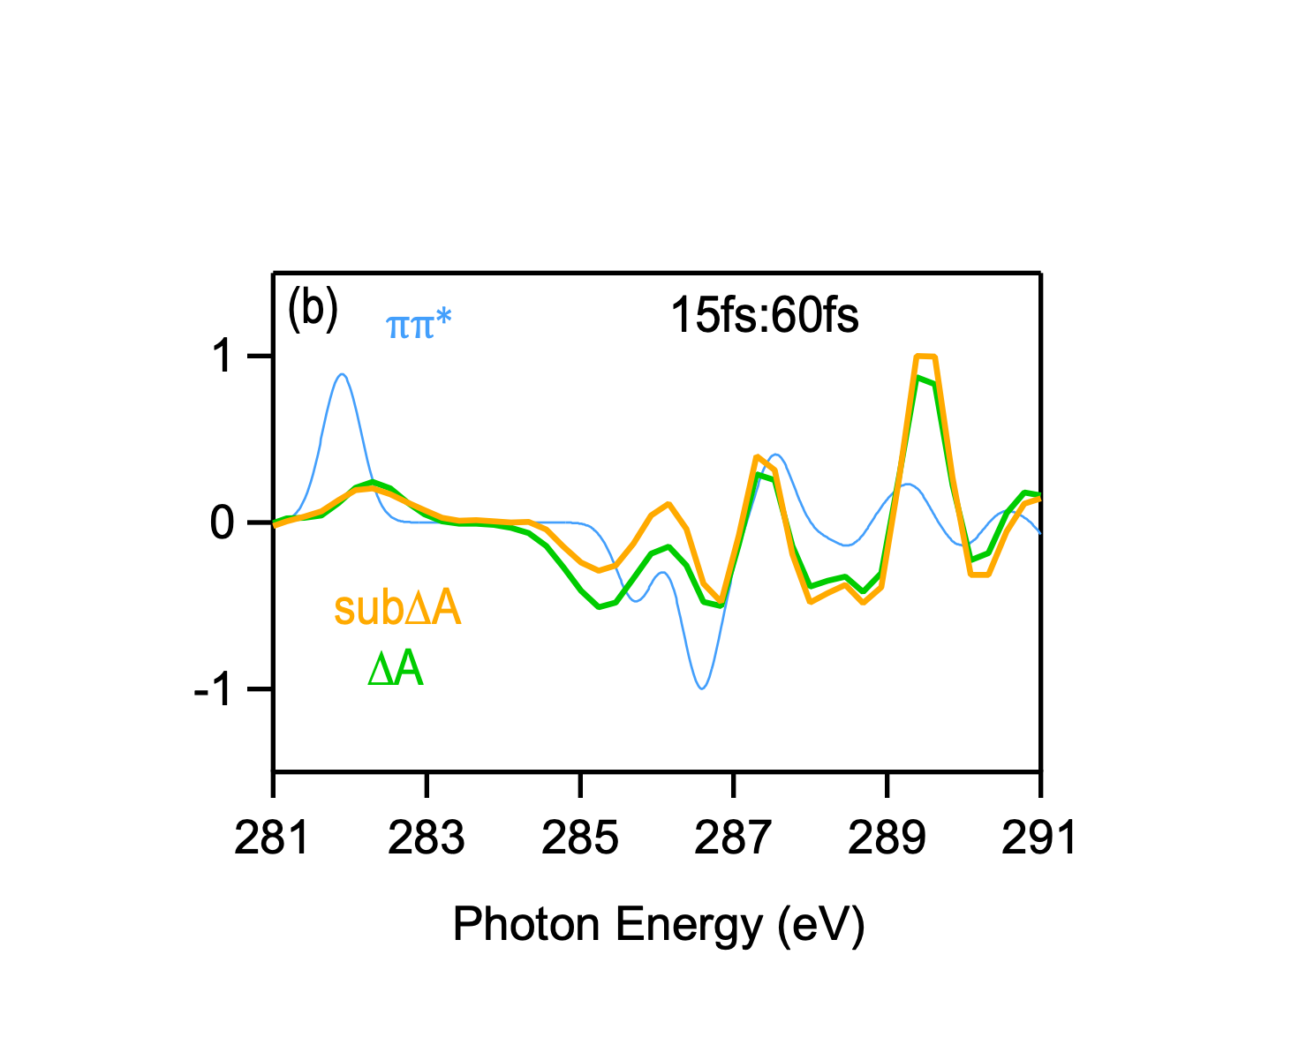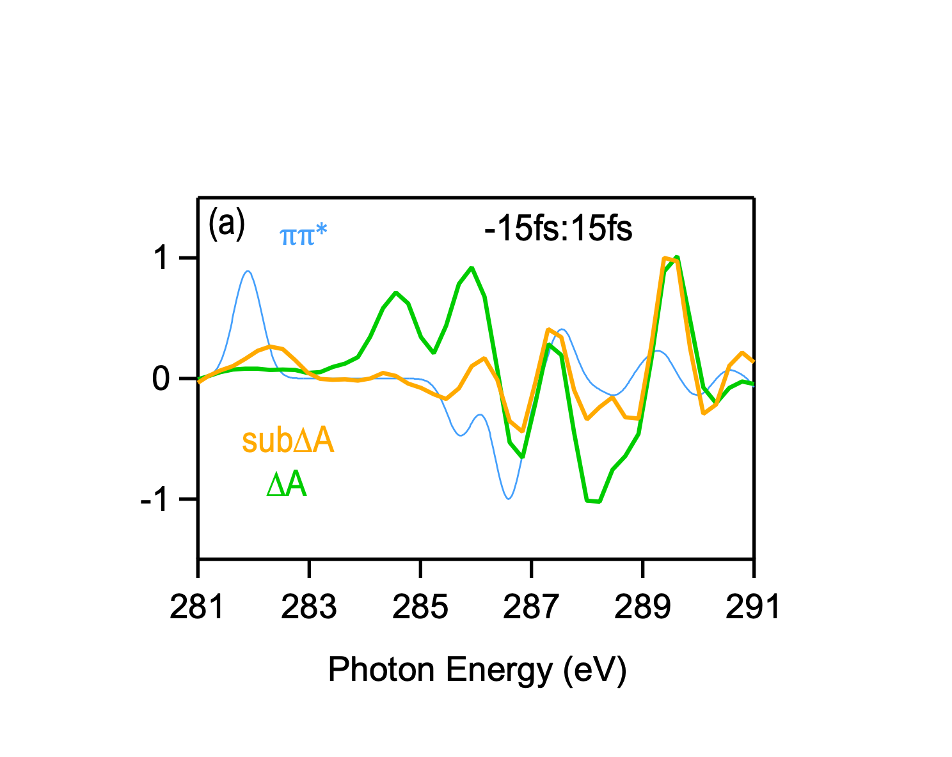
Figure S7: Comparison of the $∆A$ and the sub$∆A$ with the simulated ππ* $∆A$ spectrum in the time window -15 : 15 fs (a) and 15 : 60 fs (b). The comparison shows that the first 60 fs the dynamics is dominated by the ππ* electronic state dynamics.

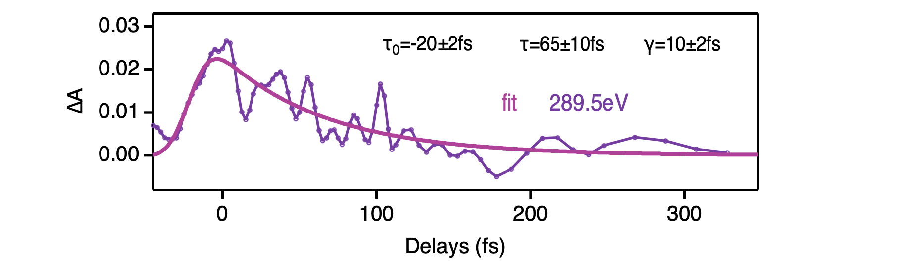
Figure S8: Temporal behavior of the energy pixel 289.5eV and its fitting result. Details of the fitting procedure in the text.

S6 One-dimensional potential energy curves

The one-dimensional potential energy surface displayed in Figure 1a of the text was obtained by linear interpolation between the optimised nuclear ground state (GS) of furan and the optimized ring-opening conical intersection (ROCI) and ring-puckering conical interaction (RPCI), respectively. The structures were obtained from (7) and the linear interpolation was done in internal redundant coordinates using (8). The electronic ground and excited states calculations were performed with the Gaussian 16 program (9) using (time-dependent) density functional theory (TD-DFT), the hybrid functional PBE0 (10, 11) and the valence triple-zeta basis set with diffuse and polarisation functions, 6-311++G(d,p) (12, 13). The obtained PES is in very good agreement with the PES in (7) using CCSD/6-311+G*+sp and MS-CASPT2(8,7)/6-311G* level of theory and, thus, confirms the validity of our theory setup for use in the subsequent semi-classical dynamics.

S7 X-ray absorption spectra

X-ray absorption spectra (XAS) were calculated at various nuclear geometries and in different electronic states. For calculations in the electronic GS, we employed equation of motion coupled cluster theory including singles and doubles (EOM-CCSD) (14, 15), while for electronic excited reference calculations we employed the core-valence-separation scheme (16) in the frozen-core equation of motion model for electronically excited states on the coupled cluster singles and doubles level of theory (fc-CVS-EOM-EE-CCSD) (17, 18). Both methods utilized the aug-cc-pVDZ basis set (19, 20) and were performed with QChem 5.3 (21). Depending on convergence and symmetry of the structure 50-120 roots were calculated.

S8 Semi-classical dynamics

For the nonadiabatic excited-state dynamics, the semi-classical program package SHARC 2.1 (22, 23) was interfaced with Gaussian using the functional and basis set described above (PBE0/6-311++g(d,p)) to calculate solutions to the time-independent electronic Schrödinger equation on-the-fly.
The initial nuclear ground state equilibrium structure was obtained using the same quantum chemical method and a subsequent vibrational analysis was carried out to verify that we obtained a minimum on the potential energy surface. To simulate the ground state nuclear wave packet, we applied a Wigner sampling at the Franck-Condon (FC) region using the harmonic GS frequencies Boltzmann weighted at 300K (24, 25). Using the delta peak assumption for the absorption, an initial 200 trajectories were started in the bright ππ* (S₂ in the FC region) state. The classic trajectories were propagated in for 750 fs with a time step of 0.5 fs, while the electrons states were treated in the diagonal representation with 25 steps for the electronic integration. Frustrated hops were reflected along the gradient difference vector and an energy-based decoherence scheme was applied. Hops to the electronic GS were forced by energy difference as explicit hops to the GS are not possible in a TD-DFT approach. The parameters of the semi-classical dynamics were studied thoroughly to ensure converged results. To this end, several calculations changing a single parameter were conducted, such as using a time step of 0.1 fs, no reflection of frustrated hops, augmented fewest-switching surface hopping decoherence, surface hopping in the molecular Coulomb Hamiltonian representation, and changing the TD-DFT parameters (B3LYP functional and aug-cc-pvdz basis set). None of these parameter changes exhibited significant change in the dynamics presented in the manuscript. Moreover, the influence of the pump pulse on the dynamics was analyzed by means of including the pump pulse in various polarization directions as off-diagonal element of the electronic Hamiltonian during propagation. No significant alternation of the RO dynamics was observed. Additionally, the pump pulse influence on the initial equilibrium wave packet was studied and did not lead to a significant alternation of the dynamics either.

S9 Energy levels at Franck-Condon region

The calculated energy level of the first excited states of furan and their corresponding oscillator strengths at the FC region allows us to identify the valence transitions relevant for the strong-field pump and assign the XAFS feature at the time-overlap and are shown in Tab. S2. The lowest state, S₁, corresponds to a Rydberg state with π3s electronic configuration, and is optically dark. S₂ (π→π* excitation) and S₃ (π→3p_{x} excitation) are energetically very close and have both non-zero probability to be optically excited, with a clear preference for a S₂ excitation. The RO relevant πσ* state is optically and energetically inaccessible at the FC region (26).

Table S2 Calculated electronic transitions, vertical excitation energies (ΔE) and oscillator strengths (f) of the first three excited state of furan at the FC region.

 | Transition | $$ΔE(eV)$$ | $$f$$
S₁ | π→3s | 5.87 | 0.00
S₂ | π→π* | 6.2 | 0.17
S₃ | π→3p | 6.37 | 0.03

S10 Trajectory analysis

The trajectories were categorized as ring-opening (RO) and ring-puckering (RP) based on their geometry at the time of the electronic GS hop. For an initial set of 150 trajectories, we found 97 RO and 29 RP trajectories. RO and RP exhibit very similar time scales as shown in Fig. S9. The combined dynamics are shown in the main text in Fig. 4a.

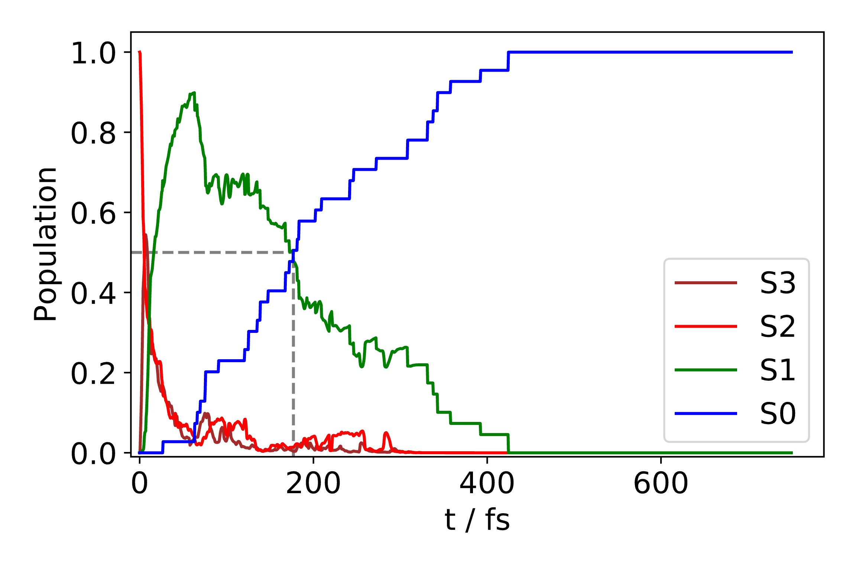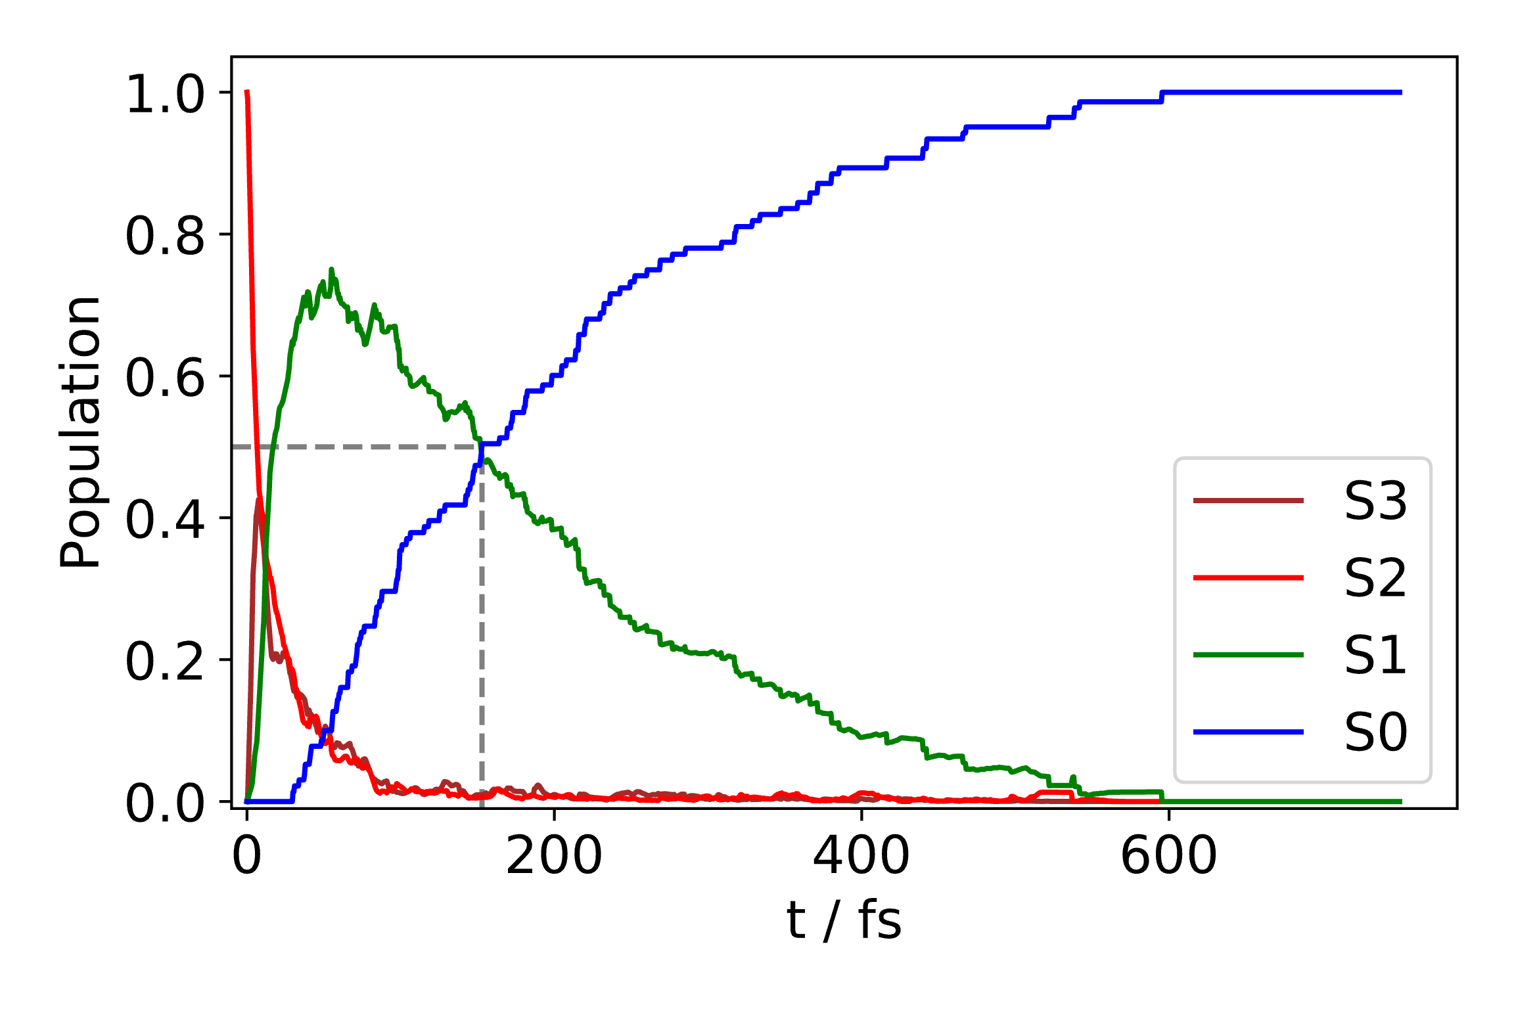
Figure S9: Population dynamics of RO (left) and RP (right) trajectories.
To obtain the average, time-resolved potential energy landscape during the non-adiabatic relaxation dynamics leading to either RO or RP, we construct the nuclear wave packet, or rather its time-dependent mean position, in the electronic excited state manifold for each of the two relaxation pathways. This is done as a post-processing of the semi-classical dynamics. To this end, we take, respectively, all RO and RP trajectories at a given time, average the structure over all trajectories, and calculate the time-resolved potential energy landscape using the quantum chemical method of the semi-classical dynamics. Note that to obtain the average structure along the RO or RP pathway at a given time the individual structures of each trajectory have to be matched and aligned in coordinate space due to the symmetry of the relaxation pathways, e.g., RO can occur by cleavage of either of the two symmetric CO bonds. This has been done using coordinate space analysis and the Hungarian method to align the molecules (27, 28). The time-dependent potential energy landscape along RO and RP pathway have been used to calculate the time-dependent energy gaps along either relaxation (see Fig. 4b in the manuscript) and, subsequently, to estimate the electronic coherence as described in the manuscript. The vibrational dynamics are investigated via normal mode analysis. Here, the harmonic normal modes of the nuclear and electronic GS are used as basis for analyzing the structural dynamics of the excited state trajectories along the RO and RP relaxation pathway. The coherent motion in each mode is judged by means of the standard deviation over time of the average trajectory and is displayed in Fig. 4d (29, 30).

S11 Symmetry breaking along ring-opening

Furan’s structure is of C_{2v} symmetry at the FC region with two distinct Carbon atoms, while it is of C_{s} symmetry at the ROCI with four distinct carbon atoms. Thus, going from the FC region to the ROCI during the RO pathway leads to a symmetry breaking. This is imprinted on the XAS by means of splitting of the SOMO peak. As discussed in the text, the SOMO peak at the FC region appears as the electronic state changes from the electronic ground to the ππ* state and constitutes two distinct transitions from the C₁ and C₂ 1s core orbital. The two different XAS at the FC region are shown in Fig. S10 in orange (GS) and green (ππ*). The SOMO peak and its two transitions are indicated as a light green and red bar referring to a 1s core transition from C₂ and C₁, respectively. The C₁ and C₂ is labelled on the right in the molecule inset. At the ROCI all four carbon atoms are unique leading to a splitting of the SOMO in the electronic S₁ state into four contributions as indicated in Figure S10 with the dashed arrows. The number under the peaks of the S₁ ROCI XAS (purple) refer to the SOMO peak originating from the four different carbon atoms. The labelling is indicated in the ROCI structure on the right. The peak at 284.5 eV, i.e., C₂ 1s -> SOMO(π), is a unique spectral feature in the experiment, not overlapping with any other XAS. In brown the electronic ground state XAS at ROCI is shown. The π orbital is fully occupied, i.e., the HOMO, and cannot be populated in the XAS anymore. The lowest transition corresponds to 1s -> σ*(LUMO).

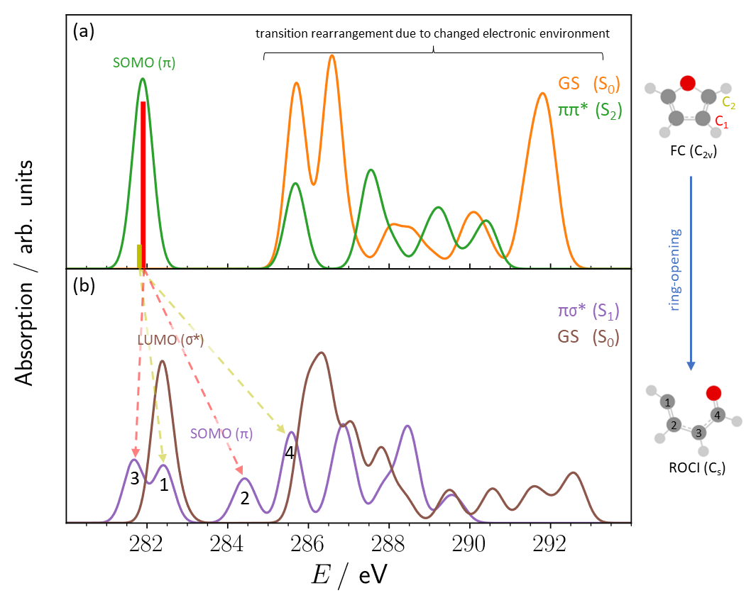
Figure S10: XAS for different electronic configurations at (a) FC region and (b) ROCI geometry. Arrows indicate how SOMO peak splits due to symmetry breaking.

Literature

1. S. L. Cousin et al., High-flux table-top soft x-ray source driven by sub-2-cycle, CEP stable, 1.85-µm 1-kHz pulses for carbon K-edge spectroscopy. Opt. Lett., OL. 39, 5383–5386 (2014).
2. F. Silva et al., Spatiotemporal isolation of attosecond soft X-ray pulses in the water window. Nat Commun. 6, 6611 (2015).
3. S. M. Teichmann et al., 0.5-keV Soft X-ray attosecond continua. Nat Commun. 7, 11493 (2016).
4. S. L. Cousin et al., Attosecond Streaking in the Water Window: A New Regime of Attosecond Pulse Characterization. Phys. Rev. X. 7, 041030 (2017).
5. D. C. Newbury, I. Ishii, A. P. Hitchcock, Inner shell electron-energy loss spectroscopy of some heterocyclic molecules. Can. J. Chem. 64, 1145–1155 (1986).
6. E. E. Rennie et al., A core-level photoionization study of furan. The Journal of Chemical Physics. 117, 6524–6532 (2002).
7. M. Stenrup, Å. Larson, A computational study of radiationless deactivation mechanisms of furan. Chemical Physics. 379, 6–12 (2011).
8. J. Steinmetzer, S. Kupfer, S. Gräfe, pysisyphus: Exploring potential energy surfaces in ground and excited states. International Journal of Quantum Chemistry. 121, e26390 (2021).
9. M. J. Frisch et al., Gaussian 16 Rev. C.01 (2016).
10. C. Adamo, V. Barone, Toward reliable density functional methods without adjustable parameters: The PBE0 model. J. Chem. Phys. 110, 6158–6170 (1999).
11. M. Ernzerhof, G. E. Scuseria, Assessment of the Perdew–Burke–Ernzerhof exchange-correlation functional. J. Chem. Phys. 110, 5029–5036 (1999).
12. T. Clark et al., Efficient diffuse function-augmented basis sets for anion calculations. III. The 3-21+G basis set for first-row elements, Li–F. Journal of Computational Chemistry. 4, 294–301 (1983).
13. R. Krishnan et al., Self‐consistent molecular orbital methods. XX. A basis set for correlated wave functions. J. Chem. Phys. 72, 650–654 (1980).
14. G. D. Purvis, R. J. Bartlett, A full coupled‐cluster singles and doubles model: The inclusion of disconnected triples. J. Chem. Phys. 76, 1910–1918 (1982).
15. J. F. Stanton, R. J. Bartlett, The equation of motion coupled‐cluster method. A systematic biorthogonal approach to molecular excitation energies, transition probabilities, and excited state properties. J. Chem. Phys. 98, 7029–7039 (1993).
16. L. S. Cederbaum, W. Domcke, J. Schirmer, Many-body theory of core holes. Phys. Rev. A. 22, 206–222 (1980).
17. M. L. Vidal et al., New and Efficient Equation-of-Motion Coupled-Cluster Framework for Core-Excited and Core-Ionized States. J. Chem. Theory Comput. 15, 3117–3133 (2019).
18. S. Coriani, H. Koch, Communication: X-ray absorption spectra and core-ionization potentials within a core-valence separated coupled cluster framework. J. Chem. Phys. 143, 181103 (2015).
19. T. H. Dunning, Gaussian basis sets for use in correlated molecular calculations. I. The atoms boron through neon and hydrogen. J. Chem. Phys. 90, 1007–1023 (1989).
20. R. A. Kendall, T. H. Dunning, R. J. Harrison, Electron affinities of the first‐row atoms revisited. Systematic basis sets and wave functions. J. Chem. Phys. 96, 6796–6806 (1992).
21. Y. Shao et al., Advances in molecular quantum chemistry contained in the Q-Chem 4 program package. Molecular Physics. 113, 184–215 (2015).
22. M. Richter et al., SHARC: ab Initio Molecular Dynamics with Surface Hopping in the Adiabatic Representation Including Arbitrary Couplings. J. Chem. Theory Comput. 7, 1253–1258 (2011).
23. S. Mai, P. Marquetand, L. González, Nonadiabatic dynamics: The SHARC approach. WIREs Computational Molecular Science. 8, e1370 (2018).
24. J. P. Dahl, M. Springborg, The Morse oscillator in position space, momentum space, and phase space. J. Chem. Phys. 88, 4535–4547 (1988).
25. R. Schinke, Photodissociation Dynamics: Spectroscopy and Fragmentation of Small Polyatomic Molecules (Cambridge University Press, Cambridge, 1993), Cambridge Monographs on Atomic, Molecular and Chemical Physics.
26. E. V. Gromov et al., Theoretical study of photoinduced ring-opening in furan. The Journal of Chemical Physics. 133, 164309 (2010).
27. H. W. Kuhn, "The Hungarian Method for the Assignment Problem" in 50 Years of Integer Programming 1958-2008: From the Early Years to the State-of-the-Art, M. Jünger et al., Eds. (Springer, Berlin, Heidelberg, 2010), pp. 29–47.
28. S. P. Ong et al., Python Materials Genomics (pymatgen): A robust, open-source python library for materials analysis. Computational Materials Science. 68, 314–319 (2013).
29. L. Kurtz, A. Hofmann, R. de Vivie-Riedle, Ground state normal mode analysis: Linking excited state dynamics and experimental observables. J. Chem. Phys. 114, 6151–6159 (2001).
30. F. Plasser, Dynamics Simulation of Excited State Intramolecular Proton Transfer, 64.

