Supplementary Information for:
Regorafenib inhibits EphA2 phosphorylation damages the liver via ERK/MDM2/p53 axis

Hao Yan ¹, Wentong Wu ¹, Yuhuai Hu ⁵, Jinjin Li ¹, Xueqin Chen ^{2,3}, Zhifei Xu ¹, Xiaochun Yang ¹, Bo Yang ⁴, Qiaojun He ^{1,5}, Peihua Luo ^{1,6,7*}
¹Center for Drug Safety Evaluation and Research of Zhejiang University, College of Pharmaceutical Sciences, Zhejiang University, Hangzhou 310058, China
²Department of Oncology, Affiliated Hangzhou Cancer Hospital, Zhejiang University School of Medicine, Key Laboratory of Clinical Cancer Pharmacology and Toxicology Research of Zhejiang Province, Hangzhou 310002, China
³Cancer Center, Zhejiang University, Hangzhou 310058, China
⁴Institute of Pharmacology & Toxicology, College of Pharmaceutical Sciences, Zhejiang University, Hangzhou 310058, China
⁵Innovation Institute for Artificial Intelligence in Medicine of Zhejiang University, Hangzhou 310018, China
⁶Department of Pharmacology and Toxicology, Hangzhou Institute of Innovative Medicine, College of Pharmaceutical Sciences, Zhejiang University, Hangzhou, 310018, China
⁷Key Laboratory of Clinical Cancer Pharmacology and Toxicology Research of Zhejiang Province, Affiliated Hangzhou Cancer Hospital, Zhejiang University School of Medicine, Hangzhou, 310002, China

Supplementary information includes 19 Supplementary figures and 6 Supplementary tables.
Supplementary figures and legends
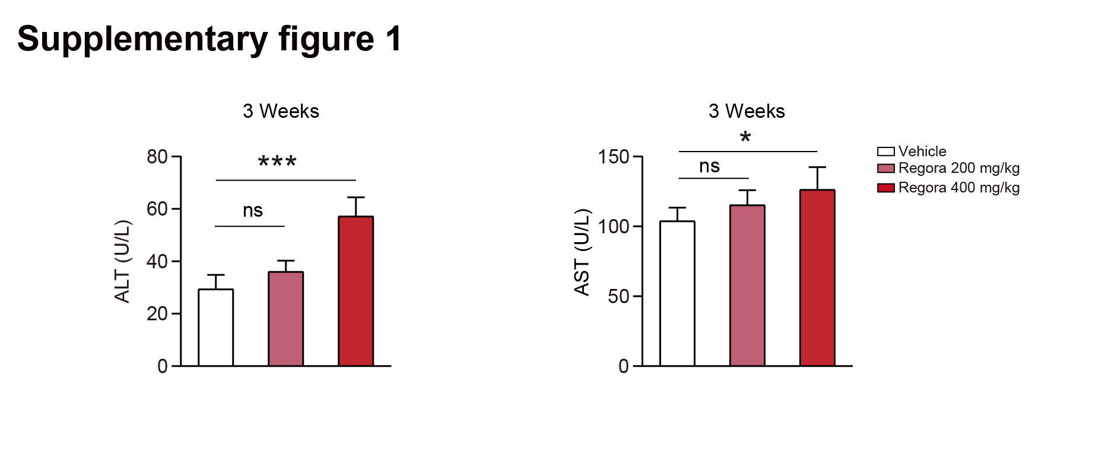
Supplementary Figure 1. Regorafenib caused liver injury with different dosage in vivo. C57BL/6J mice were treated with 0.5% CMC-Na, 200 mg/kg/day regorafenib or 400 mg/kg/day regorafenib for 3 weeks. The levels of serum ALT and AST were analyzed (n = 5 per group). Data were expressed as mean ± SD. *p < 0.05; ***p < 0.001; ns, no significance (one way ANOVA followed by Tukey post hoc test).

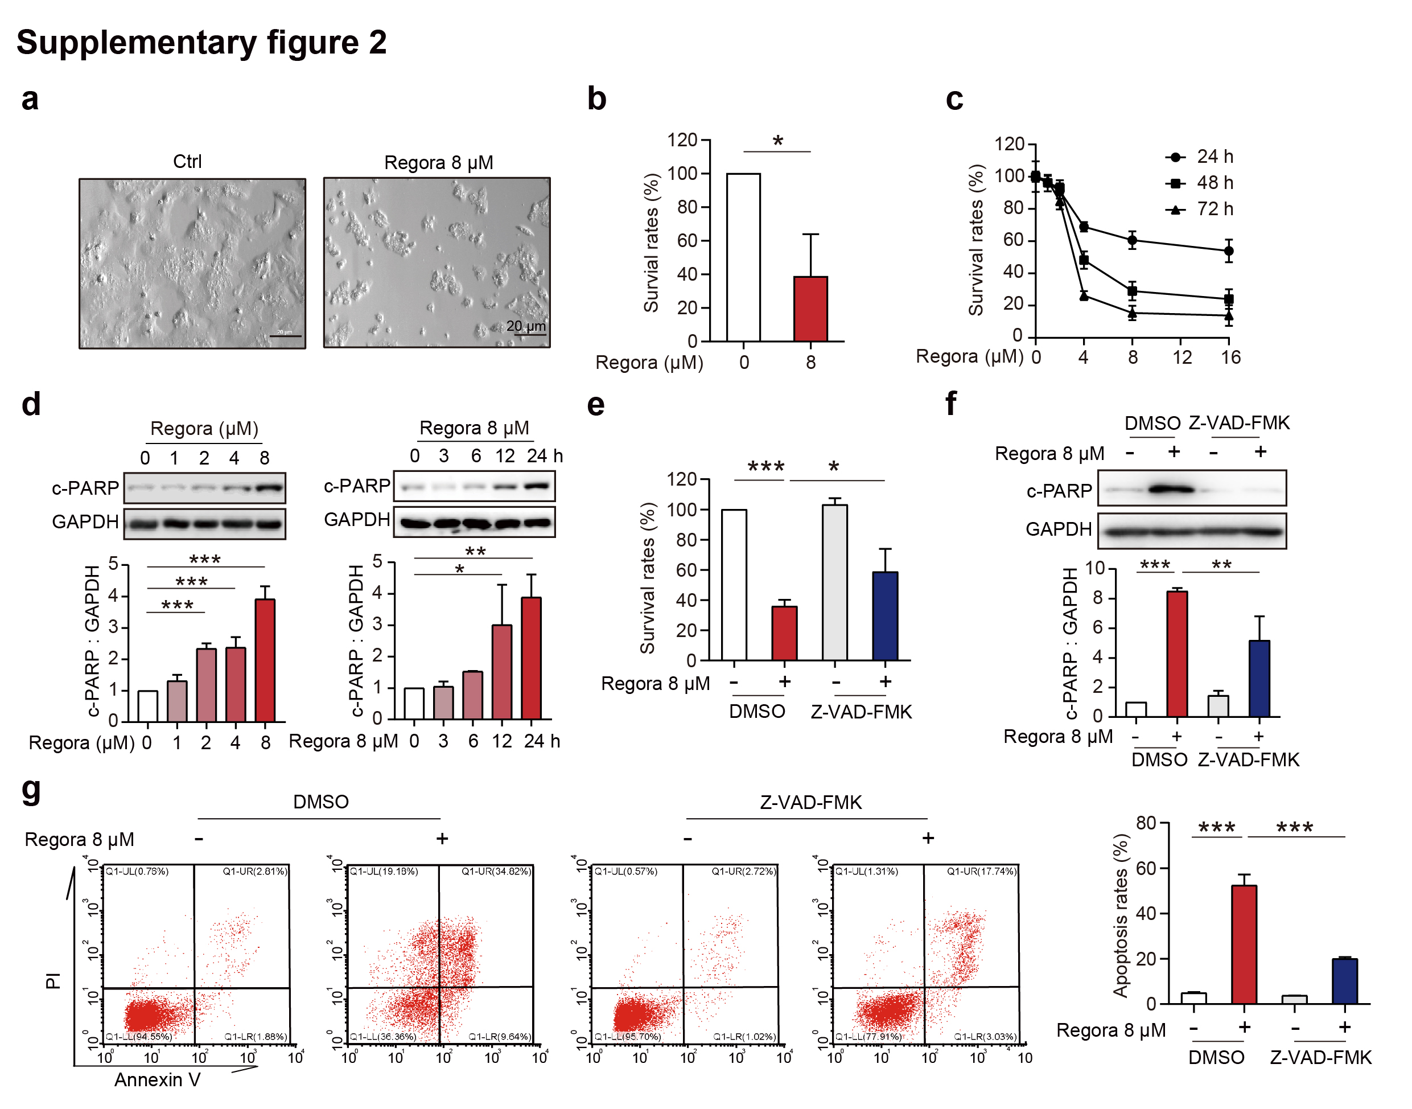
Supplementary Figure 2. Regorafenib induced hepatocytes apoptosis. a, b HPH from 3 donors were treated with DMSO or 8 μM regorafenib for 48 h. a Morphologic changes of HPH were observed by optical light microscope. Scale bar: 20 μm. b The survival rate of HPH was measured by SRB staining (n = 3 per group). c The survival rates of HL-7702 cells treated with 0, 4, 8, 12 or 16 μM regorafenib for 24 h, 48 h or 72 h were detected by SRB staining. The data were obtained from three independent experiments per group. d HL-7702 cells were treated with 0, 1, 2, 4 or 8 μM regorafenib for 24 h (left) or treated with 8 μM regorafenib for 0, 3, 6, 12 or 24 h (right). The expression level of c-PARP was measured by western blot. The data were obtained from three independent experiments per group. e-g HL-7702 cells were treated with DMSO or 8 μM regorafenib and/or 20 μM Z-VAD-FMK for 48 h (for survival rate measurement) or 24 h (for protein expression level measurement). The data were obtained from three independent experiments per group. e The survival rates of HL-7702 cells were detected by SRB staining. f The apoptosis rates were measured by flow cytometry analysis with Annexin V-PI staining. g The expression level of c-PARP was detected by western blot. Data were expressed as mean ± SD. *p < 0.05; **p < 0.01; ***p < 0.001 (Unpaired student’s t-test or one way ANOVA followed by Tukey post hoc test).

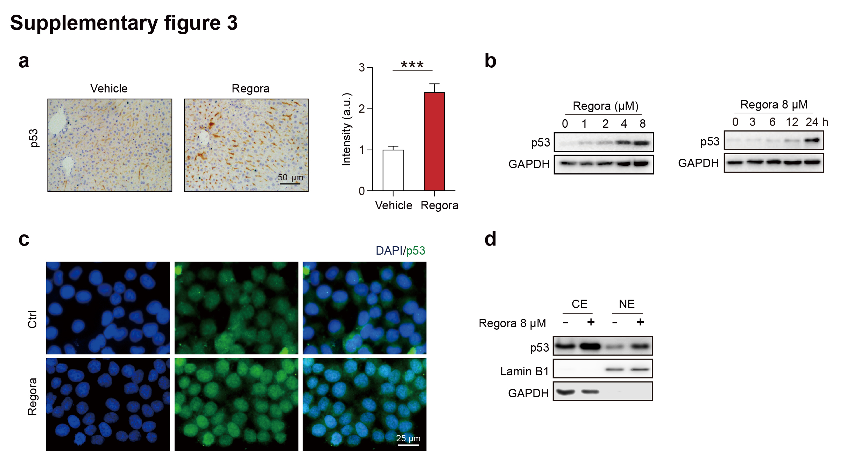
Supplementary Figure 3. Regorafenib induced upregulation of p53 in hepatocytes. a Representative images of immunohistochemistry staining for p53 in liver tissues treated with 0.5% CMC-Na or 400 mg/kg/day regorafenib for 6 weeks. Scale bar: 50 μm. The immunohistochemistry for p53 staining was quantified by densitometric analysis. One area from five mice per group. b HL-7702 cells were treated with 0, 1, 2, 4 or 8 μM regorafenib for 24 h or treated with 8 μM regorafenib for 0, 3, 6, 12 or 24 h. The expression level of p53 was detected by western blot. c Representative images of immunofluorescence for p53 in HL-7702 cells treated with or without 8 μM regorafenib for 24 h. Scale bar: 25 μm. d HL-7702 cells were treated with 8 μM regorafenib for 24 h. The expression level of p53 in cytoplasm and nuclei was detected by western blot. Data were expressed as mean ± SD. ***p < 0.001 (Unpaired student’s t-test).
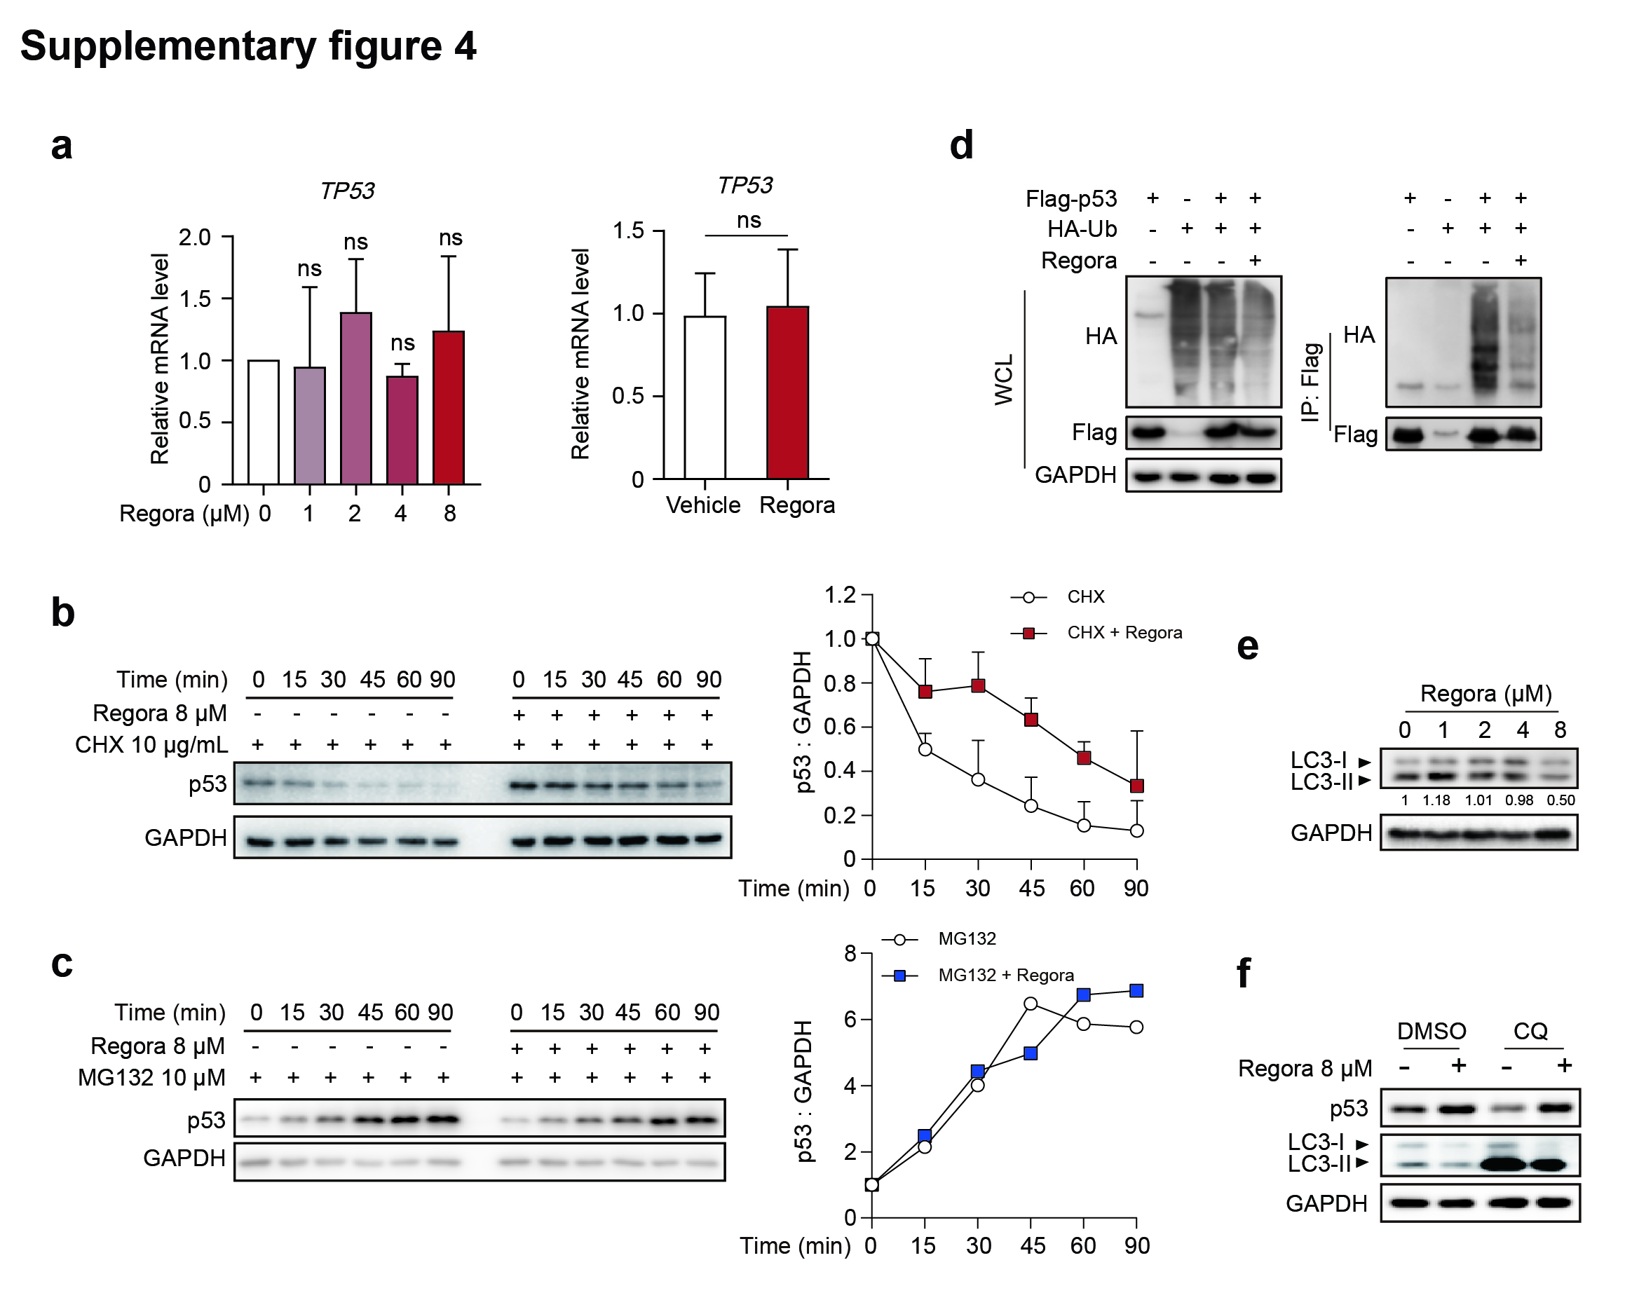
Supplementary Figure 4. The elevation of p53 caused by regorafenib is related to ubiquitin-mediated proteasomal degradation. a The mRNA expression levels of TP53 in HL-7702 cells treated with 0, 1, 2, 4 or 8 μM regorafenib for 24 h (n = 3 per group) and the mRNA expression levels of TP53 in liver tissues from mice treated with or without 400 mg/kg/day regorafenib for 6 weeks (n = 5 per group). b HL-7702 cells were treated with 10 μg/mL CHX with or without 8 μM regorafenib for indicated time. The expression level of p53 was detected by western blot. The data were obtained from three independent experiments per group. c HL-7702 cells pretreated with 10 μM MG132 for 0, 15, 30, 45, 60 or 90 min were treated with or without 8 μM regorafenib for 24 h. The expression level of p53 was detected by western blot. d HEK-293T cells were transfected with or without HA-Ub and/or Flag-p53 and then treated with DMSO or 8 μM regorafenib for 24 h. The cell lysates were subjected to immunoprecipitation by using Flag-beads, followed by western blot to detect HA-tag or Flag-tag expression. e HL-7702 cells were treated with 0, 1, 2, 4 or 8 μM regorafenib for 24 h. The expression level of LC3 was detected by western blot. f HL-7702 cells were treated with or without 8 μM regorafenib and/or 10 μM CQ for 24 h. The expression levels of p53 and LC3 were detected by western blot. Data were expressed as mean ± SD. ns, no significance (Unpaired student’s t-test or one way ANOVA followed by Tukey post hoc test).
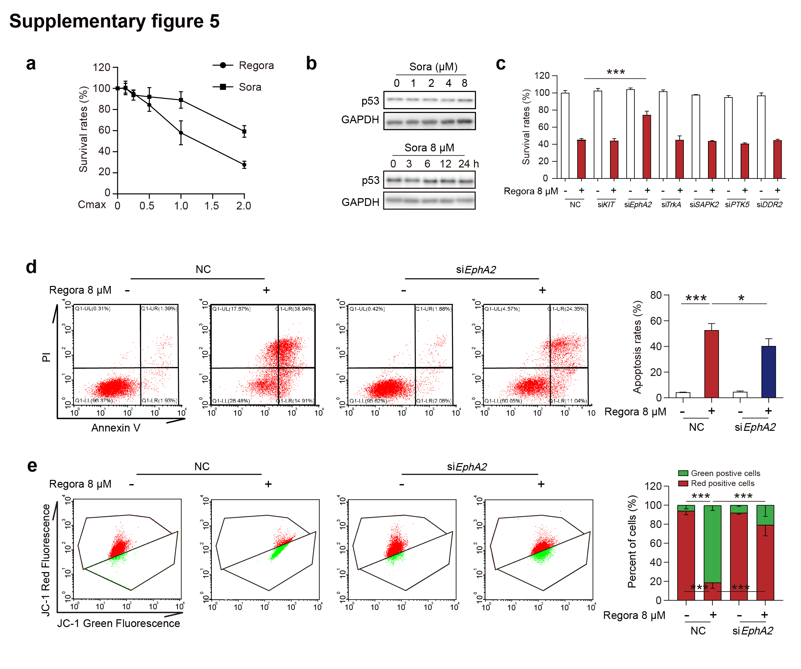
Supplementary Figure 5. EphA2 is a key target for regorafenib to induce hepatotoxicity. a The survival rates of HL-7702 cells treated with 0, 0.5, 1.0, 1.5 or 2.0 times Cmax of regorafenib or sorafenib for 24 h were detected by SRB staining. b HL-7702 cells were treated with 0, 1, 2, 4 or 8 μM sorafenib for 24 h or treated with 8 μM sorafenib for 0, 3, 6, 12 or 24 h. The expression level of p53 was detected by western blot. The data were obtained from three independent experiments per group. c HL-7702 cells were transfected with siKIT, siEpHA2, siTrkA, siSAPK2, siPTK5 or siDDR2 for 24 h before treating with 8 μM regorafenib for 48 h. The survival rates were detected by SRB staining. The data were obtained from three independent experiments per group. d, e HL-7702 cells were transfected with non-targeting siRNA (NC) or targeting EphA2 siRNA (siEphA2), followed by treatment with or without 8 μM regorafenib for 48 h (for apoptosis rate measurement) or 24 h (for MMP measurement). The data were obtained from three independent experiments per group. d Cell apoptosis rates were measured by flow cytometry with Annexin V-PI staining. e MMP was measured by flow cytometry with JC-1 staining. Data were expressed as mean ± SD. *p < 0.05; ***p < 0.001 (One way ANOVA followed by Tukey post hoc test).

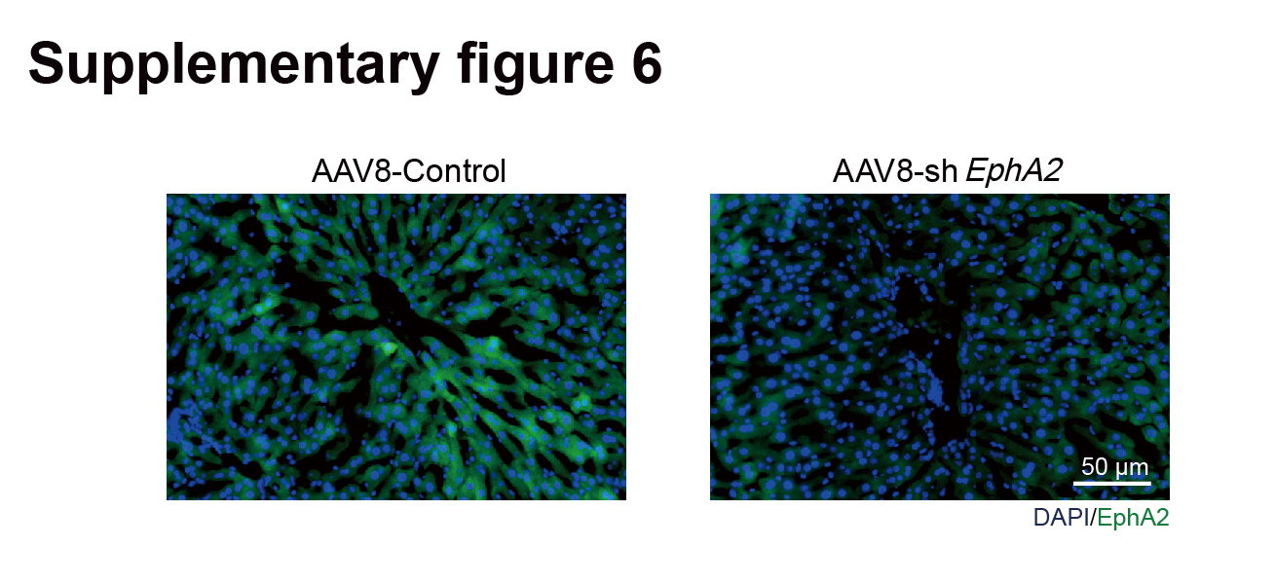
Supplementary Figure 6. The efficiency of EphA2 knockdown in mouse liver. AAV8-TBG-Control or AAV8-TBG-shEphA2 were injected into C57BL/6J mice for 6 weeks through tail vein. The knockdown efficiency of EphA2 was detected by immunofluorescence analysis. Scale bar: 50 μm.

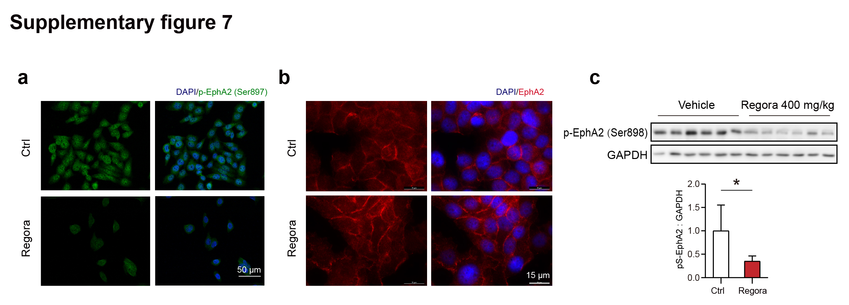
Supplementary Figure 7. p-EphA2 (Ser897) was inhibited by regorafenib. a HL-7702 cells were treated with 8 μM regorafenib for 24 h. The intracellular distribution and expression of p-EphA2 (Ser897) was observed by immunofluorescence. Scale bar: 50 µm. b Immunofluorescence analysis of EphA2 in HL-7702 cells after treatment of 8 µM regorafenib for 24 h. Scale bar: 15 µm. c C57BL/6J mice were treated with 0.5% CMC-Na or 400mg/kg/day regorafenib for 6 weeks. The expression level of p-EphA2 (Ser898) in liver tissues was analyzed by western blot (n = 6 per group). Data were expressed as mean ± SD. *p < 0.05 (Unpaired student’s t-test).

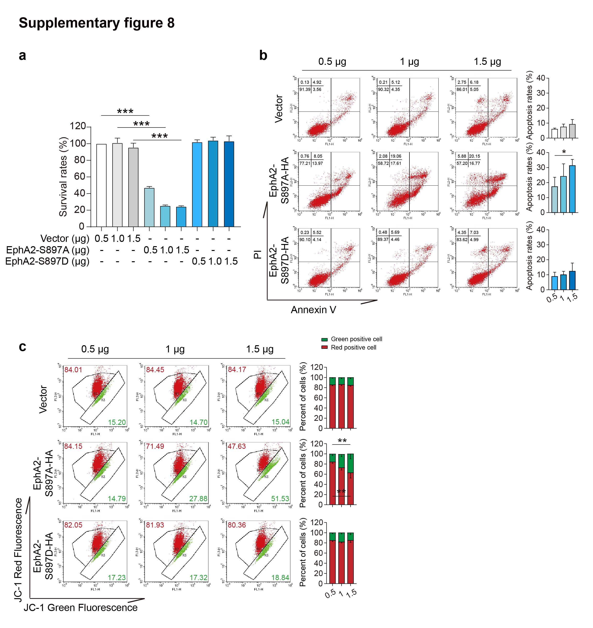
Supplementary Figure 8. Inhibition of p-EphA2 (Ser898) is related to hepatocyte apoptosis and mitochondrial dysfunction. a HL-7702 cells were transfected with 0.5, 1.0 or 1.5 μg vector, EphA2 S897A plasmid or EphA2 S897D plasmid for 48 h. The survival rates of HL-7702 cells were measured by SRB staining. The data were obtained from three independent experiments per group. b-c HL-7702 cells were transfected with 0.5, 1.0 or 1.5 μg EphA2 S897A plasmid or EphA2 S897D plasmid for 48 h (for apoptosis rate measurement) or 24 h (for MMP measurement). The data were obtained from three independent experiments per group. b The apoptosis rates were measured by flow cytometry analysis of Annexin V-PI staining. c MMP was detected by JC-1 staining and flow cytometry. Data were expressed as mean ± SD. *p < 0.05; **p < 0.01; ***p < 0.001 (one way ANOVA followed by Tukey post hoc test).

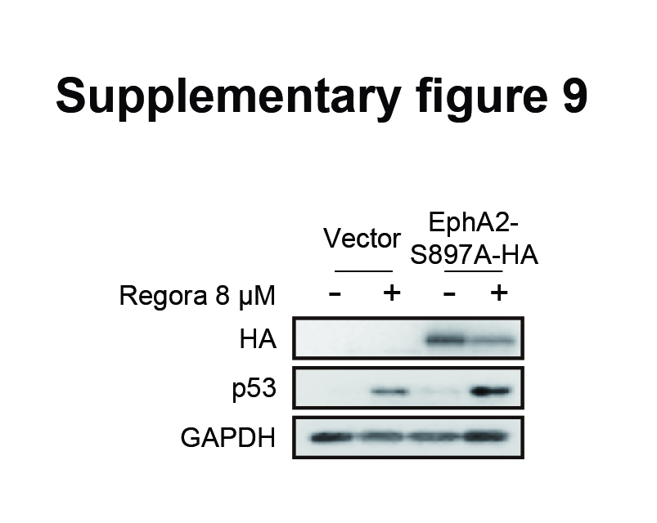
Supplementary Figure 9. Mimicking the inhibition of p-EphA2 (897) further promoted regorafenib-induced p53 upregulation. HL-7702 cells were transfected with or without 1.0 μg EphA2 S897A plasmid for 24 h, followed by treatment with or without 8 μM regorafenib for 24 h. The expression levels of HA and p53 were analyzed by western blot.

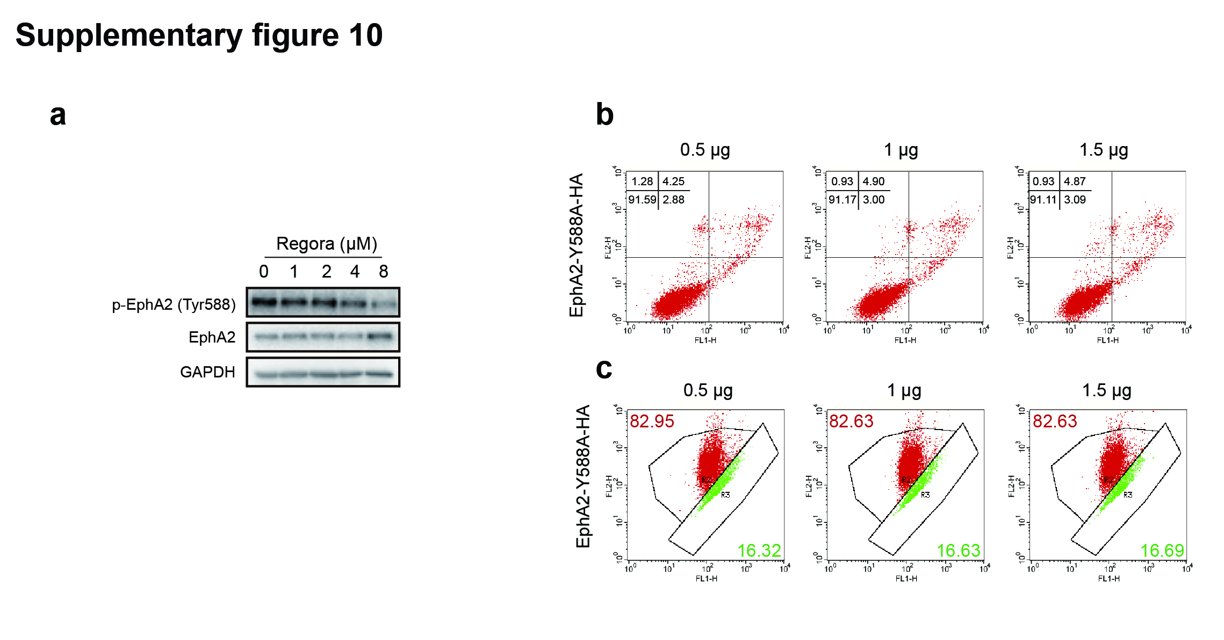
Supplementary Figure 10. Inhibition of p-EphA2 (Tyr588) was not associated with regorafenib-induced cell apoptosis. a The expression levels of p-EphA2 (Tyr588) and EphA2 in HL-7702 cells treated with 0, 1, 2, 4 or 8 μM regorafenib for 24 h were analyzed by western blot. b-c HL-7702 cells were transfected with 0.5, 1 or 1.5 μg EphA2 Y588A plasmid for 48 h (for apoptosis rate measurement) or 24 h (for MMP measurement). b Representative images of cell apoptosis rates measured by flow cytometry with Annexin V-PI staining. c Representative images of mitochondrial membrane potential measured by flow cytometry with JC-1 staining.

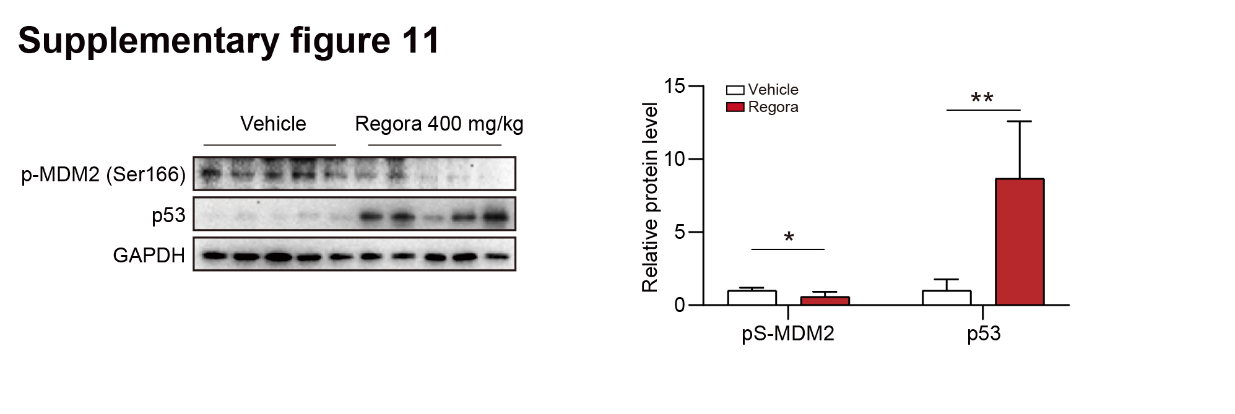
Supplementary Figure 11. Regorafenib reduced the level of p-MDM2 (Ser166) and increased the level of p53 in vitro. C57BL/6J mice were treated with or without 400 mg/kg/day regorafenib for 6 weeks. The expression levels of p-MDM2 (Ser166) and p53 in liver tissues were analyzed by western blot. The expression levels of p-MDM2 (Ser166) and p53 in liver tissues were analyzed by western blot (n = 5 per group). Data were expressed as mean ± SD. *p < 0.05; **p < 0.01 (Unpaired student’s t-test).
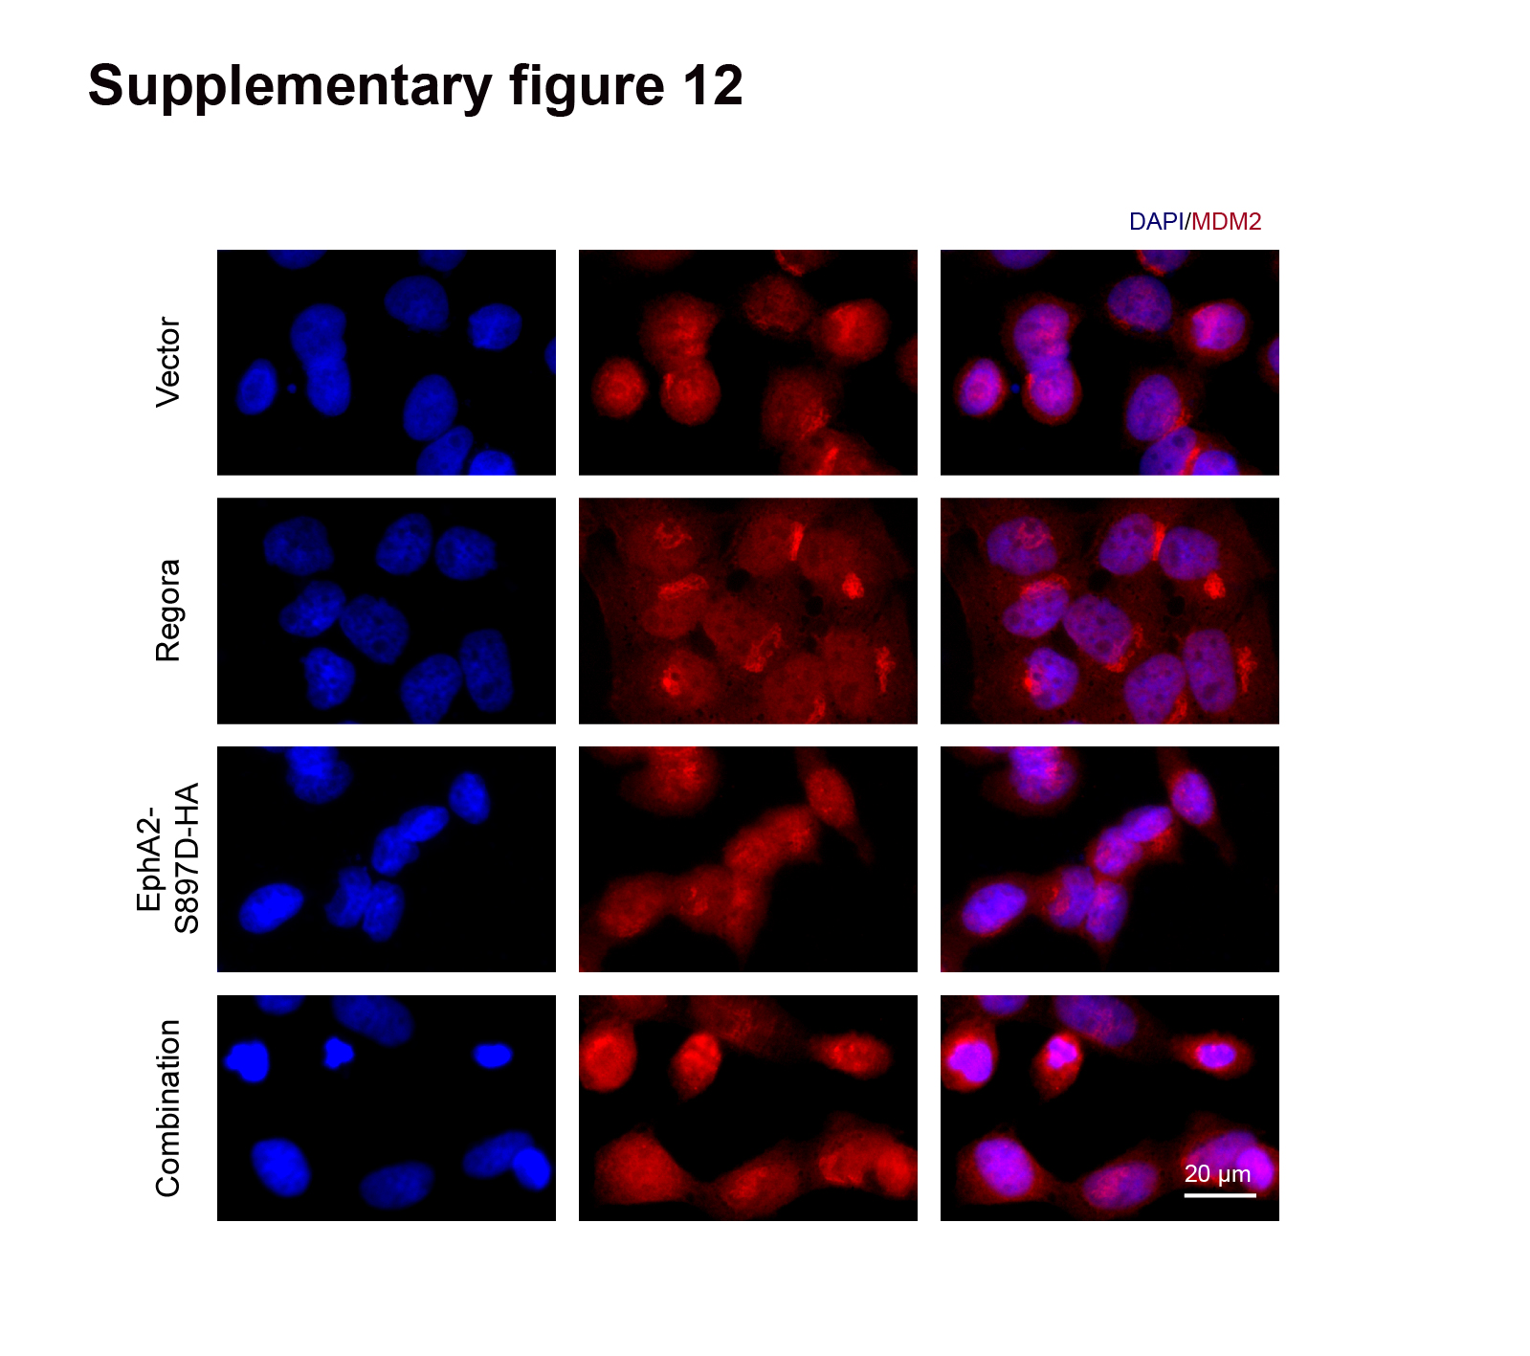
Supplementary Figure 12. Regorafenib changed the distribution of MDM2 by inhibiting the phosphorylation of EphA2 (Ser897). HL-7702 cells were treated with 8 μM regorafenib for 24 h after transfected with 1.0 μg EphA2 S897D plasmid for 24 h. The distribution of MDM2 in HL-7702 cells was observed by immunofluorescence. Scale bar: 20 μm.

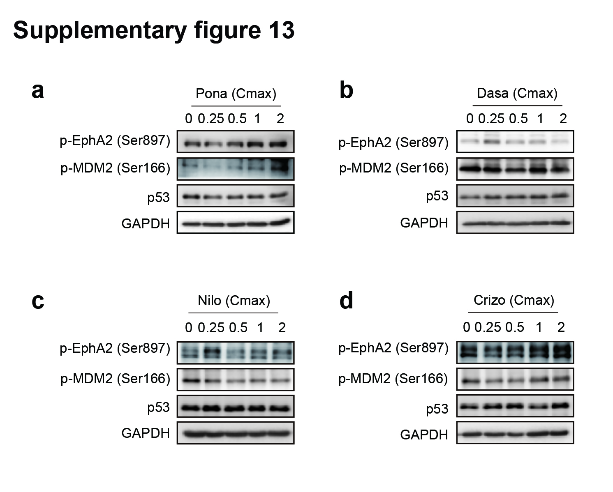
Supplementary Figure 13. The effect of EphA2 inhibitors on p-EphA2 (Ser897), p-MDM2 (Ser166) and p53. a-d HL-7702 cells were treated with 0, 0.25, 0.5, 1 or 2 multiples of Cmax of Ponatinib, Dasatinib, Nilotinib, Crizotinib for 24 h. The expression levels of p-EphA2 (Ser897), p-MDM2 (Ser166) and p53 were detected by western blot.

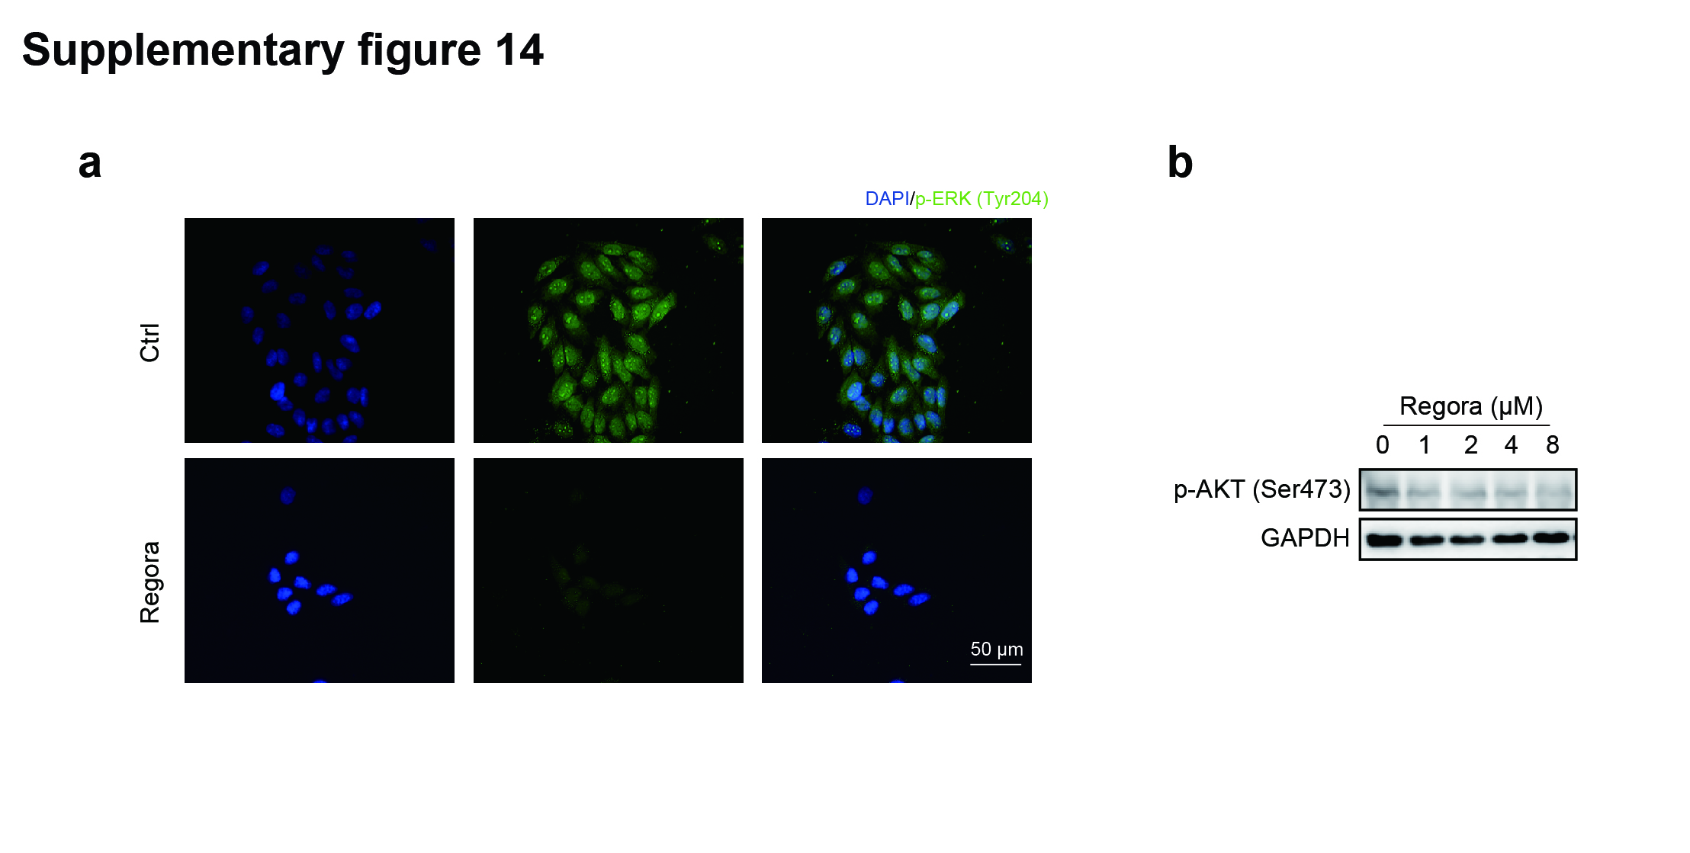
Supplementary Figure 14. p-ERK but not p-AKT was changed with the regorafenib treatment. a The distribution and expression of p-ERK (Tyr204) in HL-7702 cells treated with 8 μM regorafenib were observed by immunofluorescence. Scale bar: 50 μm. b The expression levels of p-AKT (Ser473) in HL-7702 cells treated with 0, 1, 2, 4 or 8 μM regorafenib for 24 h were detected by western blot.

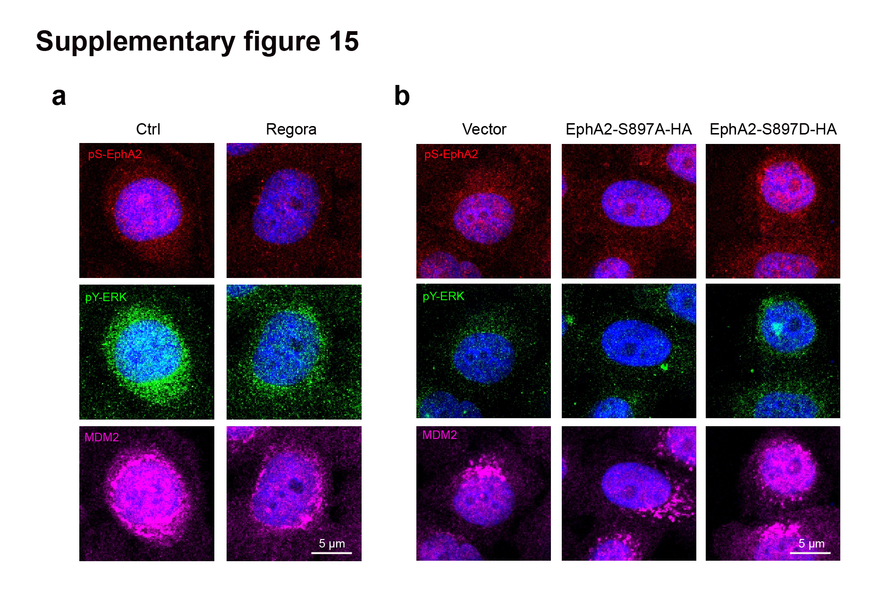
Supplementary Figure 15. p-EphA2 (Ser897) inhibition was associated with reduced p-ERK and the cytoplasmic retention of MDM2. a The expression levels of p-EphA2 (Ser897), p-ERK (Tyr204) and MDM2 in HL-7702 cells treated with 8 μM regorafenib for 24 h were observed by immunofluorescence. Scale bar: 5 µm. b HL-7702 cells were transfected with 1.0 μg EphA2 S897A plasmid or EphA2 S897D plasmid for 24 h. The expression levels and localizations of p-EphA2 (Ser897), p-ERK (Tyr204) and MDM2 were observed by immunofluorescence. Scale bar: 5 µm.

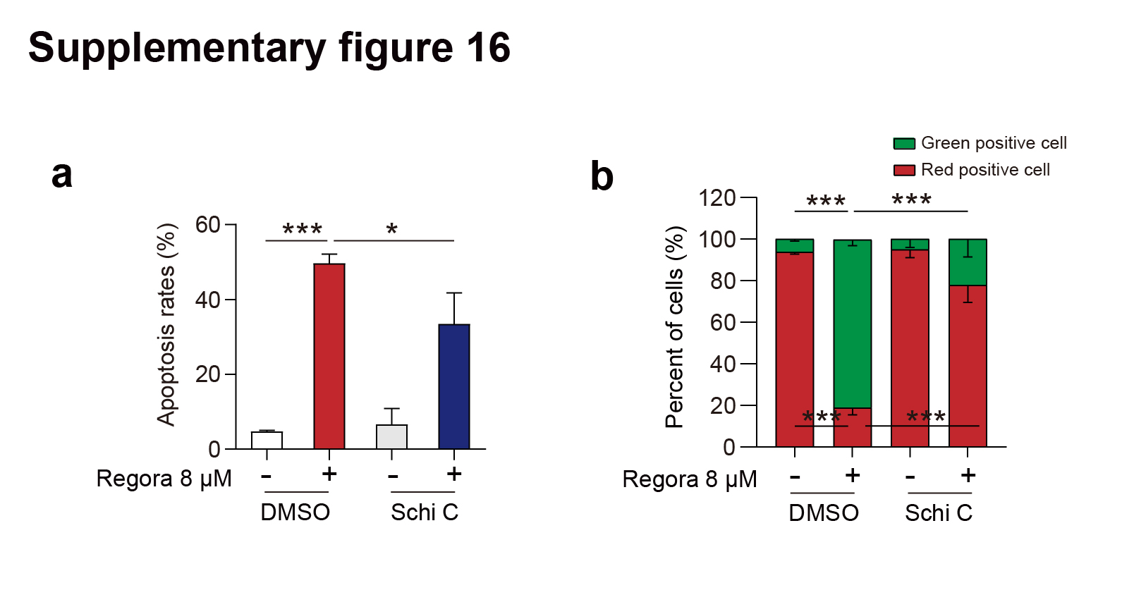
Supplementary Figure 16. Schisandrin C attenuated regorafenib-induced hepatocyte apoptosis and mitochondrial dysfunction. a, b HL-7702 cells were treated with 8 μM regorafenib and/or 40 μM schisandrin C for 48 h (for apoptosis measurement) or 24 h (for MMP measurement). The data were obtained from three independent experiments per group. a The apoptosis rates were measured by flow cytometry analysis with Annexin V-PI staining. b MMP in HL-7702 cells was detected by JC-1 staining with flow cytometry. Data were expressed as mean ± SD. *p < 0.05; ***p < 0.001 (one way ANOVA followed by Tukey post hoc test).

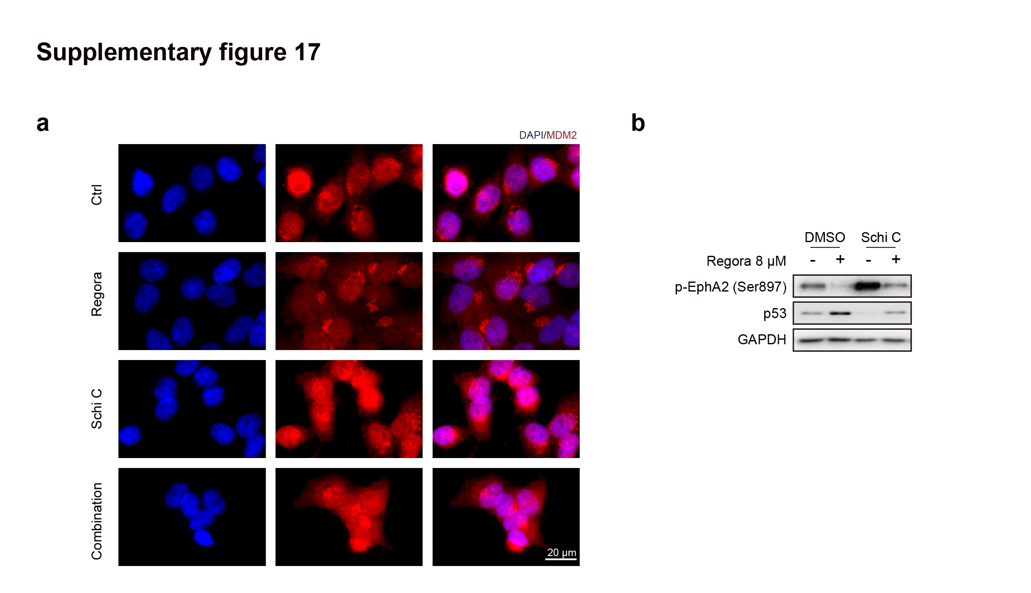
Supplementary Figure 17. Schisandrin C improved regorafenib-induced MDM2 cytoplasmic retention and increased p53 by upregulating p-EphA2 (Ser897). a, b HL-7702 cells were treated with 8 μM regorafenib and/or 40 μM schisandrin C for 24 h. a Representative images of immunofluorescence for MDM2 in HL-7702 cells. Scale bar: 20 μm. b The expression levels of p-EphA2 (Ser897) and p53 in HL-7702 cells were detected by western blot.

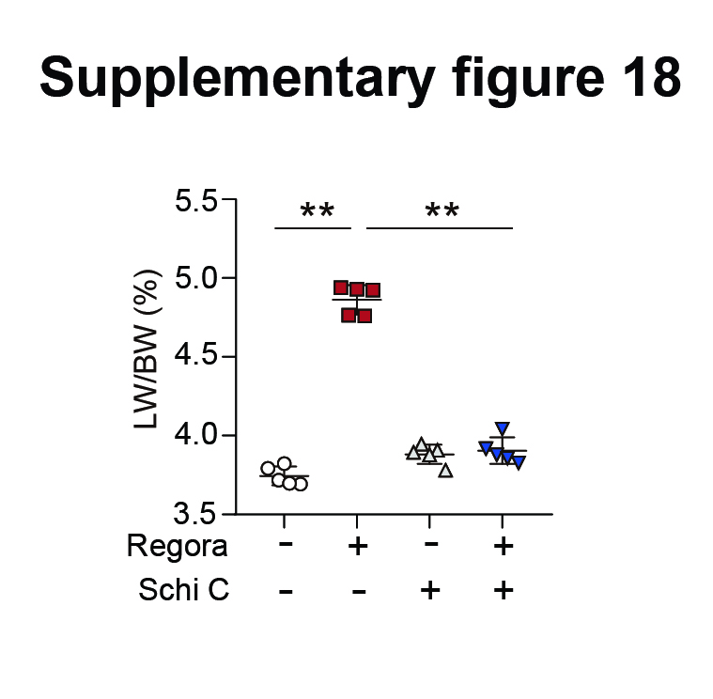
Supplementary Figure 18. Schizandra C ameliorated regorafenib-induced upregulation of LW/BW. The level of LW/BW in mice treated with 400 mg/kg/day regorafenib and/or 10 mg/kg/day schisandrin C for 6 weeks was detected (n = 5 per group). Data were expressed as mean ± SD. **p < 0.01 (one way ANOVA followed by Tukey post hoc test).

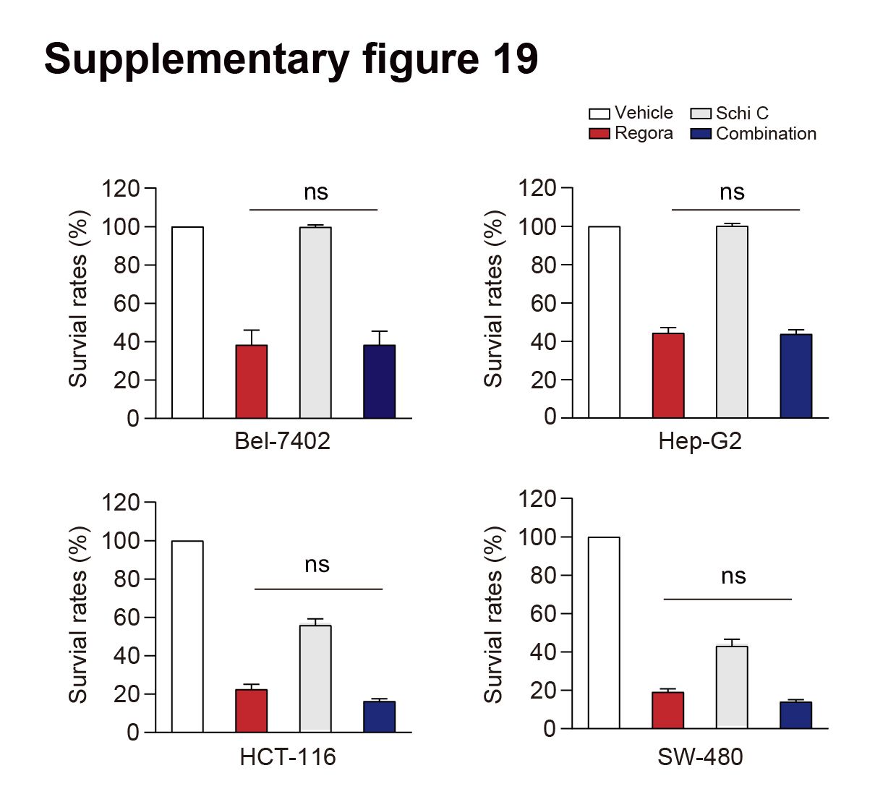
Supplementary Figure 19. Schizandra C didn’t affect the anti-tumor effect of regorafenib. Two hepatocellular carcinoma cell lines (Bel-7402 and Hep-G2) and two colon cancer cell lines (HCT-116 and SW-480) were treated with or without 8 μM regorafenib and/or 40 μM schisandrin C for 48 h. SRB staining analysis was carried out to determine the survival rates. The data were obtained from three independent experiments per group. Data were expressed as mean ± SD. ns, no significance (one way ANOVA followed by Tukey post hoc test).

Supplementary tables
Supplementary Table 1. Characteristics of the human primary hepatocytes
(Product: M00995-P | Lot: HVN****)
Donor | HVN
Gender  Age  BMI | Male
Gender  Age  BMI | 33
Gender  Age  BMI | 31.0
EBV  RPR  CMV | IgG+
EBV  RPR  CMV | Neg
EBV  RPR  CMV | Neg
COD  General  Meds | Anoxia 2nd to Natural Causes/Cardiovascular
COD  General  Meds | Depression, right wrist and ligament repair s/p MVC 7 yrs ago.
COD  General  Meds | Celexa, Seroquel
Alcohol  Tobacco  Drug | Beer:1-2 times/week, 6 pack on weekends, 3-4 on weekdays for 12 years
Alcohol  Tobacco  Drug | 0.5-1 ppd cigarettes × 15 yrs, current
Alcohol  Tobacco  Drug | Meth for 6 mos, used 1-2 times/week, last used 7 years ago, IVDA 7 yrs ago

Supplementary Table 2. Characteristics of the human primary hepatocytes
(Product: M00995-P | Lot: QBU****)
Donor | HVN
Gender  Age  BMI | Male
Gender  Age  BMI | 33
Gender  Age  BMI | 31.0
EBV  RPR  CMV | IgG+
EBV  RPR  CMV | Neg
EBV  RPR  CMV | Neg
COD  General  Meds | Anoxia 2nd to Natural Causes/Cardiovascular
COD  General  Meds | Depression, right wrist and ligament repair s/p MVC 7 yrs ago.
COD  General  Meds | Celexa, Seroquel
Alcohol  Tobacco  Drug | Beer:1-2 times/week, 6 pack on weekends, 3-4 on weekdays for 12 years
Alcohol  Tobacco  Drug | 0.5-1 ppd cigarettes × 15 yrs, current
Alcohol  Tobacco  Drug | Meth for 6 mos, used 1-2 times/week, last used 7 years ago, IVDA 7 yrs ago

Supplementary Table 3. Characteristics of the human primary hepatocytes
(Product: F00995-P | Lot: XSM****)
Donor | HVN
Gender  Age  BMI | Female
Gender  Age  BMI | 59
Gender  Age  BMI | 27.1
EBV  RPR  CMV | IgG+
EBV  RPR  CMV | Neg
EBV  RPR  CMV | Pos
COD  General  Meds | CVA
COD  General  Meds | Urethra surgery (short urethra w/ frequent UTIs).
COD  General  Meds | None
Alcohol  Tobacco  Drug | None reported
Alcohol  Tobacco  Drug | 1 ppd x 40 yrs
Alcohol  Tobacco  Drug | None reported

Supplementary Table 4. Antibodies used for western blot, immunofluorescence (IF) and immunohistochemistry (IHC) staining
Antibody | Company | Catalogue No. | Experiment of application
GAPDH | Diagbio | db106 | Western blot
P53 | Santa Cruz Biotechnology | sc-126 | Western blot; IHC staining
EphA2 | Cell Signaling Technology | #6997 | Western blot; IF
Phospho-EphA2 (Ser897) | Cell Signaling Technology | #6347 | Western blot; IF
MDM2 | Huabio | RT1382 | Western blot
phospho-MDM2 (Ser166) | Cell Signaling Technology | #3521 | Western blot; IHC staining
Cleaved PARP | Huabio | ET1608-10 | Western blot
HA tag | Diagbio | db2603 | Western blot
FLAG tag | Diagbio | db7002 | Western blot
Lamin B1 | Huabio | R1508-1 | Western blot
ERK | Santa Cruz Biotechnology | sc-81457 | Western blot
LC3 | Cell Signaling Technology | #4108 | Western blot
phospho-Akt (Ser473) | Cell Signaling Technology | #4060 | Western blot
P53 | Origene | TA808657 | IHC staining
MDM2 | Affinity Biosciences LTD | AF0208 | IF
phospho-EphA2 (Tyr588) | Cell Signaling Technology | #12677 | Western blot
phospho-ERK (Tyr204) | Santa Cruz Biotechnology | sc-7383 | Western blot; IHC staining; IF
Supplementary Table 5. The primer sequences of quantitative real time polymerase chain reaction
Gene | Forward | Reverse
H-ACTB | CACCATTGGCAATGAGCGGTTC | AGGTCTTTGCGGATGTCCACGT
H-TP53 | ATCTACAAGCAGTCACAG | TCATCCAAATACTCCACACGC
M-ACTB | GTGACGTTGACATCCGTAAAGA | GCCGGACTCATCGTACTCC
M-TP53 | ATGTTCCGGGAGCTGAATG | CCCCACTTTCTTGACCATTG
H represents human; M represents mouse

Supplementary Table 6. Oligonucleotide sequences of siRNAs
Name | Anti-sense sequences
siEphA2 | 5'-GACAGACAUAUAGGAUAUUdTdT-3´
siTP53 | 5'-AGACCUAUGGAAACUACUUdTdT-3´
siKIT | 5'-UUUGUGUUUCUAUUGACUUdTdT-3´
siDDR2 | 5'-UGGCUUGGUGUCUUACAAUdTdT-3´
siTRKA | 5'-UCUACAGCACCGACUAUUAdTdT-3´
siSAPK2 | 5'-GAAUCUACACGCAUGUAUGdTdT-3´
siPTK5 | 5'-AUUUGAUUUGUCGUAUAAAdTdT-3´

