Supplemental Figures
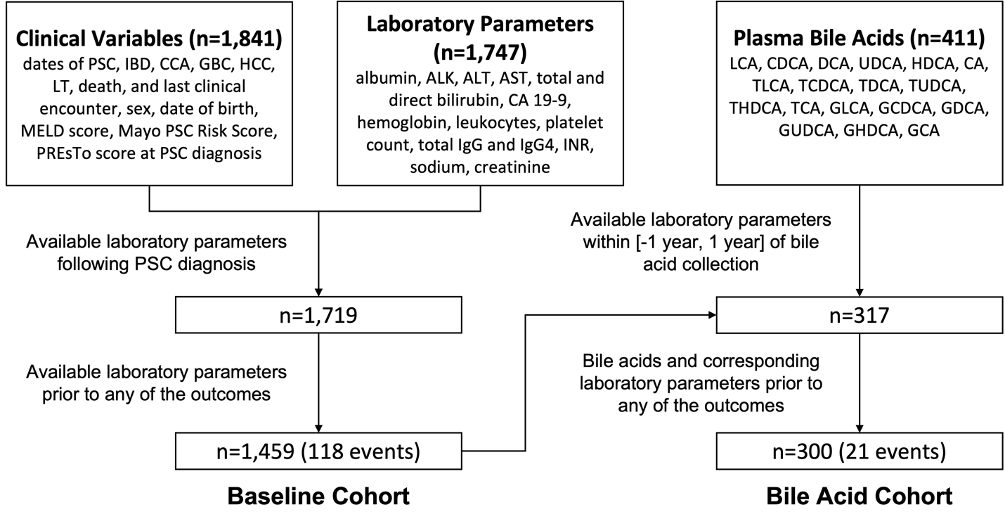
Fig. S1 Derivation of baseline cohort and bile acid cohort. Baseline cohort includes 1,459 patients who had pre-outcome laboratory parameters following PSC diagnosis, out of which 118 developed CCA prior to any other outcomes. Bile acid cohort includes 300 patients with pre-outcome plasma bile acids and laboratory parameters collected at similar times, out of which 21 developed CCA prior to any other outcomes. Abbreviations: ALK, alkaline phosphatase; AST, alanine aminotransferase; AST, aspartate aminotransferase; CA 19-9, carbohydrate antigen 19-9; CCA, cholangiocarcinoma; GBC, gallbladder cancer; IBD, inflammatory bowel disease; HCC, hepatocellular carcinoma; IgG, immunoglobulin; IgG, immunoglobulin G4; INR, international normalized ratio; LT, liver transplantation; MELD, model for end-stage liver disease; PSC, primary sclerosing cholangitis; PREsTo, PSC Risk Estimation Tool. Please see separate list of abbreviations for bile acids.

Fig. S2 Cumulative incidence function (CIF) of CCA based on a competing risks framework with GBC, HCC, LT and non-PSC death as competing risks. Patients without any events were censored at the last known clinical encounter. CIF of CCA represents the cumulative probability of developing CCA (without developing any other events). Abbreviations: CCA, cholangiocarcinoma; GBC, gallbladder cancer; HCC, hepatocellular carcinoma; LT, liver transplantation; PSC, primary sclerosing cholangitis.

Supplemental Tables
Table S1 Summary characteristics of the bile acid cohort with median (IQR) listed for the continuous features and percentage listed for the binary features.
Characteristics of Bile Acid Cohort
Variable | N | Summary
Age, years | 300 | 49.9 (35.16–61.16)
Male sex | 300 | 58.0%
PSC duration, years | 300 | 4.16 (1.85–9.47)
IBD diagnosis | 300 | 76.7%
IBD duration, years | 230 | 13.76 (4.86–24.59)
ALK x ULN | 290 | 1.57 (0.89–2.87)
AST, U/L | 286 | 45 (30–79.5)
ALT, U/L | 254 | 55 (32–111)
Total bilirubin, mg/dL | 286 | 0.8 (0.5–1.2)
Direct bilirubin, mg/dL | 194 | 0.2 (0.1–0.4)
INR | 246 | 1 (1–1.1)
Albumin, g/dL | 274 | 4.15 (3.8–4.4)
Sodium, mmol/L | 168 | 139.5 (138–142)
Creatinine, mg/dL | 243 | 0.9 (0.8–1)
Hemoglobin, g/dL | 218 | 14.1 (12.9–15)
White Blood Cells, 10⁹/L | 203 | 6.2 (5–7.5)
Platelets, 10⁹/L | 271 | 222 (173.5–279)
IgG4, mg/dL | 66 | 32 (17.98–73.8)
Total IgG, mg/dL | 62 | 1315 (1070–1737.5)
CA 19-9, U/mL | 225 | 17 (7.2–32)
LCA | 300 | 0.01 (0–0.04)
CDCA | 300 | 0.15 (0.05–0.43)
DCA | 300 | 0.09 (0.01–0.45)
UDCA | 300 | 0.15 (0.01–1.73)
HDCA | 300 | 0.01 (0–0.03)
CA | 300 | 0.07 (0.03–0.23)
GLCA | 300 | 0.02 (0–0.08)
GCDCA | 300 | 3 (1.1–6.9)
GDCA | 300 | 0.32 (0.03–0.98)
GUDCA | 300 | 0.96 (0.12–12.06)
GHDCA | 300 | 0 (0–0.01)
GCA | 300 | 1.75 (0.46–6.45)
TLCA | 300 | 0 (0–0.02)
TCDCA | 300 | 0.52 (0.13–2.3)
TDCA | 300 | 0.06 (0.01–0.26)
TUDCA | 300 | 0.08 (0.01–0.44)
THDCA | 300 | 0 (0–0)
TCA | 300 | 0.26 (0.06–2.53)
Total Bile Acids | 300 | 17.12 (5.91–41.38)
Total CA | 300 | 2.17 (0.8–10.01)
Total CDCA | 300 | 4.1 (1.58–10.2)
Total DCA | 300 | 0.66 (0.06–1.78)
Total LCA | 300 | 0.04 (0–0.15)
Total UDCA | 300 | 1.32 (0.19–15.05)
Total HDCA | 300 | 0.01 (0–0.04)
ConFrac CA | 300 | 0.97 (0.84–0.99)
ConFrac CDCA | 300 | 0.96 (0.84–0.99)
ConFrac DCA | 261 | 0.8 (0.55–0.96)
ConFrac LCA | 217 | 0.75 (0.55–0.87)
ConFrac UDCA | 294 | 0.89 (0.75–0.97)
ConFrac HDCA | 178 | 0.18 (0–0.55)
ConFrac all BA | 300 | 0.91 (0.74–0.98)
GTratio CA | 295 | 5.56 (2.59–9.37)
GTratio CDCA | 299 | 5.86 (2.75–10.3)
GTratio DCA | 223 | 4.69 (2.07–8.96)
GTratio LCA | 130 | 3 (1.34–7)
GTratio UDCA | 247 | 19.23 (6.46–36.03)
GTratio HDCA | 10 | 1.17 (1–2.6)
GTratio all BA | 299 | 8.49 (3.2–17.44)
CA:CDCA | 300 | 0.66 (0.36–1.13)
CA:DCA | 261 | 2.57 (0.81–28.14)
CDCA:(LCA+HDCA+UDCA) | 294 | 2.27 (0.22–16.46)

Supplemental Methods
Data Collection and Management
All extracted data have been manually entered into the PSC Study Data Management System (PSC-SDMS), a custom-designed SAS-based electronic data capture web application developed by the Mayo Clinic’s Biomedical Informatics Support Systems section.

Handling of missing laboratory parameters
Missing laboratory parameters were imputed first using the closest measurement of the same laboratory parameter within the past one year or the next seven days after baseline. Two separate strategies were adopted to impute the remaining missing laboratory parameters: (i) for risk factor identification, we adopted the strategy of multiple imputation to get unbiased p-value estimates from the pooled results using the predictive mean matching method in the Multivariate Imputation by Chained Equations (MICE) package¹; and (ii) for predictive models construction, we integrated missing data imputation into the cross-validation process. Specifically, we used the training data to learn to impute each feature from all other features with the scikit-learn² package.

Details of predictive models for the baseline cohort
CoxPH assumes that the HR of two subjects is constant over time and that the population of interest shares a common baseline hazard function. We used the nonparametric Breslow's method³ to estimate the baseline hazard. We added l2 and l1 regularization terms to reduce the chance of overfitting and encourage the selection of fewer features. We set the regularization parameters to 0.005 for both terms. RSF leverages bootstrapping to construct multiple survival trees and average their results for a robust prediction. We chose the log-rank statistic as the splitting rule for building the survival trees. We used 100 trees for stable performance according to the weak law of large numbers. GBSA iteratively learns an ensemble of decision trees that maximize the partial log-likelihood of the observed survival outcomes. We set the number of trees to be the default value of the software, which was also 100. For both RSF and GBSA, we set each tree's maximum depth to 3 to allow nonlinear 3-way interactions among the features when making predictions. We required a minimum of 30 patients at each leaf node for reliable estimation. We implemented all three methods in Python using the scikit-survival package⁴.

Details of predictive models for the BA cohort
In CoxPH, since feature selection was explicitly performed, we dropped the l1 regularization term and used only an l2 regularization term with 0.01 as the parameter. We kept the choices of other hyperparameters consistent with the models for the baseline cohort.

References
1. van Buuren S, Groothuis-Oudshoorn K. mice: Multivariate Imputation by Chained Equations in R. Journal of Statistical Software 2011;45:1 - 67.
2. Pedregosa F, Varoquaux G, Gramfort A, et al. Scikit-learn: Machine learning in Python. the Journal of machine Learning research 2011;12:2825-2830.
3. Breslow N. Covariance Analysis of Censored Survival Data. Biometrics 1974;30:89-99.
4. Pölsterl S. scikit-survival: A Library for Time-to-Event Analysis Built on Top of scikit-learn. J. Mach. Learn. Res. 2020;21:1-6.

