Technoeconomic data and assumptions for long-term OSeMOSYS energy systems modelling in Vietnam
Authors
Naomi Tan^{1, 2}, John Harrison¹, Mark Howells^{1,2}
Affiliations

- Centre for Sustainable Transitions: Energy, Environment and Resilience, Loughborough University
- Centre for Environmental Policy, Imperial College London

Abstract
Vietnam is at a critical juncture in planning for its future energy mix due to its fast-growing economy and recent climate commitments. Robust modelling analysis examining potential and practical energy mix alternatives are therefore key in providing key stakeholders with critical information on energy policy decision making. The challenge is that a large volume of data is required to accurately model various energy pathways at the national scale. This data note therefore provides key information on input data and assumptions underpinning the modelling of six different energy scenarios. Data regarding electricity demand, electricity imports and exports, fuel prices, emissions, refineries, power transmission and distribution, electricity generation technologies, and renewable energy potential and reserves are discussed.

Keywords
U4RIA
Renewable energy
Cost-optimization
Vietnam
Energy policy
OSeMOSYS

Specifications Table

Subject | Energy
Specific subject area | Energy System Modelling
Type of data | Tables  Graphs  Description of main modelling assumptions
How data were acquired | Literature survey (databases and reports from international organisations; journal articles)
Data format | Raw and Analysed
Parameters for data collection | Data collected based on inputs required to create an energy system model for Vietnam
Description of data collection | Data were collected from the websites, annual reports and databases of international organisations, as well as from academic articles and existing modelling databases.
Data source location | Not applicable
Data accessibility | With the article

Value of the Data
- These data can be used to develop national energy system models to inform national energy investment outlooks, policy plans and provide insights on the evolution of the electricity supply system under different trajectories.
- The data are useful for country analysts, policy makers and the broader scientific community, as a base for model development.
- These data could be used to examine a range of possible energy system pathways except the ones analysed in this study to provide further insights on the evolution of the country's power system.
- They are open-source and country specific which is not easily accessible current literature. The data can be used both for conducting an analysis of the power system but also for capacity building activities.

Data Description

This data article relates to the long-term energy pathways analyses of Vietnam’s energy system. The data provided in this paper can be used as input data to develop or further build an energy system model for Vietnam, which can be replicated in other countries. For reference, six models were generated with the cost-optimization tool OSeMOSYS for the energy pathways analyses. Table 1 lists the scenarios and their respective descriptions. The six models and its corresponding datafile derived from the study are available in Annex. The data provided were collected from publicly available sources, including the reports of international organisations, journal articles and existing model databases. It includes the techno-economic parameters of supply-side technologies, installed capacities, emissions factors, and power demands. Data and key assumptions adopted in the analysis are noted below in five sections.

Table 1: List of scenarios and their descriptions.
Abbreviation | Name | Description
PDP 7 (rev) | Power Development Plan VII (revised) for the period of 2011 – 2020 with the vision to 2030 | Follows the planned electricity generation mix from Vietnam’s PDP7 (rev)
PDP 8 (draft) | Power Development Plan VIII draft for the period of 2021-2030 with a vision to 2045 | Follows the planned capacity mix from Vietnam’s PDP8 (draft)
REDS | Renewable Energy Development Strategy | Follows the planned electricity generation mix from Vietnam’s Renewable Energy Development Strategy
RLP | Renewables-Led Pathway | Based on the planned generation mix from McKinsey & Company’s report on “Exploring an alternative pathway for Vietnam’s energy future”
NZ | Net Zero | Follows Vietnam’s COP26 commitment on a coal phase-out by 2040 and net zero by 2050.
CET | Clean Energy Transition | Assumes an ambitious target of a coal phase-out by 2030, net zero by 2040, and a gradual uptake of sustainable biomass

Electricity Demand
Data on annual electricity demand from the year 2020 to 2050 is taken from the CCG Starter Data Kit for Vietnam (Allington et al. 2021), which is based on a Business as Usual scenario from the APEC Energy Supply and Demand Outlook 7th Edition (Asia-Pacific Economic Cooperation 2019). Figure 1 displays this projection. The electricity demand assumes no influence from unforeseen circumstances such as pandemics or natural disasters.
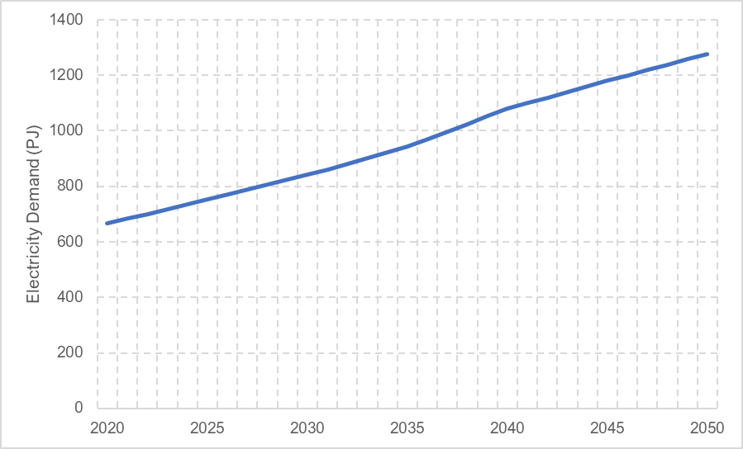
Figure 1: Projection of electricity demand in Vietnam.

Electricity Imports and Exports
Data on electricity imports and exports were taken from the International Energy Agency (IEA n.d.), noted in Table 2. As the last available entry of imports and exports are for the year 2019, the model assumes that future imports and exports for the REDS and RLP scenarios are the same as this year for the entire modelling period. The PDP 7 (rev) and PDP 8 (draft) scenarios assume the same for electricity exports only, as these scenarios have their own projected import levels (Table 3). The NZ and CET scenarios also assume the 2019 value for electricity imports only, with no limits to electricity exports.

Table 2: Electricity imports and exports from 2015-2019 (IEA n.d.).
 | 2015 | 2016 | 2017 | 2018 | 2019
Imports (PJ) | 5.89 | 9.31 | 8.075 | 10.64 | 11.305
Exports (PJ) | 2.755 | 4.845 | 5.605 | 5.13 | 7.03

Table 3: Projected import levels for the PDP 7 (rev) and PDP 8 (draft) scenarios, in percentage of electricity mix and MW, respectively (The Prime Minister 2016)(Burke and Nguyen 2021).
 | 2020 | 2025 | 2030 | 2035 | 2040 | 2045
PDP 7 (rev) (%) | 2.4 | 1.6 | 1.2
PDP 8 (draft) (MW) | 1,272 | 3,508 | 5,677 | 5,677 | 5,677 | 5,677

Fuel Prices, Emissions, Refineries, Power Transmission and Distribution
Coal, natural gas, hydro, biomass, and oil are the main fuels currently used for energy generation in Vietnam (IEA 2019). Data regarding these fuel prices are gathered from the CCG Vietnam Starter Data Kit (Allington et al. 2021). Figure 2 displays this projection. Additionally, emission factors of fuels are noted in Table 4. Power plants emit greenhouse gases over their lifetime, such as carbon dioxide (CO₂), methane, and nitrous oxides. However, in this study, it is assumed that carbon dioxide is the only gas emitted during fossil fuel combustion, due to its dominance in the power sector (EPA 2022). Thus, the emission factors in CO₂ are used throughout the modelling period. Nonetheless, the emission factor of biomass for the CET scenario was scaled down linearly to zero carbon by 2040 to represent the gradual uptake of sustainable biomass. This is noted in Table 5. Other data such as refineries (Table 6) and the power transmission and distribution system (Table 7) are from the CCG Vietnam Starter Data Kit (Allington et al. 2021) and are assumed to stay constant throughout the modelling period due to lack of available data.
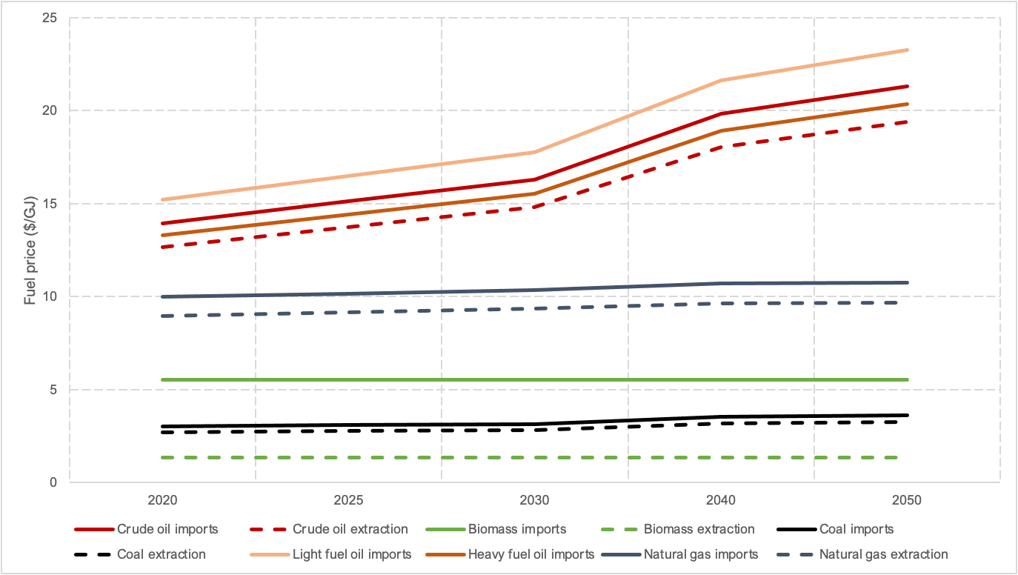
Figure 2: Projection of fuel prices.

Table 4: Estimated CO2 emission factors.
 | CO2 emission factor (kg CO2/GJ)
Crude oil | 73.3
Biomass | 100
Coal | 94.6
Light fuel oil | 69.3
Heavy fuel oil | 77.4
Natural gas | 56.1

Table 5: Assumed emission factor of biomass in the CET scenario.
 | 2020 | 2025 | 2030 | 2035 | 2040
Biomass (kg CO2/GJ) | 100 | 83.3 | 55.5 | 27.8 | 0

Table 6: Technoeconomic assumptions for refineries.
 | Capital cost ($/kW in 2020) | Variable cost ($/GJ in 2020) | Operational life (years) | Output ratio
Crude oil refinery option 1 | 24.1 | 0.71775 | 35 | 0.9 LFO : 0.1 HFO
Crude oil refinery option 2 | 24.1 | 0.71775 | 35 | 0.8 LFO : 0.2 HFO

Table 7: Technoeconomic assumptions for the transmission and distribution system.
 | Capital cost ($/kW in 2020) | Fixed cost ($/kw/yr, 2020) | Operational life (years) | Combined efficiency (2020) | Combined efficiency (2030) | Combined efficiency (2050)
Electricity transmission and distribution | 306.39 | 6.13 | 50 | 0.91 | 0.93 | 0.95

Electricity Generation Technologies
Data regarding electricity generation technologies are collected from the CCG Vietnam Starter Data Kit (Allington et al. 2021) and are shown in Table 8 and Figure 3. It is assumed that the cost and performance of the technologies in Table 8 stays constant throughout the modelling period due to lack of available data. Note that the projected cost reductions of renewable technologies in Vietnam as shown in Figure 3 were estimated based on African projected cost reductions by the International Renewable Energy Agency (IRENA 2021). Nonetheless, slight adjustments to the Starter Data Kit regarding capacities are made, which are noted in the two subsections below. These are used to assume the future proportion of renewable generation technologies in the country.

Table 8: Technoeconomic assumptions of electricity generation technologies.
 | Capital cost ($/kW in 2020) | Fixed cost ($/kW/yr in 2020) | Operational life (years) | Efficiency | Average capacity factor
Biomass power plant | 2,750 | 69 | 25 | 0.38 | 0.7
Coal power plant | 1,300 | 52 | 60 | 0.3 | 0.75
Geothermal power plant | 2,500 | 100 | 50 | 0.1 | 0/7
Light fuel oil power plant | 1,200 | 18 | 50 | 0.4 | 0.25
Oil fired gas turbine | 1,344 | 18 | 50 | 0.4 | 0.25
Gas power plant (CCGT) | 1,000 | 40 | 30 | 0.55 | 0.55
Gas power palnt (SCGT) | 784 | 23 | 30 | 0.35 | 0.55
Solar PV (utility) | 1,160 | 15.08 | 30 | 1 | 0.23
CSP with storage | 4,965.31 | 120 | 35 | 0.33 | 0.3
Large hydropower plant (10-100 MW) | 1,539 | 46.17 | 40 | 1 | 0.49
Medium hydropower plant (10-100 MW) | 1,592.86 | 47.79 | 40 | 1 | 0.49
Small hydropower plant (<10 MW) | 2,162 | 64.86 | 40 | 1 | 0.49
Onshore wind | 2,220.09 | 88.8 | 30 | 1 | 0.15
Offshore wind | 2,876.21 | 115.05 | 30 | 1 | 0.27
Nuclear power plant | 5,500 | 138.0 | 60 | 0.33 | 0.83
Light fuel oil standalone generator (1kW) | 1,500 | 38.0 | 20 | 0.42 | 0.4
Solar PV (distributed with storage) | 2,130.8 | 42.62 | 24 | 1.0 | 0.23
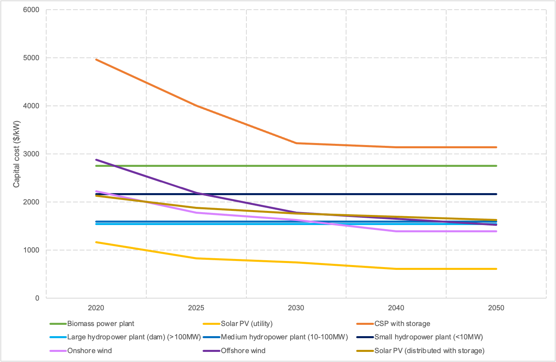
Figure 3: Projected capital costs of renewable generation technologies.

Existing Hydropower Capacity
The existing hydropower capacity within Vietnam is calculated to determine the future generation proportion of large, medium, small, and off-grid hydropower plant (Table 9). Data for this was collected from a national hydropower database (Open Development Vietnam 2020) and an international organization report (Asian Development Bank 2011). From this, scenario targets that require a certain amount of hydropower in the energy generation mix are segregated into the different sizes based on the calculation. The research therefore assumes that the capacity proportion of large, medium, small, and off-grid hydropower stays the same throughout the modelling period.

Table 9: Proportion of existing hydropower plants in Vietnam based on number and capacity.
Size | Number of power plants | Number proportion (%) | Capacity (MW) | Capacity proportion (%)
Large (> 100 MW) | 38 | 9.31 | 14,010 | 63.8
Medium (10-100 MW) | 257 | 63.0% | 7451 | 33.9
Small (< 10 MW) | 76 | 18.6% | 515.3 | 2.34
Off-grid | 37 | 9.07% | 0.254 | 0.0012

Existing Wind Power Capacity
The existing wind power capacity within Vietnam is calculated (Table 10) to determine the generation proportion of onshore and offshore wind (Table 11). Data for this calculation was gathered from an offshore wind farm database (4C Offshore 2022) and an online web article (Lin 2022). From this, scenario targets that require a certain amount of wind power in the energy generation mix are segregated into onshore and offshore based on the calculation. The research therefore assumes that the capacity proportion of onshore and offshore wind stays the same throughout the modelling period.
The existing wind power capacity within Vietnam is calculated (Table 3) to determine the generation proportion of onshore and offshore wind (Table 11). From this, scenario targets that require a certain amount of wind power in the energy generation mix are segregated into onshore and offshore based on the calculation. The research therefore assumes that the capacity proportion of onshore and offshore wind stays the same throughout the modelling period.

Table 10: List of existing offshore wind plants in Vietnam and their generation capacities.
Offshore Wind | MW
Bac Lieu – phase 1 (intertidal) | 16
Bac Lieu – phase 2 (intertidal) | 83.2
V1-1 – Truong Long Hoa (intertidal) | 48
V1-2 – Truong Long Hoa (intertidal) | 48
Total | 195.2

Table 11: Proportion of existing onshore and offshore wind plants in Vietnam based on capacity.
 | MW | Proportion (%)
Onshore Wind | 600 | 75
Offshore Wind | 195.2 | 25

Renewable Energy Potential and Reserves
In this study, data on domestic renewable energy potentials and fossil fuel reserves are taken from the CCG Vietnam Starter Data Kit (Allington et al. 2021). It is assumed that all existing and future power plants are allowed to contribute to the reserves. These reserves are kept the same in all scenarios and do not include any contribution from associated reserves in neighbouring countries. Table 12 and Table 13 lists the estimated renewable energy potentials and fossil fuel reserves. The maximum capacity potential for hydropower is noted in the subsection below.

Table 12: Renewable energy potentials
Solar PV (LCOE <$150/MWh) | 3,718.9 TWh/yr
Onshore Wind (LCOE <$150/MWh) | 636.1 TWh/yr
Offshore Wind | 4553.93 TWh/yr
Geothermal | 400 MW

Table 13: Fossil fuel reserves
Coal (million tonnes) | 3,360
Crude oil (billion barrels) | 4.4
Natural gas (trillion cubic metres) | 0.65

Maximum Hydropower Capacity
Evaluation research has shown that future exploitation of hydropower capacity in Vietnam can reach up to 38,000 MW (Vietnam Electricity 2019). From this, the technical potential is assumed to be split into 70%, 15%, 13%, and 2% into large, medium, small, and off-grid hydropower (Table 5). This value is therefore used as the total annual maximum capacity for all years in the modelling period. It is also assumed that the technical potential of hydropower will not change in the future.

Table 14: Assumed maximum hydropower capacity in Vietnam.
Size | GW
Large (> 100 MW) | 26.6
Med (10-100 MW) | 5.7
Small (< 10 MW) | 4.94
Off-grid | 0.76

Experimental Design, Materials, and Methods

Most of the above data were gathered through the free and accessible CCG Vietnam Starter Data Kit (Allington et al. 2021). Otherwise, an extensive literature review was carried out to gather the remaining data. This included material from international organizations, journal articles, and media reports. The data was compiled, presented, and discussed with local stakeholders to reach consensus on the main data and assumptions to be used in the analysis.

Acknowledgements
The research in this paper was funded by the Climate Compatible Growth (CCG) programme of the United Kingdom Foreign, Commonwealth and Development Office (FCDO), in a project carried out for the British Embassy in Hanoi. The authors would like to thank all the partners for their continued support, involvement, and guidance during this study. The views expressed in this paper do not necessarily reflect the United Kingdom government’s official policies.

References
4C Offshore. 2022. “Offshore Wind Farms in Vietnam.” 2022.
Allington, Lucy, Carla Cannone, Ioannis Pappis, Karla Cervantes Barron, Will Usher, Steve Pye, Edward Brown, et al. 2021. “Selected ‘Starter Kit’ Energy System Modelling Data for Vietnam (#CCG).” Research Square, July.
Asian Development Bank. 2011. “Energy for All: Viet Nam’s Viet Nam’s Success in Increasing Access to Energy through Rural Electrification.” Mandaluyong City, Philippines.
Asia-Pacific Economic Cooperation. 2019. “APEC Energy Demand and Supply Outlook (7th Edition) - Volume II.” Tokyo. https://www.apec.org/publications/2019/05/apec-energy-demand-and-supply-outlook-7th-edition---volume-ii.
Burke, Frederick, and Thanh Hai Nguyen. 2021. “Appendix: Key Highlights of the New Draft of National Power Development Plan (Draft PDP8).”
EPA. 2022. “Sources of Greenhouse Gas Emissions.” United States Environmental Protection Agency. August 5, 2022. https://www.epa.gov/ghgemissions/sources-greenhouse-gas-emissions.
IEA. 2019. “Viet Nam.” International Energy Agency. 2019. https://www.iea.org/countries/viet-nam.
———. n.d. “Viet Nam Balance.” International Energy Agency. Accessed August 3, 2022. https://www.iea.org/sankey/#?c=Viet%20Nam&s=Balance.
IRENA. 2021. “Planning and Prospects for Renewable Power: Eastern and Southern Africa.” Abu Dhabi.
Lin, Max Tingyao. 2022. “Vietnam Revs up Plan for Transition from Coal to Wind, Solar.” IHS Markit. April 27, 2022. https://cleanenergynews.ihsmarkit.com/research-analysis/vietnam-revs-up-plan-for-transition-from-coal-to-wind-solar.html#:~:text=According%20to%20the%20International%20Renewable,or%201%25%20of%20the%20total.
Open Development Vietnam. 2020. “Hydropower Plants in Vietnam by October 2020.” OpenDevelopment Mekong. October 2020. https://data.opendevelopmentmekong.net/en/dataset/hydropower-plants-in-vietnam-by-october-2020.
The Prime Minister. 2016. Approval of the Revised National Power Development Master Plan for the 2011-2020 Period with the Vision to 2030 (English). GIZ (Trans.). The Socialist Republic of Vietnam.
Vietnam Electricity. 2019. “Overview of Hydropower in Vietnam.” Vietnam Electricity. June 20, 2019. https://en.evn.com.vn/d6/news/Overview-of-hydropower-in-Vietnam-66-163-1514.aspx.

