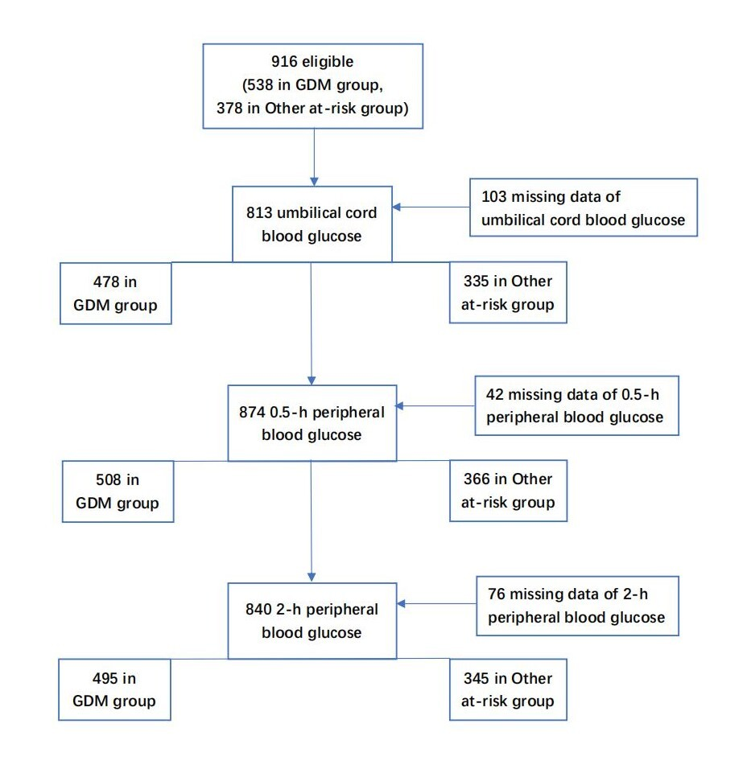

Supplementary Information 1. Flowchart of the included newborns.

