SUPPLEMENTARY
Supplementary Methods:
Flow cytometry:
Euthanized mice were sacrificed on the 31st -day post-infection and spleens were harvested out. Mechanical tapping of the spleen and passing the cells through cell strainers were done to make the single-cell suspension of the splenocytes. The cells were washed with phosphate buffer saline (PBS) and centrifuged at 1000 rpm for 10 min at 4°C and the supernatant was discarded. The cell pellet was then resuspended in 2ml RBC Lysis Buffer for getting rid of the RBC in the solution. They were incubated for 5 minutes at room temperature. After that, the cells were centrifuged for 10 min at 4°C at 1000 rpm, and the pellet was resuspended in PBS for washing. The washing was repeated for three times. The cells were finally resuspended in cell staining buffer (CSB) containing 2% FBS in PBS. The cells were first blocked by incubating them with anti-CD16/CD32 followed by two washing steps with PBS.
The cells were then aliquoted and incubated with the fluorochrome-conjugated antibodies (Milteny Biotech) according to the combination necessary for experiment requirement by following the manufacturer’s protocol for antibody dilution, duration of incubation, washing etc. For intracellular staining the permeabilization of the cells were done by the 0.1-0.3% Triton™ X-100 followed by fixation by using 4% paraformaldehyde followed by washing with PBS. Side scatter and Forward scatter gate reference is used to determine the viable or live cell population. Isotype-matched antibodies (Milteny biotech) were used as staining controls. Unstained cells are used to understand signal from each antibody and to adjust the compensation matrix. The data compensation for the fluorescence spill over to other filters was taken care of by the software gating. Fluorescence signals from the labelled cells were acquired using a BD AriaIII Machine and analysed by Flow Jo software.
Supp. Table 1: Flow Cytometry Antibody combination used in the study along with the References:
Flow Cytometry Antibody combination used | Phenotypes/Activation marker | References
Dendritic Cells |  | [1] P. J. Dunne, B. Moran, R. C. Cummins, and K. H. G. Mills, “CD11c+CD8α+ Dendritic Cells Promote Protective Immunity to Respiratory Infection with Bordetella pertussis,” J. Immunol., vol. 183, no. 1, pp. 400–410, Jul. 2009, doi: 10.4049/JIMMUNOL.0900169.  [2] P. Schnorrer et al., “The dominant role of CD8+ dendritic cells in cross-presentation is not dictated by antigen capture,” Proc. Natl. Acad. Sci. U. S. A., vol. 103, no. 28, pp. 10729–10734, Jul. 2006, doi: 10.1073/PNAS.0601956103/SUPPL_FILE/01956FIG5.PDF.
CD11c+CD8a | Conventional Dendritic cells (cDC)
CD11c+CD8a+ CD80+ CD86 | costimulatory expression
CD11c+CD8a+ MHCI+ MHCII | MHC / costimulation marker
CD11c+CD8a+ DEC 205 | Activation/ costimulation marker
T cells: |  | [1] Golubovskaya V, Wu L. Different Subsets of T Cells, Memory, Effector Functions, and CAR-T Immunotherapy. Cancers (Basel). 2016;8(3):36. Published 2016 Mar 15. doi:10.3390/cancers8030036  [2] Sengupta A, Keswani T, Sarkar S, Ghosh S, Mukherjee S, Bhattacharyya A. Autophagic induction modulates splenic plasmacytoid dendritic cell mediated immune response in cerebral malarial infection model. Microbes Infect. 2019;21(10):475-484. doi:10.1016/j.micinf.2019.05.004  [3] Abcam website: https://www.abcam.com/primary-antibodies/effector-t-cell-markers
CD3+CD8+ | Cytotoxic T cells
CD3+CD8+CD28 | costimulatory expression
CD3+CD4+ | Helper T cells
CD3+CD4+ FOXP3+ | Treg subset of CD4T cells
CD3+CD4+ RORγT+ | Th17 subset of CD4T cells
B cells: |  | [1] “Regulatory B Cell Markers: R&D Systems.” https://www.rndsystems.com/resources/cell-markers/immune-cells/b-cells/regulatory-b-cell-markers  [2] Bio Rad B cell marker guide  https://www.bio-rad-antibodies.com/b-cell-function-activation-lineage-marker-antibody.html
B220^{low/neg}+CD19-IgD-CD138+ | Plasma B cells
B220+CD19+IgM+ | Immature B
B220+CD19+CD80+ | Memory B

2.5 Serology screening
Blood samples (0.5 ml) were collected from all the animal groups of Table 1 on the day of sacrifice. We have also collected serum after the first and second vaccine dose to check the serum level of the antibody produce before the virus challenge. Serum (0.15 ml) was separated following the standard procedure as described before [41]. For serum screening, 96-well microplates (Nunclon, Copenhagen, Den-mark) were coated with 0.5 µg/mL recombinant H1N1 or H3N2 Hemagglutinin (HA) antigen (as according to experiment requirement) in sterile PBS and incubated 4°C overnight. Serum samples were diluted in PBS 2.5 % fat-free milk buffer with 0.05 % Tween 20. Serial dilutions from 1:100 to 1:100,000 were prepared and 100 µl from each dilution were transferred in duplicate wells into antigen coated plates, followed by incubation at 37oC for 90 min. Thereafter, plates were rinsed with PBS+0.05% Tween 20 (PBS-T). HRP-labelled conjugate goat-anti-mouse IgG (BioRad, Richmond, CA) was added to each well (100 µl/well) and incubated at 37oC for 90 min. For the IgG subtyping, anti-mouse IgG1, IgG2a, IgG2b and IgG3 antibodies are used followed by anti-goat IgG-HRP antibody. Then, plates were washed again with PBS-T, followed by addition of 0.2 g o-phenylenediamine (OPD) (from Sigma-Aldrich, S:t Louis, MA) to 0.03% H2O2 in 1ml. Then, plates were incubated in dark for 30 min at room temperature. The reaction termination was done by adding 100 µl of 2.5 % H2SO4 to each well. The absorbance was measured at OD in ELISA plate reader (Molecular Devices, Spectramax ID3). Cut off value for positive reactivity was calculated from the mean OD490 plus 3SD for negative control samples.
2.5 Hemagglutination inhibition assay.
The hemagglutination inhibition assay (HAI) was used to evaluate the presence of neutralizing anti-HA antibodies against viral influenza A in serum from individual mice as described previously [45]. An HI titer≥ 40 was defined as a protective amount of serum antibodies. In short, serum from individual mice was treated with receptor-destroying enzyme (RDE) at 37°C overnight. This is to remove non-specific serum HAI inhibitors. RDE was inactivated by incubation for 30 min at 56°C followed by the addition of 350µl NaCl 0.9%. The HAI assay was initiated by adding 25µl PBS to each well of a microtitre plate, followed by the addition of 50µl of receptor-destroying enzyme (RDE) treated serum. Serum was diluted in 8-fold serial dilutions starting from 1/10 up to 1/1280 dilutions. 25µl of influenza A/H1N1/CA09pdm containing 4 haemagglutinating units (HU) was added in to each well. The plate was shaken, covered, and incubated for 15 min at 20-25°C. Subsequently, 50µl chicken erythrocytes were added, and mixed, followed by incubation at 4°C for one hour. Thereafter, the plate was evaluated for hemagglutination and the degree of hemagglutination inhibition (HAI). The highest dilution fold of serum activity and neutralizations are noted to understand serum potency of virus neutralization.
SUPPLEMENTARY FIGURES
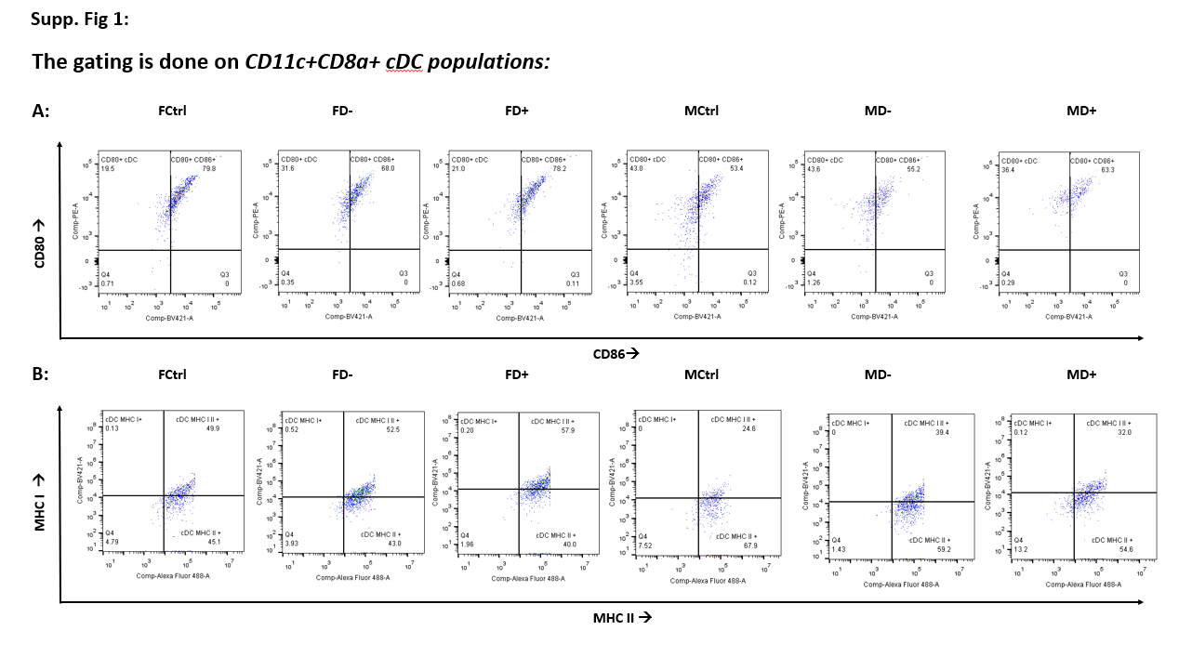
Supplementary Figure 1: Costimulatory marker CD80/ CD86 and MHCI/ MHCII expression on dendritic cells: A) The CD11c+CD8a+ dendritic cells gated out as in Fig 2A have been studied for the expression of CD80 and CD86. B) CD11c+CD8a+ cells are evaluated for the expression of MHCI and MHCII markers. These are the representative plots from individual groups that have been studied. The double positive cell populations are statistically evaluated and presented in Fig 2C of the main manuscript.
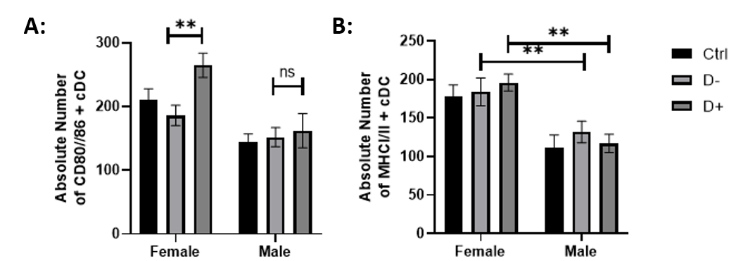
Supplementary Figure 2: A) The absolute cell number for CD11c+CD8a+CD80+CD86+ cDC are presented in the bar diagram. B) The absolute cell number for CD11c+CD8a+MHCI+MHCII+ cDC are presented in the bar diagram. Data in graphs are the representative images derived from at least four independent experiments (*p < 0.05, **p < 0.01 and ***p < 0.001).
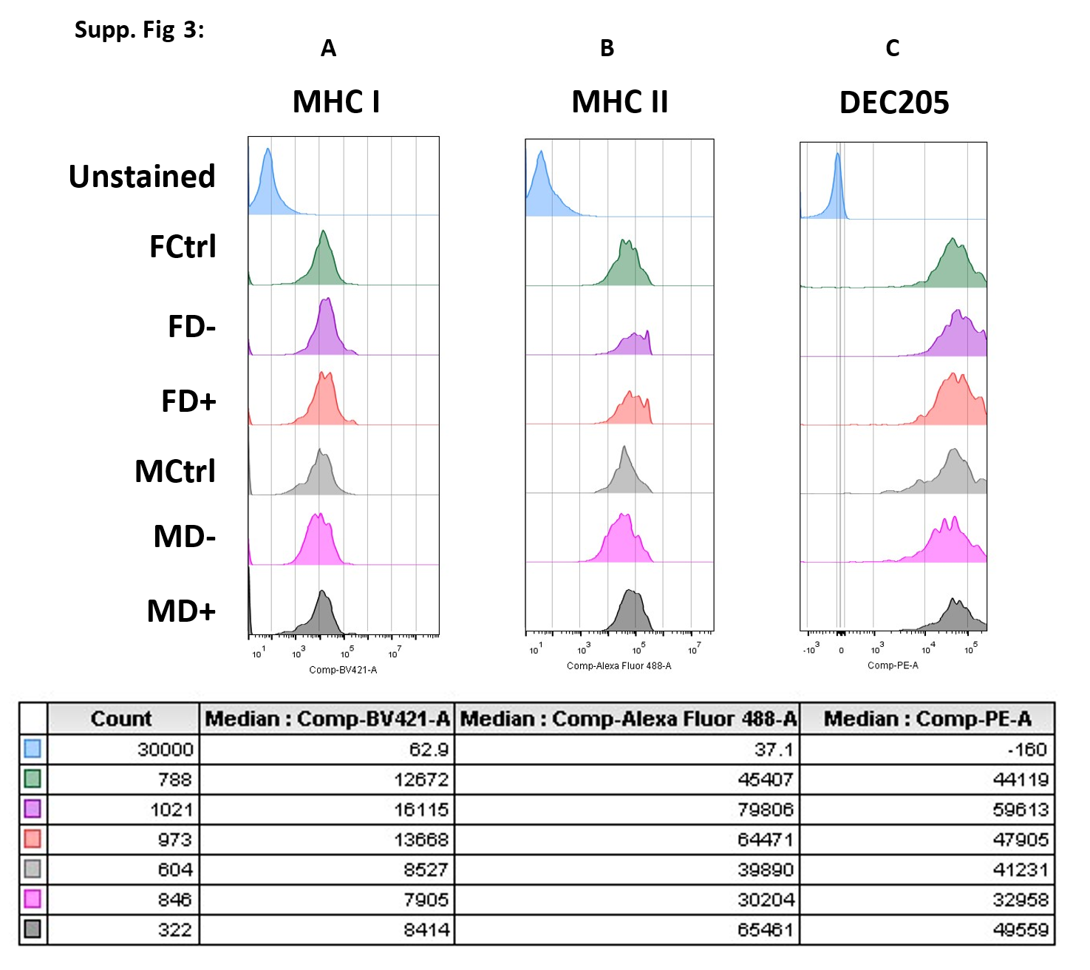
Supplementary Figure 3: Histogram plots of the cDC expressing A)MHCI B)MHCII and C)DEC205 are presented here with the MFI values in the table. These are the representative plots from individual groups that have been studied.
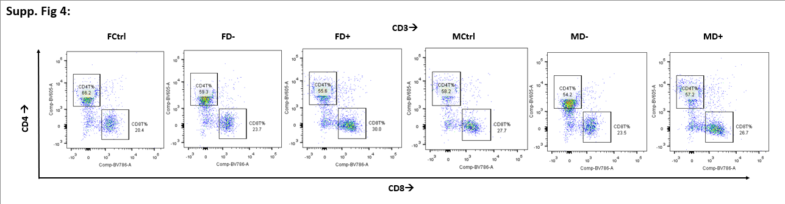
Supplementary Fig 4: CD3+ cell populations are gated out as presented in Fig 3A and the CD4+ and CD8+ expression are assessed. The helper CD4T cells and cytotoxic CD8T cells have been studied for the population percentage. These are the representative plots from individual groups that have been studied.

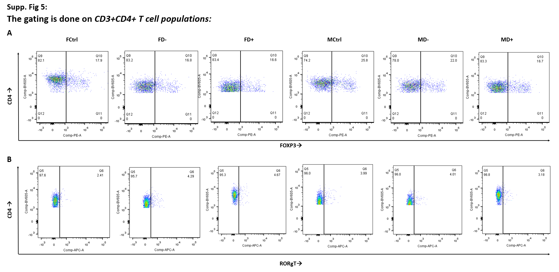
Supplementary Figure 5: CD3+CD4+ T cells are studied for the A) expression of regulatory T cell marker (FOXP3) and for B) Th17 cell marker (RORgT). These are the representative plots from individual groups that have been studied.

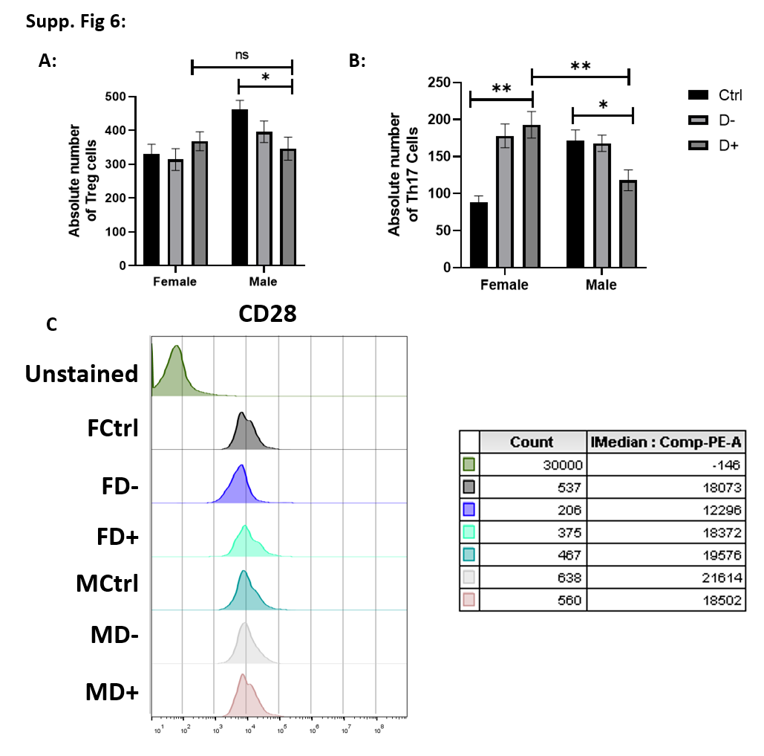
Supplementary Figure 6: A) Absolute number of CD3+CD4+FoXP3+ regulatory T cells (Treg) have been plotted in the bar diagram. B) Absolute number of CD3+CD4+RoRgT Th17 cells have been plotted in the bar diagram. C) The histogram plots with the MFI values of CD28 expression on CD3+CD8+ cytotoxic T cells are presented. These are the representative plots from individual groups that have been studied. Data in graphs are the representative images derived from at least four independent experiments (*p < 0.05, **p < 0.01 and ***p < 0.001).
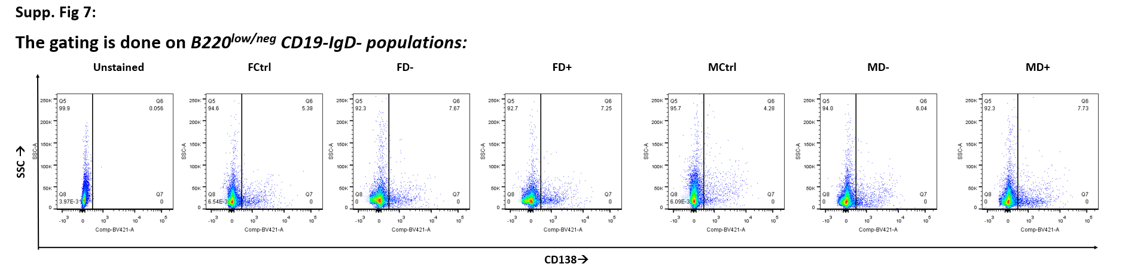
Supplementary Fig 7: CD19-IgD- cell populations gated out from B220^{low/neg} cells as shown in Fig 4A, 4B. CD138 expression on the population of B220^{low/neg}+CD19-IgD- have been gated and representative plots from each group have been presented here. B220^{low/neg}+CD19-IgD-CD138+ cell population have been considered as Plasma B cell population.
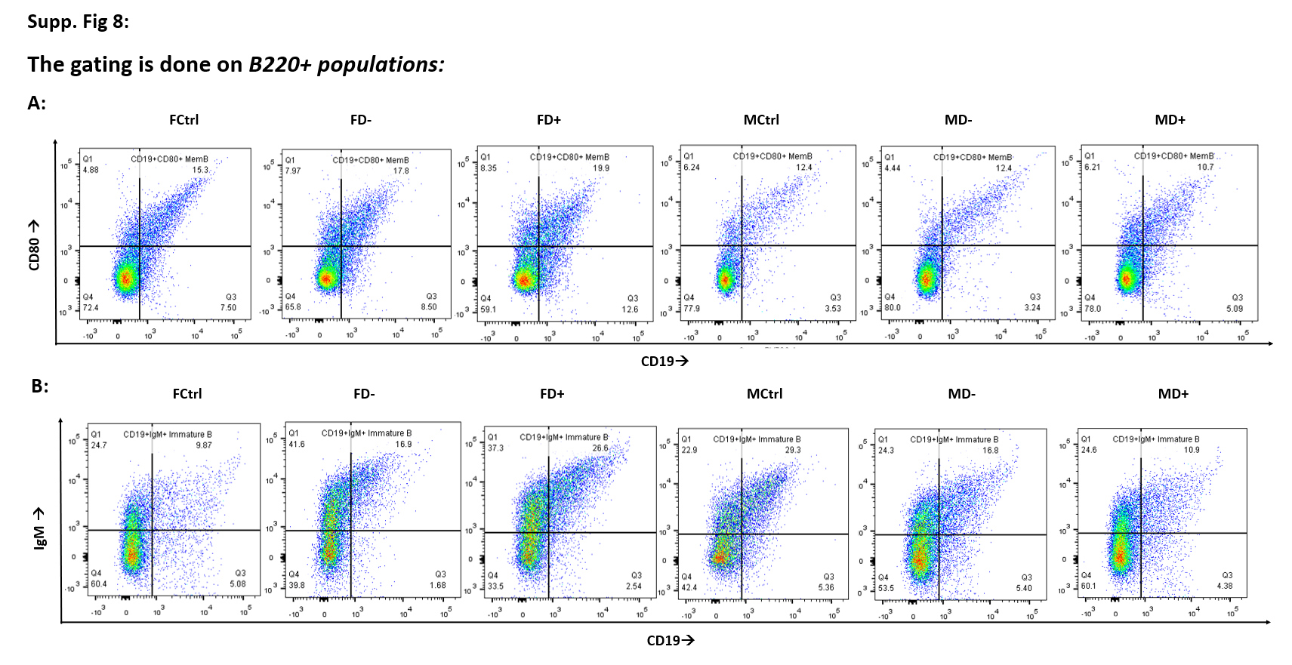
Supplementary Fig 8: B220+ cells of the splenic single cell suspensions as shown in the Fig 4A have been studied for the expression of A) CD19+CD80+ memory B cells and B) CD19+IgM+ immature B cells. The bar diagram is provided in Fig 4E. These are the representative plots from individual groups that have been studied.
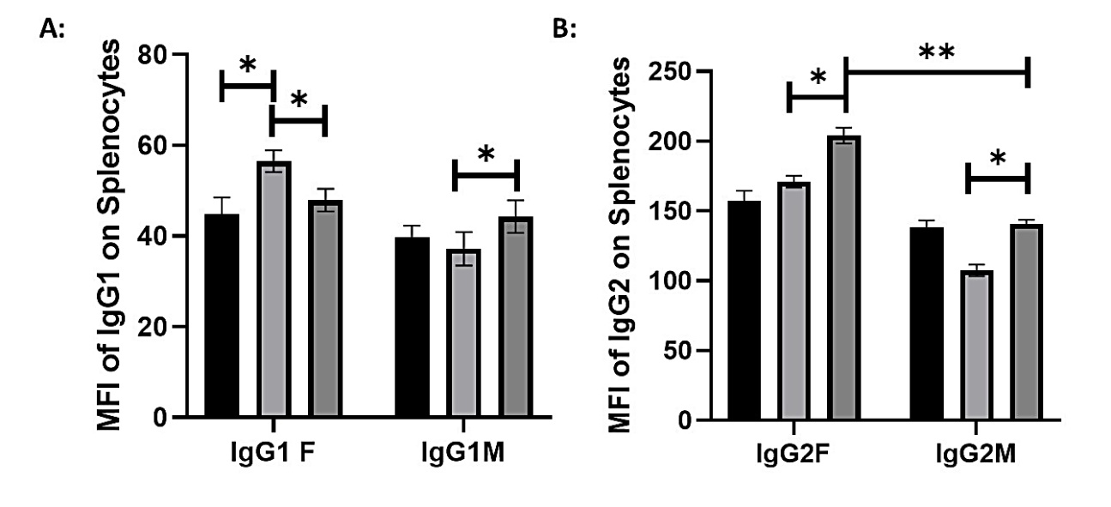
Supplementary Fig 9: The whole splenocyte single cell suspension were permeabilized and stained with the IgG1 and the IgG2 fluorochrome tagged antibodies. As congruent with our result in Fig 6A, we find A) a reduction in whole IgG1 level with B) an increase in IgG2 level in the whole spleen of the female diabetic mice as compared to FD-.

