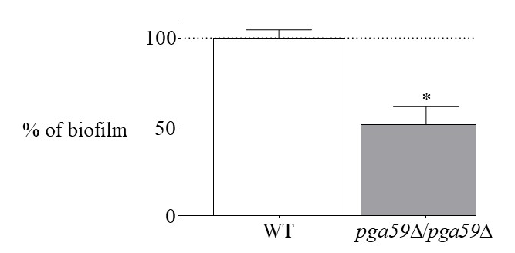

Fig. S3. C. albicans cells lacking Pga59 are defective for biofilm formation. Fungal biofilms were grown in a microfermentor continuous flow system using GHAUM medium. After 40h, the biofilm dry weight was measured in each genetic background. Data are coming from 3 independent replicates. Significance of the biofilm biomass differences was assessed using a Student’s t-test. (*) p < 0.05.

