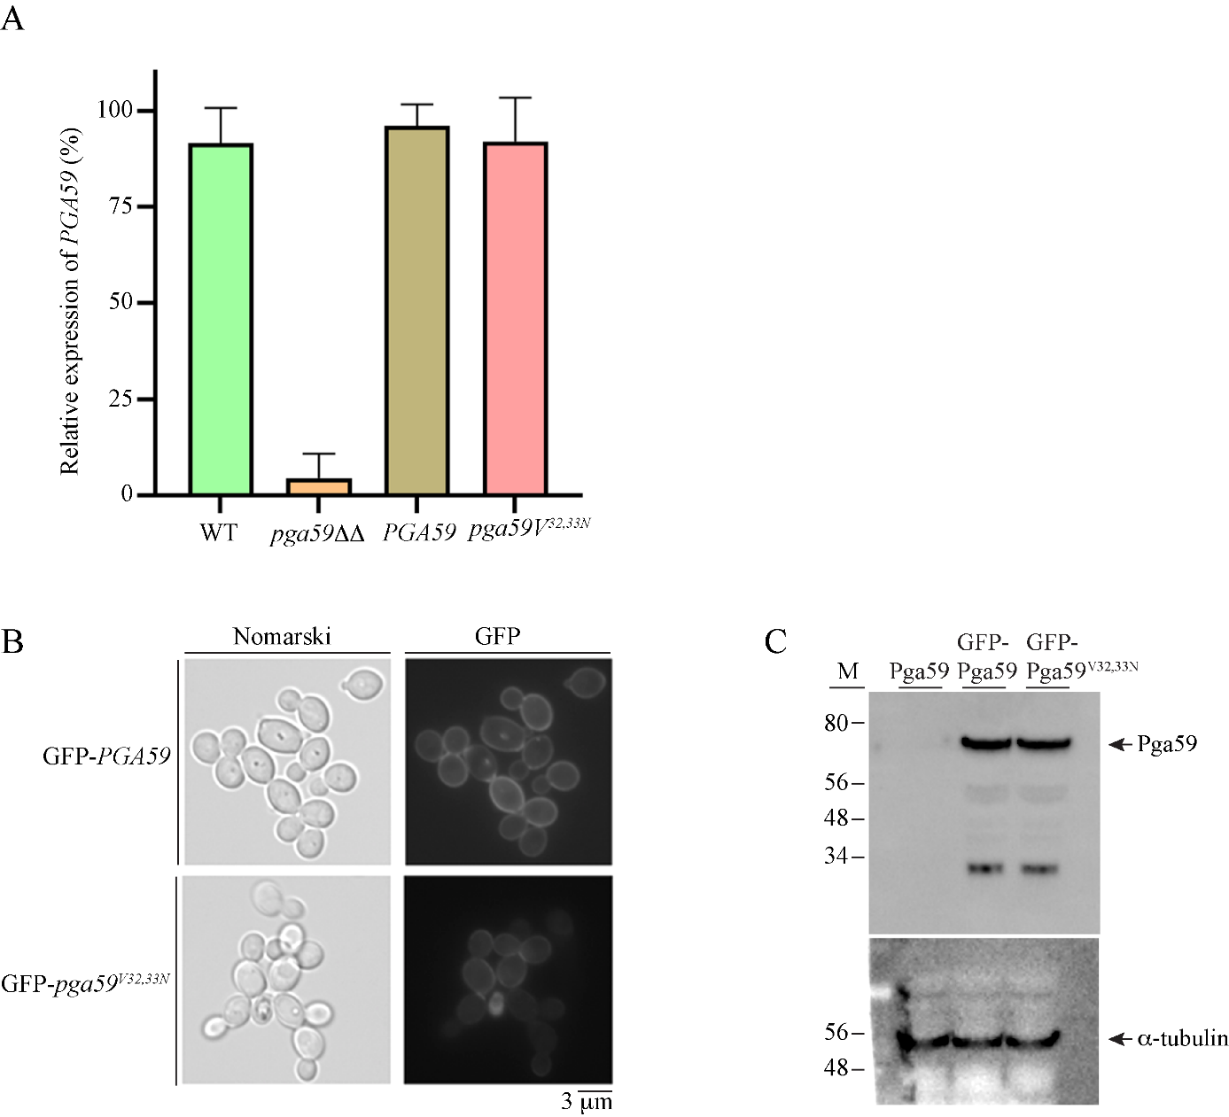

Fig. S2. Pga59^{V32,33N} is well produced and localized within the cell wall of C. albicans. A, mRNAs were isolated from C. albicans cells treated for 1 hour with BSA-coated magnetic beads to trigger cell-cell adhesion. mRNAs from the indicated strains were used to synthetize cDNAs. PGA59 gene expression was evaluated using RT-qPCR. The histogram shows the relative expression of PGA59 in each genetic background. B, fungal cells expressing either GFP-Pga59 or GFP-Pga59^{V32,33N} were analyzed by epifluorescence microscopy to assess the cellular localization of the wild type and the mutant versions of Pga59. C, whole cell extracts were prepared from adherent cells of C. albicans expressing either untagged-Pga59, GFP-Pga59 or GFP-Pga59^{V32,33N}. The quantity of Pga59 was assessed in each strain with an α-GFP antibody while the anti α-tubulin antibody was used as a loading control. Standard molecular weights (M) are indicated on the left.

