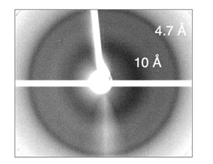
Fig. S1. His₆-Pga59 displays the cross-β diffraction pattern characteristic of β−amyloid structures. His₆-Pga59 was expressed in E. coli and purified by affinity chromatography using a Ni-NTA column. X-ray diffraction pattern after the aggregation of His₆-Pga59 shows reflections at 4.7 Å and 10 Å. The proteins used for X-ray diffraction (Fig. S1) or for TEM and ThT staining (Fig. 2) come from 2 independent rounds of purification.

