Supporting information
Mercury distribution in the surface soil of China is potentially driven by precipitation, vegetation cover and organic matter
Zhao-Yang Zhang^{1, 3}, Gang Li², Lei Yang¹, Xin-Jun Wang⁴, Guo-Xin Sun^{1, 3*}
¹ State Key Laboratory of Urban and Regional Ecology, Research Center for Eco-Environmental Sciences, Chinese Academy of Sciences, Beijing 100085, China.
² Key Laboratory of Urban Environment and Health, Institute of Urban Environment, Chinese Academy of Sciences, Xiamen 361021, China.
³ University of Chinese Academy of Sciences. Beijing 100049, China
⁴ Research Center for Environmental Protection and Water and Soil Conservation, China Academy of Transportation Sciences, 240 #, Huixinli, Chaoyang District, Beijing 100029, China
* Corresponding author. Phone: 86-10-62849328, E-mail: gxsun@rcees.ac.cn.

Figure S1. The relationships of soil Hg concentrations in Europe with (A) European precipitations and (B) soil organic carbon (SOC). The soil Hg data, precipitation and soil organic carbon used in this study are from the Geochemical Mapping of Agricultural Soils (GEMAS) project, which was carried out by the EuroGeoSurveys (EGS) Geochemistry Expert Group. The precipitation dataset Europe was separated into 19 subsets (sampling bin) with every 100 mm/year interval in R, and the last subset contains all points with precipitation greater than 2200 mm/year. One hundred sample points were randomly selected from each subset and the average value of those points was taken as the representative of this subset. The soil organic carbon (SOC) dataset was divided into 13 subsets at interval of 1 g/kg from 0 to 10 g/kg, 10-13 g/kg, 13-26 g/kg and last subset contains all points with SOC more than 26 g/kg. The average of the 200 randomly sampling points obtained for each sampling bin represents this subset.
Figure S2. (A) vegetation cover (created using ArcGIS Geographic Information Systems software version 10.2, Environmental Systems Research Institute Inc, Redlands, Calif); (B) soil Hg map surveyed in 1994.

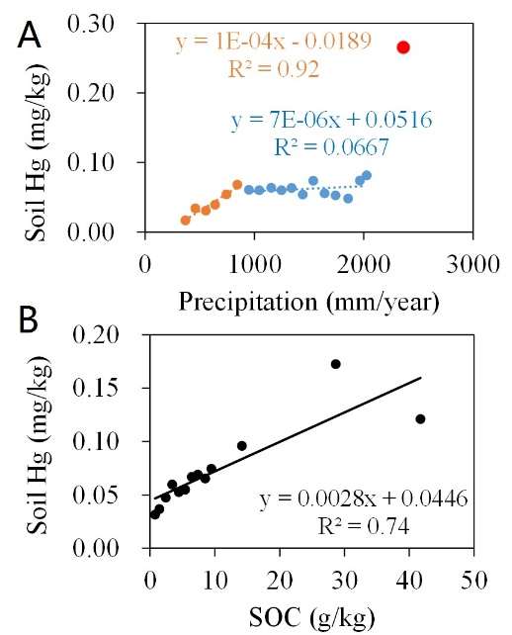
Fig S1. The relationships of soil Hg concentrations in Europe with (A) European precipitations and (B) soil organic carbon (SOC). The soil Hg data, precipitation and soil organic carbon used in this study are from the Geochemical Mapping of Agricultural Soils (GEMAS) project, which was carried out by the EuroGeoSurveys (EGS) Geochemistry Expert Group. The precipitation dataset Europe was separated into 19 subsets (sampling bin) with every 100 mm/year interval in R, and the last subset contains all points with precipitation greater than 2200 mm/year. One hundred sample points were randomly selected from each subset and the average value of those points was taken as the representative of this subset. The soil organic carbon (SOC) dataset was divided into 13 subsets at interval of 1 g/kg from 0 to 10 g/kg,10-13g/kg, 13-26g/kg and last subset contains all points with SOC more than 26g/kg the average of the 200 randomly sampling points obtained for each sampling bin represents this subset.
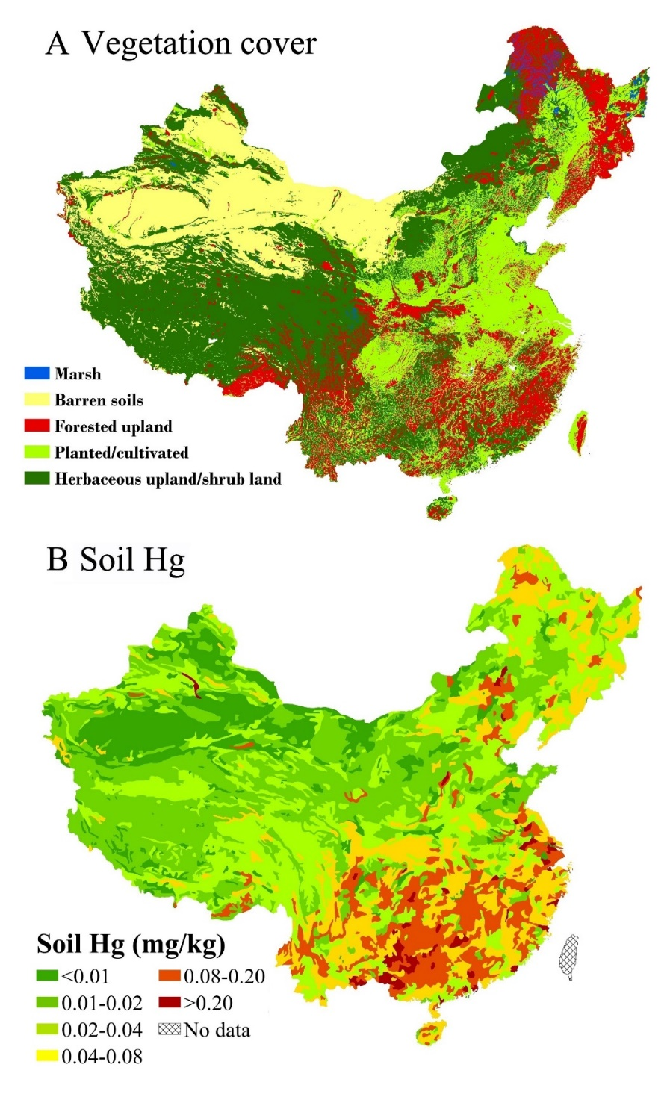
Fig. S2 (A) vegetation cover (created using ArcGIS Geographic Information Systems software version 10.2, Environmental Systems Research Institute Inc, Redlands, Calif); (B) soil Hg map surveyed in 1994.

