Supporting information
Mercury distribution in surface soil of China is potentially driven by precipitation, vegetation cover and organic matter
Zhao-Yang Zhang^{1, 3}, Gang Li², Lei Yang¹, Guo-Xin Sun^{1, 3*}
¹ State Key Laboratory of Urban and Regional Ecology, Research Center for Eco-Environmental Sciences, Chinese Academy of Sciences, Beijing 100085, China.
² Key Laboratory of Urban Environment and Health, Institute of Urban Environment, Chinese Academy of Sciences, Xiamen 361021, China.
³ University of Chinese Academy of Sciences. Beijing 100049, China
* Corresponding author. Phone: 86-10-62849328, E-mail: gxsun@rcees.ac.cn

Figure S1. Spatial distribution of (A) total Hg wet deposition in the conterminous US (Bates, et al., 2017); (B) annual average precipitation in the conterminous US.
Figure S2. (A) Land cover map of the conterminous United States (http://www.greeninfo.org/work/project/mapping-land-cover-protected-areas-for-the-us); (B) soil Hg map of the conterminous United States (Smith, et al., 2014); (C) merged map of (A) and (B).
Figure S3. (A) vegetation cover (created using ArcGIS Geographic Information Systems software version 10.2, Environmental Systems Research Institute Inc, Redlands, Calif); (B) soil Hg map surveyed in 1994.
Figure S4. The relationships of soil Hg concentrations in Europe with (A) European precipitations and (B) soil organic carbon (SOC). The soil Hg data, precipitation and soil organic carbon used in this study are from the Geochemical Mapping of Agricultural Soils (GEMAS) project, which was carried out by the EuroGeoSurveys (EGS) Geochemistry Expert Group. The precipitation dataset Europe was separated into 19 subsets (sampling bin) with every 100 mm/year interval in R, and the last subset contains all points with precipitation greater than 2200 mm/year. One hundred sample points were randomly selected from each subset and the average value of those points was taken as the representative of this subset. The soil organic carbon (SOC) dataset was divided into 13 subsets at interval of 1 g/kg from 0 to 10 g/kg, the average of the 200 randomly sampling points obtained for each sampling bin represents this subset (Figure 2H&2I).

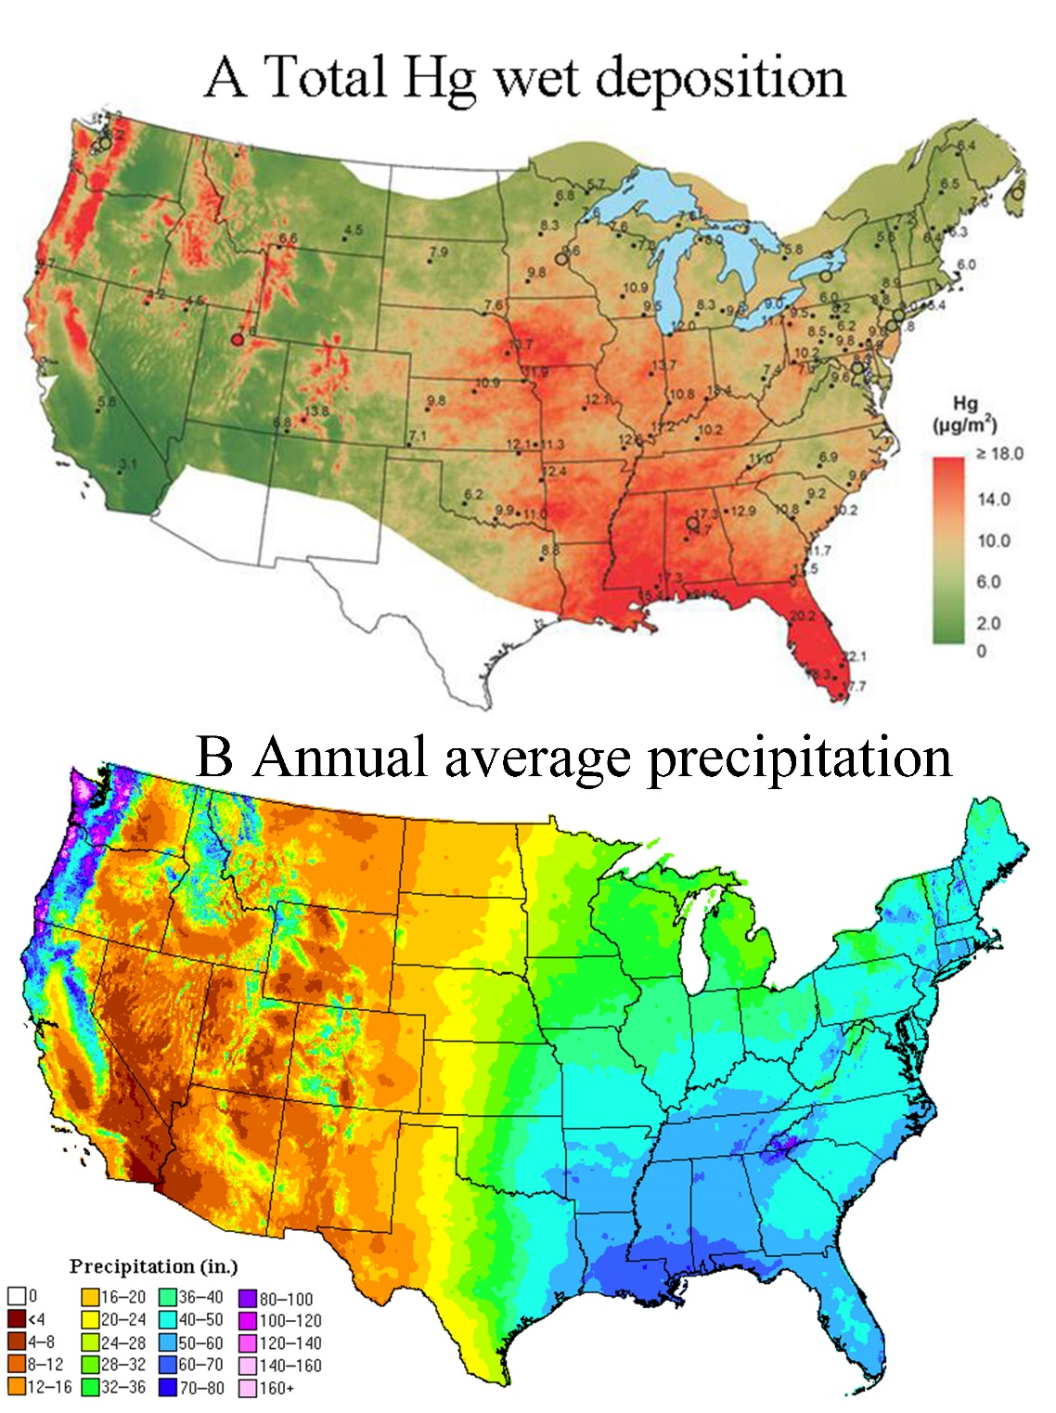
Fig. S1 Spatial distribution of (A) total Hg wet deposition in the conterminous US (Bates, et al., 2017); (B) annual average precipitation in the conterminous US.

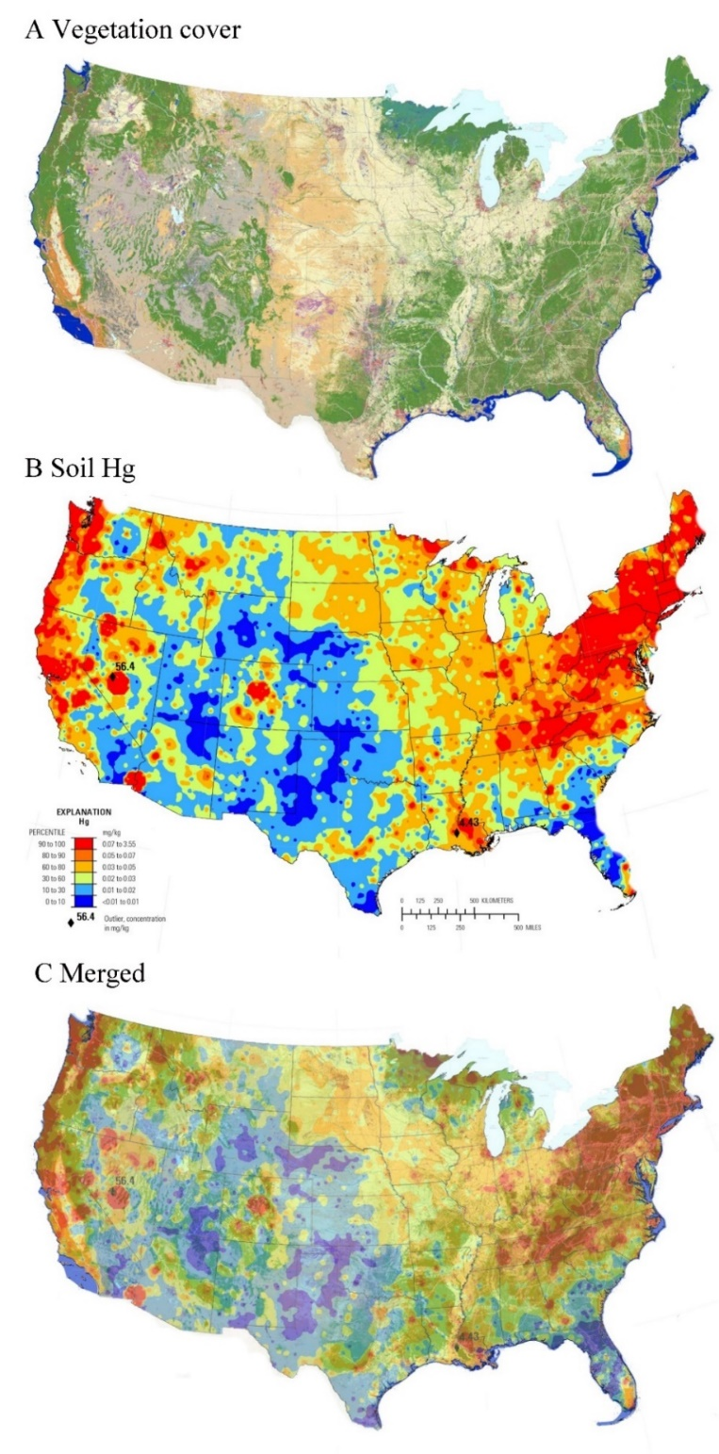
Fig. S2 Figure S2. (A) Land cover map of the conterminous United States (http://www.greeninfo.org/work/project/mapping-land-cover-protected-areas-for-the-us); (B) soil Hg map of the conterminous United States (Smith, et al., 2014); (C) merged map of (A) and (B).

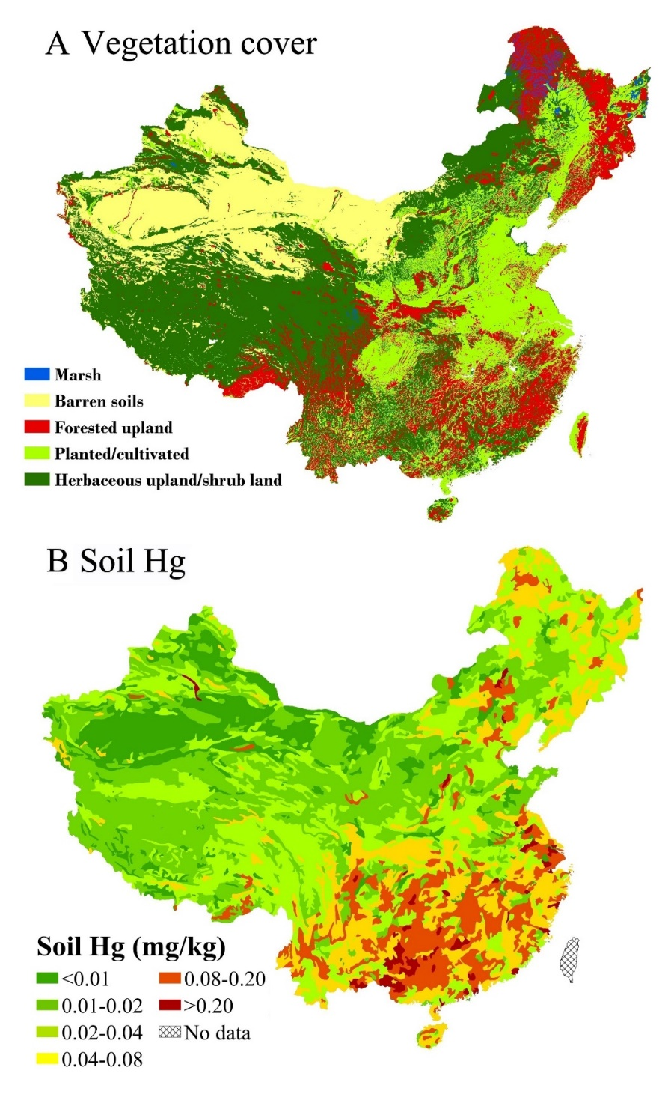
Fig. S3 (A) vegetation cover (created using ArcGIS Geographic Information Systems software version 10.2, Environmental Systems Research Institute Inc, Redlands, Calif); (B) soil Hg map surveyed in 1994.

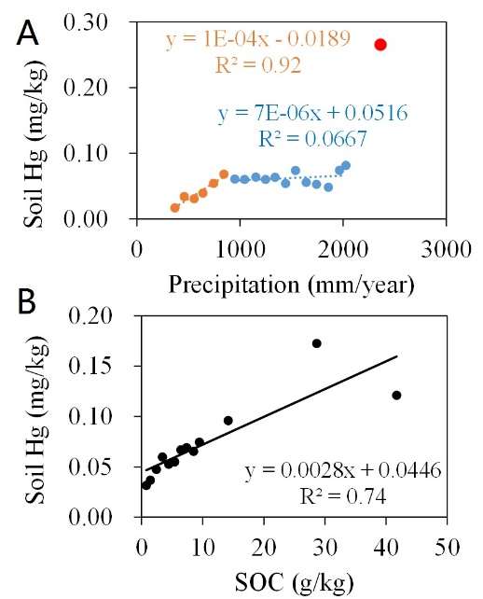
Fig. S4 The relationships of soil Hg concentrations in Europe with (A) European precipitations and (B) soil organic carbon (SOC). The soil Hg data, precipitation and soil organic carbon used in this study are from the Geochemical Mapping of Agricultural Soils (GEMAS) project, which was carried out by the EuroGeoSurveys (EGS) Geochemistry Expert Group. The precipitation dataset Europe was separated into 19 subsets (sampling bin) with every 100 mm/year interval in R, and the last subset contains all points with precipitation greater than 2200 mm/year. One hundred sample points were randomly selected from each subset and the average value of those points was taken as the representative of this subset. The soil organic carbon (SOC) dataset was divided into 13 subsets at interval of 1 g/kg from 0 to 10 g/kg, the average of the 200 randomly sampling points obtained for each sampling bin represents this subset (Figure 2H&2I).

REFERENCES
Bates, P. C., J. R. Miller, D. M. Styers, C. Burda, R. Davis, T. Martin, and B. D. Kloeppel. 2017. Natural resource condition assessment: Carl Sandburg Home National Historic Site. Natural Resource Report NPS/CARL/NRR—2017/1373. National Park Service, Fort Collins, Colorado.
Smith, D. B., Cannon, W. F., Woodruff, L. G., Solano, F., & Ellefsen, K. J. 2014. Geochemical and mineralogical maps for soils of the conterminous United States (No. 2014-1082). US Geological Survey.

