Supplementary tables

Table S1. Primers used for PCR amplification of selected contigs.
Primer name | Primer sequence | Product
PRWline_F | CGGAACACCTGAAAGAGCGA | PRW LINE-like (540 bp)
PRWline_R | GCATGTGTCCAGTCTCCTTG | PRW LINE-like (540 bp)
PRW_F1 | CGAATCCGTCCCCCTACTCT | PRW Bel-Pao part I (1394 bp)
PRW_R1 | ATACAGCCACAAGTCCCACG | PRW Bel-Pao part I (1394 bp)
PRW_F2 | GCAATTCTTCTTGCTCCCAAA | PRW Bel-Pao part II (1466 bp)
PRW_R2 | GCTCCAGTATTTGAAGGCGG | PRW Bel-Pao part II (1466 bp)

Supplementary figures

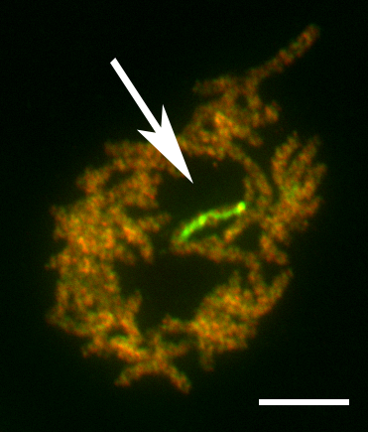
Figure S1. Female pachytene nucleus of Peribatodes rhomboidaria after comparative genomic hybridization (CGH). Male (red signals) and female (green signals) genomic DNAs were hybridized to female meiotic chromosomes. The W chromosome is strongly highlighted by the female probe, suggesting the presence of W-specific or highly W-enriched sequences. Arrow indicates the WZ bivalent. Bar = 10 μm.
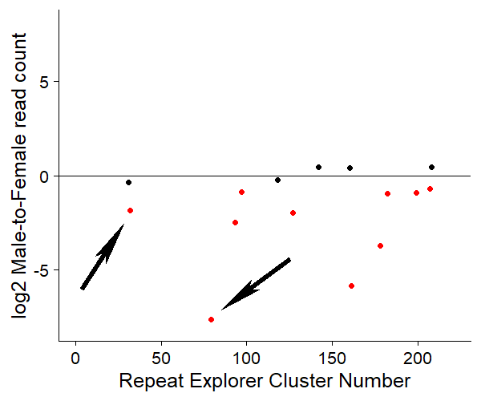
Figure S2. RepeatExplorer results of comparative analysis. Only clusters with statistically significant results between male and female read counts are shown (t-test, P < 0.05). Red dots represent clusters classified as putative W repeats. Clusters 32 and 79, which were further analysed are marked by arrows.

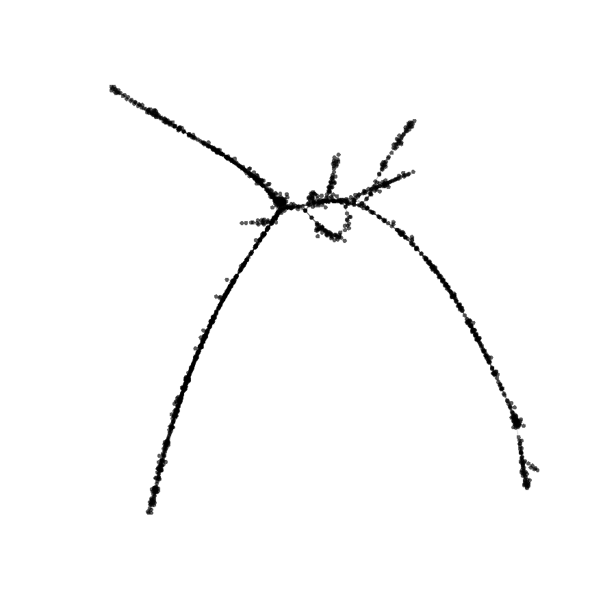
Figure S3. PRW LINE-like RepeatExplorer graph. Graph layout for cluster 32 generated by RepeatExplorer2. Nodes represent individual illumina reads and edges their sequence overlap.

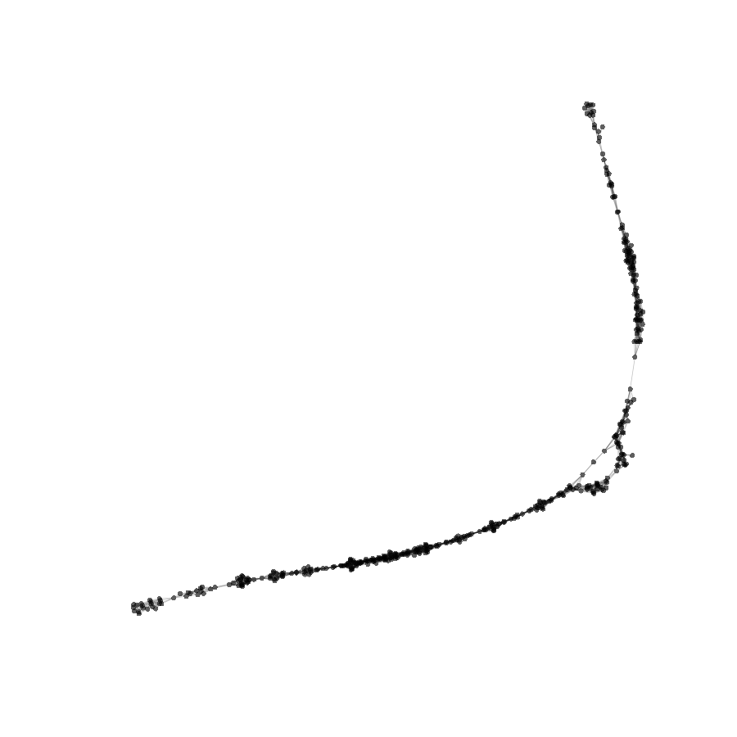Figure S4. PRW Bel-Pao RepeatExplorer graph. Graph layout for cluster 79 generated by RepeatExplorer2. Nodes represent individual illumina reads and edges their sequence overlap.

