Supplemental Materials
Age-dependent prebiotic effects of soluble corn fiber in M-SHIME® gut microbial ecosystems
Marta Calatayud Arroyo ^{1,2#}, Ieva Laurie ^{3#*}, Chloë Rotsaert ¹, Massimo Marzorati ^{1,2}, Davide Risso ³ and Kavita Karnik ³
¹ ProDigest, Technologiepark 82, 9052 Zwijnaarde, Belgium; marta.calatayudarroyo@ugent.be (MCA), chloe.rotsaert@prodigest.eu (CR), massimo.marzorati@prodigest.eu (MM)
² Center for Microbial Ecology and Technology (CMET), Faculty of Bioscience Engineering, Ghent University, Coupure Links 653, 9000 Ghent, Belgium
³ Tate & Lyle PLC, 5 Marble Arch, London, W1H 7EJ, United Kingdom; ieva.laurie@tateandlyle.com (IL), da-vide.risso@tateandlyle.com (DR), kavita.karnik@tateandlyle.com (KK)
* Correspondence: ieva.laurie@tateandlyle.com; Tel.: +447900632410
# Equal contribution

Table S1. Effect of M-SHIME supernatants from baby A on epithelial barrier function, cytokine production and NFΚβ activity of the Caco-2 model. Data represent mean ± standard deviation (n=3) of cells exposed to M-SHIME supernatants from week 2 of control period, week 3 of treatment period (1.5 g/L) and week 2 of washout period. TEER values measured after 6 hours of LPS proinflammatory trigger in presence of M-SHIME supernatants are refereed to baseline values obtained after exposure to M-SHIME supernatants (24 hours), before LPS addition. Statistically significant differences (ordinary one-way ANOVA) between control period and treatment or washout periods are marked in bold. Differences between treatment period and washout are marked with italics.

 |  | TEER |  |  | LY |  |  | IL-8 |  |  | TNF |  |  | IL-6 |  |  | IL-10 |  |  | NF-kB
 |  | % to baseline |  |  | µM |  |  | ng/mL |  |  |  |  |  | pg/mL |  |  |  |  |  | OD630
Control | AC | 77.53 | ± | 9.90 | 7.23 | ± | 0.98 | 13.604 | ± | 1.617 | 6.077 | ± | 2.416 | 55.026 | ± | 4.320 | 33.540 | ± | 3.625 | 0.785 | ± | 0.038
Treatment | AC | 94.82 | ± | 5.78 | 5.26 | ± | 1.63 | 11.093 | ± | 1.364 | 7.401 | ± | 3.299 | 44.477 | ± | 0.774 | 18.698 | ± | 3.800 | 0.722 | ± | 0.030
Washout | AC | 92.74 | ± | 3.24 | 3.25 | ± | 0.43 | 11.585 | ± | 1.496 | 4.391 | ± | 5.428 | 49.810 | ± | 16.814 | 22.195 | ± | 8.135 | 0.793 | ± | 0.046
Control | TC | 68.73 | ± | 5.67 | 8.76 | ± | 0.07 | 17.504 | ± | 0.745 | 6.541 | ± | 3.116 | 60.836 | ± | 6.335 | 52.428 | ± | 9.705 | 0.866 | ± | 0.074
Treatment | TC | 83.39 | ± | 7.38 | 6.07 | ± | 0.94 | 13.337 | ± | 1.102 | 2.449 | ± | 1.467 | 49.965 | ± | 2.096 | 26.476 | ± | 2.133 | 0.681 | ± | 0.055
Washout | TC | 86.98 | ± | 3.72 | 4.45 | ± | 0.56 | 14.104 | ± | 0.082 | 6.462 | ± | 3.192 | 64.354 | ± | 6.237 | 41.960 | ± | 10.445 | 0.760 | ± | 0.074
Control | DC | 72.67 | ± | 9.05 | 7.45 | ± | 0.74 | 15.036 | ± | 0.197 | 3.787 | ± | 0.423 | 57.661 | ± | 5.142 | 37.108 | ± | 4.439 | 0.780 | ± | 0.079
Treatment | DC | 85.57 | ± | 6.24 | 7.14 | ± | 1.33 | 13.454 | ± | 2.582 | 6.763 | ± | 1.422 | 50.366 | ± | 7.960 | 31.204 | ± | 7.969 | 0.713 | ± | 0.053
Washout | DC | 75.84 | ± | 2.76 | 6.44 | ± | 1.44 | 14.589 | ± | 0.195 | 4.486 | ± | 2.369 | 59.428 | ± | 5.632 | 46.499 | ± | 5.813 | 0.808 | ± | 0.045

Table S2. Effect of M-SHIME supernatants from Baby B on epithelial barrier function of the Caco-2 model. Data represent mean ± standard deviation (n=3) of cells exposed to M-SHIME supernatants from week 2 of control period, week 3 of treatment period (1.5 g/L, 3 g/L ad 4.5 g/L) and week 2 of washout period, in fecal simulations from donor Baby B. Epithelial barrier was evaluated measuring transepithelial electrical resistance (TEER) and transport to the basolateral compartment of the fluorescent marker Lucifer yellow (LY). TEER values measured after 6 hours of LPS proinflammatory trigger in presence of M-SHIME supernatants are refereed to baseline values obtained after exposure to M-SHIME supernatants (24 hours), before LPS addition. Statistically significant differences (ordinary one-way ANOVA) between control period and treatment or washout periods are marked in bold. Differences between treatment period and washout are marked with italics.

 | Proximal colon
 | TEER (%) |  |  |  |  |  |  |  |  | LY (µM)
 | SCF 1.5 g/L |  |  | SCF 3 g/L |  |  | SCF 4.5 g/L |  |  | SCF 1.5 g/L |  |  | SCF 3 g/L |  |  |  | SCF 4.5 g/L
Control | 110.55 | ± | 2.44 | 118.99 | ± | 2.79 | 109.14 | ± | 6.80 | 3.83 | ± | 0.52 | 2.75 | ± | 0.24 | 3.12 |  | ± | 0.76
Treatment | 97.83 | ± | 2.75 | 98.55 | ± | 4.59 | 103.94 | ± | 0.51 | 4.49 | ± | 0.30 | 4.23 | ± | 0.32 | 3.73 |  | ± | 0.05
Wash-out | 102.83 | ± | 4.01 | 107.87 | ± | 6.02 | 119.79 | ± | 2.59 | 3.34 | ± | 0.20 | 6.21 | ± | 0.67 | 5.31 |  | ± | 0.13
 | Distal colon
 | TEER (%) |  |  |  |  |  |  |  |  | LY (µM)
Control | 107.73 | ± | 3.07 | 108.89 | ± | 0.82 | 107.67 | ± | 3.89 | 3.31 | ± | 0.32 | 3.61 | ± | 0.83 | 3.13 |  | ± | 0.60
Treatment | 100.57 | ± | 4.34 | 97.31 | ± | 4.45 | 100.85 | ± | 2.91 | 4.03 | ± | 0.36 | 4.18 | ± | 0.80 | 3.90 |  | ± | 0.45
Wash-out | 100.16 | ± | 2.49 | 108.71 | ± | 8.09 | 117.07 | ± | 0.79 | 3.46 | ± | 0.42 | 5.31 | ± | 0.20 | 6.42 |  | ± | 1.27

Table S3. Effect of M-SHIME supernatants from Baby B on cytokine production and NFΚβ activity of the Caco-2 model. Data represent mean ± standard deviation (n=3) of cells exposed to M-SHIME supernatants from proximal and distal colon at week 2 of control period, week 3 of treatment period (1.5 g/L, 3 g/L ad 4.5 g/L) and week 2 of washout period. Statistically significant differences (ordinary one-way ANOVA) between control period and treatment or washout periods are marked in bold. Differences between treatment period and washout are marked with italics. PC = proximal colon; DC = distal colon.

SCF dose | Compartment | Treatment period | IL-8 |  |  | TNF |  |  | IL-6 |  |  | IL10 |  |  | NF-kB activity
SCF dose | Compartment | Treatment period | ng/mL |  |  |  |  |  | pg/mL |  |  |  |  |  | OD630
1.5 g/d | PC | Control | 24.32 | ± | 0.89 | 20.73 | ± | 3.80 | 87.49 | ± | 5.08 | 93.93 | ± | 4.86 | 0.79 | ± | 0.01
1.5 g/d | PC | Treatment | 22.25 | ± | 1.11 | 21.55 | ± | 3.27 | 89.60 | ± | 4.05 | 90.33 | ± | 5.62 | 0.79 | ± | 0.02
1.5 g/d | PC | Wash-out | 24.65 | ± | 2.40 | 17.23 | ± | 3.26 | 80.79 | ± | 2.60 | 97.02 | ± | 2.78 | 0.82 | ± | 0.01
1.5 g/d | DC | Control | 19.92 | ± | 2.09 | 18.45 | ± | 1.13 | 109.75 | ± | 1.31 | 189.33 | ± | 9.82 | 0.87 | ± | 0.01
1.5 g/d | DC | Treatment | 25.64 | ± | 0.77 | 15.25 | ± | 3.27 | 133.37 | ± | 9.37 | 182.97 | ± | 8.27 | 0.92 | ± | 0.01
1.5 g/d | DC | Wash-out | 23.08 | ± | 4.09 | 16.33 | ± | 3.70 | 135.42 | ± | 6.38 | 207.69 | ± | 2.54 | 0.92 | ± | 0.02
3 g/d | PC | Control | 27.48 | ± | 2.64 | 22.16 | ± | 3.37 | 112.83 | ± | 7.51 | 164.28 | ± | 3.08 | 0.82 | ± | 0.01
3 g/d | PC | Treatment | 26.19 | ± | 1.68 | 12.42 | ± | 3.69 | 126.78 | ± | 2.98 | 186.69 | ± | 2.35 | 0.87 | ± | 0.01
3 g/d | PC | Wash-out | 26.50 | ± | 4.25 | 17.99 | ± | 5.19 | 121.41 | ± | 6.60 | 146.93 | ± | 7.12 | 0.95 | ± | 0.03
3 g/d | DC | Control | 24.67 | ± | 2.76 | 19.57 | ± | 3.89 | 120.17 | ± | 12.68 | 182.04 | ± | 9.83 | 0.84 | ± | 0.01
3 g/d | DC | Treatment | 24.11 | ± | 3.16 | 13.33 | ± | 4.55 | 136.70 | ± | 3.44 | 210.64 | ± | 6.25 | 0.89 | ± | 0.02
3 g/d | DC | Wash-out | 25.04 | ± | 3.14 | 19.19 | ± | 5.24 | 130.57 | ± | 9.37 | 196.09 | ± | 6.01 | 0.93 | ± | 0.03
4.5 g/d | PC | Control | 23.98 | ± | 3.44 | 18.40 | ± | 1.91 | 99.09 | ± | 7.04 | 116.25 | ± | 5.71 | 0.83 | ± | 0.02
4.5 g/d | PC | Treatment | 24.72 | ± | 2.27 | 18.55 | ± | 1.88 | 108.14 | ± | 5.36 | 143.32 | ± | 7.55 | 0.83 | ± | 0.01
4.5 g/d | PC | Wash-out | 25.64 | ± | 4.62 | 14.00 | ± | 2.30 | 99.88 | ± | 1.53 | 130.24 | ± | 4.01 | 0.88 | ± | 0.02
4.5 g/d | DC | Control | 22.47 | ± | 2.78 | 15.07 | ± | 2.52 | 129.76 | ± | 5.31 | 200.40 | ± | 11.73 | 0.90 | ± | 0.01
4.5 g/d | DC | Treatment | 25.81 | ± | 2.19 | 9.89 | ± | 1.24 | 136.58 | ± | 7.24 | 208.56 | ± | 10.60 | 0.93 | ± | 0.02
4.5 g/d | DC | Wash-out | 26.23 | ± | 2.93 | 25.09 | ± | 0.81 | 134.81 | ± | 9.92 | 205.28 | ± | 4.29 | 0.97 | ± | 0.01

Table S4. Effect of M-SHIME supernatants from baby D on epithelial barrier function assessed by TEER. Data represent mean ± standard deviation (n=3) of cells exposed to M-SHIME supernatants from week 2 of control period, week 3 of treatment period (1.5 g/L). TEER values measured after 6 hours of LPS proinflammatory trigger in presence of M-SHIME supernatants are refereed to baseline values obtained after exposure to M-SHIME supernatants (24 hours), before LPS addition. PC = proximal colon; DC = distal colon; SCF = soluble corn fiber. No significant differences between control condition in each compartment and SCF treatment were detected.
Compartment | Treatment | TEER (% initial value)
PC | Control | 109.17 | ± | 6.08
PC | SCF 3 g/L | 115.48 | ± | 2.74
DC | Control | 86.54 | ± | 5.55
DC | SCF 3 g/L | 94.04 | ± | 6.27

Table S5. Effect of M-SHIME supernatants from baby D on cytokine production and NFΚβ activity of the Caco-2 model. Data represent mean ± standard deviation (n=3) of cells exposed to M-SHIME supernatants from week 2 of control period, week 3 of treatment period (3 g/L SCF). Statistically significant differences (ordinary one-way ANOVA) between control period and treatment or washout periods are marked in bold. Differences between treatment period and washout are marked with italics. PC = proximal colon; DC = distal colon; LPS = lipopolysaccharide from E. coli; SCF = soluble corn fiber.

Condition | Treat-  ment | IL-8 |  |  | TNF-a |  |  | IL-10 |  |  | IL-1b |  |  | IL-6 |  |  | NF-kB activity
Condition | Treat-  ment | pg/mL |  |  |  |  |  |  |  |  |  |  |  |  |  |  | OD630
 |  | PROXIMAL COLON
LPS- |  | 27770.2 | ± | 1357.6 | 72.4 | ± | 10.6 | 1.2 | ± | 0.01 | 28.7 | ± | 7.7 | 13.7 | ± | 23.7 | 0.3 | ± | 0.01
LPS+ |  | 67328.8 | ± | 7862.5 | 2975.5 | ± | 2754.9 | 5.2 | ± | 0.2 | 130.8 | ± | 2.0 | 256.6 | ± | 56.3 | 0.6 | ± | 0.1
SCF (+LPS) | Control | 52877.7 | ± | 4823.5 | 3475.6 | ± | 1334.7 | 11.1 | ± | 0.5 | 271.7 | ± | 7.9 | 365.2 | ± | 21.9 | 0.7 | ± | 0.01
 | SCF | 68265.1 | ± | 14178.4 | 3016.9 | ± | 177.3 | 16.1 | ± | 0.5 | 255.2 | ± | 26.7 | 471.6 | ± | 19.2 | 0.8 | ± | 0.1
 |  | DISTAL COLON
LPS- |  | 40567.0 | ± | 3932.0 | 58.8 | ± | 2.2 | 2.2 | ± | 0.2 | 30.2 | ± | 10.4 | 0.0 | ± | 0.0 | 0.4 | ± | 0.01
LPS+ |  | 68719.7 | ± | 7593.9 | 3086.2 | ± | 1724.1 | 4.2 | ± | 0.1 | 83.5 | ± | 7.9 | 213.8 | ± | 48.7 | 0.6 | ± | 0.02
SCF (+LPS) | Control | 63203.1 | ± | 7347.4 | 4291.5 | ± | 1621.4 | 12.1 | ± | 2.0 | 236.2 | ± | 26.4 | 558.1 | ± | 41.1 | 0.7 | ± | 0.1
 | SCF | 73458.7 | ± | 27360.2 | 1689.4 | ± | 1334.6 | 13.7 | ± | 3.5 | 194.6 | ± | 20.4 | 689.5 | ± | 48.2 | 0.9 | ± | 0.2

Table S6. Effect of M-SHIME supernatants from adult B on epithelial barrier function, cytokine production and NFkb activity of the Caco-2 model. Data represent mean ± standard deviation (n=3) of cells exposed to M-SHIME supernatants from week 2 of control period, week 3 of treatment period (8.5 g/L) and week 2 of washout period. TEER values measured after 6 hours of LPS proinflammatory trigger in presence of M-SHIME supernatants are refereed to baseline values obtained after exposure to M-SHIME supernatants (24 hours), before LPS addition. Statistically significant differences (ordinary one-way ANOVA) between control period and treatment or washout periods are marked in bold. Differences between treatment period and washout are marked with italics. TEER = transepithelial electrical resistance; PC = proximal colon; DC = distal colon; LPS = lipopolysaccharide from E. coli; SCF = soluble corn fiber
Condition | Compartment | IL8 |  |  | TNF |  |  | IL10 |  |  | IL6 |  |  | NF-Kb |  |  | TEER |  |  | LY
 |  | ng/mL |  |  |  |  |  | pg/mL |  |  |  |  |  | OD630 |  |  | % initial value |  |  | uM
Control | AC | 28.73 | ± | 1.74 | 11.74 | ± | 5.38 | 65.62 | ± | 9.33 | 136.12 | ± | 3.06 | 1.23 | ± | 0.03 | 112.07 | ± | 2.20 | 3.95 | ± | 0.29
Treatment | AC | 31.06 | ± | 4.03 | 3.59 | ± | 1.47 | 85.14 | ± | 6.97 | 200.13 | ± | 23.49 | 1.36 | ± | 0.10 | 108.19 | ± | 17.16 | 3.73 | ± | 0.21
Washout | AC | n.a |  |  | n.a |  |  | n.a |  |  | n.a |  |  | n.a |  |  | 98.50 | ± | 7.41 | 7.06 | ± | 2.67
Control | TC | 29.53 | ± | 4.41 | 12.31 | ± | 2.90 | 83.74 | ± | 7.61 | 154.31 | ± | 8.21 | 1.18 | ± | 0.02 | 117.91 | ± | 1.14 | 3.48 | ± | 0.48
Treatment | TC | 29.02 | ± | 0.11 | 6.11 | ± | 1.94 | 67.07 | ± | 4.09 | 165.51 | ± | 11.15 | 1.25 | ± | 0.03 | 118.79 | ± | 2.60 | 5.71 | ± | 0.07
Washout | TC | 35.42 | ± | 4.41 | 14.98 | ± | 0.38 | 11.50 | ± | 0.68 | 41.36 | ± | 16.00 | 0.81 | ± | 0.20 | 109.62 | ± | 11.24 | 4.84 | ± | 0.01
Control | DC | 31.25 | ± | 5.61 | 10.76 | ± | 2.08 | 87.98 | ± | 15.04 | 155.92 | ± | 14.47 | 1.37 | ± | 0.07 | 109.74 | ± | 8.04 | 2.87 | ± | 0.10
Treatment | DC | 33.45 | ± | 1.40 | 4.72 | ± | 0.49 | 79.21 | ± | 4.11 | 144.53 | ± | 2.39 | 1.34 | ± | 0.07 | 102.15 | ± | 3.20 | 4.24 | ± | 0.63
Washout | DC | 32.56 | ± | 6.04 | 9.36 | ± | 6.42 | 12.48 | ± | 4.27 | 60.05 | ± | 6.27 | 1.05 | ± | 0.05 | 104.95 | ± | 2.69 | 4.28 | ± | 1.34

Table S7. Microbial community composition in the proximal and distal colon of the baby M-SHIME® experiment (donor baby A) during the control, treatment and washout periods (1.5 g/d SCF) as assessed by qPCR in the luminal and mucosal compartments. Data represent mean ± standard deviation of the mean (n=3 time points per period and n=3 technical replicates per sample). PC = proximal colon; DC = distal colon. M-SHIME = mucosal simulator of the human intestinal microbial ecosystem
 |  | Total bacteria |  |  | Bacteroidetes group |  |  | Firmicutes group |  |  | Lactobacilli |  |  | Bifidobacteria
Compartment | Period | PC (copies/mL)
Lumen | Control 1 | 1,19E+10 | ± | 8,69E+08 | 5,18E+07 | ± | 3,13E+06 | 6,05E+09 | ± | 2,67E+08 | 5,28E+05 | ± | 4,81E+04 | 1,77E+10 | ± | 1,04E+09
Lumen | Control 2 | 6,93E+09 | ± | 5,84E+08 | 1,09E+08 | ± | 8,75E+05 | 4,70E+09 | ± | 1,71E+08 | 4,81E+05 | ± | 1,60E+04 | 1,74E+10 | ± | 1,49E+09
Lumen | Treatment 1 | 6,49E+09 | ± | 7,66E+08 | 3,76E+07 | ± | 3,50E+06 | 5,98E+09 | ± | 9,04E+08 | 4,43E+05 | ± | 9,81E+04 | 2,58E+10 | ± | 4,38E+08
Lumen | Treatment 2 | 6,49E+09 | ± | 8,03E+08 | 3,76E+07 | ± | 3,48E+06 | 5,98E+09 | ± | 9,11E+08 | 4,43E+05 | ± | 4,92E+04 | 2,58E+10 | ± | 2,13E+09
Lumen | Treatment 3 | 9,59E+09 | ± | 1,78E+08 | 2,46E+08 | ± | 1,99E+07 | 4,41E+09 | ± | 4,74E+08 | 4,87E+05 | ± | 2,55E+04 | 9,26E+09 | ± | 1,95E+08
Lumen | Wash Out 1 | 6,00E+09 | ± | 6,40E+08 | 2,84E+07 | ± | 1,38E+06 | 4,74E+09 | ± | 4,53E+08 | 6,07E+05 | ± | 5,48E+04 | 2,10E+10 | ± | 6,27E+08
Lumen | Wash Out 2 | 5,40E+09 | ± | 7,73E+08 | 3,79E+07 | ± | 7,23E+06 | 4,31E+09 | ± | 5,73E+08 | 4,59E+05 | ± | 4,33E+04 | 1,87E+10 | ± | 2,76E+09
Mucus | Control 1 | 4.99E+08 | ± | 4.83E+07 | 9.57E+06 | ± | 9.15E+05 | 9.08E+09 | ± | 2.23E+08 | 0.00E+00 | ± | 0.00E+00 | 2.01E+09 | ± | 3.94E+07
Mucus | Control 2 | 1.03E+09 | ± | 3.85E+07 | 2.92E+07 | ± | 1.03E+06 | 2.06E+10 | ± | 4.20E+08 | 0.00E+00 | ± | 0.00E+00 | 3.76E+09 | ± | 6.30E+08
Mucus | Treatment 1 | 1.85E+09 | ± | 9.45E+07 | 3.68E+07 | ± | 4.90E+06 | 5.46E+10 | ± | 2.72E+09 | 0.00E+00 | ± | 0.00E+00 | 4.15E+09 | ± | 6.11E+08
Mucus | Treatment 2 | 1.85E+09 | ± | 1.11E+08 | 3.68E+07 | ± | 2.94E+06 | 5.46E+10 | ± | 3.29E+09 | 0.00E+00 | ± | 0.00E+00 | 4.15E+09 | ± | 1.68E+08
Mucus | Treatment 3 | 5.97E+09 | ± | 1.88E+08 | 1.74E+08 | ± | 2.60E+07 | 2.00E+11 | ± | 4.33E+09 | 0.00E+00 | ± | 0.00E+00 | 5.58E+09 | ± | 1.59E+08
Mucus | Wash Out 1 | 1.79E+09 | ± | 6.94E+07 | 2.48E+07 | ± | 1.89E+06 | 4.30E+10 | ± | 5.66E+09 | 5.93E+03 | ± | 2.81E+03 | 6.19E+09 | ± | 7.10E+08
Mucus | Wash Out 2 | 2.19E+09 | ± | 1.15E+08 | 1.02E+08 | ± | 2.60E+06 | 4.03E+10 | ± | 2.20E+09 | 0.00E+00 | ± | 0.00E+00 | 7.86E+09 | ± | 8.04E+08
 |  | DC (copies/mL)
Lumen | Control 1 | 1,74E+10 | ± | 1,91E+09 | 8,70E+09 | ± | 7,17E+08 | 7,42E+09 | ± | 1,67E+09 | 2,72E+05 | ± | 3,36E+04 | 1,92E+10 | ± | 5,66E+08
Lumen | Control 2 | 1,63E+10 | ± | 8,41E+07 | 8,28E+09 | ± | 4,69E+08 | 6,82E+09 | ± | 4,81E+08 | 3,18E+05 | ± | 5,88E+04 | 1,33E+10 | ± | 9,93E+07
Lumen | Treatment 1 | 1,93E+10 | ± | 1,21E+09 | 6,81E+09 | ± | 1,59E+08 | 1,28E+10 | ± | 7,26E+08 | 2,27E+05 | ± | 1,15E+04 | 2,03E+10 | ± | 6,49E+08
Lumen | Treatment 2 | 2,16E+10 | ± | 2,13E+09 | 6,41E+09 | ± | 5,39E+08 | 1,27E+10 | ± | 5,36E+08 | 1,92E+05 | ± | 1,75E+04 | 6,44E+09 | ± | 2,49E+08
Lumen | Treatment 3 | 2,53E+10 | ± | 5,85E+08 | 1,01E+10 | ± | 3,64E+08 | 9,41E+09 | ± | 3,97E+08 | 8,57E+04 | ± | 2,91E+03 | 2,53E+09 | ± | 5,43E+07
Lumen | Wash Out 1 | 2,01E+10 | ± | 2,91E+09 | 6,99E+09 | ± | 3,16E+08 | 8,03E+09 | ± | 5,62E+08 | 9,79E+04 | ± | 4,16E+04 | 5,78E+09 | ± | 7,42E+08
Lumen | Wash Out 2 | 2,19E+10 | ± | 2,70E+09 | 8,72E+09 | ± | 2,20E+08 | 9,14E+09 | ± | 6,50E+08 | 1,45E+05 | ± | 1,84E+04 | 1,25E+10 | ± | 2,73E+08
Mucus | Control 1 | 1.13E+09 | ± | 1.98E+08 | 3.06E+08 | ± | 7.22E+07 | 2.05E+10 | ± | 8.07E+08 | 0.00E+00 | ± | 0.00E+00 | 1.05E+09 | ± | 1.58E+08
Mucus | Control 2 | 1.64E+09 | ± | 2.14E+07 | 4.29E+08 | ± | 1.34E+07 | 3.06E+10 | ± | 3.35E+08 | 0.00E+00 | ± | 0.00E+00 | 1.24E+09 | ± | 1.09E+07
Mucus | Treatment 1 | 3.65E+09 | ± | 2.02E+07 | 4.40E+08 | ± | 3.66E+07 | 9.09E+10 | ± | 1.88E+09 | 1.31E+05 | ± | 4.87E+04 | 2.74E+09 | ± | 4.89E+07
Mucus | Treatment 2 | 3.16E+09 | ± | 1.26E+08 | 6.83E+08 | ± | 7.32E+07 | 6.64E+10 | ± | 6.70E+08 | 4.99E+04 | ± | 1.26E+04 | 9.12E+08 | ± | 1.96E+07
Mucus | Treatment 3 | 6.32E+09 | ± | 5.71E+07 | 7.36E+08 | ± | 5.19E+07 | 2.03E+11 | ± | 2.06E+09 | 5.28E+03 | ± | 2.60E+03 | 3.16E+08 | ± | 1.82E+07
Mucus | Wash Out 1 | 2.29E+09 | ± | 1.24E+08 | 9.14E+08 | ± | 2.84E+07 | 3.43E+10 | ± | 1.66E+09 | 5.98E+04 | ± | 2.37E+04 | 2.25E+08 | ± | 5.41E+06
Mucus | Wash Out 2 | 2.06E+09 | ± | 6.02E+07 | 8.89E+08 | ± | 2.81E+07 | 2.96E+10 | ± | 9.44E+08 | 0.00E+00 | ± | 0.00E+00 | 9.53E+08 | ± | 6.11E+07

Table S8. Luminal microbial community composition in the proximal colon (PC) of the baby M-SHIME® experiment (donor baby B) during the control, treatment and washout periods (1.5, 3 and 4.5 g/d SCF) as assessed by qPCR. All samples were analyzed in technical triplicates. Data are shown as mean ± standard deviation. PC = proximal colon. SCF = soluble corn fiber. M-SHIME = mucosal simulator of the human intestinal microbial ecosystem
 |  | Total bacteria |  |  | Bacteroidetes group |  |  | Firmicutes group |  |  | Lactobacilli |  |  | Bifidobacteria
Treatment (SCF) | Period | PC - LUMEN (copies/mL)
1.5 g/d | Control 1 | 1.55E+10 | ± | 1.02E+09 | 1.09E+06 | ± | 1.50E+05 | 2.53E+09 | ± | 4.03E+08 | 7.09E+04 | ± | 8.63E+04 | 3.26E+09 | ± | 1.95E+08
1.5 g/d | Control 2 | 1.67E+10 | ± | 1.90E+09 | 1.62E+05 | ± | 7.83E+03 | 2.74E+09 | ± | 8.76E+07 | 2.68E+05 | ± | 1.12E+05 | 5.11E+09 | ± | 2.66E+08
1.5 g/d | Treatment 1 | 2.54E+10 | ± | 7.43E+08 | 3.10E+05 | ± | 3.58E+04 | 3.58E+09 | ± | 1.28E+08 | 1.92E+05 | ± | 1.63E+05 | 7.00E+09 | ± | 3.32E+08
1.5 g/d | Treatment 2 | 2.20E+10 | ± | 4.73E+08 | 1.69E+05 | ± | 4.35E+04 | 4.28E+09 | ± | 2.25E+08 | 4.44E+04 | ± | 6.16E+04 | 1.53E+10 | ± | 1.49E+09
1.5 g/d | Treatment 3 | 2.19E+10 | ± | 5.08E+08 | 1.34E+05 | ± | 0.00E+00 | 3.79E+09 | ± | 9.60E+08 | 2.00E+05 | ± | 1.54E+05 | 1.17E+10 | ± | 1.94E+08
1.5 g/d | Wash Out 1 | 1.36E+10 | ± | 1.45E+08 | 1.01E+06 | ± | 1.38E+05 | 2.46E+09 | ± | 9.90E+07 | 3.06E+05 | ± | 1.16E+05 | 6.33E+09 | ± | 6.66E+07
1.5 g/d | Wash Out 2 | 1.84E+10 | ± | 2.10E+08 | 2.08E+05 | ± | 1.79E+04 | 3.32E+09 | ± | 3.13E+08 | 5.43E+04 | ± | 6.53E+03 | 7.32E+09 | ± | 1.17E+08
3 g/d | Control 1 | 6.44E+09 | ± | 9.34E+08 | 1.76E+08 | ± | 1.75E+07 | 7.90E+09 | ± | 4.19E+08 | 1.28E+05 | ± | 2.29E+04 | 1.98E+09 | ± | 2.34E+08
3 g/d | Control 2 | 2.14E+09 | ± | 9.40E+07 | 8.75E+07 | ± | 4.34E+06 | 4.02E+09 | ± | 9.58E+07 | 3.87E+04 | ± | 4.49E+03 | 1.00E+09 | ± | 4.51E+07
3 g/d | Treatment 1 | 1.21E+10 | ± | 3.18E+08 | 4.92E+08 | ± | 2.05E+07 | 2.25E+10 | ± | 7.92E+08 | 2.31E+05 | ± | 1.48E+04 | 3.13E+09 | ± | 7.06E+07
3 g/d | Treatment 2 | 1.50E+10 | ± | 6.19E+07 | 8.24E+08 | ± | 1.19E+07 | 2.60E+10 | ± | 2.37E+09 | 3.11E+05 | ± | 3.97E+04 | 4.90E+09 | ± | 8.81E+07
3 g/d | Treatment 3 | 7.15E+09 | ± | 8.79E+08 | 2.60E+08 | ± | 1.14E+07 | 1.33E+10 | ± | 3.81E+08 | 1.68E+05 | ± | 2.19E+04 | 3.26E+09 | ± | 2.07E+08
3 g/d | Wash Out 1 | 7.39E+09 | ± | 2.04E+08 | 4.46E+08 | ± | 1.45E+07 | 1.41E+10 | ± | 1.28E+09 | 4.66E+05 | ± | 6.56E+04 | 2.79E+09 | ± | 1.49E+08
3 g/d | Wash Out 2 | 9.54E+09 | ± | 1.81E+08 | 4.88E+08 | ± | 2.29E+07 | 1.75E+10 | ± | 2.95E+08 | 1.77E+05 | ± | 4.77E+04 | 4.25E+09 | ± | 1.37E+08
4.5 g/d | Control 1 | 6.42E+09 | ± | 7.17E+08 | 5.07E+06 | ± | 5.97E+05 | 8.02E+09 | ± | 6.78E+08 | 2.12E+04 | ± | 6.14E+03 | 2.38E+09 | ± | 1.53E+08
4.5 g/d | Control 2 | 1.24E+10 | ± | 2.16E+08 | 1.28E+08 | ± | 2.75E+06 | 1.78E+10 | ± | 6.85E+08 | 3.36E+04 | ± | 6.27E+03 | 4.09E+09 | ± | 1.84E+08
4.5 g/d | Treatment 1 | 1.41E+10 | ± | 4.86E+08 | 1.01E+07 | ± | 1.96E+05 | 1.80E+10 | ± | 4.78E+08 | 9.59E+04 | ± | 3.06E+04 | 3.60E+09 | ± | 8.57E+07
4.5 g/d | Treatment 2 | 1.04E+10 | ± | 3.96E+08 | 2.02E+06 | ± | 1.00E+05 | 1.58E+10 | ± | 1.59E+09 | 8.56E+05 | ± | 1.51E+05 | 4.88E+09 | ± | 1.83E+08
4.5 g/d | Treatment 3 | 1.08E+10 | ± | 1.94E+08 | 1.29E+05 | ± | 2.82E+03 | 2.17E+10 | ± | 1.24E+09 | 1.45E+07 | ± | 4.73E+05 | 6.14E+09 | ± | 9.38E+07
4.5 g/d | Wash Out 1 | 1.43E+10 | ± | 2.69E+08 | 3.23E+07 | ± | 7.21E+05 | 2.01E+10 | ± | 1.18E+09 | 1.54E+07 | ± | 4.59E+05 | 5.61E+09 | ± | 1.32E+08
4.5 g/d | Wash Out 2 | 8.83E+09 | ± | 5.28E+08 | 1.54E+08 | ± | 7.83E+06 | 1.68E+10 | ± | 8.48E+08 | 2.07E+07 | ± | 7.00E+05 | 3.36E+09 | ± | 2.30E+07

Table S9. Luminal microbial community composition in the distal colon (DC) of the baby M-SHIME® experiment (donor baby B) during the control, treatment and washout periods (1.5, 3 and 4.5 g/d SCF) as assessed by qPCR. All samples were analyzed in technical triplicates. Data are shown as mean ± standard deviation. DC = distal colon. SCF = soluble corn fiber. M-SHIME = mucosal simulator of the human intestinal microbial ecosystem

 |  | Total bacteria |  |  | Bacteroidetes group |  |  | Firmicutes group |  |  | Lactobacilli |  |  | Bifidobacteria
Treatment (SCF) | Period | DC - LUMEN (copies/mL)
1.5 g/d | Control 1 | 2.74E+10 | ± | 3.38E+09 | 4.06E+09 | ± | 7.57E+08 | 5.68E+09 | ± | 4.36E+08 | 6.08E+04 | ± | 4.11E+04 | 4.09E+09 | ± | 2.38E+08
1.5 g/d | Control 2 | 4.19E+10 | ± | 4.34E+08 | 8.51E+09 | ± | 1.28E+08 | 9.79E+09 | ± | 2.58E+08 | 2.43E+04 | ± | 2.06E+04 | 5.33E+09 | ± | 6.91E+07
1.5 g/d | Treatment 1 | 1.60E+10 | ± | 1.27E+08 | 3.87E+09 | ± | 1.60E+08 | 3.84E+09 | ± | 1.21E+08 | 4.08E+04 | ± | 3.38E+04 | 2.42E+09 | ± | 1.66E+08
1.5 g/d | Treatment 2 | 1.35E+10 | ± | 2.63E+08 | 3.50E+09 | ± | 5.36E+07 | 3.36E+09 | ± | 1.79E+08 | 4.49E+04 | ± | 7.14E+03 | 2.94E+09 | ± | 3.34E+07
1.5 g/d | Treatment 3 | 2.47E+10 | ± | 2.59E+08 | 7.51E+09 | ± | 1.29E+08 | 6.69E+09 | ± | 2.02E+08 | 5.61E+04 | ± | 2.45E+04 | 2.75E+09 | ± | 1.87E+08
1.5 g/d | Wash Out 1 | 2.45E+10 | ± | 4.93E+08 | 5.49E+09 | ± | 9.39E+07 | 5.90E+09 | ± | 6.26E+08 | 1.12E+05 | ± | 1.05E+05 | 2.85E+09 | ± | 8.19E+07
1.5 g/d | Wash Out 2 | 3.83E+10 | ± | 2.39E+09 | 7.75E+09 | ± | 2.52E+08 | 8.33E+09 | ± | 8.77E+07 | 5.53E+04 | ± | 4.99E+04 | 5.53E+09 | ± | 1.92E+08
3 g/d | Control 1 | 1.37E+10 | ± | 1.08E+09 | 1.22E+09 | ± | 8.57E+07 | 2.79E+10 | ± | 2.50E+09 | 8.06E+04 | ± | 2.64E+04 | 1.98E+09 | ± | 2.56E+08
3 g/d | Control 2 | 1.02E+10 | ± | 8.57E+08 | 1.55E+09 | ± | 8.78E+07 | 2.28E+10 | ± | 8.99E+08 | 8.07E+04 | ± | 1.40E+04 | 1.41E+09 | ± | 4.18E+07
3 g/d | Treatment 1 | 1.56E+10 | ± | 5.72E+08 | 2.29E+09 | ± | 7.47E+07 | 4.00E+10 | ± | 1.31E+09 | 6.24E+04 | ± | 1.14E+04 | 1.47E+09 | ± | 3.01E+07
3 g/d | Treatment 2 | 1.29E+10 | ± | 3.48E+08 | 1.79E+09 | ± | 5.54E+07 | 3.20E+10 | ± | 1.46E+09 | 4.94E+04 | ± | 1.62E+04 | 1.47E+09 | ± | 6.14E+07
3 g/d | Treatment 3 | 8.28E+09 | ± | 2.22E+08 | 1.03E+09 | ± | 6.45E+07 | 2.24E+10 | ± | 1.43E+09 | 2.24E+04 | ± | 2.81E+03 | 1.20E+09 | ± | 2.95E+07
3 g/d | Wash Out 1 | 3.90E+09 | ± | 1.11E+08 | 4.36E+08 | ± | 8.18E+06 | 1.07E+10 | ± | 3.97E+08 | 8.92E+04 | ± | 2.11E+04 | 9.33E+08 | ± | 7.13E+07
3 g/d | Wash Out 2 | 7.39E+09 | ± | 1.62E+08 | 8.61E+08 | ± | 8.30E+06 | 1.73E+10 | ± | 3.77E+08 | 5.99E+04 | ± | 1.31E+04 | 1.65E+09 | ± | 6.51E+07
4.5 g/d | Control 1 | 1.09E+10 | ± | 7.25E+08 | 1.25E+09 | ± | 1.00E+08 | 2.71E+10 | ± | 2.57E+09 | 1.01E+04 | ± | 3.58E+03 | 2.07E+09 | ± | 4.20E+08
4.5 g/d | Control 2 | 1.59E+10 | ± | 1.16E+09 | 2.28E+09 | ± | 1.26E+08 | 3.88E+10 | ± | 1.55E+08 | 1.07E+04 | ± | 8.18E+03 | 2.37E+09 | ± | 1.23E+08
4.5 g/d | Treatment 1 | 1.81E+10 | ± | 7.45E+08 | 1.75E+09 | ± | 1.67E+07 | 5.23E+10 | ± | 3.72E+09 | 4.89E+04 | ± | 1.40E+04 | 2.49E+09 | ± | 1.10E+08
4.5 g/d | Treatment 2 | 2.48E+10 | ± | 4.06E+08 | 1.97E+09 | ± | 3.19E+07 | 7.46E+10 | ± | 5.43E+09 | 6.88E+05 | ± | 6.73E+04 | 5.24E+09 | ± | 1.87E+08
4.5 g/d | Treatment 3 | 2.02E+10 | ± | 4.54E+08 | 1.79E+09 | ± | 1.85E+08 | 6.40E+10 | ± | 4.72E+09 | 2.30E+06 | ± | 2.82E+05 | 4.50E+09 | ± | 1.84E+08
4.5 g/d | Wash Out 1 | 2.13E+10 | ± | 3.63E+08 | 2.67E+09 | ± | 1.20E+08 | 6.69E+10 | ± | 7.98E+09 | 7.06E+06 | ± | 1.97E+04 | 3.15E+09 | ± | 7.32E+07
4.5 g/d | Wash Out 2 | 2.32E+10 | ± | 4.57E+08 | 2.24E+09 | ± | 9.72E+07 | 6.61E+10 | ± | 2.28E+09 | 8.51E+06 | ± | 1.17E+05 | 3.15E+09 | ± | 1.56E+08

Table S10. Mucosal microbial community composition in the proximal colon of the baby M-SHIME® experiment (donor baby B) during the control, treatment and washout periods (1.5, 3 and 4.5 g/d SCF) as assessed by qPCR. All samples were analyzed in technical triplicates. Data are shown as mean ± standard deviation. PC = proximal colon. SCF = soluble corn fiber. M-SHIME = mucosal simulator of the human intestinal microbial ecosystem
 |  | Total bacteria |  |  | Bacteroidetes group |  |  | Firmicutes group |  |  |  | Lactobacilli |  |  |  | Bifidobacteria
Treatment (SCF) | Period | PC -MUCUS (copies/mL)
1.5 g/d | Control 1 | 4.82E+09 | ± | 4.03E+07 | 1.59E+06 | ± | 2.18E+05 | 2.84E+09 | ± | 4.65E+07 | 2.24E+02 |  | ± | 0.00E+00 | 5.89E+09 |  | ± | 5.71E+08
1.5 g/d | Control 2 | 2.71E+08 | ± | 5.91E+07 | 5.17E+05 | ± | 8.70E+04 | 2.34E+08 | ± | 2.88E+07 | 3.58E+03 |  | ± | 1.70E+03 | 3.26E+08 |  | ± | 2.95E+07
1.5 g/d | Treatment 1 | 3.11E+09 | ± | 3.11E+08 | 5.07E+06 | ± | 5.59E+05 | 1.49E+09 | ± | 8.45E+07 | 6.48E+03 |  | ± | 2.96E+03 | 3.94E+09 |  | ± | 1.11E+08
1.5 g/d | Treatment 2 | 4.29E+09 | ± | 2.21E+08 | 3.42E+06 | ± | 2.00E+05 | 2.19E+09 | ± | 1.38E+08 | 1.11E+03 |  | ± | 7.70E+02 | 1.04E+10 |  | ± | 7.14E+08
1.5 g/d | Treatment 3 | 2.74E+09 | ± | 9.17E+07 | 1.37E+06 | ± | 9.72E+04 | 1.57E+09 | ± | 3.45E+07 | 2.21E+04 |  | ± | 3.98E+03 | 8.04E+09 |  | ± | 1.09E+08
1.5 g/d | Wash Out 1 | 3.53E+09 | ± | 4.65E+07 | 7.81E+06 | ± | 2.19E+05 | 3.05E+09 | ± | 1.22E+08 | 6.11E+02 |  | ± | 1.94E+02 | 5.21E+09 |  | ± | 3.36E+08
1.5 g/d | Wash Out 2 | 2.44E+09 | ± | 3.38E+07 | 2.98E+06 | ± | 2.28E+05 | 1.84E+09 | ± | 4.40E+08 | 3.33E+04 |  | ± | 1.11E+04 | 3.90E+09 |  | ± | 1.36E+08
3 g/d | Control 1 | 8.69E+07 | ± | 1.15E+07 | 1.94E+07 | ± | 1.23E+06 | 3.47E+08 | ± | 5.33E+07 | 9.61E+02 |  | ± | 2.38E+02 | 2.49E+07 |  | ± | 2.80E+06
3 g/d | Control 2 | 1.95E+08 | ± | 2.48E+07 | 5.34E+07 | ± | 4.41E+06 | 8.97E+08 | ± | 7.50E+07 | 2.52E+03 |  | ± | 1.87E+03 | 3.98E+07 |  | ± | 3.68E+05
3 g/d | Treatment 1 | 3.46E+09 | ± | 4.57E+07 | 5.21E+08 | ± | 2.56E+07 | 2.28E+10 | ± | 7.26E+08 | 3.10E+03 |  | ± | 2.72E+03 | 6.40E+08 |  | ± | 1.21E+07
3 g/d | Treatment 2 | 1.62E+09 | ± | 2.15E+07 | 3.18E+08 | ± | 3.82E+06 | 1.26E+10 | ± | 2.93E+08 | 3.27E+03 |  | ± | 2.40E+03 | 2.63E+08 |  | ± | 5.54E+06
3 g/d | Treatment 3 | 1.76E+09 | ± | 1.37E+08 | 2.84E+08 | ± | 1.04E+07 | 1.31E+10 | ± | 6.60E+08 | 5.39E+04 |  | ± | 1.07E+04 | 3.71E+08 |  | ± | 1.69E+07
3 g/d | Wash Out 1 | 1.05E+09 | ± | 1.38E+07 | 2.53E+08 | ± | 6.84E+06 | 8.32E+09 | ± | 1.79E+08 | 6.89E+04 |  | ± | 1.28E+04 | 1.24E+08 |  | ± | 7.04E+06
3 g/d | Wash Out 2 | 7.12E+08 | ± | 3.16E+07 | 1.80E+08 | ± | 8.96E+06 | 5.57E+09 | ± | 1.37E+09 | 6.62E+04 |  | ± | 1.85E+04 | 9.24E+07 |  | ± | 1.47E+07
4.5 g/d | Control 1 | 9.51E+09 | ± | 1.01E+09 | 2.21E+07 | ± | 2.87E+05 | 3.40E+09 | ± | 1.08E+08 | 1.58E+02 |  | ± | 0.00E+00 | 9.77E+09 |  | ± | 9.28E+08
4.5 g/d | Control 2 | 1.59E+10 | ± | 4.17E+08 | 3.10E+08 | ± | 5.40E+06 | 4.97E+09 | ± | 1.21E+08 | 7.65E+02 |  | ± | 2.77E+02 | 1.68E+10 |  | ± | 3.20E+08
4.5 g/d | Treatment 1 | 3.01E+10 | ± | 5.87E+08 | 2.97E+08 | ± | 1.13E+07 | 7.15E+09 | ± | 3.97E+08 | <LOQ |  |  |  | 2.50E+10 |  | ± | 5.26E+08
4.5 g/d | Treatment 2 | 1.80E+10 | ± | 1.90E+09 | 8.48E+06 | ± | 2.27E+05 | 6.80E+09 | ± | 1.23E+08 | 9.39E+02 |  | ± | 7.27E+02 | 2.54E+10 |  | ± | 1.96E+08
4.5 g/d | Treatment 3 | 1.48E+10 | ± | 5.27E+08 | 4.21E+06 | ± | 1.34E+05 | 6.49E+09 | ± | 1.40E+08 | 3.37E+03 |  | ± | 2.43E+03 | 1.25E+10 |  | ± | 5.79E+08
4.5 g/d | Wash Out 1 | 1.51E+10 | ± | 3.02E+08 | 1.00E+08 | ± | 8.14E+06 | 7.69E+09 | ± | 2.38E+08 | 3.73E+02 |  | ± | 1.92E+02 | 6.67E+09 |  | ± | 7.75E+08
4.5 g/d | Wash Out 2 | 7.80E+09 | ± | 1.45E+08 | 2.31E+08 | ± | 6.42E+06 | 3.41E+09 | ± | 2.54E+07 | 9.69E+04 |  | ± | 6.45E+04 | 3.34E+09 |  | ± | 1.70E+08

Table S11. Mucosal microbial community composition in the distal colon of the baby M-SHIME® experiment (donor baby B) during the control, treatment and washout periods (1.5, 3 and 4.5 g/d SCF) as assessed by qPCR. Data represent mean ± standard deviation of the mean (n=3 time points per period and n=3 technical replicates per sample). DC = distal colon. SCF = soluble corn fiber. M-SHIME = mucosal simulator of the human intestinal microbial ecosystem
 |  | Total bacteria |  |  | Bacteroidetes group |  |  | Firmicutes group |  |  |  | Lactobacilli |  |  |  | Bifidobacteria
Treatment (SCF) | Period | DC -MUCUS (copies/mL)
1.5 g/d | Control 1 | 3.67E+08 | ± | 3.93E+07 | 7.49E+07 | ± | 3.79E+06 | 5.84E+08 | ± | 6.91E+07 | 2.32E+03 |  | ± | 1.57E+03 | 2.53E+07 |  | ± | 3.71E+06
1.5 g/d | Control 2 | 3.71E+09 | ± | 1.45E+08 | 1.68E+09 | ± | 8.86E+07 | 4.60E+09 | ± | 5.51E+08 | <LOQ |  |  |  | 4.93E+08 |  | ± | 1.57E+07
1.5 g/d | Treatment 1 | 3.67E+08 | ± | 1.24E+07 | 1.36E+08 | ± | 2.19E+06 | 4.68E+08 | ± | 2.41E+07 | 3.35E+03 |  | ± | 3.43E+03 | 3.76E+07 |  | ± | 2.26E+06
1.5 g/d | Treatment 2 | 6.14E+09 | ± | 1.21E+08 | 3.37E+09 | ± | 1.86E+08 | 7.03E+09 | ± | 3.85E+08 | 1.65E+03 |  | ± | 4.95E+02 | 1.31E+09 |  | ± | 5.34E+07
1.5 g/d | Treatment 3 | 4.58E+09 | ± | 1.63E+07 | 3.04E+09 | ± | 1.12E+08 | 4.94E+09 | ± | 2.82E+08 | 1.52E+04 |  | ± | 9.54E+03 | 7.41E+08 |  | ± | 1.01E+08
1.5 g/d | Wash Out 1 | 4.48E+09 | ± | 2.15E+08 | 2.50E+09 | ± | 1.37E+08 | 4.95E+09 | ± | 1.32E+09 | 1.62E+03 |  | ± | 7.25E+02 | 6.74E+08 |  | ± | 1.02E+07
1.5 g/d | Wash Out 2 | 1.65E+08 | ± | 2.62E+06 | 9.25E+07 | ± | 7.02E+06 | 2.00E+08 | ± | 5.43E+06 | 2.17E+04 |  | ± | 3.88E+03 | 5.98E+07 |  | ± | 3.31E+06
3 g/d | Control 1 | 1.07E+08 | ± | 3.37E+06 | 3.34E+07 | ± | 1.48E+06 | 7.57E+08 | ± | 6.10E+07 | 7.95E+02 |  | ± | 3.21E+02 | 5.36E+06 |  | ± | 3.42E+05
3 g/d | Control 2 | 4.53E+09 | ± | 1.36E+08 | 1.34E+09 | ± | 8.41E+07 | 3.77E+10 | ± | 7.29E+09 | 3.43E+02 |  | ± | 0.00E+00 | 2.07E+08 |  | ± | 5.81E+06
3 g/d | Treatment 1 | 7.96E+09 | ± | 2.95E+08 | 2.02E+09 | ± | 8.37E+07 | 5.62E+10 | ± | 4.08E+09 | 2.38E+03 |  | ± | 1.76E+03 | 7.00E+08 |  | ± | 4.14E+07
3 g/d | Treatment 2 | 9.71E+08 | ± | 3.16E+07 | 4.11E+08 | ± | 2.49E+07 | 7.35E+09 | ± | 7.21E+08 | 1.06E+03 |  | ± | 7.19E+02 | 4.80E+07 |  | ± | 8.49E+05
3 g/d | Treatment 3 | 6.34E+08 | ± | 9.95E+07 | 3.23E+08 | ± | 5.16E+06 | 4.51E+09 | ± | 2.67E+08 | 2.42E+04 |  | ± | 6.35E+03 | 5.12E+07 |  | ± | 5.01E+06
3 g/d | Wash Out 1 | 5.18E+08 | ± | 2.02E+07 | 1.79E+08 | ± | 3.67E+06 | 3.91E+09 | ± | 3.20E+08 | 5.53E+04 |  | ± | 1.63E+04 | 4.03E+07 |  | ± | 4.57E+06
3 g/d | Wash Out 2 | 2.70E+07 | ± | 7.52E+05 | 1.71E+07 | ± | 5.96E+05 | 2.28E+08 | ± | 1.80E+07 | 1.10E+04 |  | ± | 2.21E+03 | 1.47E+06 |  | ± | 9.66E+04
4.5 g/d | Control 1 | 1.25E+10 | ± | 4.14E+08 | 6.68E+08 | ± | 2.06E+07 | 9.22E+09 | ± | 1.24E+09 | <LOQ |  |  |  | 1.53E+09 |  | ± | 2.47E+08
4.5 g/d | Control 2 | 1.16E+10 | ± | 6.48E+08 | 8.92E+08 | ± | 1.29E+08 | 7.53E+09 | ± | 5.07E+08 | <LOQ |  |  |  | 2.39E+09 |  | ± | 1.44E+08
4.5 g/d | Treatment 1 | 8.91E+08 | ± | 1.56E+07 | 6.24E+07 | ± | 1.12E+06 | 6.47E+08 | ± | 2.04E+07 | <LOQ |  |  |  | 6.97E+07 |  | ± | 2.93E+06
4.5 g/d | Treatment 2 | 2.99E+10 | ± | 2.61E+09 | 2.32E+09 | ± | 1.96E+08 | 1.52E+10 | ± | 4.71E+08 | 2.78E+03 |  | ± | 7.86E+02 | 6.28E+09 |  | ± | 6.69E+08
4.5 g/d | Treatment 3 | 1.35E+09 | ± | 4.05E+07 | 8.54E+07 | ± | 4.12E+06 | 9.47E+08 | ± | 5.35E+07 | 1.14E+04 |  | ± | 1.77E+03 | 1.41E+08 |  | ± | 8.05E+06
4.5 g/d | Wash Out 1 | 9.34E+09 | ± | 1.71E+08 | 7.48E+08 | ± | 8.85E+06 | 5.78E+09 | ± | 3.01E+08 | 3.09E+04 |  | ± | 5.77E+03 | 1.08E+09 |  | ± | 5.72E+07
4.5 g/d | Wash Out 2 | 3.39E+08 | ± | 6.85E+06 | 3.39E+07 | ± | 5.06E+05 | 2.25E+08 | ± | 2.77E+06 | 1.09E+04 |  | ± | 3.23E+03 | 1.58E+07 |  | ± | 1.29E+06

Table S12. Statistical analysis (3-way ANOVA) of SCF effect on major microbial taxa of infant gut microbiota in baby C and baby D, during the control period (C) or different weeks of SCF treatment (week 1 = W1; week 2 = W2; week 3 = W3), in the mucus and luminal compartment.
 |  |  | Lumen |  |  | Mucus
Tukey's multiple comparisons test |  |  | Bacteroidetes | Firmicutes | Bifidobacetria | Bacteroidetes | Firmicutes | Bifidobacetria
 |  |  | Summary | Summary | Summary | Summary | Summary | Summary
 | PC | Baby C vs. Baby D | **** | **** | *** | ns | *** | **
 | DC | Baby C vs. Baby D | **** | **** | **** | ns | ** | *
Baby C | PC | Control vs. SCF_W1 | **** | **** | **** | ns | ns | ns
 |  | Control vs. SCF_W2 | ns | ** | ns | **** | **** | ****
 |  | Control vs. SCF_W3 | ns | ** | ns | **** | ** | ****
 |  | SCF_W1 vs. SCF_W2 | **** | **** | **** | **** | **** | ****
 |  | SCF_W2 vs. SCF_W3 | **** | **** | **** | **** | ** | ****
 |  | SCF_W1 vs. SCF_W3 | ns | ns | ns | ** | ns | ns
 | DC | Control vs. SCF_W1 | ns | ns | ns | **** | ** | ns
 |  | Control vs. SCF_W2 | ns | ns | **** | * | * | **
 |  | Control vs. SCF_W3 | ns | * | ** | ns | ns | ns
 |  | SCF_W1 vs. SCF_W2 | ** | ns | **** | **** | ns | ns
 |  | SCF_W2 vs. SCF_W3 | * | ns | *** | **** | ns | ns
 |  | SCF_W1 vs. SCF_W3 | ns | ns | **** | ns | ns | ns
Baby D | PC | Control vs. SCF_W1 | ns | ns | ns | **** | **** | ns
 |  | Control vs. SCF_W2 | ns | ns | ns | **** | * | ns
 |  | Control vs. SCF_W3 | ns | ns | ns | **** | **** | ****
 |  | SCF_W1 vs. SCF_W2 | ns | ns | ns | **** | ns | ns
 |  | SCF_W2 vs. SCF_W3 | ns | ns | ns | **** | ns | **
 |  | SCF_W1 vs. SCF_W3 | ns | ns | ns | **** | * | *
 | DC | Control vs. SCF_W1 | *** | ns | ns | ** | ns | ns
 |  | Control vs. SCF_W2 | ns | ns | ns | ns | ns | ns
 |  | Control vs. SCF_W3 | ns | ns | ns | **** | ns | ns
 |  | SCF_W1 vs. SCF_W2 | ns | ns | ns | ns | ns | ns
 |  | SCF_W2 vs. SCF_W3 | ns | ns | ns | ns | ns | ns
 |  | SCF_W1 vs. SCF_W3 | ns | ns | ns | **** | ns | ns

Table S13. Short chain fatty acid (SCFA) production during the baby M-SHIME experiment (donor A, 1.5g/d SCF). Data represent geometric mean ± standard deviation (n=3 time points per week) of SCFA at different time points of the assay.
 |  | Short chain fatty acids (mmol/L)
 |  | Ascending
 | Week (W) | Acetate |  |  | Propionate |  |  | Butyrate |  |  | Total SCFA
AC | Control 1 (W1) | 8,73 | ± | 2,11 | 4,04 | ± | 0,48 | 4,87 | ± | 0,55 | 19,37 | ± | 2,73
AC | Control 2 (W2) | 9,05 | ± | 2,56 | 4,17 | ± | 0,30 | 5,87 | ± | 0,87 | 21,39 | ± | 3,92
AC | Treatment 1 (W3) | 10,00 | ± | 0,67 | 4,24 | ± | 0,39 | 6,92 | ± | 0,47 | 23,53 | ± | 0,94
AC | Treatment 2 (W4) | 9,25 | ± | 1,71 | 4,14 | ± | 0,12 | 7,90 | ± | 0,97 | 23,63 | ± | 1,34
AC | Treatment 2 (W5) | 8,70 | ± | 2,25 | 3,83 | ± | 0,63 | 5,80 | ± | 0,98 | 20,69 | ± | 3,75
AC | Washout 1 (W6) | 11,30 | ± | 0,44 | 5,22 | ± | 0,18 | 8,09 | ± | 0,88 | 27,16 | ± | 0,70
AC | Washout 2 (W7) | 11,22 | ± | 0,22 | 4,96 | ± | 0,02 | 7,69 | ± | 0,30 | 26,44 | ± | 0,52
TC | Control 1 (W1) | 20,08 | ± | 2,36 | 7,55 | ± | 0,36 | 6,48 | ± | 0,30 | 36,18 | ± | 2,30
TC | Control 2 (W2) | 17,84 | ± | 1,74 | 7,93 | ± | 1,20 | 7,37 | ± | 1,63 | 35,60 | ± | 4,83
TC | Treatment 1 (W3) | 21,53 | ± | 0,62 | 11,17 | ± | 1,11 | 10,80 | ± | 0,54 | 46,22 | ± | 2,01
TC | Treatment 2 (W4) | 22,36 | ± | 0,46 | 12,40 | ± | 0,46 | 10,13 | ± | 0,61 | 47,57 | ± | 0,58
TC | Treatment 2 (W5) | 23,52 | ± | 1,47 | 12,95 | ± | 0,47 | 7,70 | ± | 0,48 | 46,82 | ± | 2,22
TC | Washout 1 (W6) | 23,50 | ± | 0,47 | 12,34 | ± | 1,05 | 9,80 | ± | 0,51 | 48,59 | ± | 1,09
TC | Washout 2 (W7) | 24,16 | ± | 1,14 | 11,15 | ± | 0,67 | 10,11 | ± | 0,41 | 48,45 | ± | 2,12
DC | Control 1 (W1) | 24,67 | ± | 2,69 | 10,37 | ± | 0,66 | 7,37 | ± | 0,35 | 44,73 | ± | 3,10
DC | Control 2 (W2) | 21,26 | ± | 1,30 | 9,91 | ± | 0,67 | 7,57 | ± | 1,32 | 41,26 | ± | 3,47
DC | Treatment 1 (W3) | 24,04 | ± | 0,59 | 12,19 | ± | 0,99 | 11,01 | ± | 0,86 | 50,09 | ± | 2,28
DC | Treatment 2 (W4) | 24,77 | ± | 0,70 | 13,49 | ± | 0,60 | 10,47 | ± | 0,35 | 51,48 | ± | 1,50
DC | Treatment 2 (W5) | 27,40 | ± | 1,09 | 14,05 | ± | 0,68 | 8,15 | ± | 0,70 | 52,38 | ± | 2,40
DC | Washout 1 (W6) | 26,45 | ± | 0,94 | 13,45 | ± | 1,23 | 10,00 | ± | 0,55 | 53,00 | ± | 1,60
DC | Washout 2 (W7) | 24,84 | ± | 0,64 | 11,56 | ± | 0,51 | 10,21 | ± | 0,40 | 49,68 | ± | 1,47

Table S14. Short chain fatty acid (SCFA) production during the baby M-SHIME experiment (donor B, 1.5, 3 and 4.5 g/d SCF). Data represent geometric mean ± standard deviation (n=3 time points per week) of SCFA at different time points of the assay. PC = proximal colon; DC = distal colon; SCF = soluble corn fiber

 |  | Short chain fatty acids (mmol/L)
SCF |  | Week (W) | Acetate |  |  | Propionate |  |  | Butyrate |  |  | Total SCFA
1.5 g/d | PC | Control 1 (W1) | 4.52 | ± | 0.45 | 0.47 | ± | 0.24 | 5.62 | ± | 1.75 | 14.93 | ± | 2.55
1.5 g/d | PC | Control 2 (W2) | 3.53 | ± | 0.22 | 0.24 | ± | 0.01 | 6.10 | ± | 0.11 | 15.42 | ± | 0.34
1.5 g/d | PC | Treatment 1 (W3) | 3.97 | ± | 0.44 | 0.30 | ± | 0.05 | 6.37 | ± | 0.26 | 17.32 | ± | 1.22
1.5 g/d | PC | Treatment 2 (W4) | 3.71 | ± | 0.59 | 0.15 | ± | 0.13 | 6.86 | ± | 0.95 | 18.28 | ± | 0.62
1.5 g/d | PC | Treatment 2 (W5) | 4.82 | ± | 0.57 | 0.30 | ± | 0.03 | 7.23 | ± | 0.73 | 18.47 | ± | 1.61
1.5 g/d | PC | Washout 1 (W6) | 4.67 | ± | 1.12 | 0.27 | ± | 0.06 | 7.74 | ± | 1.29 | 19.02 | ± | 2.47
1.5 g/d | PC | Washout 2 (W7) | 3.69 | ± | 0.72 | 0.18 | ± | 0.16 | 6.74 | ± | 0.46 | 17.31 | ± | 1.33
1.5 g/d | DC | Control 1 (W1) | 19.47 | ± | 1.17 | 2.77 | ± | 0.02 | 8.45 | ± | 0.84 | 36.01 | ± | 1.44
1.5 g/d | DC | Control 2 (W2) | 15.55 | ± | 0.99 | 2.64 | ± | 0.18 | 10.50 | ± | 0.50 | 34.86 | ± | 1.51
1.5 g/d | DC | Treatment 1 (W3) | 17.91 | ± | 3.28 | 3.71 | ± | 0.94 | 10.78 | ± | 1.03 | 39.30 | ± | 5.59
1.5 g/d | DC | Treatment 2 (W4) | 20.80 | ± | 0.40 | 4.63 | ± | 0.04 | 12.32 | ± | 0.74 | 45.09 | ± | 0.32
1.5 g/d | DC | Treatment 2 (W5) | 16.74 | ± | 3.33 | 4.01 | ± | 0.77 | 10.47 | ± | 3.15 | 36.90 | ± | 9.15
1.5 g/d | DC | Washout 1 (W6) | 19.94 | ± | 1.18 | 4.28 | ± | 0.65 | 13.03 | ± | 0.54 | 44.25 | ± | 1.35
1.5 g/d | DC | Washout 2 (W7) | 17.42 | ± | 2.40 | 3.42 | ± | 0.42 | 12.31 | ± | 1.02 | 40.78 | ± | 4.32
3 g/d | PC | Control 1 (W1) | 8.78 | ± | 0.15 | 0.86 | ± | 0.06 | 6.90 | ± | 0.22 | 20.71 | ± | 0.59
3 g/d | PC | Control 2 (W2) | 12.42 | ± | 0.53 | 1.11 | ± | 0.18 | 9.19 | ± | 0.37 | 27.70 | ± | 0.94
3 g/d | PC | Treatment 1 (W3) | 13.32 | ± | 0.80 | 1.41 | ± | 0.05 | 9.74 | ± | 0.52 | 29.87 | ± | 1.17
3 g/d | PC | Treatment 2 (W4) | 14.89 | ± | 1.71 | 1.54 | ± | 0.23 | 12.25 | ± | 1.03 | 35.08 | ± | 3.41
3 g/d | PC | Treatment 2 (W5) | 13.31 | ± | 0.98 | 1.36 | ± | 0.12 | 11.85 | ± | 1.40 | 32.44 | ± | 2.73
3 g/d | PC | Washout 1 (W6) | 13.50 | ± | 0.93 | 1.62 | ± | 0.22 | 11.68 | ± | 1.56 | 33.34 | ± | 3.55
3 g/d | PC | Washout 2 (W7) | 12.75 | ± | 0.23 | 1.59 | ± | 0.03 | 10.70 | ± | 0.12 | 31.18 | ± | 0.16
3 g/d | DC | Control 1 (W1) | 23.21 | ± | 3.29 | 2.86 | ± | 0.27 | 9.51 | ± | 0.45 | 40.60 | ± | 3.80
3 g/d | DC | Control 2 (W2) | 21.24 | ± | 2.99 | 2.77 | ± | 0.31 | 10.47 | ± | 0.81 | 39.93 | ± | 4.40
3 g/d | DC | Treatment 1 (W3) | 24.07 | ± | 4.33 | 4.53 | ± | 1.70 | 11.77 | ± | 1.46 | 46.08 | ± | 7.53
3 g/d | DC | Treatment 2 (W4) | 30.16 | ± | 3.35 | 6.33 | ± | 0.85 | 14.67 | ± | 0.74 | 57.51 | ± | 5.13
3 g/d | DC | Treatment 2 (W5) | 27.19 | ± | 1.50 | 5.77 | ± | 0.23 | 14.61 | ± | 0.89 | 53.88 | ± | 2.69
3 g/d | DC | Washout 1 (W6) | 25.76 | ± | 7.56 | 4.98 | ± | 2.69 | 13.93 | ± | 2.68 | 51.62 | ± | 13.37
3 g/d | DC | Washout 2 (W7) | 19.40 | ± | 0.25 | 2.77 | ± | 0.03 | 11.71 | ± | 0.10 | 40.44 | ± | 0.15
4.5 g/d | PC | Control 1 (W1) | 7.86 | ± | 0.22 | 0.41 | ± | 0.03 | 7.43 | ± | 0.30 | 20.46 | ± | 0.62
4.5 g/d | PC | Control 2 (W2) | 8.49 | ± | 0.36 | 0.62 | ± | 0.15 | 7.64 | ± | 0.34 | 21.74 | ± | 0.16
4.5 g/d | PC | Treatment 1 (W3) | 9.32 | ± | 0.36 | 0.87 | ± | 0.09 | 8.40 | ± | 1.24 | 24.47 | ± | 2.47
4.5 g/d | PC | Treatment 2 (W4) | 12.08 | ± | 2.06 | 0.79 | ± | 0.07 | 11.47 | ± | 1.34 | 31.72 | ± | 4.40
4.5 g/d | PC | Treatment 2 (W5) | 11.50 | ± | 0.77 | 0.65 | ± | 0.02 | 10.65 | ± | 0.39 | 29.01 | ± | 0.92
4.5 g/d | PC | Washout 1 (W6) | 10.81 | ± | 2.15 | 0.80 | ± | 0.16 | 9.53 | ± | 0.73 | 27.05 | ± | 2.81
4.5 g/d | PC | Washout 2 (W7) | 10.33 | ± | 0.66 | 1.00 | ± | 0.00 | 9.15 | ± | 0.43 | 26.22 | ± | 1.14
4.5 g/d | DC | Control 1 (W1) | 18.84 | ± | 0.77 | 2.69 | ± | 0.11 | 10.67 | ± | 0.70 | 37.72 | ± | 0.21
4.5 g/d | DC | Control 2 (W2) | 19.30 | ± | 0.72 | 3.27 | ± | 0.16 | 10.74 | ± | 0.11 | 39.05 | ± | 0.90
4.5 g/d | DC | Treatment 1 (W3) | 24.54 | ± | 4.83 | 5.32 | ± | 1.74 | 13.42 | ± | 2.25 | 49.57 | ± | 9.57
4.5 g/d | DC | Treatment 2 (W4) | 28.75 | ± | 0.47 | 5.93 | ± | 0.41 | 15.56 | ± | 0.51 | 57.72 | ± | 1.00
4.5 g/d | DC | Treatment 2 (W5) | 33.70 | ± | 2.92 | 6.51 | ± | 0.99 | 17.19 | ± | 0.45 | 64.77 | ± | 4.16
4.5 g/d | DC | Washout 1 (W6) | 31.17 | ± | 10.42 | 6.70 | ± | 2.85 | 16.10 | ± | 3.41 | 61.38 | ± | 17.14
4.5 g/d | DC | Washout 2 (W7) | 21.50 | ± | 0.86 | 4.04 | ± | 0.24 | 12.87 | ± | 0.09 | 45.26 | ± | 1.00

Table S15. Short chain fatty acid (SCFA) production during the baby M-SHIME experiment (donor C and D, 3 g/d SCF). Data represent geometric mean ± standard deviation (n=3 time points per week) of SCFA at different time points of the assay. PC = proximal colon; DC = distal colon; SCF = soluble corn fiber
 |  |  | SCFA (mmol/L)
Donor |  | Week | Acetate |  |  | Propionate |  |  | Butyrate |  |  | Total SCFA
Baby C | PC | Control 1 (W1) | 20.74 | ± | 1.10 | 11.01 | ± | 0.76 | 8.09 | ± | 0.45 | 42.08 | ± | 2.28
Baby C | PC | Control 2 (W2) | 21.89 | ± | 1.40 | 10.80 | ± | 1.19 | 8.41 | ± | 1.45 | 43.42 | ± | 4.14
Baby C | PC | Treatment 1 (W3) | 34.47 | ± | 0.40 | 22.07 | ± | 1.66 | 13.25 | ± | 1.09 | 72.05 | ± | 2.80
Baby C | PC | Treatment 2 (W4) | 33.84 | ± | 2.34 | 20.05 | ± | 1.45 | 13.75 | ± | 1.64 | 69.83 | ± | 5.70
Baby C | PC | Treatment 2 (W5) | 32.47 | ± | 1.76 | 21.11 | ± | 1.15 | 14.69 | ± | 0.31 | 70.61 | ± | 2.21
Baby C | DC | Control 1 (W1) | 24.51 | ± | 3.04 | 13.09 | ± | 1.65 | 10.52 | ± | 0.94 | 51.10 | ± | 6.06
Baby C | DC | Control 2 (W2) | 22.71 | ± | 1.10 | 11.16 | ± | 0.79 | 9.33 | ± | 0.91 | 45.80 | ± | 2.75
Baby C | DC | Treatment 1 (W3) | 36.76 | ± | 2.69 | 26.47 | ± | 1.93 | 11.60 | ± | 0.39 | 77.21 | ± | 4.96
Baby C | DC | Treatment 2 (W4) | 40.27 | ± | 0.77 | 28.91 | ± | 0.80 | 13.80 | ± | 0.96 | 85.50 | ± | 2.51
Baby C | DC | Treatment 2 (W5) | 37.59 | ± | 1.63 | 27.18 | ± | 0.70 | 13.38 | ± | 0.62 | 80.60 | ± | 2.90
Baby D | PC | Control 1 (W1) | 23.25 | ± | 2.79 | 9.13 | ± | 0.85 | 11.00 | ± | 0.53 | 46.30 | ± | 4.07
Baby D | PC | Control 2 (W2) | 22.95 | ± | 2.82 | 9.51 | ± | 1.02 | 11.72 | ± | 0.28 | 47.25 | ± | 4.18
Baby D | PC | Treatment 1 (W3) | 28.55 | ± | 0.86 | 18.46 | ± | 5.43 | 15.77 | ± | 2.55 | 65.54 | ± | 4.84
Baby D | PC | Treatment 2 (W4) | 32.97 | ± | 3.68 | 28.09 | ± | 2.68 | 14.41 | ± | 1.81 | 78.40 | ± | 7.96
Baby D | PC | Treatment 2 (W5) | 37.64 | ± | 1.13 | 28.96 | ± | 1.65 | 14.91 | ± | 0.50 | 84.70 | ± | 3.19
Baby D | DC | Control 1 (W1) | 24.43 | ± | 0.82 | 9.18 | ± | 0.30 | 11.51 | ± | 0.42 | 48.40 | ± | 1.60
Baby D | DC | Control 2 (W2) | 26.41 | ± | 2.87 | 9.49 | ± | 1.12 | 11.34 | ± | 1.10 | 52.94 | ± | 5.69
Baby D | DC | Treatment 1 (W3) | 33.86 | ± | 3.11 | 20.80 | ± | 3.98 | 16.29 | ± | 0.70 | 75.14 | ± | 7.83
Baby D | DC | Treatment 2 (W4) | 37.69 | ± | 4.26 | 29.81 | ± | 3.97 | 13.10 | ± | 2.36 | 85.79 | ± | 11.1
Baby D | DC | Treatment 2 (W5) | 40.95 | ± | 1.93 | 31.49 | ± | 0.96 | 14.29 | ± | 0.43 | 92.41 | ± | 2.26

Table S16. Short chain fatty acid (SCFA) production during the M-SHIME experiment (adult A, 3 g/d SCF; adult B 8.5 g/d). Data represent geometric mean ± standard deviation (n=3 time points per week) of SCFA at different time points of the assay. PC = proximal colon; DC = distal colon; AC = ascending colon; TC= transverse colon; SCF = soluble corn fiber
 |  |  |  | Short chain fatty acids (mmol/L)
SCF | Donor |  | Week | Acetate |  |  | Propionate |  |  | Butyrate |  |  | Total SCFA
3 g/d | Adult A | PC | Control 1 (W1) | 26.89 | ± | 3.18 | 7.22 | ± | 0.82 | 8.47 | ± | 0.32 | 44.55 | ± | 4.32
3 g/d | Adult A | PC | Control 2 (W2) | 25.60 | ± | 0.31 | 7.46 | ± | 0.21 | 9.14 | ± | 0.38 | 44.19 | ± | 0.80
3 g/d | Adult A | PC | Treatment 1 (W3) | 28.23 | ± | 0.81 | 9.20 | ± | 0.56 | 10.64 | ± | 2.86 | 50.17 | ± | 3.47
3 g/d | Adult A | PC | Treatment 2 (W4) | 25.68 | ± | 1.52 | 9.58 | ± | 1.04 | 13.67 | ± | 0.81 | 50.97 | ± | 2.46
3 g/d | Adult A | PC | Treatment 2 (W5) | 23.88 | ± | 1.18 | 12.68 | ± | 0.94 | 12.91 | ± | 2.27 | 51.80 | ± | 2.54
3 g/d | Adult A | PC | Washout 1 (W6) | 22.32 | ± | 0.65 | 7.43 | ± | 0.75 | 15.15 | ± | 2.40 | 47.30 | ± | 4.04
3 g/d | Adult A | PC | Washout 2 (W7) | 22.76 | ± | 0.62 | 6.31 | ± | 0.60 | 12.42 | ± | 0.92 | 43.55 | ± | 0.95
3 g/d | Adult A | DC | Control 1 (W1) | 44.14 | ± | 1.00 | 9.94 | ± | 0.08 | 10.45 | ± | 0.21 | 68.08 | ± | 1.12
3 g/d | Adult A | DC | Control 2 (W2) | 42.58 | ± | 2.72 | 10.19 | ± | 0.62 | 10.17 | ± | 0.88 | 66.47 | ± | 4.42
3 g/d | Adult A | DC | Treatment 1 (W3) | 54.19 | ± | 2.11 | 16.74 | ± | 1.10 | 11.41 | ± | 1.23 | 85.96 | ± | 3.57
3 g/d | Adult A | DC | Treatment 2 (W4) | 53.91 | ± | 0.26 | 17.63 | ± | 0.95 | 14.38 | ± | 0.45 | 89.86 | ± | 1.31
3 g/d | Adult A | DC | Treatment 2 (W5) | 50.79 | ± | 1.21 | 19.39 | ± | 0.28 | 12.42 | ± | 1.41 | 86.55 | ± | 2.79
3 g/d | Adult A | DC | Washout 1 (W6) | 44.69 | ± | 5.42 | 12.92 | ± | 2.99 | 14.81 | ± | 1.35 | 76.88 | ± | 10.18
3 g/d | Adult A | DC | Washout 2 (W7) | 44.21 | ± | 2.06 | 9.58 | ± | 0.51 | 11.30 | ± | 1.14 | 68.70 | ± | 1.09
8.5 g/d | Adult B | AC | Control 1 (W1) | 15,59 | ± | 1,58 | 8,67 | ± | 0,30 | 8,48 | ± | 1,42 | 34,48 | ± | 3,41
8.5 g/d | Adult B | AC | Control 2 (W2) | 14,87 | ± | 2,17 | 8,00 | ± | 0,60 | 8,71 | ± | 0,32 | 33,26 | ± | 3,04
8.5 g/d | Adult B | AC | Treatment 1 (W3) | 27,26 | ± | 12,06 | 9,02 | ± | 1,33 | 12,87 | ± | 4,04 | 50,65 | ± | 17,07
8.5 g/d | Adult B | AC | Treatment 2 (W4) | 28,23 | ± | 2,32 | 14,54 | ± | 1,08 | 19,24 | ± | 1,14 | 63,45 | ± | 0,53
8.5 g/d | Adult B | AC | Treatment 2 (W5) | 24,03 | ± | 3,57 | 15,12 | ± | 1,79 | 18,06 | ± | 0,99 | 58,59 | ± | 6,17
8.5 g/d | Adult B | AC | Washout 1 (W6) | 17,44 | ± | 8,45 | 11,72 | ± | 5,50 | 14,18 | ± | 3,73 | 45,00 | ± | 17,34
8.5 g/d | Adult B | AC | Washout 2 (W7) | 12,64 | ± | 2,03 | 7,04 | ± | 0,83 | 9,74 | ± | 0,89 | 31,14 | ± | 3,86
8.5 g/d | Adult B | TC | Control 1 (W1) | 23,33 | ± | 1,91 | 10,42 | ± | 0,99 | 11,20 | ± | 0,87 | 47,03 | ± | 3,63
8.5 g/d | Adult B | TC | Control 2 (W2) | 22,04 | ± | 0,74 | 10,28 | ± | 0,20 | 11,57 | ± | 0,30 | 46,01 | ± | 0,86
8.5 g/d | Adult B | TC | Treatment 1 (W3) | 35,48 | ± | 15,60 | 16,54 | ± | 6,58 | 15,23 | ± | 4,45 | 69,08 | ± | 26,43
8.5 g/d | Adult B | TC | Treatment 2 (W4) | 51,87 | ± | 2,07 | 26,65 | ± | 1,98 | 22,75 | ± | 0,77 | 102,90 | ± | 2,82
8.5 g/d | Adult B | TC | Treatment 2 (W5) | 51,45 | ± | 0,91 | 32,24 | ± | 0,86 | 22,89 | ± | 0,35 | 108,22 | ± | 1,39
8.5 g/d | Adult B | TC | Washout 1 (W6) | 36,63 | ± | 11,78 | 26,83 | ± | 8,86 | 19,81 | ± | 2,48 | 85,15 | ± | 22,83
8.5 g/d | Adult B | TC | Washout 2 (W7) | 19,14 | ± | 1,29 | 10,81 | ± | 0,91 | 12,84 | ± | 1,19 | 44,79 | ± | 2,91
8.5 g/d | Adult B | DC | Control 1 (W1) | 30,12 | ± | 1,00 | 10,46 | ± | 0,90 | 10,00 | ± | 0,29 | 56,13 | ± | 1,75
8.5 g/d | Adult B | DC | Control 2 (W2) | 28,51 | ± | 0,90 | 10,63 | ± | 0,30 | 10,63 | ± | 0,09 | 54,73 | ± | 1,36
8.5 g/d | Adult B | DC | Treatment 1 (W3) | 42,23 | ± | 14,52 | 17,45 | ± | 6,51 | 12,34 | ± | 2,05 | 77,68 | ± | 24,07
8.5 g/d | Adult B | DC | Treatment 2 (W4) | 68,36 | ± | 2,57 | 30,84 | ± | 1,84 | 18,09 | ± | 0,84 | 126,20 | ± | 4,01
8.5 g/d | Adult B | DC | Treatment 2 (W5) | 62,65 | ± | 0,73 | 33,62 | ± | 0,09 | 18,75 | ± | 0,27 | 124,19 | ± | 0,43
8.5 g/d | Adult B | DC | Washout 1 (W6) | 51,74 | ± | 8,44 | 29,53 | ± | 5,34 | 17,67 | ± | 0,33 | 107,63 | ± | 14,73
8.5 g/d | Adult B | DC | Washout 2 (W7) | 27,16 | ± | 0,97 | 12,46 | ± | 1,41 | 12,87 | ± | 0,85 | 57,24 | ± | 3,81

Table S17. Short chain fatty acid (SCFA) production during the M-SHIME experiment (elderly, 8.5 g/d). Data represent geometric mean ± standard deviation (n=3 time points per week) of SCFA at different time points of the assay. AC = ascending colon; TC = transverse colon; DC = distal colon.
 |  | SCFA (mmol/L)
 |  | Acetate |  |  | Propionate |  |  | Butyrate |  |  | Total SCFA
AC | Control 1 (W1) | 18.70 | ± | 1.32 | 8.74 | ± | 0.78 | 18.17 | ± | 0.13 | 48.19 | ± | 2.23
AC | Control 2 (W2) | 18.00 | ± | 1.69 | 9.16 | ± | 0.75 | 21.39 | ± | 1.27 | 51.35 | ± | 3.56
AC | Treatment 1 (W3) | 20.78 | ± | 1.85 | 9.87 | ± | 0.67 | 26.74 | ± | 4.51 | 60.12 | ± | 4.53
AC | Treatment 2 (W4) | 28.49 | ± | 12.00 | 15.13 | ± | 9.09 | 34.57 | ± | 3.02 | 80.87 | ± | 22.57
AC | Treatment 2 (W5) | 19.46 | ± | 1.18 | 9.69 | ± | 0.95 | 22.03 | ± | 2.74 | 53.91 | ± | 3.65
AC | Washout 1 (W6) | 21.83 | ± | 2.79 | 9.70 | ± | 1.18 | 38.32 | ± | 1.30 | 72.35 | ± | 2.95
AC | Washout 2 (W7) | 20.57 | ± | 3.26 | 8.68 | ± | 0.33 | 17.33 | ± | 0.88 | 48.97 | ± | 2.20
TC | Control 1 (W1) | 20.71 | ± | 0.57 | 10.54 | ± | 1.07 | 17.44 | ± | 0.32 | 51.56 | ± | 1.99
TC | Control 2 (W2) | 21.45 | ± | 0.66 | 11.94 | ± | 0.39 | 19.26 | ± | 1.66 | 55.73 | ± | 2.10
TC | Treatment 1 (W3) | 34.06 | ± | 7.47 | 21.34 | ± | 6.68 | 25.04 | ± | 7.30 | 83.42 | ± | 21.51
TC | Treatment 2 (W4) | 39.06 | ± | 14.51 | 22.39 | ± | 10.93 | 36.74 | ± | 2.12 | 101.08 | ± | 27.71
TC | Treatment 2 (W5) | 23.30 | ± | 0.27 | 12.90 | ± | 0.97 | 19.61 | ± | 3.36 | 58.89 | ± | 2.42
TC | Washout 1 (W6) | 49.85 | ± | 11.10 | 27.03 | ± | 1.89 | 41.25 | ± | 6.07 | 121.08 | ± | 18.54
TC | Washout 2 (W7) | 22.66 | ± | 1.03 | 10.81 | ± | 0.63 | 15.06 | ± | 1.21 | 51.35 | ± | 2.86
DC | Control 1 (W1) | 23.51 | ± | 1.98 | 11.39 | ± | 1.31 | 15.84 | ± | 0.29 | 56.16 | ± | 4.20
DC | Control 2 (W2) | 22.55 | ± | 3.69 | 13.47 | ± | 1.01 | 17.14 | ± | 1.75 | 58.43 | ± | 6.40
DC | Treatment 1 (W3) | 39.21 | ± | 15.57 | 24.77 | ± | 11.18 | 21.39 | ± | 5.72 | 89.44 | ± | 32.10
DC | Treatment 2 (W4) | 61.96 | ± | 1.26 | 45.47 | ± | 1.50 | 33.48 | ± | 1.85 | 144.88 | ± | 2.62
DC | Treatment 2 (W5) | 24.24 | ± | 1.80 | 14.10 | ± | 2.88 | 17.55 | ± | 2.83 | 60.79 | ± | 7.08
DC | Washout 1 (W6) | 59.70 | ± | 23.94 | 45.82 | ± | 11.24 | 36.51 | ± | 5.83 | 146.07 | ± | 44.62
DC | Washout 2 (W7) | 23.83 | ± | 4.16 | 12.33 | ± | 0.74 | 14.51 | ± | 0.45 | 54.95 | ± | 4.97

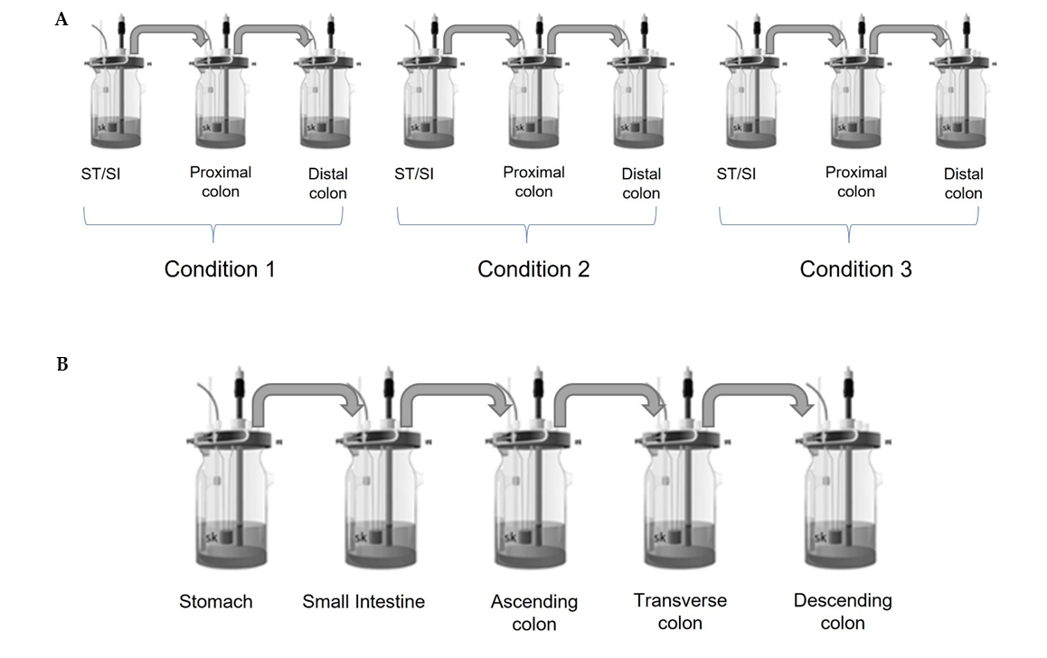
Figure S1. M-SHIME® reactor setups used in this study (A) triple M-SHIME® and (B) standard M-SHIME®. M-SHIME® = mucosal simulator of the human intestinal microbial ecosystem.

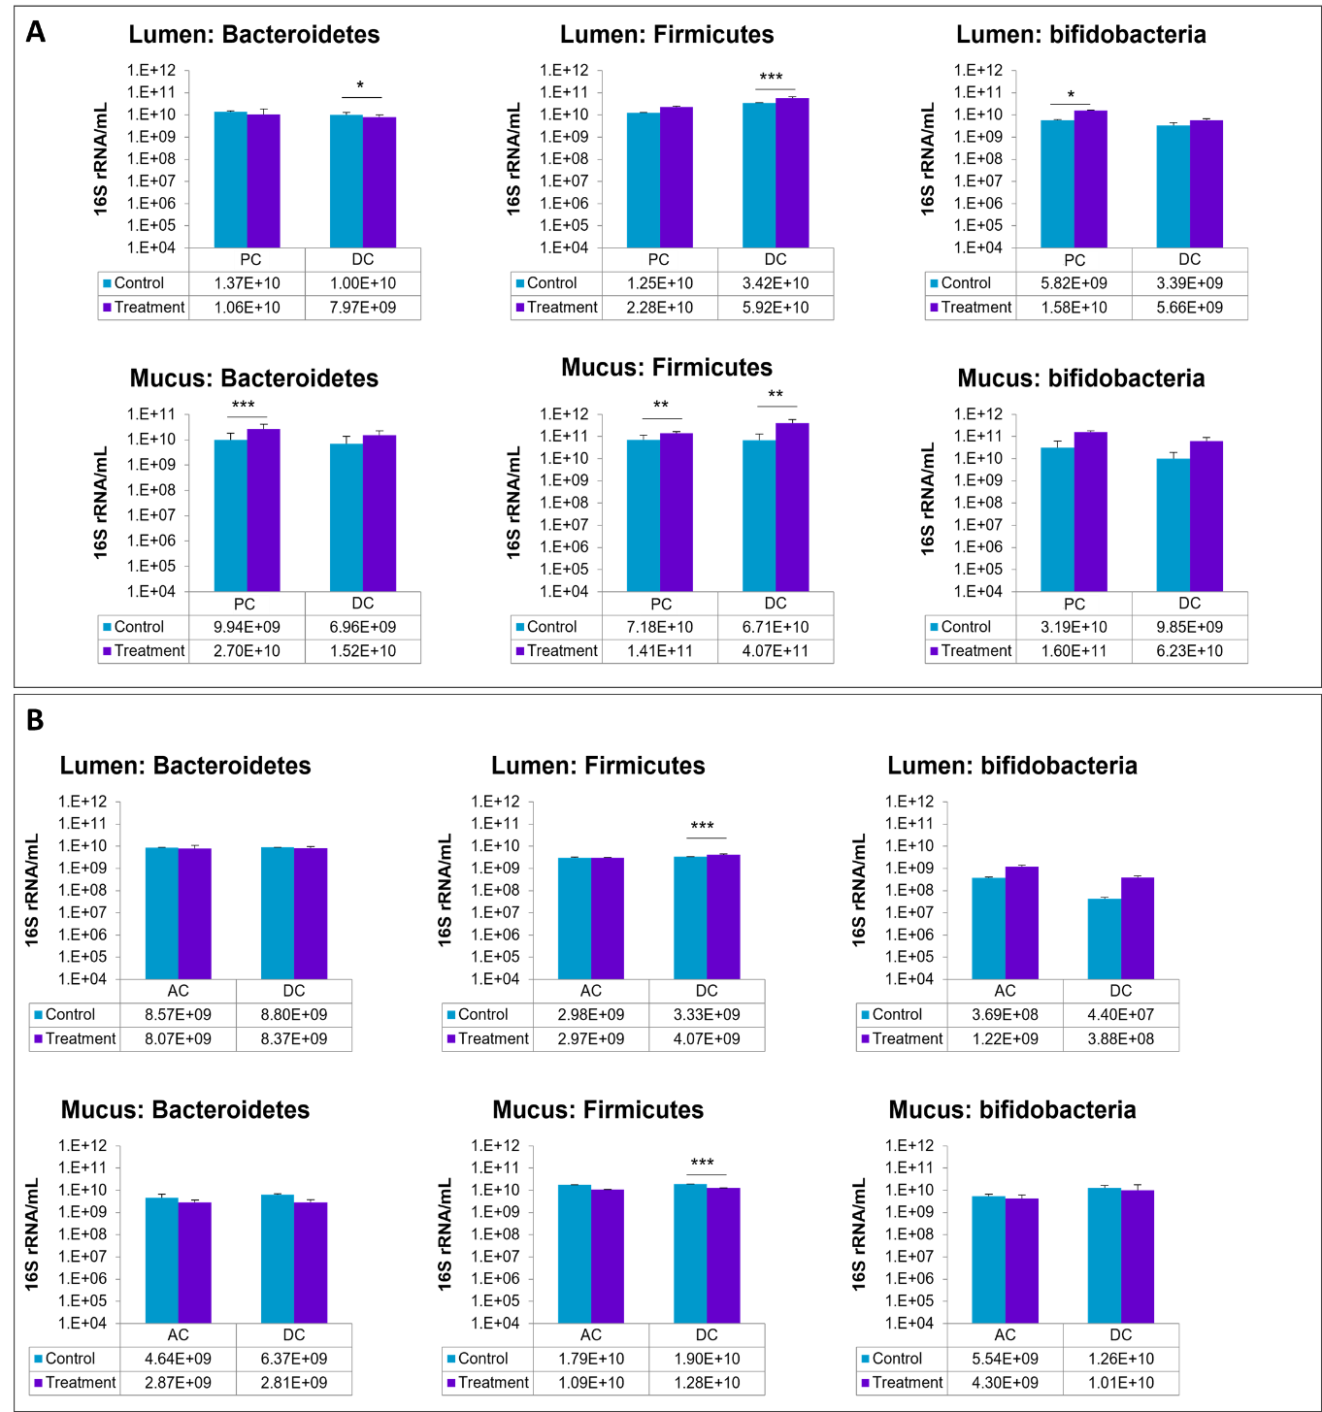
Figure S2. Luminal and mucosal microbial community composition during the control and treatment periods in the adult M-SHIME® experiment as assessed by qPCR for adult A (3 g/d SCF, panel A) and adult B (8.5 g/d SCF, panel B). Bars represent geometric mean ± standard deviation of three sampling points per week (n=6 for control and n=9 for treatment) and three technical replicates of the qPCR technique. Data are shown as mean ± standard deviation. Data were analyzed using Tukey’s multiple comparison’s test. * p <0.05, **p <0.01, *** p <0.001. AC = ascending colon; DC = distal colon; M-SHIME® = mucosal simulator of the human intestinal microbial ecosystem; PC = proximal colon; SCF = soluble corn fiber.
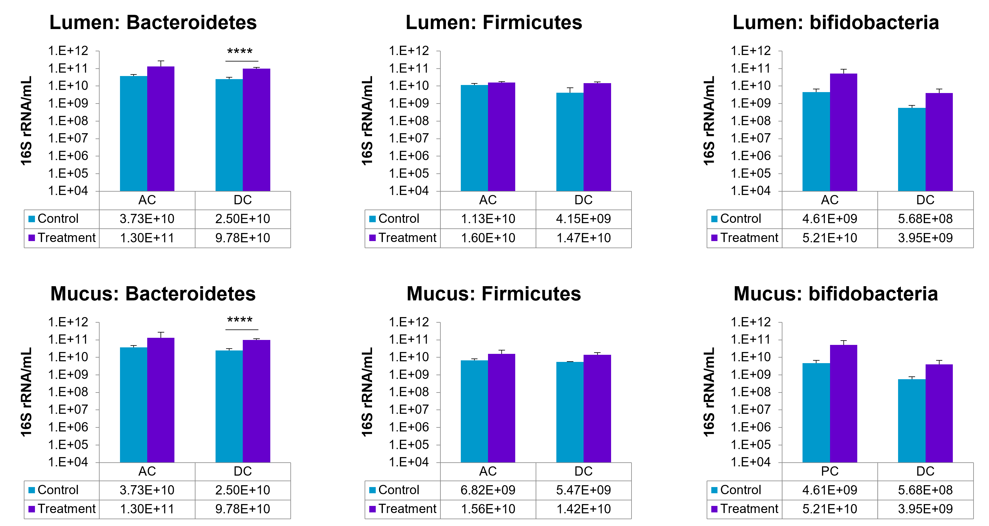Figure S3. Luminal and mucosal microbial community composition during the control and treatment periods (8.5 g/d SCF) in the elderly M-SHIME® experiment as assessed by qPCR. Bars represent geometric mean ± standard deviation of three sampling points per week (n=6 for control and n=9 for treatment) and three technical replicates of the qPCR technique. Data were analyzed using Tukey’s multiple comparison’s test. **** p <0.0001. AC = ascending colon; DC = distal colon; M-SHIME® = mucosal simulator of the human intestinal microbial ecosystem; SCF = soluble corn fiber.

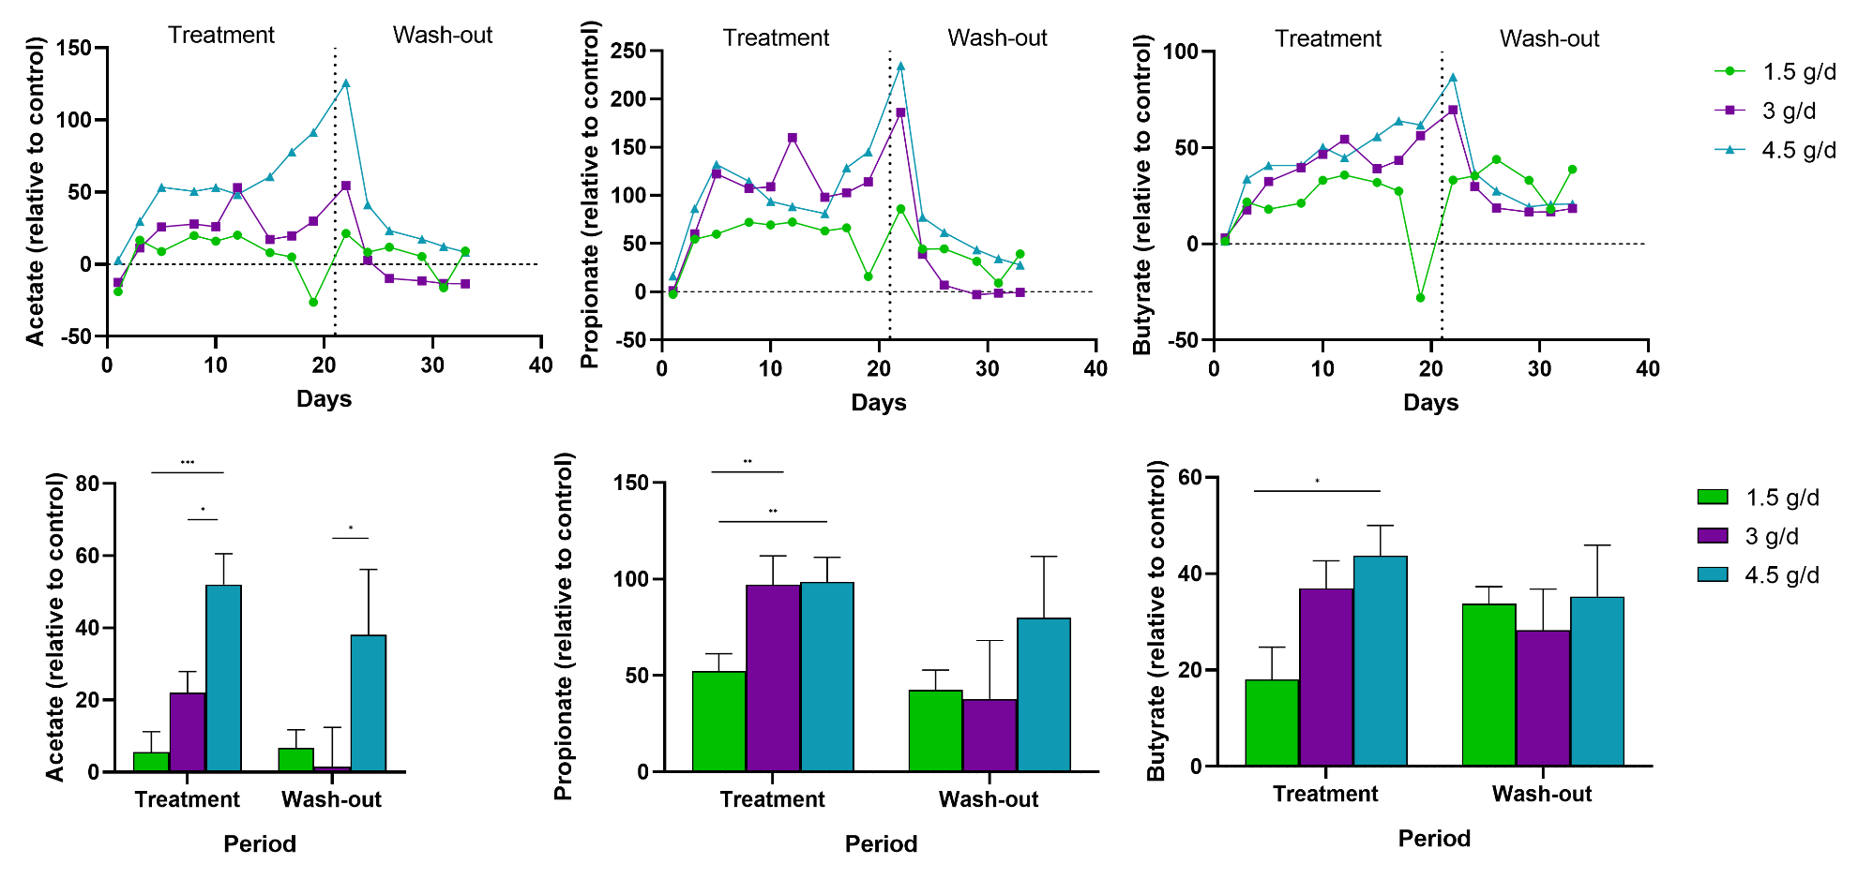
Figure S4. Changes in SCFA levels in the DC during the treatment (Baby B, 1.5 g/d, 3 g/d, and 4.5 g/d SCF) and washout periods in the baby M-SHIME®. The top three graphs show changes in SCFA levels over time relative to the control period. The bottom three graphs show the mean SCFA level for the treatment (3 sampling times per week, 3 weeks, n=9) or washout (2 sampling points per week, 2 weeks, n=6) period relative to the control period; error bars represent standard error of the mean. Differences in SCFA levels between SCF doses were analyzed using a two-way ANOVA with Dunnett’s multiple comparison test. * p <0.05, **p ≤0.01, *** p <0.001. Samples were assayed in triplicate. ANOVA = analysis of variance; DC = distal colon; M-SHIME® = mucosal simulator of the human intestinal microbial ecosystem; SCF = soluble corn fiber; SCFA, short-chain fatty acid.

A
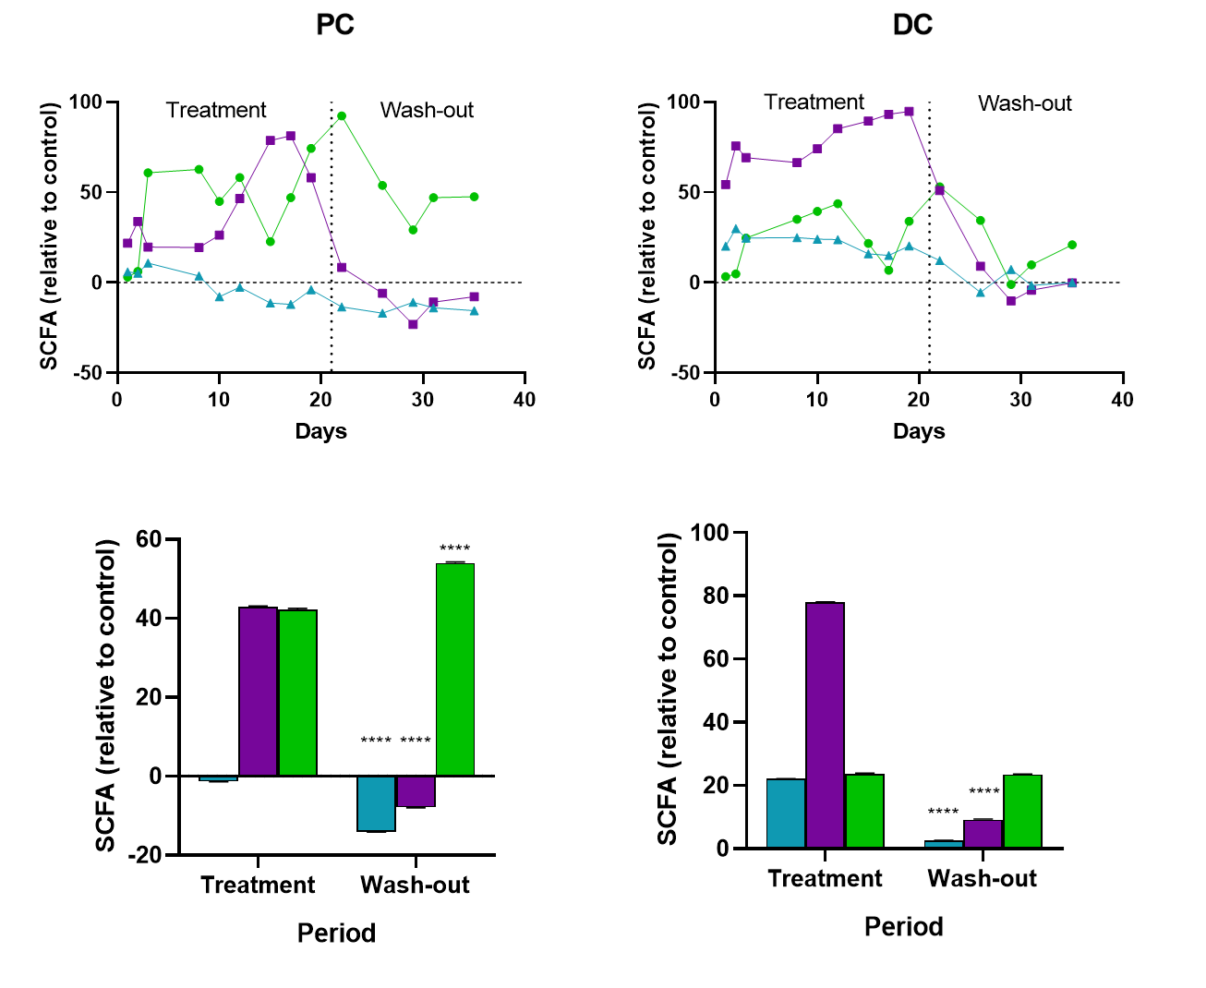
B
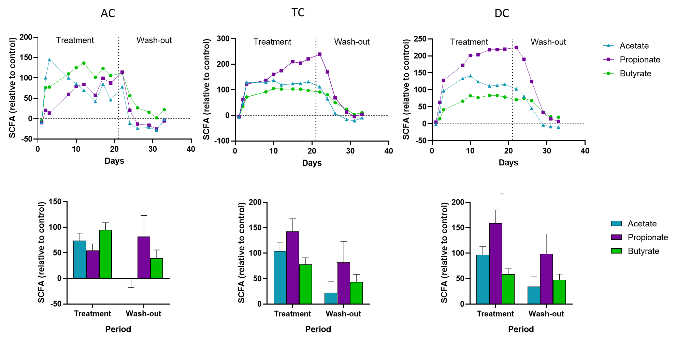
Figure S5. Changes in SCFA levels in the PC and DC for adult A (3 g/d SCF) (A) and in the AC, TC and DC for adult B (8.5 g/d SCF)(B) during the treatment and washout periods in the adult M-SHIME®. The top graphs show changes in SCFA levels over time relative to the control period. The bottom graphs show the SCFA level for the treatment or washout period relative to the control period. Bars represent the average ± standard error of the mean (n = 9 sampling points for the treatment period and n = 6 sampling points for the washout period. Differences between SCFA levels were analyzed using a two-way ANOVA with Dunnett’s multiple comparison test. **p <0.01. ANOVA = analysis of variance; AC = ascending colon; DC = distal colon; M-SHIME® = mucosal simulator of the human intestinal microbial ecosystem; SCF = soluble corn fiber; SCFA, short-chain fatty acid.

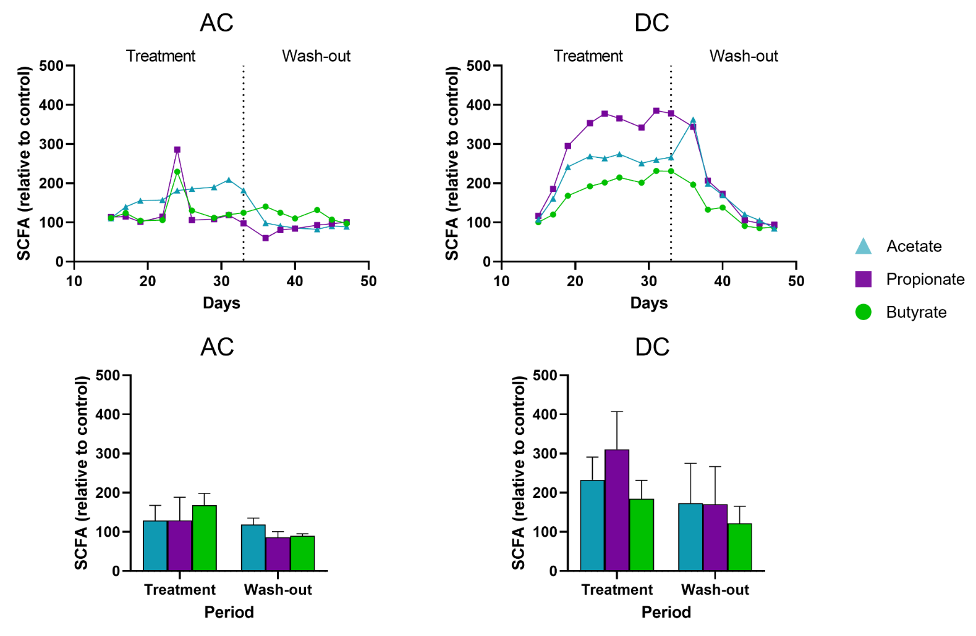
Figure S6. Changes in SCFA levels in the AC and DC during the treatment (8.5 g/d SCF) and washout periods in the elderly M-SHIME®. The top two graphs show changes in SCFA levels over time relative to the control period. The bottom graphs show the SCFA level for the treatment or washout period relative to the control period. Bars represent the average ± standard error of the mean (n = 9 sampling points for the treatment period and n = 6 sampling points for the washout period. Differences between SCFA levels were analyzed using a two-way ANOVA with Dunnett’s multiple comparison test. Samples were assayed in triplicate. ANOVA = analysis of variance; AC = ascending colon; DC = distal colon; M-SHIME® = mucosal simulator of the human intestinal microbial ecosystem; SCF = soluble corn fiber; SCFA, short-chain fatty acid.

