Confidential manuscript submitted to Bulletin of Earthquake Engineering

The 30 October 2020 Samos (Eastern Aegean Sea) Earthquake: effects of source rupture, path and local-site conditions on the observed and simulated ground motions

A. Akinci¹ ● D. Cheloni¹ ● A. A. Dindar^{2,*}
¹ Istituto Nazionale di Geofisica e Vulcanologia, Via di Vigna Murata 605, 00143 Rome, Italy
² Gebze Technical University, Department of Civil Engineering, 41400 Kocaeli, Turkey
Corresponding author: Ahmet Anil Dindar (adindar@gtu.edu.tr)

Supplementary Material
The supporting information material contains information relative to processed InSAR interferograms, InSAR data downsampling, data weighting, spatial smoothing constraints for the variable slip model, and ground motion simulations and site amplification information.

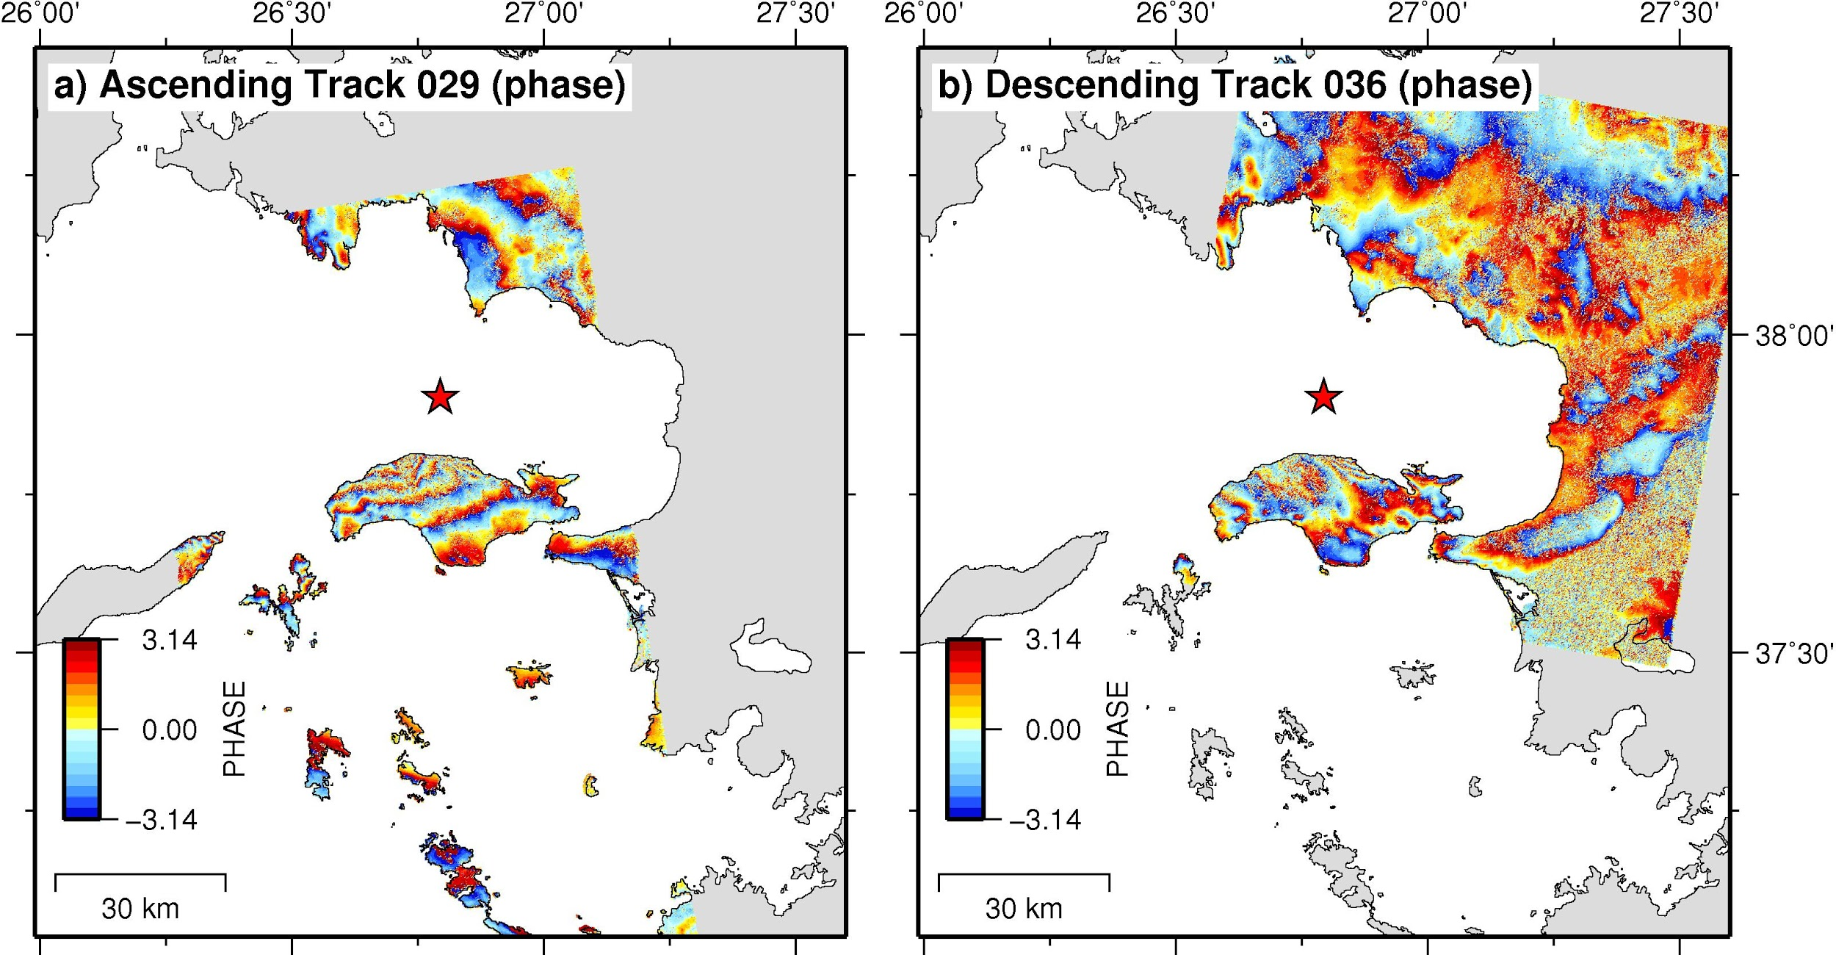
Figure S1. Sentinel-1 wrapped interferograms (ascending and descending orbits). (a) Ascending track 029; (b) descending track 036. Each fringe represents about 2.8 cm of LOS (Line-Of-Sight) deformation. The red star is the main shock epicenter (KOERI location).

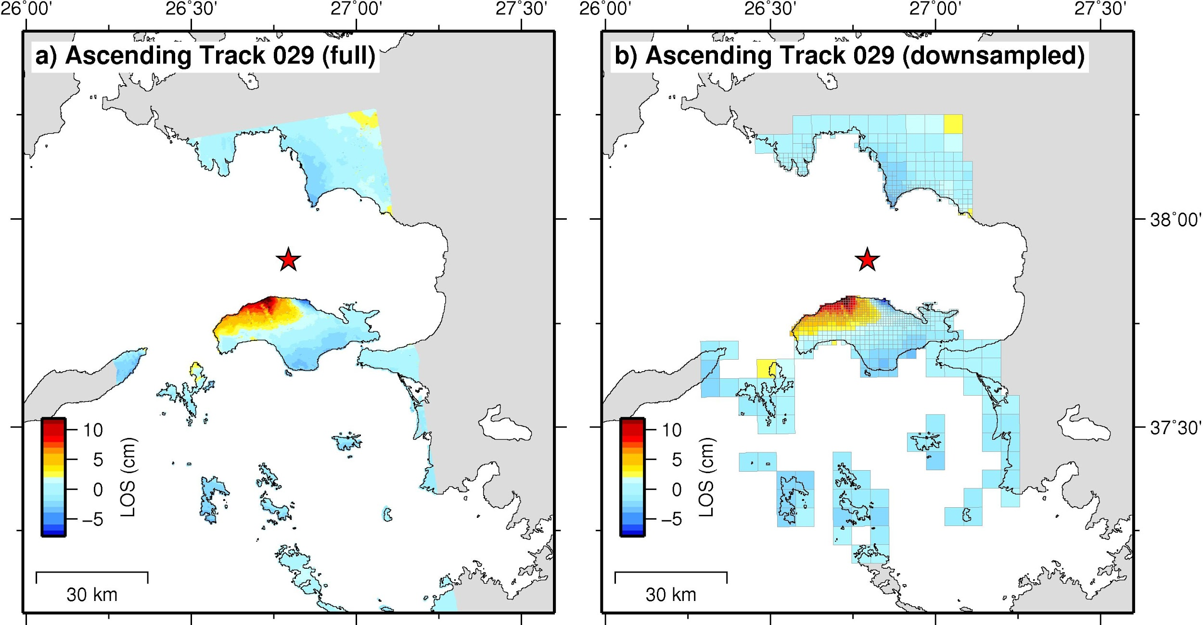
Figure S2. Downsampling of the Sentinel-1 ascending track 029 LOS coseismic displacements: (a) full unwrapped interferogram; (b) resampled interferogram. Squares indicate areas within the LOS displacements are averaged. The red star is the main shock epicenter (KOERI location).

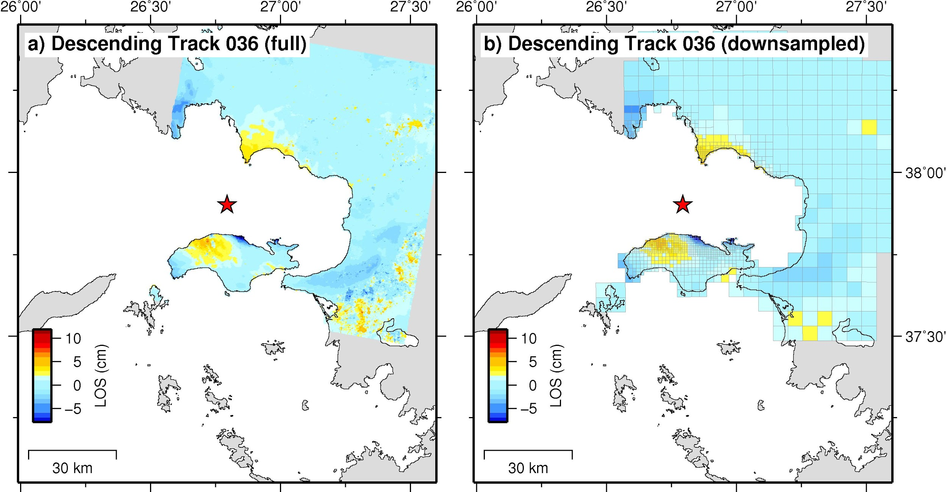
Figure S3. Downsampling of the Sentinel-1 descending track 036 LOS coseismic displacements: (a) full unwrapped interferogram; (b) resampled interferogram. Squares indicate areas within the LOS displacements are averaged. The red star is the main shock epicenter (KOERI location).

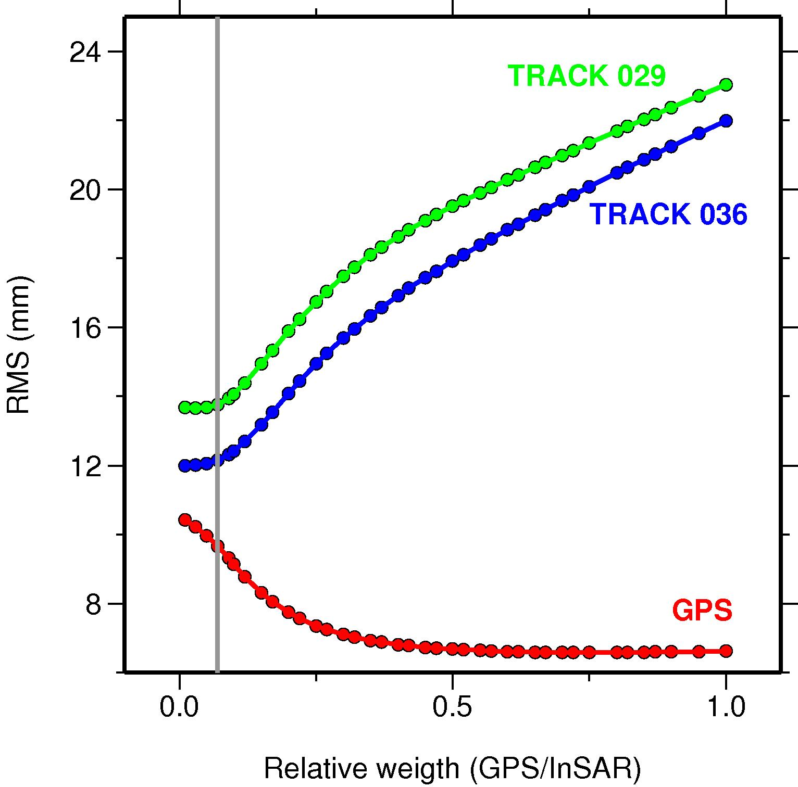
Figure S4. Relationship between RMS data reduction and relative weighting factors. Red circles represent the RMS reduction of GPS data, while green and blue circles are relevant to the ascending track 029 and to the descending track 036, respectively.

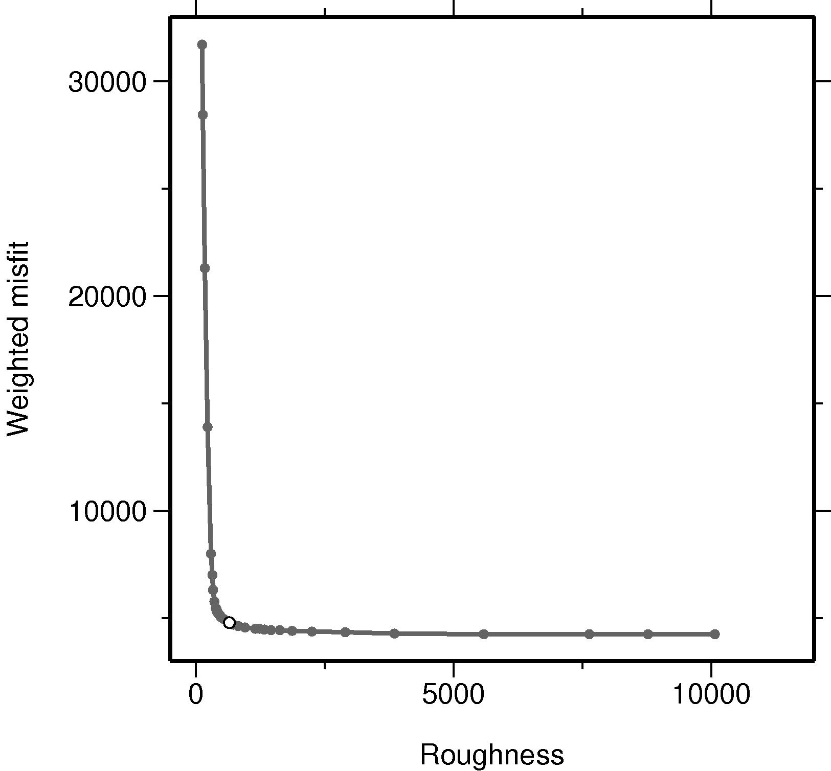
Figure S5. Trade-off curve between solution roughness and weighted misfit. The white circle indicates the chosen scalar smoothing factor.
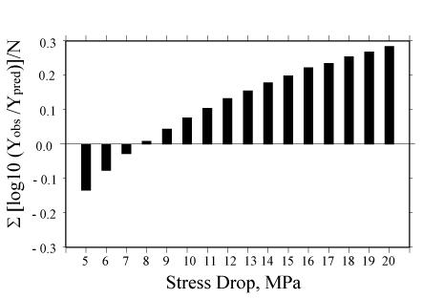
Figure S6. Residuals computed for various stress drop parameters that minimizes the misfit between the observed and simulated ground motions in terms of PGA.

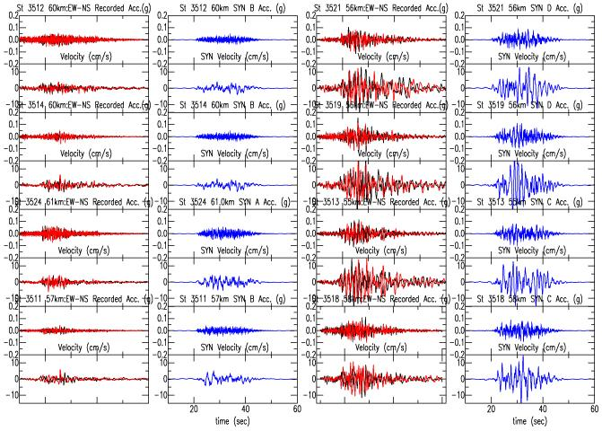
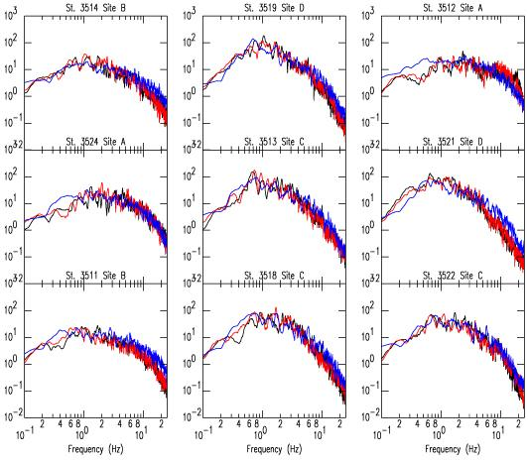
Figure S7. Comparisons between (a) observed and simulated (SYN) acceleration and velocity time histories and (b) Fourier Amplitude spectra at selected stations in the Izmir metropolitan area. Simulations are improved using the site response calculated with the PPM approximation that were able reproduced resonant peaks and their amplitudes compared to those by the QWL (see also Fig. 6 of the main text). Recorded horizontal ground motion data are indicated with black and red for NS and EW components, and synthetics are presented with blue color.

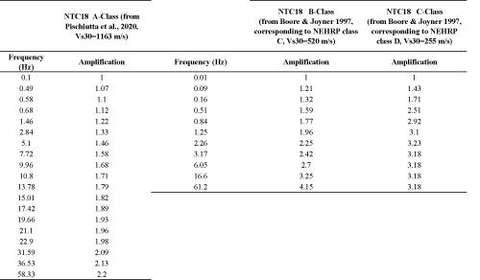
Table S1. The site amplification factors as a function of frequency characterized by the averaged shear wave velocity over the upper 30 m adopted in this study for sites A, B and C according to NTC-18 (from Boore and Joyner 1997; Pischiutta et al. 2020).

