SUPPLEMENTARY FIGURE
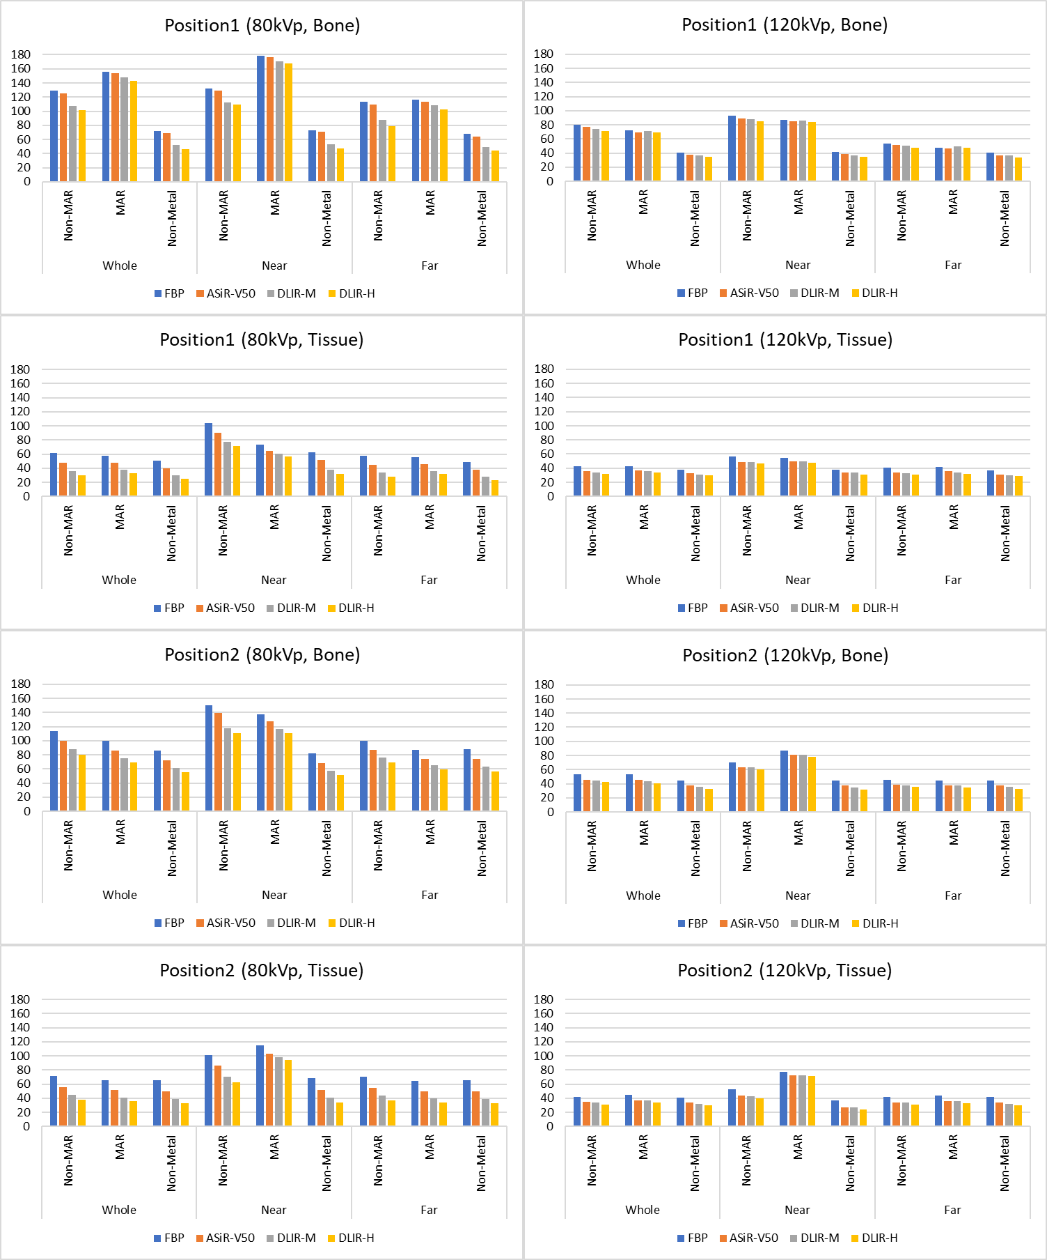
Supplementary Figure 1. Full width at half the maximum (FWHM) calculated from bone and tissue models
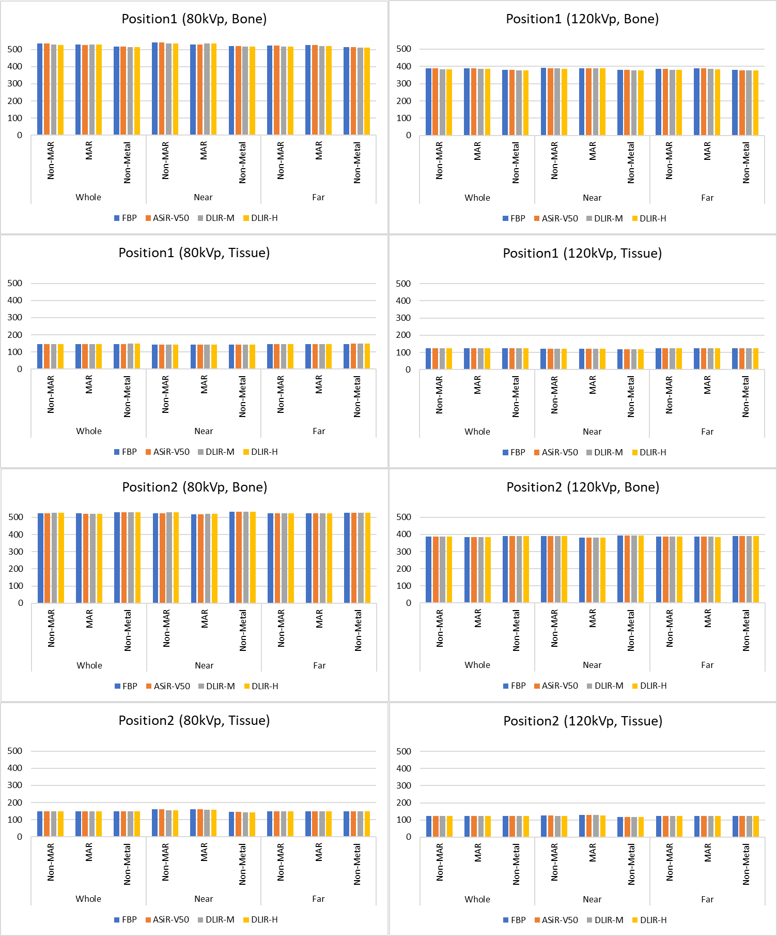
Supplementary Figure 2. Centroid calculated from bone and tissue models

