Hunting for ecological indicators:
Are large herbivore skeleton measures from harvest data useful proxies for monitoring?
Å.Ø. Pedersen, B.-J. Bårdsen, V. Veiberg, R. J. Irvine, B. B. Hansen
Supplementary material

Online Resource 1. Number of Svalbard reindeer harvested distributed by age, sex and month
Table S1. Summary of the number of Svalbard reindeer hunted or culled during the study period (1984-2012) by sex, age and month. Note that reindeer shot in July was removed from the dataset used in the statistical analysis.
 | Female |  |  |  |  | Male
Age | July | August | September | October | Sum | July | August | September | October | Sum
0 | 1 | 2 | 3 | 32 | 38 | 4 | 4 | 5 | 29 | 42
1 | 1 | 7 | 1 | 40 | 49 | 0 | 4 | 2 | 13 | 19
2 | 2 | 2 | 3 | 23 | 30 | 0 | 0 | 0 | 3 | 3
3 | 1 | 2 | 3 | 39 | 45 | 0 | 0 | 1 | 3 | 4
4 | 2 | 2 | 3 | 25 | 32 | 0 | 3 | 1 | 0 | 4
5 | 1 | 2 | 4 | 22 | 29 | 0 | 1 | 1 | 0 | 2
6 | 2 | 0 | 1 | 24 | 27 | 0 | 2 | 0 | 3 | 5
7 | 0 | 0 | 2 | 19 | 21 | 0 | 0 | 1 | 3 | 4
8 | 0 | 0 | 2 | 16 | 18 | 0 | 0 | 0 | 0 | 0
9 | 1 | 0 | 0 | 11 | 12 | 0 | 0 | 1 | 0 | 1
10 | 1 | 1 | 0 | 6 | 8 | 0 | 1 | 0 | 0 | 1
11 | 1 | 0 | 0 | 6 | 7 | - | - | - | - | -
12 | 1 | 0 | 0 | 3 | 4 | - | - | - | - | -
13 | 1 | 0 | 0 | 4 | 5 | - | - | - | - | -
14 | 0 | 0 | 0 | 3 | 3 | - | - | - | - | -
15 | 0 | 0 | 0 | 2 | 2 | - | - | - | - | -
16 | 0 | 0 | 1 | 0 | 1 | - | - | - | - | -
17 | 0 | 0 | 0 | 1 | 1 | - | - | - | - | -
Sum | 15 | 18 | 23 | 276 | 332 | 4 | 15 | 12 | 54 | 85

Online Resource 2. Model selection procedure
The three-step model selection table for the analyses of carcass mass of Svalbard reindeer as a function of jaw length (i) and hind-leg length (ii). In addition to these two predictors, we also included sex (a factor with male and female as levels) as a potential predictor. a) Linear Mixed Effect (LME) models were selected over the Generalized Least Squares (GLS) model, keeping the fixed effects part of the model constant using our a priori defined most complex structure. These two variance structures are different (see Pinheiro et al. 2000, Zuur et al. 2009) as the varExp allows the variance to increase exponentially with the included continuous covariate. At the same time, the varPower represents the power of the absolute value of the variance covariate. The random effects in the LME included the constant effect of hunting units (i.e., random intercepts only). In contrast, Generalized Least Squares (GLS) fitted models represented a model structure without any random effects (see main text for details). b) Variance functions were added to both models due to heteroscedasticity (i.e., support for the added complexity acquired through adding a variance structure to the model) of the residuals in both models. c) Fixed effects structures for the jaw length and hind-leg length models. Model selection was performed based on the difference in AICc-value relative to model with the smallest AICc-value (Δ_{i}) and Akaike’s weight (w_{i}).
Table S2. Model selection for the confirmatory analyses of carcass mass and its relations to the skeletal measures. Preferred models in bold.
 | i | Model |  | i) Jaw length (mm) |  |  |  |  | ii) Hind-leg length (mm)
 | i | Model |  | df |  | Δ_{i} | w_{i} |  | df |  | Δ_{i} | w_{i}
a) Random effects: conditional on the most complex fixed effect structure in c (model 3)
 | 1 | GLS |  | 5 |  | 18.967 | <0.001 |  | 5 |  | 2.045 | 0.265
 | 2 | LME (random = ~1|Hunting unit) |  | 6 |  | 0 | 1.000 |  | 6 |  | 0 | 0.735
b) Variance structure: conditional on the selected model in a
 | 1 | . |  | 6 |  | 21.071 | <0.001 |  | 6 |  | 2.294 | 0.214
 | 2 | varExp(value = 0,form=~Xª) |  | 7 |  | 0 | 1.000 |  | 7 |  | 3.559 | 0.114
 | 3 | varPower(form = ~ X) |  | 7 |  | 22.356 | <0.001 |  | 7 |  | 0 | 0.673
 | 4 | varFixed(value = ~ X) |  | 6 |  | 535.307 | <0.001 |  | 6 |  | 150.466 | <0.001
c) Fixed effects: conditional on the model selected under a-b
 | 1 | fixed = ~X + Sex + X × Sex |  | 7 |  | 3.539 | 0.109 |  | 7 |  | 0 | 0.605
 | 2 | fixed = ~X + Sex |  | 6 |  | 1.834 | 0.255 |  | 6 |  | 1.853 | 0.395
 | 3 | fixed = ~X |  | 5 |  | 0 | 0.637 |  | 5 |  | 29.694 | <0.001
Notes: ªX replaces either Jaw length (i) or Hind-leg length (ii).

Online Resource 3. Summary statistics of the skeletal measures and carcass mass by age and sex
Table S3. Summary statistics of the skeletal measures and carcass mass for females (A) and males (B). SD = standard deviation, SE = standard error, N = total number of animals with respective skeletal or carcass mass measures available, dash (-) = no data are available. Note that no data are available for males older than 10 years.
A. | Female Svalbard reindeer
 | Jaw length (mm) |  |  |  |  |  | Hind-leg length (mm) |  |  |  |  |  | Carcass mass (kg)
Age | Mean | SD | SE | 2. quantile | 4. quantile | N | Mean | SD | SE | 2. quantile | 4. quantile | N | Mean | SD | SE | 2. quantile | 4. quantile | N
0 | 164.68 | 8.12 | 1.39 | 160.25 | 170.75 | 34 | 249.00 | 8.89 | 1.48 | 245.00 | 256.00 | 36 | 17.86 | 2.52 | 0.41 | 16.08 | 19.58 | 38
1 | 197.40 | 7.58 | 1.11 | 193.00 | 203.00 | 47 | 275.27 | 8.58 | 1.34 | 269.00 | 280.00 | 41 | 28.27 | 4.26 | 0.60 | 25.75 | 30.80 | 51
2 | 209.05 | 6.23 | 0.92 | 204.78 | 214.45 | 46 | 281.57 | 8.37 | 1.58 | 278.00 | 287.25 | 28 | 32.37 | 4.71 | 0.70 | 29.10 | 35.73 | 46
3 | 211.22 | 6.77 | 0.91 | 207.70 | 215.00 | 55 | 279.38 | 6.52 | 1.01 | 275.00 | 283.00 | 42 | 36.75 | 8.56 | 1.17 | 32.03 | 38.75 | 54
4 | 213.11 | 6.47 | 1.16 | 209.00 | 219.00 | 31 | 278.50 | 6.27 | 1.14 | 274.25 | 283.00 | 30 | 36.31 | 7.07 | 1.21 | 32.10 | 39.95 | 34
5 | 215.41 | 4.20 | 0.82 | 212.00 | 218.75 | 26 | 278.62 | 7.11 | 1.32 | 276.00 | 283.00 | 29 | 35.27 | 4.71 | 0.86 | 31.80 | 39.50 | 30
6 | 215.44 | 5.73 | 1.10 | 211.50 | 218.50 | 27 | 280.89 | 6.38 | 1.23 | 278.00 | 285.00 | 27 | 34.57 | 4.04 | 0.78 | 32.10 | 37.35 | 27
7 | 215.57 | 5.37 | 1.17 | 212.00 | 218.00 | 21 | 283.24 | 8.32 | 1.82 | 279.00 | 287.00 | 21 | 35.11 | 4.33 | 0.94 | 31.20 | 37.50 | 21
8 | 217.92 | 8.60 | 1.92 | 214.23 | 220.25 | 20 | 281.06 | 8.38 | 1.97 | 276.25 | 285.75 | 18 | 36.41 | 6.66 | 1.45 | 33.00 | 37.70 | 21
9 | 215.57 | 6.95 | 2.09 | 215.15 | 220.00 | 11 | 280.75 | 11.44 | 3.30 | 273.75 | 289.25 | 12 | 35.30 | 6.78 | 1.96 | 30.05 | 41.13 | 12
10 | 217.71 | 6.50 | 2.46 | 213.50 | 219.50 | 7 | 282.60 | 7.37 | 3.30 | 279.00 | 283.00 | 5 | 36.16 | 6.64 | 2.51 | 34.10 | 40.50 | 7
11 | 215.67 | 8.69 | 3.55 | 211.00 | 217.00 | 6 | 277.43 | 5.13 | 1.94 | 273.50 | 280.00 | 7 | 33.67 | 3.89 | 1.47 | 32.05 | 36.60 | 7
12 | 218.58 | 6.51 | 2.91 | 215.00 | 217.00 | 5 | 282.75 | 3.86 | 1.93 | 280.50 | 284.25 | 4 | 32.86 | 2.70 | 1.21 | 31.90 | 32.00 | 5
13 | 218.00 | 4.00 | 1.79 | 216.00 | 220.00 | 5 | 285.00 | 5.48 | 2.45 | 283.00 | 289.00 | 5 | 34.72 | 2.78 | 1.24 | 32.50 | 35.10 | 5
14 | 217.33 | 4.73 | 2.73 | 215.50 | 220.00 | 3 | 286.50 | 4.95 | 3.50 | 284.75 | 288.25 | 2 | 37.40 | 5.39 | 3.11 | 35.60 | 40.50 | 3
15 | 217.00 | 2.83 | 2.00 | 216.00 | 218.00 | 2 | 285.00 | 1.41 | 1.00 | 284.50 | 285.50 | 2 | 32.40 | 1.27 | 0.90 | 31.95 | 32.85 | 2
16 | 225.00 | ‐ | ‐ | 225.00 | 225.00 | 1 | 281.00 | ‐ | ‐ | 281.00 | 281.00 | 1 | 37.00 | ‐ | ‐ | 37.00 | 37.00 | 1
17 | 219.00 | ‐ | ‐ | 219.00 | 219.00 | 1 | 276.00 | ‐ | ‐ | 276.00 | 276.00 | 1 | 27.90 | ‐ | ‐ | 27.90 | 27.90 | 1

B. | Male Svalbard reindeer
 | Jaw length (mm) |  |  |  |  |  | Hind-leg length (mm) |  |  |  |  |  | Carcass mass (kg)
Age | Mean | SD | SE | 2. quantile | 4. quantile | N | Mean | SD | SE | 2. quantile | 4. quantile | N | Mean | SD | SE | 2. quantile | 4. quantile | N
0 | 162.83 | 11.22 | 1.90 | 156.00 | 168.50 | 35 | 248.83 | 11.75 | 1.86 | 241.75 | 257.50 | 40 | 17.23 | 2.97 | 0.47 | 15.05 | 19.00 | 39
1 | 202.35 | 7.94 | 1.93 | 198.00 | 205.00 | 17 | 279.88 | 10.86 | 2.63 | 273.00 | 287.00 | 17 | 29.07 | 4.69 | 1.05 | 25.00 | 32.00 | 20
2 | 217.69 | 4.62 | 1.54 | 216.50 | 220.00 | 9 | 294.67 | 4.04 | 2.33 | 292.50 | 296.50 | 3 | 36.41 | 3.53 | 1.06 | 33.10 | 39.00 | 11
3 | 228.31 | 12.06 | 2.92 | 222.00 | 235.10 | 17 | 291.75 | 15.88 | 7.94 | 282.75 | 301.00 | 4 | 43.39 | 8.25 | 1.95 | 38.00 | 48.75 | 18
4 | 232.04 | 13.08 | 4.94 | 225.10 | 241.70 | 7 | 316.00 | 8.49 | 6.00 | 313.00 | 319.00 | 2 | 48.58 | 9.71 | 3.96 | 45.25 | 54.50 | 6
5 | 237.00 | 15.56 | 11.00 | 231.50 | 242.50 | 2 | 325.00 | ‐ | ‐ | 325.00 | 325.00 | 1 | 46.25 | 20.15 | 14.25 | 39.13 | 53.38 | 2
6 | 247.04 | 6.00 | 2.27 | 242.50 | 252.00 | 7 | 315.00 | ‐ | ‐ | 315.00 | 315.00 | 1 | 56.75 | 7.20 | 2.94 | 52.25 | 61.63 | 6
7 | 241.75 | 6.95 | 3.47 | 237.00 | 246.75 | 4 | 301.67 | 8.62 | 4.98 | 297.00 | 305.50 | 3 | 51.80 | 6.73 | 3.36 | 48.33 | 56.83 | 4
8 | 222.50 | ‐ | ‐ | 222.50 | 222.50 | 1 | ‐ | ‐ | ‐ | ‐ | ‐ | 0 | 70.00 | ‐ | ‐ | 70.00 | 70.00 | 1
9 | 244.60 | 11.72 | 5.24 | 236.50 | 248.50 | 5 | 313.00 | ‐ | ‐ | 313.00 | 313.00 | 1 | 60.00 | 19.03 | 8.51 | 45.00 | 75.00 | 5
10 | 245.00 | ‐ | ‐ | 245.00 | 245.00 | 1 | ‐ | ‐ | ‐ | ‐ | ‐ | 0 | 49.50 | ‐ | ‐ | 49.50 | 49.50 | 1

Online Resource 4. Model outputs for the R statistical analysis of the relations between carcass mass (response) and skeletal measures(jaw length and hind-leg length

Online Resource 5. Predicted plots of best models as a function of A) jaw length and B) hind-leg length at normalised scale
A)
B)
Fig. S2. The plot of predicted values from the best fitted linear mixed effect model describing Svalbard reindeer carcass mass (normalised scale) as a function of A) jaw length (centred so that the mean value of jaw length is subtracted from all observed jaw lengths to let the intercept represent predicted carcass mass for an average jaw length) and B) hind-leg length.
Online Resource 6. Within and between annual variation in jaw length, hind-leg length and carcass mass for male and female calves and yearlings of Svalbard reindeer
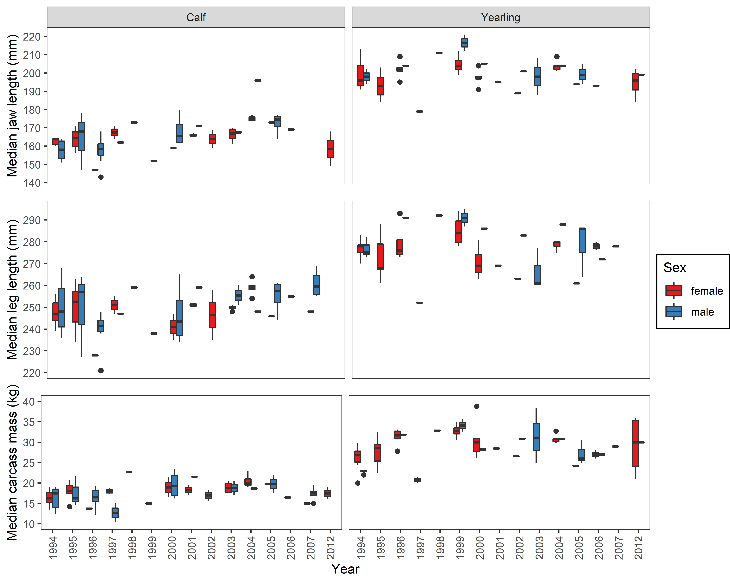
Fig. S1. Within and between annual variation in jaw length, hind-leg length and carcass mass for Svalbard reindeer male and female calves (left panels) and yearlings (right panels) available for the study.
*****

