Supplementary Material
Supplementary Tables
Table S1. Demographics and the clinical information of lung ADC with MPP/SOL pattern of training and validation sets
 | Training set  (n=360) | Testing set  (n=154) | Mann-Whitney U value/t value/χ² | p value
Age (Mean SD, year) | 59.5±9.9 | 59.3±10.3 | -0.214^{t} | 0.831
Gender (M/F) | 162/198 | 66/88 | 0.201ª | 0.654
Smoking History(no/yes) | 298/62 | 124/30 | 0.374ª | 0.541
Family History (no/yes) | 349/11 | 151/3 | 0.499ª | 0.480
Serum CEA value(ng/ml) | 2.1 (1.4,3.5) | 2.2(1.3,3.2) | 26684.500^{c} | 0.502
Serum CYFRA21-1 value  (ng/ml) | 2.2(1.7,2.7) | 2.1(1.6,2.8) | 27481.000 ^{c} | 0.877
Serum NSE value (ng/ml) | 16.1(13.5,20.6) | 16.6(14.6,19.0) | 26580.000 ^{c} | 0.460
CEA (negative/positive) | 59/301 | 22/132 | 0.359ª | 0.549
CYFRA211(negative/positive) | 49/311 | 22/132 | 1.082ª | 0.299
NSE(negative/positive) | 178/182 | 85/69 | 1.427ª | 0.233
Tumor Location |  |  | 2697.92^{c} | 0.616
RUL | 103 | 43 | 2697.92^{c} | 0.616
RML | 55 | 21 | 2697.92^{c} | 0.616
RLL | 109 | 60 | 2697.92^{c} | 0.616
LUL | 28 | 12 | 2697.92^{c} | 0.616
LLL | 65 | 18 | 2697.92^{c} | 0.616
Note: Data are mean ± standard deviation or median with interquartile range in parentheses and numbers of patients; RUL: right upper lobe; RML: right middle lobe; RLL: right lower lobe; LUL: left upper lobe; LLL: left lower lobe; " a " represents Chi-square test, "-" represents Fisher's exact tests, "c" represents Mann-Whitney U test, "t" represents Student t test.

Supplementary Figures
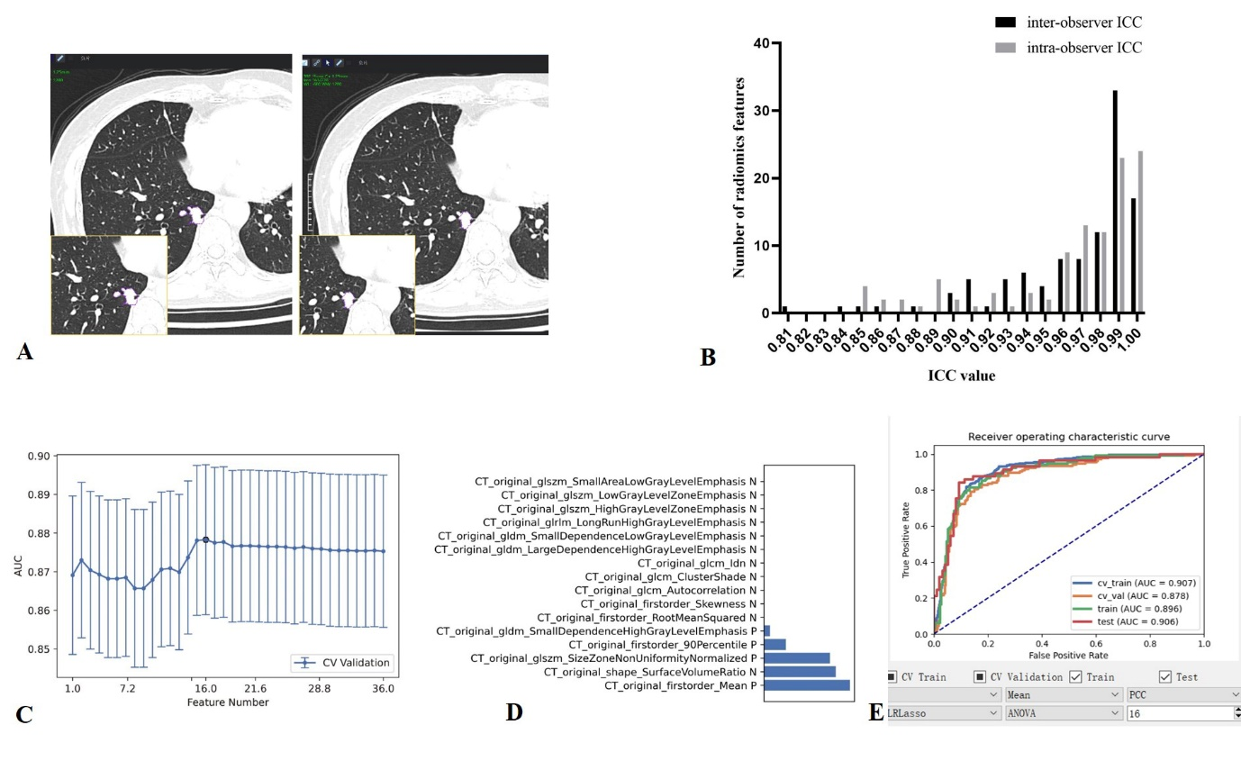
Figure S1
Figure. S1. a-e VOI segmentation, radiomics features extraction and selection and model construction
Radiomics features were extracted from the manually annotated VOI implemented with in-house software(a). The stable features with ICC >0.80 were remained for subsequent analysis(b) and the finally 16 features were selected with the aid of FeAture Explorer Pro (FAE) software(c) in the process of ANOVA and with LASSO according to " one-standard error " rule. The weight of feature coefficients of the candidate 5 features is exhibited with the blue barchart, and " P" and " N" after the features′ name indicates the positive and negative correlation, respectively(d). The model′s ROC curve in different dataset was plotted ("test" and "train" represent testing and training set, respectively) (e).

Figure S2
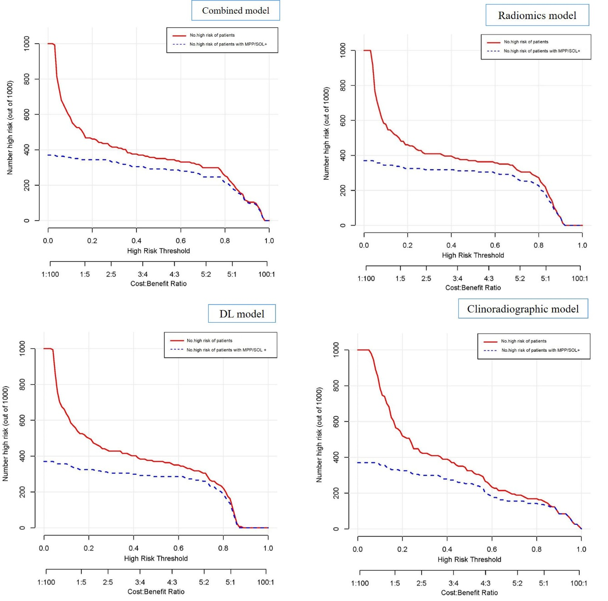
Figure. S2. Clinical impact curve for the four models.
No. means the number of. Of 1000 patients, the heavy red line represents the total number who would be deemed high risk for each risk threshold. The blue dashed line shows how many cases of those true positive cases of patients at the same risk threshold. When the threshold probability is greater than 80% of the prediction score probability value, the four models determines that the high-risk population of MPP/SOL+ is highly matched with the actual population of MPP/SOL+, which indicates the high clinical efficiency of the four models.

