Supplement to “Pilot study: validity and reliability of textile insoles used to measure the characteristics of landing tasks during rehabilitation and artistic gymnastics”

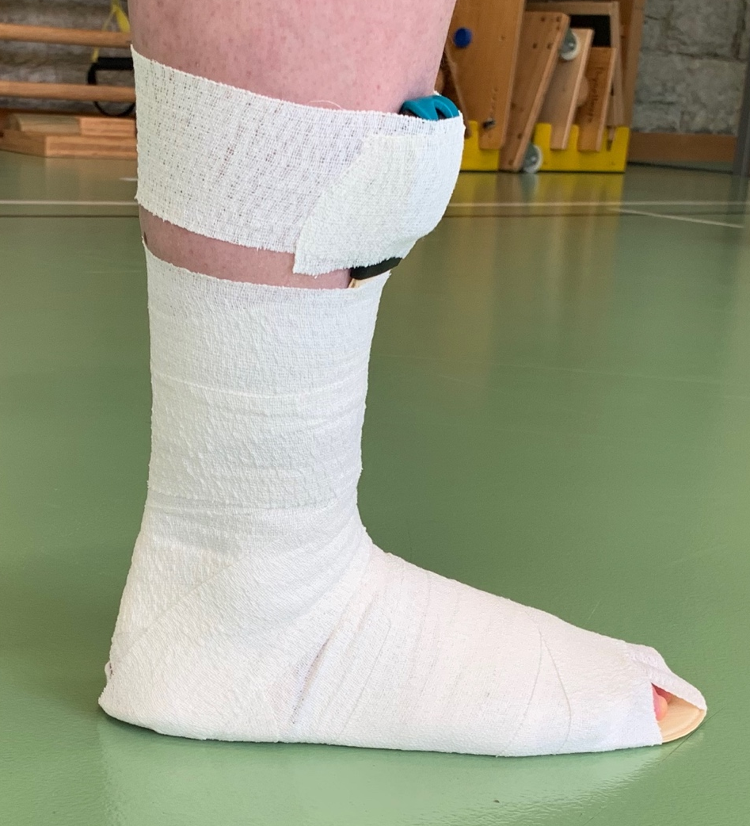
Insole attachment

Figure 1 The novel loadsol® pro insoles are attached to the foot with elastic adhesive bandage because gymnasts normally train barefoot and the measurements should be specific to artistic gymnastics.

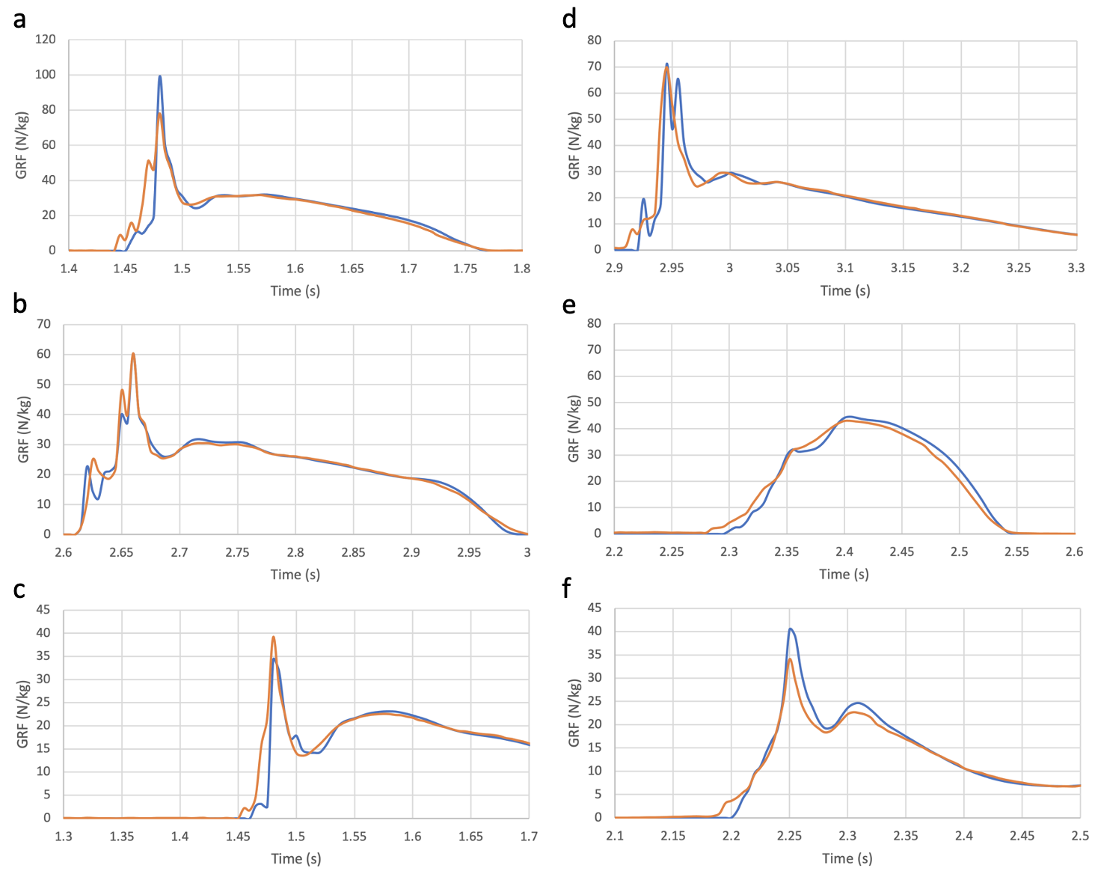
Force-time graphs of different jumps
Figure 2 The force plate and insole measurements are labelled in blue respectively orange. a) participant 1, DJ 40cm; b) participant 1, DJ 60cm; c) participant 1, DL 20cm; d) participant 2, CMJ; e) participant 2, DJ 20cm; f) participant 2, DL 20cm
CMJ: countermovement jump, DJ: drop jump, DL: drop landing

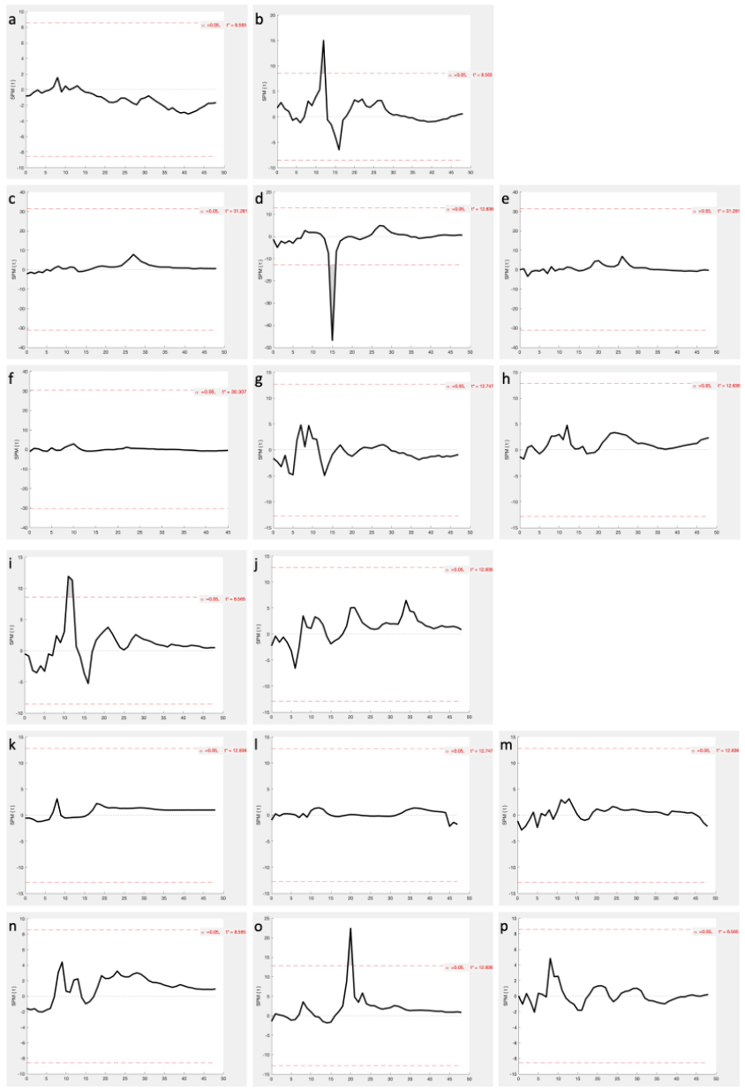
SPM plots of both participants

Figure 3 SPM plots of all exercises of both participants (participant 1: a-h, 2: i-p). The x-axis is the time frame axis where the maximal vertical GRF is normally at x=9.
a,i) CMJ; b,j) SJ; c,k) DJ 20cm; d,l) DJ 40cm; e,m) DJ 60cm; f,n) DL 20cm (in f the maximal vertical GRF is at x=6); g,o) DL 40cm (in g the maximal vertical GRF is at x=8); h,p) DL 60cm
CMJ: countermovement jump, SJ: squat jump, DJ: drop jump, DL: drop landing

RMSE of maximal vertical GRF
participant 1
Exercise | ∅ force plate (N/kg) and SD | ∅ insole (N/kg) and SD | RMSE (N/kg) | % of mean force (force plate)
CMJ | 43 ± 13 | 33 ± 1 | 16 | 37
SJ | 48 ± 9 | 34 ± 2 | 17 | 36
DJ 20cm | 50 ± 7 | 39 ± 2 | 14 | 28
DJ 40cm | 69 ± 22 | 52 ± 16 | 20 | 30
DJ 60cm | 78 ± 14 | 60 ± 4 | 26 | 33
DL 20cm | 37 ± 4 | 33 ± 5 | 8 | 22
DL 40cm | 71 ± 9 | 44 ± 2 | 28 | 40
DL 60cm | 87 ± 34 | 45 ± 9 | 50 | 57
Mean (n=31) | 60 ± 14 | 43 ± 5 | 22 | 35
participant 2
CMJ | 65 ± 13 | 52 ± 10 | 17 | 26
SJ | 88 ± 19 | 53 ± 4 | 39 | 44
DJ 20cm | 47 ± 3 | 43 ± 3 | 5 | 10
DJ 40cm | 53 ± 3 | 53 ± 2 | 2 | 3
DJ 60cm | 78 ± 4 | 73 ± 12 | 11 | 14
DL 20cm | 57 ± 16 | 36 ± 6 | 24 | 43
DL 40cm | 87 ± 22 | 47 ± 5 | 44 | 51
DL 60cm | 74 ± 11 | 54 ± 10 | 21 | 29
Mean (n=35) | 69 ± 11 | 51 ± 6 | 20 | 27
Mean (n=66) | 65 ± 13 | 47 ± 6 | 21 | 31
Table 1 RMSE of maximal vertical GRF of different exercises of both participants
CMJ: countermovement jump, SJ: squat jump, DJ: drop jump, DL: drop landing

RMSE of impulse
participant 1
Exercise | ∅ force plate (Ns/kg) and SD | ∅ insole (Ns/kg) and SD | RMSE (Ns/kg) | % of mean impulse (force plate)
CMJ | 3.3 ± 0.2 | 3.5 ± 0.4 | 0.3 | 9.2
SJ | 3.0 ± 0.1 | 3.0 ± 0.1 | 0.2 | 6.3
DJ 20cm | 4.4 ± 0.1 | 4.3 ± 0.03 | 0.2 | 3.9
DJ 40cm | 4.7 ± 0.1 | 4.8 ± 0.1 | 0.1 | 2.3
DJ 60cm | 5.3 ± 0.2 | 5.2 ± 0.1 | 0.1 | 2.7
DL 20cm | 2.4 ± 0.1 | 2.6 ± 0.3 | 0.4 | 18.2
DL 40cm | 3.2 ± 0.1 | 3.9 ± 1.2 | 1.4 | 42.9
DL 60cm | 3.7 ± 0.1 | 3.3 ± 0.1 | 0.4 | 10.4
Mean (n=31) | 3.8 ± 0.1 | 3.8 ± 0.3 | 0.4 | 12.0
participant 2
CMJ | 3.6 ± 0.2 | 3.7 ± 0.4 | 0.2 | 4.6
SJ | 3.6 ± 0.2 | 3.6 ± 0.1 | 0.1 | 3.9
DJ 20cm | 4.4 ± 0.1 | 4.0 ± 0.2 | 0.4 | 9.8
DJ 40cm | 5.2 ± 0.1 | 4.9 ± 0.1 | 0.3 | 5.4
DJ 60cm | 5.8 ± 0.2 | 5.7 ± 0.2 | 0.2 | 3.2
DL 20cm | 2.0 ± 0.2 | 1.7 ± 0.3 | 0.4 | 20.6
DL 40cm | 3.4 ± 0.1 | 3.1 ± 0.2 | 0.4 | 11.3
DL 60cm | 4.0 ± 0.1 | 3.7 ± 0.4 | 0.5 | 12.2
Mean (n=35) | 4.0 ± 0.2 | 3.8 ± 0.2 | 0.3 | 8.9
Mean (n=66) | 3.9 ± 0.2 | 3.8 ± 0.3 | 0.4 | 10.5
Table 2 RMSE of impulse of different exercises of both participants
CMJ: countermovement jump, SJ: squat jump, DJ: drop jump, DL: drop landing

ICC and p-values of maximal vertical GRF
participant 1
Exercise | ICC value | p-value | 95% confidence interval
CMJ | 0.04 | 0.46 | -0.52 | 0.79
SJ | 0.02 | 0.46 | -0.19 | 0.63
DJ 20cm | -0.22 | 0.81 | -0.42 | 0.80
DJ 40cm | 0.66 | 0.07 | -0.15 | 0.97
DJ 60cm | -0.20 | 0.72 | -0.53 | 0.87
DL 20cm | -0.16 | 0.59 | -1.20 | 0.94
DL 40cm | -0.01 | 0.57 | -0.08 | 0.49
DL 60cm | 0.20 | 0.24 | -0.19 | 0.87
Mean (n=31) | 0.04 | 0.49 | -0.41 | 0.79
participant 2
CMJ | 0.41 | 0.12 | -0.20 | 0.90
SJ | 0.07 | 0.33 | -0.12 | 0.75
DJ 20cm | 0.43 | 0.13 | -0.14 | 0.94
DJ 40cm | 0.86 | 0.04 | -0.21 | 0.99
DJ 60cm | 0.46 | 0.19 | -0.59 | 0.95
DL 20cm | 0.20 | 0.22 | -0.17 | 0.80
DL 40cm | 0.08 | 0.31 | -0.12 | 0.76
DL 60cm | 0.29 | 0.16 | -0.09 | 0.84
Mean (n=35) | 0.35 | 0.19 | -0.21 | 0.87
Mean (n=66) | 0.19 | 0.34 | -0.31 | 0.83
Table 3 ICC values of maximal vertical GRF of the different exercises of both participants
CMJ: countermovement jump, SJ: squat jump, DJ: drop jump, DL: drop landing

ICC and p-values of impulse
participant 1
Exercise | ICC value | p-value | 95% confidence interval
CMJ | 0.63 | 0.06 | -0.17 | 0.95
SJ | -0.09 | 0.58 | -0.84 | 0.78
DJ 20cm | 0.25 | 0.22 | -0.19 | 0.95
DJ 40cm | 0.68 | 0.06 | -0.16 | 0.97
DJ 60cm | 0.74 | 0.06 | -0.21 | 0.99
DL 20cm | -1.07 | 0.82 | -2.11 | 0.85
DL 40cm | 0.004 | 0.5 | -0.86 | 0.88
DL 60cm | 0.13 | 0.2 | -0.04 | 0.76
Mean (n=31) | 0.16 | 0.31 | -0.57 | 0.89
participant 2
CMJ | 0.89 | 0.01* | 0.26 | 0.99
SJ | 0.68 | 0.07 | -0.3 | 0.98
DJ 20cm | 0.16 | 0.22 | -0.1 | 0.82
DJ 40cm | 0.1 | 0.26 | -0.08 | 0.74
DJ 60cm | 0.72 | 0.06 | -0.12 | 0.98
DL 20cm | 0.39 | 0.13 | -0.15 | 0.89
DL 40cm | 0.24 | 0.19 | -0.09 | 0.87
DL 60cm | 0.11 | 0.37 | -0.39 | 0.8
Mean (n=35) | 0.41 | 0.16 | -0.12 | 0.88
Mean (n=66) | 0.29 | 0.24 | -0.35 | 0.89
Table 4 ICC values of impulse of the different exercises of both participants; * indicates significant correlation
CMJ: countermovement jump, SJ: squat jump, DJ: drop jump, DL: drop landing

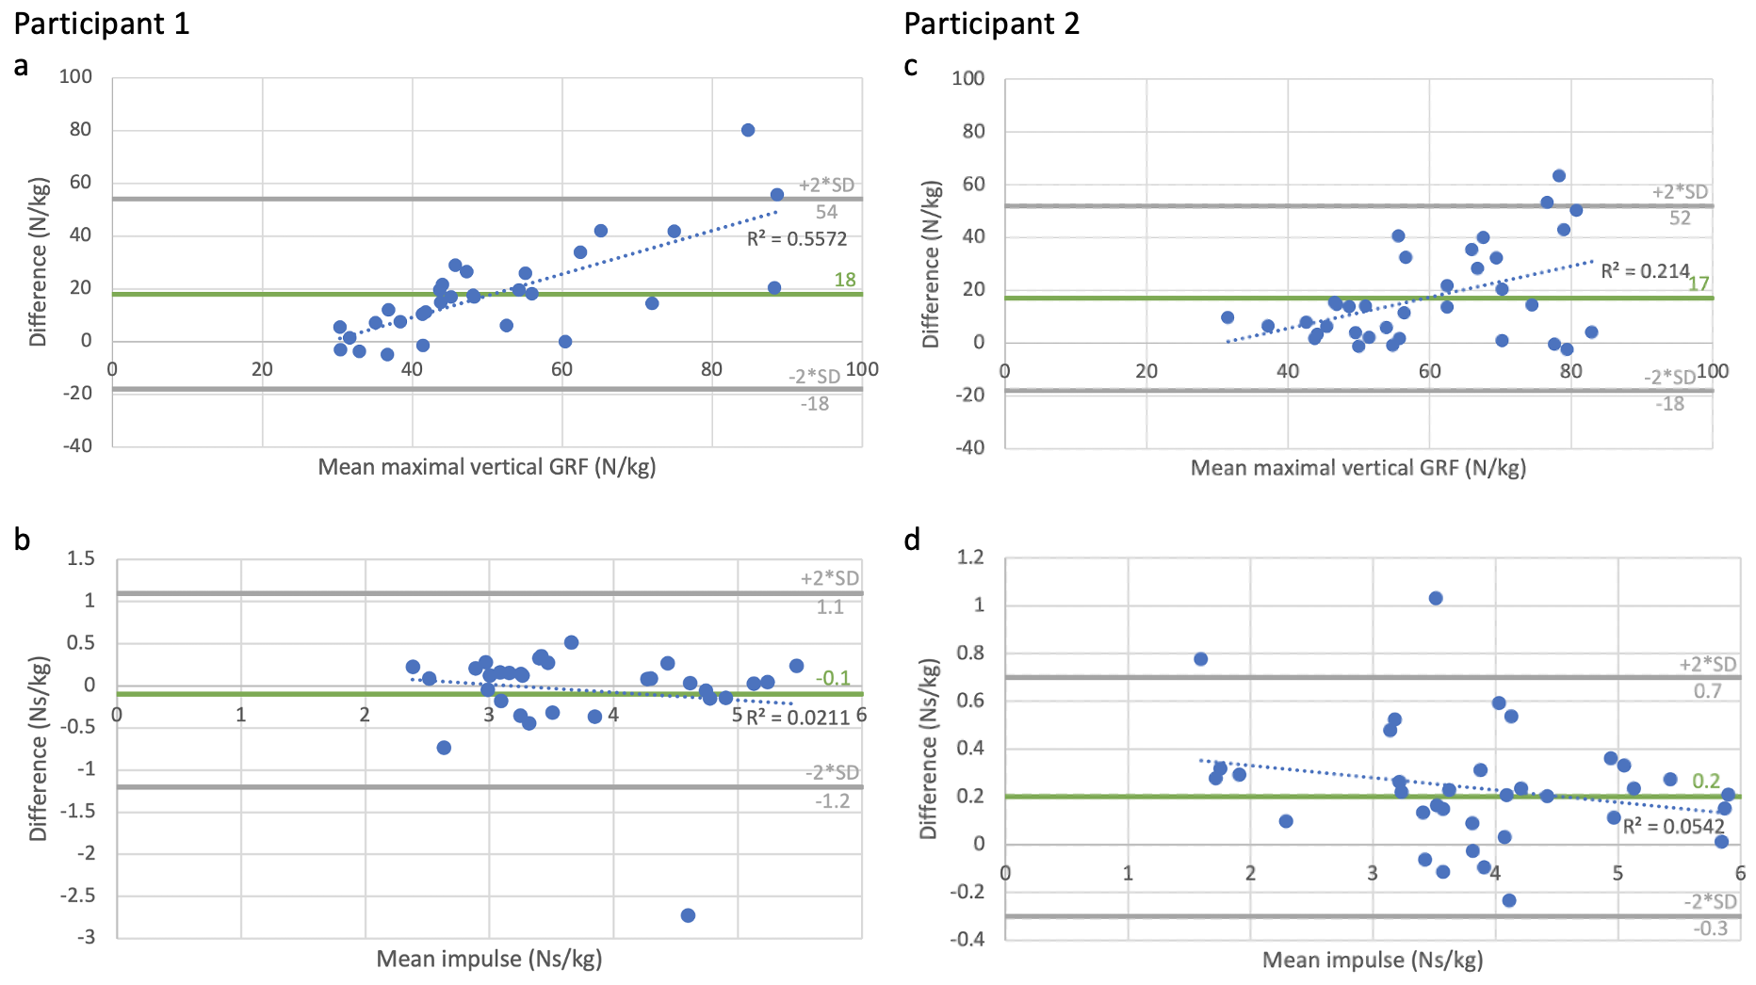
Bland-Altmann diagrams
Figure 4 Bland Altmann diagrams comparing force plate and insole measurements of maximal vertical GRF (a, c) and impulse (b, d) of both participants. For the difference the insole values are subtracted from the force plate values. The mean of all values is displayed in green and the limits of agreement are labelled in grey.

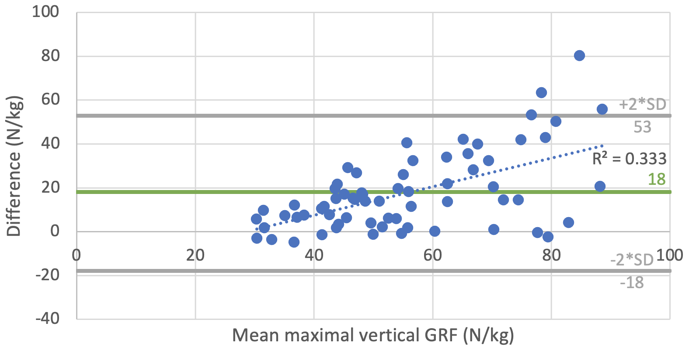
Bland-Altmann diagram of maximal vertical GRF of both participants

Figure 5 Bland Altmann diagram comparing force plate and insole measurements of maximal vertical GRF of both participants (n=66). For the difference the insole values are subtracted from the force plate values. The mean of all values is displayed in green and the limits of agreement are labelled in grey.
Generally, the insoles underestimate the GRF. Therefore, a formula was developed for a force range of 28.5 to 90N/kg to calculate the real GRF value:
Real GRF value in N/kg = 28.5 + (measured GRF value in N/kg – 28.5) * 1.65

