Additional files

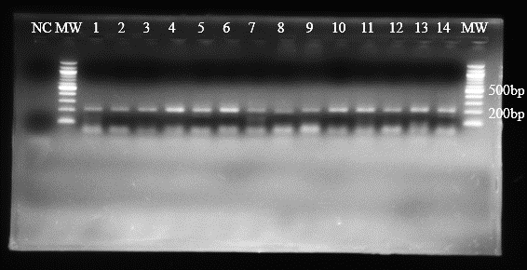
Figure 2: Agarose gel electrophoresis for the identification of Brucella genus from cattle and
sheep blood samples. NC: negative control (nuclease- free water); MW marker: 100 bp DNA ladder (New England Biolabs). Lane 1-14 : positive samples showing a specific band of 223 bp.

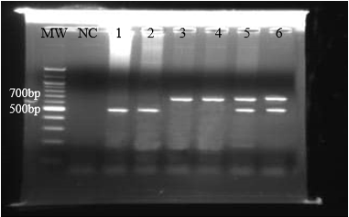

Figure 3: Agarose gel electrophoresis of products from AMOS-PCR of the IS711 gene using species-specific primers for the identification of Brucella abortus and Brucella melitensis from cattle and sheep blood samples. Lanes 1 and 2 show amplification products of 498 bp in length for Brucella abortus; Lanes 3 and 4 show amplification products of 730 bp for B. melitensis; Lanes 5 and 6 show double amplification as a result of mixed infection of both B. abortus and B. melitensis, in the samples. NC: negative control (nuclease-free water); MW marker: 100 bp DNA ladder (New England Biolabs).

