Source apportionment of heavy metals in agricultural soils around a coal gangue heap with the APCS-MLR and PMF receptor models
Jie Ma^{a,b,}*,1,Zhijie Shen^{c,1}, Shenglan Wang^{a,b}, Li Deng^{a,b}, Jing Sun^{a,b}, Ping Liu^{a,b}, Zelei She^{d}
ªChongqing Ecological and Environmental Monitoring Center, Chongqing 401147, China
^{b}Rural Ecology and Soil Monitoring Technology Research Center, Chongqing 401147, China
^{c}College of Resources and Environment, Southwest University, Chongqing 400715, China
^{d}Chongqing University of Arts and Sciences, Chongqing 402160, China
Supplementary Tables
Table S1 Total variance of interpretation and rotating component matrix in the APCS-MLR model with metal sources in the soil.
Component | Initial eigenvalue |  |  | Component |  |  | Rotating component matrix
Component | Total | variance | Accumulate | PC1 | PC2 | PC3 | PC1 | PC2 | PC3
Cd | 3.13 | 39.06 | 39.06 | 0.606 | 0.363 | 0.528 | 0.827 | 0.295 | 0.082
Hg | 2.10 | 26.25 | 65.31 | 0.737 | -0.158 | 0.420 | 0.828 | -0.237 | -0.046
As | 1.23 | 15.38 | 80.69 | 0.882 | 0.073 | 0.013 | 0.743 | -0.026 | -0.479
Pb | 0.56 | 6.94 | 87.63 | 0.839 | -0.017 | 0.070 | 0.731 | -0.111 | -0.402
Cr | 0.40 | 5.01 | 92.64 | -0.580 | -0.334 | 0.587 | -0.184 | -0.265 | 0.830
Cu | 0.31 | 3.84 | 96.48 | -0.542 | 0.151 | 0.650 | -0.074 | 0.214 | 0.830
Ni | 0.24 | 2.99 | 99.47 | -0.319 | 0.928 | 0.018 | -0.170 | 0.958 | 0.130
Zn | 0.04 | 0.53 | 100.00 | 0.032 | 0.971 | -0.045 | 0.089 | 0.961 | -0.118
KMO and Bartlett’s Test
Kaiser Meyer Olkin Measure of Sampling Adequacy |  |  |  |  | 0.573
Bartlett’s Test of Sphericity |  | Approx. Chi-Square |  |  | 111.54
 |  | df |  |  | 28
 |  | Significance |  |  | ＜0.001
Metals | Sources contributions (%) |  |  |  |  |  | R²
Metals | Factor 1 |  | Factor 2 |  | Factor 3
Cd | 74.58 |  | 20.66 |  | 4.76 |  | 0.778
Hg | 79.37 |  | 17.77 |  | 2.85 |  | 0.744
As | 69.08 |  | 1.86 |  | 29.06 |  | 0.783
Pb | 67.23 |  | 7.96 |  | 24.81 |  | 0.709
Cr | 19.35 |  | 21.77 |  | 58.88 |  | 0.793
Cu | 9.41 |  | 21.21 |  | 69.38 |  | 0.740
Ni | 16.94 |  | 74.59 |  | 8.47 |  | 0.963
Zn | 9.69 |  | 81.82 |  | 8.49 |  | 0.946

Table S2 Summary of input data statistics of studied metals in PMF model and linear correlation between the measured and predicted values with factor profiles and contributions of four PMF-estimated factors for the contents of heavy metals in the soil.
Metals | Category | S/N | Min | 25th | 50th | 75th | Max
Cd | Strong | 8.9 | 0.11 | 0.30 | 0.44 | 0.56 | 1.07
Hg | Strong | 9.0 | 0.08 | 0.10 | 0.14 | 0.17 | 0.30
As | Strong | 5.6 | 4.60 | 5.84 | 9.55 | 12.0 | 17.1
Pb | Strong | 8.5 | 22.5 | 27.1 | 30.7 | 35.6 | 39.8
Cr | Strong | 8.9 | 102 | 112 | 124 | 144 | 150
Cu | Strong | 9.0 | 50.1 | 77.4 | 95.4 | 113 | 140
Ni | Strong | 8.9 | 38.9 | 61.5 | 80.9 | 88.8 | 113
Zn | Strong | 9.0 | 98.5 | 135 | 151 | 182 | 248
Metals | Category | R² | Intercept | Intercept SE | Slope | Slope SE | SE
Cd | Strong | 0.99938 | -0.00184 | 0.00266 | 1.00469 | 0.00511 | 0.00614
Hg | Strong | 0.77440 | 0.04220 | 0.01104 | 0.65767 | 0.07246 | 0.01970
As | Strong | 0.77552 | 2.27018 | 0.82879 | 0.73296 | 0.08050 | 1.46546
Pb | Strong | 0.52742 | 10.13491 | 3.99431 | 0.65486 | 0.12653 | 3.22527
Cr | Strong | 0.52525 | 34.96963 | 17.59996 | 0.71066 | 0.13791 | 11.13236
Cu | Strong | 0.82608 | 19.58348 | 7.14537 | 0.77685 | 0.07276 | 8.33863
Ni | Strong | 0.97994 | 0.94029 | 2.26340 | 0.98430 | 0.02874 | 3.04161
Zn | Strong | 0.95276 | 6.30060 | 7.07033 | 0.95502 | 0.04341 | 8.63303
Metals | Factor profile(mg/kg) |  |  |  | Factor profile(%)
Metals | Factor 1 | Factor 2 | Factor 3 | Factor 4 | Factor 1 | Factor 2 | Factor 3 | Factor 4
Cd | 0.32 | 0.08 | 0.00 | 0.05 | 69.65 | 18.16 | 0.68 | 11.51
Hg | 0.09 | 0.00 | 0.05 | 0.01 | 60.72 | 0.74 | 33.41 | 5.13
As | 5.37 | 70 | 3.30 | 0.02 | 57.41 | 7.16 | 35.26 | 0.17
Pb | 12.8 | 2.40 | 9.29 | 6.08 | 41.89 | 7.86 | 30.34 | 19.91
Cr | 32.9 | 11.1 | 31.4 | 49.6 | 26.32 | 8.86 | 25.13 | 39.69
Cu | 15.0 | 14.3 | 17.3 | 47.2 | 16.00 | 15.28 | 18.47 | 50.25
Ni | 0.00 | 33.7 | 15.0 | 27.0 | 0.00 | 44.46 | 19.87 | 35.67
Zn | 16.7 | 63.1 | 35.4 | 42.2 | 10.62 | 40.09 | 22.49 | 26.80
Supplementary Figures
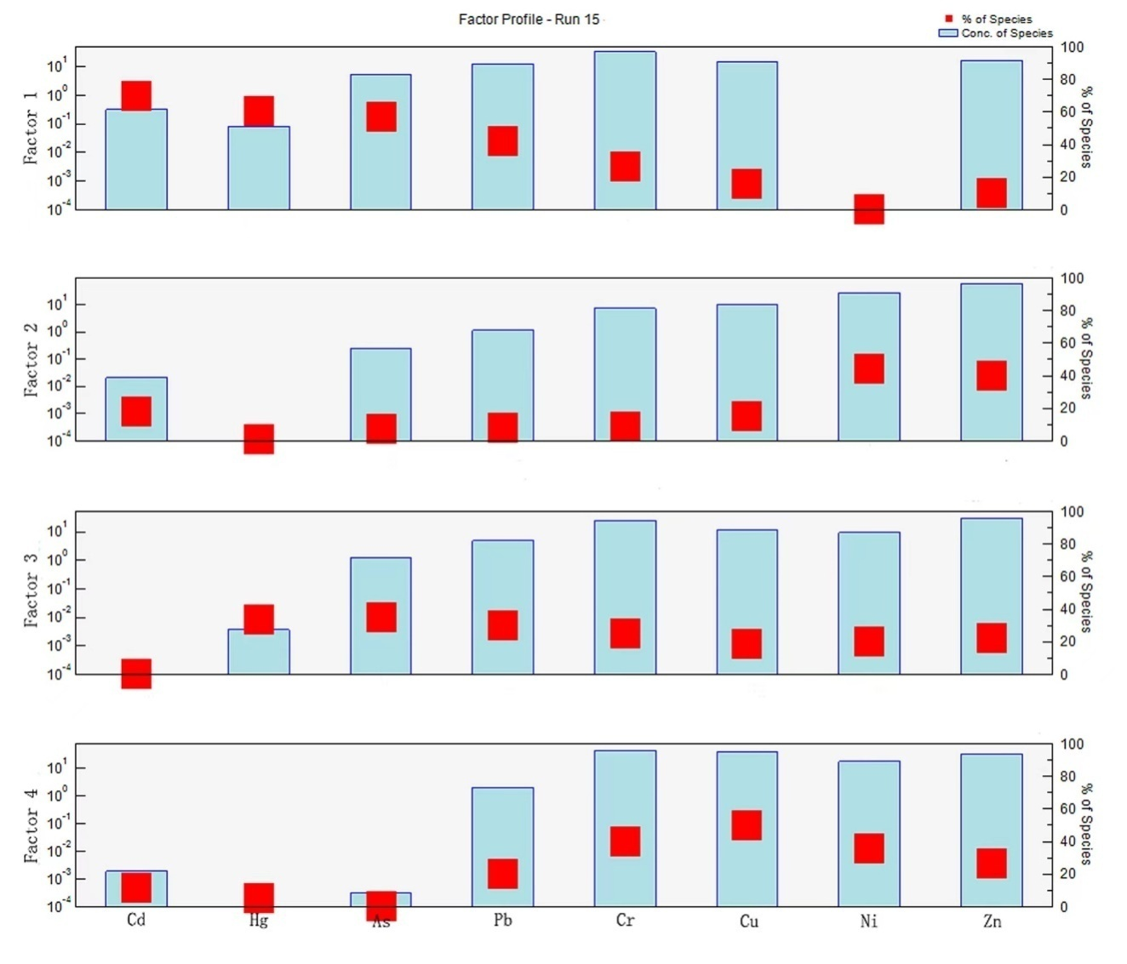
Fig.S1 The factor profile of four factors (i.e., pollution sources) from the PMF model to eight heavy metals is shown. The minimum and maximum displacements are shown in the boxes, and the factor contributions obtained in the base displacements are shown as filled blue boxes for comparison
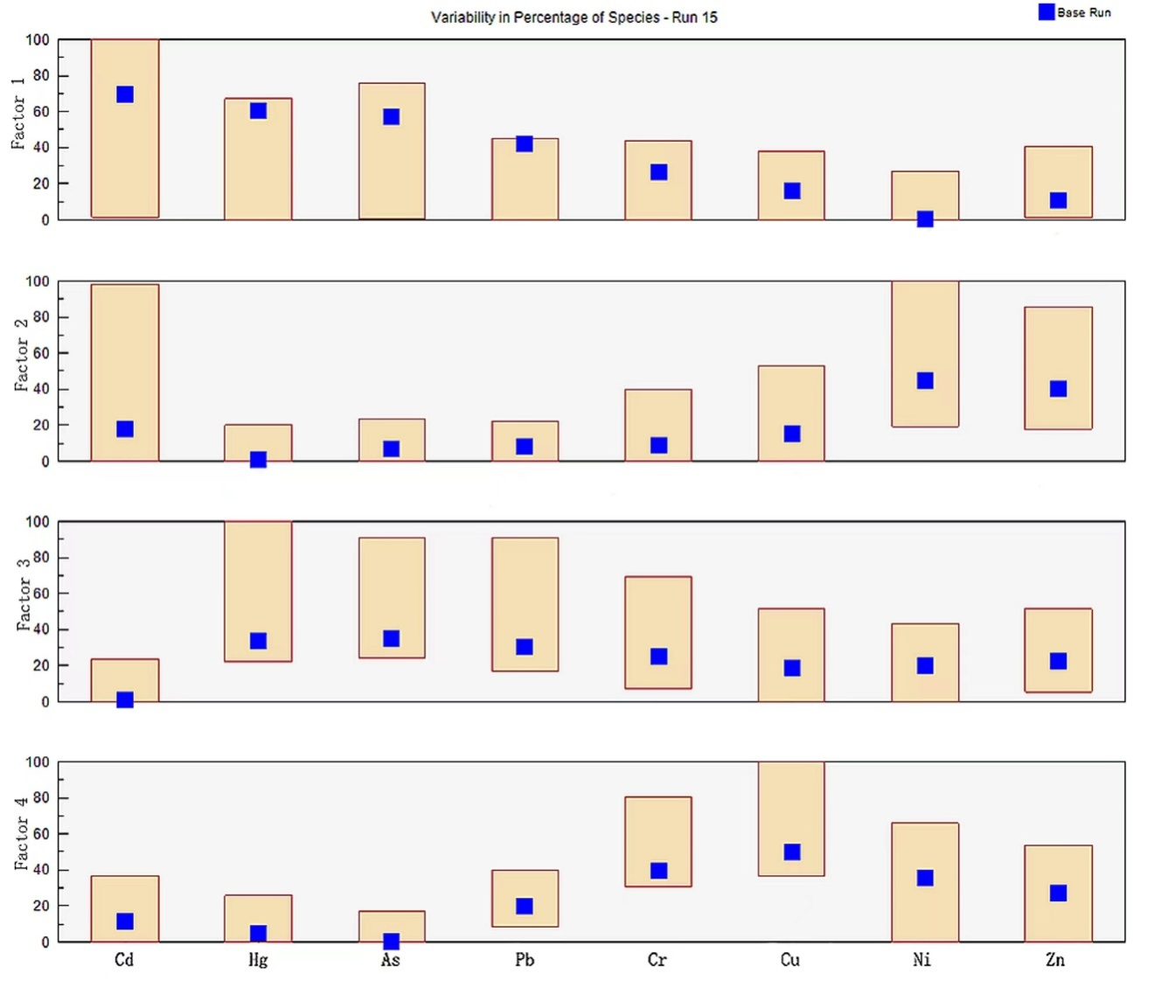Fig.S2 Based on DISP analysis, the variability of the percentage contribution of four factors (i.e., pollution sources) from the PMF model to eight heavy metals is shown. The minimum and maximum displacements are shown in the boxes, and the factor contributions obtained in the base displacements are shown as filled blue boxes for comparison
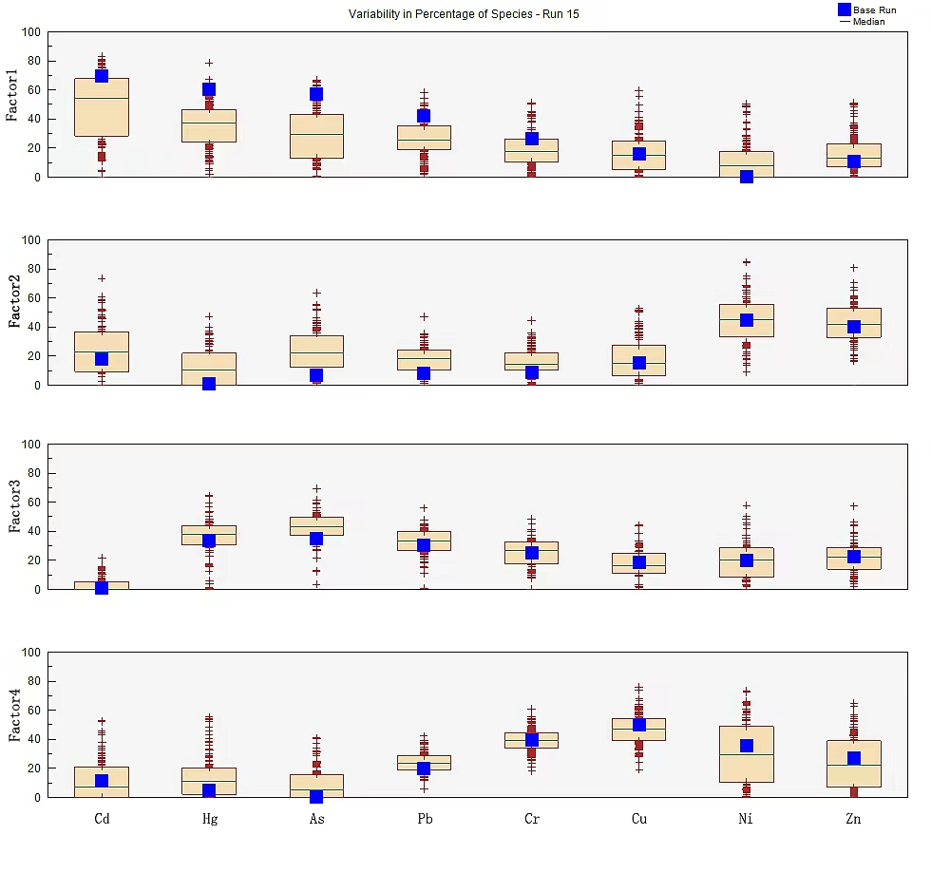Fig.S3 Based on Bootstrap (BS) analysis, the variability of the percentage contribution of four factors (i.e., pollution sources) from the PMF model to eight heavy metals is shown. The box represents the interquartile range (25th to 75th percentile), and values outside this range are represented as crosses. The horizontal green line represents the median, and the percentage factor contribution obtained in the base test is shown as a filled blue box for comparison
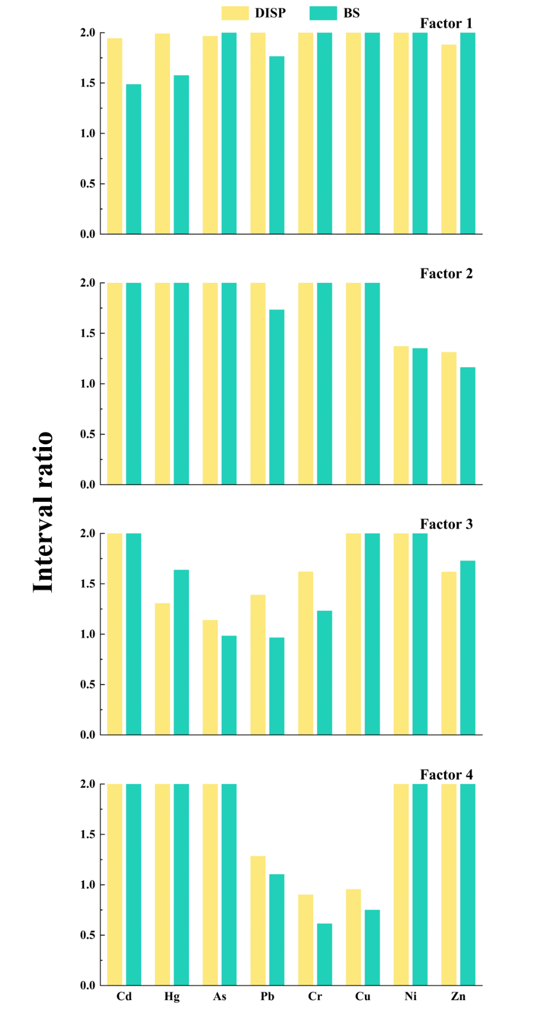
Fig.S4 Interval ratio of uncertainty in estimating the contribution rate of heavy metals in the study area by PMF model based on BS and DISP analysis
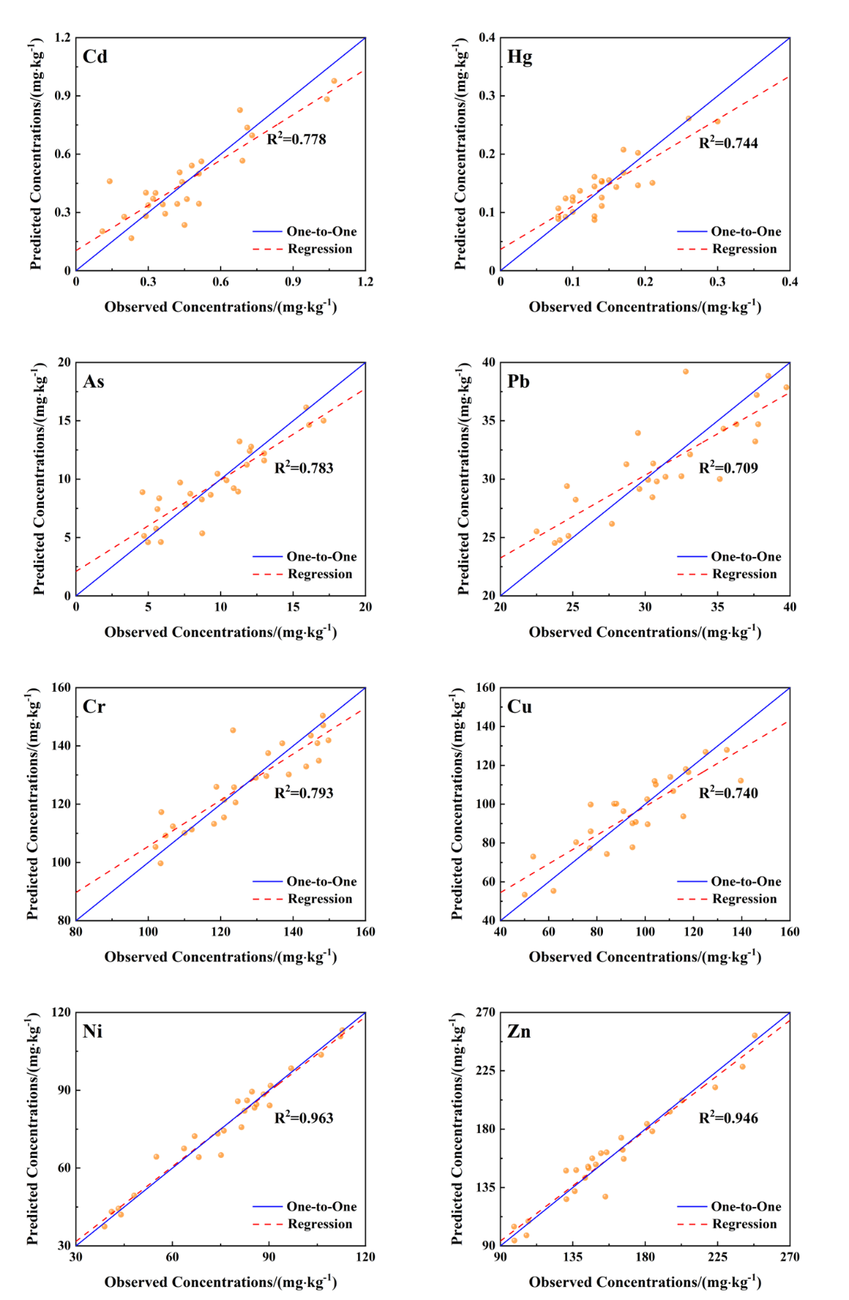
Fig.S5 Scatter plots of predicted and observed concentrations of heavy metals using the APCS-MLR model
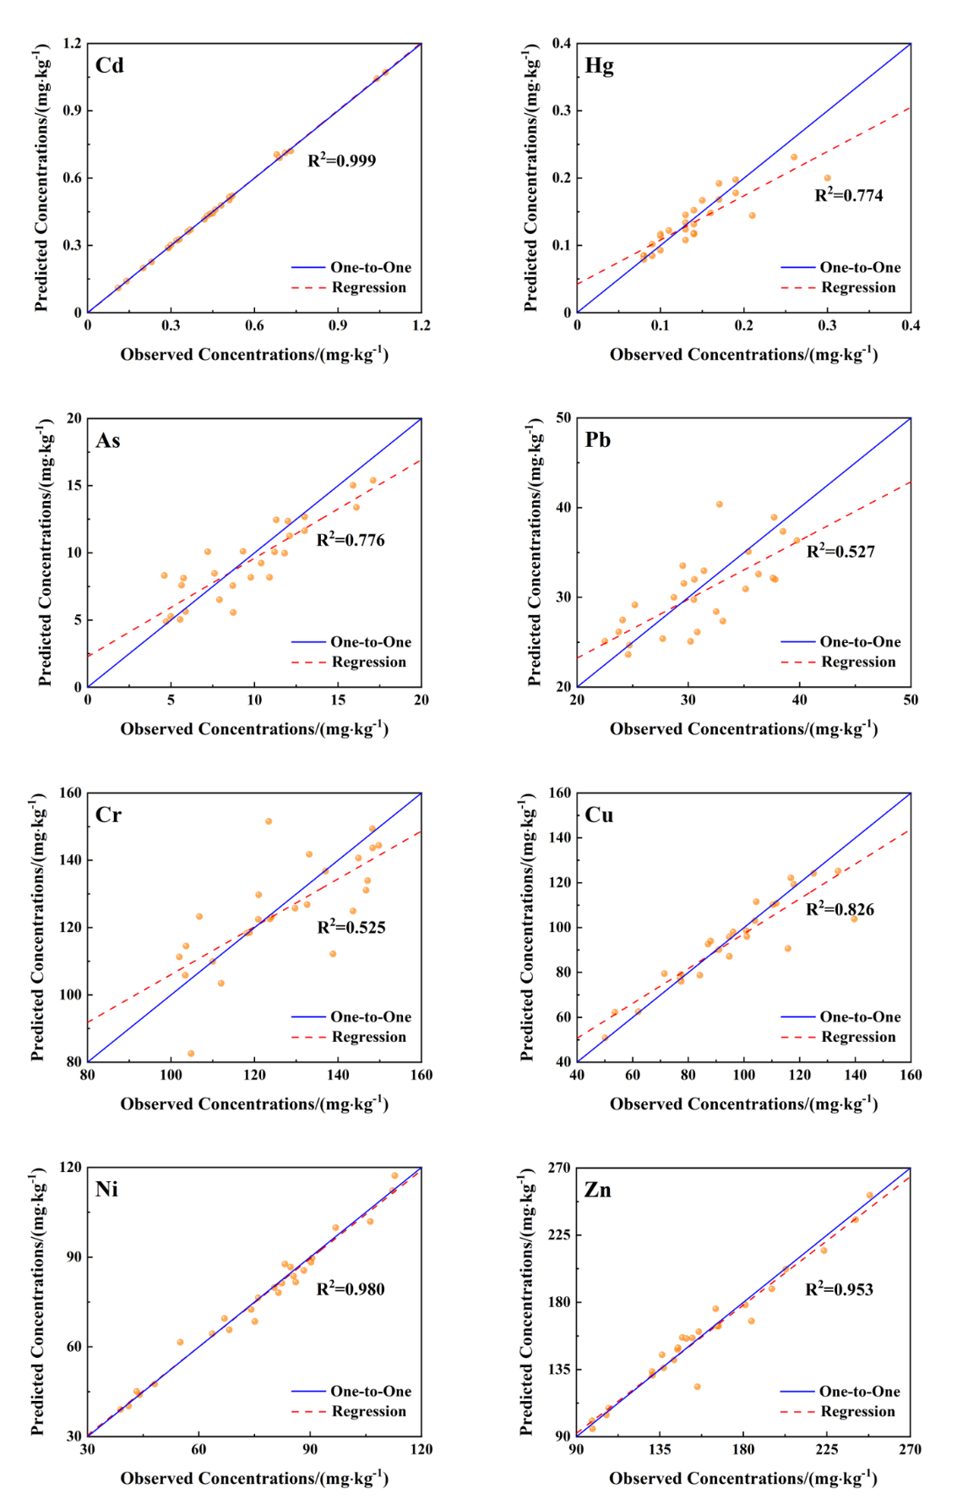
Fig.S6 Scatter plots of predicted and observed concentrations of heavy metals using the PMF model

¹These authors contributed equally to this work. ∗Corresponding author E-mail address:pony312@qq.com (J. Ma).

