Supplementary information of the article:
Saline soil reclamation by halophytes increased soil multifunctionality through modulation of soil microbial communities
Shuai Zhao¹, Samiran Banerjee², Martin Hartmann³, Bin Peng¹, Rylie Elvers², Zhen-Yong Zhao¹, Na Zhou¹, Chang-Yan Tian^{1*} and Teng-Xiang Lian^{3, 4*}
¹State Key Laboratory of Desert and Oasis Ecology, Xinjiang Institute of Ecology and Geography, Chinese Academy of Sciences, Urumqi 830011, China
²Department of Microbiological Sciences, North Dakota State University, Fargo, North Dakota 58102, USA
³Sustainable Agroecosystems, Department of Environmental Systems Science, ETH Zurich, Zurich, Switzerland
⁴The State Key Laboratory for Conservation and Utilization of Subtropical Agro-bioresources, South China Agricultural University, Guangzhou, Guangdong, China.

This supplementary information contains:
- 10 Tables
- 4 Figures

Table S1 Real-time qPCR primers and thermal profiles used for the quantification of target genes.
Gene /Primers | Target | Sequence (5’ – 3’) | Thermal conditions | References
16S rRNA  338F  518R | Total bacterial abundance | ACT CCT ACG GGA GGC AGC AG  ATT ACC GCG GCT GCT GG | 95°C, 1min, 95°C for 10 s, 53°C for 30 s, 72°C for 1 min, 30 cycles | Muyzer et al., 1993
ITS  ITS1F  ITS2R | Total fungal abundance | CTT GGT CATT TAG AGGA AGT AA  GCT GCG TTC TTC ATC GAT GC | 95°C, 15 min, 95°C for 30 s, 60°C for 30 s, 72°C for 45 s, 30 cycles | Gardes and Bruns, 1993
cbbL  K2f  V2r | bacterial gene coding for RubisCO catalyzes | ACCACCAAGCCGAAGCTCGG  GCCTTCCAGCTTGCCCACCGC | 95°C, 3 min, 95°C for 60 s, 62°C for 60 s, 72°C for 90 s, 72°C for 10 min, 35 cycles | Nanba et al., 2004
nifH  Pol-F  Pol-R | bacterial gene coding for nitrogenase | TGCGAYCCSAARGCBGACTC  ATSGCCATCATYTCRCCGGA | 94°C, 30s; 58°C, 40s; 72°C, 40s, 30 cycles | Poly et al., 2001
AOB  amoA-1F  amoA-2R | bacterial gene coding for ammonia oxidase | GGGGTTTCTACTGGTGGT  CCCCTCKGSAAAGCCTTCTTC | 95 °C for 30s, 55 °C for 60s, 72 °C for 60 s, 72 °C for 5min, 35 cycles. | Rotthauwe et al 1997
cnorB  cnorB2F  cnorB6R | bacterial gene coding for nitric oxide reductase | GGN CAY CAR GGN TAY GA  GAA NCC CCA NAC NCC NGC | 95°C for 30 s, 55°C for 40 s, 72°C for 60 s, 35 cycles | Braker and Tiedje, 2003)
nirK  F1aCu  R3Cu | bacterial gene coding for nitrite reductase | ATCATGGTSCTGCCGCG GCCTCGATCAGRTTGTGGTT | 95°C, 30s, 60°C for 30s, 72°C for 30 s, 35 cycles | Hallin et al., 1999
nosZ  nosZ1F  nosZ1R | bacterial gene coding for nitrous oxide reductase | CGC RAC GGC AAS AAG GTS MSS  CAK RTG CAK SGC RTG GCA GAA | 95°C, 30s, 62°C for 40 s, 72°C for 40 s, 30 cycles | Henry et al., 2006)
narG  narG1960f  narG2650r | bacterial gene coding for nitate reductase | TAYGTSGGSCARGARAA  TTYTCRTACCABGTBGC | 94°C, 30 s, 55°C for 30 s, 72°C for 45 s, 30 cycles | Philippot et al., 2002

References
Nanba K, King GM, Dunfield K. Analysis of facultative lithotrophic distribution and diversity on volcanic deposits by use of the large subunit of ribulose 1,5-bisphosphate carboxylase/oxygenase. Appl Environ Microbiol. 2004;70:2245-2253.
Poly F, Ranjard L, Nazaret S, Gourbiere F, Monrozier LJ. Comparison of nifH gene pools in soils and soil microenvironments with contrasting properties. Appl Environ Microbiol.2001;67:2255-2262.
Rotthauwe J, Witzel K, Liesack W. The ammonia monooxygenase structural gene amoA as a functional marker: Molecular fine-scale analysis of natural ammonia-oxidizing populations. Appl Environ Microbiol. 1997;63:4704-4712.
Muyzer G, Waal ECD, Uitterlinden AG. Proﬁling of complex microbial populations by denaturing gradient gel electrophoresis analysis of polymerase chain reaction-ampliﬁed genes coding for 16S rRNA. Appl Environ Microbl. 1993;59:695–700.
Hallin S, Lindgren PE. 1999. PCR detection of genes encoding nitrite reductase in denitrifying bacteria. Appl Environ Microbl. 1999;65:1652-1657.
Gardes M, Bruns TD. ITS primers with enhanced specificity for basidiomycetes– application to the identification of mycorrhizae and rusts. Mol Ecol. 1993;2:113–118.
Henry S, Baudoin E, López-Gutiérrez JC, Martin-Laurent F, Brauman A, Philippot L. Quantification of denitrifying bacteria in soils by nirK gene targeted real-time PCR. J Microbiol Meth. 2004;59:327–335.
Braker G, Tiedje JM. Nitric oxide reductase (norB) genes from pure cultures and environmental samples. Appl Environ Microb. 2003;69:3476–3483.
Philippot L, Piutti S, Martin-Laurent F, Hallet S, Germon JC. Molecular analysis of the nitrate-reducing community from unplanted and maize-planted soils. Appl Environ Microbiol. 2002;68(12):6121-6128.

Table S2 Assembly accession ID of each whole genome downloading from JGI-IMG website with > 97% identity to dominant OTUs in different ecological clusters.

Please see the excel file (SI_Table S2.xlsx).

Table S3 Plant properties and net salt removal amount during remediation. The values (mean ± s.e) sharing the same letter are not significantly different at P < 0.05.
 | P1 | P2 | P3 | P4 | P5
Fresh weight (kg m⁻²) | 4.147 ±0.208c | 5.443 ±0.293b | 7.113 ±0.106a | 7.220 ±0.238a | 7.283 ±0.202a
Dry weight (kg m⁻²) | 0.833 ±0.063c | 0.323 ±0.110b | 1.737 ±0.037a | 1.873 ±0.029a | 1.857 ±0.071a
Salt content in ash (kg hm⁻²) | 1805.333 ±150.034d | 2501.667 ±98.476c | 3281.000 ±42.008b | 3756.000 ±62.944a | 3778.333 ±25.773a
Na⁺ accumulation (g kg⁻¹ dry weight) | 57.680 ±0.900a | 55.033 ±2.104ab | 49.954 ±2.231bc | 47.573 ±2.744c | 46.874 ±4.073c
Cl⁻ accumulation (g kg⁻¹ dry weight) | 118.444 ±2.127a | 110.202 ±1.971a | 98.048 ±2.844b | 91.327 ±4.349b | 90.151 ±6.399b
net salt removal quantity (kg hm⁻²) | 825 | 1521 | 2301 | 2789 | 2776
The quantity of imported salt via irrigation per year: irrigation volume (4665 m³ hm⁻²) × average salinity of irrigation water (0.21 g L⁻¹) = 980 kg ha⁻¹.
The net salt removal (kg hm⁻²) = Salt content in ash − imported salt via irrigation (980 kg hm⁻²).
Different letters indicate significant differences among treatments (P < 0.05).

Table S4 Soil properties and soil enzymes activity for this study. The values (mean ± s.e) sharing the same letter are not significantly different at P < 0.05.
Property | OS | OSI | P1 | P2 | P3 | P4 | P5
OM (g kg⁻¹) | 7.379 ± 0.252de | 6.768 ± 0.260e | 7.758 ± 0.130d | 8.804 ± 0.142c | 10.193 ± 0.514b | 9.758 ± 0.078b | 10.929 ± 0.470a
TN (g kg⁻¹) | 0.473 ± 0.030d | 0.575 ± 0.004ab | 0.531 ± 0.050bcd | 0.631 ± 0.021a | 0.559 ± 0.011bc | 0.5 ± 0.021cd | 0.543 ± 0.039bc
TP (g kg⁻¹) | 0.711 ± 0.054a | 0.696 ± 0.033a | 0.727 ± 0.028a | 0.708 ± 0.002a | 0.661 ± 0.010a | 0.675 ± 0.019a | 0.682 ± 0.008a
TK (g kg⁻¹) | 18.529 ± 0.180b | 18.286 ± 0.437b | 18.499 ± 0.217b | 18.066 ± 0.140b | 19.902 ± 0.290a | 19.958 ± 0.224a | 19.416 ± 0.167a
NO₃⁻-N (mg kg⁻¹) | 383.642 ± 10.987b | 456.508 ± 12.636s | 198.817 ± 2.609d | 272.583 ± 10.894c | 167.972 ± 15.509e | 54.702 ± 4.755f | 66.647 ± 3.032f
NH₄⁺-N (mg kg⁻¹) | 8.54 ± 0.701bcd | 10.282 ± 0.261a | 8.34 ± 0.416cde | 9.58 ± 1.083abc | 6.888 ± 0.435e | 7.916 ± 0.706de | 10.011 ± 0.672ab
AP (mg kg⁻¹) | 4.486 ± 0.833ab | 3.742 ± 0.694b | 5.054 ± 1.468ab | 6.009 ± 1.130a | 3.609 ± 0.337b | 3.864 ± 0.700b | 4.408 ± 0.776ab
AK (mg kg⁻¹) | 137.341 ± 2.215c | 154.848 ± 2.138b | 139.135 ± 1.516c | 159.55 ± 2.477a | 103.235 ± 0.578e | 127.781 ± 1.582d | 135.599 ± 0.339c
pH (1:5) | 7.423 ± 0.059ab | 7.49 ± 0.036a | 7.417 ± 0.026ab | 7.473 ± 0.045a | 7.353 ± 0.021b | 7.227 ± 0.054c | 7.243 ± 0.073c
EC (1:5) (ms cm⁻¹) | 23.367 ± 0.309a | 17.7 ± 0.216b | 16.75 ± 0.210c | 14.34 ± 0.128d | 6.05 ± 0.024e | 4.583 ± 0.029g | 5.097 ± 0.068f
Cl⁻ (g kg⁻¹) | 27.573 ± 0.285a | 20.686 ± 0.157b | 19.546 ± 0.142c | 16.957 ± 0.337d | 6.573 ± 0.165e | 4.188 ± 0.212f | 6.719 ± 0.257e
SO₄²⁻ (g kg⁻¹) | 9.098 ± 0.271a | 5.686 ± 0.045c | 6.79 ± 0.078b | 5.153 ± 0.272d | 1.446 ± 0.254f | 2.992 ± 0.033e | 5.112 ± 0.031d
Ca²⁺ (g kg⁻¹) | 3.933 ± 0.019a | 4.041 ± 0.039a | 3.897 ± 0.094b | 2.569 ± 0.011c | 1.089 ± 0.011f | 1.549 ± 0.043e | 1.94 ± 0.057d
Mg²⁺ (g kg⁻¹) | 2.532 ± 0.031a | 2.371 ± 0.020b | 1.899 ± 0.018d | 2.098 ± 0.038c | 0.529 ± 0.063f | 0.5 ± 0.013f | 0.842 ± 0.053e
K⁺ (g kg⁻¹) | 0.078 ± 0.005a | 0.073 ± 0.001a | 0.06 ± 0.003b | 0.074 ± 0.001a | 0.04 ± 0.003d | 0.048 ± 0.002c | 0.064 ± 0.003b
Na⁺ (g kg⁻¹) | 11.828 ± 0.506a | 10.091 ± 0.012b | 6.38 ± 0.202c | 5.47 ± 0.226d | 3.37 ± 0.165e | 1.962 ± 0.345g | 2.737 ± 0.237f
SC (g kg⁻¹) | 51.03 ± 2.588a | 47.492 ± 1.379b | 43.033 ± 1.441c | 35.15 ± 1.803d | 14.192 ± 1.263e | 12.125 ± 2.361e | 13.942 ± 1.827e
BD (g·cm⁻³) | 1.573 ± 0.009a | 1.573 ± 0.005a | 1.483 ± 0.012b | 1.38 ± 0.024c | 1.267 ± 0.034d | 1.22 ± 0.008e | 1.223 ± 0.005e
β-G (mg PNP kg⁻¹h⁻¹) | 17.467±0.521d | 18.501±0.446d | 53.583±0.626c | 57.603±0.572c | 110.717±2.565b | 144.705±1.058a | 148.333±1.175a
A-P (mg PNP g⁻¹ h⁻¹) | 0.092±0.017b | 0.100±0.019b | 0.142±0.007b | 0.148±0.006b | 2.900±0.093a | 3.167±0.109a | 3.150±0.106a
U (mg NH₃-N kg⁻¹ h⁻¹) | 12.983±0.346c | 12.783±0.320c | 14.067±0.361bc | 14.233±0.230bc | 15.350±0.362b | 17.717±0.381a | 17.550±0.416a
OS: Original soil; OSI: Original soil with irrigation.
SC, total water-soluble salt content (g kg⁻¹); OM, soil organic matter (g kg⁻¹); TN, soil total nitrogen (g kg⁻¹); TP, soil total phosphorus (g kg⁻¹); TK, soil total potassium (g kg⁻¹); AP, available phosphorus (mg kg⁻¹); AK, available potassium (mg kg⁻¹); NH₄⁺-N, ammonium nitrogen (mg kg⁻¹); NO₃⁻-N, nitrate nitrogen (mg kg⁻¹); BD, bulk density; β-G, β-glucosidase (mg PNP kg⁻¹h⁻¹); A-P, Alkaline phosphatase (mg PNP g⁻¹ h⁻¹); U, Urease (mg NH₃-N kg⁻¹ h⁻¹).
Different letters indicate significant differences among treatments (P < 0.05).

Table S5 Effect of phytoremediation years on the differentiation of soil microbial communities and subcommunities based on PERMANOVA.
Grouping |  | All
Grouping |  | R | P
Bacteria
Group I vs. II |  | 0.175 | 0.005
Group I vs. III |  | 0.885 | 0.001
Group II vs. III |  | 0.839 | 0.001
Fungi
Group I vs. II |  | 0.860 | 0.001
Group I vs. III |  | 0.449 | 0.001
Group II vs. III |  | 0.454 | 0.001
Group I: OS (original soil), OSI (original soil with irrigation), and P1-P2 (1- and 2-year phytoremediation); Group II: P3 (the third phytoremediation year); Group III: P4–P5 (4- and 5-year phytoremediation).
Bold font indicates signiﬁcant value (P < 0.01)

Table S6 The PERMANOVA analysis results shows differences between before and after phytoremediation from phylum to genus levels.
(Note: "--" indicates that there is no value here, and P value were adjusted using "fdr" method)
Please see the excel file (SI_Table S6.xlsx).

Table S7 Functional genes abundance among different treatments.
Gene | OS | OSI | P1 | P2 | P3 | P4 | P5
nifH | 4.42±0.06cd | 4.45±0.05c | 4.34±0.06d | 4.42±0.07cd | 4.78±0.09b | 5±0.06a | 5.03±0.07a
nirK | 4.93±0.07a | 4.94±0.08a | 4.92±0.04a | 4.91±0.05a | 4.96±0.11a | 4.9±0.07a | 4.9±0.06a
nosZ | 4.5±0.03a | 4.54±0.04a | 4.54±0.05a | 4.5±0.05a | 4.55±0.02a | 4.53±0.03a | 4.54±0.05a
AOB | 4.28±0.12c | 4.25±0.08c | 4.22±0.11a | 4.25±0.17c | 4.8±0.06b | 4.83±0.33ab | 5.02±0.1a
cnorB | 4.72±0.06a | 4.74±0.04a | 4.76±0.04a | 4.71±0.04a | 4.76±0.08a | 4.74±0.07a | 4.69±0.06a
narG | 4.93±0.04a | 4.94±0.10a | 4.90±0.14a | 4.83±0.09a | 4.88±0.08a | 4.86±0.09a | 4.9±0.16a
cbbL | 4.55±0.01a | 4.55±0.02a | 4.53±0.02a | 4.52±0.01a | 4.44±0.03b | 4.32±0.06c | 4.15±0.06d
OS: original soil; OSI: original soil with irrigation; P1-P5: 1-year phytoremediation to 5-year phytoremediation, respectively.
Different letters indicate significant differences among treatments (P < 0.05).

Table S8 Operational taxonomic unit (OTU) numbers of soil taxa at different levels (phylum, class, family and genus) within each module.

Please see the excel file (SI_Table S8.xlsx).

Table S9 Operational taxonomic unit (OTU) numbers of mapped taxa at different levels (phylum, class, family and genus) within each module.

Please see the excel file (SI_Table S9.xlsx).

Table S10 The multifunctionality for soil fertility along years. The multifunctionality index was calculated using nine variables after Z-score transformation.
Treatment | Multifunctionality | N cycle | C cycle | P cycle
OS | 0.613±0.011f | 0.82±0.027c | 0.49±0.012f | 0.668±0.049bc
OSI | 0.637±0.013f | 0.926±0.009b | 0.466±0.019f | 0.609±0.071c
P1 | 0.728±0.018e | 0.94±0.051b | 0.699±0.008e | 0.719±0.127bc
P2 | 0.728±0.018d | 1.025±0.041a | 0.788±0.014d | 0.78±0.098b
P3 | 1.085±0.026c | 1±0.032ab | 1.113±0.052c | 1.016±0.068a
P4 | 1.17±0.019b | 1.026±0.046a | 1.282±0.016b | 1.073±0.103a
P5 | 1.24±0.027a | 1.044±0.071a | 1.379±0.03a | 1.175±0.089a
OS: original soil; OSI: original soil with irrigation; P1-P5: 1- year phytoremediation to 5-year phytoremediation, respectively.
Different letters indicate significant differences among treatments (P < 0.05).

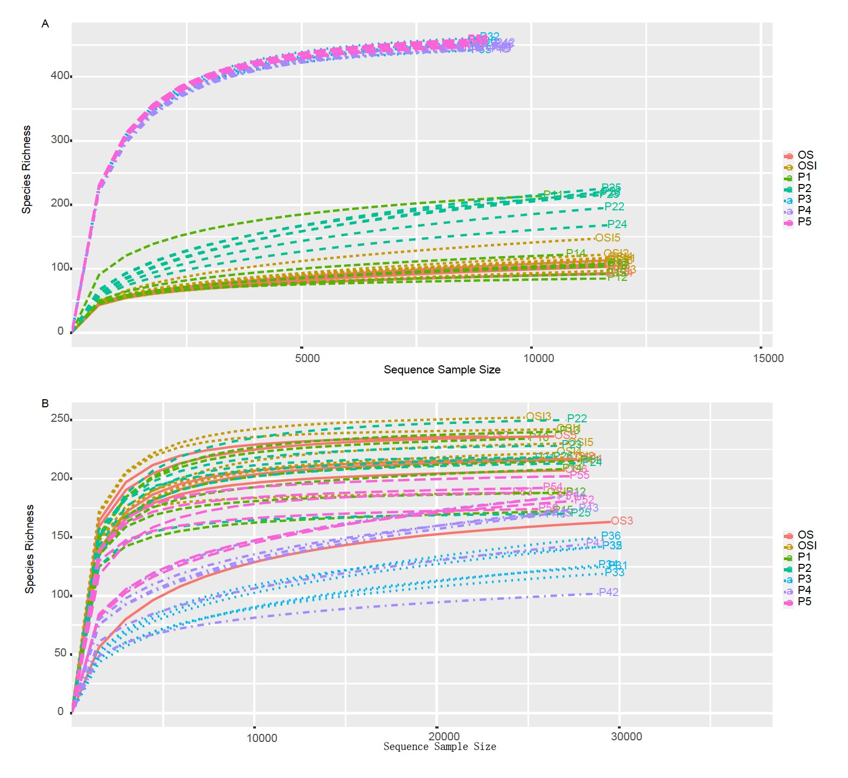
Fig. S1 Rarefaction curves of similarity-based operational taxonomic unit (OTU) at 97% sequence similarity level. A: bacteria; B: fungi.

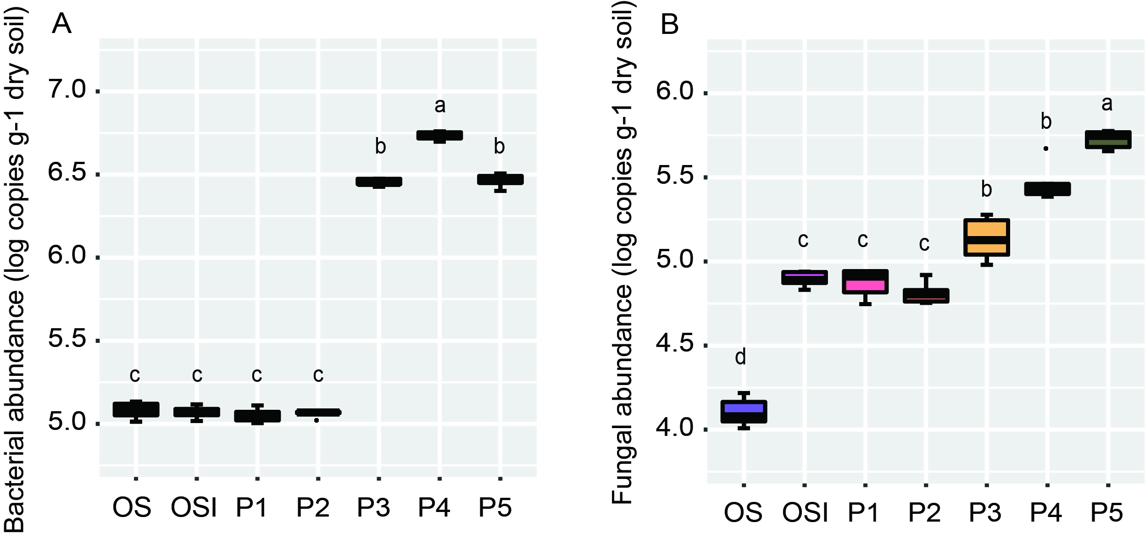
Fig. S2 Abundance of bacterial (A) and fungal (B) community varied among treatments. Different letters above the boxes indicate significant differences.

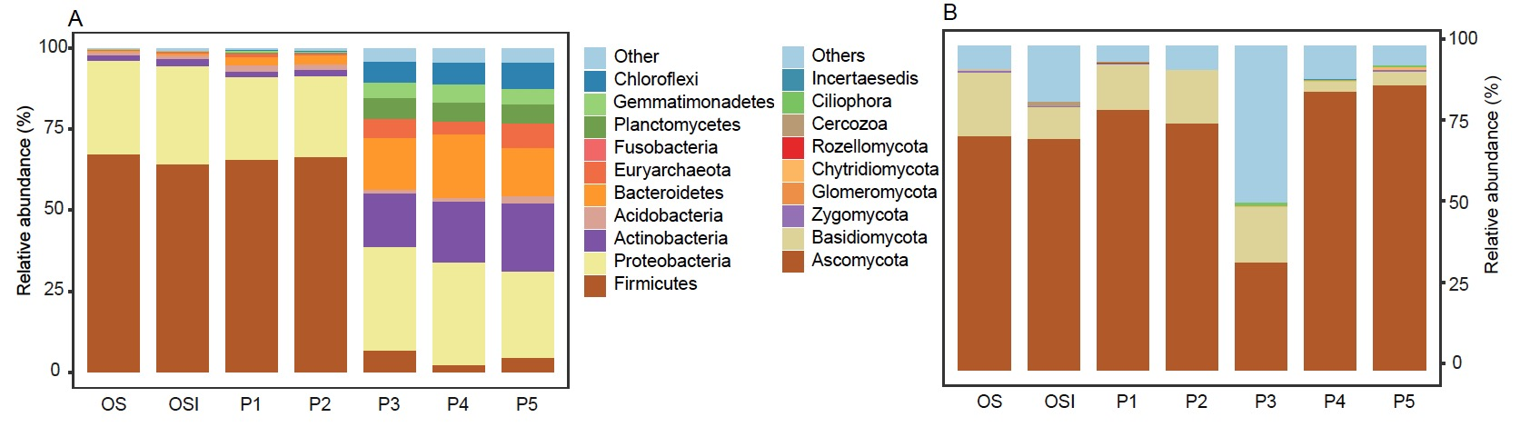
Fig. S3 The relative abundance of bacterial (A) and fungal (B) taxa at the phylum level.

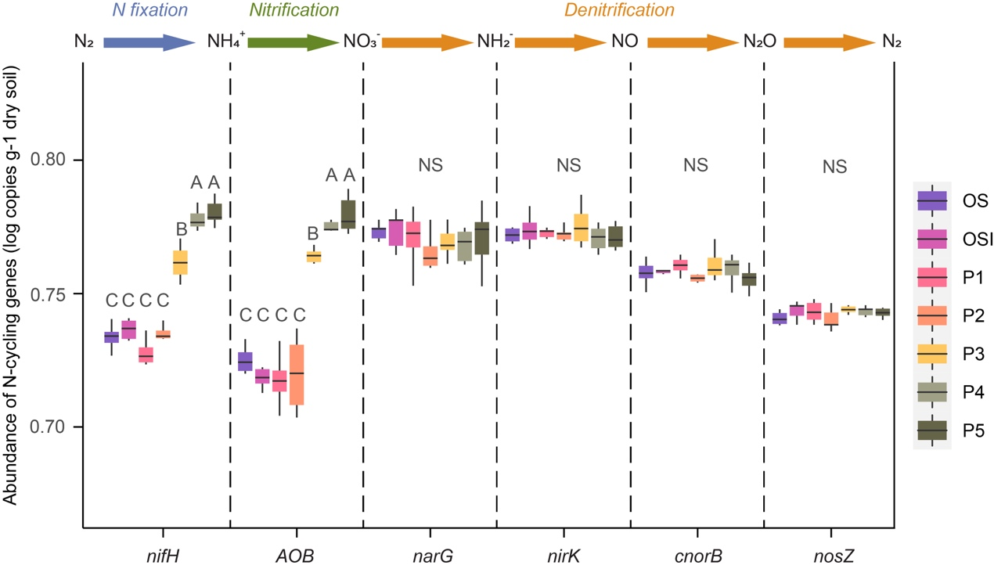
Fig. S4 Abundances of genes involved in N-cycling shown as log copy numbers per gram dry soil. Different letters above the boxes indicate significant differences among treatments. NS: no significant differences among groups.

