Structure and X‑ray analysis of diethyl 2-((Z)-((Z)-3-(2-ethoxy-2-oxoethyl)-5-(2-methoxy-2-oxoethylidene)-4-oxothiazolidin-2-ylidene)amino)-4,5-dihydrothieno[2,3-c]pyridine-3,6(7H)-dicarboxylate
Mohamed Ramadan¹, Ashraf A. Aly²*, Essam Kh. Ahmed², Martin Nieger³, Alan B. Brawn⁴, Stefan Bräse^{5,6}*
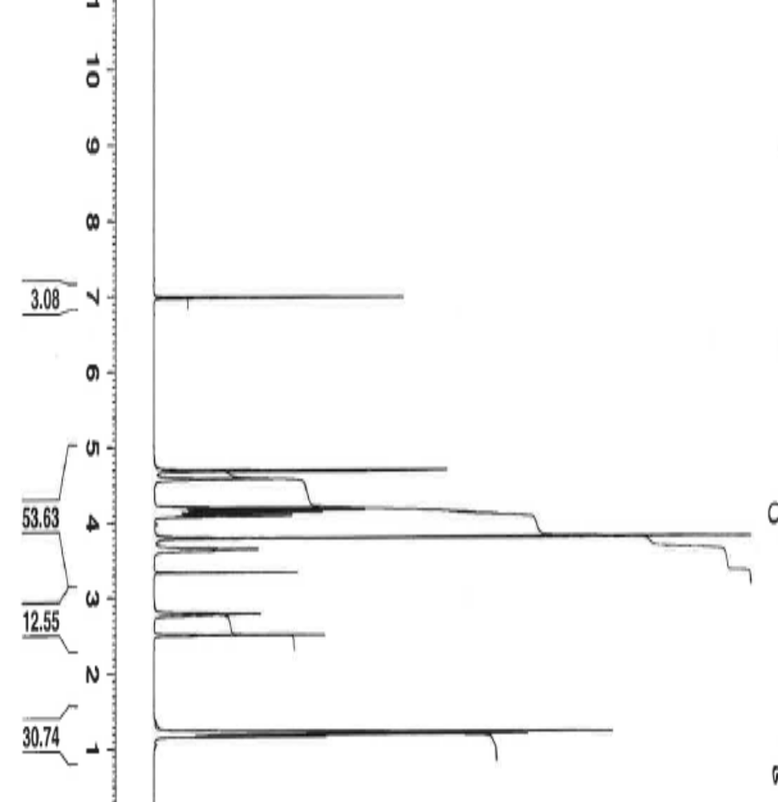
SI Figure 1. ¹H NMR spectrum of compound 8

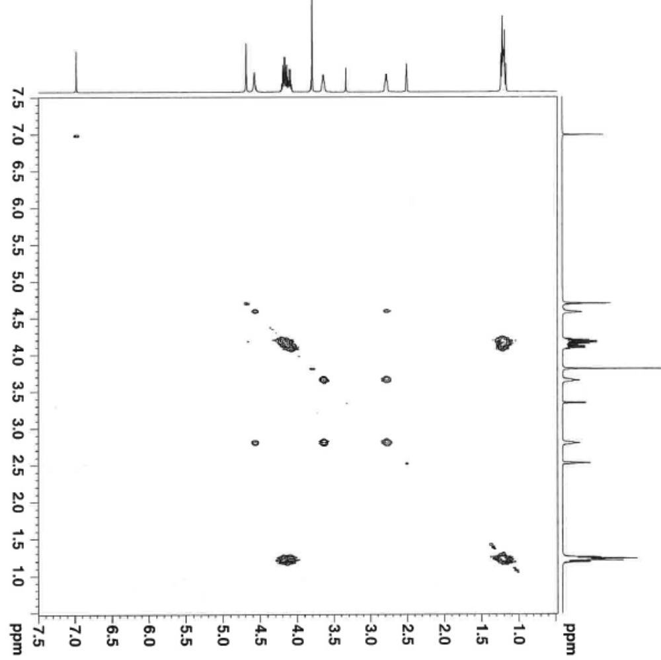
SI Figure 2. COSY H-H spectrum of compound 8
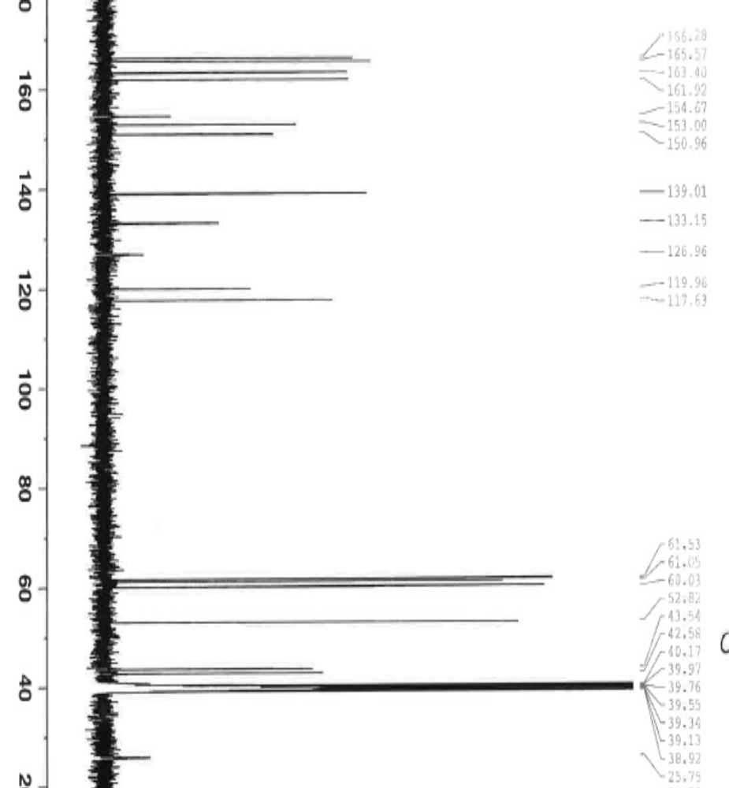
SI Figure 3. ¹³C NMR spectrum of compound 8

Diethyl 2-(((2Z,5Z)-3-(2-ethoxy-2-oxoethyl)-5-(2-methoxy-2-oxoethylidene)-4-oxothiazolidin-2-ylidene)amino)-4,7-dihydrothieno[2,3-c]pyridine-3,6(5H)-dicarboxylate 8
Crystal data
C₂₃H₂₇N₃O₉S₂ | F(000) = 1160
M_{r} = 553.59 | D_{x} = 1.479 Mg m⁻³
Monoclinic, P2₁/c (no.14) | Cu Kα radiation, λ = 1.54178 Å
a = 12.6554 (4) Å | Cell parameters from 9918 reflections
b = 7.5654 (2) Å | θ = 3.4–72.3°
c = 26.2314 (7) Å | μ = 2.46 mm⁻¹
β = 98.271 (2)° | T = 123 K
V = 2485.35 (12) Å³ | Plates, orange
Z = 4 | 0.20 × 0.04 × 0.02 mm

Data collection
Bruker D8 VENTURE diffractometer with PhotonII CPAD detector | 4195 reflections with I > 2σ(I)
Radiation source: INCOATEC microfocus sealed tube | R_{int} = 0.045
rotation in φ and ω, 1°, shutterless scans | θ_{max} = 72.3°, θ_{min} = 3.4°
Absorption correction: multi-scan  SADABS (Sheldrick, 2014) | h = -1515
T_{min} = 0.830, T_{max} = 0.929 | k = -7→9
24931 measured reflections | l = -32→32
4903 independent reflections
Refinement
Refinement on F² | Primary atom site location: dual
Least-squares matrix: full | Secondary atom site location: difference Fourier map
R[F² > 2σ(F²)] = 0.040 | Hydrogen site location: mixed
wR(F²) = 0.100 | H-atom parameters constrained
S = 1.04 | w = 1/[σ²(F_{o}²) + (0.0457P)² + 1.8138P]  where P = (F_{o}² + 2F_{c}²)/3
4903 reflections | (Δ/σ)_{max} = 0.001
332 parameters | Δ⟩_{max} = 0.46 e Å⁻³
24 restraints | Δ⟩_{min} = -0.57 e Å⁻³
Special details
Experimental. dx = 40 mm, 1 deg., 9+1 runs, 1423 frames, 15/30/60 sec./frame
Geometry. All esds (except the esd in the dihedral angle between two l.s. planes) are estimated using the full covariance matrix. The cell esds are taken into account individually in the estimation of esds in distances, angles and torsion angles; correlations between esds in cell parameters are only used when they are defined by crystal symmetry. An approximate (isotropic) treatment of cell esds is used for estimating esds involving l.s. planes.
Refinement. One ethyl acetate moiety disordered, use of constraints (EADP) and restraints (SADI) for the refinement, disordered atoms refined isotropically.

Fractional atomic coordinates and isotropic or equivalent isotropic displacement parameters (Å²) for compound 8
 | x | y | z | U_{iso}*/U_{eq} | Occ. (<1)
S1 | 0.61474 (4) | 0.25167 (6) | 0.56427 (2) | 0.01940 (12)
C2 | 0.74658 (15) | 0.3065 (3) | 0.58374 (7) | 0.0201 (4)
C3 | 0.79782 (16) | 0.2800 (3) | 0.63859 (8) | 0.0250 (4)
H3A | 0.7515 | 0.3292 | 0.6625 | 0.030*
H3B | 0.8078 | 0.1523 | 0.6459 | 0.030*
N4 | 0.90077 (15) | 0.3696 (3) | 0.64591 (7) | 0.0349 (5)
C5 | 0.96420 (18) | 0.3375 (4) | 0.60432 (9) | 0.0440 (7)
H5A | 0.9725 | 0.2085 | 0.5998 | 0.053*
H5B | 1.0363 | 0.3890 | 0.6138 | 0.053*
C6 | 0.91190 (16) | 0.4182 (3) | 0.55368 (8) | 0.0304 (5)
H6A | 0.9210 | 0.5481 | 0.5549 | 0.037*
H6B | 0.9468 | 0.3720 | 0.5250 | 0.037*
C7 | 0.79441 (15) | 0.3730 (3) | 0.54459 (8) | 0.0205 (4)
C8 | 0.72194 (15) | 0.3874 (2) | 0.49726 (7) | 0.0187 (4)
C9 | 0.62065 (15) | 0.3238 (2) | 0.50156 (7) | 0.0180 (4)
N10 | 0.53621 (13) | 0.3155 (2) | 0.46223 (6) | 0.0186 (3)
C11 | 0.44399 (15) | 0.2534 (2) | 0.46565 (7) | 0.0181 (4)
S12 | 0.39204 (4) | 0.15822 (6) | 0.51887 (2) | 0.01890 (12)
C13 | 0.26777 (16) | 0.1262 (2) | 0.48142 (7) | 0.0205 (4)
C14 | 0.26826 (16) | 0.1865 (3) | 0.42722 (8) | 0.0214 (4)
O14 | 0.19317 (11) | 0.1765 (2) | 0.39282 (6) | 0.0288 (3)
N15 | 0.36647 (13) | 0.2554 (2) | 0.42214 (6) | 0.0196 (3)
C16 | 0.39293 (16) | 0.3148 (3) | 0.37288 (7) | 0.0210 (4)
H16A | 0.4394 | 0.4205 | 0.3781 | 0.025*
H16B | 0.3268 | 0.3483 | 0.3500 | 0.025*
C17 | 0.45001 (16) | 0.1696 (3) | 0.34764 (7) | 0.0214 (4)
O17 | 0.44147 (15) | 0.0147 (2) | 0.35600 (7) | 0.0385 (4)
O18 | 0.50903 (11) | 0.23666 (18) | 0.31415 (5) | 0.0238 (3)
C19 | 0.57695 (18) | 0.1096 (3) | 0.29206 (8) | 0.0275 (5)
H19A | 0.5324 | 0.0196 | 0.2717 | 0.033*
H19B | 0.6246 | 0.0487 | 0.3199 | 0.033*
C20 | 0.64188 (19) | 0.2093 (3) | 0.25811 (9) | 0.0345 (5)
H20A | 0.6881 | 0.1268 | 0.2428 | 0.052*
H20B | 0.5941 | 0.2686 | 0.2307 | 0.052*
H20C | 0.6859 | 0.2976 | 0.2786 | 0.052*
C21 | 0.18106 (16) | 0.0566 (3) | 0.49744 (8) | 0.0238 (4)
H21 | 0.1169 | 0.0460 | 0.4739 | 0.029*
C22 | 0.18326 (16) | -0.0036 (3) | 0.55083 (8) | 0.0237 (4)
O22 | 0.26141 (12) | 0.0020 (2) | 0.58333 (6) | 0.0285 (3)
O23 | 0.08817 (12) | -0.0661 (2) | 0.55897 (6) | 0.0320 (4)
C24 | 0.0838 (2) | -0.1357 (4) | 0.61012 (9) | 0.0368 (5)
H24A | 0.1316 | -0.2378 | 0.6163 | 0.055*
H24B | 0.0105 | -0.1723 | 0.6129 | 0.055*
H24C | 0.1062 | -0.0441 | 0.6358 | 0.055*
C25 | 0.75636 (16) | 0.4694 (3) | 0.45084 (8) | 0.0224 (4)
O25 | 0.84559 (13) | 0.5227 (3) | 0.45038 (7) | 0.0553 (6)
O26 | 0.67994 (11) | 0.48811 (19) | 0.41083 (5) | 0.0255 (3)
C27 | 0.71125 (17) | 0.5823 (3) | 0.36696 (8) | 0.0262 (4)
H27A | 0.7514 | 0.5028 | 0.3467 | 0.031*
H27B | 0.7574 | 0.6841 | 0.3789 | 0.031*
C28 | 0.61091 (18) | 0.6451 (3) | 0.33453 (8) | 0.0305 (5)
H28A | 0.6292 | 0.7093 | 0.3046 | 0.046*
H28B | 0.5660 | 0.5432 | 0.3229 | 0.046*
H28C | 0.5720 | 0.7238 | 0.3550 | 0.046*
C29 | 0.9293 (2) | 0.5024 (4) | 0.67886 (10) | 0.0456 (7)
O29 | 1.01169 (18) | 0.5852 (3) | 0.68199 (9) | 0.0709 (8)
O30 | 0.85464 (17) | 0.5325 (2) | 0.71043 (7) | 0.0485 (5)
C31 | 0.8724 (4) | 0.6631 (5) | 0.75272 (17) | 0.0461 (9)* | 0.639 (4)
H31A | 0.9497 | 0.6703 | 0.7657 | 0.055* | 0.639 (4)
H31B | 0.8354 | 0.6232 | 0.7815 | 0.055* | 0.639 (4)
C32 | 0.8320 (4) | 0.8431 (6) | 0.73526 (19) | 0.0540 (10)* | 0.639 (4)
H32A | 0.8450 | 0.9262 | 0.7642 | 0.081* | 0.639 (4)
H32B | 0.8694 | 0.8838 | 0.7072 | 0.081* | 0.639 (4)
H32C | 0.7552 | 0.8368 | 0.7230 | 0.081* | 0.639 (4)
C31A | 0.9066 (6) | 0.6935 (9) | 0.7371 (3) | 0.0461 (9)* | 0.361 (4)
H31C | 0.9713 | 0.6638 | 0.7615 | 0.055* | 0.361 (4)
H31D | 0.9237 | 0.7847 | 0.7125 | 0.055* | 0.361 (4)
C32A | 0.8146 (6) | 0.7455 (11) | 0.7640 (3) | 0.0540 (10)* | 0.361 (4)
H32D | 0.8331 | 0.8524 | 0.7844 | 0.081* | 0.361 (4)
H32E | 0.7518 | 0.7686 | 0.7384 | 0.081* | 0.361 (4)
H32F | 0.7987 | 0.6493 | 0.7868 | 0.081* | 0.361 (4)

Atomic displacement parameters (Å²) for compound 8
 | U¹¹ | U²² | U³³ | U¹² | U¹³ | U²³
S1 | 0.0199 (2) | 0.0219 (2) | 0.0170 (2) | -0.00283 (17) | 0.00483 (17) | 0.00030 (17)
C2 | 0.0202 (9) | 0.0204 (9) | 0.0202 (10) | -0.0010 (7) | 0.0048 (7) | -0.0007 (7)
C3 | 0.0248 (10) | 0.0311 (11) | 0.0193 (10) | -0.0051 (8) | 0.0037 (8) | 0.0019 (8)
N4 | 0.0281 (10) | 0.0542 (13) | 0.0212 (9) | -0.0160 (9) | -0.0011 (7) | 0.0068 (9)
C5 | 0.0199 (11) | 0.083 (2) | 0.0283 (12) | -0.0034 (12) | 0.0028 (9) | 0.0185 (13)
C6 | 0.0208 (10) | 0.0493 (14) | 0.0212 (10) | -0.0052 (9) | 0.0028 (8) | 0.0068 (9)
C7 | 0.0206 (10) | 0.0221 (9) | 0.0196 (9) | 0.0002 (7) | 0.0055 (8) | -0.0007 (7)
C8 | 0.0196 (9) | 0.0177 (9) | 0.0195 (9) | 0.0010 (7) | 0.0051 (7) | -0.0013 (7)
C9 | 0.0223 (9) | 0.0156 (9) | 0.0173 (9) | 0.0019 (7) | 0.0063 (7) | -0.0004 (7)
N10 | 0.0195 (8) | 0.0177 (8) | 0.0192 (8) | 0.0012 (6) | 0.0044 (6) | -0.0008 (6)
C11 | 0.0210 (9) | 0.0160 (9) | 0.0179 (9) | 0.0014 (7) | 0.0045 (7) | -0.0031 (7)
S12 | 0.0188 (2) | 0.0217 (2) | 0.0168 (2) | -0.00167 (17) | 0.00453 (17) | -0.00166 (17)
C13 | 0.0221 (9) | 0.0203 (9) | 0.0194 (9) | 0.0019 (7) | 0.0033 (7) | -0.0033 (7)
C14 | 0.0211 (10) | 0.0223 (10) | 0.0214 (10) | 0.0013 (7) | 0.0051 (8) | -0.0024 (8)
O14 | 0.0222 (7) | 0.0413 (9) | 0.0221 (7) | -0.0038 (6) | 0.0002 (6) | 0.0012 (6)
N15 | 0.0185 (8) | 0.0228 (8) | 0.0181 (8) | 0.0008 (6) | 0.0047 (6) | -0.0015 (6)
C16 | 0.0238 (10) | 0.0216 (10) | 0.0184 (9) | 0.0015 (7) | 0.0062 (8) | 0.0005 (7)
C17 | 0.0271 (10) | 0.0218 (10) | 0.0162 (9) | 0.0002 (8) | 0.0057 (8) | 0.0001 (7)
O17 | 0.0623 (11) | 0.0216 (8) | 0.0380 (9) | 0.0022 (7) | 0.0288 (8) | 0.0034 (7)
O18 | 0.0308 (8) | 0.0197 (7) | 0.0235 (7) | 0.0015 (6) | 0.0127 (6) | -0.0004 (5)
C19 | 0.0362 (12) | 0.0225 (10) | 0.0264 (11) | 0.0062 (8) | 0.0132 (9) | -0.0015 (8)
C20 | 0.0394 (13) | 0.0338 (12) | 0.0343 (12) | 0.0034 (10) | 0.0191 (10) | -0.0009 (10)
C21 | 0.0203 (10) | 0.0275 (10) | 0.0237 (10) | -0.0016 (8) | 0.0042 (8) | -0.0014 (8)
C22 | 0.0219 (10) | 0.0239 (10) | 0.0261 (10) | -0.0021 (8) | 0.0058 (8) | -0.0012 (8)
O22 | 0.0239 (7) | 0.0367 (8) | 0.0246 (8) | -0.0042 (6) | 0.0025 (6) | 0.0008 (6)
O23 | 0.0236 (7) | 0.0446 (9) | 0.0278 (8) | -0.0083 (7) | 0.0039 (6) | 0.0108 (7)
C24 | 0.0339 (12) | 0.0470 (14) | 0.0305 (12) | -0.0061 (10) | 0.0074 (10) | 0.0148 (10)
C25 | 0.0221 (10) | 0.0268 (10) | 0.0192 (10) | 0.0007 (8) | 0.0059 (8) | 0.0014 (8)
O25 | 0.0227 (9) | 0.1074 (18) | 0.0358 (10) | -0.0114 (9) | 0.0039 (7) | 0.0331 (11)
O26 | 0.0275 (7) | 0.0303 (8) | 0.0184 (7) | -0.0052 (6) | 0.0020 (6) | 0.0048 (6)
C27 | 0.0339 (11) | 0.0270 (10) | 0.0186 (10) | -0.0028 (9) | 0.0068 (8) | 0.0045 (8)
C28 | 0.0406 (13) | 0.0240 (10) | 0.0266 (11) | 0.0010 (9) | 0.0039 (9) | 0.0036 (8)
C29 | 0.0556 (16) | 0.0456 (15) | 0.0292 (13) | -0.0198 (13) | -0.0160 (12) | 0.0189 (11)
O29 | 0.0664 (14) | 0.0732 (15) | 0.0617 (14) | -0.0482 (12) | -0.0303 (11) | 0.0321 (12)
O30 | 0.0656 (13) | 0.0394 (10) | 0.0348 (10) | -0.0083 (9) | -0.0123 (9) | -0.0057 (8)

Geometric parameters (Å, º) for compound 8
S1—C2 | 1.724 (2) | C20—H20A | 0.9800
S1—C9 | 1.7449 (19) | C20—H20B | 0.9800
C2—C7 | 1.361 (3) | C20—H20C | 0.9800
C2—C3 | 1.504 (3) | C21—C22 | 1.469 (3)
C3—N4 | 1.457 (3) | C21—H21 | 0.9500
C3—H3A | 0.9900 | C22—O22 | 1.210 (3)
C3—H3B | 0.9900 | C22—O23 | 1.338 (2)
N4—C29 | 1.340 (3) | O23—C24 | 1.450 (3)
N4—C5 | 1.465 (3) | C24—H24A | 0.9800
C5—C6 | 1.524 (3) | C24—H24B | 0.9800
C5—H5A | 0.9900 | C24—H24C | 0.9800
C5—H5B | 0.9900 | C25—O25 | 1.201 (3)
C6—C7 | 1.511 (3) | C25—O26 | 1.328 (2)
C6—H6A | 0.9900 | O26—C27 | 1.456 (2)
C6—H6B | 0.9900 | C27—C28 | 1.500 (3)
C7—C8 | 1.438 (3) | C27—H27A | 0.9900
C8—C9 | 1.389 (3) | C27—H27B | 0.9900
C8—C25 | 1.487 (3) | C28—H28A | 0.9800
C9—N10 | 1.376 (3) | C28—H28B | 0.9800
N10—C11 | 1.273 (3) | C28—H28C | 0.9800
C11—N15 | 1.394 (2) | C29—O29 | 1.209 (3)
C11—S12 | 1.7787 (19) | C29—O30 | 1.362 (4)
S12—C13 | 1.747 (2) | O30—C31 | 1.478 (4)
C13—C21 | 1.338 (3) | O30—C31A | 1.508 (6)
C13—C14 | 1.494 (3) | C31—C32 | 1.503 (5)
C14—O14 | 1.215 (2) | C31—H31A | 0.9900
C14—N15 | 1.372 (3) | C31—H31B | 0.9900
N15—C16 | 1.452 (2) | C32—H32A | 0.9800
C16—C17 | 1.518 (3) | C32—H32B | 0.9800
C16—H16A | 0.9900 | C32—H32C | 0.9800
C16—H16B | 0.9900 | C31A—C32A | 1.498 (7)
C17—O17 | 1.200 (3) | C31A—H31C | 0.9900
C17—O18 | 1.333 (2) | C31A—H31D | 0.9900
O18—C19 | 1.464 (2) | C32A—H32D | 0.9800
C19—C20 | 1.499 (3) | C32A—H32E | 0.9800
C19—H19A | 0.9900 | C32A—H32F | 0.9800
C19—H19B | 0.9900
C2—S1—C9 | 91.90 (9) | C19—C20—H20A | 109.5
C7—C2—C3 | 126.41 (18) | C19—C20—H20B | 109.5
C7—C2—S1 | 112.45 (15) | H20A—C20—H20B | 109.5
C3—C2—S1 | 121.14 (14) | C19—C20—H20C | 109.5
N4—C3—C2 | 108.56 (16) | H20A—C20—H20C | 109.5
N4—C3—H3A | 110.0 | H20B—C20—H20C | 109.5
C2—C3—H3A | 110.0 | C13—C21—C22 | 121.16 (19)
N4—C3—H3B | 110.0 | C13—C21—H21 | 119.4
C2—C3—H3B | 110.0 | C22—C21—H21 | 119.4
H3A—C3—H3B | 108.4 | O22—C22—O23 | 124.23 (19)
C29—N4—C3 | 125.9 (2) | O22—C22—C21 | 124.21 (19)
C29—N4—C5 | 118.6 (2) | O23—C22—C21 | 111.56 (17)
C3—N4—C5 | 113.60 (19) | C22—O23—C24 | 115.54 (17)
N4—C5—C6 | 111.5 (2) | O23—C24—H24A | 109.5
N4—C5—H5A | 109.3 | O23—C24—H24B | 109.5
C6—C5—H5A | 109.3 | H24A—C24—H24B | 109.5
N4—C5—H5B | 109.3 | O23—C24—H24C | 109.5
C6—C5—H5B | 109.3 | H24A—C24—H24C | 109.5
H5A—C5—H5B | 108.0 | H24B—C24—H24C | 109.5
C7—C6—C5 | 109.94 (18) | O25—C25—O26 | 122.35 (19)
C7—C6—H6A | 109.7 | O25—C25—C8 | 122.36 (19)
C5—C6—H6A | 109.7 | O26—C25—C8 | 115.19 (17)
C7—C6—H6B | 109.7 | C25—O26—C27 | 115.25 (16)
C5—C6—H6B | 109.7 | O26—C27—C28 | 107.39 (17)
H6A—C6—H6B | 108.2 | O26—C27—H27A | 110.2
C2—C7—C8 | 112.45 (17) | C28—C27—H27A | 110.2
C2—C7—C6 | 119.93 (18) | O26—C27—H27B | 110.2
C8—C7—C6 | 127.60 (17) | C28—C27—H27B | 110.2
C9—C8—C7 | 112.65 (17) | H27A—C27—H27B | 108.5
C9—C8—C25 | 126.43 (18) | C27—C28—H28A | 109.5
C7—C8—C25 | 120.89 (17) | C27—C28—H28B | 109.5
N10—C9—C8 | 125.53 (17) | H28A—C28—H28B | 109.5
N10—C9—S1 | 123.96 (14) | C27—C28—H28C | 109.5
C8—C9—S1 | 110.50 (14) | H28A—C28—H28C | 109.5
C11—N10—C9 | 125.79 (17) | H28B—C28—H28C | 109.5
N10—C11—N15 | 118.84 (17) | O29—C29—N4 | 125.6 (3)
N10—C11—S12 | 130.60 (15) | O29—C29—O30 | 122.6 (3)
N15—C11—S12 | 110.55 (13) | N4—C29—O30 | 111.8 (2)
C13—S12—C11 | 91.10 (9) | C29—O30—C31 | 121.6 (3)
C21—C13—C14 | 122.34 (18) | C29—O30—C31A | 97.1 (3)
C21—C13—S12 | 126.19 (16) | O30—C31—C32 | 111.6 (3)
C14—C13—S12 | 111.47 (14) | O30—C31—H31A | 109.3
O14—C14—N15 | 125.06 (18) | C32—C31—H31A | 109.3
O14—C14—C13 | 125.29 (18) | O30—C31—H31B | 109.3
N15—C14—C13 | 109.66 (17) | C32—C31—H31B | 109.3
C14—N15—C11 | 117.19 (16) | H31A—C31—H31B | 108.0
C14—N15—C16 | 122.16 (16) | C31—C32—H32A | 109.5
C11—N15—C16 | 120.45 (16) | C31—C32—H32B | 109.5
N15—C16—C17 | 110.43 (16) | H32A—C32—H32B | 109.5
N15—C16—H16A | 109.6 | C31—C32—H32C | 109.5
C17—C16—H16A | 109.6 | H32A—C32—H32C | 109.5
N15—C16—H16B | 109.6 | H32B—C32—H32C | 109.5
C17—C16—H16B | 109.6 | C32A—C31A—O30 | 96.5 (5)
H16A—C16—H16B | 108.1 | C32A—C31A—H31C | 112.5
O17—C17—O18 | 124.48 (18) | O30—C31A—H31C | 112.5
O17—C17—C16 | 124.49 (18) | C32A—C31A—H31D | 112.5
O18—C17—C16 | 111.02 (16) | O30—C31A—H31D | 112.5
C17—O18—C19 | 115.31 (15) | H31C—C31A—H31D | 110.0
O18—C19—C20 | 107.94 (16) | C31A—C32A—H32D | 109.5
O18—C19—H19A | 110.1 | C31A—C32A—H32E | 109.5
C20—C19—H19A | 110.1 | H32D—C32A—H32E | 109.5
O18—C19—H19B | 110.1 | C31A—C32A—H32F | 109.5
C20—C19—H19B | 110.1 | H32D—C32A—H32F | 109.5
H19A—C19—H19B | 108.4 | H32E—C32A—H32F | 109.5
C9—S1—C2—C7 | -1.27 (16) | C13—C14—N15—C11 | 1.2 (2)
C9—S1—C2—C3 | 178.76 (17) | O14—C14—N15—C16 | -4.0 (3)
C7—C2—C3—N4 | 11.4 (3) | C13—C14—N15—C16 | 176.10 (16)
S1—C2—C3—N4 | -168.68 (15) | N10—C11—N15—C14 | 179.65 (17)
C2—C3—N4—C29 | 118.8 (2) | S12—C11—N15—C14 | -0.3 (2)
C2—C3—N4—C5 | -45.3 (3) | N10—C11—N15—C16 | 4.7 (3)
C29—N4—C5—C6 | -99.1 (3) | S12—C11—N15—C16 | -175.29 (13)
C3—N4—C5—C6 | 66.2 (3) | C14—N15—C16—C17 | -95.5 (2)
N4—C5—C6—C7 | -46.4 (3) | C11—N15—C16—C17 | 79.2 (2)
C3—C2—C7—C8 | -177.75 (19) | N15—C16—C17—O17 | 24.8 (3)
S1—C2—C7—C8 | 2.3 (2) | N15—C16—C17—O18 | -156.50 (16)
C3—C2—C7—C6 | 3.7 (3) | O17—C17—O18—C19 | -8.1 (3)
S1—C2—C7—C6 | -176.31 (16) | C16—C17—O18—C19 | 173.27 (17)
C5—C6—C7—C2 | 13.7 (3) | C17—O18—C19—C20 | -176.60 (18)
C5—C6—C7—C8 | -164.6 (2) | C14—C13—C21—C22 | 179.25 (18)
C2—C7—C8—C9 | -2.4 (2) | S12—C13—C21—C22 | -0.6 (3)
C6—C7—C8—C9 | 176.1 (2) | C13—C21—C22—O22 | -1.2 (3)
C2—C7—C8—C25 | 175.46 (17) | C13—C21—C22—O23 | 179.08 (19)
C6—C7—C8—C25 | -6.1 (3) | O22—C22—O23—C24 | -2.2 (3)
C7—C8—C9—N10 | -177.80 (17) | C21—C22—O23—C24 | 177.49 (19)
C25—C8—C9—N10 | 4.5 (3) | C9—C8—C25—O25 | 179.3 (2)
C7—C8—C9—S1 | 1.4 (2) | C7—C8—C25—O25 | 1.8 (3)
C25—C8—C9—S1 | -176.32 (15) | C9—C8—C25—O26 | 2.8 (3)
C2—S1—C9—N10 | 179.10 (16) | C7—C8—C25—O26 | -174.73 (17)
C2—S1—C9—C8 | -0.11 (15) | O25—C25—O26—C27 | -1.7 (3)
C8—C9—N10—C11 | 178.18 (18) | C8—C25—O26—C27 | 174.82 (16)
S1—C9—N10—C11 | -0.9 (3) | C25—O26—C27—C28 | -160.75 (18)
C9—N10—C11—N15 | 179.64 (16) | C3—N4—C29—O29 | -174.0 (2)
C9—N10—C11—S12 | -0.4 (3) | C5—N4—C29—O29 | -10.6 (4)
N10—C11—S12—C13 | 179.48 (19) | C3—N4—C29—O30 | 7.6 (3)
N15—C11—S12—C13 | -0.58 (14) | C5—N4—C29—O30 | 171.0 (2)
C11—S12—C13—C21 | -178.95 (19) | O29—C29—O30—C31 | -3.4 (4)
C11—S12—C13—C14 | 1.22 (14) | N4—C29—O30—C31 | 175.1 (3)
C21—C13—C14—O14 | -1.3 (3) | O29—C29—O30—C31A | 6.5 (4)
S12—C13—C14—O14 | 178.51 (17) | N4—C29—O30—C31A | -175.1 (4)
C21—C13—C14—N15 | 178.58 (18) | C29—O30—C31—C32 | 90.6 (4)
S12—C13—C14—N15 | -1.6 (2) | C29—O30—C31A—C32A | 169.7 (5)
O14—C14—N15—C11 | -178.90 (19)

Hydrogen-bond geometry (Å, º) for compound 8
D—H···A | D—H | H···A | D···A | D—H···A
C5—H5B···O25^{i} | 0.99 | 2.50 | 3.157 (3) | 124
C21—H21···O23^{ii} | 0.95 | 2.62 | 3.515 (3) | 157
C24—H24B···O14^{ii} | 0.98 | 2.56 | 3.508 (3) | 163
C24—H24B···O29^{iii} | 0.98 | 2.58 | 3.056 (3) | 110
C27—H27B···O22^{iv} | 0.99 | 2.60 | 3.403 (3) | 139
C28—H28B···O18 | 0.98 | 2.43 | 3.361 (3) | 159
C32—H32A···O29^{v} | 0.98 | 2.45 | 3.278 (5) | 142

Symmetry codes: (i) -x+2, -y+1, -z+1; (ii) -x, -y, -z+1; (iii) x-1, y-1, z; (iv) -x+1, -y+1, -z+1; (v) -x+2, y+1/2, -z+3/2.

