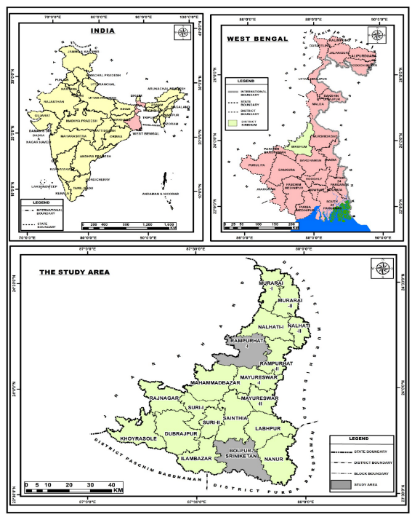

Fig. 1

Fig. 2

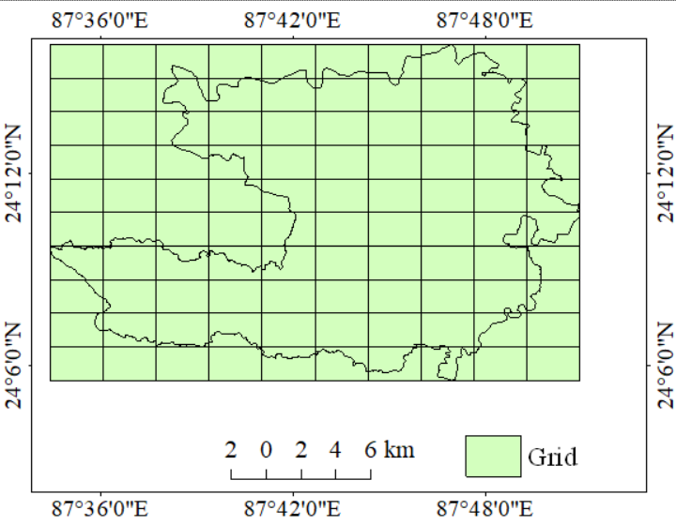
Fig. 3 Fig. 4

Fig. 5 Fig. 6

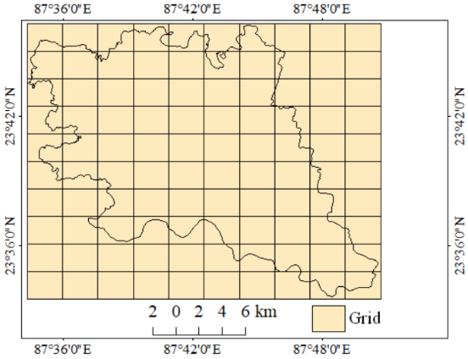
Fig. 7 Fig. 8

Fig. 9 Fig. 10

Fig. 11 Fig. 12

Fig. 13 Fig. 14 Fig. 15

Fig. 16 Fig. 17 Fig. 18

Fig. 19 Fig. 20 Fig. 21

Fig. 22 Fig. 23 Fig. 24
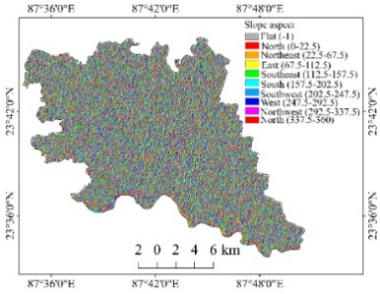

Fig. 25 Fig. 26 Fig. 27

Fig. 28 Fig. 29 Fig. 30
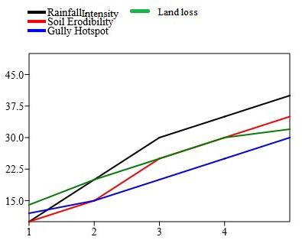
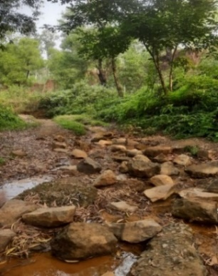

Fig. 31 Fig. 32

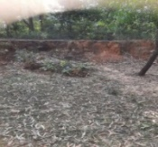
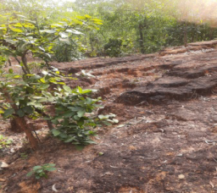
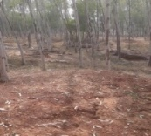

Fig. 33 (a) Fig. 33 (b) Fig. 33 (c)

Fig. 33 (a,b,c)

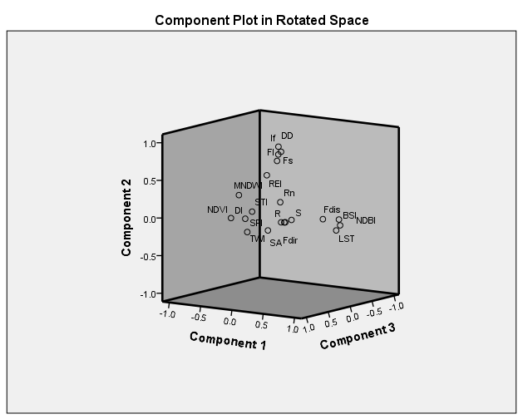
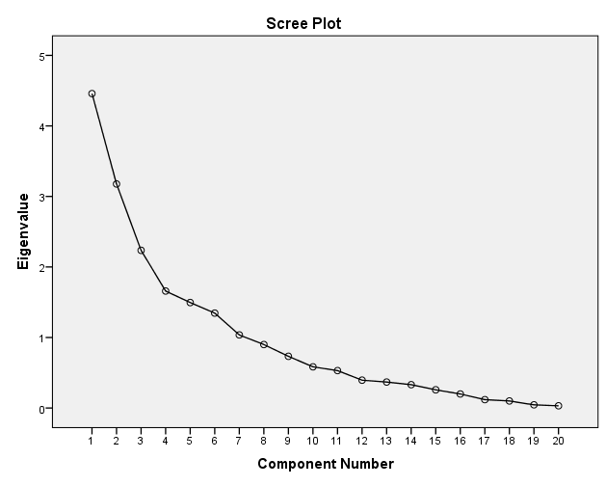

Fig. 74 Fig. 75

Fig. 76 Fig. 77

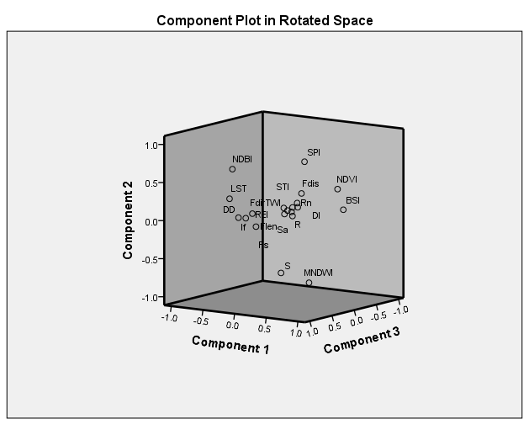
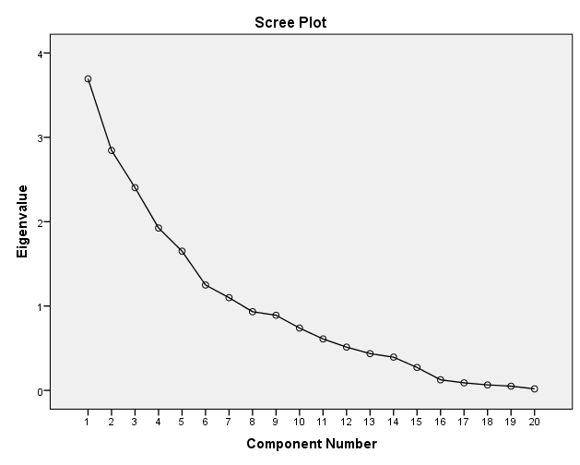

Fig. 78 Fig. 79

Fig. 80 Fig. 81
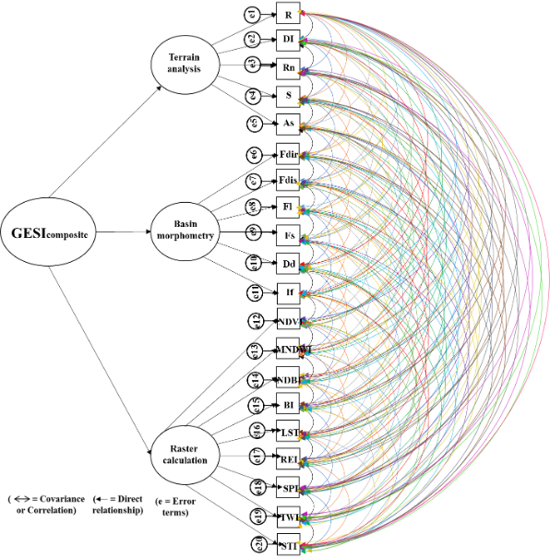
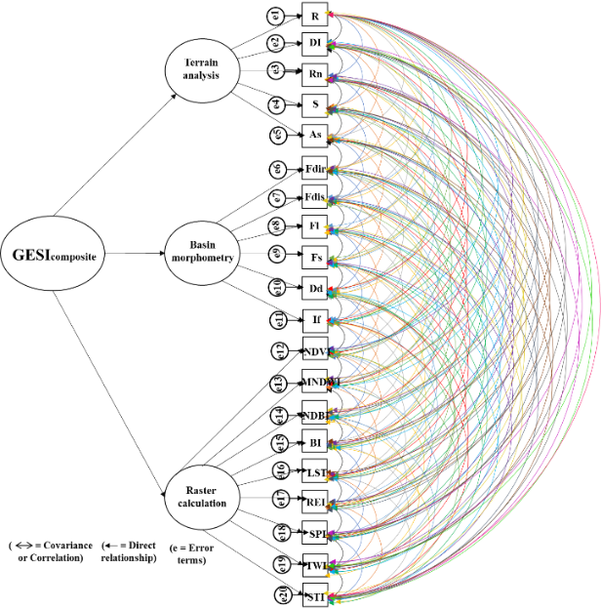

Fig. 82 Fig. 83

Fig. 84 Fig. 85

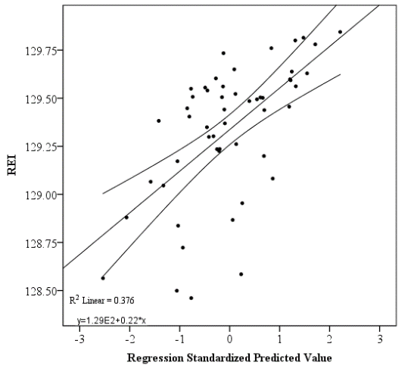
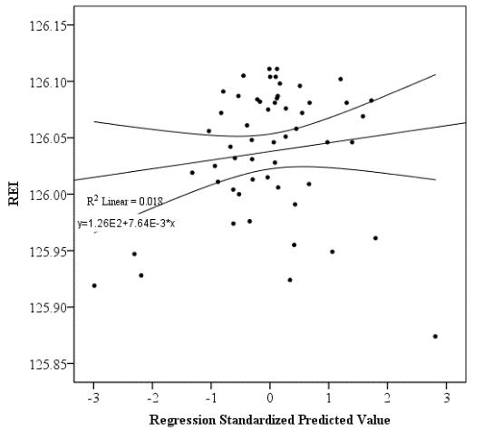

Fig. 86 Fig. 87

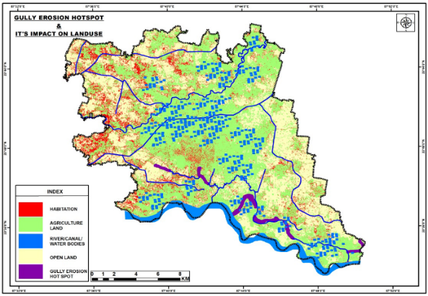
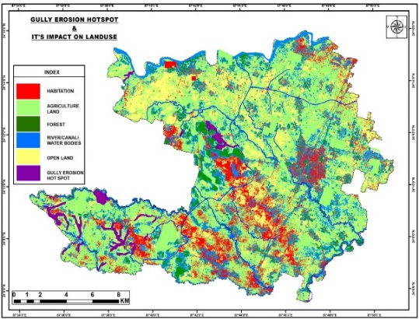

Fig. 88 Fig. 89
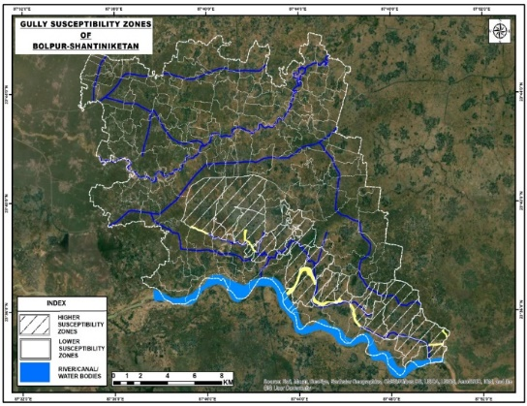
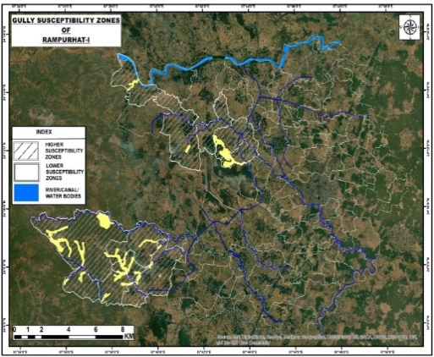

Fig. 90 Fig. 91

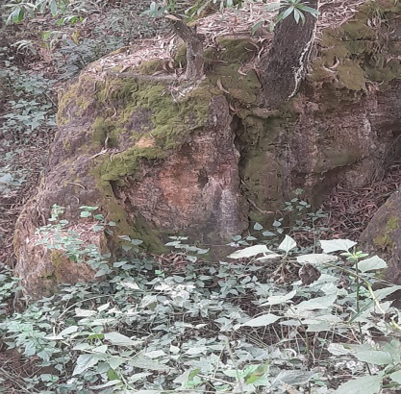
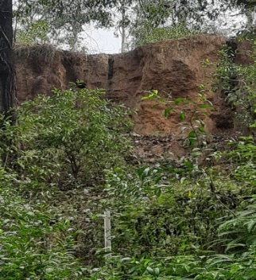

Fig. 92 Fig. 93

Fig. 94 Fig. 95

Fig. 34 Fig. 35 Fig. 36 Fig. 37

Fig. 38 Fig. 39 Fig. 40 Fig. 41

Fig. 42 Fig. 43 Fig. 44 Fig. 45

Fig. 46 Fig. 47 Fig. 48 Fig. 49

Fig. 50 Fig. 51 Fig. 52 Fig. 53

Fig. 54 Fig. 55 Fig. 56 Fig. 57

Fig. 58 Fig. 59 Fig. 60 Fig. 61

Fig. 62 Fig. 63 Fig. 64 Fig. 65

Fig. 66 Fig. 67 Fig. 68 Fig. 69

Fig. 70 Fig. 71 Fig. 72 Fig. 73
Figure Captions
Fig. 1 Location map of the study area
Fig. 2 A general methodological framework of the study
Fig. 3 FCC image of LANDSAT 7 (Rampurhat-I)
Fig. 4 FCC image of LANDSAT 7 (Bolpur-Sriniketan)
Fig. 5 Grids of Rampurhat-I
Fig. 6 Grid points of Rampurhat-I
Fig. 7 Stream network within Rampurhat-I
Fig. 8 Stream orders (Rampurhat-I)
Fig. 9 Grids of Bolpur-Sriniketan
Fig. 10 Grid points of Bolpur-Sriniketan
Fig. 11 River basin and stream network
Fig. 12 Stream orders (Bolpur- Sriniketan)
Fig. 13 Digital Elevation Model
Fig. 14 Ruggedness number
Fig. 15 Slope
Fig. 16 Slope aspect
Fig. 17 The direction of aspect
Fig. 18 Stream length line density
Fig. 19 Stream distance
Fig. 20 Basin flow
Fig. 21 Flow distance
Fig. 22 Digital Elevation Model
Fig. 23 Ruggedness number
Fig. 24 Percentage slope
Fig. 25 Slope aspect
Fig. 26 Direction of aspect
Fig. 27 Stream length line density
Fig. 28 Stream distance
Fig. 29 Basin flow
Fig. 30 Flow distance
Fig. 31 Along the channel of a gully (Shantiniketan)
Fig. 32 Analogous reciprocal of the factors
Fig. 33 (a) Gullies in spare forest area
Fig. 33 (b) Gully channel formation over semi-bare land
Fig. 33 (c) Eroded fallow or barren land area
Figure 33 (a,b,c). Soil erosion due to gully Formation (Rampurhat-I and Bolpur-Sriniketan block)
Factors of gully erosion and gully erosion susceptibility zones
Fig. 34 Relative relief
Fig. 35 Dissection index
Fig. 36 Ruggedness number
Fig. 37 Average slope
Fig. 38 Slope aspect
Fig. 39 Flow direction
Fig. 40 Flow distance
Fig. 41 Flow length
Fig. 42 Stream frequency
Fig. 43 Drainage density
Fig. 44 Infiltration number
Fig. 45 NDVI
Fig. 46 MNDWI
Fig. 47 NDBI
Fig. 48 BSI
Fig. 49 LST
Fig. 50 REI
Fig. 51 SPI
Fig. 52 TWI
Fig. 53 STI
Fig. 54 Relative relief
Fig. 55 Dissection index
Fig. 56 Ruggedness number
Fig. 57 Average slope
Fig. 58 Slope aspect
Fig. 59 Flow direction
Fig. 60 Flow distance
Fig. 61 Flow length
Fig. 62 Stream frequency
Fig. 63 Drainage density
Fig. 64 Infiltration number
Fig. 65 NDVI
Fig. 66 MNDWI
Fig. 67 NDBI
Fig. 68 BSI
Fig. 69 LST
Fig. 70 REI
Fig. 71 SPI
Fig. 72 TWI
Fig. 73 STI
Fig. 74 Scree plot of factor analysis
Fig. 75 Component plots of factor analysis (Rampurhat-I)
Fig. 76 Composite gully erosion susceptibility indices (Rampurhat-I)
Fig. 77 Standardized predicted scores of Composite gully erosion susceptibility (Rampurhat-I)
Fig. 78 Scree plot of factor analysis
Fig. 79 Component plots of factor analysis (Bolpur- Sriniketan)
Fig. 80 Composite gully erosion susceptibility indices (Bolpur-Sriniketan)
Fig. 81 Standardized predicted scores of Composite gully erosion susceptibility (Bolpur-Sriniketan)
Fig. 82 The general framework of SEM (Rampurhat-I)
Fig. 83 General framework of SEM (Bolpur-Sriniketan)
Fig. 84 Overlapping of gully erosion susceptibility isoline on rainfall erosivity index (Rampurhat-I)
Fig. 85 Overlapping of gully erosion susceptibility isoline on rainfall erosivity index (Bolpur-Sriniketan)
Fig. 86 Relationship between rainfall erosivity index and its determinants (Rampurhat-I)
Fig. 87 Relationship between rainfall erosivity index and its determinants (Bolpur-Sriniketan)
Fig. 88 Land use land cover (Rampurhat-I block)
Fig. 89 Land use land cover (Bolpur-Sriniketan block)
Fig. 90 Gully hotspot areas (Rampurhat-I block)
Fig. 91 Gully hotspot areas (Bolpur-Sriniketan block)
Fig. 92 Gully landform around vegetative area-1
Fig. 93 Gully landform around vegetative area-2
Fig. 94 Cross profile along with the gully areas (Rampurhat-I)
Fig. 95 Cross profile along with the gully erosion (Bolpur-

