Role of ST2 as a predictor of post-liver transplant renal outcomes

Supplementary Figure 1. Elevated serum sST2 levels reflect deteriorated liver function according to multiple laboratory results.
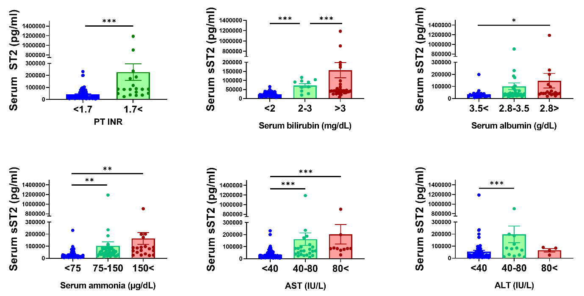
PT, prothrombin time; AST, aspartate aminotransferase; ALT, alanine transaminase

