Table 1:
Abbreviation: FC, fold change
P < 0.05 was considered statistically significant (PD-L1 / PD-L2 dKO mice vs. WT C57BL / 6J mice).
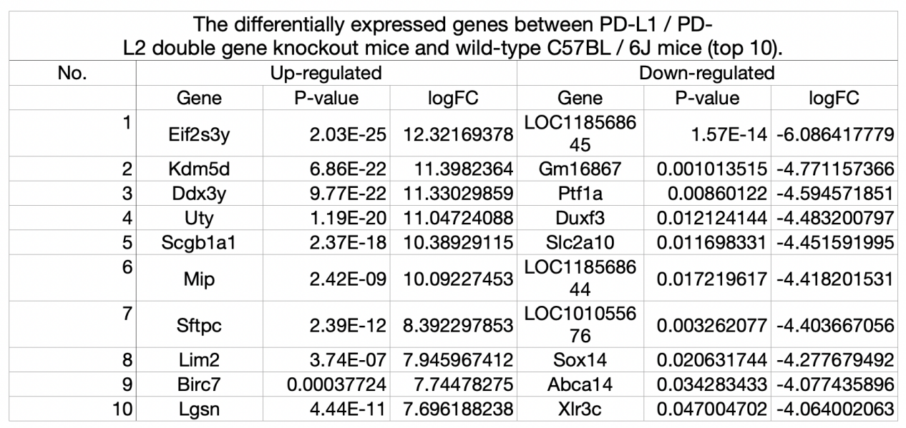

Table 2:
Abbreviations: BP, biological process; CC, cellular component; DEG, differentially expressed gene; GO, Gene Ontology; MF, molecular function.
P<0.05 was considered statistically significant.
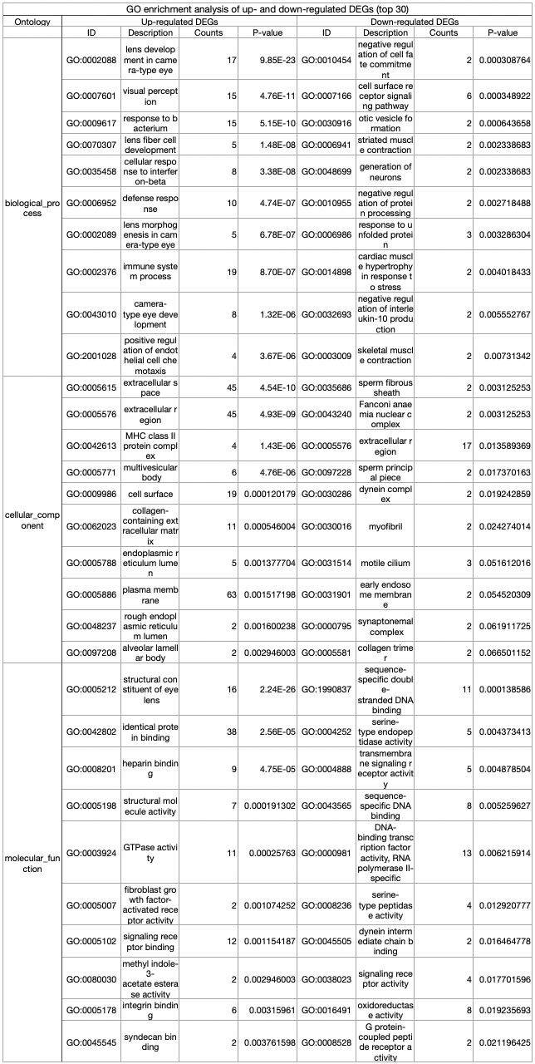

Table 3:
Abbreviations: DEG, differentially expressed genes; KEGG, Kyoto Encyclopedia of Genes and Genomes.
P<0.05 was considered statistically significant.
