Supplementary Information

Size matters - Amplified spontaneous emission limited by accumulation of dark excitons in thin quasi-2D perovskites

Isabella Wagner^{1,2}, Wouter T.M. Van Gompel³, Laurence Lutsen^{3,4}, Dirk Vanderzande^{3,4}, Sheng Hsiung Chang⁵, Pieter Geiregat^{6,7}, Justin M. Hodgkiss^{1,2}* and Kai Chen^{2,8,9}*

¹ School of Chemical and Physical Sciences, Victoria University of Wellington, 6012, Wellington, New Zealand.
² MacDiarmid Institute for Advanced Materials and Nanotechnology, New Zealand.
³ Hybrid Materials Design (HyMaD), Institute for Materials Research (IMO), Hasselt University, 3500, Hasselt, Belgium
⁴ Associated Laboratory IMOMEC, Imec, Wetenschapspark 1, 3590, Diepenbeek, Belgium
⁵ Department of Physics, Chung Yuan Christian University, 320314, Taoyuan, Taiwan
⁶ Physics and Chemistry of Nanostructures, Ghent University, 9000, Ghent, Belgium
⁷ Center for Nano and Biophotonics, Ghent University, Belgium
⁸ The Dodd-Walls Centre for Photonic and Quantum Technologies, Dunedin, New Zealand
⁹ Robinson Research Institute, Victoria University of Wellington, 6012, Wellington, New Zealand

*Correspondence should be sent to K. C. (Kai.Chen@vuw.ac.nz) and J.M.H. (Justin.Hodgkiss@vuw.ac.nz)

Table of Contents
Estimation of exciton binding energy from temperature dependent steady state photoluminescence 3
Estimation of exciton binding energy and absorption contribution of individual grains from steady-state absorption 4
Calculation of carrier density 5
ASE threshold for different excitation conditions 6
Calculation of Mott-transition 7
Ultrafast kinetics of ASE development in Q2D perovskite films in comparison to bulk MAPbI₃ perovskite films 8
Time-resolved kinetics of <n> = 8 grains 11
Dynamic photoluminescence quenching on thin <n> = 2 domains 11
Estimation of triplet exciton lifetime 12
Estimation of singlet-singlet exciton annihilation rate 13
Estimation of singlet-triplet exciton annihilation rate 15
Kinetic modelling to estimate boundaries for${ γ}_{STA}$: 18
Comparison of hot carrier relaxation dynamics in an oxygen containing and free environment 20
Deposition and characterisation of Q2D and MAPbI₃ perovskite films 21

Estimation of exciton binding energy from temperature dependent steady state photoluminescence
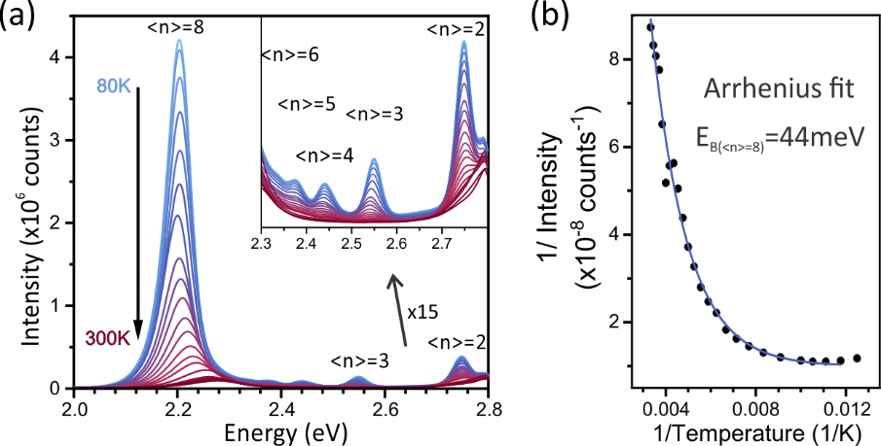
Figure S1: (a) Steady state temperature dependent photoluminescence spectrum of the Q2D perovskite film excited with 405 nm (3.06 eV). The inset shows a zoom into the high energy region which reveals the thin film contains different grain sizes between <n> = 8 and <n> = 2. (b) An exciton binding energy (E_{b}) of 44 meV could be determined from the corresponding inverse intensity evolution of <n> = 8 peak intensity as a function of inverse temperature using an Arrhenius fit¹, I(T)=I₀/(1+A₀exp(-E_{B}/(k_{b}T))), where T is the temperature, A₀ a constant, k_{b} the Boltzmann constant and I₀ the integrated PL intensity.

Estimation of exciton binding energy and absorption contribution of individual grains from steady-state absorption
The steady-state absorption spectrum of the mixed Q2D perovskite film has been modelled using the well-established quantum well absorption model considering the individual contribution mainly from originates from <n> = 8 and <n> = 2 grains. It describes the absorbance $A$ as a superposition of excitonic lines $X$ and free carrier transitions $C$:
 | $$A(E)=\sum_{n}{X_{n}\left(E\right)+C_{n}(E)}$$ | (S1)
with the exciton and free carrier contributions:
 | $$X_{n}\left(E\right)=\frac{{A_{X}}_{n}}{2μ_{n}}∙\left[erf\left(\frac{E-E_{X_{n}}+E_{B_{n}}}{w_{n}}-\frac{w_{n}}{2μ_{n}}\right)+1\right]∙exp\left(\frac{w_{n}^{2}}{4μ_{n}^{2}}-\frac{E-E_{X_{n}}+E_{B_{n}}}{μ_{n}}\right)$$ | (S2)
 | $$C\left(E\right)={A_{C}}_{n}∙θ(E-E_{X_{n}})∙\sqrt{E-E_{X_{n}}}∙\frac{π∙exp\left(π∙\sqrt{E-E_{X_{n}}}\right)}{sinh\left(π∙\sqrt{E-E_{X_{n}}}\right)}$$ | (S3)
where $E_{X}$ is the exciton energy and $E_{B}$ is the exciton binding energy, $w$ is the exciton line width, $μ$ is the asymmetric broadening term due to transitions into higher energies or due to exciton localisation, and $A$the weight of the amplitudes for each contribution.
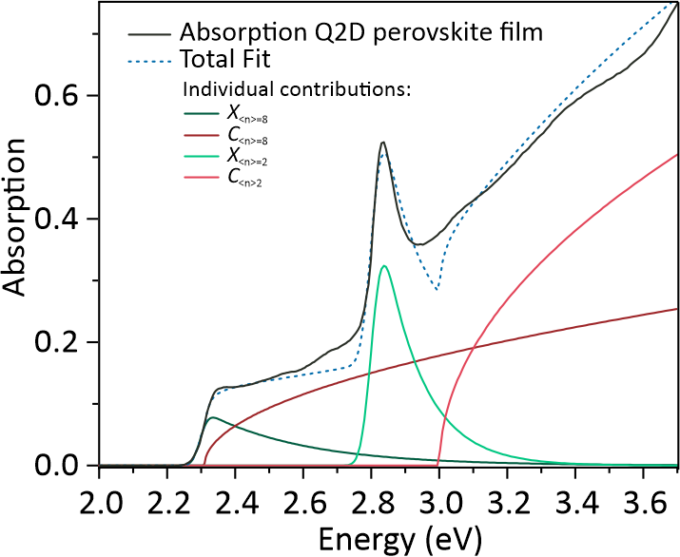
Figure S2: Decomposition of the absorption spectrum using the Elliot formula with main contributions from Q2D grains of <n>=8 and <n>=2, showing the exciton (green, solid) and continuum (red, solid) contributions as well as the sum (blue, dashed).

$E_{X_{<n>8}}$ [eV] | 2.3130 ± 0.0054
$E_{B_{<n>8}}$ [eV] | 0.0157 ± 0.0015
${A_{X}}_{<n>8}$ [eV] | 0.0371 ± 0.0087
${A_{C}}_{<n>8}$ [eV] | 0.0265 ± 0.0048
$w_{<n>8}$ [eV] | 0.0266 ± 0.0162
$μ_{<n>8}$ [eV] | 0.2925 ± 0.0047
$E_{X_{<n>2}}$ [eV] | 3.0008 ± 0.3052
$E_{B_{<n>2}}$ [eV] | 0.1980 ± 0.0062
${A_{X}}_{<n>2}$ [eV] | 0.0959 ± 0.0116
${A_{C}}_{<n>2}$ [eV] | 0.0571 ± 0.0083
$w_{<n>2}$ [eV] | 0.0346 ± 0.0048
$μ_{<n>2}$ [eV] | 0.1166 ± 0.0191
Table S1: Fitting parameters from the steady state absorption spectrum of the mixed Q2D perovskite film in Figure S2 using a sum of exciton and free carrier absorbance for <n> = 8 and <n> = 2 grains.

Calculation of carrier density
The carrier density ($n_{c}$) created within the film after pulsed excitation was estimated using the following relation:
 | $$n_{c}=\frac{α∙P}{E_{ph}∙RR}∙\frac{1}{π∙{\left(\frac{r}{2}\right)}^{2}∙d}$$ | (S4)

where $α$ is the absorption coefficient of the Q2D perovskite film at the excitation energy, r is the FWHM of the excitation spot size, P is the laser power, RR is the repetition rate of the laser, E_{ph} is the photon energy of the excitation beam and d is the thickness of the perovskite film. To estimate the initial carrier density on the <n> = 2 and <n> = 8 grains after photoexcitation with 3.6 eV, the ratio of their corresponding absorption contribution estimated from the absorption decomposition in Figure S2 has been used to estimate initial exciton density at the individual grain sizes of the mixed film.

ASE threshold for different excitation conditions
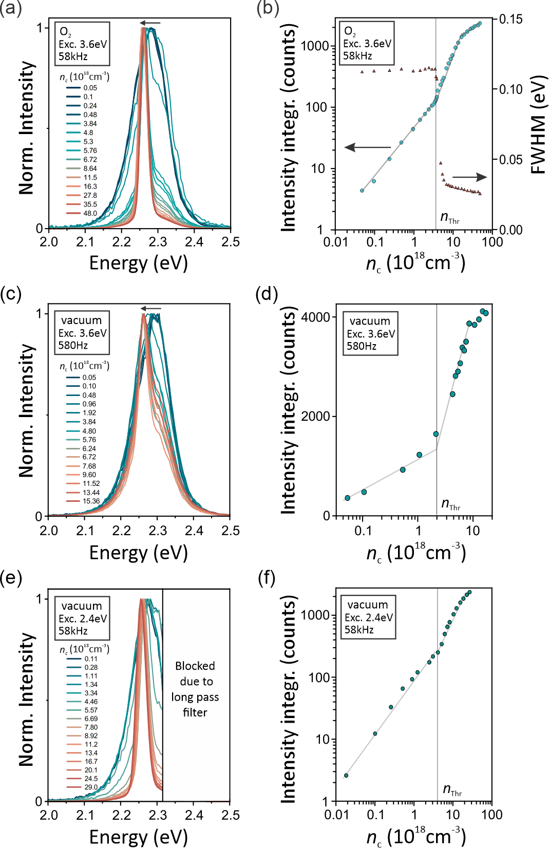
Figure S3: Excitation density dependent evolution of the steady state photoluminescence spectrum for different excitation conditions with corresponding ASE thresholds. (a) Spectral evolution under ambient conditions excited at 3.6 eV (343 nm) with a laser repetition rate of 58 kHz. (b) Corresponding intensity evolution reveals an ASE threshold at around 3.8·10¹⁸cm⁻³. (c) Spectral evolution under vacuum excited at 3.6 eV (343 nm) with a laser repetition rate of 580 Hz. (d) Corresponding intensity evolution reveals an ASE threshold at around 1.8·10¹⁸cm⁻³. (e) Spectral evolution under vacuum excited at 2.4 eV (515 nm) with a laser repetition rate of 58 kHz. (f) Corresponding intensity evolution reveals an ASE threshold at around 4.3·10¹⁸cm⁻³.

Calculation of Mott-transition
The static Mott density $n_{M}$ can be approximate by:
 | $$n_{M}=0.028∙\frac{k_{b}∙T}{E_{B}∙r_{X}^{3}}$$ | (S5)

Were $k_{b}$ is the Boltzmann coefficient, T is the lattice temperature, $E_{B}$ is the exciton binding energy and r_{X} is the exciton radius described by r_{X}=sqrt(ћ²/2E_{B}m_{eff}). With an effective mass coefficient for FAPbBr₃ of 0.13m₀² and the determined exciton binding energy of about 44 meV, the Mott transition for the high dimensional ASE site can be estimated to be around 1.836∙10¹⁸ cm⁻³ at 300K.

Ultrafast kinetics of ASE development in Q2D perovskite films in comparison to bulk MAPbI₃ perovskite films
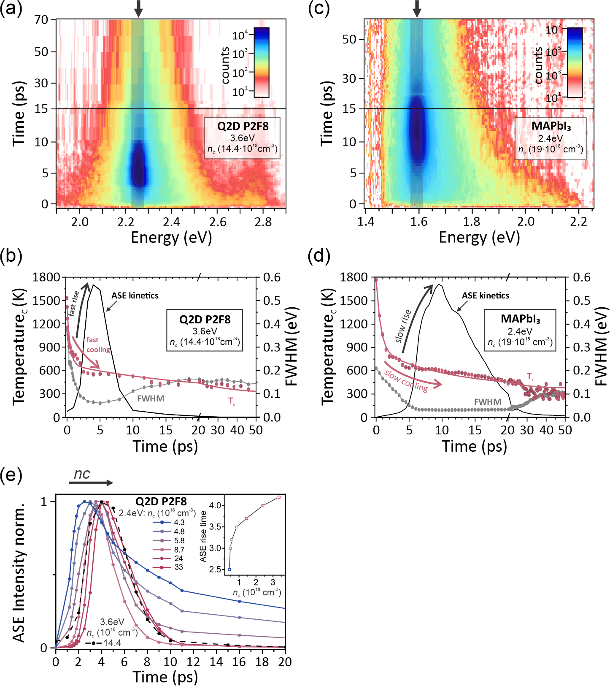
Figure S4: (a) Transient photoluminescence map of a mixed Q2D perovskite film after photoexcitation at 3.6 eV with an excitation density above the ASE threshold. (b) Corresponding ASE evolution from spectral integration of the shaded area in the PL map shows the carrier temperature dependent build-up of the stimulated emission. (c) Transient photoluminescence map of a bulk MAPbI₃ perovskite film after photoexcitation at 2.4 eV with an excitation density above the ASE threshold. (d) Corresponding ASE evolution from spectral integration of the shaded area in the PL map shows carrier temperature dependent build-up of stimulated emission. (e) Excitation density dependent delay of the ASE onset of the mixed Q2D perovskite film after photoexcitation at 2.4 eV, which corresponds to almost resonant (120 meV excess energy) excitation conditions.

To further investigate the nature of excited states at the ASE site, we investigated the intrinsic mechanism responsible for population inversion in mixed Q2D perovskite films by directly monitoring the emissive species under ambient conditions to prevent STA. Figure S3a shows the transient PL map of the Q2D perovskite film after photoexcitation at 3.6 eV with an excitation density of 14.4x10¹⁸ cm⁻³, well above the ASE threshold. Several distinct emissive features are present: one short-lived high-energy peak around 2.7-2.85 eV corresponding to emission from low-dimensional <n> = 2 domains, the dominant much broader emission region from the lower bandgap of <n> = 8 grains and the slightly redshifted narrow but intense ASE peak at around 2.25 eV.
Evidence for a free carrier plasma-like origin of optical gain in the Q2D perovskite film can be found from the carrier temperature dependence of the ASE build-up. Using the common approach of assuming a Fermi-Dirac carrier distribution after the initial rapid thermalization of photogenerated carriers, the effective carrier temperature can be extracted from the broadband PL transients. With this estimation, the effective carrier temperature can be obtained by fitting the high-energy tail of the <n> = 8 PL spectrum with a Maxwell-Boltzmann distribution $PL(E)∝\sqrt{E-E_{BG} }∙\exp^{-\left(\frac{E-E_{BG}}{k_{b}∙T_{C}}\right)}$, where $E_{BG}$ is the semiconductor bandgap, $k_{b}$ is the Boltzmann constant and $T_{C}$ is the carrier temperature^{3–5}. The received carrier temperature as a function of delay time compared with the corresponding kinetic evolution of the ASE signal is shown in Figure S3b. Here, the large excess energy of 1350 meV introduced into the system leads to an initial elevated carrier temperature of about 1500 K. The carrier temperature evolution can be fitted with a combination of two exponential functions. While the first rapid cooling regime corresponds to carrier cooling due to the emission of optical phonons, the second slower cooling stage points towards the on-set of a cooling bottleneck as previously observed in different kinds of perovskite compositions.^{3,4} During the first fast cooling regime, simultaneous narrowing of the peak width indicates the onset of stimulated emission. This behaviour indicates a shift of the carrier population towards the band edges as a result of the carrier cooling process. Once the carrier temperature approximates 600 K, the ASE build-up is complete, and the onset of a phonon bottleneck delays phonon emission and slows down further carrier relaxation. This carrier temperature-limited evolution of population inversion for <n> = 8 Q2D grains strongly suggests a free electron-hole plasma-like origin⁶ as can also be observed in bulk MAPbI₃ perovskite films (Figure S3c and Figure S3d), which further supports the weak excitonic characteristics within thick Q2D slabs.
The free carrier characteristics within the thick Q2D slabs are further supported by the excitation density dependent ASE evolution under resonant pumping of selectively <n> = 8 Q2D perovskite grains. As can be seen in Figure S3e, when excited with a carrier density just above the ASE threshold (4.3x10¹⁸cm⁻³, blue line), the ASE kinetics build up almost immediately after excitation (see Inset Figure S3e). Here, the small amount of excess energy introduced into the system leads to a reduced initial carrier temperature compared to the excitation with a photoenergy of 3.6 eV. This leads to a faster relaxation of carriers and as a result, accelerates the build-up of a critical carrier concentration on the band edges required for population inversion. The increase in the carrier density is associated with more pronounced state filling effects, which results in an increase in the initial carrier temperature. This leads to longer carrier cooling times and a delay in the ASE build-up with increasing excitation density. This excitation density dependent evolution of population inversion after resonant pumping of the <n> = 8 grains is further proof for the free carrier like characteristics of the thick Q2D grains.

Time-resolved kinetics of <n> = 8 grains
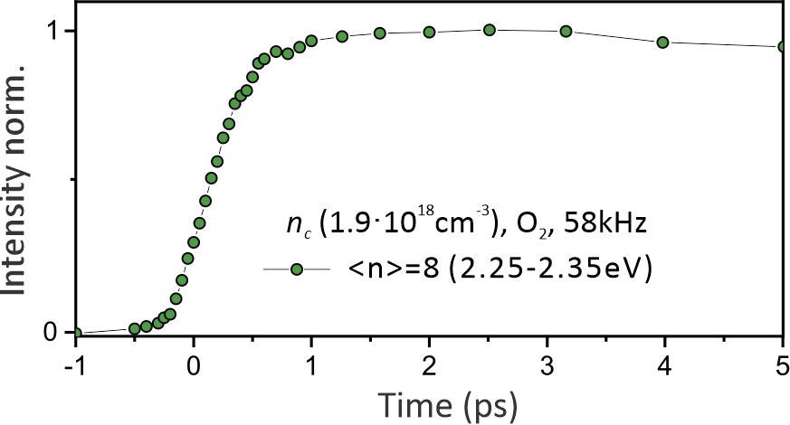
Figure S5: Photoluminescence kinetics integrated over the spectral range of 2.25 – 2.35 eV corresponding to the emission from the <n> = 8 grains after photoexcitation at 3.6 eV ($n_{c}$ = 1.9∙10¹⁸ cm⁻³) with a laser repetition rate of 58 kHz under ambient conditions.

Dynamic photoluminescence quenching on thin <n> = 2 domains
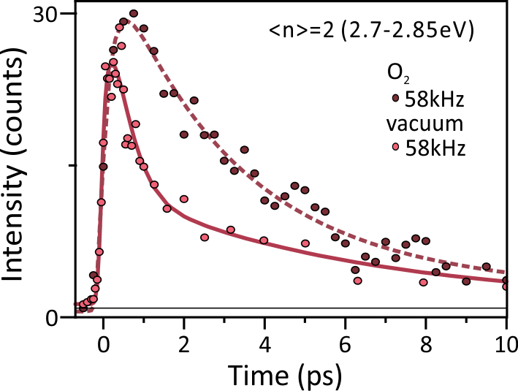
Figure S6: Photoluminescence kinetics integrated over the spectral range of 2.70 – 2.85 eV corresponding to the emission from the <n> = 2 grains after photoexcitation at 3.6 eV ($n_{c}$ = 1.9∙10¹⁸ cm⁻³) with a laser repetition rate of 58 kHz. Comparison of decay in vacuum vs ambient conditions reveals a dynamic quenching behaviour in the presence of accumulated inorganic triplet excitons.

Estimation of triplet exciton lifetime
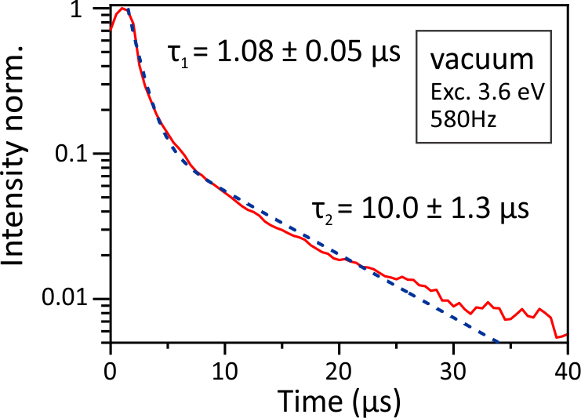
Figure S7: Time-resolved photoluminescence of the mixed Q2D perovskite film stored in a vacuum and excited at 3.6 eV (580 Hz) indicates biexponential decay. The slower decay is associated with thermal assisted reverse intersystem crossing from the dark triplet state back to the emissive singlet state⁷ and is therefore used to describe the lifetime of the long-lived dark triplet state population within the film.

Estimation of singlet-singlet exciton annihilation rate
Since excitonic species are dominant in low dimensional Q2D perovskite slabs, their recombination dynamics can be described by the following rate equation:⁸
 | $$\frac{dn(t)}{dt}=-k_{1}∙n\left(t\right)- k_{2}{∙n\left(t\right)}^{2}$$ | (S6)

where $n(t)$ is the time-dependent exciton density, $k_{1}$ the monomolecular decay rate due to radiative and nonradiative recombination and $k_{2}=k_{SSA}$ the singlet-singlet exciton annihilation rate coefficient.
If we assume the annihilation rate is time-independent, we can derive the analytical solution:
 | $$n\left(t\right)=\frac{n_{c}∙e^{-k_{1}∙t}}{1+\frac{k_{2}}{k_{1}}∙n_{c}∙(1-e^{k_{1}∙t})}$$ | (S7)

where $n_{c}$is the initial excitation density. Assuming an intrinsic monomolecular recombination rate of k₁ = 1.64∙10¹⁰ s⁻¹, as determined from low fluence measurements in Figure S7a, we can fit the excitation density dependent PL kinetics integrated over the entire emission range in Figure S7b globally with the above equation. Doing so, we obtain a singlet-singlet annihilation constant of about 1.7∙10⁻⁸ cm³s⁻¹, which is similar to the bimolecular recombination rate observe by Li and co-workers⁹.
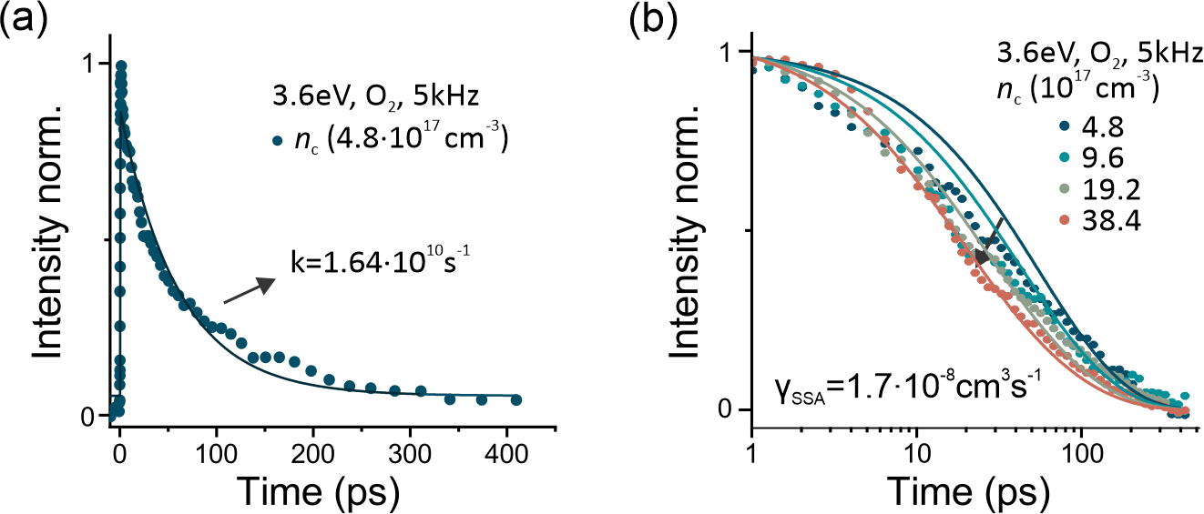
Figure S8: Normalized decay dynamics integrated over entire emission of the Q2D perovskite film under ambient conditions after photoexcitation at 343 nm (3.6 eV) with a repetition rate of 5 kHz: (a) Under a low carrier density of 4.8∙10¹⁷cm⁻³, a monoexponential fit is used to extract the intrinsic monomolecular decay constant k. (b) Fluence dependent kinetics integrated over the entire emission range reveal annihilation behaviour with a bimolecular recombination constant of about 1.7∙10⁻⁸cm³s⁻¹.

Estimation of singlet-triplet exciton annihilation rate
To obtain quantitative values for the annihilation process due to long-lived accumulated triplet states, we formulate a STA model to describe the underlying kinetics. Here, the temporal evolution of the bright singlet excitons n(t) is given by:¹⁰
 | $$\frac{dn(t)}{dt}=G\left(t\right)-k∙n\left(t\right)-γ_{STA}∙N\left(t\right)∙n(t)$$ | (S8)

where $G\left(t\right)$ is the singlet exciton generation rate, $k$ is the singlet exciton decay rate, $γ_{STA}$ is the STA rate constant and N(t) is the triplet exciton concentration. The corresponding triplet population N(t) over time can be expressed as:¹⁰
 | $$\frac{dN(t)}{dt}=k_{ISC}∙n\left(t\right)-K_{T}∙N\left(t\right)$$ | (S9)

where $K_{T}$ is the triplet exciton decay rate and $k_{ISC} is$the intersystem crossing rate constant. Since the singlet lifetime $k$ is several orders of magnitude shorter than the triplet state lifetime, which is in the order of microseconds, the change of the triplet state concentration between two laser pulses is negligibly small compared to the accumulated triplet population. Hence, we can replace $N(t)$ by its stationary population $N_{T}$ and the singlet exciton population can be described with a simple single exponential using:¹⁰
 | $$n\left(t\right)=n_{c}∙e^{-\left(k+γ_{STA}∙N_{T}\right)t}$$ | (S10)

This shows that the accumulation of singlet state quenchers (triplet states) only accelerates the annihilation dynamics compared to completely relaxed ground state conditions, and the accumulated triplet concentration after several pulses can be described by:¹⁰
 | $$N_{T}=\frac{k_{ISC}}{k+γ_{STA}∙N_{T}}\frac{n_{c}∙R}{K_{T}}=ϕ_{ST}\frac{n_{c}∙R}{K_{T}}$$ | (S11)

where $R$is the laser repetition rate, $ϕ_{ST}$ is the triplet generation quantum yield or intersystem crossing quantum yield, and $n_{c} is$the initial concentration of singlet excitons created by one single excitation pulse. We can now derive an accumulated triplet exciton dependent singlet exciton lifetime by substituting Equation 8 into Equation 7:¹⁰
 | $$\frac{1}{τ_{s}}=k+γ_{STA}{∙N}_{T}$$ | (S12)

With this estimation, we can link the repetition rate dependent accumulated triplet exciton density to the fast photoluminescence quenching from bright singlet excitonic states. Indeed, the PL kinetics of the <n> = 2 grains in Figure S8 reveal the singlet exciton lifetime $τ_{s}$ is dependent on the laser repetition rate.

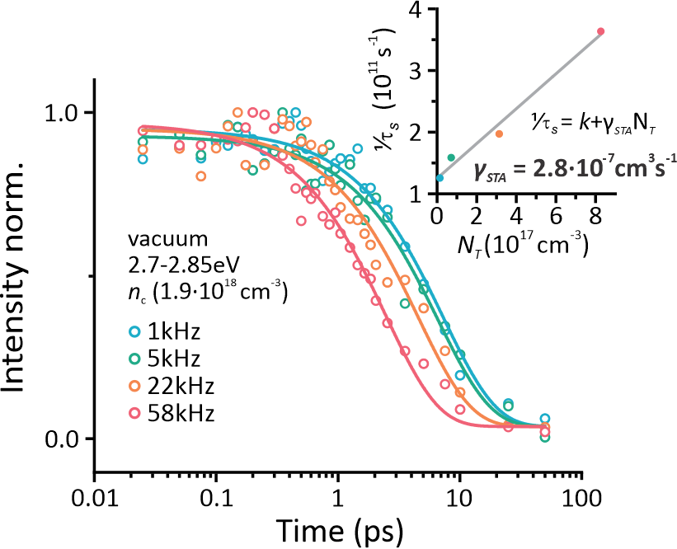
Figure S9: Laser repetition rate-dependent PL kinetics of <n> = 2 slabs with exponential lifetime fits. Inset: Singlet exciton recombination rate as a function of repetition rate-dependent accumulated triplet state density fitted with an STA model.

By using the triplet lifetime of 10 μs, as determined from time-resolved PL measurements under vacuum conditions (Figure S6) and an $ϕ_{ST}$ of 0.75 according to spin statistics^{38,52}, we can estimate the repetition rate-dependent concentration of accumulated inorganic triplet states in the absence of a triplet exciton quencher. Then, the inverse singlet lifetimes, 1/$τ_{s}$, as a function of the accumulated triplet concentration (Inset Figure S8), can be fitted with Equation S9 to determine a STA rate of ${ γ}_{STA}$ = 2.8∙10⁻⁷ cm³s⁻¹ assuming all excitations are initially created at the <n> = 2 grains ($n_{c <n>2}=$1.9∙10¹⁸ cm⁻³). This value might underestimate the quenching potential of the accumulated triplet excitons and an upper value for ${ γ}_{STA}$has been estimated considering only 66% of the initial absorption occurs on the <n> = 2 grains (according to the decomposition of the absorption spectrum in Figure S2), which yields a STA rate of ${ γ}_{STA}$= 6.0∙10⁻⁷ cm³s⁻¹.
However, the value for $ϕ_{ST}$is only an estimation since no experimental data on the triplet generation quantum yield in Q2D perovskites was available. Assuming a lower $ϕ_{ST}$ of only 0.5, the corresponding STA rate might even be faster with ${ γ}_{STA}$ = 5.5∙10⁻⁷ cm³s⁻¹ and ${ γ}_{STA}$ = 8.3∙10⁻⁷ cm³s⁻¹, for 100% and only 66% absorption on the <n> = 2 grains, respectively but still lies in the same order of magnitude than the STA rate calculated with an $ϕ_{ST}$ of 0.75.

Kinetic modelling to estimate boundaries for ${ γ}_{STA}$:
In order to simulate the ultrafast quenching potential of the accumulated triplet states, the exciton populations on the different grain sizes been modelled. To do so, we solved coupled rate equations for the exciton concentrations on <n> = 8 and <n> = 2 grains by MATLAB using the ODE45 solver and convoluted with a Gaussian function to account for the instantaneous response function $IRF$ of the system according to
 | $$I_{PL_{<n> x}}(t)=conv\left[{n_{c}}_{<n>x}(t)∙IRF\right]$$ | (S13)
where $I_{PL_{<n> x}}(t)$ corresponds to the modelled experimental kinetics from the different grain sizes, $IRF=A/{\sqrt{2πσ^{2}}∙e^{-({t-t_{0}}^{2}/2∙σ^{2})}}$ is the instantaneous response function of the photoluminescence setup described by a Gaussian function with a width $σ$ of ${160fs}/{\sqrt{ln⁡(4)}}$, and ${n_{c}}_{<n>x}$ is the time-dependent exciton population on the specific grains described by the rate equations:
 | $$\frac{d {n_{c}}_{<n>2}}{dt}=-k_{<n>2}∙{n_{c}}_{<n>2}(t)-k_{SSA}∙{n_{c}}_{<n>2}(t)∙{n_{c}}_{<n>2}(t)-k_{STA}∙{n_{c}}_{<n>2}(t){∙N}_{T}$$ | (S14)
 | $$\frac{d {n_{c}}_{<n>8}}{dt}=-k_{<n>8}∙{n_{c}}_{<n>8}(t)-k_{SSA}∙{n_{c}}_{<n>8}(t)∙{n_{c}}_{<n>8}(t)+k_{<n>2}∙{n_{c}}_{<n>2}(t)+k_{SSA}∙{n_{c}}_{<n>2}(t)∙{n_{c}}_{<n>2}(t)$$ | (S15)
where $k_{<n>x}$ is the singlet exciton decay rate.
The simulation of the theoretical quenching potential using the experimental determined values of ${ γ}_{SSA}$ = 1.7∙10⁻⁸ cm³s⁻¹ and ${ γ}_{STA}$ = 6.0∙10⁻⁷ cm³s⁻¹ in Figure S10 (green, solid) shows that the determined STA is still too slow to account for the observed PL quenching intensity in Figure 3b. Instead, a STA rate of 9∙10⁻⁶ cm³s⁻¹ (blue, solid) matches better with the observed emission quenching ratio 250 fs after photoexcitation on the <n> = 8 grains due to accumulated triplet excitons.

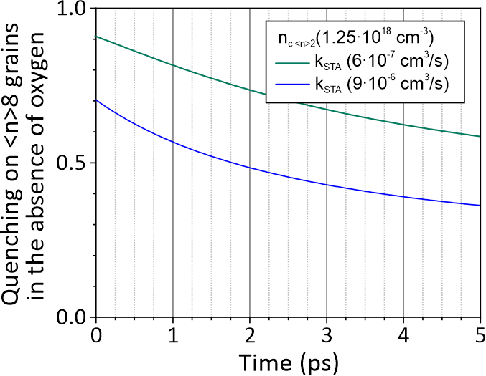
Figure S10: Modelling of emission quenching on <n> = 8 grains in the presence of accumulated triplet excitons using the above model and the experimental determined values for $k_{<n>2}$ = 1.25·10⁻¹¹ s⁻¹, $k_{<n>8}$ = 1.53·10⁻¹⁰ s⁻¹ and $k_{SSA}$ = 1.7·10⁻⁸ cm³s⁻¹ . Simulation considering the experimental determined $k_{STA}$ = 6.0∙10⁻⁷ cm³s⁻¹ (green, solid) and a faster annihilation rate of $k_{STA}$ = 9∙10⁻⁶ cm³s⁻¹ (blue, solid) accounting for a 60% PL quench at 250 fs after photoexcitation.

Comparison of hot carrier relaxation dynamics in an oxygen containing and free environment
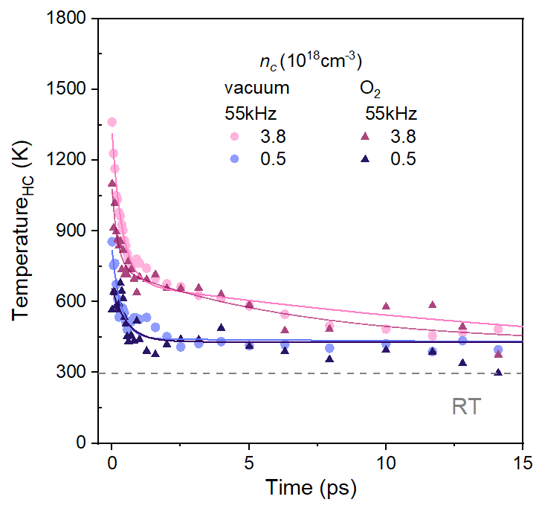
Figure S11: Carrier temperature evolution under ambient conditions (dots) and in an oxygen free (triangles) environment demonstrate similar relaxation dynamics. This confirms that the absence of ASE does not relate to a change in carrier temperature relaxation in the absence of oxygen.

Deposition and characterisation of Q2D and MAPbI₃ perovskite films
Materials
PEABr (≥98%) was obtained from Sigma Aldrich, FABr (>99.5%) was obtained from Ossila, PbBr₂ (99.998%) was obtained from Alfa Aesar. CH₃NH₃I (MAI) powder was obtained from Lumtec. PbI₂ (99.995%) was obtained from Sigma Aldrich. Methanol, diethyl ether, dimethylformamide (DMF), dimethylsulfoxide (DMSO) and chlorobenzene (CB) were obtained from ECHO Chemical Co., LTD. All materials except of MAI were used without further purification. The MAI powder was purified using a methanol/diethyl ether purification process to obtain high-quality MAI crystals. The dry DMF that was used to make the precursor solutions, and the dry toluene that was used for anti-solvent dripping were obtained from a solvent purification system (MBRAUN SPS-800).
Q2D film preparation
For the Q2D film, precursor solutions were prepared by dissolving 20.2 mg of PEABr, 50 mg of FABr and 146.8 mg of PbBr₂ in 1 ml of DMF by stirring at 60 °C for 12h. All precursor solutions were filtered through a PTFE syringe filter (0.45 μm mash) before use. Quartz substrates were cleaned through successive sonication steps in the following order of solvents (detergent water, deionized water, acetone, and isopropanol; 15 min for each step), followed by a UV-ozone treatment of 15 min. The precursor solutions were deposited as thin films on quartz substrates by spin coating at 4500 rpm for 30 s, using an acceleration of 2000 rpm/s. During spinning, 0.3 ml of toluene was dropped onto the perovskite precursor layer. The films were subsequently annealed on a hotplate at 70 °C for 15 min, followed by 100 °C for 5 min, in a glove box under a nitrogen atmosphere (< 1 ppm O₂, < 1 ppm H₂O).
MAPbI₃ film preparation
The fused silica substrate was treated by using a UV Ozone cleaner for 40 min to remove organic residuals from the surface. A 1.5 M MAPbI₃ perovskite precursor solution is prepared by mixing 119 mg MAI and 345 mg PbI₂ in a 0.5 mL mixture (9:1 v/v) of DMF and DMSO. To form a uniform precursor, the solution is continuously stirred at 40 °C and 600 rpm for 4 hrs. Before the spin coating process, the fused silica substrate is preheated at 100 °C for 20 min in a nitrogen-filled glove box to minimize residual moisture. The MAPbI₃ solution is deposited on top of the fused silica substrate by using a spin coater with the washing-enhanced nucleation process¹¹. During the spin coating, a 0.3 mL CB is dropped onto the fused silica substrate at the last 23 s as the washing solvent. After the spin coating, the sample is heated at 100 °C for 20 min. Then, the MAPbI3/fused silica sample is cooled down to room temperatures in a glass petri dish.
X-ray diffraction pattern of the Q2D film
X-ray diffraction measurements on thin films were performed at room temperature in ambient atmosphere on a Bruker D8 Discover diffractometer with a parallel beam geometry using a Göbel mirror and CuK_{α} radiation, with a one-dimensional detector (Lynxeye).
Based on the absorption spectrum of the film at low temperature (80K; Figure S1), the film is composed of a mixture of Q2D phases with a different number of inorganic layers (<n>) up to 8, resulting in a complex XRD pattern containing reflections related to phases of different <n>-values. The main reflections are tentatively assigned to phases of a certain <n>-value, based on the literature on PEA₂FA_{n-1}Pb_{n}Br_{3n+1} thin films^{12,13}
Figure S12: X-ray diffraction pattern of the mixed Q2D film. The numbers above the reflections indicate that they correspond to diffraction from grains with a certain <n>-value.

1. Lee, S. M. et al. Temperature-Dependent Photoluminescence of Cesium Lead Halide Perovskite Quantum Dots: Splitting of the Photoluminescence Peaks of CsPbBr3 and CsPb(Br/I)3 Quantum Dots at Low Temperature. J. Phys. Chem. C 121, 26054–26062 (2017).
2. Galkowski, K. et al. Determination of the exciton binding energy and effective masses for methylammonium and formamidinium lead tri-halide perovskite semiconductors. Energy Environ. Sci. 9, 962–970 (2016).
3. Price, M. B. et al. Hot-carrier cooling and photoinduced refractive index changes in organic-inorganic lead halide perovskites. Nat. Commun. 6, 1–8 (2015).
4. Geiregat, P. et al. Using Bulk-like Nanocrystals To Probe Intrinsic Optical Gain Characteristics of Inorganic Lead Halide Perovskites. ACS Nano 12, 10178–10188 (2018).
5. Lim, J. W. M. et al. Hot Carriers in Halide Perovskites: How Hot Truly? J. Phys. Chem. Lett. 11, 2743–2750 (2020).
6. Chen, K., Barker, A. J., Morgan, F. L. C., Halpert, J. E. & Hodgkiss, J. M. Effect of carrier thermalization dynamics on light emission and amplification in organometal halide perovskites. J. Phys. Chem. Lett. 6, 153–158 (2015).
7. Qin, C. et al. Triplet management for efficient perovskite light-emitting diodes. Nat. Photonics 14, 70–75 (2020).
8. Delport, G. et al. Exciton–Exciton Annihilation in Two-Dimensional Halide Perovskites at Room Temperature. J. Phys. Chem. Lett. 10, 5153–5159 (2019).
9. Li, Y. et al. Exciton versus free carrier emission: Implications for photoluminescence efficiency and amplified spontaneous emission thresholds in quasi-2D and 3D perovskites. Mater. Today 49, 35–47 (2021).
10. Zaushitsyn, Y., Jespersen, K. G., Valkunas, L., Sundström, V. & Yartsev, A. Ultrafast dynamics of singlet-singlet and singlet-triplet exciton annihilation in poly(3- 2′ -methoxy- 5′ octylphenyl)thiophene films. Phys. Rev. B - Condens. Matter Mater. Phys. 75, 195201 (2007).
11. Chang, S. H. et al. Effects of the washing-enhanced nucleation process on the material properties and performance of perovskite solar cells. J. Alloys Compd. 808, 151723 (2019).
12. Laxmi & Kabra, D. Optimization of Composition with Reduced Phase Impurity in Quasi‐2D Perovskite for Electroluminescence. Adv. Photonics Res. 2, 2000164 (2021).
13. Qin, C. et al. Stable room-temperature continuous-wave lasing in quasi-2D perovskite films. Nature 585, 53–57 (2020).
14. Chen, K., Gallaher, J. K., Barker, A. J. & Hodgkiss, J. M. Transient grating photoluminescence spectroscopy: An ultrafast method of gating broadband spectra. J. Phys. Chem. Lett. 5, 1732–1737 (2014).

