Universal narrowband wavefront shaping with high quality factor meta-reflect-arrays: Supplementary Information

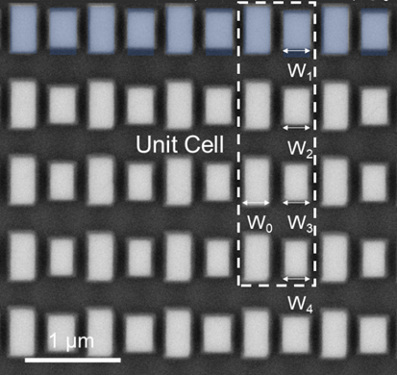
Figure S1. Top-view SEM image of the fabricated metasurfaces with 4 antennas with ΔL=100 nm and δ_{w}= 7, 1, -1, -7nm.

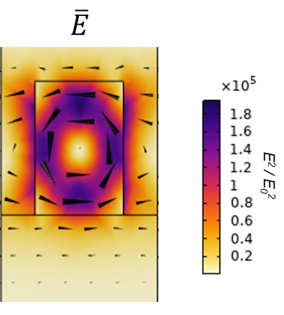
Figure S2. Near-field intensity enhancement at the resonant wavelength with ΔL=10nm of the primary pair

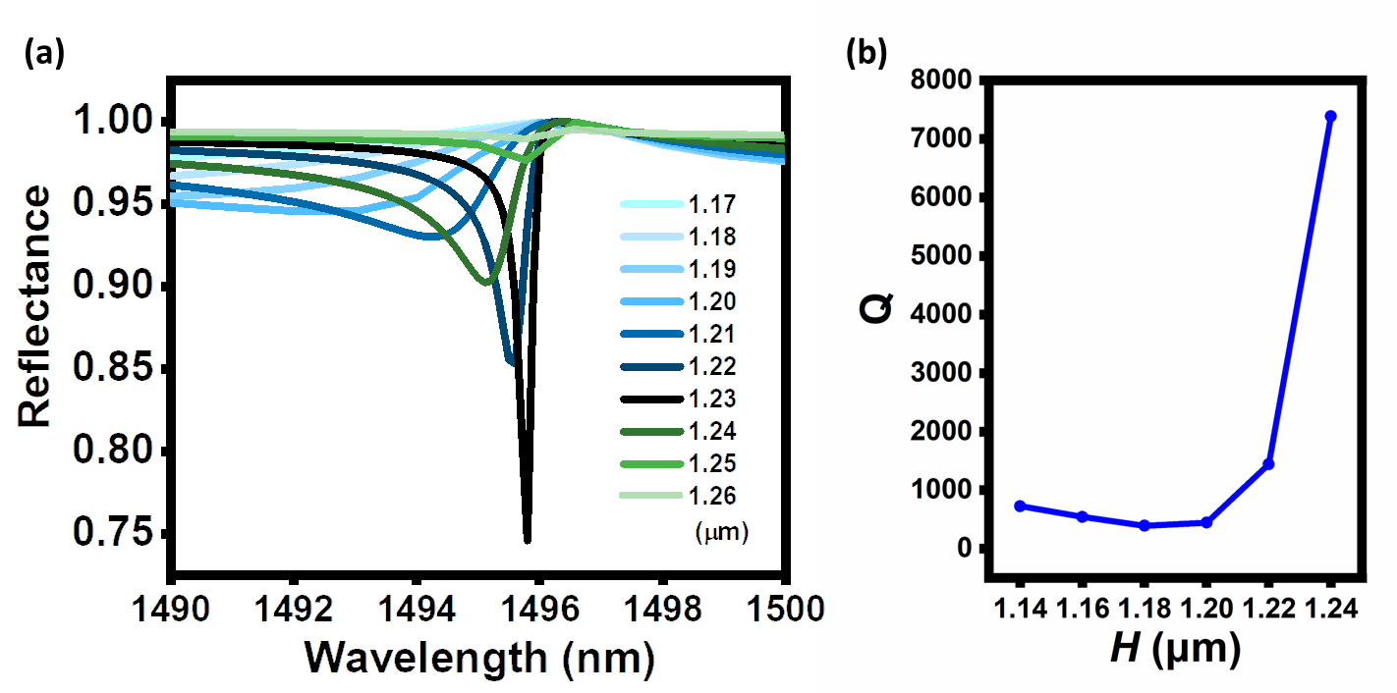
Figure S3. (a) The variation of resonant dip and corresponding (b) Q factor when height of the PMMA thickness H swept from 1.14µm to 1.26μm
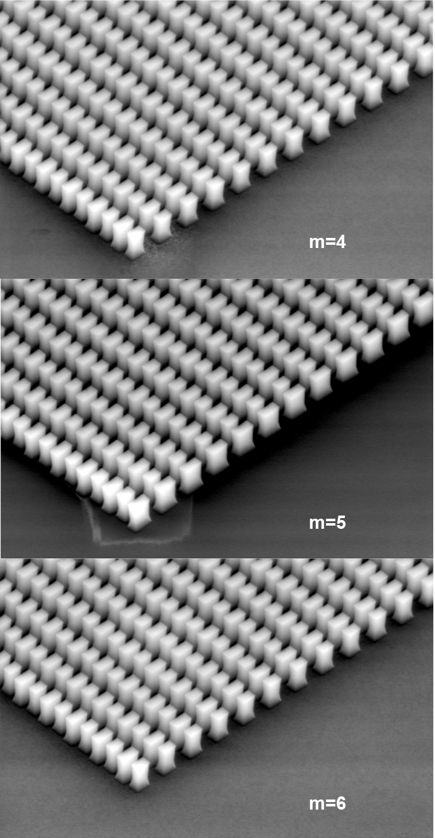
Figure S4. Comparison of the geometry of fabricated metasurfaces with m=4, 5, and 6 antennas in each unit cell with ΔL=100 nm and δ_{w}= 7, 1, -1, -7nm, δ_{w}= 6, 1, 0, -1, -6nm, and δ_{w}= 4, 3, 1, 0, -3, -4nm.

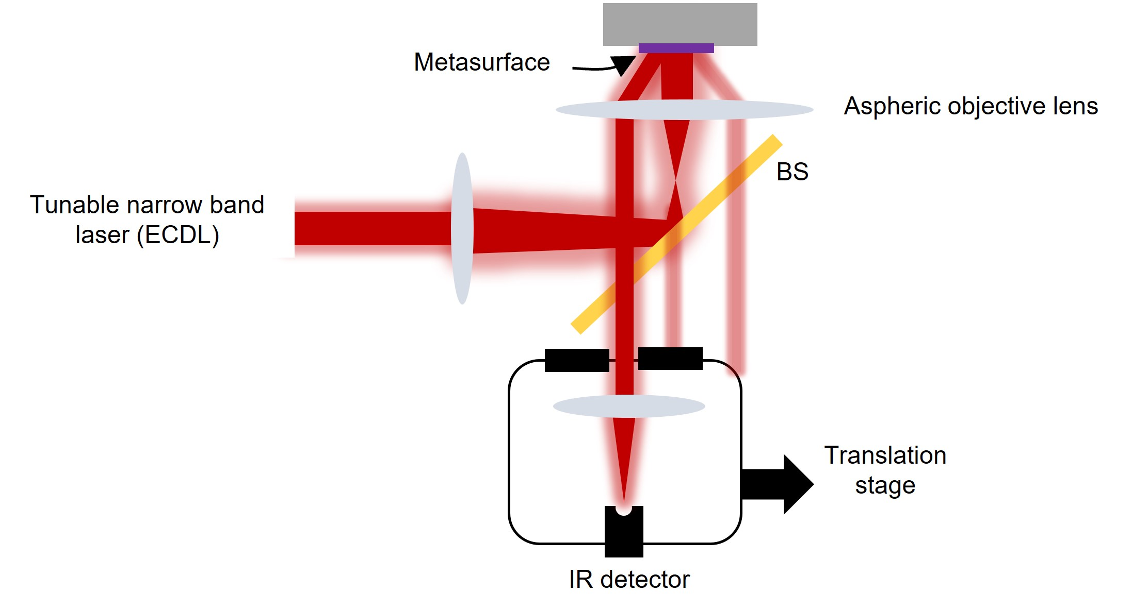

Figure S5. Microscopic setup for measuring the spectroscopic intensity and imaging.

