Supplementary Information for the manuscript:

Caudate-anchored cognitive connectivity pursuant to orthostatic hypotension in early Parkinson disease

Sang-Won Yoo, Seunggyun Ha, Yoon-Sang Oh, Dong-Woo Ryu, Ji-Yeon Yoo, Kwang-Soo Lee, and Joong-Seok Kim

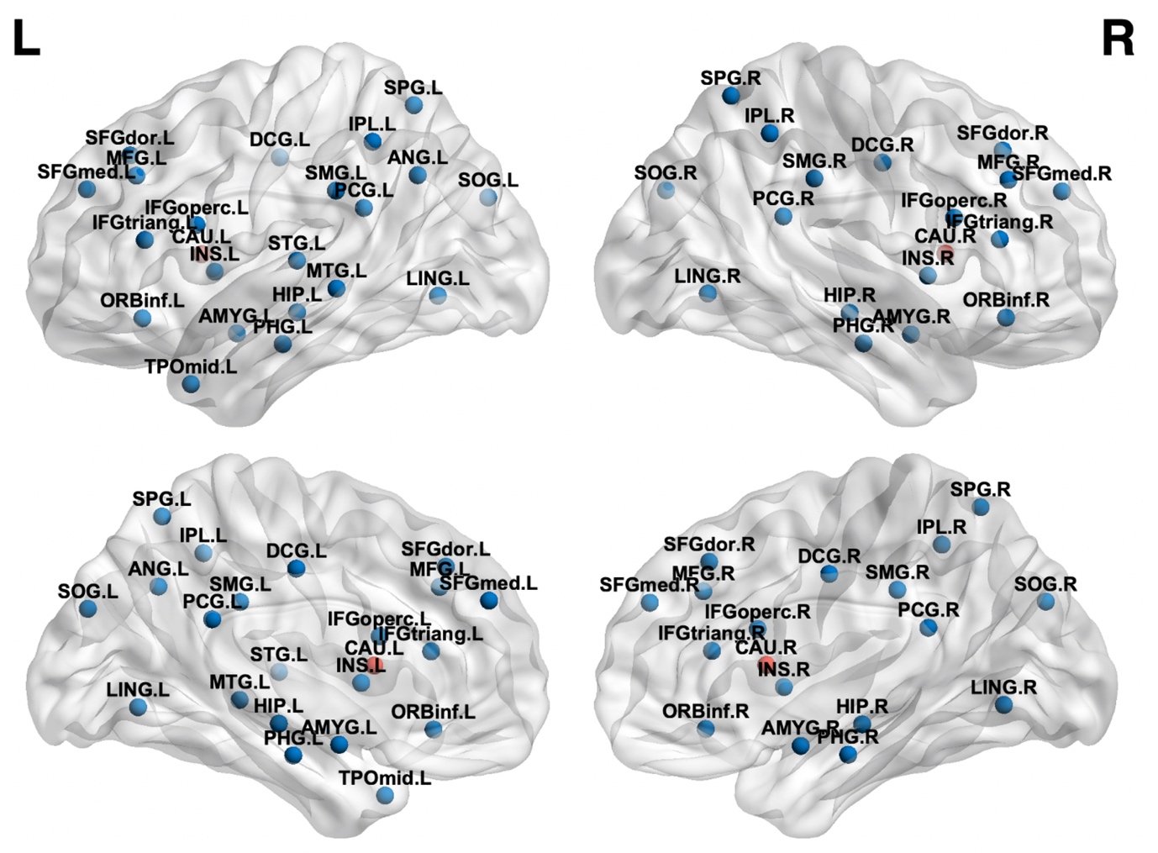
Supplementary Figure 1. The prespecified areas of cognitive domains.
Nodes represent the prespecified regions of interest (ROIs).
Red node, caudate nucleus (seed ROI); Blue node, pre-specified ROIs paired to the seed.
L, left; R, right; SFGdor, dorsolateral superior frontal gyrus; MFG, middle frontal gyrus; IFGoperc, inferior frontal gyrus, opercular part; IFGtriang, inferior frontal gyrus, triangular part; ORBinf, inferior frontal gyrus, orbital part; SFGmed, medial superior frontal gyrus; INS, insula; DCG, middle cingulate and paracingulate gyrus; PCG, posterior cingulate gyrus; HIP, hippocampus; PHG, parahippocampus; AMYG, amygdala; LING, lingual gyrus; SOG, superior occipital gyrus; SPG, superior parietal gyrus; IPL, inferior parietal gyrus; SMG, supramarginal gyrus; ANG, angular gyrus; CAU, caudate; STG, superior temporal gyrus; MTG, middle temporal gyrus; TPOmid, temporal pole: middle temporal gyrus.

Supplementary Table 1. Prespecified areas of cognitive domains
Domain/function |  | AAL atlas anatomical areas | Abbreviations
Attention/working memory domain | Dorsolateral prefrontal cortex | Dorsolateral superior frontal gyrus | SFGdor
 |  | Middle frontal gyrus | MFG
 | Right ventrolateral prefrontal cortex | Right inferior frontal gyrus
 |  | opercular part | IFGoperc. R
 |  | triangular part | IFGtriang. R
 |  | orbital part | ORBinf. R
 | Posterior parietal cortex | Superior parietal gyrus | SPG
 |  | Inferior parietal gyrus (supramarginal and angular gyrus excluded) | IPL
 |  | Right supramarginal gyrus | SMG. R
 | Medial prefrontal corex | Medial superior frontal gyrus | SFGmed
 |  | Middle cingulate and paracingulate gyrus | DCG
 | Insula | Insula | INS
Frontal/Executive domain | Dorsolateral prefrontal cortex | Dorsolateral superior frontal gyrus | SFGdor
 |  | Middle frontal gyrus | MFG
 | Ventrolateral prefrontal cortex | Inferior frontal gyrus
 |  | opercular part | IFGoperc
 |  | triangular part | IFGtriang
 |  | orbital part | ORBinf
 | Insula | Insula | INS
 | Subcortical deep nuclei | Caudate | CAU
 |  | Amygdala | AMYG
Memory domain | Limbic system | Hippocampus | HIP
 |  | Parahippocampus | PHG
 |  | Amygdala | AMYG
 |  | Posterior cingulate gyrus | PCG
 | Retrosplenial cortex | Lingual gyrus | LING
Language domain | Wernicke area | Left supramaginal gyrus | SMG. L
 |  | Left angular gyrus | ANG. L
 |  | Left superior temporal gyrus | STG. L
 |  | Left middle temporal gyrus | MTG. L
 |  | Left temporal pole: middle temporal gyrus | TPOmid. L
 | Broca area | Left inferior frontal gyrus
 |  | opercular part | IFGoperc. L
 |  | triangular part | IFGtriang. L
Visuospatial domain |  | Superior occipital gyrus | SOG
 |  | Superior parietal gyrus | SPG

Supplementary Table 2. Individual hemispheric correlation linkage between ipsilateral caudate nucleus (seed) and prespecified subregions
Domain/function |  | Abbreviations |  | Left caudate | Right caudate
Attention/working memory domain | Dorsolateral prefrontal cortex | SFGdor |  | O | O
 |  | MFG |  | O | O
 | Right ventrolateral prefrontal cortex
 |  | IFGoperc. R |  | - | O
 |  | IFGtriang. R |  | - | O
 |  | ORBinf. R |  | - | O
 | Posterior parietal cortex | SPG |  | O | O
 |  | IPL |  | O | O
 |  | SMG. R |  | - | O
 | Medial prefrontal corex | SFGmed |  | O | O
 |  | DCG |  | O | O
 | Insula | INS |  | O | O
Frontal/Executive domain | Dorsolateral prefrontal cortex | SFGdor |  | O | O
 |  | MFG |  | O | O
 | Ventrolateral prefrontal cortex
 |  | IFGoperc |  | O | O
 |  | IFGtriang |  | O | O
 |  | ORBinf |  | O | O
 | Insula | INS |  | O | O
 | Subcortical deep nuclei | AMYG |  | O | O
Memory domain | Limbic system | HIP |  | O | O
 |  | PHG |  | O | O
 |  | AMYG |  | O | O
 |  | PCG |  | O | O
 | Retrosplenial cortex | LING |  | O | O
Language domain | Wernicke area | SMG. L |  | O | -
 |  | ANG. L |  | O | -
 |  | STG. L |  | O | -
 |  | MTG. L |  | O | -
 |  | TPOmid. L |  | O | -
 | Broca area
 |  | IFGoperc. L |  | O | -
 |  | IFGtriang. L |  | O | -
Visuospatial domain |  | SOG |  | O | O
 |  | SPG |  | O | O

A total of fifty-three Spearman partial correlation analyses were performed. Interhemispheric correlations were not investigated. Coefficients whose p value < 0.00094 (Bonferroni correction threshold: < 0.05/53) were selected for further analyses.

