Aestuariimicrobium ganziense sp. nov., a new Gram-positive bacterium isolated from soil in the Ganzi Tibetan Autonomous Prefecture, China
Yu Geng¹∙, Jiang-Yuan Zhao, Hui-Ren Yuan, Le-Le Li, Meng-Liang Wen, Ming-Gang Li*, Shu-Kun Tang*
Yunnan Institute of Microbiology, Key Laboratory for Conservation and Utilization of Bio-resource, and Key Laboratory for Microbial Resources of the Ministry of Education, School of Life Sciences, Yunnan University, Kunming, 650091, PR China

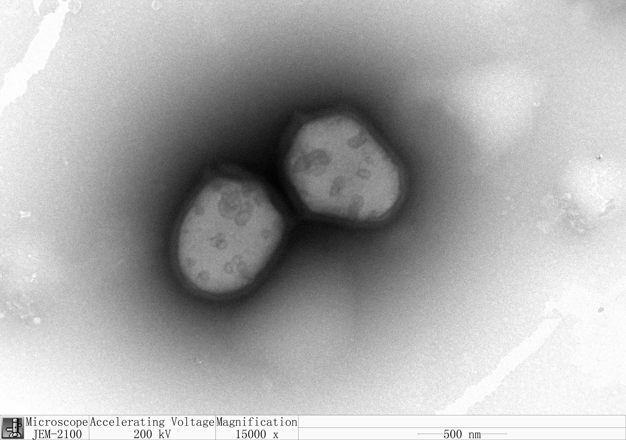
Fig. S1. Transmission electron micrograph of stain YIM S02566^{T} grown on R2A at 30 ℃ for 5d. Bar, 500nm

Fig. S2. Maximum-parsimony tree (MEGA 7.0) based on 16S rRNA gene sequences showing the relationships between strain YIM S02566^{T} and some members of the family Propionibacteriaceae. Bootstrap values (> 50%) based on 1000 replicates are shown at the branch nodes. Terrabacter tumescens JCM 1365^{T} was used as an outgroup

Fig. S3. Maximum-likelihood tree (MEGA 7.0) based on 16S rRNA gene sequences showing the relationships between strain YIM S02566T and some members of the family Propionibacteriaceae. Bootstrap values (> 50%) based on 1000 replicates are shown at the branch nodes. Terrabacter tumescens JCM 1365^{T} was used as an outgroup

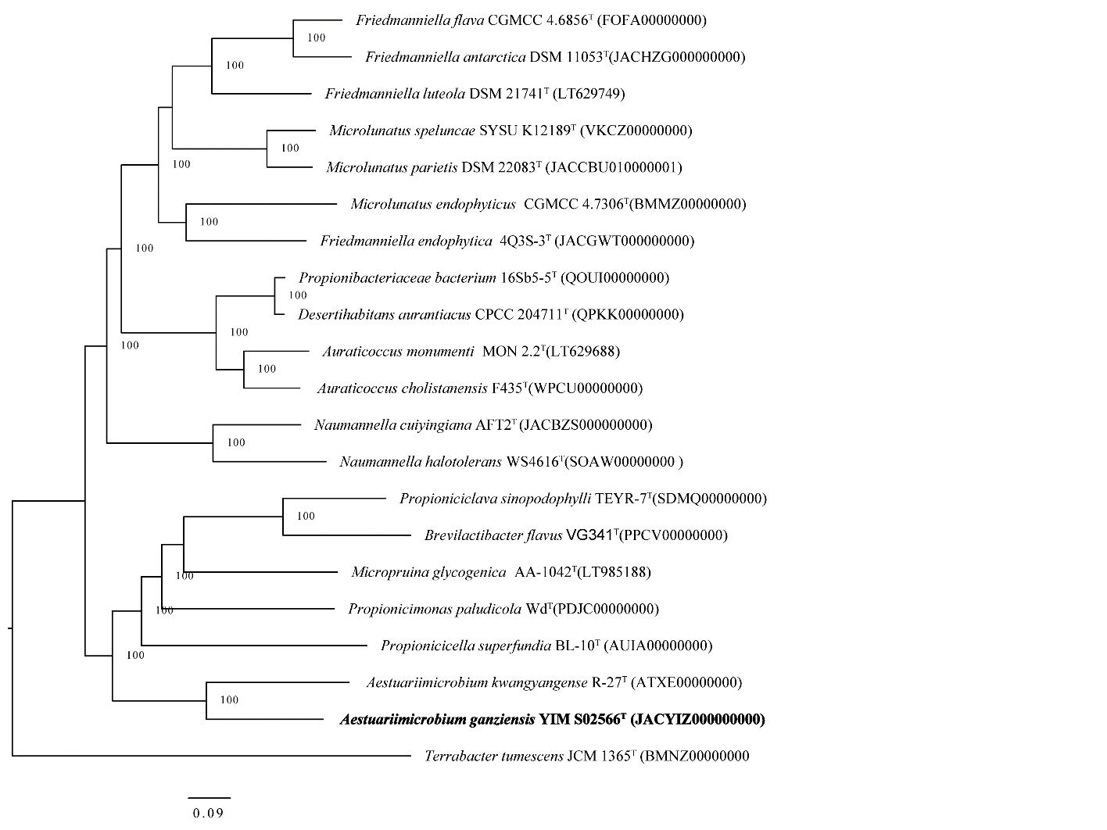
Fig. S4. Phylogenomics tree of YIM S02566^{T} and some members of the family Propionibacteriaceae (containing 232 protein marker genes). Terrabacter tumescens JCM 1365^{T} was used as an outgroup. Bootstrap analysis was carried out using 100 replications. Percentage bootstrap values (≥ 70%) were given at branching points

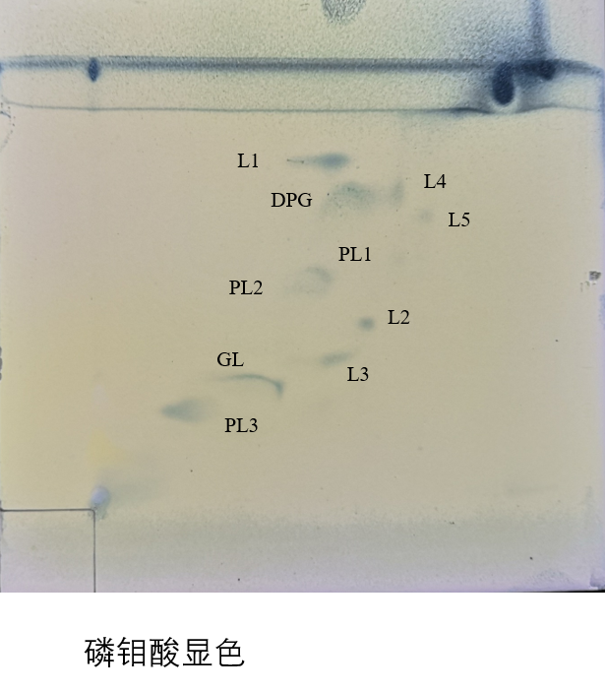
Fig. S5. Polar lipid profile of strain YIM B00363^{T} by two-dimensional TLC. The spray reagent is molybdatophosphoric acid. DPG, Diphosphatidylglycerol; L, lipids.PL, unknown phospholipid; GL, unidentified glycolipids

Table S1. All negative properties of commercial kits
For enzyme activities API ZYM: Negative for alkaline phosphatase, lipase (C14), cystine arylamidase, α-chymotrypsin, β-glucuronidase.
For the utilization of carbon sources or nitrogen sources: The following substrates are not utilized for growth: D-maltose, D-cellobiose, D-turanose, α-D-lactose, D-melibiose, N-acetyl-d-glucosamine, N-acetyl-β-d-mannosamine, N-acetyl-d-galactosamine, N-acetylneuraminic acid, α-D-glucose, D-mannose, D-Fructose, 3-methylglucose, L-rhamnose, inosine, D-mannitol, glycerol, D-glucose-6-PO₄, D-fructose-6-PO₄, D-aspartic acid, glycyl-l-prolin, L-arginine, L-aspartic acid, L-glutamic acid, L-histidine, L-serine, L-galactonic acid lactone, D-gluconic acid, mucic acid, quinic acid, D-saccharic acid, p-hydroxy-phenylacetic acid, methyl pyruvate, D-lactic acid methyl ester, L-lactic acid, citric acid, D-malic acid, L-Malic acid, bromo-succinic acid, γ-amino-butryricacid, α-hydroxy-butyricacid, β- hydroxy-d.l butyricacid , α-keto-butyricacid.
With API 50CH: Acid is not produced from: donitol I, methyl-β-d-xylopyranoside, mannitol, sorbitol, D-fucose, D-arabinitol, L-arabinitol, potassium gluconate, 2-ketogluconate D-fucose, L-fucose, D-arabitol, L-arabitol, potassium gluconate, potassium 2-ketogluconate.

