IL-18 and CD14 variants in chronic HBV predisposition: an experimental–bioinformatics study focused on transcription and splicing

Mohammad Sarhadi ¹, Elham Pahlavani ^{2,*}, Niloufar Hosseini Razavi ¹, Fatemeh Ghadyani ³, Zahra Abdollahi ⁴, Somayeh Sarhadi ⁵, Mahdi Majidpour ^{1,6,**}

¹Cellular and Molecular Research Center, Research Institute of Cellular and Molecular Sciences in Infectious Diseases, Zahedan University of Medical Sciences, Zahedan, Iran
² Infectious Diseases and Tropical Medicine Research Center, Research Institute of Cellular and Molecular Sciences in Infectious Diseases, Zahedan University of Medical Sciences, Zahedan, Iran
³Department of Cellular and Molecular, Faculty of Biology Sciences, Islamic Azad University, North Tehran Branch, Tehran, Iran
⁴ Department of Cell and Molecular Biology, Faculty of Chemistry, University of Kashan, Kashan, Iran
⁵ Department of Biology, Faculty of Sciences, Hamedan Branch, Islamic Azad University, Hamedan 15847-43311, Iran
⁶ Department of Clinical Biochemistry, Zahedan University of Medical Sciences, Zahedan, Iran

*,**Corresponding authors: Elham Pahlavani (Tel: +98 (915) 191-0321, E-mail: e.pahlavani@zaums.ac.ir)
Mahdi Majidpour (Tel: +98 (921) 653-2199, E-mail: mahdimajidpour@gmail.com)

Supplementary Fig 1 Locus of CD14 variations on chromosome 5 (5q31.3) and of IL-18 on chromosome 11 (11q23.1). CD14, cluster of differentiation antigen 14; IL-18, interleukin 18; rs, reference single-nucleotide polymorphism; p and q stand for the short and long arms of the chromosomes, respectively. The figure was obtained from the UCSC Genome Browser (accessible at http://www.genome.ucsc.edu)

Supplementary Table 1 The primers used for the amplification of IL-18 and CD14 polymorphisms
Gene | SNP | Primer Sequence (5′ to 3′) | RE | Fragment Size | Annealing Temperature
IL-18 | rs187238 C>G | F: CACAGAGCCCCAACTTTTACGGCAGAGAA  R: GACTGCTGTCGGCACTCCTTGG | MboII | G:116 + 39 bp  C:155 bp | 61 °C
IL-18 | rs1946518 T>G | F: AAAGGATAGTTGATACAGGCCATT  R*: TTCTGTTGCAGAAAGTGTAAAAATTTT | DraI | T:125 + 28 bp  G:153 bp | 57 °C
CD14 | rs2569190 A>G | F**: ATCATCCTTTTCCCACACC  R**: AACTCTTCGGCTGCCTCT | BsuRI | A: 296 bp  G: 155 + 141 bp | 60 °C
IL-18, interleukin 18; CD14, cluster of differentiation antigen 14; SNP, single-nucleotide polymorphism; 3' and 5', the third carbon of sugar ribose or deoxyribose, which is bound to the hydroxy group or a triple phosphate group, respectively; RE, restriction enzyme; bp, base pair; rs, reference SNP; F, Forward; R, Reverse.
*The primer was designed based on the mismatch polymerase chain reaction-restriction fragment length polymorphism (PCR-RFLP) technique.
**Primers were designed based on the anti-sense strand.

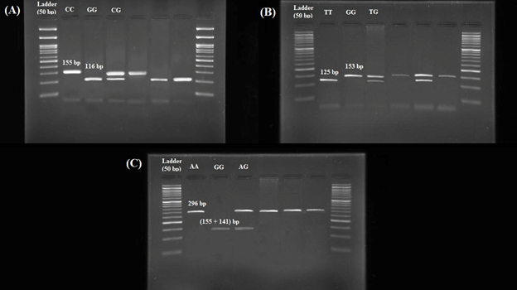
Supplementary Fig 2 Electrophoresis images of polymerase chain reaction-restriction fragment length polymorphism (PCR-RFLP) for IL-18 and CD14 polymorphisms (A: IL-18–rs187238 C>G, B: IL-18–rs1946518 T>G, and C: CD14–rs2569190 A>G). IL-18, interleukin 18; CD14, cluster of differentiation antigen 14; rs, reference single-nucleotide polymorphism

Supplementary Table 2 Haplotype analysis of IL-18 gene polymorphisms on chronic HBV risk
IL-18–rs187238 C>G | IL-18–rs1946518 T>G | HBV (%) | Control (%) | OR (95% CI) | p-value
C | T | 202 (50.5) | 157 (39.3) | 1 [reference]
G | T | 89 (22.2) | 113 (28.2) | 0.61 (0.43-0.87) | 0.005*
C | G | 83 (20.8) | 85 (21.3) | 0.76 (0.52-1.09) | 0.141
G | G | 26 (6.5) | 45 (11.2) | 0.45 (0.26-0.76) | 0.002*
*p < 0.05 was considered statistically significant and indicated in bold. IL-18, interleukin 18; HBV, hepatitis B virus; rs, reference single-nucleotide polymorphism; OR, odds ratio; CI, confidence intervals.

Supplementary Fig 3 Pairwise linkage disequilibrium (LD) analysis of IL-18–rs187238 C>G and –rs1946518 T>G SNPs. No robust linkage disequilibrium was seen between the three studied SNPs. IL-18, interleukin 18; SNP, single-nucleotide polymorphism; rs, reference SNP

Supplementary Fig 4 The WebLogo server indicated DNA sequence conservation around the studied SNPs loci with a 10-nucleotide flanking region. The red vertical line shows the positions of the SNP locus in humans and the conservation of wild alleles across multiple mammalian species. The height of the y-axis is the maximum entropy for the given sequence type. The high nucleotide symbols stand for more conservation, while the small and more diverse ones demonstrate less conservation. SNP, single-nucleotide polymorphism; rs, reference SNP

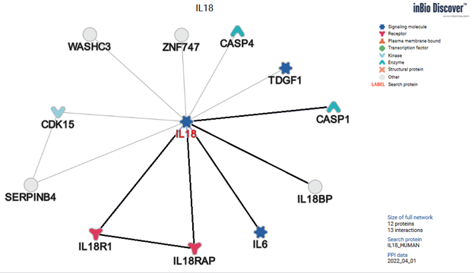

Supplementary Fig 5 The inBio Discover™ database (available at https://inbio-discover.intomics.com/map.html) predicted the protein-protein interaction network of IL-18. Edges along which proteins interact are indicated in bold. CASP1, caspase 1; CASP4, caspase 4; TDGF1, teratocarcinoma-derived growth factor 1; ZNF747, zinc-finger protein 747; IL-6, interleukin 6; CDK15, cyclin-dependent kinase 15; SERPINB4, serpin B4; IL-18, interleukin 18; IL-18RAP, interleukin 18 receptor accessory protein; IL-18R1, interleukin 18 receptor 1; IL-18BP, interleukin 18-binding protein; WASHC3, WASH complex subunit 3

Supplementary Fig 6 The inBio Discover™ database (available at https://inbio-discover.intomics.com/map.html) predicted the protein-protein interaction network of CD14. CD14, cluster of differentiation antigen 14; LY96, lymphocyte antigen 96; TANK, TRAF family member-associated NF-kappaB activator; IRF3, interferon regulatory factor 3; MYD88, myeloid differentiation primary response protein MyD88; TAB2, TGF-beta-activated kinase 1 and MAP3K7-binding protein 2; TAB1, TGF-beta-activated kinase 1 and MAP3K7-binding protein 1; RIPK3, receptor-interacting serine/threonine-protein kinase 3; IKBKE, inhibitor of nuclear factor kappaB kinase subunit beta; TLR4, toll-like receptor 4; TAB3, TGF-beta-activated kinase 1 and MAP3K7-binding protein 3; TLR2, toll-like receptor 2; LBP, lipopolysaccharide-binding protein; FADD, FAS-associated death domain protein; TIRAP, toll/interleukin 1 receptor domain-containing adapter protein; ITGAM, integrin alpha-M; TLR6, toll-like receptor 6; IRAK1, interleukin 1 receptor-associated kinase 1; IRF7, interferon regulatory factor 7; TLR1, toll-like receptor 1; TRAF3, TNF receptor-associated factor 3; RIPK1, receptor-interacting serine/threonine-protein kinase 1; IRAK2, interleukin 1 receptor-associated kinase-like 2; IRAK4, interleukin 1 receptor-associated kinase-like 4; CD36, platelet glycoprotein 4 (or cluster of differentiation antigen 36); SARM1, NAD⁺ hydrolase SARM1; BTK, tyrosine-protein kinase BTK; TICAM2, TIR domain-containing adapter molecule 2; TICAM1, TIR domain-containing adapter molecule 1

