Supplementary Materials
Table S.1. Prediction accuracy results and error matrices of ResNet models performed with 50, 100 and 200 epochs.
ResNet Model - 50 epochs
Class Name | Marsh | Open Water | Swamp | Upland | Total | Users’ Accuracy
Marsh | 1169 | 747 | 43 | 6 | 1965 | 0.59
Open Water | 75 | 1079 | 11 | 0 | 1165 | 0.93
Swamp | 6 | 7 | 162 | 0 | 175 | 0.93
Upland | 851 | 167 | 14 | 1994 | 3026 | 0.66
Total | 2101 | 2000 | 230 | 2000 | 6331
Producers’ Accuracy | 0.56 | 0.54 | 0.70 | 1.00
Overall Kappa | 0.56
Overall Accuracy | 0.70
ResNet Model - 100 epochs
Class Name | Marsh | Open Water | Swamp | Upland | Total | Users’ Accuracy
Marsh | 1252 | 645 | 56 | 2 | 1955 | 0.64
Open Water | 87 | 1148 | 5 | 0 | 1240 | 0.93
Swamp | 5 | 1 | 152 | 0 | 158 | 0.96
Upland | 757 | 206 | 17 | 1998 | 2978 | 0.67
Total | 2101 | 2000 | 230 | 2000 | 6331
Producers’ Accuracy | 0.60 | 0.57 | 0.66 | 1.00
Overall Kappa | 0.59
Overall Accuracy | 0.72
ResNet Model - 200 epochs
Class Name | Marsh | Open Water | Swamp | Upland | Total | Users’ Accuracy
Marsh | 1282 | 639 | 8 | 5 | 1934 | 0.66
Open Water | 101 | 1202 | 2 | 0 | 1305 | 0.92
Swamp | 16 | 7 | 207 | 0 | 230 | 0.90
Upland | 702 | 152 | 13 | 1995 | 2862 | 0.70
Total | 2101 | 2000 | 230 | 2000 | 6331
Producers’ Accuracy | 0.61 | 0.60 | 0.90 | 1.00
Overall Kappa | 0.62
Overall Accuracy | 0.74

Table S.2 Error matrices of ResNet, Support Vector Machine, and Random Forest classifications
Reference Data
ResNet Model 200 |  | Marsh | Open Water | Swamp | Upland | Total
Map Data | Marsh | 1282 | 639 | 8 | 5 | 1934
Map Data | Open Water | 101 | 1202 | 2 | 0 | 1305
Map Data | Swamp | 16 | 7 | 207 | 0 | 230
Map Data | Upland | 702 | 152 | 13 | 1995 | 2862
 | Total | 2101 | 2000 | 230 | 2000 | 6331
SVM Model |  | Marsh | Open Water | Swamp | Upland | Total
Map Data | Marsh | 1280 | 686 | 61 | 124 | 2151
Map Data | Open Water | 105 | 1122 | 16 | 0 | 1243
Map Data | Swamp | 43 | 46 | 132 | 49 | 270
Map Data | Upland | 673 | 146 | 21 | 1827 | 2667
 | Total | 2101 | 2000 | 230 | 2000 | 6331
Reference Data
RF Model |  | Marsh | Open Water | Swamp | Upland | Total
Map Data | Marsh | 1283 | 822 | 81 | 126 | 2312
Map Data | Open Water | 50 | 1078 | 17 | 0 | 1145
Map Data | Swamp | 14 | 43 | 107 | 33 | 197
Map Data | Upland | 754 | 57 | 25 | 1841 | 2677
 | Total | 2101 | 2000 | 230 | 2000 | 6331

Figure S.1. Examples of ground truth and Predictions of ResNet modelling based on 50 epochs. In the figure, brown depicts marsh, blue open water, and green swamps.
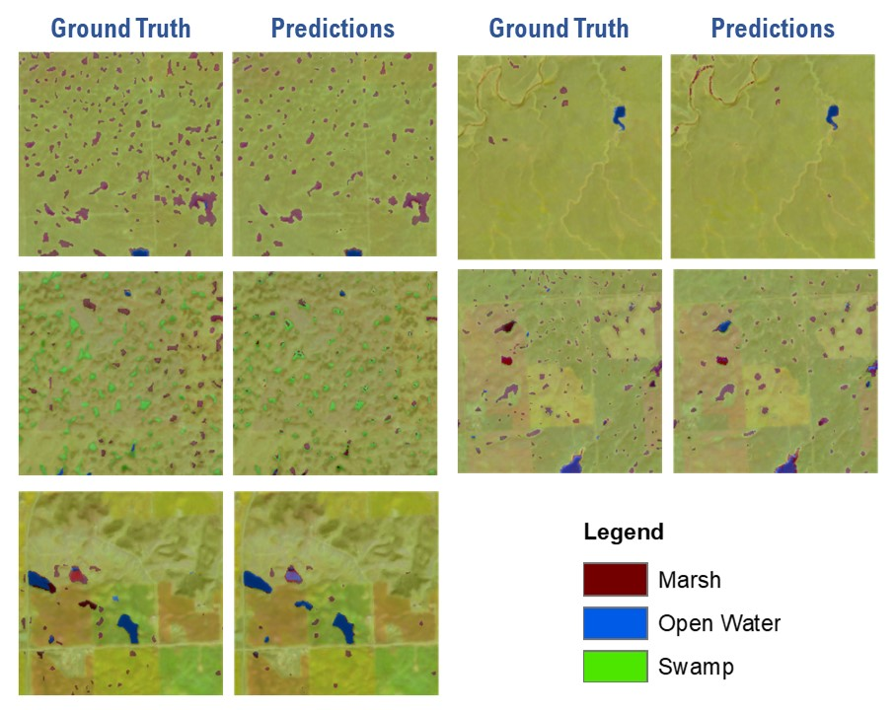

Figure S.2. Google Earth Engine wetland explorer app for the Parkland and Grassland Natural Region (landing page)
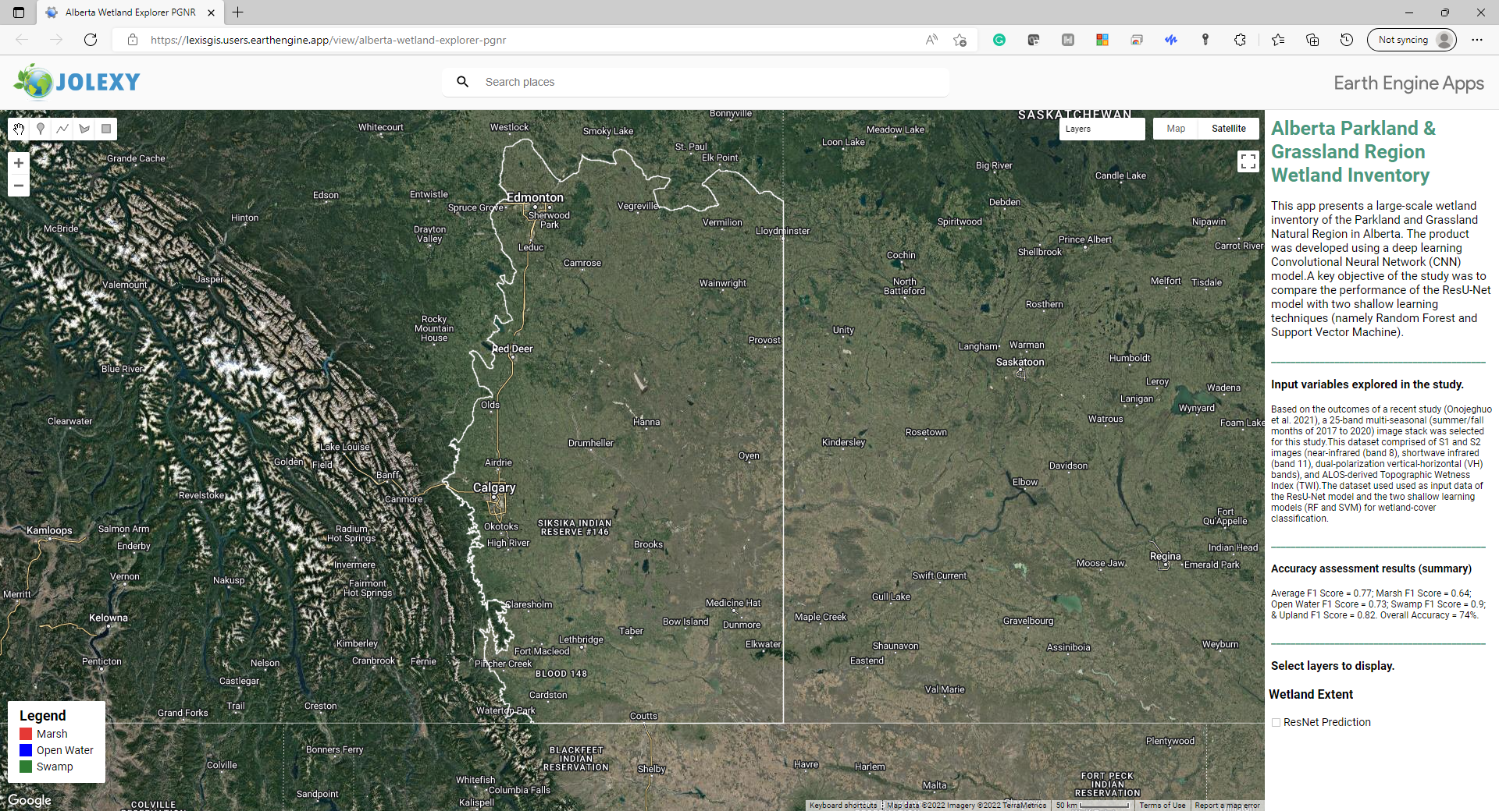

URL: https://lexisgis.users.earthengine.app/view/alberta-wetland-explorer-pgnr

Figure S.3. ArcGIS Online wetland explorer app for the Parkland and Grassland Natural Region (landing page)
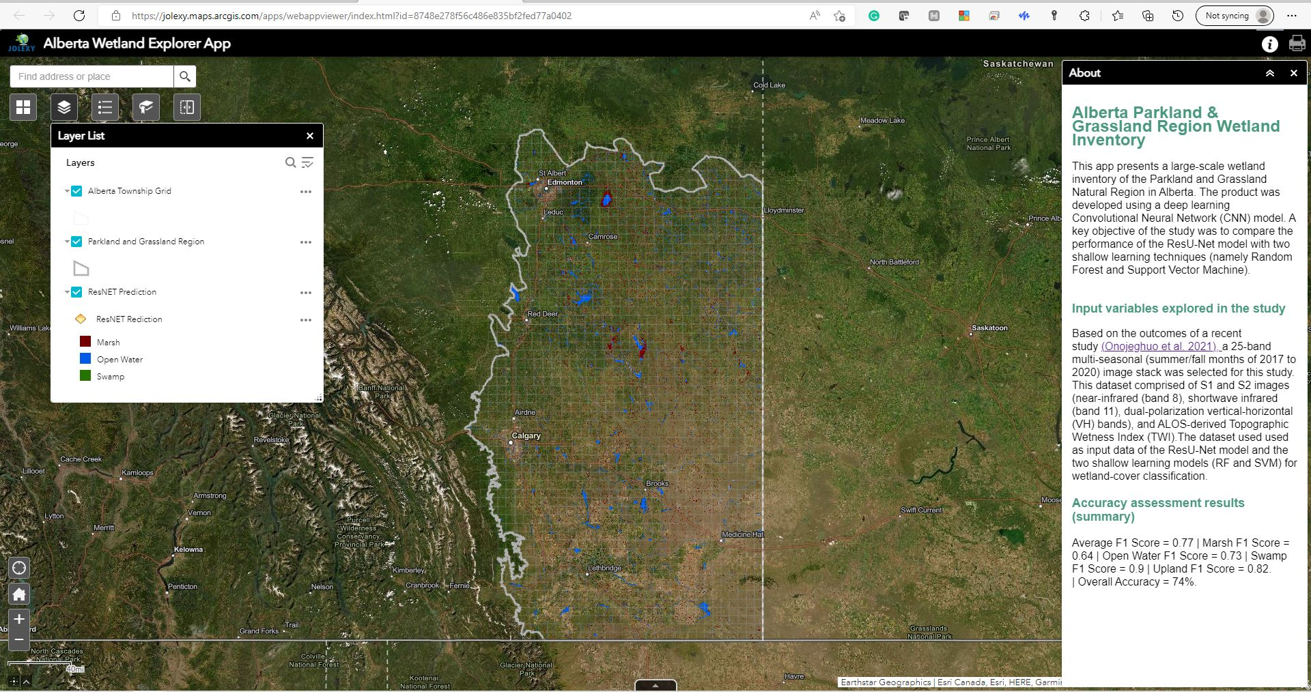
URL: https://jolexy.maps.arcgis.com/apps/webappviewer/index.html?id=8748e278f56c486e835bf2fed77a0402

Figure S.4. Visual comparison of ResNet prediction with Alberta Biodiversity Monitoring Institute (ABMI) and Alberta Merged Wetland Inventory (ABMI) wetland inventory products with high-resolution satellite imagery (Maxmar imagery dated July 25, 2019) of selected locations in the study area. The top images represent Crawling Lake, and the bottom image is Beaverhill Lake, both prominent wetland habitats in the region.
