Supporting Information for
Prediction of watershed processes based on morphometric features using feature selection and neural network algorithms

Marzieh Mokarram^{1*} Hamid Reza Pourghasemi² John P. Tiefenbacher³
¹ Department of Geography, Faculty of Economics, Management and Social sciences, Shiraz University, Shiraz, Iran, Email: m.mokarram@shirazu.ac.ir
²Department of Natural Resources and Environmental Engineering, College of Agriculture, Shiraz University, Shiraz, Iran, Email: hr.pourghasemi@shirazu.ac.ir
³Department of Geography, Texas State University, San Marcos, TX USA, Email: tief@txstate.edu
*Corresponding author: Marzieh Mokarram, Tel.: +98-917-8020115; Fax: +987136134479 Address: Shiraz university, Iran, Postal Code: 71379-58756, Email: m.mokarram@shirazu.ac.ir

Table S1. Morphometric parameters characteristics
Symbol | Variable | Symbol | Variable
A_{b} | Basin area (m²) | D_{d} | Drainage density (km⁻¹)
P_{b} | Basin perimeter (m) | Mel | Melton’s number  Mel = ΔH_{b}/(A_{b})0.5
L_{b} | Basin Length (m) | A_{f} | Fan area ( m²)
L_{c} | Main channel length (m) | P_{f} | Fan perimeter (m)
H_{min}_b | Basin minimum height (m) | L_{f} | Fan length (m)
H_{max}_b | Basin maximum height (m) | H_{min}_f | Fan minimum height (m)
ΔH_{b} | Basin relief (m)  ΔH_{b}= H_{max_b} − H_{min_b} | ΔH_{f} | Fan relief (m)  ΔH_{f} = H_{max}_f − H_{min}_f
R_{r}b | Basin Relief ratio (m) R_{r}b = ΔH_{b}/L_{b} | R_{r}f | Fan Relief ratio  R_{r}f = ΔH_{f}/L_{f}
β_{b} | Basin mean slope (°) | β_{f} | Fan mean slope (°)
BS | Basin shape | BL/BW | BL:Basin length  BW: Basin width
β_{low}_b | Lower basin slope (°) | βupp_f | Upper fan slope (°)
β_{c} | Main channel slope (°) | α | Sweep angle (°)
Cirb | Cirb  $$v=A_{b}/(\frac{πГ2α}{360})$$  π is equal to 3.14, Г is the radius of the cone and α is the angle between the two margins of the alluvial fan at the junction of the alluvial fan | V_{f} | Fan volume (m³)$$V=(\frac{π×r^{2}×h}{3})×(\frac{s}{360})$$  π is the fan radius in meters, h is the height difference between the apex and the base of the fan in meters, S is the sweeping angle

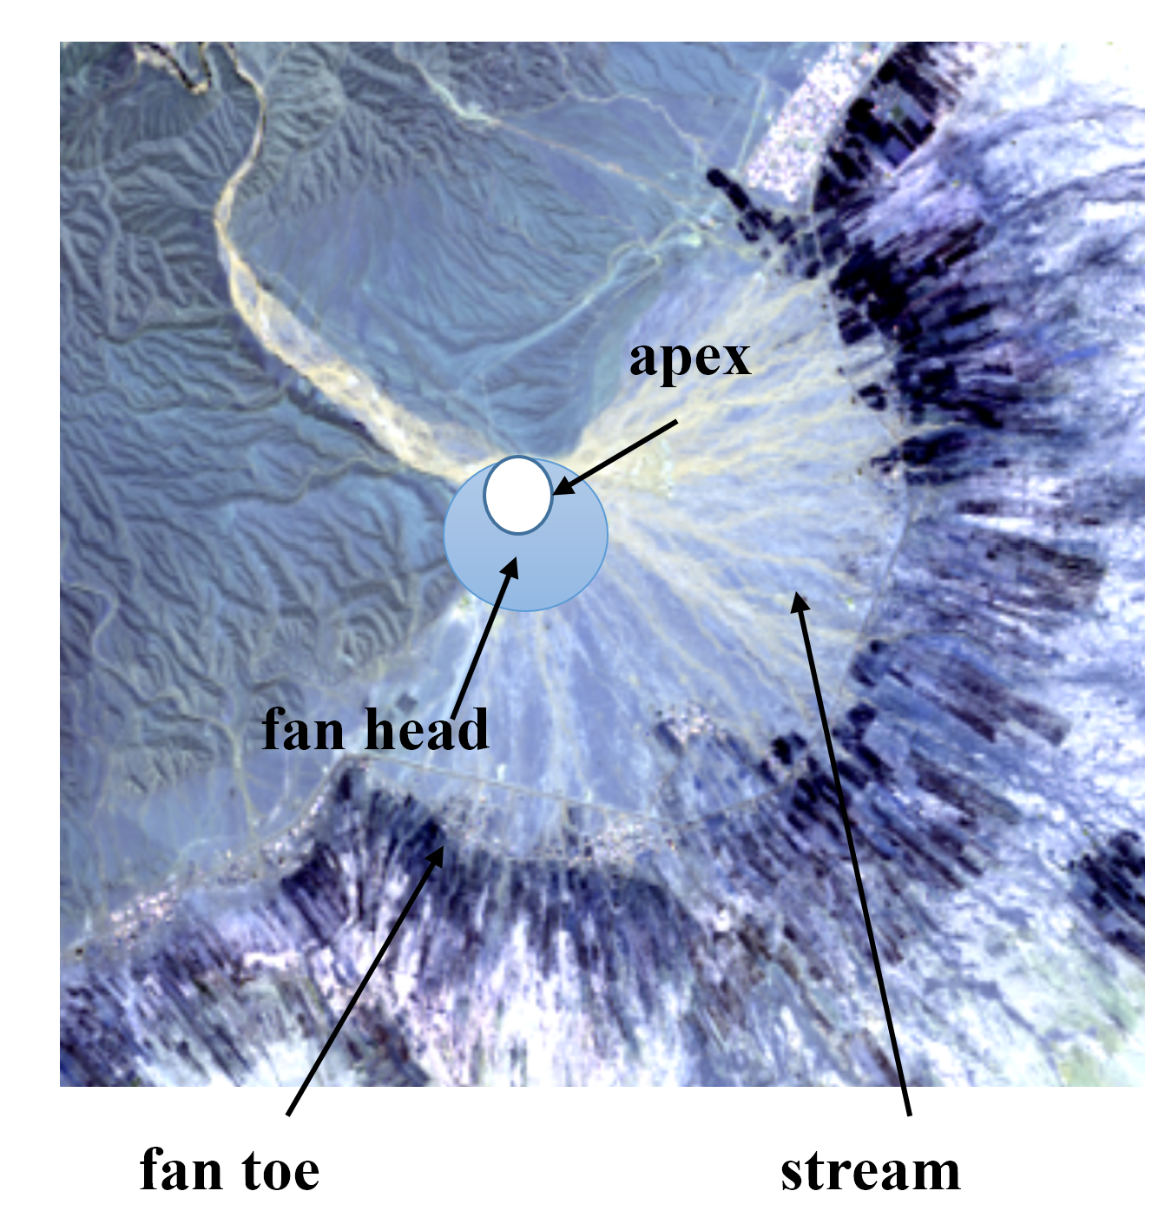
Fig. S1. The structure of an alluvial fan
Fig. S2. Steps of research
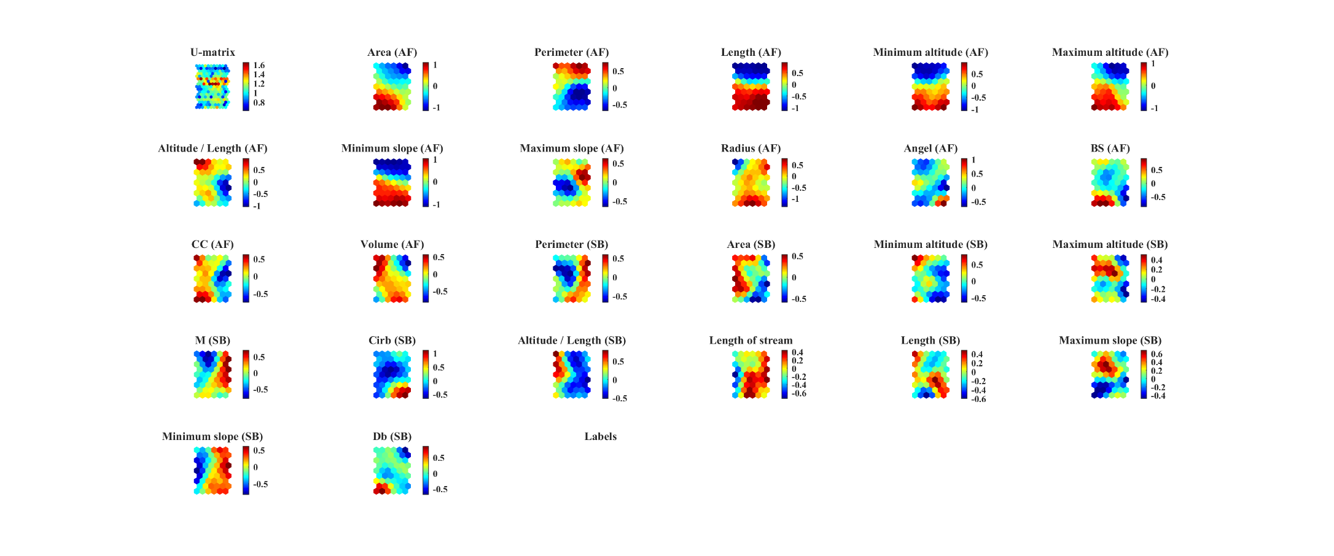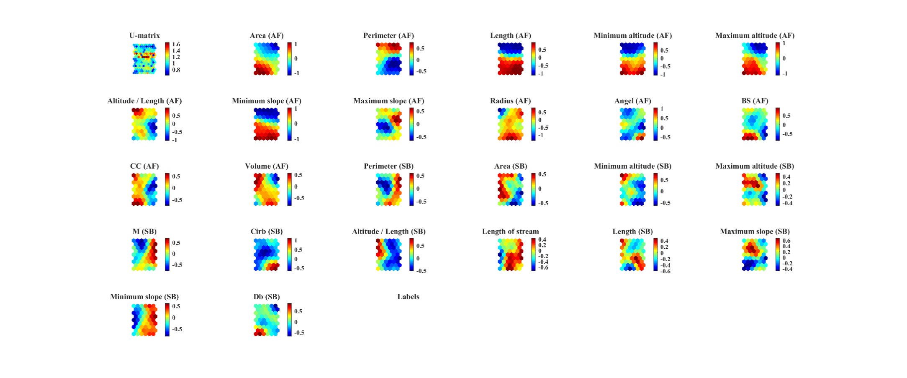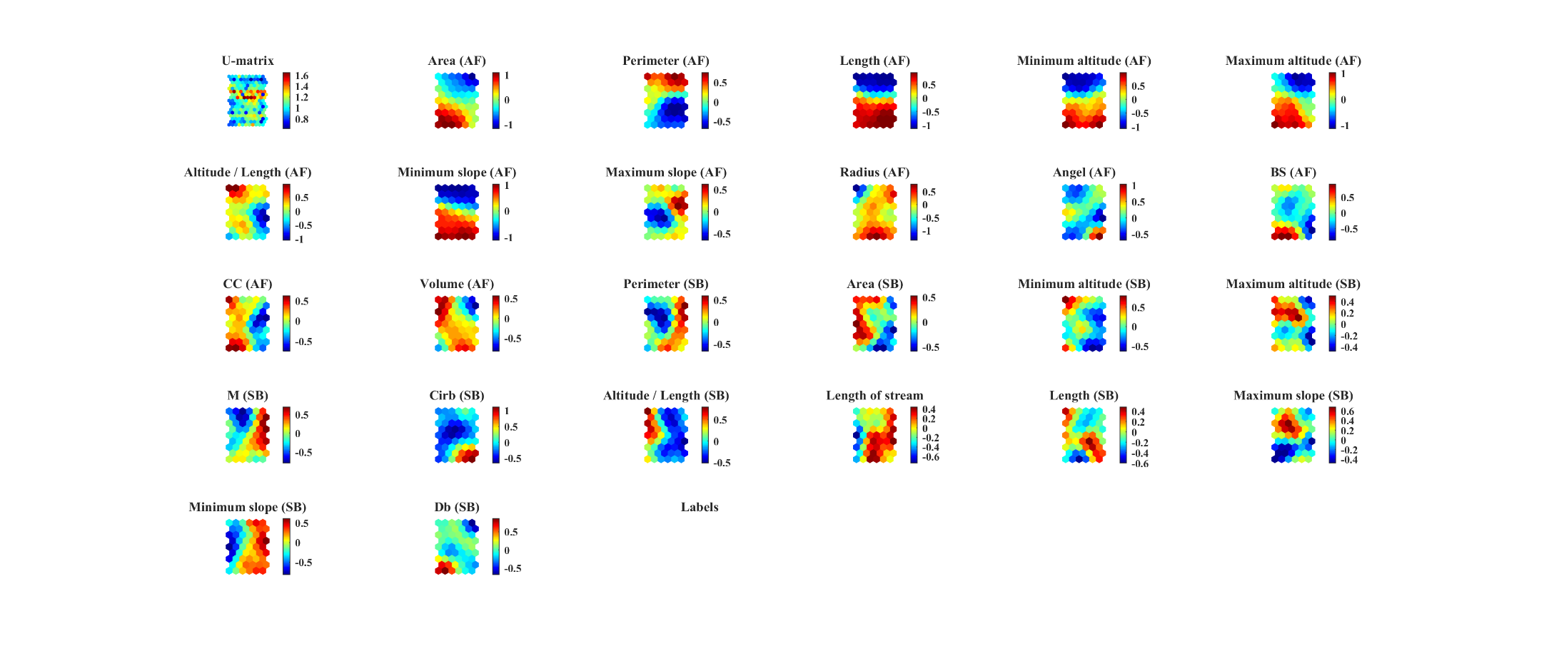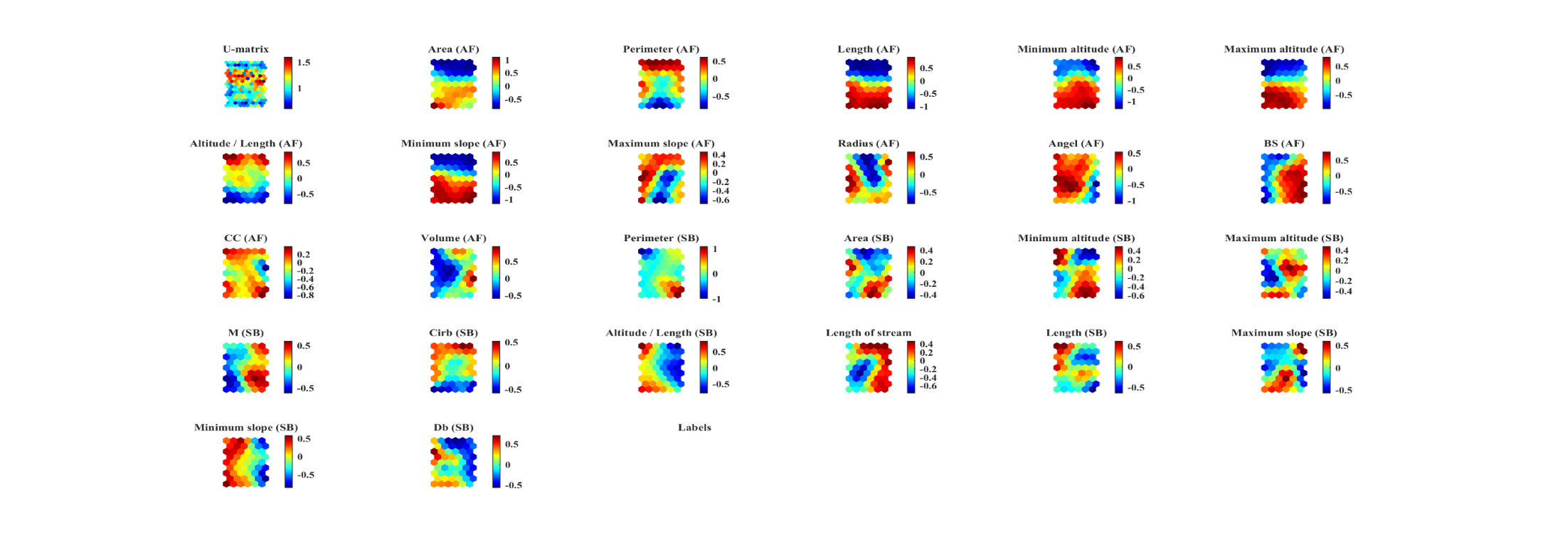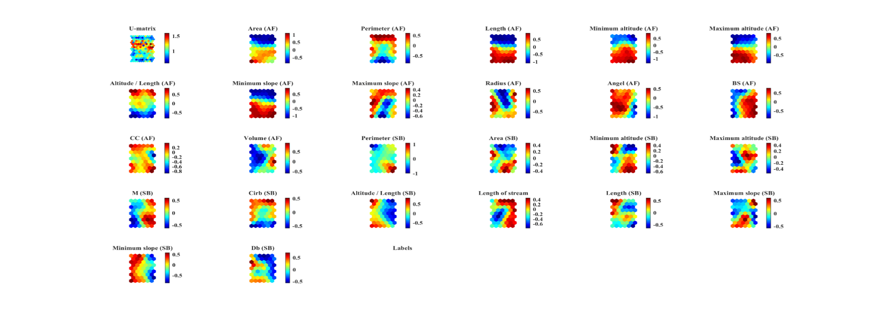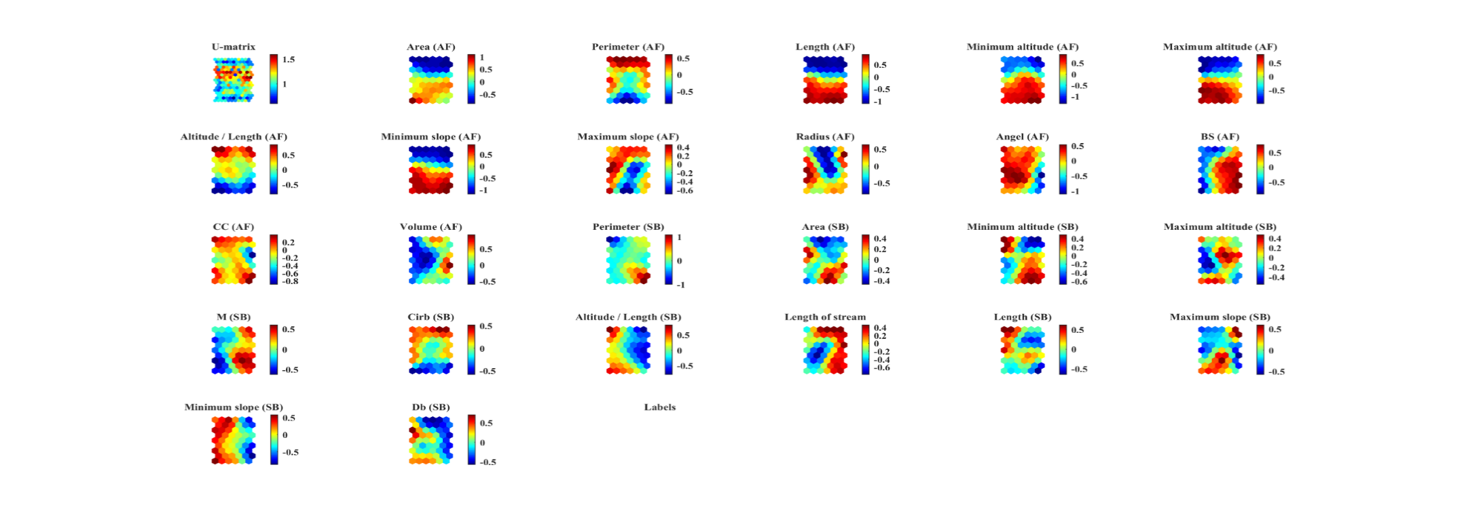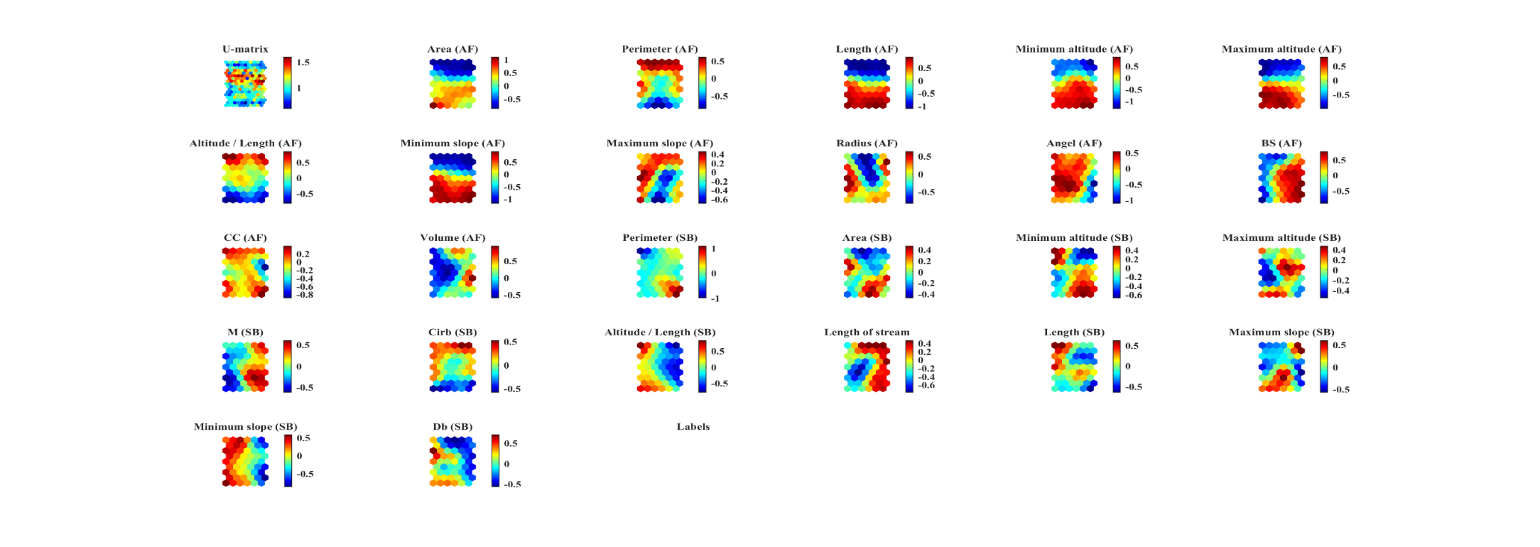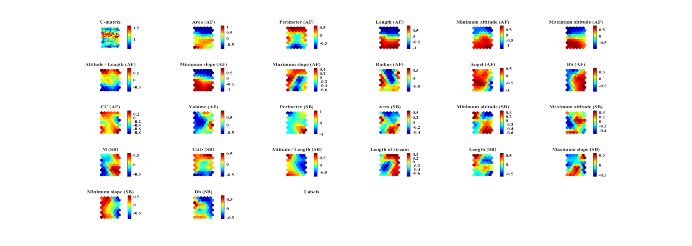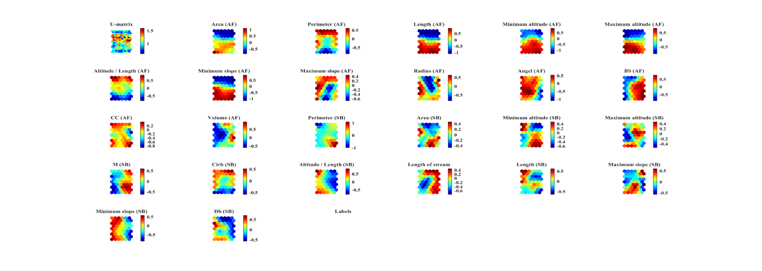
(a)
(b)
Fig. S3. SOM visualization through U-matrix (a): lithology, (b): erosion

